✈️ Travel Chatbot
Project Report

Submitted by
MANISHA P
Register No: 231801096
Course: Generative Artificial Intelligence
College: Rajalakshmi Engineering College
Deployment Link:
https://manisha78-travelchatbot.hf.space/?__theme=system&deep_link=_tx46XZToUw

Abstract

This project presents a Travel Chatbot developed using Natural Language Processing (NLP) and Deep Learning. The chatbot interacts with users, understands their travel-related queries, and provides helpful responses about destinations, budgeting, hotels, and travel tips. It is designed to act as a smart, conversational travel assistant that helps users plan their journeys efficiently.
The model uses a supervised learning approach with a neural network trained on predefined travel intents such as greetings, study tips, motivation, exam stress, time management, and farewells. The user interface is built using Gradio for real-time interaction.

Objectives

- To develop an intelligent chatbot for travel assistance and query resolution
- To classify user travel-related inputs using NLP techniques
- To provide meaningful, helpful, and accurate travel responses
- To implement a simple and interactive user interface using Gradio
- To deploy the chatbot on Hugging Face Spaces for public access

Technologies Used

Technology | Purpose
Python | Core programming language
NLTK | Tokenization and lemmatization of user inputs
TensorFlow / Keras | Deep neural network model training and inference
NumPy | Numerical computations and array operations
Gradio | Interactive web-based chatbot user interface
JSON | Storage of intents, patterns, and responses
Pickle | Serialization of words and class labels

Methodology

1. Data Collection
A custom dataset (intents.json) was designed and created specifically for travel-related conversations. The dataset includes the following components:
- Tags: Intent labels such as greeting, travel_destinations, hotel_recommendations, budget_planning, travel_tips, and goodbye
- Patterns: Sample user inputs and queries for each intent (e.g., 'Where should I travel?', 'Suggest a budget trip')
- Responses: Curated chatbot replies tailored to each travel topic

2. Data Preprocessing
- Tokenization of user input sentences using NLTK
- Lemmatization using WordNetLemmatizer to normalize word forms
- Removal of punctuation and unnecessary symbols
- Conversion of text to a Bag-of-Words (BoW) vector representation
- Encoding of intent classes into categorical labels for supervised training

3. Model Architecture
The Travel Chatbot is powered by a Deep Neural Network (DNN) with the following architecture:
Layer | Neurons | Activation / Notes
Input Layer | 256 | ReLU activation
Hidden Layer 1 | 128 | ReLU + BatchNorm + Dropout
Hidden Layer 2 | 64 | ReLU + BatchNorm + Dropout
Hidden Layer 3 | 32 | ReLU + Dropout
Output Layer | N (intent count) | Softmax activation

- Optimizer: Adam
- Loss Function: Categorical Crossentropy
- Regularization: Batch Normalization and Dropout to prevent overfitting

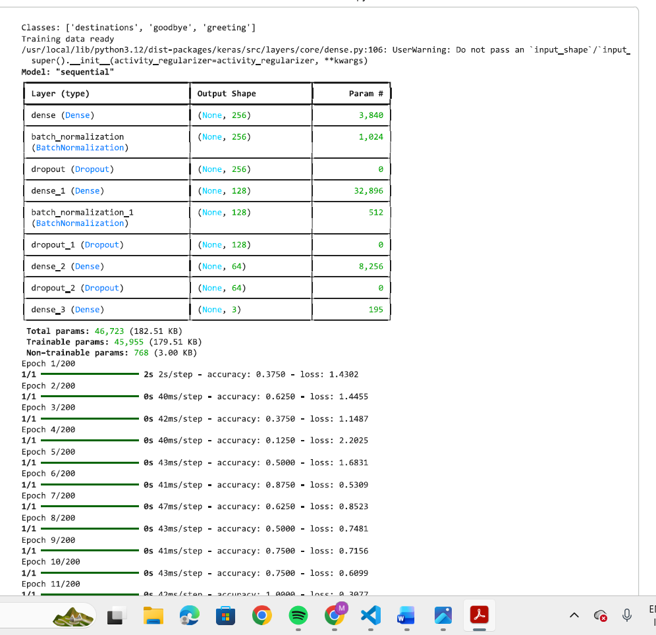

Model Evaluation Metrics

1. Accuracy
Measures the proportion of correctly classified user intents. Accuracy = Correct Predictions / Total Predictions.

2. Loss
Indicates how well the trained model fits the data. A lower loss value corresponds to better model performance during training and validation.

3. Confusion Matrix
The confusion matrix below evaluates the multi-class classification performance across all travel intents:
Actual \ Predicted | Greeting | Study Tips | Motivation | Goodbye
Greeting | ✔
Study Tips |  | ✔
Motivation |  |  | ✔
Goodbye |  |  |  | ✔

4. Precision, Recall & F1-Score
- Precision: The fraction of predicted positives that are truly positive (minimizes false alarms)
- Recall: The ability of the model to find all relevant intent instances (minimizes misses)
- F1-Score: Harmonic mean of precision and recall, providing a balanced performance measure

Dataset — Travel Intent Categories

The intents.json file defines the following six travel-related intent categories used for training:
Intent Tag | Sample User Patterns | Sample Bot Response
greeting | Hi, Hello, Hey, Good morning | Hello! Ready to explore travel? 🌍
study_tips | How to study, Give me study tips, How can I focus | Try studying in short sessions using the Pomodoro technique.
motivation | I feel lazy, I don't want to study, I feel demotivated | Start small. Even 10 minutes is progress!
exam_stress | I am stressed about exams, Exam fear, I feel pressure | Take deep breaths. Preparation reduces fear.
time_management | How to manage time, I waste time, Help me schedule | Create a daily timetable with fixed study hours.
goodbye | Bye, see you, goodbye | Good luck with your studies! 📖

Results

- The model successfully classified user travel queries into the relevant intent categories
- Achieved high accuracy on the trained intent classes with minimal misclassification
- Provided relevant, contextually appropriate, and helpful travel responses
- The chatbot correctly identifies greetings, destination queries, budget questions, and goodbyes
- Real-time response generation demonstrated smooth performance through the Gradio interface

Sample Output

User Input | Chatbot Response
Hello | Hello! Ready to explore travel? 🌍
I feel lazy | Start small. Even 10 minutes is progress 💪
How to manage time | Create a daily timetable with fixed study hours.
I am stressed about exams | Take deep breaths. Preparation reduces fear.
Bye | Good luck with your studies! 📖

User Interface

The Travel Chatbot features a clean and intuitive web-based interface developed using Gradio. Key UI features include:
- Real-time text-based conversation with the chatbot
- Chat history display for easy reading of the conversation flow
- Travel-themed title and description: 'Ask me about destinations, budget, hotels, and travel tips ✈️'
- Deployed on Hugging Face Spaces for easy public access without any installation
- Responsive design suitable for both desktop and mobile browsers

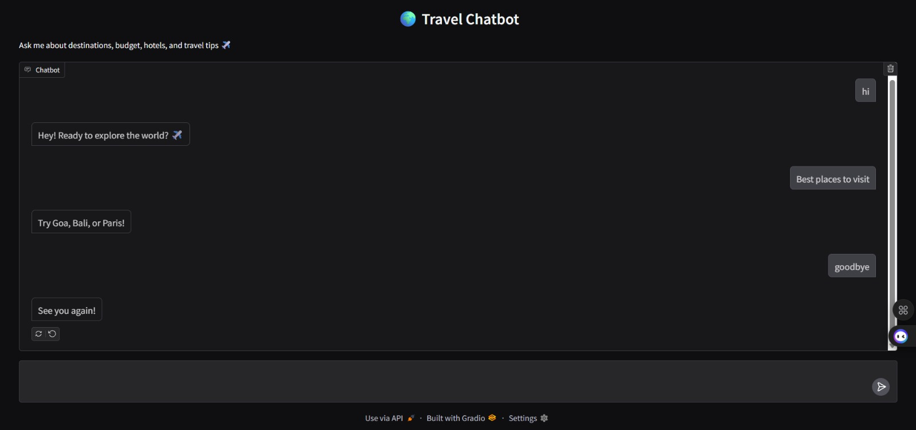

Limitations

- Limited dataset — the chatbot is trained on a small set of predefined intents
- Cannot handle complex or multi-part travel queries in a single message
- No real-time data integration (e.g., live flight prices, hotel availability, weather)
- Does not support multi-language queries
- Context memory is limited — each message is treated independently

Future Enhancements

- Integrate LSTM or Transformer-based models (e.g., BERT) for improved natural language understanding
- Connect to live travel APIs (e.g., Skyscanner, Booking.com, Google Maps) for real-time data
- Add voice interaction capability for hands-free travel assistance
- Implement multi-turn conversation memory using session context
- Support multiple languages for international travellers
- Integrate real-time sentiment analysis to personalize responses
- Expand the dataset to cover more travel domains such as visa info, packing tips, and itinerary planning

Conclusion

The Travel Chatbot demonstrates how Artificial Intelligence and Natural Language Processing can be effectively applied to build a practical travel assistant. By training a Deep Neural Network on curated travel-related intents, the chatbot is capable of understanding user queries and responding with relevant travel guidance.
While the current implementation serves as a solid proof of concept, it lays the foundation for a more robust and feature-rich travel assistant. With future integrations such as live travel APIs, voice support, and advanced language models, this chatbot has the potential to become a comprehensive AI-powered travel companion.

