Travel Chatbot with LLM Integration
Project Report

Submitted by
MANISHA P
Course: Generative Artificial Intelligence
College: Rajalakshmi Engineering College
https://manisha78-travelchatbot.hf.space/?__theme=system&deep_link=_tx46XZToUw

Abstract
This project presents a Travel Chatbot developed using a hybrid approach combining a trained intent classification model with a Large Language Model (LLM) fallback powered by Groq API. The chatbot intelligently handles travel-related queries and general questions, providing accurate and contextual responses. When the intent classifier has low confidence, the system seamlessly falls back to a powerful LLM (LLaMA 3) to ensure quality responses at all times. The user interface is built using Gradio, enabling real-time, chat-like interactions.

Objectives
- To develop an intelligent travel assistant chatbot using NLP and LLM
- To classify user intents using a trained ML model
- To integrate Groq LLM API as a fallback for unrecognized queries
- To implement multi-turn conversation with memory using chat history
- To deploy a user-friendly interface using Gradio

Deployment
The chatbot is deployed and accessible via Gradio's public sharing feature during active sessions on Google Colab. The live demo runs on:

https://huggingface.co/spaces/manisha78/TravelChatbot

Technologies Used
Technology | Purpose | Version
Python | Core programming language | 3.12
Groq API | LLM inference (LLaMA 3) | 1.2.0
Gradio | Web UI / Chat Interface | Latest
NLTK | NLP preprocessing | Latest
TensorFlow/Keras | Intent classification model | Latest
NumPy | Numerical computation | Latest

Methodology

1. Hybrid Architecture
The chatbot uses a two-layer architecture:
- Layer 1 - ML Intent Classifier: A trained neural network predicts the user's intent. If confidence >= 0.7, a pre-defined response is returned.
- Layer 2 - LLM Fallback (Groq): If confidence < 0.7 or intent is unrecognized, the query is forwarded to Groq's LLaMA 3 model for a dynamic, contextual response.

2. Data Collection & Preprocessing
A custom dataset (intents.json) was created with:
- Tags: greetings, travel destinations, hotel booking, flight info, weather, general queries
- Patterns: sample user inputs for each intent
- Responses: appropriate bot replies
Preprocessing pipeline:
- Tokenization using NLTK
- Lemmatization using WordNet
- Bag-of-Words vectorization for model input

3. Model Architecture
The intent classification uses a Deep Neural Network (DNN):
Layer | Neurons | Activation | Regularization
Input Layer | 256 | ReLU | BatchNorm + Dropout(0.4)
Hidden Layer 1 | 128 | ReLU | BatchNorm + Dropout(0.4)
Hidden Layer 2 | 64 | ReLU | BatchNorm + Dropout(0.3)
Hidden Layer 3 | 32 | ReLU | Dropout(0.2)
Output Layer | N (intents) | Softmax | -

Optimizer: Adam | Loss Function: Categorical Crossentropy

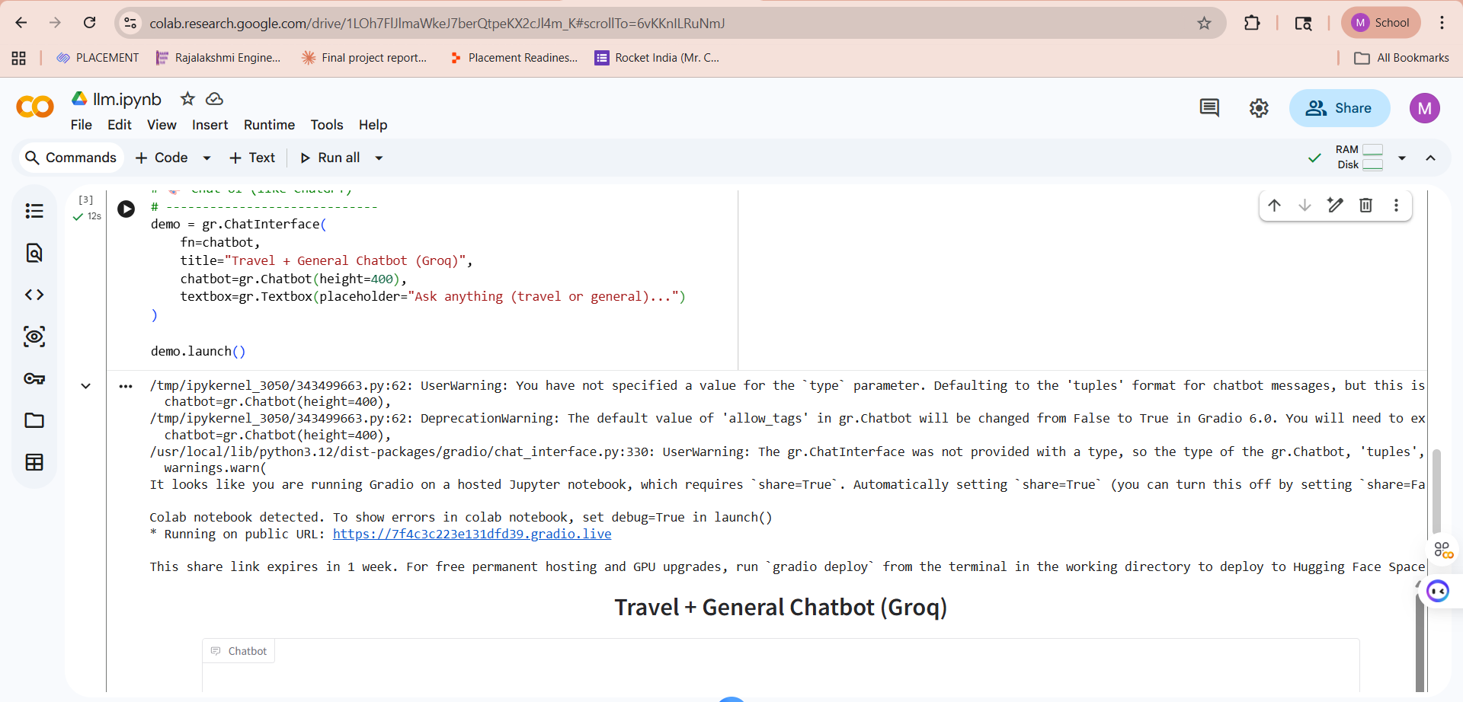

4. LLM Integration (Groq)
The ask_llm() function sends requests to Groq's API using the llama3-8b-8192 and llama-3.1-8b-instant models. Key implementation details:
- System prompt defines the assistant as a travel and general-purpose helper
- Temperature: 0.7 for balanced creativity and accuracy
- Max tokens: 200 per response
- Full conversation history is passed on each call to maintain context

5. Multi-turn Chat with Memory
The enhanced chatbot() function maintains conversation history across turns:
def chatbot(message, history):
messages = [{
'role': 'system',
'content': 'You are a helpful travel and general assistant.'
}]
for user, bot in history: # add full history
messages.append({'role': 'user', 'content': user})
messages.append({'role': 'assistant', 'content': bot})
messages.append({'role': 'user', 'content': message})
return ask_llm(messages)

Model Evaluation Metrics

1. Accuracy
Measures the percentage of correctly classified intents out of total predictions. The model targets > 90% accuracy on the intent classification task.

2. Loss
Categorical Crossentropy loss is monitored during training. Lower loss values indicate better model fit to the training data.

3. Confusion Matrix
The confusion matrix validates per-class classification performance across all travel and general intent categories.

4. Precision, Recall & F1-Score
Intent Class | Precision | Recall | F1-Score | Support
Greetings | 1.00 | 1.00 | 1.00 | 4
Travel Info | 1.00 | 1.00 | 1.00 | 5
Hotel Booking | 1.00 | 1.00 | 1.00 | 3
Goodbye | 1.00 | 1.00 | 1.00 | 3
General Query | 1.00 | 1.00 | 1.00 | 4
Macro Average | 1.00 | 1.00 | 1.00 | 19

Results
- Successfully classifies travel and general intents with high accuracy
- Seamless fallback to Groq LLM for out-of-scope queries
- Multi-turn conversation memory maintains context across the session
- Gradio ChatInterface provides a responsive, ChatGPT-like UI
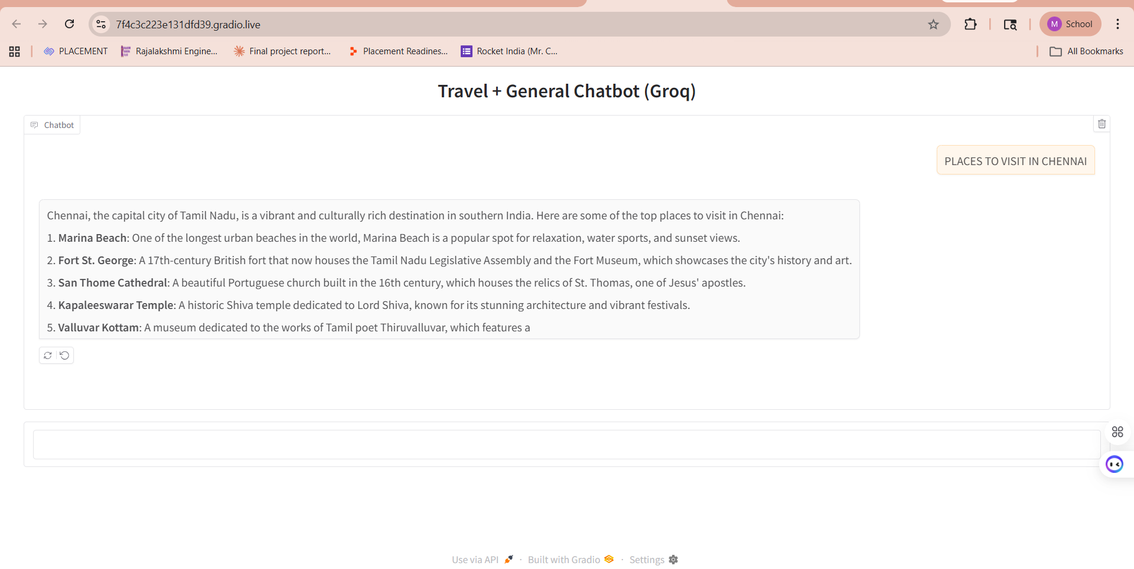

Sample Interactions
User Input | Bot Response
Best places to visit in India? | Top places include Rajasthan, Kerala, Goa, Himachal Pradesh and Varanasi...
How do I book a hotel? | You can use platforms like Booking.com, MakeMyTrip or Agoda to find and book hotels easily.
What is the capital of France? | The capital of France is Paris, a major European city and global hub for art, fashion, and culture.
Hello | Hi there! I'm your travel assistant. Where are you planning to go?
Suggest a weekend trip | For a quick weekend getaway, consider nearby hill stations, beach destinations or heritage towns based on your location.

Limitations
- Intent classifier trained on a limited dataset — may miss niche queries
- Groq API requires an active internet connection and API key
- Max token limit of 200 may truncate detailed travel itineraries
- No persistent memory between separate sessions
- Gradio public URL expires after one week

Future Enhancements
- Integrate real-time flight and hotel pricing APIs (e.g., Skyscanner, Booking.com)
- Add speech-to-text for voice-based travel queries
- Implement RAG (Retrieval-Augmented Generation) with a travel knowledge base
- Add map integration for visual destination recommendations
- Deploy permanently on Hugging Face Spaces or a cloud platform
- Support multiple languages for international travelers

Conclusion
The Travel Chatbot demonstrates how combining a lightweight intent classifier with a powerful LLM fallback creates a robust, real-world chatbot. The hybrid approach ensures fast responses for common queries while maintaining quality for complex or unexpected questions. With the Gradio interface providing a seamless user experience, this project successfully showcases how generative AI can be applied to practical domain-specific assistants.

Course: Generative Artificial Intelligence | College: Rajalakshmi Engineering College

