**Servlet Program to Display 'Hello, World!' in Browser**

**EXP NO: 3**

# AIM:

To write a servlet program that prints "HelloWorld!" and displays it in the browser when accessed.

# CODE:

package com.karthick.servlet;

import java.io.IOException; import java.io.PrintWriter;

import javax.servlet.ServletException; import javax.servlet.annotation.WebServlet; import javax.servlet.http.HttpServlet;

import javax.servlet.http.HttpServletRequest; import javax.servlet.http.HttpServletResponse;

/**

* Servlet implementation class HelloWorld

*/ @WebServlet("/HelloWorld")

public class HelloWorld extends HttpServlet { private static final long serialVersionUID = 1L;

/**

* @see HttpServlet#HttpServlet()

*/

public HelloWorld() { super();

// TODO Auto-generated constructor stub

}

/**

* @see HttpServlet#doGet(HttpServletRequest request, HttpServletResponse response)

*/

protected void doGet(HttpServletRequest request, HttpServletResponse response) throws ServletException, IOException {

PrintWriter p = response.getWriter(); p.println("Hello World!!!");

}

/**

* @see HttpServlet#doPost(HttpServletRequest request, HttpServletResponse response)

*/

protected void doPost(HttpServletRequest request, HttpServletResponse response) throws ServletException, IOException {

// TODO Auto-generated method stub doGet(request, response);

}

}

# OUTPUT:

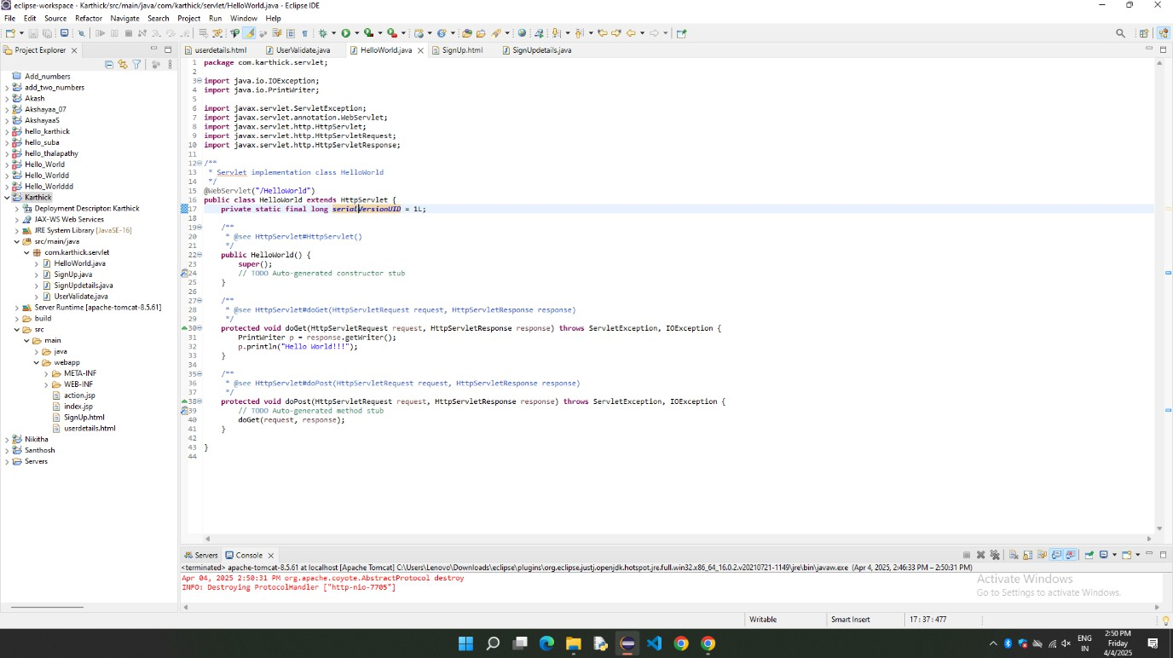

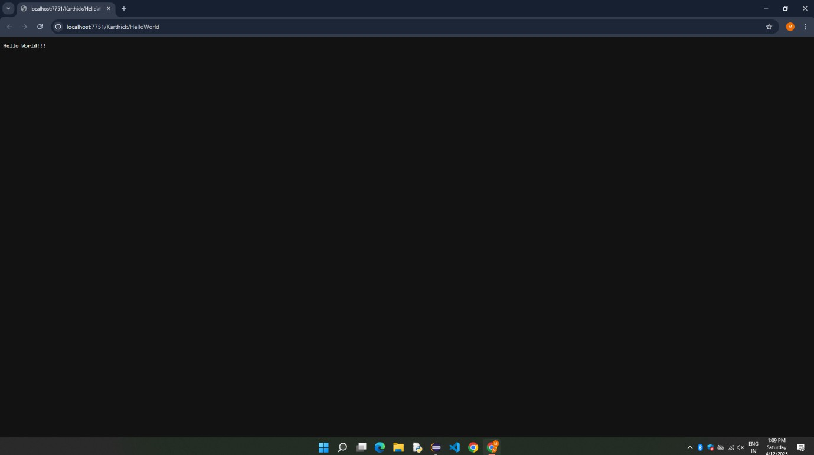

**RESULT:**

Thus, the Servlet Program to print/display Hello World in the web browser is successfully Implemented.