**Web Form with Servlet to Capture and Display User's Name and Age**

**EXP NO: 4**

**AIM:**

Create a web form that accepts a user's name and age. Write a Servlet to process the

form data and display it back on the browser.

# CODE:

**Userdetails.html**

<!DOCTYPE html>

<html>

<head>

<meta charset="ISO-8859-1">

<title>Insert title here</title>

</head>

<body>

<form action="./UserValidate">

<label for="name">User Name</label>

<input type="text" id="name" name="name" placeholder="Enter Your Name" required><br><br>

<label for="age">Age</label>

<input type="number" id="age" name="age" placeholder="Enter Your Age"><br><br>

<button type="submit">Submit</button>

</form>

</body>

</html>

# UserValidate.Java

package com.karthick.servlet;

import java.io.IOException;

import java.io.PrintWriter;

import javax.servlet.ServletException; import javax.servlet.annotation.WebServlet; import javax.servlet.http.HttpServlet;

import javax.servlet.http.HttpServletRequest; import javax.servlet.http.HttpServletResponse;

/**

* Servlet implementation class UserValidate

*/ @WebServlet("/UserValidate")

public class UserValidate extends HttpServlet { private static final long serialVersionUID = 1L;

/**

* @see HttpServlet#HttpServlet()

*/

public UserValidate() { super();

// TODO Auto-generated constructor stub

}

/**

* @see HttpServlet#doGet(HttpServletRequest request, HttpServletResponse response)

*/

protected void doGet(HttpServletRequest request, HttpServletResponse response) throws ServletException, IOException {

String user=request.getParameter("name");

int age=Integer.parseInt(request.getParameter("age"));

PrintWriter pw=response.getWriter(); pw.println("User Name: "+ user); pw.println("Age: "+ age);

}

}

# OUTPUT:

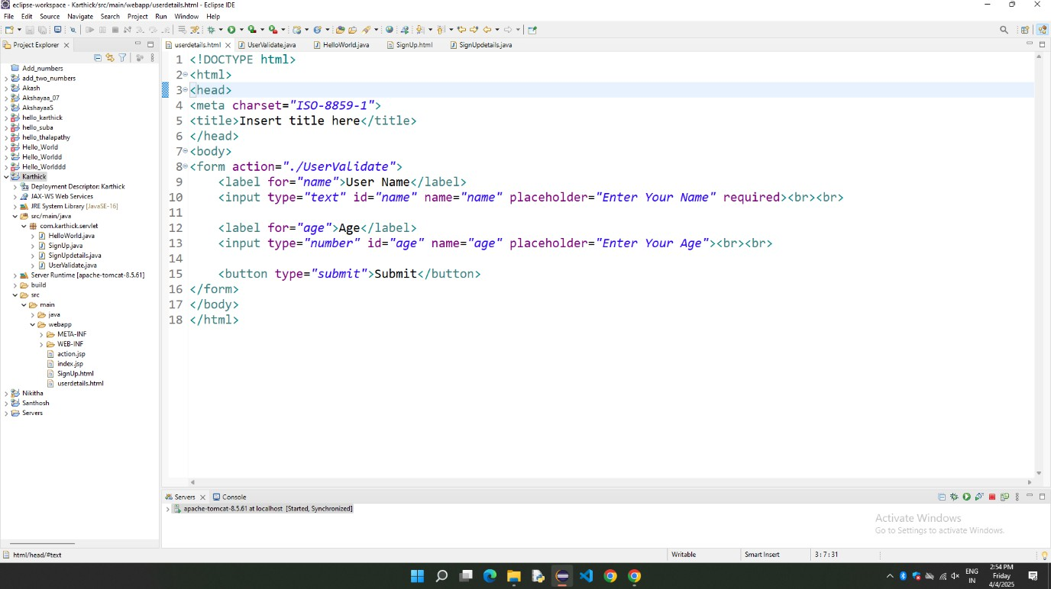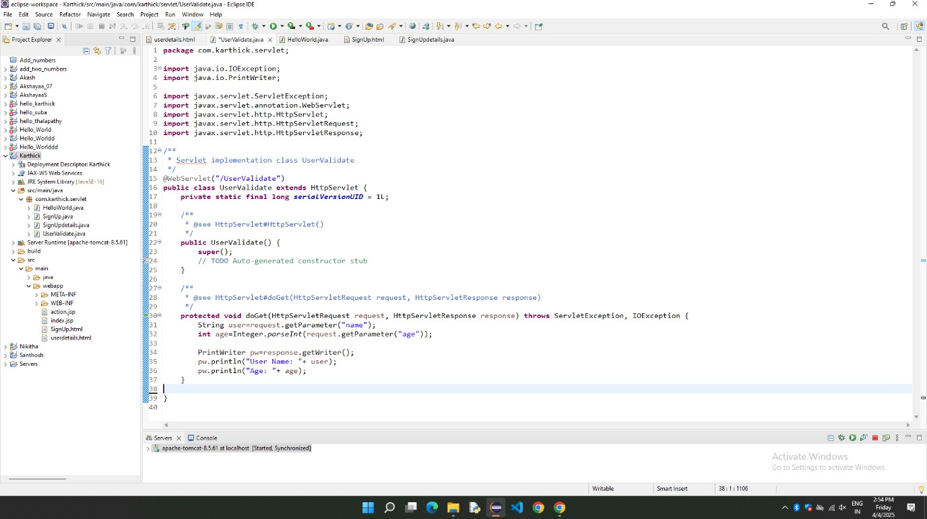

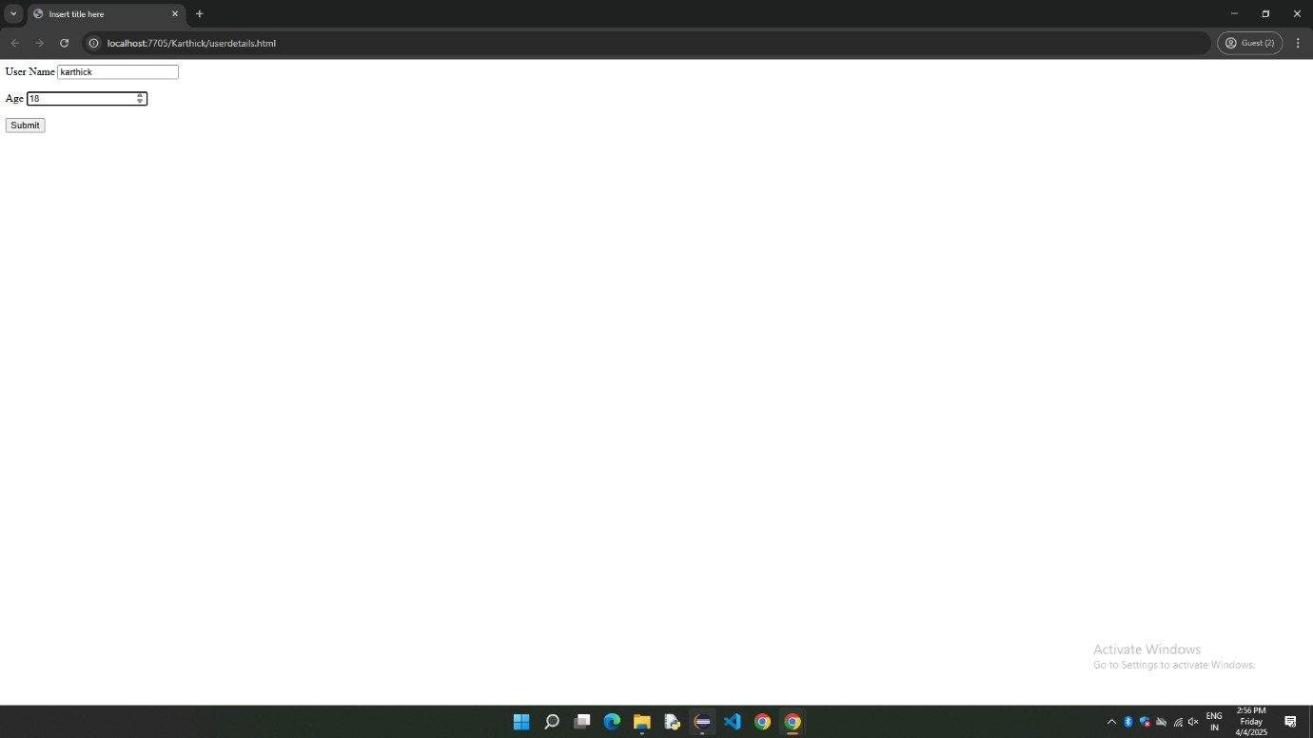

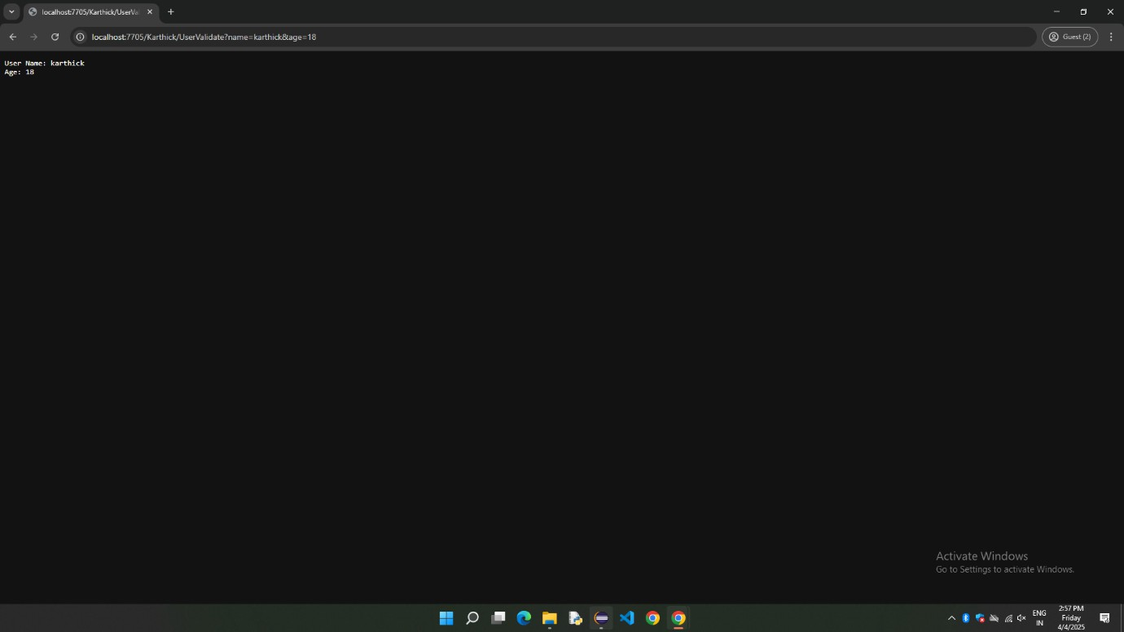

**RESULT:**

Thus, the web form is Implemented Successfully using html and Servlet.