**Servlet Example Demonstrating HTTP GET vs POST Methods with Form Handling**

**EXP NO: 5**

AIM:

Write a Servlet to demonstrate the difference between HTTP GET and POST methods by creating a form and handling requests accordingly.

# CODE:

**SignUp.html**

<!DOCTYPE html>

<html>

<head>

<meta charset="ISO-8859-1">

<title>Sign_up</title>

</head>

<body>

<form action="./SignUpdetails" method="post">

<label for="fname">FirstName:</label>

<input type="text" name="fname" placeholder="Enter Your First Name"><br><br>

<label for="lname">LastName:</label>

<input type="text" name="lname" placeholder="Enter Your First Name"><br><br>

<label for="age">Age:</label>

<input type="number" name="age" placeholder="Enter Your Age"><br><br>

<label for="date">Date Of Birth:</label>

<input type="date" name="datee"><br><br>

<label for="gender">Male</label>

<input type="radio" name="gender"><br><br>

<label for="gender">Female</label>

<input type="radio" name="gender"><br><br>

<label for="address">Address:</label>

<textarea name="address" ></textarea>

<input type="submit" value="Sign-Up">

</form>

</body>

</html>

# SignupDetails.java

package com.karthick.servlet;

import java.io.IOException; import java.io.PrintWriter;

import javax.servlet.ServletException; import javax.servlet.annotation.WebServlet; import javax.servlet.http.HttpServlet;

import javax.servlet.http.HttpServletRequest; import javax.servlet.http.HttpServletResponse;

/**

* Servlet implementation class SignUpdetails

*/ @WebServlet("/SignUpdetails")

public class SignUpdetails extends HttpServlet { private static final long serialVersionUID = 1L;

/**

* @see HttpServlet#HttpServlet()

*/

public SignUpdetails() { super();

// TODO Auto-generated constructor stub

}

protected void doPost(HttpServletRequest request, HttpServletResponse response) throws ServletException, IOException {

String firstname=request.getParameter("fname"); String lastname=request.getParameter("lname");

int age=Integer.parseInt(request.getParameter("age")); String date=request.getParameter("date");

String gender=request.getParameter("gender"); String address=request.getParameter("address");

PrintWriter p = response.getWriter(); p.println("FirstName :"+firstname); p.println("LastName :"+lastname); p.println("Age :"+age); p.println("Date Of Birth :"+date); p.println("Gender :"+gender); p.println("Address :"+address);

}

}

**OUTPUT:**

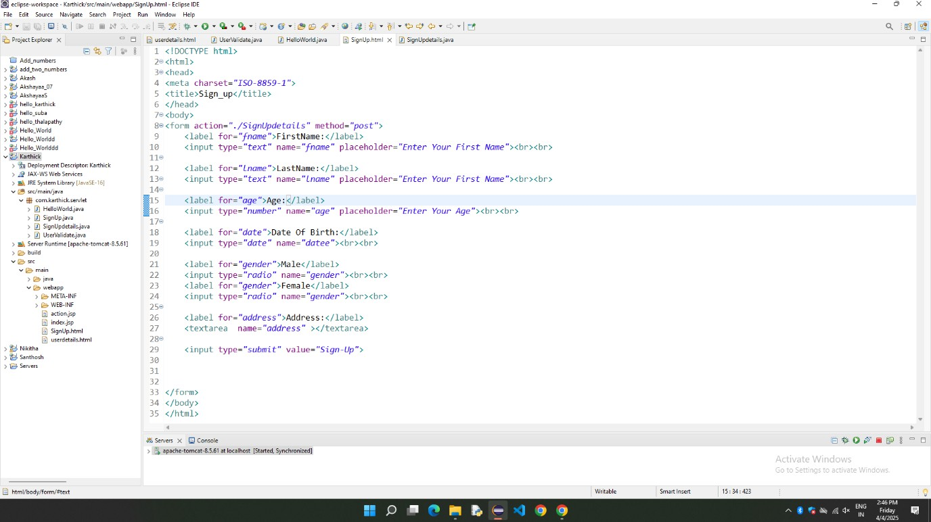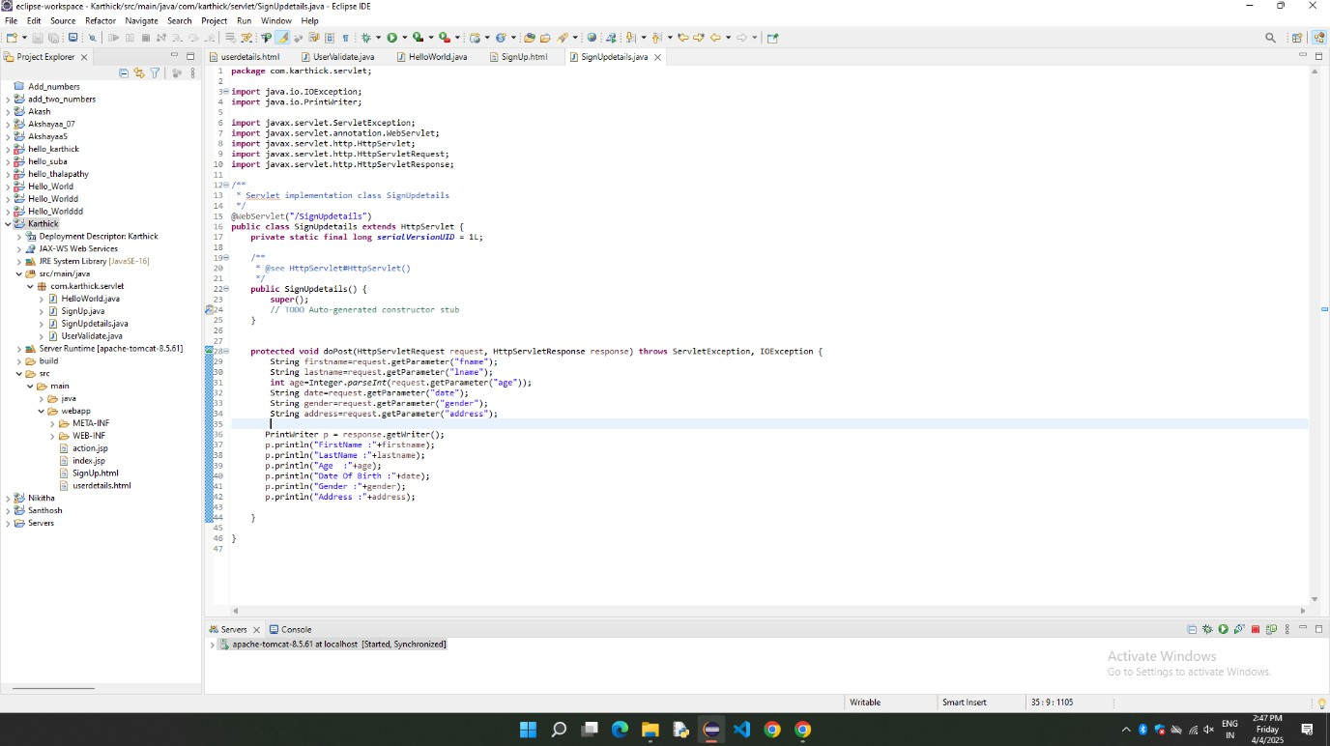

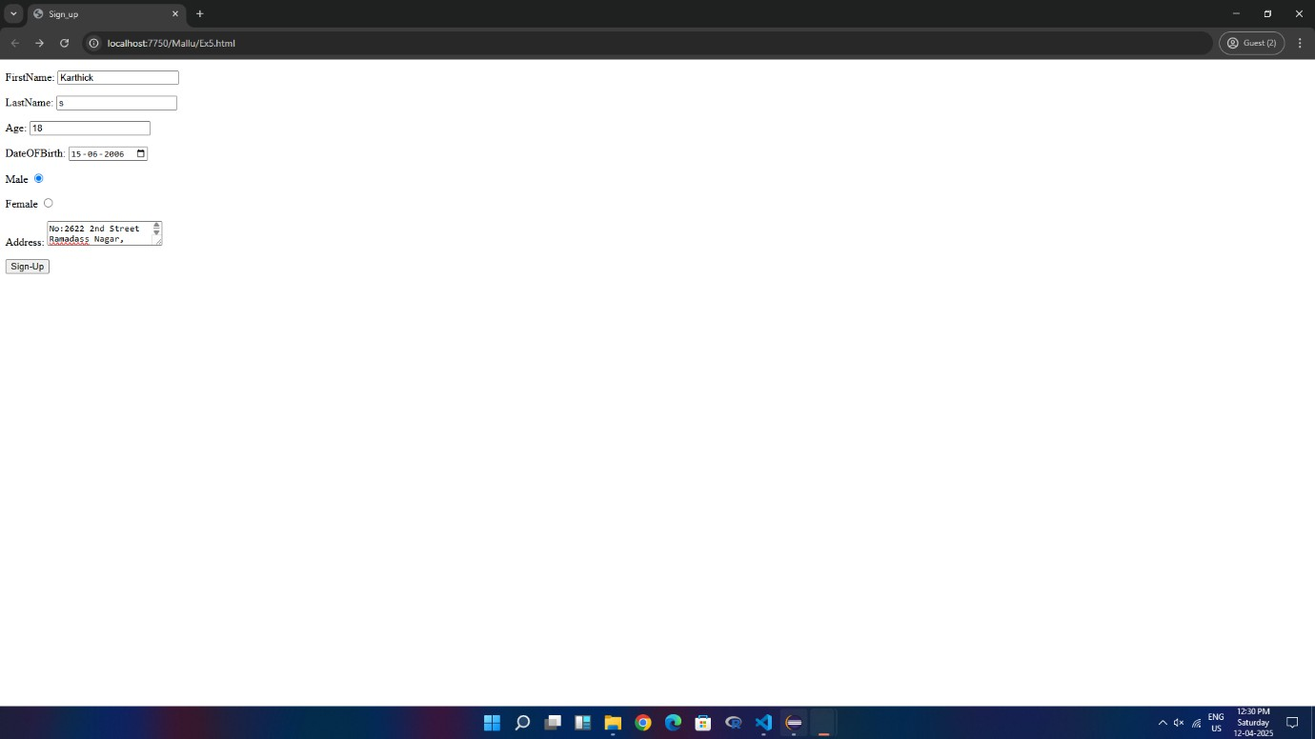

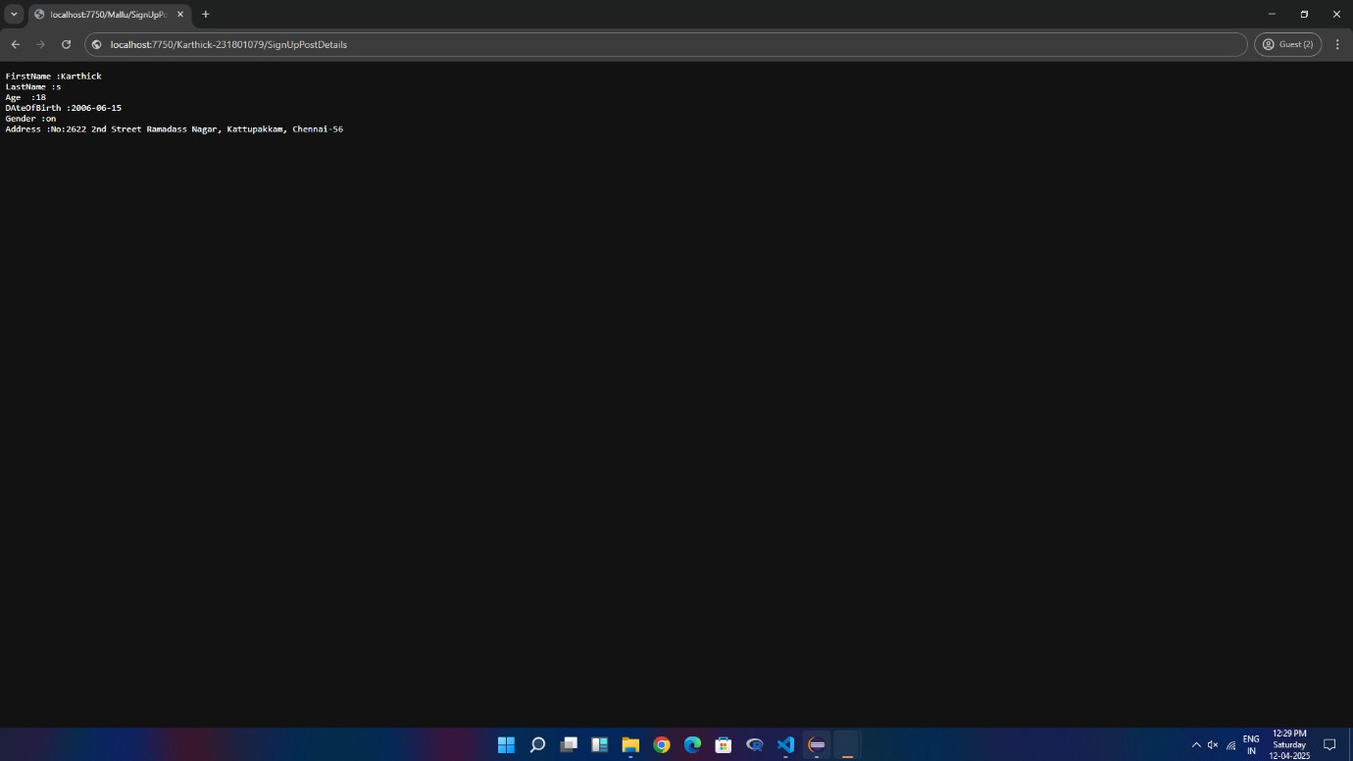

RESULT:

Thus, the difference between HTTP GET and POST Method is Successful demonstrated by creating a form and handling requests.