**Servlet Program to Store and Retrieve User Preferences Using Cookies**

**EXP NO: 7**

# Aim:

Write a Servlet program to store a user's preferences (like theme or language) using cookies.

Retrieve and display these preferences on subsequent visits.

# Code:

**Cookie.jsp**

<%@ page language="java" contentType="text/html; charset=ISO-8859-1" pageEncoding="ISO-8859-1"%>

<!DOCTYPE html>

<html>

<head>

<meta charset="ISO-8859-1">

<title>Set Preferences</title>

</head>

<body>

<form method="post">

<p>

<label>Theme: </label>

<select name="theme">

<option value="light">Light</option>

<option value="dark">Dark</option>

</select>

</p>

<p>

<label>Language: </label>

<select name="language">

<option value="English">English</option>

<option value="Tamil">Tamil</option>

<option value="Hindi">Hindi</option>

</select>

</p>

<button type="submit">Save Preferences</button>

</form>

<%

if ("POST".equals(request.getMethod())) {

String theme = request.getParameter("theme"); String language = request.getParameter("language");

Cookie themeCookie = new Cookie("theme", theme); Cookie langCookie = new Cookie("language", language);

themeCookie.setMaxAge(60 * 60 * 24 * 7); // 7 days

langCookie.setMaxAge(60 * 60 * 24 * 7); // 7 days

themeCookie.setPath("/"); langCookie.setPath("/");

response.addCookie(themeCookie); response.addCookie(langCookie);

response.sendRedirect("getCookie.jsp");

}

%>

</body>

</html>

## Getcookie.jsp

<%@ page language="java" contentType="text/html; charset=ISO-8859-1" pageEncoding="ISO-8859-1"%>

<!DOCTYPE html>

<html>

<head>

<meta charset="ISO-8859-1">

<title>Your Preferences</title>

</head>

<body>

<%

String theme = "Not set"; String language = "Not set";

Cookie[] cookies = request.getCookies(); if (cookies != null) {

for (Cookie cookie : cookies) {

if ("theme".equals(cookie.getName())) { theme = cookie.getValue();

} else if ("language".equals(cookie.getName())) { language = cookie.getValue();

}

}

}

%>

<h2>Your Saved Preferences</h2>

<p>Theme: <%= theme %></p>

<p>Language: <%= language %></p>

</body>

</html>

## OUTPUT:

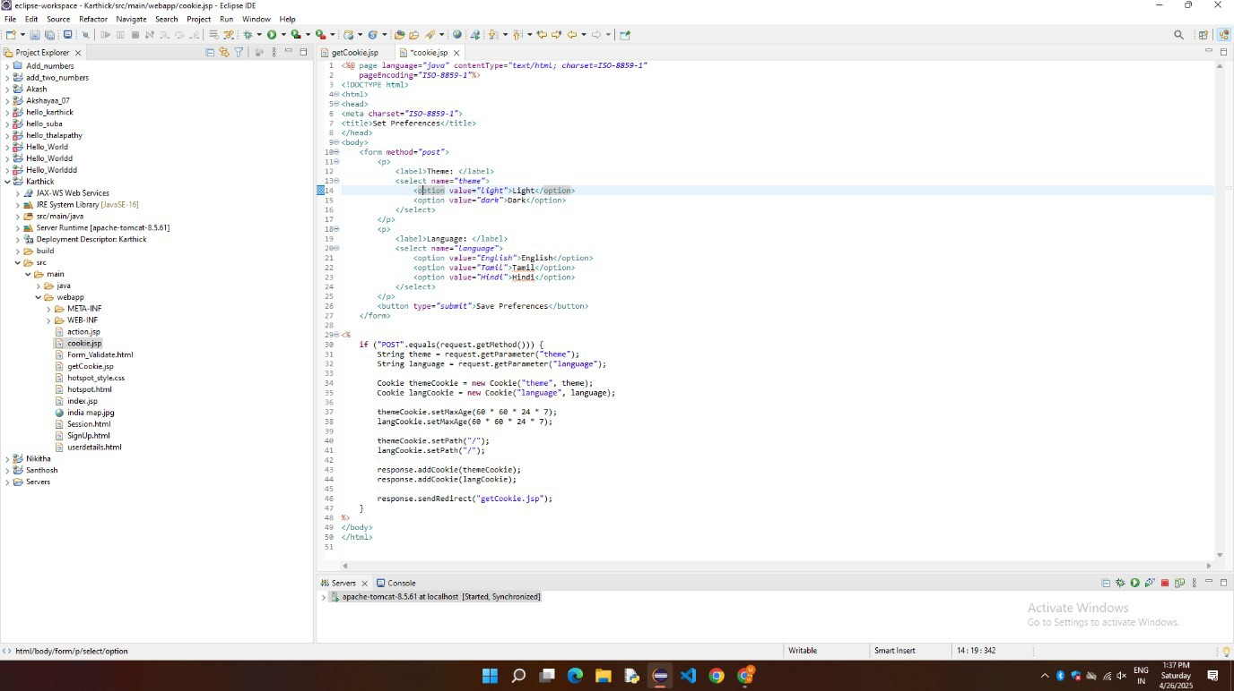

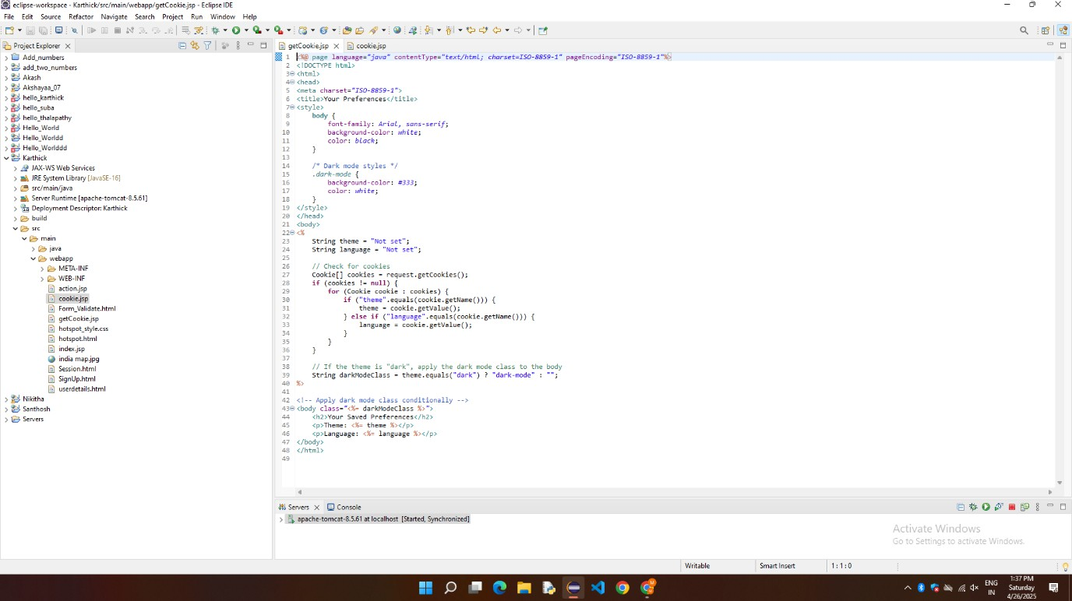

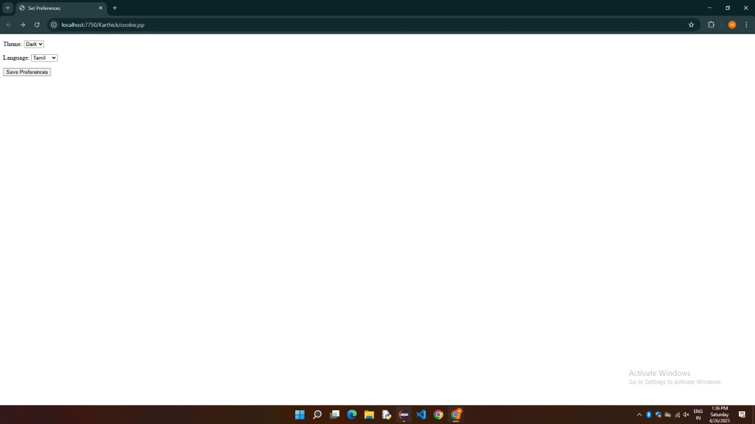

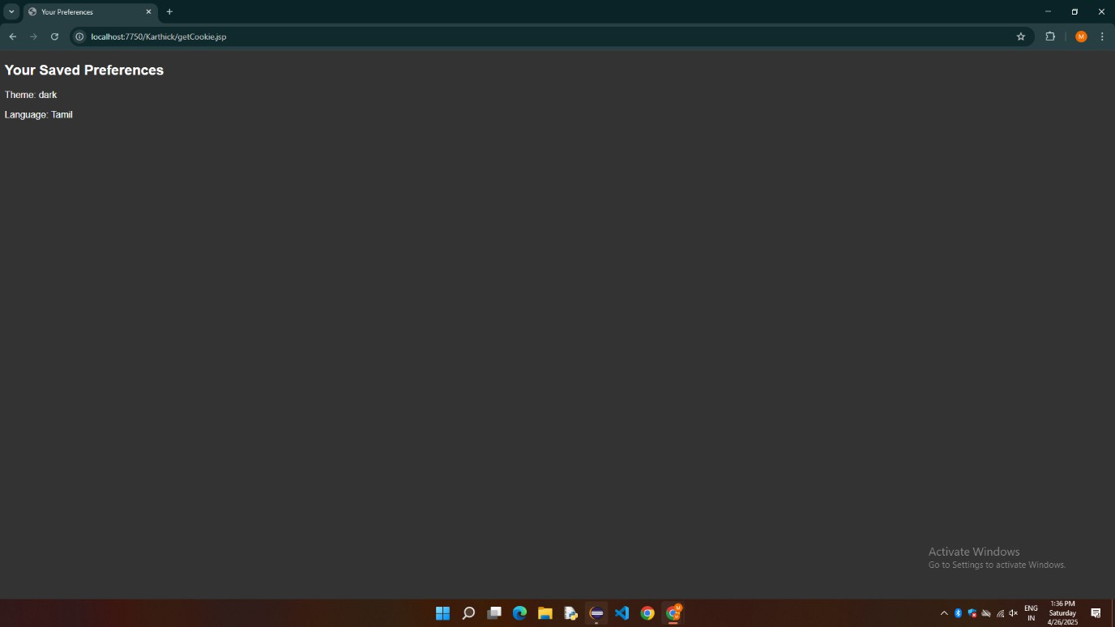

**RESULT:**

Thus, the Cookies is demonstrated Successfully.