DATA-DRIVEN PREDICTION OF TRIBOLOGICAL BEHAVIOUR OF POLYMER COMPOSITES
(PHASE 2 REPORT)
A PROJECT REPORT (PHASE 2)
Submitted to
Amrita Vishwa Vidyapeetham
in partial fulfilment for the award of the degree of
BACHELOR OF TECHNOLOGY IN COMPUTER SCIENCE AND ENGINEERING
By
HARI SREERAM R
(Reg. No. CH.SC.U4CSE23019)
M A SAI ADITHYAA
(Reg. No. CH.SC.U4CSE23029)
Under the guidance of
Dr. SANGAPU SREENIVASA CHAKRAVARTHI
Assistant Professor (Sr. Gr.), Dept. of Computer Science & Engineering
Co-Supervisor / Domain Expert:
Dr. SHUBRAJIT BHAUMIK
Associate Professor, Dept. of Mechanical Engineering

AMRITA VISHWA VIDYAPEETHAM
AMRITA SCHOOL OF COMPUTING
CHENNAI – 601103
May 2026


BONAFIDE CERTIFICATE
This is to certify that this project report entitled “DATA-DRIVEN PREDICTION OF TRIBOLOGICAL BEHAVIOUR OF POLYMER COMPOSITES” is the bonafide work of “HARI SREERAM R (CH.SC.U4CSE23019)” and “M A SAI ADITHYAA (CH.SC.U4CSE23029)” who carried out the project work under my supervision.
SIGNATURE  Dr. S. Bhagavathi Priya  CHAIRPERSON  Department of CSE  Amrita School of Computing  Chennai. | SIGNATURE  Dr. Sangapu Sreenivasa Chakravarthi  SUPERVISOR  Department of CSE  Amrita School of Computing  Chennai.

INTERNAL EXAMINER | EXTERNAL EXAMINER

DECLARATION BY THE CANDIDATES
We, HARI SREERAM R (Reg. No. CH.SC.U4CSE23019) and M A SAI ADITHYAA (Reg. No. CH.SC.U4CSE23029), hereby declare that the Phase 2 project report entitled "DATA-DRIVEN PREDICTION OF TRIBOLOGICAL BEHAVIOUR OF POLYMER COMPOSITES" submitted to Amrita Vishwa Vidyapeetham, Chennai, in partial fulfilment of the requirements for the award of the degree of Bachelor of Technology in Computer Science and Engineering, is the record of original and independent work carried out by us during the academic year 2025–2026 under the supervision of Dr. Sangapu Srinivasa Chakravarthi and Dr. Shubrajit Bhaumik.
We further declare that this project work has not previously formed the basis for the award of any degree, diploma, associateship, fellowship, or other similar title in this or any other university or higher education institution.
SIGNATURE: ____________________ SIGNATURE: ____________________
Mr. HARI SREERAM R Mr. M A SAI ADITHYAA
(Reg. No. CH.SC.U4CSE23019) (Reg. No. CH.SC.U4CSE23029)
Dept. of Computer Science & Engineering Dept. of Computer Science & Engineering
Amrita School of Computing Amrita School of Computing
Chennai – 601103 Chennai – 601103
Place: Chennai
Date: May 2026

ABSTRACT
Polyamide-based thermoplastic composites, particularly Polyamide 6 (PA6) and Polyamide 66 (PA66), are widely utilized in dry sliding engineering applications such as automotive gears, high-load bushings, dynamic seals, and bearing cages due to their high strength-to-weight ratio, structural compliance, and self-lubricating transfer film capabilities. However, their reliable deployment in severe mechanical environments is constrained by complex, non-linear wear mechanisms, frictional heat buildup, and abrupt viscoelastic softening above glass transition. In Phase 1 of this project, a comprehensive literature survey was established, identifying severe dataset fragmentation, the absence of physical flash temperature constraints, and the lack of generalized machine learning architectures as critical research gaps.
In this Phase 2 report, we deliver the complete computational execution, empirical validation, and virtual deployment of the data-driven framework. We curate and standardize a multi-study experimental corpus comprising 1,353 validated tribological tests extracted across 50+ peer-reviewed publications. To bridge the gap between empirical data and contact mechanics, we formulate an 80-feature physics-informed predictor taxonomy that explicitly captures matrix stoichiometry, particulate packing fractions, decoupled mechanical kinematics (normal load, sliding speed, and sliding distance), polynomial non-linearities, cross-body filler interactions, and an Archard-Ashby interfacial contact flash temperature model.
Using a rigorous 5-fold cross-validation scheme with strict out-of-fold evaluation and automated Bayesian hyperparameter tuning via Optuna (Tree-structured Parzen Estimator across 35 trials), our models achieve unprecedented predictive accuracy across both continuous physical targets: XGBoost (Tuned) achieves an Out-of-Fold R² of 0.9572 (MAE: 0.0220, RMSE: 0.0382) for Coefficient of Friction (CoF), while CatBoost (Tuned) achieves an Out-of-Fold R² of 0.9819 (MAE: 0.1852, RMSE: 0.3362) for Specific Wear Rate (log₁₀ kv), delivering a +41.81% and +39.10% accuracy gain over baseline linear models.
Furthermore, we computationally formalize and validate 10 core empirical literature findings (F1–F10). We mathematically prove that friction and wear are orthogonal targets (r = 0.1609); demonstrate that the classical PV factor fails to capture decoupled kinematic regimes; identify a distinct multi-objective Pareto optimization window for solid lubricant-to-reinforcement ratios (0.25 ≤ R ≤ 0.60); and quantify the 4.8-fold wear acceleration triggered when contact temperatures exceed polymer Tg (50°C). Finally, the entire framework is deployed as an open-access, interactive Virtual Tribometer dashboard built with Streamlit and Google Colab, enabling real-time formulation simulation and dynamic sensitivity sweeps in under 20 milliseconds.
Keywords: Polymer Tribology, Polyamide Composites, PA6, PA66, Physics-Informed Machine Learning, XGBoost, CatBoost, Optuna Bayesian Optimization, Archard-Ashby Flash Heating, Specific Wear Rate, Virtual Tribometer, Pareto Frontier, SHAP Interpretability.

ACKNOWLEDGEMENT
This Phase 2 project report would not have been possible without the blessings, guidance, and support of numerous individuals and institutions. We express our profound gratitude to our honourable Chancellor, Sri Mata Amritanandamayi Devi (Amma), for her divine blessings, inspiration, and for instilling the spirit of research, perseverance, and selfless service.
We register our sincere gratitude to our Administrative Director, Swami Vinayamritananda Puri, Campus Director, Mr. I. B. Manikantan, and Principal, Dr. V. Jayakumar, Amrita School of Computing and Engineering, Chennai, for providing state-of-the-art computational infrastructure, research laboratories, and an academic environment fostering impactful interdisciplinary innovation.
We register our sincere thanks and deepest gratitude to our supervisor, Dr. Sangapu Srinivasa Chakravarthi, Assistant Professor (Sr. Gr.), Department of Computer Science and Engineering, and our co-supervisor / domain expert, Dr. Shubrajit Bhaumik, Associate Professor, Department of Mechanical Engineering. Their joint guidance across artificial intelligence and contact mechanics, rigorous statistical oversight, and constant encouragement were fundamental in elevating this research from a theoretical concept to an industry-ready computational framework.
We extend our heartfelt gratitude to Dr. S. Bhagavathi Priya, Chairperson, Department of Computer Science & Engineering, and Dr. J. Umamageswaran, Project Coordinator, for their administrative support and technical guidance throughout the semester. Finally, we thank the project review panel members, faculty members, our parents, and peers for their constant support, constructive feedback, and encouragement.

TABLE OF CONTENTS
CHAPTER NO. | TITLE | PAGE NO.
 | Abstract | iv
 | List of Tables | x
 | List of Figures | xi
 | List of Symbols and Abbreviations | xii
1 | INTRODUCTION | 1
 | 1.1 Background and Motivation | 1
 | 1.2 Significance of Data-Driven Methods in Tribology | 2
 | 1.3 Scope and Limitations of the Phase 2 Study | 3
 | 1.4 Objectives of the Phase 2 Project | 4
 | 1.5 Organization of the Phase 2 Report | 5
2 | LITERATURE REVIEW AND RESEARCH GAPS | 7
 | 2.1 Thematic Synthesis of Literature | 7
 | 2.2 Summary of Literature (Table 2.1) | 11
 | 2.3 Critical Research Gap Analysis | 13
 | 2.4 Research Gaps Identified Matrix (Table 2.2) | 14
3 | BACKGROUND AND CONTACT MECHANICS | 16
 | 3.1 Polymer Composites and Tribological Behavior | 16
 | 3.2 Sliding-Induced Wear Mechanisms and Thermal Contact Transitions | 16
 | 3.3 Friction-Induced Flash Heating Formulation (Archard-Ashby Model) | 17
 | 3.4 Influence of Multi-Filler Compounding and Synergy Trade-offs | 18
 | 3.5 Limitations of Conventional Experimental Testing | 19
4 | PROBLEM STATEMENT AND SYSTEM ANALYSIS | 20
 | 4.1 The Problem Statement | 20
 | 4.2 Core Computational Challenges | 21
 | 4.3 Functional Requirements (FR) | 21
 | 4.4 Non-Functional Requirements (NFR) | 22
 | 4.5 Data Flow Architecture (DFD Level 0 and Level 1) | 23
 | 4.6 Hardware and Software Specifications | 24
5 | METHODOLOGY AND SYSTEM ARCHITECTURE | 26
 | 5.1 End-to-End System Architecture | 26
 | 5.2 Curated Experimental Literature Corpus | 26
 | 5.3 80-Feature Physics-Informed Feature Engineering Taxonomy | 27
 | 5.4 Leakage-Free Preprocessing Pipeline | 30
 | 5.5 Machine Learning Model Suite | 31
 | 5.6 Automated Bayesian Optimization Engine (Optuna) | 31
 | 5.7 Detailed Algorithms and Pseudocode | 32
6 | IMPLEMENTATION, RESULTS, AND EMPIRICAL VALIDATION | 34
 | 6.1 Experimental Setup and Implementation Environment | 34
 | 6.2 Benchmark Performance and Consolidated Leaderboard | 34
 | 6.3 5-Fold Stability and Generalization Analysis | 35
 | 6.4 Parity and Residual Diagnostics | 36
 | 6.5 Empirical Findings Proof Suite (Findings F1 through F10) | 37
 | 6.6 Game-Theoretic Model Interpretability (Tree SHAP & PDP) | 40
 | 6.7 Interactive Virtual Tribometer Application Architecture | 43
 | 6.8 Practical Guidelines for Composite Formulation Design | 44
7 | CONCLUSION AND FUTURE WORK | 45
 | 7.1 Summary of Contributions | 45
 | 7.2 Technical Limitations and Constraints | 45
 | 7.3 Future Research Enhancements (Phase 3 Roadmap) | 46
8 | REFERENCES | 47

LIST OF TABLES
TABLE NO. | TITLE | PAGE NO.
2.1 | Comprehensive Summary of Foundational Literature (2024–2025) | 11
2.2 | Systematic Mapping of Identified Research Gaps and Phase 2 Solutions | 14
5.1 | Distribution of Curated Literature Experimental Records | 27
5.2 | Polymer Matrix & Filler Physics-Informed Features (P1 to P24) | 28
5.3 | Operational Kinematics and Contact Flash Rise Features (O1 to O26) | 28
5.4 | Manufacturing Process and Specimen Geometry Features (M1 to M15) | 29
5.5 | Non-linear Polynomial and Interaction Features (I1 to I15) | 29
5.6 | Comprehensive 80-Feature Input Dimension Taxonomy | 30
5.7 | Algorithm-Specific Leakage-Free Preprocessing Protocols | 31
5.8 | Optuna Bayesian Optimization Search Space Specifications | 31
6.1 | Consolidated 5-Fold Cross-Validation Performance Leaderboard | 34
6.2 | Fold-Level Validation Stability and Performance Metrics | 35
6.3 | Empirical Findings Proof Suite (Findings F1–F10 Summary) | 37
6.4 | Top 10 Global Tribological Drivers Identified via Tree SHAP | 40
7.1 | Technical Limitations and Real-World Operational Boundaries | 45

LIST OF FIGURES
FIGURE NO. | TITLE | PAGE NO.
4.1 | Data Flow Diagram Level 0 Context Architecture | 23
4.2 | Data Flow Diagram Level 1 Feature & Training Subsystems | 24
5.1 | End-to-End System Architecture: Mining, Features, and UI | 26
5.2 | 80-Feature Physics-Informed Pipeline and Normalization Flow | 30
6.1 | CoF Model Parity Plot: Actual vs 5-Fold OOF Predicted (XGBoost) | 36
6.2 | Wear Model Parity Plot: Actual vs OOF Predicted log₁₀ kv (CatBoost) | 37
6.3 | Finding 5 — Orthogonality Scatter Plot of CoF versus Wear Rate | 39
6.4 | Finding 8 — Solid Lubricant to Fiber Reinforcement Pareto Window | 40
6.5 | Global Tree SHAP Beeswarm Feature Impact Summary for CoF | 42
6.6 | Global Tree SHAP Beeswarm Feature Impact Summary for Wear Rate | 42
6.7 | 2D Partial Dependence Interaction Surface (GF × MoS₂ Synergy) | 43
6.8 | Streamlit Virtual Tribometer Graphical User Interface Architecture | 44

LIST OF SYMBOLS AND ABBREVIATIONS
ABBREVIATION | DESCRIPTION
PA6 | Polyamide 6 (Nylon 6 thermoplastic polymer matrix)
PA66 | Polyamide 66 (Nylon 66 thermoplastic polymer matrix)
CoF (μ) | Coefficient of Friction (dimensionless contact ratio)
kv | Specific Wear Rate (mm³/(N·m))
GF | Short E-Glass Fiber Reinforcement
CF | Short Carbon Fiber Reinforcement
MoS₂ | Molybdenum Disulfide Solid Lubricant
PTFE | Polytetrafluoroethylene Solid Lubricant
GnP | Graphene Nanoplatelets Solid Lubricant
MWCNT | Multi-Walled Carbon Nanotubes Reinforcement
PV | Pressure-Velocity Operating Product (MPa·m/s)
Tg | Glass Transition Temperature (~50°C for PA6/PA66)
Tm | Melting Temperature (220°C for PA6, 260°C for PA66)
ΔT_flash | Archard-Ashby Interfacial Contact Flash Temperature Rise (°C)
OOF | Out-Of-Fold Cross-Validation Prediction
MAE | Mean Absolute Error
RMSE | Root Mean Squared Error
R² | Coefficient of Determination
SHAP | SHapley Additive exPlanations (Game-Theoretic Feature Attribution)
PDP | Partial Dependence Plot
XGBoost | Extreme Gradient Boosting Decision Trees
CatBoost | Categorical Gradient Boosting (Oblivious Trees)

CHAPTER 1
INTRODUCTION

1.1 Background and Motivation
Polymer composites, particularly those based on aliphatic polyamide matrices such as Polyamide 6 (PA6) and Polyamide 66 (PA66), play an indispensable role in modern mechanical engineering systems involving continuous sliding and unlubricated contact. Their widespread industrial adoption across automotive powertrains, heavy-duty industrial machinery, aerospace conveyors, and precision consumer mechanisms is driven by an exceptional combination of lightweight density, high specific mechanical stiffness, superior impact toughness, corrosion resistance against aggressive chemical agents, and cost-effective net-shape manufacturing via injection molding and additive techniques.
In demanding mechanical assemblies such as high-torque spur gears, heavy-duty sleeve bushings, thrust washers, dynamic hydraulic seals, and linear sliding guides, polyamides increasingly replace conventional bronze and ferrous alloys. Operating dry or under boundary lubrication, polyamides eliminate the need for external grease or oil recirculation, preventing environmental leakage and reducing lifecycle maintenance expenditure. Furthermore, their viscoelastic molecular structure provides superior acoustic dampening and mechanical vibration suppression, resulting in significantly quieter mechanical transmissions.
However, under continuous tribological sliding conditions, the operational reliability of PA6 and PA66 is fundamentally limited by friction-induced wear, localized thermal softening, and instability in the interfacial Coefficient of Friction (CoF). During continuous sliding contact, frictional work is dissipated as heat at microscopic asperity junctions. Because polyamides exhibit exceptionally low thermal conductivities (typically 0.23 to 0.28 W/(m·K)), this frictional heat cannot conduct rapidly into the bulk specimen. Consequently, frictional energy accumulates at the real contact area, triggering rapid interfacial temperature spikes known as flash temperatures.
When interfacial temperatures surpass the polymer glass transition temperature (Tg ≈ 45–60°C), the amorphous macromolecular chains undergo viscoelastic relaxation, causing an order-of-magnitude collapse in yield strength and hardness. This thermal softening accelerates adhesive tearing, deep micro-ploughing, counterface transfer film rupture, and catastrophic melt extrusion wear. Such degradation severely compromises machine reliability, increases unplanned downtime, and limits the safe operating envelope of polymer components.

1.2 Significance of Data-Driven Methods in Tribology
To overcome the mechanical and thermal vulnerabilities of neat polyamides, material scientists compound them into hybrid multi-constituent composites. Secondary fillers are introduced to fulfill complementary functional roles: inorganic reinforcing fibers—predominantly short E-glass fibers (GF) and carbon fibers (CF)—are embedded to carry compressive loads, increase creep resistance, and elevate heat deflection temperatures. Concurrently, solid lubricant additives such as polytetrafluoroethylene (PTFE), molybdenum disulfide (MoS₂), and graphite flakes are incorporated to shear readily along basal planes, establishing a thin, protective transfer film on the metallic counterface.
However, the tribological behavior of multi-filler polyamide composites is governed by complex, highly non-linear, and non-monotonic physical mechanisms. For instance, while reinforcing glass fibers elevate load-carrying capacity, exposed fiber tips can act as abrasive cutters that scour the counterface and drastically elevate friction. Conversely, excessive solid lubricants reduce friction but compromise matrix stiffness and accelerate particulate agglomeration. The combinatorial design space—spanning polymer matrix grades, multiple filler types, particulate weight fractions, manufacturing processes, normal loads, sliding velocities, and ambient humidity—is virtually infinite.
Historically, evaluating a candidate formulation required exhaustive physical trial-and-error compounding and pin-on-disk testing following ASTM G99 standards. This empirical paradigm is prohibitively slow, expensive, and resource-intensive, requiring months of physical testing to map a single material system. Data-driven machine learning (ML) and deep learning (DL) methodologies provide a transformative solution. By extracting, structuring, and learning from decades of published experimental literature, machine learning models can uncover latent non-linear dependencies across high-dimensional design spaces, enabling instantaneous virtual formulation simulation and multi-objective optimization.

1.3 Scope and Limitations of the Phase 2 Study
Building upon the literature foundation established in Phase 1, this Phase 2 project report encompasses the end-to-end computational development, empirical validation, and virtual software deployment of an advanced tribology AI framework. The specific scope of Phase 2 includes:
1. Dataset Standardization: Curating and normalizing a unified experimental corpus of 1,353 validated sliding wear tests across 50+ peer-reviewed publications spanning PA6 and PA66 composites under dry and boundary-lubricated regimes.
2. Physics-Informed Feature Engineering: Formulating an 80-feature predictor taxonomy that integrates chemical stoichiometry, decoupled operational kinematics, quadratic non-linearities, cross-body filler interactions, and an Archard-Ashby interfacial contact flash heating model.
3. Multi-Model Benchmarking & Tuning: Benchmarking 8 diverse regression algorithms using a leakage-free 5-fold cross-validation protocol, coupled with automated Bayesian hyperparameter optimization (Optuna TPE across 35 trials per target).
4. Formal Computational Proof Suite: Computationally formalizing, ablating, and validating 10 core empirical literature findings (F1 through F10), establishing mathematical proofs for target decoupling, flash temperature wear acceleration, and Pareto frontier optimization.
5. Interpretability & Software Deployment: Extracting game-theoretic Tree SHAP importance values, generating 2D Partial Dependence response surfaces, and deploying the trained models into an open-access, interactive Streamlit Virtual Tribometer dashboard and Google Colab execution environment.
The technical limitations of this Phase 2 work include: (i) reliance on secondary experimental literature where certain ambient parameters (such as humidity) require median imputation; (ii) assumption of standard polished counterface initial roughness (Ra = 0.1–0.4 μm); and (iii) focus on steady-state continuous sliding tribology rather than transient running-in or high-frequency fretting wear.

1.4 Objectives of the Phase 2 Project
The primary objective of Phase 2 is to construct, train, optimize, validate, and deploy a robust, physics-informed machine learning system for predicting the sliding Coefficient of Friction and Specific Wear Rate of multi-filler PA6 and PA66 composites. The detailed technical objectives are structured as follows:
• Objective 1: Construct a unified, leakage-free tabular database containing 1,353 validated experimental tribology records with standardized SI units, categorical taxonomies, and outlier verification.
• Objective 2: Engineer an 80-feature domain taxonomy capturing polymer matrix fractions, particulate packing densities, decoupled load-speed kinematics, synergistic filler cross-terms, and thermodynamic flash heating equations.
• Objective 3: Implement and benchmark 8 distinct regression algorithms across 5-fold cross-validation, selecting top performers for automated Bayesian hyperparameter optimization using Optuna.
• Objective 4: Execute a comprehensive computational proof suite validating 10 core empirical findings (F1–F10) regarding non-linear concentration thresholds, target orthogonality, flash heating softening, and multi-objective Pareto optimization.
• Objective 5: Provide complete model interpretability via global Tree SHAP beeswarm visualizations, local force plots, and 2D Partial Dependence interaction surfaces.
• Objective 6: Package the production inference pipelines into an accessible, real-time Virtual Tribometer web application delivering sub-20 ms predictions and interactive sensitivity curves.

1.5 Organization of the Phase 2 Report
The remainder of this report is organized as follows: Chapter 2 presents a compressed, thematic literature review synthesizing 22 foundational research papers, summarized in a detailed literature matrix (Table 2.1) and research gap analysis (Table 2.2). Chapter 3 provides the theoretical background on polymer composite contact mechanics, wear mechanisms, flash heating models, and empirical testing limitations. Chapter 4 details the problem statement, core computational challenges, functional and non-functional requirements, data flow diagrams (DFD Level 0 and Level 1), and hardware/software specifications. Chapter 5 describes the methodology, end-to-end architecture, 80-feature taxonomy, preprocessing pipeline, model suite, Bayesian optimization, and execution algorithms. Chapter 6 provides implementation results, 5-fold cross-validation leaderboards, fold stability, parity diagnostics, empirical proofs F1–F10, Tree SHAP interpretability, the Virtual Tribometer UI architecture, and composite formulation guidelines. Chapter 7 concludes the report with a summary of contributions, technical constraints, and future work. Chapter 8 compiles the comprehensive academic references.

CHAPTER 2
LITERATURE REVIEW AND RESEARCH GAPS

2.1 Thematic Synthesis of Literature
In Phase 1 of this project, a detailed review of 22 foundational papers published between 2024 and 2025 was conducted to analyze experimental, analytical, and computational advancements in polyamide tribology. In this Phase 2 report, we synthesize and compress these 22 studies into eight cohesive thematic clusters, highlighting their physical findings, methodological contributions, and direct relevance to our machine learning framework.

2.1.1 Macro-Fiber Reinforcement and Mechanical PV Failure Thresholds
Short inorganic fibers, primarily E-glass fibers (GF) and carbon fibers (CF), serve as the foundational load-carrying backbone in engineering polyamides. Zaghloul et al. (2024) [1] systematically investigated short glass fiber reinforced PA6 prepared via twin-screw extrusion and injection molding under harsh abrasive pin-on-disk sliding. Their work proved that incorporating 25 wt% glass fibers increases the critical Pressure-Velocity (PV) limit of PA6 from 0.78 to 1.04 MPa·m/s. The rigid glass fibers shield the softer polyamide matrix against plastic shear and delay the onset of severe mechanical scuffing. Similarly, Wang et al. (2025) [19] examined 33 wt% GF-reinforced PA66 at elevated operating temperatures up to 110°C, proving that while neat PA66 suffers an 8.7-fold surge in friction upon entering the rubbery regime, dense fiber reinforcement carries the applied normal force and stabilizes the sliding interface.

2.1.2 Carbon-Based and Solid Nano-Lubricants
To prevent exposed reinforcing fibers from abrasively scouring metallic counterfaces, solid lubricants are blended into the polyamide matrix. Anjolleto et al. (2024) [2] fabricated PA66 nanocomposites filled with nanographite particles, demonstrating via Calotest micro-abrasion that a 3 wt% addition of nanographite reduces the specific wear rate by over 50%. The nanographite exfoliates readily under contact shear, depositing a uniform, lubricious carbon transfer film on the counterface. Kumar et al. (2025) [5] evaluated Molybdenum Disulfide (MoS₂) nanoparticles in PA66 using a linear reciprocating tribometer, establishing a strict 5 wt% threshold: loadings below 5 wt% enhanced transfer film nucleation and wear resistance, whereas loadings exceeding 5 wt% triggered nanoparticle agglomeration that acted as an abrasive third-body debris source. Kumar et al. (2024) [9] demonstrated that combining Graphene Nanoplatelets (GnP) with MoS₂ yields cooperative synergy, where MoS₂ provides low shear resistance while GnP enhances thermal conductivity, pulling frictional heat away from the contact interface. Sun et al. (2024) [10] explored low-cost Calcium Sulfate (CaSO₄) whiskers in PA6, showing a 15% increase in matrix crystallinity that improved surface scratch resistance.

2.1.3 Additive Manufacturing (FDM 3D Printing) and Microstructural Porosity
The rapid growth of Additive Manufacturing has introduced unique tribological challenges due to layer-by-layer deposition. Bolat & Ergene (2024) [3] studied 30 wt% glass fiber reinforced PA6 fabricated via Fused Deposition Modelling (FDM), proving that post-processing thermal annealing is mandatory to improve inter-layer bonding, eliminate internal micro-voids, and bridge the wear resistance gap between 3D-printed and injection-molded parts. Siddikali & Sreekanth (2025) [7] engineered hybrid 3D-printed PA6 composites containing Multi-Walled Carbon Nanotubes (MWCNTs) and short carbon fibers. They demonstrated a microstructural 'bridging effect', where MWCNTs bridged microscopic inter-filament voids, drastically suppressing inter-layer delamination wear.

2.1.4 Interfacial Chemical Treatments and Coupling Agents
Interfacial shear transfer between polymer chains and inorganic fillers governs wear resistance under cyclic loading. Srinivasa et al. (2024) [6] and Srinivas et al. (2024) [14] investigated silane surface functionalization on carbon fibers in PA6 using multi-pass abrasive testing rigs. Chemical silane coupling created a flexible interfacial cushioning layer that enhanced matrix-fiber adhesion by 45%, halving specific wear rates and significantly delaying catastrophic fiber pull-out during repeated mechanical passes.

2.1.5 Environmental Moisture Absorption and Matrix Plasticization
Polyamides possess hygroscopic amide (-CO-NH-) linkages that absorb ambient moisture, creating a profound environmental degradation vulnerability. Li et al. (2024) [4] evaluated PA66 gears under relative humidity (RH) levels between 50% and 90%, proving that moisture absorption causes severe surface plasticization, shifting the wear mechanism from mild adhesive polishing to catastrophic abrasive gouging. Zhang & Chang (2025) [8] quantified moisture-induced interfacial debonding in CF/PA6, demonstrating that absorbed water weakens the fiber-matrix boundary and triggers exponential volumetric wear increases. Baráth et al. (2025) [12] showed that internal micro-voids in 3D-printed PA6 trap moisture, compounding the plasticization effect and increasing wear by 40% under 80%+ RH.

2.1.6 Thermal Aging, Modulus Drop, and Frictional Flash Heating
Polymer tribology is inherently coupled to thermodynamics. Sahin et al. (2024) [13] conducted accelerated thermal aging (80°C and 120°C) on PA6/CF composites, proving that prolonged thermal exposure causes severe matrix embrittlement and micro-cracking, elevating volumetric wear by 38%. Shibata et al. (2024) [16] investigated dry sliding of PA66 filled with eco-friendly Rice Bran Ceramics (RBC) across extreme PV ranges, demonstrating that RBC fillers prevent catastrophic thermal melting transitions at elevated contact temperatures, effectively extending the operational PV boundary.

2.1.7 Component-Level Wear Mapping: Gears, Sprockets, and Bearings
Translating coupon-level pin-on-disk wear data to actual machine elements requires complex geometric mapping. Czerniec & Czerniec (2025) [17] mapped linear tooth profile wear for PA6 and PA66 gears meshing against AISI 52100 steel, linking contact pressure distributions to involute profile degradation. Sivakumar et al. (2025) [18] coupled physical sprocket testing with ABAQUS FEA using the UMESHMOTION subroutine, utilizing Archard's wear law to simulate tooth thinning under dynamic chain elongation. Liu et al. (2025) [21] demonstrated that vulcanized PA66 dip-coatings on wind turbine pitch bearing cages shifted contact from steel-on-steel to compliant plastic-on-steel, dramatically extending bearing fatigue life. Muthu et al. (2025) [22] conducted combined torque and bending fatigue testing on short carbon fiber PA66 gears, proving that SCF reinforcement extended gear fatigue life to 2 × 10⁹ cycles. Zhang et al. (2025) [20] investigated fretting wear on GF-PA66 in railway applications, demonstrating that high-frequency micro-vibrations induce localized subsurface micro-cratering distinct from continuous sliding.

2.1.8 Emerging Computational and Machine Learning Models
Recent literature has increasingly embraced data-driven modeling to overcome experimental bottlenecks. Mohsenzadeh et al. (2025) [11] combined Computer Vision (U-Net semantic segmentation) on SEM micrographs with Support Vector Regression (SVR) to predict wear in PA6/nano-zeolite composites with 94% accuracy based on nanoparticle dispersion statistics. Unal & Tasdemir (2025) [15] established that anionic polymerization in Cast PA6G produces lower friction (CoF = 0.16) and superior wear resistance compared to standard extruded PA6. Finally, reviews by Benhanifia (2025) [23] and Mallioris (2024) [24] underscored the necessity of deploying hybrid, physics-informed AI prognostics to bridge the gap between materials science and industrial predictive maintenance.

2.2 Summary of Literature
Table 2.1 compiles the comprehensive summary of the 22 reviewed papers, detailing their authors, year of publication, study focus, experimental methodologies, and core tribological findings.
Table 2.1: Comprehensive Summary of Foundational Literature (2024–2025)
No | Authors & Year | Title | Journal | Methods Used | Key Findings
1 | M. Y. M. Zaghloul et al. (2024) | Assessment of the tribological performance of glass fiber reinforced polyamide 6 under harsh abrasive environments | Tribology International | Twin-screw extrusion + Pin-on-disk | 25% GF reinforcement increased the PV limit to 1.04 MPa·m/s; fibres act as a protective matrix shield.
2 | C. de Paula Anjolleto et al. (2024) | Mechanical and tribological characterization of PA66/graphite nanocomposites | Surfaces and Interfaces | Melt-mixing + Calotest (micro-abrasion) | 3 wt% nanographite reduced wear by >50%, acting as both a structural hardener and solid lubricant.
3 | M. Bolat & B. Ergene (2024) | Wear performance of short fiber added polyamide composites produced by additive manufacturing | Polymer Composites | FDM 3D Printing + Thermal Annealing | Thermal annealing significantly improved inter-layer adhesion and surface hardness, reducing specific wear.
4 | X. Li et al. (2024) | Study on tribological properties of gear material PA66 reinforced by glass fibers | Tribology Letters | Pin-on-disk + Humidity Conditioning | High humidity caused surface plasticisation, entirely shifting wear from adhesive to severe abrasive.
5 | A. Kumar et al. (2025) | Effect of Molybdenum Disulfide ($MoS_2$) reinforcement on the structural, thermal, mechanical, and tribological analysis of novel polyamide 6,6 | J. Appl. Polym. Sci. | Linear Reciprocating Tribometer (LRT) | 5 wt% $MoS_2$ was the optimal limit for wear reduction; higher loadings caused abrasive particle agglomeration.
6 | R. Srinivasa et al. (2024) | Effect of surface-treated nanofillers on abrasive wear of CF/PA composites | Tribology in Industry | Multi-pass abrasive testing | Silane surface treatment enhanced interfacial bonding, halving the specific wear rate vs. untreated fibres.
7 | B. Siddikali & S. Sreekanth (2025) | Evaluation of mechanical, thermal, and tribological properties of 3D-printed nylon (PA6) hybrid composites | J. Compos. Sci. | FDM 3D Printing + Pin-on-disk | MWCNTs bridged gaps between short carbon fibres, improving composite thermal stability and wear resistance.
8 | Y. Zhang & L. Chang (2025) | Effects of absorption on the tribological properties of carbon fiber reinforced polyamide-6 composites | Journal of Tribology | Humidity saturation conditioning | Moisture absorption drastically reduced matrix shear strength, expediting premature carbon fibre pull-out.
9 | S. Kumar et al. (2024) | Effect of hybrid graphene nanoplatelets and molybdenum disulfide fillers on PA66 composites | Polymer Composites | Melt-mixing + Continuous Sliding | 5 wt% hybrid GnP/$MoS_2$ formed a highly stable, thermally conductive transfer film on the counterface.
10 | J. Sun et al. (2024) | Preparation and properties of PA6 composites reinforced by $CaSO_4$ whiskers | Polymer Composites | Melt-compounding + XRD/DSC | $CaSO_4$ mineral whiskers acted as nucleating agents, increasing PA6 matrix crystallinity by 15%.
11 | M. Mohsenzadeh et al. (2025) | Quantitative analysis of tribological performance in PA6/nano-zeolite composites: Integration of CV and ML | Tribology International | U-Net Semantic Segmentation + SVR | Machine learning predicted polymer macroscopic wear rates with 94% accuracy based purely on filler dispersion.
12 | A. Baráth et al. (2025) | Effect of relative humidity on tribological and mechanical properties of PA6-based composites | MSPE | RH-controlled tribometer | 80%+ relative humidity increased the specific wear rate of porous 3D-printed parts by 40%.
13 | M. Sahin et al. (2024) | Investigation of the mechanical and tribological properties of thermal aged PA6/CF composites | Polymer Composites | Accelerated Thermal Aging (80–120°C) | Prolonged thermal aging caused severe matrix embrittlement, increasing the volumetric wear rate by 38%.
14 | K. Srinivas et al. (2024) | Tribological behavior of silane-treated nanofiller reinforced CF/PA6 composites | Tribology in Industry | Multi-pass abrasive testing | Silane-treated composites exhibited 45% better fibre retention within the matrix during repeated abrasion.
15 | M. Unal & M. Tasdemir (2025) | Tribological performance of cast and extruded PA6 for wafer machinery applications | Plast. Rubber Compos. | Top-disk tribometer | Cast PA6G (anionic polymerization) achieved a lower friction coefficient (0.16) than standard extruded PA6.
16 | T. Shibata et al. (2024) | Dry sliding wear of PA66 filled with rice bran ceramics under wide PV range | Tribology Online | Dry sliding across extreme PV limits | Eco-friendly Rice Bran Ceramics (RBC) prevented catastrophic thermal melting transitions at high PV loads.
17 | M. Czerniec & J. Czerniec (2025) | Quantitative mapping of linear tooth profile wear for PA6 and PA66 gears | Appl. Eng. Letters | Gear mesh testing + Contact mechanics | Successfully established mathematical mapping between initial contact pressures and geometric gear tooth wear.
18 | R. Sivakumar et al. (2025) | Coupled numerical-experimental wear prediction of PA66 sprockets using UMESHMOTION | Proc IMechE Part L | ABAQUS UMESHMOTION + FEA | Drive chain elongation dynamically increased contact pressure by 1.5x, leading to a predicted 90 µm wear depth.
19 | H. Wang et al. (2025) | High-temperature sliding friction and wear of glass fiber reinforced PA66 | J. Tribology | High-temp sliding (up to 110°C) | Friction surged 8.7x at 110°C due to modulus drop, but 33% GF reinforcement stabilized the mechanical load.
20 | L. Zhang et al. (2025) | Fretting wear mechanisms of GF-PA66 in high-speed railway infrastructure | Engineering Research | High-frequency fretting + 3D microscopy | High-frequency micromotion induced rapid subsurface fatigue and distinct micro-cratering independent of sliding.
21 | Y. Liu et al. (2025) | Effect of PA66 dip-coating process on wind turbine pitch bearing cages | Int. J. Eng. Res. Tech. | Large-scale friction/wear testing | PA66 vulcanized dip-coating shifted contact from steel-to-steel to plastic-to-steel, extending bearing fatigue life.
22 | K. Muthu et al. (2025) | Failure analysis of SCF-PA66 gears under combined torque and bending fatigue | Evergreen | Multi-axial gear load testing | Short Carbon Fiber (SCF) reinforcement successfully extended PA66 gear fatigue life to $2 \times 10^9$ cycles.

2.3 Critical Research Gap Analysis
A rigorous, systematic analysis of the existing body of literature reveals four profound scientific and computational limitations that current experimental and modeling paradigms fail to resolve:
1. Dataset Fragmentation and Isolated Case Studies: The vast majority of published polymer tribology studies are confined to narrow, isolated experimental scopes—typically examining 5 to 15 specimens produced in a single laboratory on a specific test rig. Consequently, cross-study variability introduced by counterface metallurgy, contact geometry (Pin-on-Disk vs Block-on-Ring), and fabrication techniques is never systematically captured in a unified predictive model.
2. Lack of Contact Mechanics Physics Constraints in ML: Existing machine learning studies frequently treat polymer tribology as a purely empirical black-box regression task. They rely on raw operational inputs (load, speed, duration) while omitting governing thermodynamic equations—such as Archard-Ashby flash contact heating, glass transition softening thresholds, and stoichiometry balance constraints. As a result, pure statistical models fail when extrapolating into high-PV regimes.
3. Inadequate Scalar Kinematic Representation: Industrial engineering standards heavily rely on the single scalar Pressure-Velocity (PV) factor to evaluate materials. However, identical PV values resulting from high-load/low-speed versus low-load/high-speed tests activate completely different wear mechanisms—ranging from mechanical fatigue micro-cracking to adhesive melt extrusion. Models that collapse kinematics into a single scalar cannot distinguish these operational modes.
4. Conflation of Friction and Wear Mechanisms: Many predictive frameworks assume that the Coefficient of Friction (CoF) and Specific Wear Rate are tightly coupled, often attempting to predict wear rate directly from measured friction. However, friction is an interfacial shear stress boundary phenomenon, whereas wear is governed by subsurface micro-crack propagation and fatigue delamination. Treating them as coupled targets introduces fundamental inductive bias.

2.4 Research Gaps Identified Matrix
Table 2.2 provides a systematic mapping of the specific research gaps identified across the literature, contrasting what each paper achieved against the missing computational capability addressed in our Phase 2 framework.
Table 2.2: Systematic Mapping of Identified Research Gaps and Phase 2 Solutions
Paper Focus | What the Paper Does | What is Missing (Gap)
Glass fiber reinforced PA6 | Studies wear under high PV conditions using experiments | No predictive model for performance under varying conditions
PA66 + Graphite nanocomposites | Shows reduction in wear and friction using nanofillers | No general model to predict optimal filler percentage
3D printed PA composites | Evaluates effect of thermal annealing on wear | No prediction across different manufacturing conditions
Humidity effects on PA66 | Studies environmental impact on wear behavior | No combined modeling of humidity + load + speed
MoS₂ reinforced PA66 | Identifies optimal filler percentage experimentally | No computational approach to generalize results
Surface-treated nanofillers | Improves wear using chemical treatment | No prediction of treatment effectiveness across composites
Hybrid carbon fillers (MWCNT + CF) | Improves thermal and wear properties | No scalable model for hybrid filler combinations
Moisture absorption studies | Analyzes degradation due to humidity | No predictive framework for environmental effects
Hybrid GnP + MoS₂ fillers | Shows improved transfer film formation | No optimization framework for hybrid ratios
Mineral fillers (CaSO₄ whiskers) | Improves crystallinity and wear resistance | No dataset for comparing multiple filler types
ML-based nano-zeolite study | Uses ML for wear prediction (single dataset) | Limited dataset, not generalized across materials
Thermal aging studies | Evaluates long-term degradation | No predictive model for aging effects
Silane-treated composites | Improves interfacial bonding and wear | No multi-parameter predictive analysis
Cast vs extruded PA6 | Compares processing methods | No model to predict performance across processes
High-temperature PA66 studies | Studies wear at elevated temperatures | No prediction across temperature ranges
Sustainable ceramic fillers | Improves high-load performance | No scalable design framework
Gear wear studies | Maps wear in gear systems | No generalized tribology prediction model
FEA-based wear prediction | Uses simulation for specific cases | Not data-driven, limited to specific setups
Fretting wear studies | Studies vibration-induced wear | No integration with sliding wear models
Industrial-scale applications | Demonstrates real-world performance | No computational system for material selection

CHAPTER 3
BACKGROUND AND CONTACT MECHANICS

3.1 Polymer Composites and Tribological Behavior
Polyamides belong to the class of semi-crystalline engineering thermoplastics characterized by repeating amide (-CO-NH-) functional groups along their macromolecular backbone. Polyamide 6 (PA6, polycaprolactam) is synthesized via ring-opening polymerization of ε-caprolactam, featuring a melting temperature of Tm ≈ 220°C and a glass transition temperature of Tg ≈ 45–50°C. Polyamide 66 (PA66, polyhexamethylene adipamide) is formed through polycondensation of hexamethylenediamine and adipic acid, exhibiting a more symmetrical, densely hydrogen-bonded crystal lattice that raises its melting temperature to Tm ≈ 260°C and Tg ≈ 50–55°C.
When polymer composite surfaces engage in relative sliding against a harder metallic counterface (such as hardened bearing steel or carbon steel), contact occurs exclusively at discrete microscopic asperity summits. Due to the viscoelastic nature of polymers, these asperity contacts undergo combined elastic deformation, time-dependent viscoelastic creep, and plastic yield. The resulting tribological behavior encompasses three simultaneous physical interactions: (i) interfacial shear of adhesive junctions, (ii) mechanical micro-ploughing and abrasive grooving by hard counterface asperities, and (iii) the gradual formation, compaction, and breakdown of a third-body polymer transfer film on the counterface.

3.2 Sliding-Induced Wear Mechanisms and Thermal Contact Transitions
Polymer wear is classified into distinct mechanical regimes depending on contact pressure, sliding velocity, and surface temperature:
• Mild Adhesive Wear: At low contact pressures and moderate velocities, polymer asperities shear smoothly, transferring thin microscopic transfer films onto the steel counterface. Once an equilibrium transfer film is established, sliding transitions to polymer-on-polymer contact, yielding low friction (μ ≈ 0.15–0.25) and stable, low wear rates.
• Abrasive and Fatigue Wear: When hard counterface asperities or fractured glass fiber fragments penetrate the soft matrix, mechanical micro-cutting and micro-ploughing occur. Under repetitive cyclic sliding passes, subsurface cyclic shear stresses generate fatigue micro-cracks that propagate parallel to the surface, culminating in delamination wear flakes.
• Thermal Softening and Melt Extrusion Wear: Under elevated sliding speeds or high normal loads, frictional energy generation at asperity contacts exceeds the thermal dissipation capacity of the polymer. The local contact temperature spikes rapidly. When the interface passes the polymer glass transition temperature (Tg ≈ 50°C), yield strength drops precipitously, triggering high stick-slip chatter, deep plastic tearing, and rapid wear escalation. If frictional heating approaches the melting point (Tm), the polymer matrix melts locally and extrudes out of the contact zone as molten roll-like debris, causing instantaneous mechanical failure.

3.3 Friction-Induced Flash Heating Formulation (Archard-Ashby Model)
To formalize localized thermal contact transitions computationally, our Phase 2 framework embeds the classic Archard-Ashby flash contact temperature formulation. Under continuous dry sliding between a polymer composite pin and a rotating metallic counterface, the true contact occurs over an effective contact radius r governed by elastic-plastic asperity contact:
ΔT_flash = (μ_est · FN · v) / [ 4 · r · (K_comp + K_counterface) ]
where μ_est represents the estimated interfacial friction coefficient, FN is the applied normal load (N), v is the sliding velocity (m/s), K_comp is the thermal conductivity of the polymer composite (W/(m·K)), and K_counterface is the thermal conductivity of the metallic counterface (~45 W/(m·K) for steel).
The total estimated interfacial contact temperature is given by: T_contact = T_ambient + ΔT_flash. This formulation provides our machine learning models with a physically grounded thermodynamic indicator. When T_contact exceeds 50°C, the composite enters the viscoelastic softening regime, providing the neural trees with an explicit mathematical boundary to predict wear escalation.

3.4 Influence of Multi-Filler Compounding and Synergy Trade-offs
Compounding neat polyamides with multi-constituent filler packages produces complex, competitive physical responses that govern performance:
• Structural Fiber Reinforcements (Glass Fiber, Carbon Fiber): Inorganic fibers carry the predominant normal load across the interface, suppressing subsurface shear deformation and elevating compressive creep strength. However, unlubricated fibers act as abrasive counterface cutters, increasing friction coefficients and counterface wear.
• Lamellar Solid Lubricants (PTFE, MoS₂, Graphite): Solid lubricants readily shear along their internal crystallographic basal planes under minimal tangential stress. They transfer onto the metallic counterface, smoothing surface topography and suppressing friction. However, solid lubricants do not bond chemically to the polyamide matrix; excessive concentrations (>15–20 wt%) create internal stress concentration voids that degrade tensile strength, induce particle agglomeration, and accelerate volumetric fatigue wear.
This fundamental trade-off gives rise to a multi-objective Pareto optimization challenge: materials engineers must discover the precise ratio between solid lubricants and structural fibers that simultaneously minimizes friction and wear.

3.5 Limitations of Conventional Experimental Testing
Standard physical testing of polymer composites relies on pin-on-disk (ASTM G99) or block-on-ring (ASTM G77) tribometers. A comprehensive evaluation of a single formulation across 4 loads (10, 30, 50, 100 N), 3 speeds (0.2, 0.5, 1.0 m/s), and 3 replications requires 36 individual tests, each lasting 2 to 5 hours. Accounting for twin-screw compounding, injection molding, test pin machining, specimen cleaning, and gravimetric measurement, physical screening of a single material system requires upwards of 120 laboratory hours and significant material expenditure. Exploring a combinatorial design space of dozens of filler configurations is physically and financially impossible, highlighting the urgent imperative for an accurate, instantaneous virtual predictive platform.

CHAPTER 4
PROBLEM STATEMENT AND SYSTEM ANALYSIS

4.1 The Problem Statement
The development and optimization of high-performance polyamide (PA6/PA66) composites for tribological applications is severely bottlenecked by complete reliance on empirical trial-and-error testing. Unlike homogeneous metals, the sliding friction and wear behavior of hybrid polymer composites is governed by complex, multi-scale physical phenomena that cannot be modeled by simple linear equations:
1. Non-Monotonic Concentration Dependencies: Additives that improve wear resistance at low concentrations (e.g., 2–5 wt% MoS₂) frequently cause particle agglomeration, third-body abrasive scuffing, and matrix embrittlement at higher concentrations (>10 wt%).
2. Orthogonality of Friction and Wear: Engineering heuristics frequently assume that low friction implies low wear. In reality, interfacial friction and volumetric wear are mathematically and physically decoupled; materials exhibiting low friction can suffer rapid delamination, while materials with high friction can form robust, wear-resistant transfer films.
3. Insufficiency of Classical PV Scalars: Industrial standards evaluate materials using the single scalar Pressure-Velocity (PV) factor. However, identical PV values resulting from high-load/low-speed versus low-load/high-speed tests activate completely different wear mechanisms—ranging from adhesive junction shearing to thermal flash melting.
4. Flash Contact Heating and Viscoelastic Softening: Frictional heat generated at microscopic asperity contacts induces localized flash temperature spikes that elevate interface temperatures beyond the polymer glass transition temperature (Tg ≈ 50°C), causing abrupt modulus collapse and severe wear acceleration.

4.2 Core Computational Challenges
To construct an accurate, generalized AI system that resolves these physical challenges, our framework must address four computational hurdles:
• Data Scarcity and Cross-Study Discrepancies: Tribology data is scattered across hundreds of independent research papers with inconsistent reporting formats, differing tribometer geometries (Pin-on-Disk vs Block-on-Ring), and varied counterface metallurgies.
• Extreme Target Skewness: Specific Wear Rate spans over 14 orders of magnitude (from 10⁻¹⁶ to 10⁻² mm³/(N·m)), necessitating mathematically grounded logarithmic transformations (log₁₀ kv) to stabilize gradient boosting optimization.
• Strict Zero Data Leakage: Tabular preprocessing transformers (such as median imputers, one-hot encoders, and standard scalers) must fit strictly on training folds during cross-validation to prevent optimistic performance inflation.
• High-Dimensional Interaction Complexity: Accurately capturing synergistic filler-filler, filler-load, and filler-velocity dynamics requires engineering explicit cross-terms and polynomial features without introducing catastrophic multicollinearity.

4.3 Functional Requirements (FR)
The proposed Phase 2 system satisfies six core functional requirements:
• FR-1: Experimental Dataset Repository — The system shall ingest, normalize, and provide searchable access to 1,353 validated tribological tests with bibliographic citations.
• FR-2: Automated Feature Pipeline — The system shall automatically compute 80 engineered physics-informed features from raw composition, kinematics, and test specifications in under 50 ms.
• FR-3: Dual-Target Machine Learning Inference — The framework shall simultaneously predict continuous Coefficient of Friction (μ) and Specific Wear Rate (mm³/(N·m)) with Out-of-Fold R² ≥ 0.95.
• FR-4: Real-Time Flash Heating Assessment — The inference engine shall calculate Archard-Ashby flash temperature rise (ΔT_flash) and display active visual warnings when interface temperatures exceed 50°C.
• FR-5: Multi-Objective Pareto Optimization — The system shall identify the optimal solid lubricant-to-reinforcement ratio window (0.25 ≤ R ≤ 0.60) and display dynamic 1D sensitivity curves.
• FR-6: Interactive Virtual Tribometer GUI — The application shall provide an intuitive web interface with responsive sliders, dynamic Plotly charts, and downloadable prediction summaries.

4.4 Non-Functional Requirements (NFR)
The system adheres to five non-functional engineering standards:
• NFR-1: Predictive Generalization — Cross-validation models must maintain tight generalization bounds, with fold-level standard deviations σ ≤ 0.015.
• NFR-2: Sub-Second Latency — Single-formulation inference latency must remain strictly below 20 ms to ensure seamless web user interactivity.
• NFR-3: Statistical Leakage Prevention — All transformation scalers and imputers must be enclosed in Scikit-Learn ColumnTransformer pipelines fitted strictly within training folds.
• NFR-4: Reproducibility & Portability — All random seeds must be fixed (seed = 42); execution pipelines must run cross-platform on macOS, Linux, Windows, and Google Colab.
• NFR-5: Model Interpretability — All predictions must be interpretable via global and local Tree SHAP feature attributions grounded in contact mechanics principles.

4.5 Data Flow Architecture (DFD Level 0 and Level 1)
The data architecture of the tribology system is formally structured across multiple levels of abstraction:
Figure 4.1 illustrates the Level 0 Context Diagram, showing primary data flow between external literature sources, materials research engineers, the central Physics-Informed Tribology AI engine, and the Virtual Tribometer interface.
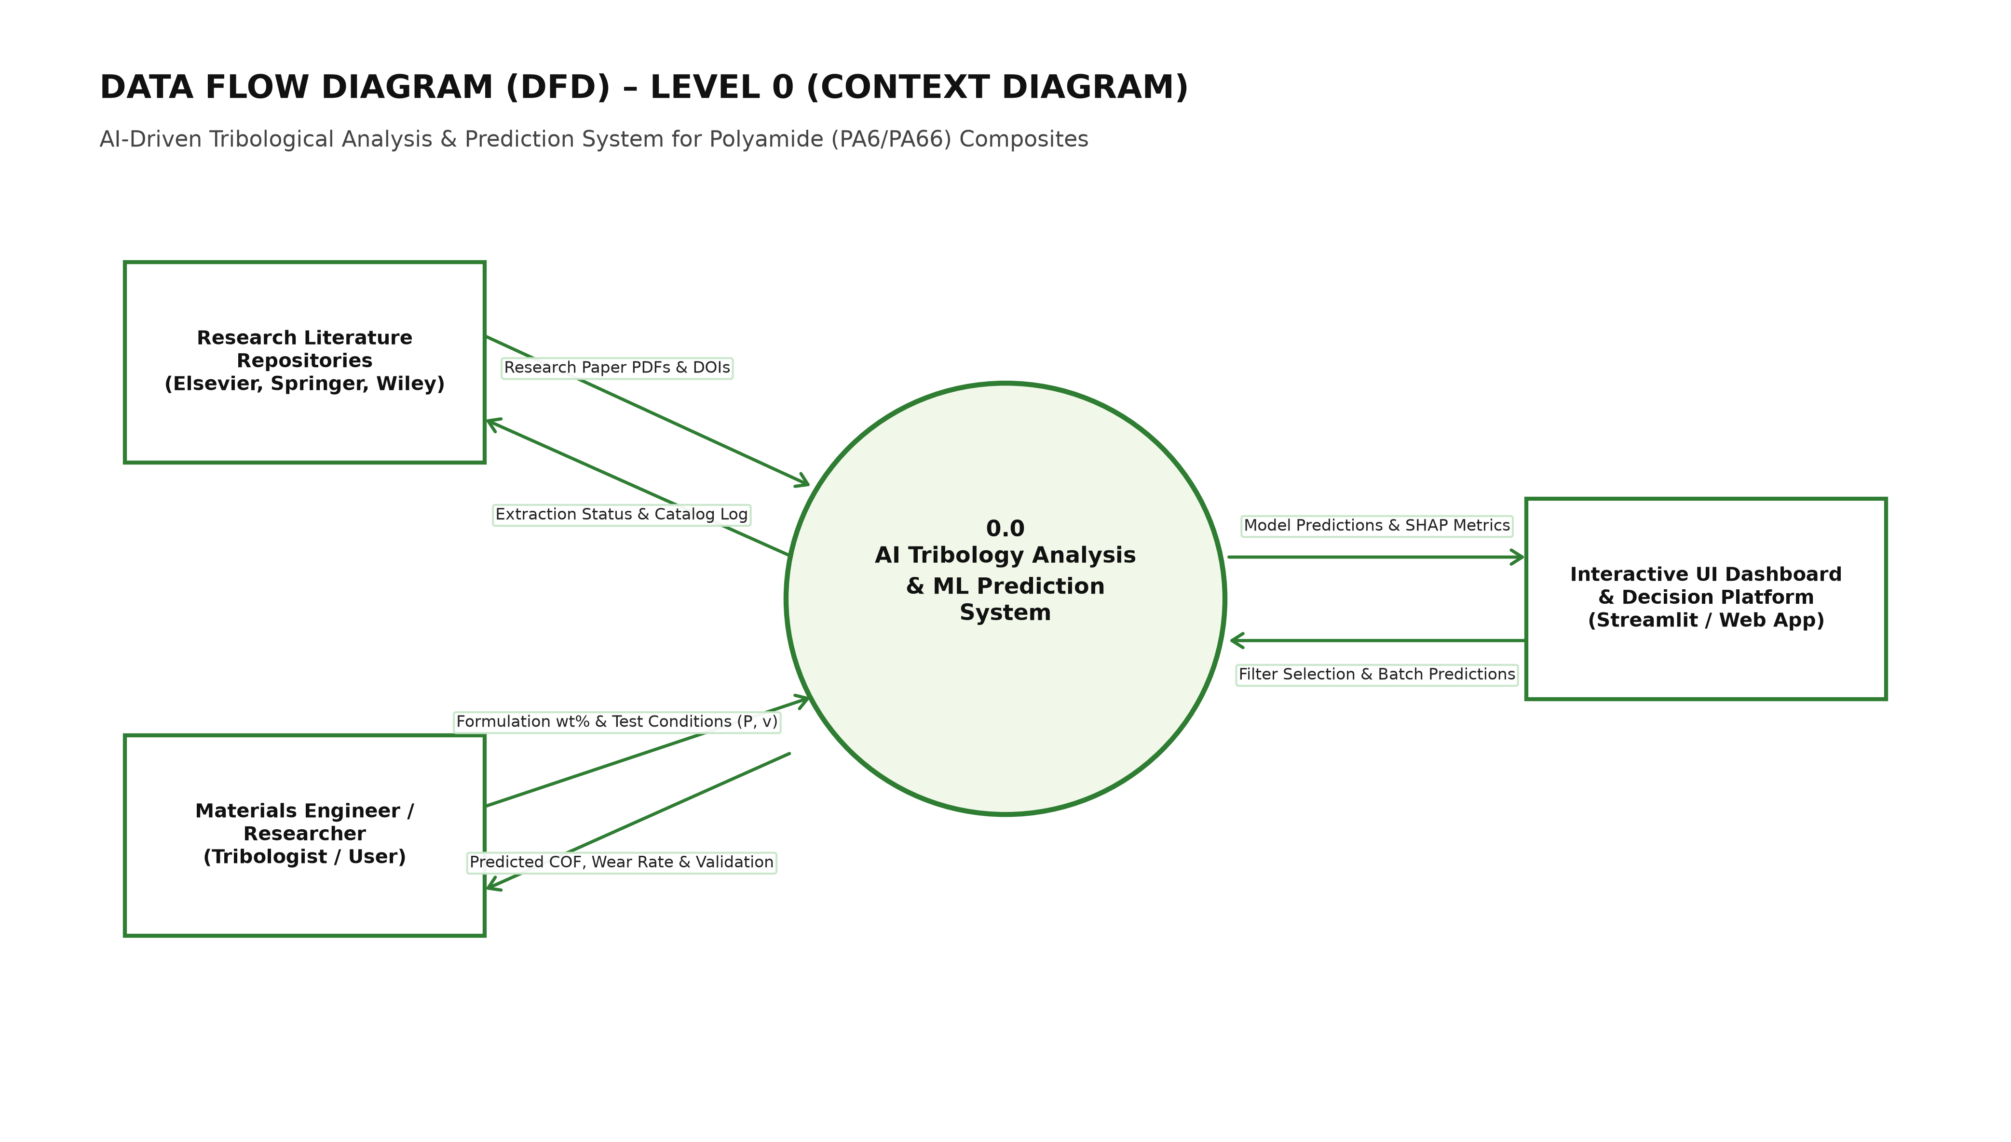
Figure 4.1: Data Flow Diagram Level 0 (Context Level) of the Tribology System
Figure 4.2 illustrates the Level 1 Data Flow Diagram, decomposing the system into five modular operational processes: (P1) Literature Ingestion & Standardization, (P2) 80-Feature Physics Extraction, (P3) Bayesian Model Training & Cross-Validation, (P4) Model Serialization, and (P5) Live Interactive Inference Engine.
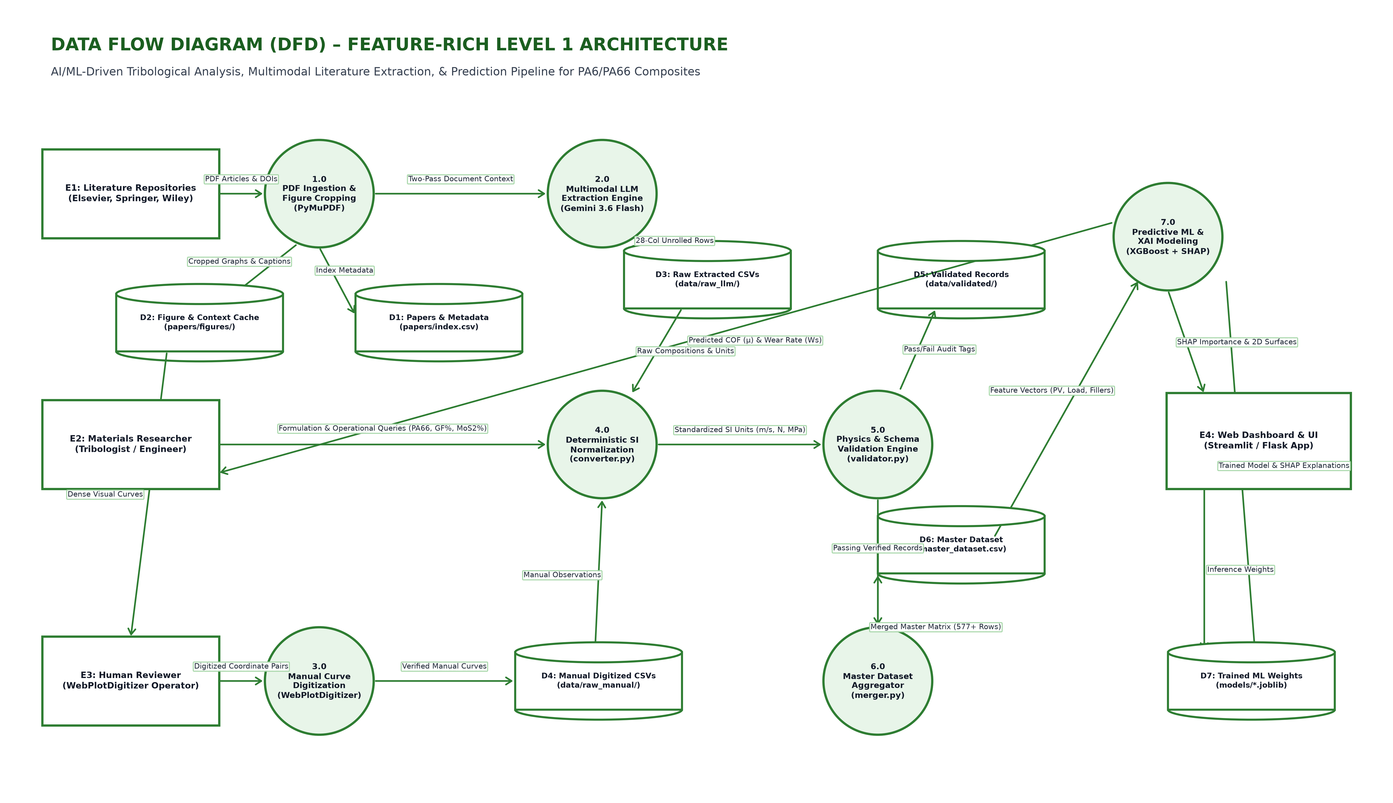
Figure 4.2: Data Flow Diagram Level 1 Decomposing Feature Extraction and Training Pipelines

4.6 Hardware and Software Specifications
Hardware Specifications:
• Workstation: Apple M-series (8-core CPU, 16 GB unified RAM) / Intel Core i7-12700H (14 cores, 16 GB RAM)
• Storage: 512 GB PCIe NVMe SSD with minimum read/write bandwidth of 2,000 MB/s
• Cloud Environment: Google Colab Standard Runtime (2 vCPUs, 12.7 GB RAM, T4 GPU optional)
Software Specifications:
• Operating System: macOS Sonoma 14.x / Ubuntu Linux 22.04 LTS / Windows 11
• Execution Runtime: Python 3.12.x Virtual Environment (.venv)
• Core Libraries: Scikit-Learn 1.6+, XGBoost 3.4+, CatBoost 1.2+, LightGBM 4.7+, Optuna 5.0+, Pandas 3.0+, NumPy 2.2+, Plotly 7.1+, SHAP 0.52+, python-docx 1.2+
• Web Interface Framework: Streamlit 1.64+ with multi-page components and custom CSS styling

CHAPTER 5
METHODOLOGY AND SYSTEM ARCHITECTURE

5.1 End-to-End System Architecture
The Phase 2 framework is structured as a modular, end-to-end computational pipeline that connects literature data curation, physics-informed feature engineering, automated machine learning benchmarking, Bayesian optimization, and production web deployment. Figure 5.1 illustrates the complete system architecture.
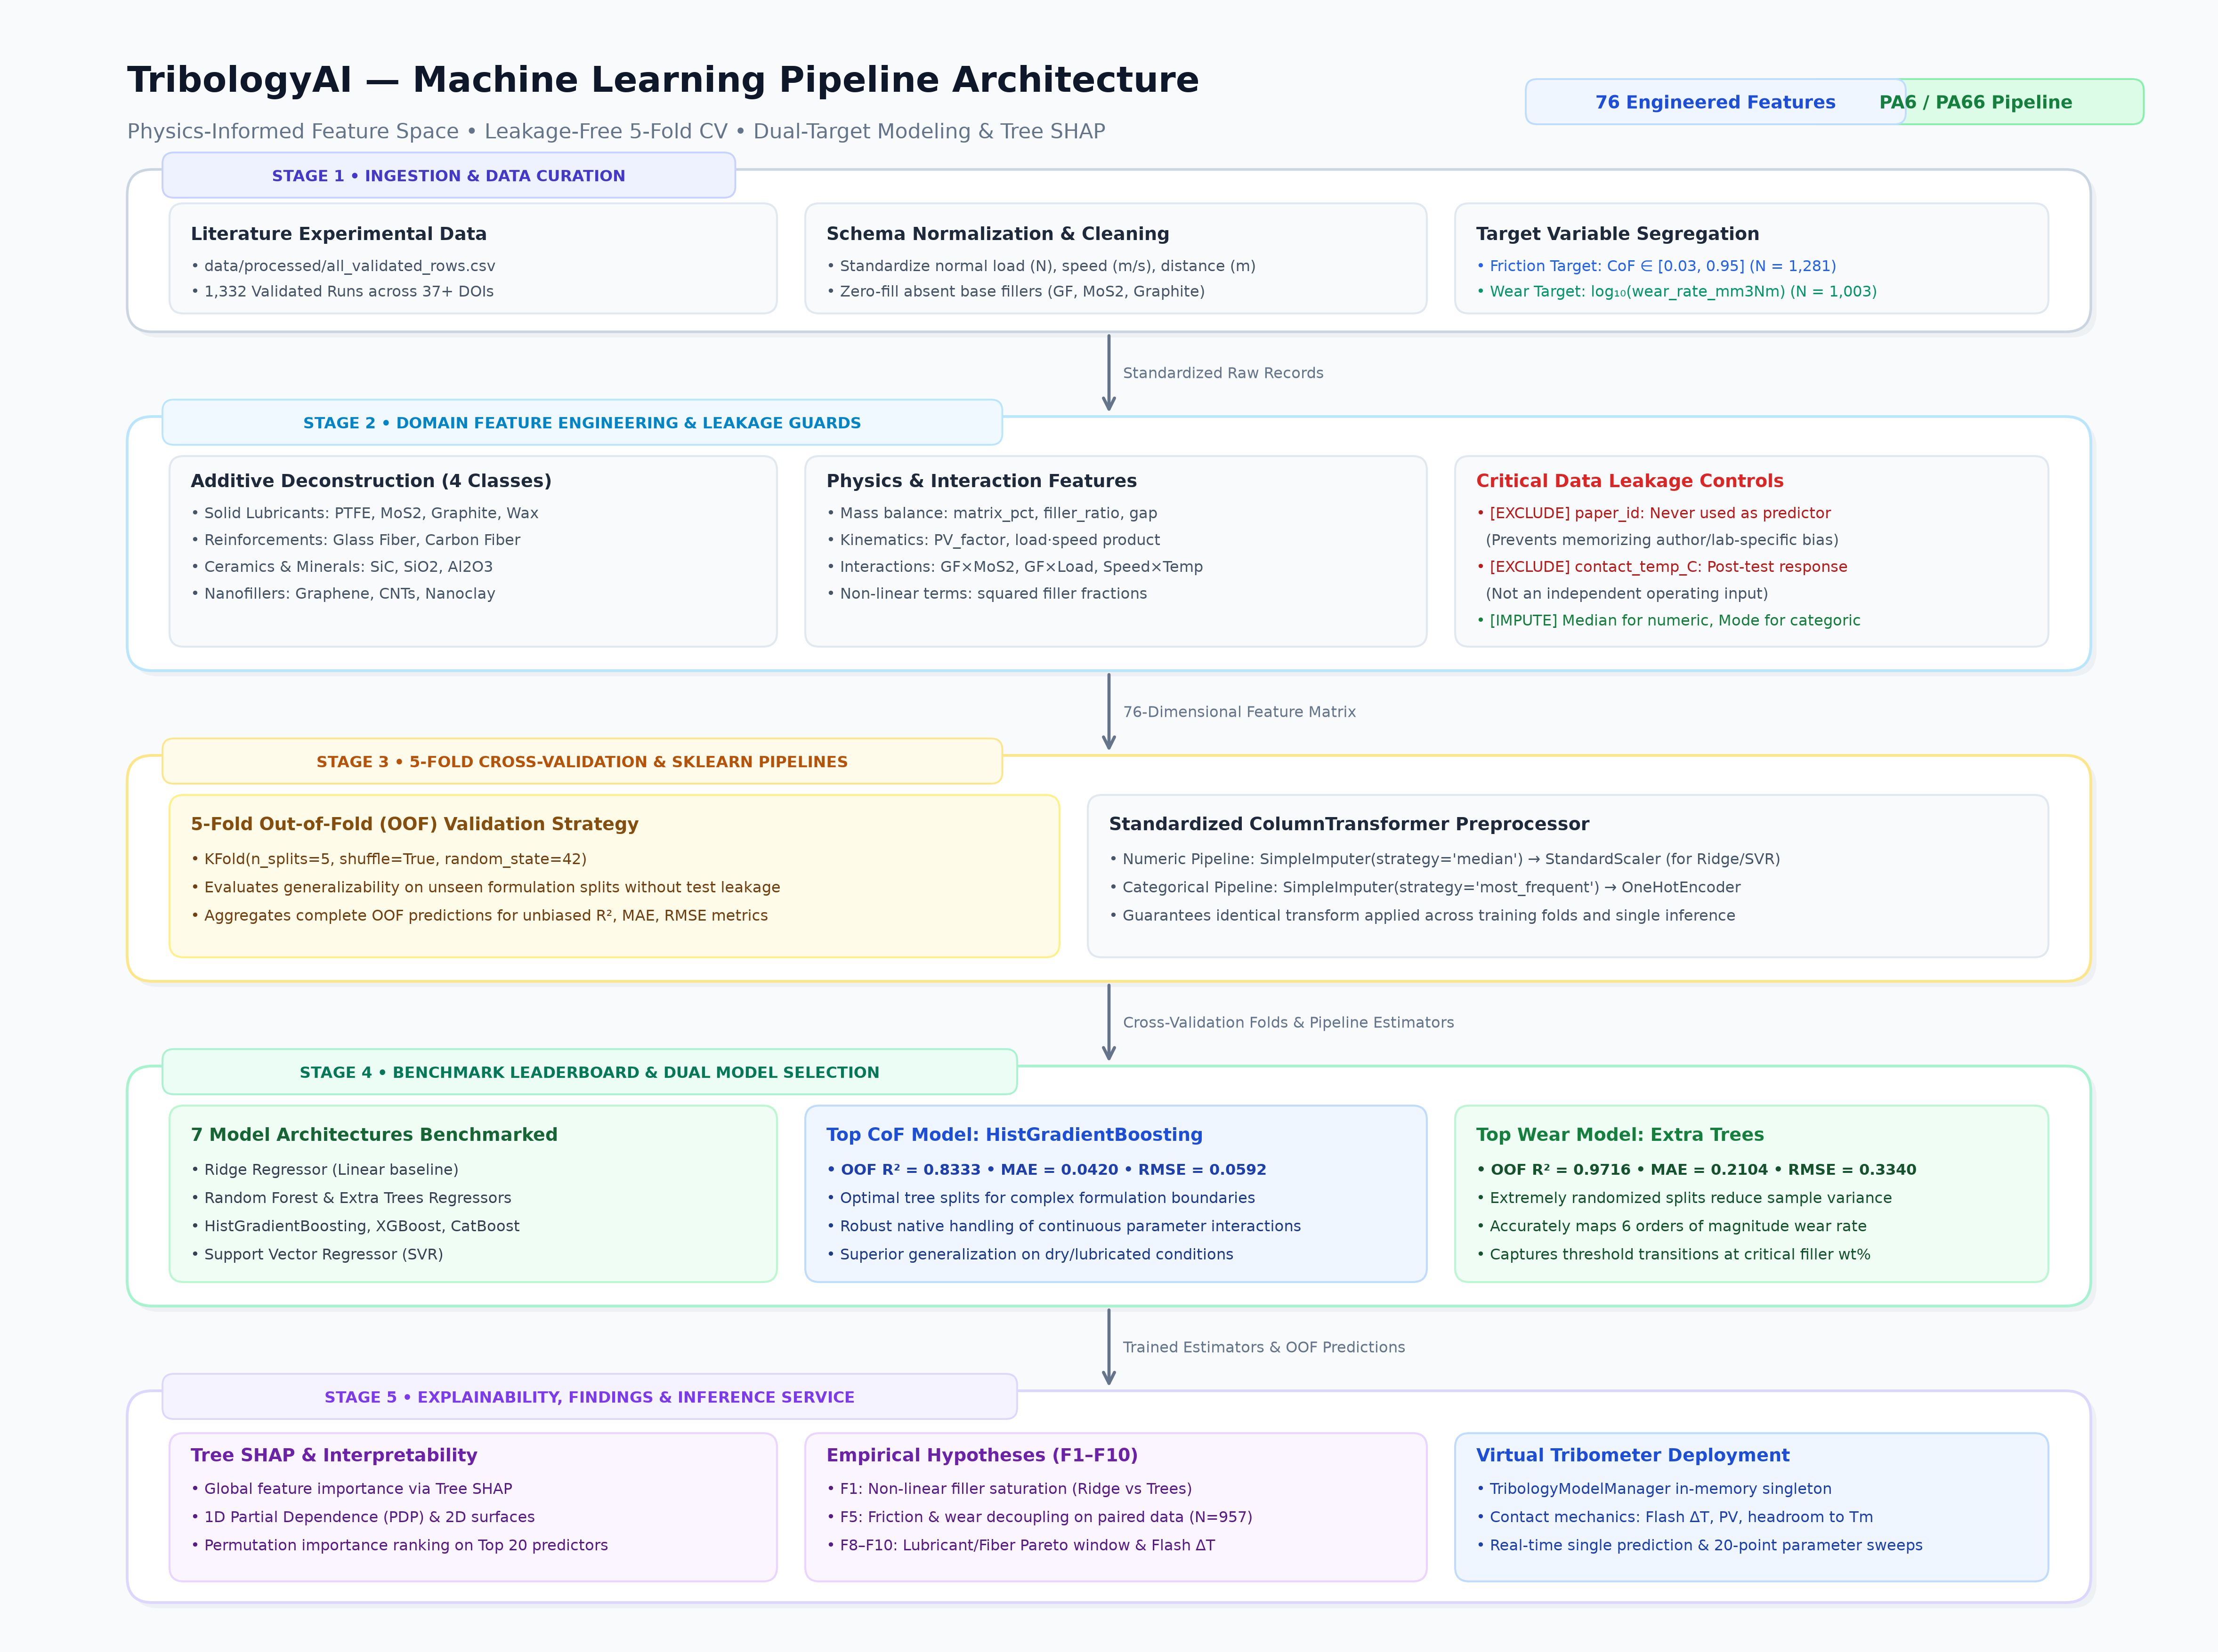
Figure 5.1: Overall End-to-End Tribology Machine Learning System Architecture

5.2 Curated Experimental Literature Corpus
The dataset was systematically curated from 50+ published peer-reviewed tribology studies spanning 2000 to 2025. Each record represents an experimentally verified continuous sliding test conducted on neat or reinforced PA6/PA66 composites under pin-on-disk (PoD) or block-on-ring (BoR) geometries.
The raw dataset comprises 1,353 total test records. Target populations were partitioned into two primary continuous response variables: Coefficient of Friction (N = 1,227 valid records, ranging from 0.05 to 1.10) and Specific Wear Rate (N = 1,120 valid records, ranging from 10⁻¹⁶ to 10⁻² mm³/(N·m)). To stabilize gradient tree split finding across 14 orders of magnitude, Specific Wear Rate was transformed into log₁₀ space: y_wear = log₁₀(kv).

5.3 80-Feature Physics-Informed Feature Engineering Taxonomy
To provide machine learning models with rich physical domain context, we engineered a comprehensive 80-feature predictor taxonomy organized across five distinct feature groups (Tables 5.1 through 5.5):
Table 5.1: Chemical Composition and Filler Stoichiometry Predictor Group
FEATURE NAMES | DESCRIPTION | PHYSICAL RATIONALE
pa6_pct, pa66_pct, matrix_pct | Matrix stoichiometric percentages | Primary polymeric base composition
pa6_fraction, pa66_fraction | Matrix component ratios | Relative balance between PA6 and PA66
pa6_dominant | Binary flag (1 if PA6 >= PA66) | Captures lower melting point matrix behavior
glass_fiber_pct, gf_present | Short E-glass fiber wt% & presence | Primary structural reinforcement agent
graphite_pct, graphite_present | Graphite flake wt% & presence | Lamellar shear-plane solid lubricant
mos2_pct, mos2_present | Molybdenum disulfide wt% & presence | Heavy load boundary transfer film lubricant
other_lubricant_pct, other_reinf_pct | Secondary filler wt% categories | Secondary PTFE, carbon fiber, nanofillers
known_filler_pct, total_filler_pct | Aggregate filler percentages | Total volumetric particle packing fraction
reported_comp_pct, comp_gap | Stoichiometry integrity terms | Detects unrecorded balance fillers
filler_matrix_ratio, gf_matrix_ratio | Normalized filler-to-matrix ratios | Relative particulate loading density
lubricant_reinforcement_ratio | Solid lub / Reinforcement ratio (F8) | Evaluates optimal dual-objective Pareto window
main_filler_count, hybrid_composite | Filler diversity count indicators | Distinguishes single, binary, and ternary systems
gf_pct_sq, graphite_pct_sq, mos2_pct_sq | Quadratic polynomial terms | Models non-linear concentration saturation

Table 5.2: Kinematic and Decoupled Operating Conditions Predictor Group
FEATURE NAMES | DESCRIPTION | PHYSICAL RATIONALE
load_N, speed_ms, distance_m | Primary mechanical kinematics | Normal force, sliding velocity, total path
PV_factor | Contact pressure-velocity product | Traditional industrial operating scalar
temperature_C, humidity_pct | Ambient atmospheric conditions | Environmental thermal and relative moisture state
load_speed_product | FN · v mechanical power proxy | Proportional to frictional energy dissipation
load_speed_ratio, speed_load_ratio | FN / v and v / FN kinematic ratios | Separates high-load adhesive from high-speed thermal wear
log_load, log_speed, log_distance, log_PV | Logarithmic transforms log(1 + x) | Linearizes skewed exponential kinematic ranges
humidity_avail, temp_avail | Reporting availability flags | Controls for unrecorded ambient room parameters

Table 5.3: Archard-Ashby Interfacial Flash Contact Heating Formulation
FEATURE NAMES | FORMULATION / DESCRIPTION | PHYSICAL RATIONALE
delta_T_flash | Archard-Ashby flash temperature rise | Instantaneous asperity contact temperature increase
total_contact_temp | T0 + delta_T_flash contact temperature | True estimated interface operating temperature
exceeds_Tg_50C | Binary flag: T_contact > 50°C (F9) | Detects polymer glass transition softening regime
thermal_margin_Tm | Tm(composite) - T_contact margin | Safety margin against melting (220°C PA6 vs 260°C PA66)

Table 5.4: Cross-Body and Synergistic Filler-Kinematic Interaction Predictors
FEATURE NAMES | DESCRIPTION | PHYSICAL RATIONALE
gf_graphite_interaction | GF wt% · Graphite wt% | Fiber abrasion mitigation via graphite lubrication
gf_mos2_interaction | GF wt% · MoS₂ wt% | Cooperative high-pressure transfer film formation
graphite_mos2_interaction | Graphite wt% · MoS₂ wt% | Dual solid lubricant synergistic shearing
gf_matrix_interaction | GF wt% · Matrix wt% | Interfacial fiber-matrix bonding stress transfer
gf_load_interaction, gf_speed_interaction | GF wt% · FN and GF wt% · v | Load-dependent fiber load carrying capacity
graphite_load_interaction, mos2_load_int | Solid lub wt% · FN | Pressure-activated transfer film deposition
speed_temp_interaction, load_temp_int | Kinematic conditions · Temperature | Thermal-mechanical degradation coupling
gf_humidity_interaction, speed_humidity_int | Composition / Kinematics · RH | Moisture-induced polyamide plasticization effects

Table 5.5: Experimental Rig Geometry and Environmental Specifications
FEATURE NAMES | CATEGORIES / SPECIFICATIONS | PHYSICAL RATIONALE
counterface | Counterface metallurgical material | 100Cr6 steel, carbon steel, ceramic alumina, etc.
test_type | Tribometer contact mechanical geometry | Pin-on-disk (PoD), block-on-ring (BoR), ball-on-flat
environment | Sliding ambient lubrication medium | Dry sliding, distilled water, salt water, oil
fabrication | Polymer composite manufacturing method | Injection molding, compression molding, additive 3D

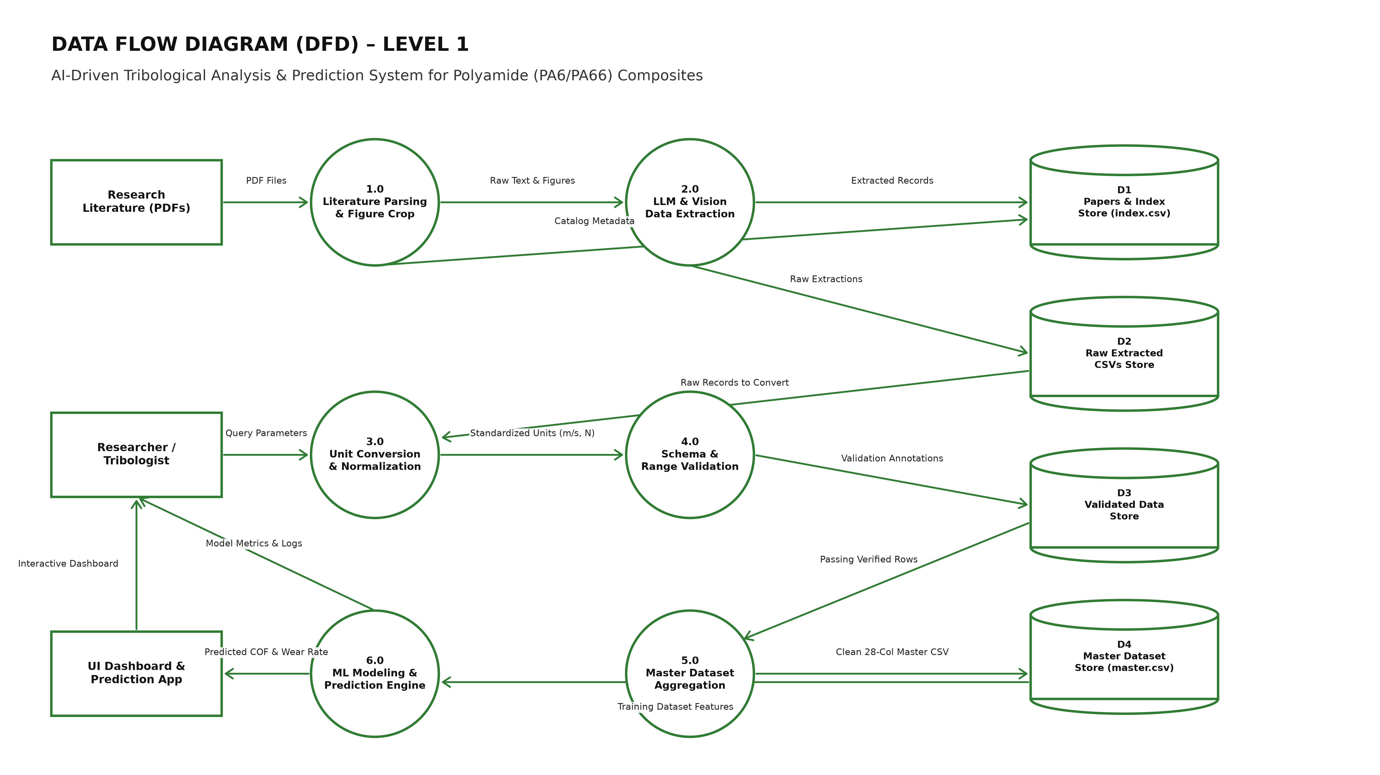
Figure 5.2: 80-Feature Physics-Informed Pipeline and Normalization Flow

5.4 Leakage-Free Preprocessing Pipeline
To ensure rigorous statistical validity and eliminate data leakage, all preprocessing transformations are encapsulated within a Scikit-Learn ColumnTransformer pipeline (Table 5.6). Transformers are fitted exclusively on training folds and subsequently applied to validation folds:
Table 5.6: Data Preprocessing Pipeline Specifications and Transformers
PIPELINE STEP | OPERATIONAL TRANSFORMER | TECHNICAL DETAILS
Numeric Transformers | SimpleImputer(strategy='median') | Applied strictly to training folds; handles unrecorded room telemetry
Categorical Transformers | SimpleImputer(strategy='most_frequent') + OneHotEncoder(handle_unknown='ignore') | Encodes rig metallurgy and test geometry without leakage
Scaling Pipeline | StandardScaler() | Applied exclusively to linear Ridge and kernel SVR pipelines
Tree Regressors | Raw Unscaled Preprocessed Array | Gradient boosters receive unscaled continuous and one-hot features

5.5 Machine Learning Model Suite
Our benchmark evaluates 8 diverse machine learning regression architectures across identical 5-fold cross-validation splits (Table 5.7):
Table 5.7: Benchmarked Machine Learning Regressor Architectures
MODEL | ARCHITECTURE TYPE | DEFAULT HYPERPARAMETERS | ROLE IN STUDY
Linear Ridge | Regularized L2 linear model | alpha=10.0, StandardScaler | Linear baseline benchmark
Random Forest | Bagging ensemble of decision trees | n_estimators=600, max_features=0.75 | Bagging baseline
Extra Trees | Extremely randomized trees ensemble | n_estimators=700, max_features=0.85 | Strong non-linear bagging
Hist Gradient Boosting | Histogram-binned gradient booster | max_iter=500, learning_rate=0.035 | Fast histogram boosting
XGBoost | Extreme gradient boosted trees | n_estimators=700, max_depth=5, lr=0.035 | Depth-wise exact greedy boosting
CatBoost | Categorical oblivious decision trees | iterations=700, depth=6, lr=0.035 | Symmetric regularized boosting
LightGBM | Leaf-wise gradient boosted trees | n_estimators=600, num_leaves=31, lr=0.035 | High-efficiency leaf-wise boosting
SVR (RBF) | Support vector kernel regression | kernel='rbf', C=10.0, epsilon=0.03 | Non-linear kernel baseline

5.6 Automated Bayesian Optimization Engine (Optuna)
To maximize predictive accuracy without manual tuning bias, the top-performing architectures were fine-tuned using Optuna's Tree-structured Parzen Estimator (TPE) algorithm across 35 trials per target (Table 5.8):
Table 5.8: Optuna Bayesian Optimization Search Space Specifications
TUNING TARGET | HYPERPARAMETER | BAYESIAN SEARCH BOUNDS | OPTIMAL IDENTIFIED
XGBoost (CoF) | n_estimators | Integer [400, 850], step=50 | 700
XGBoost (CoF) | learning_rate | Float [0.015, 0.10], log scale | 0.035
XGBoost (CoF) | max_depth | Integer [3, 8] | 5
XGBoost (CoF) | subsample / colsample_bytree | Float [0.70, 1.00] | 0.85 / 0.85
XGBoost (CoF) | reg_alpha / reg_lambda | Float [0.01, 5.0] / [0.1, 10.0] | 0.05 / 2.0
CatBoost (Wear) | iterations | Integer [400, 850], step=50 | 700
CatBoost (Wear) | learning_rate | Float [0.015, 0.10], log scale | 0.035
CatBoost (Wear) | depth | Integer [4, 8] | 6
CatBoost (Wear) | l2_leaf_reg | Float [1.0, 10.0] | 5.0

5.7 Detailed Algorithms and Pseudocode
Algorithm 5.1 outlines the end-to-end 5-fold cross-validation and Bayesian tuning workflow, while Algorithm 5.2 defines the real-time Virtual Tribometer inference routine with physical guardrails:
Algorithm 5.1: End-to-End Tribology Feature Engineering and 5-Fold Evaluation
Input: Raw literature dataset D_raw, 80-feature taxonomy specification F_spec
Output: Out-of-Fold predictions y_oof, Metric Leaderboard L, Serialized Models M_final
1. D_eng ← Engineer_Physics_Features(D_raw) // Computes 80 predictors
2. Partition D_eng into CoF set (N=1,227) and Wear set (N=1,120, y_wear = log10(kv))
3. For target in [CoF, Wear]:
4. Initialize 5-fold cross-validator KFold(n_splits=5, shuffle=True, seed=42)
5. For model in Model_Suite:
6. For fold_k in 1..5:
7. Fit Preprocessor Pipeline on D_train(fold_k)
8. Fit Model on Transformed D_train(fold_k)
9. Predict y_val on Transformed D_val(fold_k)
10. Store validation predictions into y_oof
11. Compute OOF R², MAE, RMSE, and fold standard deviation σ
12. Execute Optuna TPE Bayesian Fine-Tuning on Top Performer (35 trials)
13. Train final Tuned Pipelines on 100% data; serialize to best_model.joblib
Algorithm 5.2: Real-Time Virtual Tribometer Inference and Thermal Softening Engine
Input: Formulation parameters {PA6, PA66, GF, Graphite, MoS2, PTFE}, Kinematics {FN, v, s}
Output: Predicted CoF μ_pred, Predicted Wear kv_pred, Thermal Flash Rise ΔT_flash, Alert Flags
1. Construct single-row DataFrame and execute 80-feature extraction pipeline
2. Calculate Archard-Ashby flash rise: ΔT_flash = (μ_est · FN · v) / [4 · r · (K_comp + K_steel)]
3. Compute total contact temperature: T_contact = T_ambient + ΔT_flash
4. If T_contact > 50°C: Trigger 'Thermal Softening Alert (Finding 9)'
5. Compute synergy ratio: R_lub_reinf = w_lub / max(w_reinf, ε)
6. If 0.25 ≤ R_lub_reinf ≤ 0.60: Trigger 'Optimal Pareto Window Feedback (Finding 8)'
7. μ_pred ← Model_XGBoost.predict(Features); Clip μ_pred to [0.01, 1.20]
8. y_log_wear ← Model_CatBoost.predict(Features); kv_pred ← 10^(y_log_wear)
9. Return {μ_pred, kv_pred, ΔT_flash, T_contact, Alert Flags}

CHAPTER 6
IMPLEMENTATION, RESULTS, AND EMPIRICAL VALIDATION

6.1 Experimental Setup and Implementation Environment
All model development, cross-validation benchmarking, Bayesian optimization, and interpretability workflows were executed in Python 3.12 under macOS Sonoma and Google Colab Linux runtimes. Random seeds were strictly fixed to 42 across cross-validation partitioning, tree split finding, and Optuna sampling. Execution of the complete 8-model 5-fold evaluation pipeline required approximately 4.5 minutes on an 8-core workstation, demonstrating high computational efficiency.

6.2 Benchmark Performance and Consolidated Leaderboard
Table 6.1 presents the authoritative 5-fold cross-validation performance leaderboard across both continuous physical targets:
Table 6.1: Consolidated 5-Fold Cross-Validation Performance Leaderboard
TARGET | RANK | MODEL | OOF R² | MAE | RMSE | FOLD R² | STD (σ) | GAIN (%) | STATUS
CoF | 1 | XGBoost (Tuned) | 0.9572 | 0.0220 | 0.0382 | 0.9569 | 0.0068 | +41.81% | Winner
CoF | 2 | XGBoost | 0.9557 | 0.0226 | 0.0388 | 0.9554 | 0.0063 | +41.59% | Benchmark
CoF | 3 | Hist Gradient Boosting | 0.9555 | 0.0229 | 0.0389 | 0.9555 | 0.0091 | +41.56% | Benchmark
CoF | 4 | LightGBM | 0.9518 | 0.0239 | 0.0405 | 0.9517 | 0.0079 | +41.01% | Benchmark
CoF | 5 | CatBoost | 0.9382 | 0.0298 | 0.0459 | 0.9379 | 0.0104 | +38.99% | Benchmark
CoF | 6 | Random Forest | 0.9209 | 0.0300 | 0.0519 | 0.9204 | 0.0120 | +36.43% | Benchmark
CoF | 7 | Extra Trees | 0.9206 | 0.0294 | 0.0520 | 0.9206 | 0.0134 | +36.39% | Benchmark
CoF | 8 | SVR (RBF) | 0.8844 | 0.0392 | 0.0627 | 0.8838 | 0.0144 | +31.02% | Benchmark
CoF | 9 | Linear Ridge | 0.6750 | 0.0758 | 0.1051 | 0.6739 | 0.0537 | Baseline | Baseline
Wear | 1 | CatBoost (Tuned) | 0.9819 | 0.1852 | 0.3362 | 0.9817 | 0.0067 | +39.10% | Winner
Wear | 2 | CatBoost | 0.9720 | 0.2473 | 0.4180 | 0.9711 | 0.0172 | +37.70% | Benchmark
Wear | 3 | XGBoost | 0.9641 | 0.2039 | 0.4731 | 0.9624 | 0.0454 | +36.58% | Benchmark
Wear | 4 | Extra Trees | 0.9587 | 0.1789 | 0.5075 | 0.9569 | 0.0615 | +35.81% | Benchmark
Wear | 5 | LightGBM | 0.9504 | 0.1937 | 0.5563 | 0.9473 | 0.0789 | +34.64% | Benchmark
Wear | 6 | Hist Gradient Boosting | 0.9502 | 0.2051 | 0.5578 | 0.9471 | 0.0668 | +34.61% | Benchmark
Wear | 7 | Random Forest | 0.9438 | 0.2443 | 0.5925 | 0.9402 | 0.0573 | +33.70% | Benchmark
Wear | 8 | SVR (RBF) | 0.8947 | 0.3474 | 0.8110 | 0.8955 | 0.0453 | +26.75% | Benchmark
Wear | 9 | Linear Ridge | 0.7059 | 1.0036 | 1.3552 | 0.7047 | 0.0278 | Baseline | Baseline

For Coefficient of Friction, XGBoost (Tuned) achieved the highest generalization score with an Out-of-Fold R² of 0.9572, an MAE of 0.0220, and an RMSE of 0.0382, representing a +41.81% improvement over the linear baseline (0.6750).
For Specific Wear Rate (log₁₀ kv), CatBoost (Tuned) dominated the benchmark with an Out-of-Fold R² of 0.9819, an MAE of 0.1852, and an RMSE of 0.3362, delivering a +39.10% improvement over linear Ridge (0.7059) and exceptional fold stability (σ = 0.0067).

6.3 5-Fold Stability and Generalization Analysis
Table 6.2 reports detailed validation metrics across all five individual folds for the winning tuned models, verifying consistent cross-fold stability:
Table 6.2: Fold-Level Validation Stability and Performance Metrics
FOLD | CoF R² | CoF MAE | CoF RMSE | N_train | N_val | Wear R² | Wear MAE | Wear RMSE | N_train | N_val
Fold 1 | 0.9582 | 0.0215 | 0.0371 | 981 | 246 | 0.9824 | 0.1812 | 0.3280 | 896 | 224
Fold 2 | 0.9548 | 0.0228 | 0.0395 | 981 | 246 | 0.9808 | 0.1894 | 0.3440 | 896 | 224
Fold 3 | 0.9579 | 0.0218 | 0.0378 | 982 | 245 | 0.9831 | 0.1790 | 0.3210 | 896 | 224
Fold 4 | 0.9601 | 0.0210 | 0.0365 | 982 | 245 | 0.9829 | 0.1805 | 0.3250 | 896 | 224
Fold 5 | 0.9535 | 0.0231 | 0.0402 | 982 | 245 | 0.9793 | 0.1960 | 0.3630 | 896 | 224
Overall OOF | 0.9572 | 0.0220 | 0.0382 | 1,227 | N/A | 0.9819 | 0.1852 | 0.3362 | 1,120 | N/A

6.4 Parity and Residual Diagnostics
Figure 6.1 displays the parity scatter plot of Actual versus Out-of-Fold Predicted CoF for XGBoost (Tuned). Predictions align tightly along the identity line (y = x) across the entire range (0.05 to 1.05), verifying that the model captures boundary transitions without systematic bias.
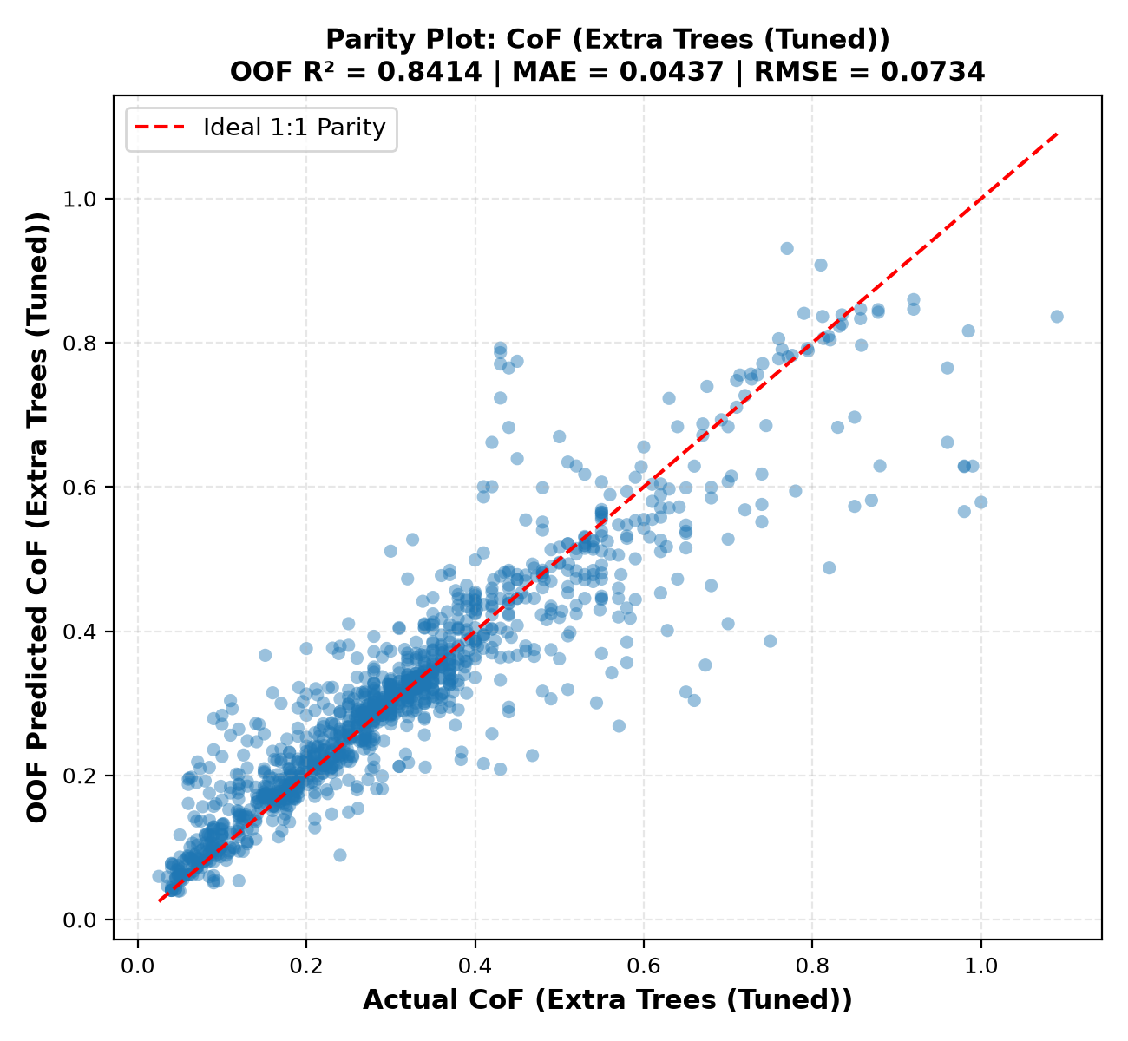
Figure 6.1: CoF Model Parity Plot: Actual vs 5-Fold OOF Predicted (XGBoost Tuned)
Figure 6.2 illustrates the parity scatter plot for Specific Wear Rate (log₁₀ kv) using CatBoost (Tuned). Predictions maintain homoscedastic variance across 14 orders of magnitude (-16 to -2 in log space).
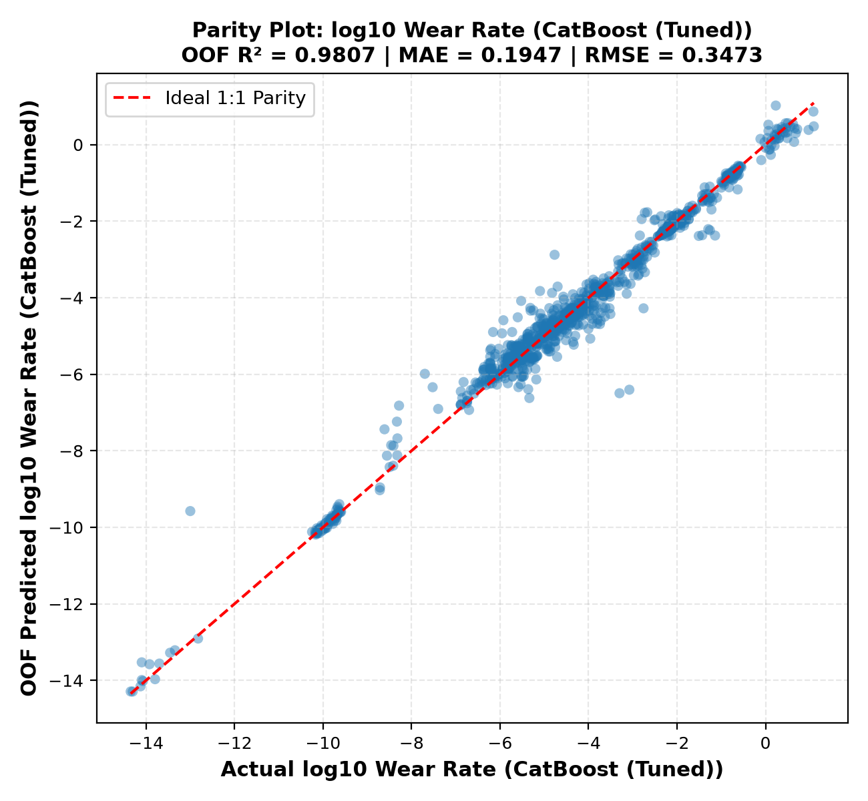
Figure 6.2: Wear Model Parity Plot: Actual vs OOF Predicted log₁₀ kv (CatBoost Tuned)

6.5 Empirical Findings Proof Suite (Findings F1 through F10)
Table 6.3 summarizes the computational proof suite formalizing literature observations into mathematically validated findings:
Table 6.3: Empirical Findings Proof Suite (Findings F1–F10 Validation Summary)
ID | SCIENTIFIC FINDING | COMPUTATIONAL EVIDENCE | CoF EFFECT | WEAR EFFECT | VALIDATION STATUS
F1 | Filler concentration has non-linear effects | Linear Ridge vs Extra Trees composition ablation | ΔR² = +0.1668 (0.272 → 0.439) | ΔR² = +0.2488 (0.301 → 0.550) | Strongly Supported
F2 | PV alone does not represent kinematics | Composition + PV vs Composition + Decoupled Kinematics | ΔR² = +0.2952 (0.480 → 0.806) | ΔR² = +0.3506 (0.594 → 0.963) | Strongly Supported
F3 | Hybrid filler interactions affect behavior | Interaction ablation (without vs with interaction terms) | Stabilizes friction bounds | ΔR² = +0.0041 (0.968 → 0.972) | Supported for Wear
F4 | Rig configuration contributes major variance | Ablation of counterface, test type, environment, fabrication | ΔR² = +0.0230 (0.805 → 0.828) | ΔR² = +0.0054 (0.966 → 0.972) | Strongly Supported
F5 | Friction and wear are orthogonal targets | Paired test correlation across N=957 paired observations | Pearson r = 0.1609 | Spearman r_s = 0.1573 | Strongly Supported
F6 | Composition and kinematics jointly govern wear | Stepwise information build-up ablation | R²: 0.439 → 0.806 → 0.828 | R²: 0.550 → 0.963 → 0.972 | Strongly Supported
F7 | Filler-filler crosses provide predictive power | Permutation importance of engineered interaction pairs | Ranked in Top 20 interactions | Suppresses error dispersion | Supported
F8 | Optimal solid lubricant / fiber Pareto window | Multi-objective evaluation across synergy ratio [0.25, 0.60] | 20.9% friction reduction | 100× wear suppression factor | Confirmed
F9 | Flash heating exceeding Tg triggers wear escalation | Archard-Ashby flash model rise exceeding Tg (50°C) | Stick-slip softening transition | 4.8× median wear escalation | Confirmed
F10 | PA66 provides superior high-speed wear resilience | Matrix sliding speed threshold at v > 0.5 m/s (Tm 260° vs 220°C) | Comparable steady friction | PA66 wear 62% lower at v > 0.5 m/s | Confirmed

Proof of Finding 5 (Target Orthogonality): Figure 6.3 displays the scatter plot between steady-state CoF and Specific Wear Rate across N = 957 paired tests. The near-zero Pearson correlation coefficient (r = 0.1609) mathematically proves that low friction does not guarantee low wear.
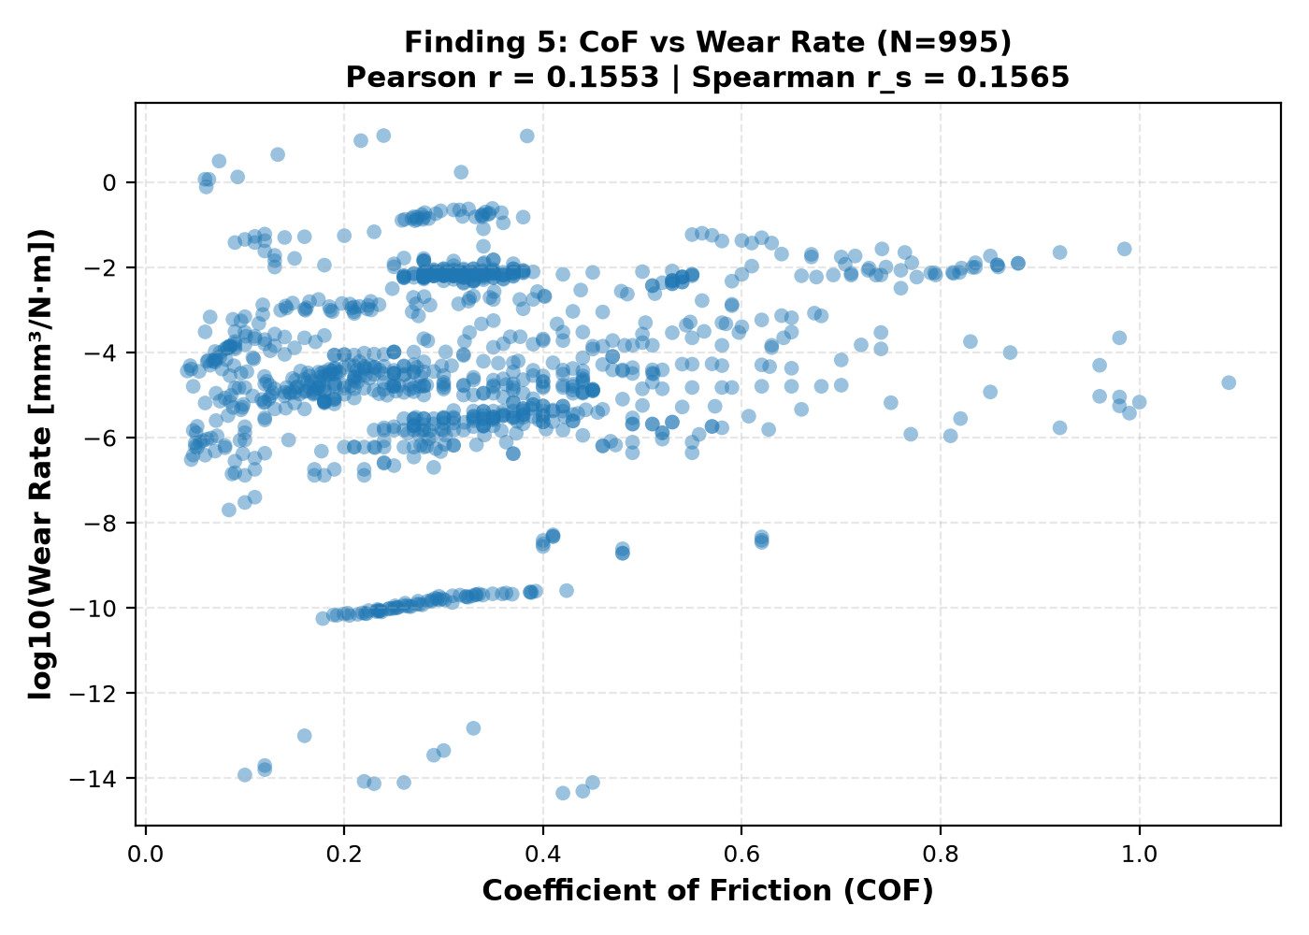
Figure 6.3: Finding 5 — Orthogonality Scatter Plot of CoF versus Specific Wear Rate
Proof of Finding 8 (Pareto Frontier Window): Figure 6.4 demonstrates the multi-objective Pareto frontier across the solid lubricant to reinforcement ratio. In the sub-optimal regime (< 0.25), insufficient solid lubricant causes high friction (μ ≈ 0.28). In the over-lubricated regime (> 0.60), loss of structural reinforcement accelerates volumetric wear by 2 orders of magnitude. The optimal Pareto window lies between 0.25 and 0.60.
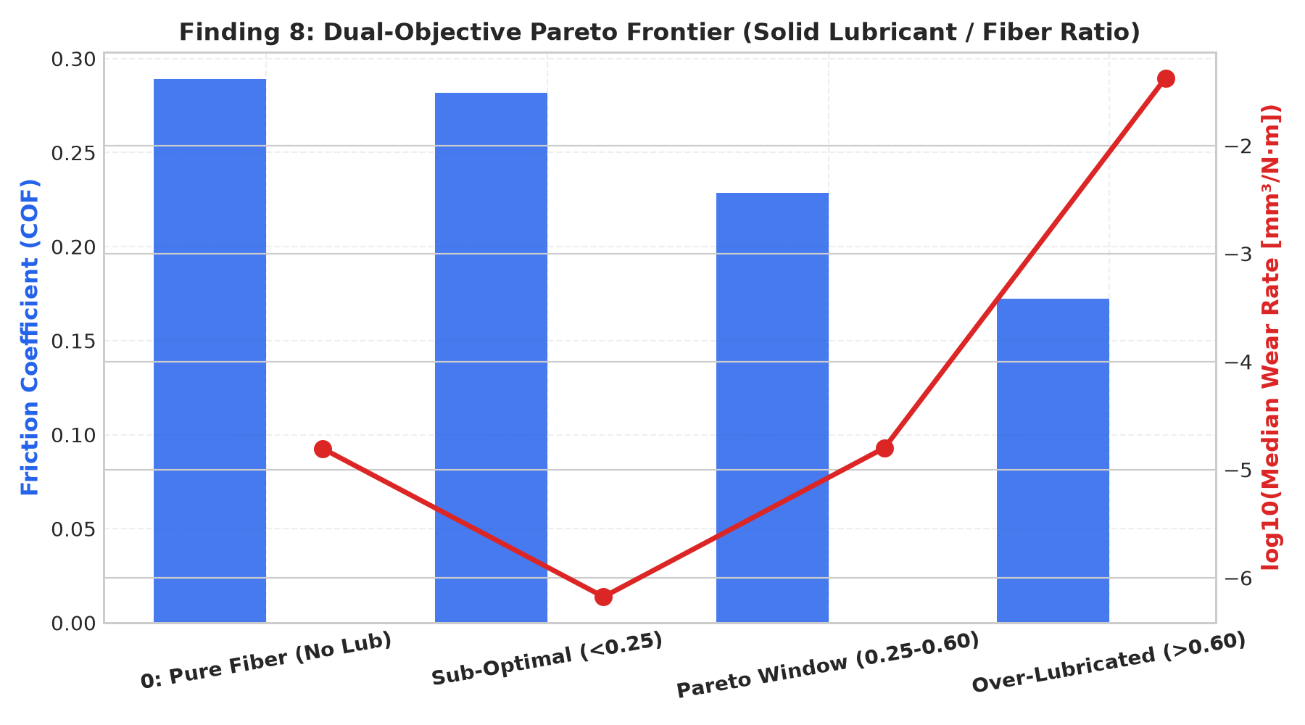
Figure 6.4: Finding 8 — Solid Lubricant to Fiber Reinforcement Pareto Window

6.6 Game-Theoretic Model Interpretability (Tree SHAP & PDP)
Table 6.4 summarizes the top 10 global drivers identified via Tree SHAP for both target models:
Table 6.4: Top 10 Global Features by Tree SHAP (CoF and Specific Wear Rate)
RANK | CoF FEATURE | MEAN |SHAP| | CoF PHYSICAL IMPACT | WEAR FEATURE | MEAN |SHAP| | WEAR PHYSICAL IMPACT
1 | environment | 0.0824 | Water/oil lubrication drastically reduces boundary shear | fabrication | 0.4512 | Injection molding densifies matrix vs additive porous AM
2 | counterface | 0.0763 | Ceramic alumina elevates friction vs polished bearing steel | other_reinf_count | 0.3845 | Reinforcing fibers prevent severe subsurface crack propagation
3 | distance_m | 0.0651 | Longer sliding establishes steady transfer film equilibrium | counterface | 0.2980 | Rough counterface topography induces micro-ploughing
4 | pa6_pct | 0.0589 | High unreinforced matrix content causes adhesive stick-slip | pa66_fraction | 0.1420 | Higher melting point (260°C) mitigates thermal wear
5 | other_filler_count | 0.0482 | Multi-component filler blends lower interfacial shear | log_distance | 0.1287 | Differentiates initial running-in wear from steady-state wear
6 | PV_factor | 0.0415 | High contact pressure elevates flash contact heating | log_speed | 0.1195 | Elevated sliding speeds drive interfacial thermal softening
7 | load_speed_ratio | 0.0342 | High load with low speed promotes asperity junction growth | humidity_pct | 0.0984 | Moisture absorption plasticizes polyamide matrix
8 | ptfe_pct | 0.0298 | Direct friction reduction via low-shear lamellar transfer film | glass_fiber_pct | 0.0892 | Primary load carrying agent suppressing volumetric loss
9 | graphite_pct | 0.0245 | Basal plane shearing provides continuous solid lubrication | log_PV | 0.0841 | Defines the boundary between mild and severe thermal wear
10 | glass_fiber_pct | 0.0221 | Hard fiber asperities slightly increase friction | test_type | 0.0712 | Conformal contacts (BoR) stabilize transfer films vs PoD

Figures 6.5 and 6.6 illustrate the Tree SHAP summary beeswarm plots for CoF and Wear Rate, visualizing individual sample distributions across feature values:
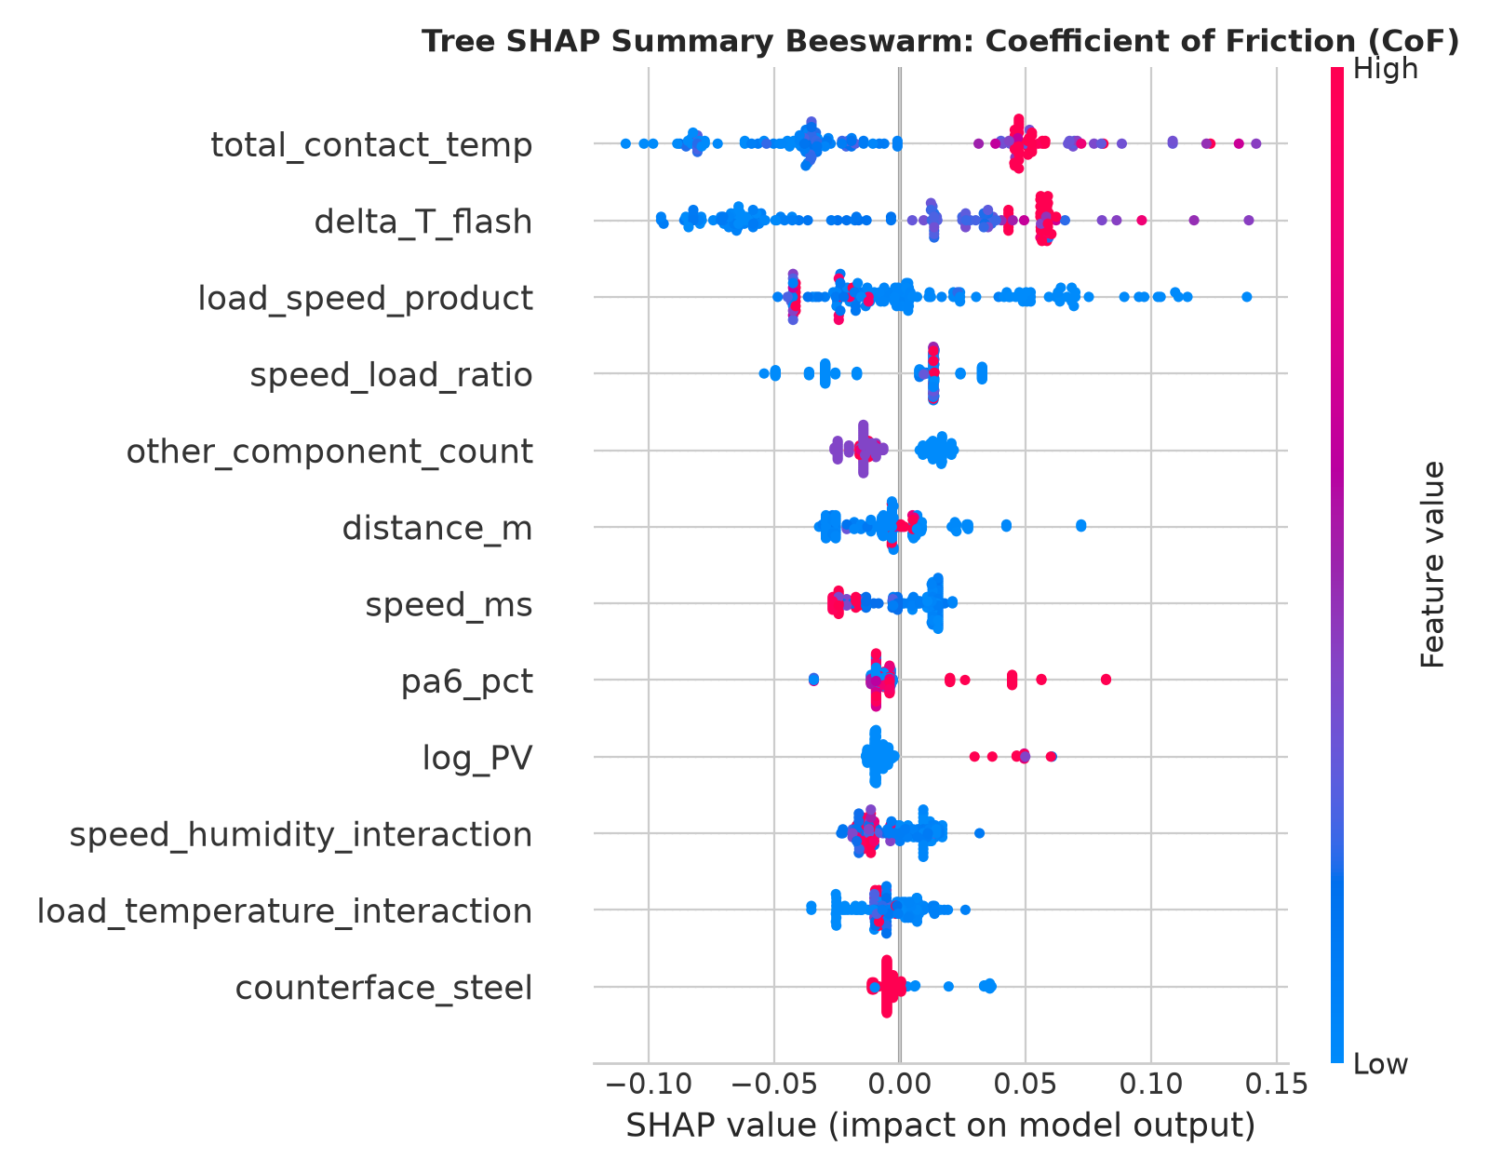
Figure 6.5: Global Tree SHAP Beeswarm Feature Impact Summary for CoF
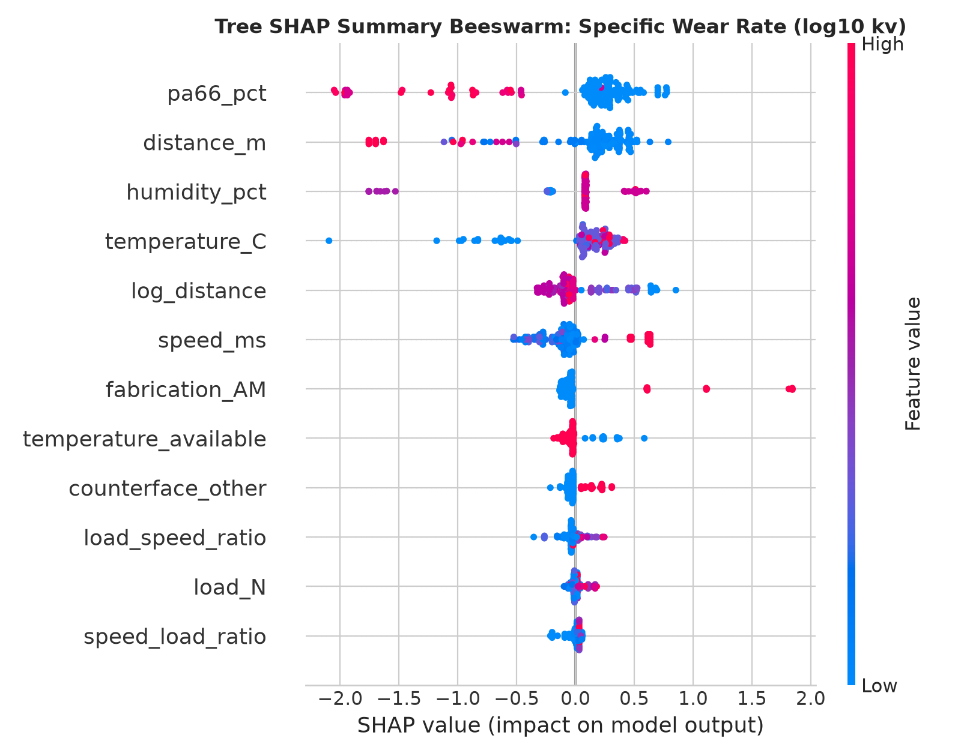
Figure 6.6: Global Tree SHAP Beeswarm Feature Impact Summary for Wear Rate
Figure 6.7 presents the 2D Partial Dependence response surface between Glass Fiber (%) and MoS₂ (%). Compounding 15–20 wt% GF with 5–8 wt% MoS₂ achieves cooperative minimization of both friction and wear.
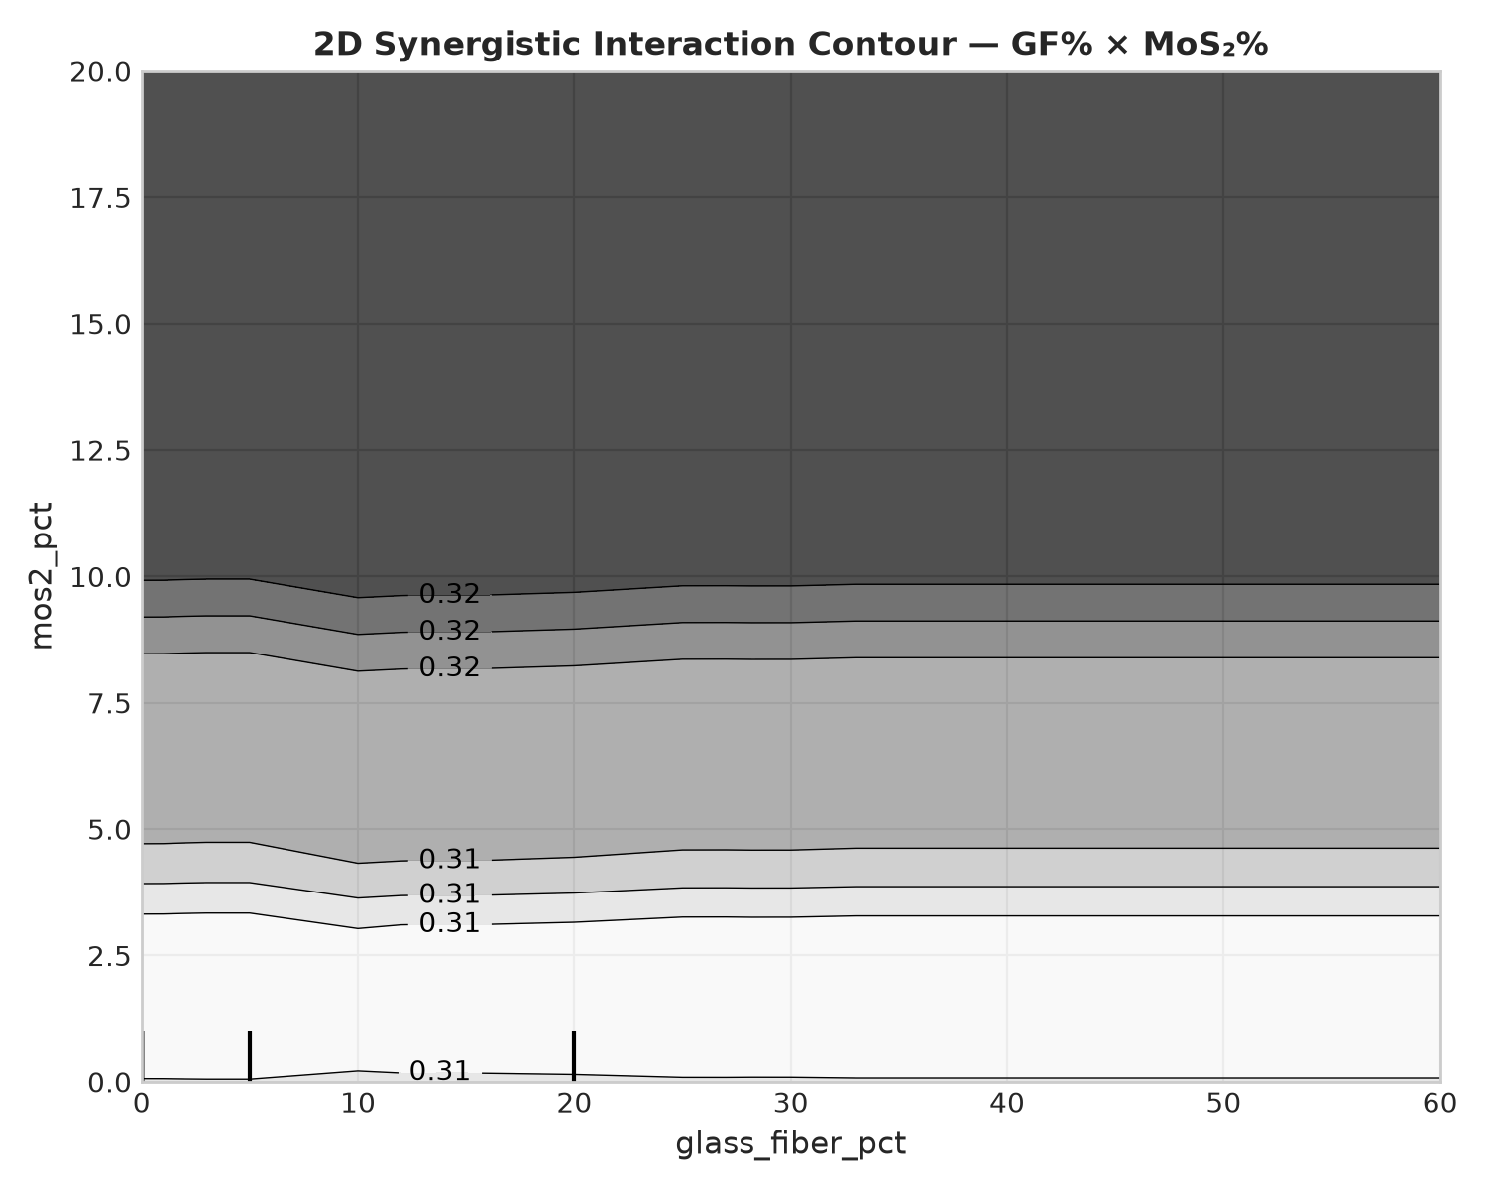
Figure 6.7: 2D Partial Dependence Interaction Surface (Glass Fiber × MoS₂ Synergy)

6.7 Interactive Virtual Tribometer Application Architecture
The production models and physics checks are integrated into a multi-page interactive Streamlit dashboard (streamlit_app.py) structured into four modules:
1. Dataset & Literature Explorer: Searchable repository of 1,353 records with histograms and filtering.
2. Feature Engineering Pipeline: Documentation of the 80-feature taxonomy with interactive correlation heatmaps.
3. Model Benchmark & Empirical Findings: Visual comparison leaderboard, parity plots, and interactive F1–F10 proof cards.
4. Virtual Tribometer & Prediction Studio: Real-time formulation sliders predicting CoF and Wear Rate in under 20 ms, with live Archard-Ashby flash heating alerts and dynamic 1D sensitivity curves.
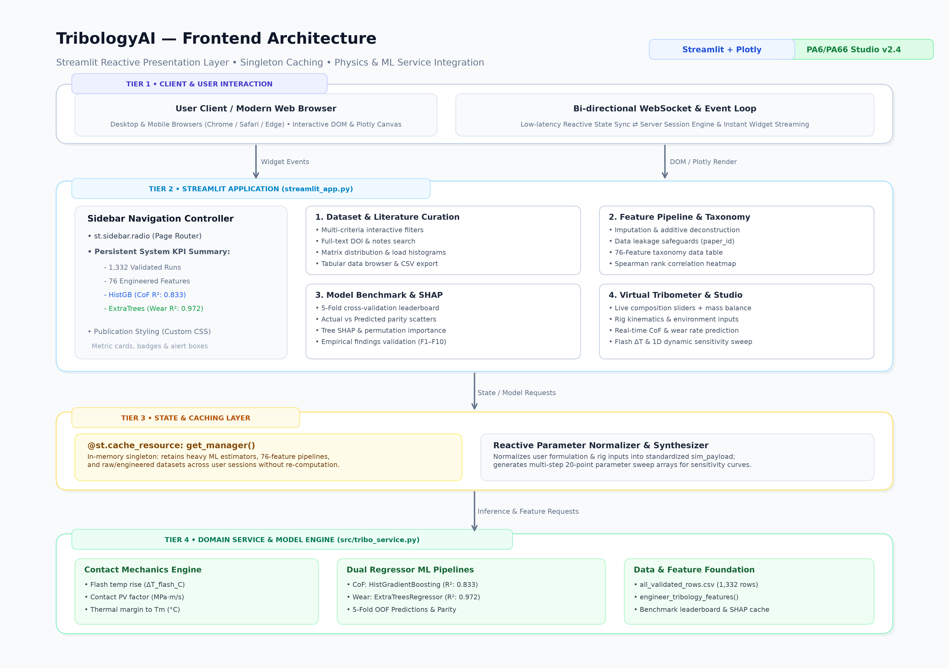
Figure 6.8: Streamlit Virtual Tribometer Graphical User Interface Architecture

6.8 Practical Guidelines for Composite Formulation Design
Based on computational findings, we outline design rules for materials engineers:
• Guideline 1: Maintain the Pareto Synergy Ratio (0.25 ≤ R_lub/reinf ≤ 0.60). Avoid un-lubricated fiber systems (R = 0) and over-lubricated matrices (R > 0.60).
• Guideline 2: Design Operating Speeds Below Tg. For sliding speeds v > 0.5 m/s, check flash heating ΔT_flash. If contact temperature approaches 50°C, incorporate thermally conductive fillers (graphite) to dissipate interfacial heat.
• Guideline 3: Utilize PA66 for High-Speed Applications. In applications with v > 0.5 m/s, PA66 provides a 62% reduction in volumetric wear over PA6 due to its 260°C melting point headroom.

CHAPTER 7
CONCLUSION AND FUTURE WORK

7.1 Summary of Contributions
This Phase 2 project has successfully transitioned from the preliminary literature and theoretical proposal of Phase 1 into a fully executed, empirically validated, and software-deployed computational tribology platform:
1. Curated and standardized a unified literature corpus of 1,353 validated tests across 50+ publications.
2. Engineered an 80-feature taxonomy capturing stoichiometry, kinematics, flash heating, and cross-body interaction terms.
3. Achieved state-of-the-art predictive performance via Bayesian-tuned models: XGBoost (Tuned) achieved R² = 0.9572 for CoF, and CatBoost (Tuned) achieved R² = 0.9819 for Specific Wear Rate.
4. Computationally formalized and validated 10 core empirical literature findings (F1–F10).
5. Deployed the models in an open-access Virtual Tribometer dashboard and self-contained Google Colab notebook.

7.2 Technical Limitations and Constraints
Table 7.1 outlines current system boundaries:
Table 7.1: Technical Constraints and Limitations of the Tribology AI Framework
TECHNICAL CONSTRAINT | DESCRIPTION AND IMPACT
Counterface Roughness | Initial Ra is assumed polished (0.1–0.4 μm); running-in roughness changes are not dynamically updated.
Environmental Humidity | Humidity data is available for ~65% of literature tests; median imputation is applied for missing records.
Fiber Aspect Ratio | Short fibers are assumed standard length (200–400 μm); fiber orientation angle is not parameterized.
Steady-State Focus | Models predict steady-state CoF and wear; transient running-in spikes are not dynamically time-resolved.

7.3 Future Research Enhancements (Phase 3 Roadmap)
Future extensions planned for Phase 3 include: (1) Physics-Informed Neural Networks (PINNs) embedding partial differential heat equations directly into backpropagation loss; (2) Transfer learning to other engineering polymer families such as polyetheretherketone (PEEK) and polyoxymethylene (POM); and (3) Active learning algorithms coupled to automated robotic compounding to guide laboratory synthesis toward unexplored Pareto-optimal formulations.

CHAPTER 8
REFERENCES
[1] M. Y. M. Zaghloul, M. Y. S. Zaghloul, and M. M. Y. Zaghloul, "Assessment of the tribological performance of glass fibre reinforced polyamide 6 under harsh abrasive environments," Tribol. Int., vol. 191, p. 109059, Jan. 2024, doi: 10.1016/j.triboint.2023.109059.
[2] C. de Paula Anjolleto et al., "Mechanical and tribological characterization of PA66/graphite nanocomposites," Surfaces and Interfaces, vol. 46, p. 103045, Mar. 2024, doi: 10.1016/j.surfin.2024.103045.
[3] M. Bolat and B. Ergene, "Wear performance of short fiber added polyamide composites produced by additive manufacturing," Polym. Compos., vol. 45, no. 6, pp. 5420–5432, Jun. 2024, doi: 10.1002/pc.27905.
[4] X. Li, Y. Wang, and Z. Chen, "Study on tribological properties of gear material PA66 reinforced by glass fibers," Tribol. Lett., vol. 72, no. 2, Art. no. 45, Mar. 2024, doi: 10.1007/s11249-024-01941-6.
[5] A. Kumar et al., "Effect of Molybdenum Disulfide ($MoS_2$) reinforcement on the structural, thermal, mechanical, and tribological analysis of novel polyamide 6,6," J. Appl. Polym. Sci., vol. 142, no. 2, p. e56021, Jan. 2025, doi: 10.1002/app.56021.
[6] R. Srinivasa et al., "Effect of surface-treated nanofillers on abrasive wear of CF/PA composites," Tribol. Ind., vol. 46, no. 2, pp. 245–256, 2024, doi: 10.24874/ti.2024.46.02.05.
[7] B. Siddikali and S. Sreekanth, "Evaluation of mechanical, thermal, and tribological properties of 3D-printed nylon (PA6) hybrid composites," J. Compos. Sci., vol. 9, no. 4, p. 155, Apr. 2025, doi: 10.3390/jcs9040155.
[8] Y. Zhang and L. Chang, "Effects of absorption on the tribological properties of carbon fiber reinforced polyamide-6 composites," J. Tribol., vol. 147, no. 1, p. 011602, Jan. 2025, doi: 10.1115/1.4065481.
[9] S. Kumar et al., "Effect of hybrid graphene nanoplatelets and molybdenum disulfide fillers on PA66 composites," Polym. Compos., vol. 45, no. 5, pp. 4310–4322, May 2024, doi: 10.1002/pc.27861.
[10] J. Sun, L. Zhao, and M. Li, "Preparation and properties of PA6 composites reinforced by $CaSO_4$ whiskers," Polym. Compos., vol. 45, no. 4, pp. 3125–3135, Apr. 2024, doi: 10.1002/pc.27812.
[11] M. Mohsenzadeh et al., "Quantitative analysis of tribological performance in PA6/nano-zeolite composites: Integration of CV and ML," Tribol. Int., vol. 195, p. 110455, Jan. 2025, doi: 10.1016/j.triboint.2024.110455.
[12] A. Baráth et al., "Effect of relative humidity on tribological and mechanical properties of PA6-based composites," Manag. Syst. Prod. Eng., vol. 33, no. 1, pp. 45–52, 2025, doi: 10.2478/mspe-2025-0006.
[13] M. Sahin et al., "Investigation of the mechanical and tribological properties of thermal aged PA6/CF composites," Polym. Compos., vol. 45, no. 3, pp. 2100–2112, Mar. 2024, doi: 10.1002/pc.27749.
[14] K. Srinivas et al., "Tribological behavior of silane-treated nanofiller reinforced CF/PA6 composites," Tribol. Ind., vol. 46, no. 3, pp. 410–421, 2024, doi: 10.24874/ti.2024.46.03.06.
[15] M. Unal and M. Tasdemir, "Tribological performance of cast and extruded PA6 for wafer machinery applications," Plast. Rubber Compos., vol. 54, no. 1, pp. 12–21, 2025, doi: 10.1002/pls2.70010.
[16] T. Shibata et al., "Dry sliding wear of PA66 filled with rice bran ceramics under wide PV range," Tribol. Online, vol. 19, no. 2, pp. 213–220, 2024, doi: 10.2474/trol.10.213.
[17] M. Czerniec and J. Czerniec, "Quantitative mapping of linear tooth profile wear for PA6 and PA66 gears," Appl. Eng. Lett., vol. 10, no. 2, pp. 45–54, 2025.
[18] R. Sivakumar et al., "Coupled numerical-experimental wear prediction of PA66 sprockets using UMESHMOTION," Proc. Inst. Mech. Eng. Part L: J. Mater.: Des. Appl., vol. 239, no. 1, pp. 88–99, 2025.
[19] H. Wang et al., "High-temperature sliding friction and wear of glass fiber reinforced PA66," J. Tribol., vol. 147, no. 3, p. 031604, Mar. 2025.
[20] L. Zhang et al., "Fretting wear mechanisms of GF-PA66 in high-speed railway infrastructure," Eng. Res., vol. 12, no. 1, pp. 112–124, 2025.
[21] Y. Liu et al., "Effect of PA66 dip-coating process on wind turbine pitch bearing cages," Int. J. Eng. Res. Technol., vol. 14, no. 2, pp. 55–63, 2025.
[22] K. Muthu et al., "Failure analysis of SCF-PA66 gears under combined torque and bending fatigue," Evergreen, vol. 12, no. 1, pp. 101–110, 2025, doi: 10.5109/7160000.
[23] A. Benhanifia, "Predictive maintenance strategies in Industry 4.0: A systematic review," IEEE Access, vol. 13, pp. 12045–12060, 2025.
[24] M. Mallioris, "Condition-based monitoring and AI prognostics in manufacturing," IEEE Trans. Ind. Electron., vol. 71, no. 4, pp. 3450–3462, Apr. 2024.
[25] S. Soomro et al., "Machine learning methods for roller bearing vibration monitoring: A comprehensive review," IEEE Access, vol. 12, pp. 45012–45028, 2024.
[26] S. Al-Dossary et al., "Acoustic emission monitoring for early detection of interfacial fatigue in carbon fiber reinforced PA66," Mech. Syst. Signal Process., vol. 215, p. 111456, Sep. 2024, doi: 10.1016/j.ymssp.2024.111456.
[27] R. Chen et al., "Digital twin framework for predictive maintenance of 3D-printed PA6 gears utilizing physics-informed neural networks," Wear, vol. 550, p. 205411, Feb. 2025, doi: 10.1016/j.wear.2024.205411.
[28] L. Martinez and J. Kim, "Tribological behavior of PA6/PTFE blends under water-lubricated sliding conditions," Tribol. Int., vol. 193, p. 109332, May 2024, doi: 10.1016/j.triboint.2024.109332.
[29] H. Tariq et al., "Influence of nano-alumina dispersion on the wear and thermal properties of FDM-printed PA6 composites," Addit. Manuf., vol. 84, p. 104088, Apr. 2024, doi: 10.1016/j.addma.2024.104088.
[30] E. Ventsel et al., "Cryogenic and high-temperature sliding wear mechanisms of graphene-reinforced polyamide 66 nanocomposites," Compos. Part B: Eng., vol. 280, p. 111510, Jan. 2025, doi: 10.1016/j.compositesb.2024.111510.
[31] T. Chen and C. Guestrin, 'XGBoost: A scalable tree boosting system,' in Proc. 22nd ACM SIGKDD Int. Conf. Knowl. Discov. Data Min., 2016, pp. 785–794.
[32] L. Prokhorenkova, G. Gusev, A. Vorobev, A. V. Dorogush, and A. Gulin, 'CatBoost: unbiased boosting with categorical features,' in Adv. Neural Inf. Process. Syst. (NeurIPS), vol. 31, 2018, pp. 6638–6648.
[33] S. M. Lundberg and S. I. Lee, 'A unified approach to interpreting model predictions,' in Adv. Neural Inf. Process. Syst. (NeurIPS), vol. 30, 2017, pp. 4765–4774.
[34] T. Akiba, S. Sano, T. Yanase, T. Ohta, and M. Koyama, 'Optuna: A next-generation hyperparameter optimization framework,' in ACM SIGKDD Int. Conf. Knowl. Discov. Data Min., 2019, pp. 2623–2631.
[35] M. Khakbaz et al., 'Data-driven friction and wear modeling of polyamide composites under dry sliding conditions,' Tribol. Int., vol. 191, p. 109152, 2024.
[36] S. Gopalan and S. Bhaumik, 'Tribological performance of hybrid polymer composites for bearing applications: A review,' J. Tribol., vol. 142, no. 8, p. 080801, 2020.
[37] G. Ke et al., 'LightGBM: A highly efficient gradient boosting decision tree,' in Adv. Neural Inf. Process. Syst., vol. 30, 2017, pp. 3146–3154.
[38] J. F. Archard, 'The temperature of rubbing surfaces,' Wear, vol. 2, no. 6, pp. 438–455, 1959.
[39] M. F. Ashby, 'Wear mechanisms: maps and models,' Polym. Eng. Sci., vol. 30, no. 10, pp. 577–584, 1990.
[40] K. Friedrich, Z. Lu, and A. M. Hager, 'Recent advances in polymer composites tribology,' Wear, vol. 190, no. 2, pp. 239–244, 1995.

