WEEK 4 PROJECT REPORT
Predictive Modeling and Optimization in Logistics Systems
Python | Regression Modeling | Model Evaluation | Operational Recommendations
Dataset: Week 3 Hypothetical Logistics Dataset (90 shipment records)

Executive Summary
This project predicts shipment delivery time in hours using distance, shipment volume, route and vehicle type. The 90-row hypothetical dataset was split into 72 training and 18 test records (80/20, random_state=42). A mean baseline, Linear Regression and a tuned Decision Tree Regressor were compared. Linear Regression performed best on the held-out test set: MAE 0.567 hours, RMSE 0.674 hours and R² 0.774. Five-fold cross-validation on the training portion gave MAE 0.649, RMSE 0.784, and R² 0.753. Since the data are simulated and small, these results demonstrate a workflow, not proven real-world accuracy.

1. Problem Definition and Business Context
Prediction question: Given planned distance, shipment volume, route and vehicle type, what delivery time (hours) should be expected? Delivery_Time_hours is a continuous target, so this is a regression task. The prediction can help dispatchers review shipments that may exceed a promised delivery window. It does not itself calculate an optimal route or prove that a change will improve operations.

2. Dataset Description and Preparation
Property | Observed value / handling
Rows and columns | 90 rows × 10 columns
Missing cells | 0
Exact duplicate rows | 0
Target | Delivery_Time_hours
Predictors | Distance_km, Shipment_Volume, Route, Vehicle_Type
Train/test split | 72 training / 18 test rows (80/20, random_state=42)
Preprocessing | Median imputation for numeric; most-frequent imputation and one-hot encoding for categorical features
The original dataset has no missing cells and no exact duplicate rows. Imputation is included in the pipeline to make the workflow robust to future missing values. Route and Vehicle_Type are one-hot encoded. Leakage control: Shipment_ID is an identifier; Date is excluded for this random-split exercise; Transportation_Cost_INR and Fuel_Consumed_L may not be available until after a trip; On_Time is outcome-derived. These columns are not used as predictors.

3. Model Selection and Rationale

3.1 Mean baseline
Predicts the training-set mean delivery time for every test row. It provides a simple benchmark that candidate models should beat.

3.2 Linear Regression
An interpretable model for estimating additive relationships between delivery time and selected predictors. It is a suitable starting point for a small dataset, although it may miss nonlinear patterns and interactions.

3.3 Decision Tree Regressor
Can represent nonlinear splits and interactions, but can overfit small datasets. GridSearchCV tuned max_depth [2, 3, 4, 5, None], min_samples_leaf [2, 3, 5, 8] and min_samples_split [2, 5, 10], using MAE on five folds of the training partition.

4. Implementation and Validation Design
The supplied Python script loads the CSV, checks required columns, splits data before fitting transformations, fits imputation and one-hot encoding inside scikit-learn pipelines, trains the models, tunes the tree, and evaluates all models on the same held-out test set. Five-fold shuffled cross-validation is reported for Linear Regression on the training partition. The Decision Tree GridSearchCV best score is explicitly labelled a tuning score, not an independent validation estimate, because those folds selected the hyperparameters.
For a genuine future-delivery forecasting system, a chronological train/test split and time-aware validation would usually be preferable. The current random split measures performance on held-out rows from this simulated sample, not future periods.

5. Evaluation Metrics
- MAE: mean absolute prediction error in hours; lower is better and easy to interpret.
- RMSE: square root of mean squared error; penalizes larger mistakes more heavily than MAE.
- R²: relative to predicting the test-set mean, indicates how much test-set variation is explained; can be negative.

6. Verified Model Results
Model | Test MAE (h) | Test RMSE (h) | Test R²
Mean baseline | 1.209 | 1.574 | -0.234
Linear Regression | 0.567 | 0.674 | 0.774
Tuned Decision Tree | 0.960 | 1.077 | 0.423
Linear Regression reduced test MAE by 53.1% versus the mean baseline (1.209 to 0.567 hours). A test MAE of 0.567 hours is approximately 34.0 minutes. Test R² was 0.774. These estimates are based on only 18 held-out records and may be unstable.
Linear Regression 5-fold training CV: MAE 0.649 hours; RMSE 0.784 hours; R² 0.753. Decision Tree best parameters: {'model__max_depth': 3, 'model__min_samples_leaf': 2, 'model__min_samples_split': 2}. Its best tuning-fold MAE was 0.711 hours; this is for model selection and should not be compared to test MAE as if it were independent validation.
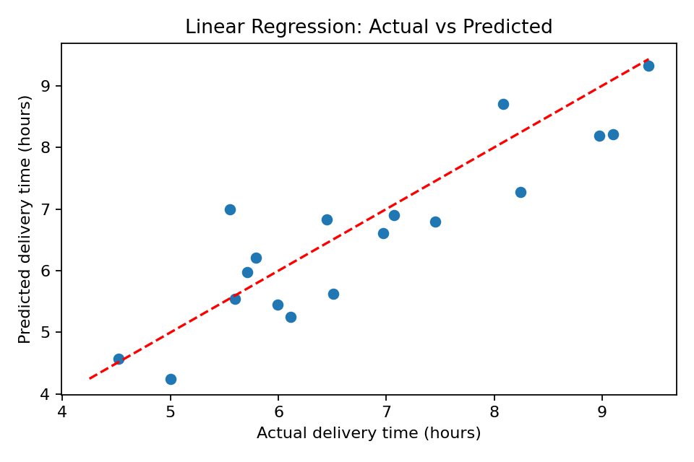
Figure 1. Actual vs predicted delivery times for the Linear Regression test set. Points nearer the dashed diagonal are more accurate.
7. Residual Analysis and Limitations
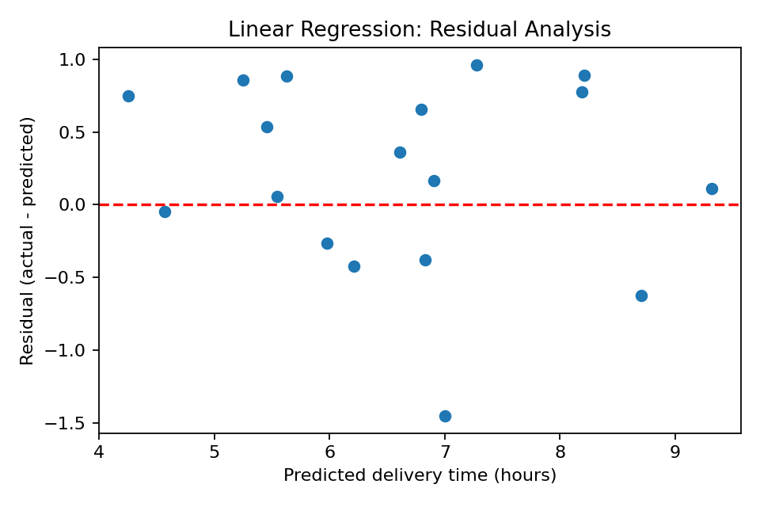
Figure 2. Residuals are actual minus predicted delivery time; positive values indicate underprediction and negative values indicate overprediction.
- Small sample: 90 hypothetical rows cannot establish stable performance across seasons, locations, traffic or weather.
- Synthetic data: learned relationships may reflect how the dataset was generated, not genuine logistics behavior.
- Missing predictors: traffic, weather, departure time, loading/unloading delays, driver availability, road restrictions and delivery priority are not represented.
- Predictors must be known before dispatch; predictions should be recalculated if planned route, distance or vehicle changes.
- Association is not causation: this model does not prove changing a route or vehicle will reduce delivery time.
- No external validation: the model has not been tested on new real shipment records.

8. Optimization Strategies Based on Model Insights

8.1 Pre-dispatch review flags
Compare each prediction with the actual customer promise or planned delivery window. Flag shipments approaching or exceeding that window for dispatcher review. The threshold must come from a real business SLA; the 6.5-hour threshold used in the script is only illustrative.

8.2 Route E investigation
Week 3 descriptive analysis reported Route E with the highest average delivery time (7.51 hours), compared with Route A (5.35 hours). This justifies investigation, not a causal conclusion. Review distance mix, departure time, loading delays, road conditions and dispatch records before changing route assignments.

8.3 Resource allocation and dispatch
- Prioritize manual review for shipments whose predicted time is close to or above the promised delivery window.
- Use volume and vehicle type to support capacity checks, after validating vehicle capacity and compatibility constraints.
- Consider staggered departures or additional capacity only if real data confirm a recurring bottleneck and the benefit exceeds added cost.

8.4 Future route optimization
This project predicts delivery time; it does not solve a mathematical route-optimization problem. A future phase could combine predictions with route distance, cost, vehicle capacity, time windows and driver constraints in an optimization solver. Compare feasible plans on total cost, on-time delivery, distance and operational constraints.

8.5 Pilot measurement plan
Action | Measure | Decision guidance
Log predictions vs actuals | MAE and RMSE on new real shipments | Reassess if errors exceed an agreed tolerance.
Monitor flagged shipments | On-time rate and number of late deliveries | Keep flags only if they improve intervention outcomes without overloading dispatchers.
Pilot schedule/route changes | On-time rate, average delivery time, cost per shipment, fuel per km | Compare with baseline or control group; do not assume improvement.
Review drift | Error by route, vehicle, distance band and month | Review features or retrain when systematic error appears.

9. Conclusion
The workflow compared a mean baseline, Linear Regression and a tuned Decision Tree using the Week 3 hypothetical dataset. Linear Regression was the best candidate on the held-out test set (MAE 0.567 hours, RMSE 0.674 hours, R² 0.774). The project includes leakage-aware feature selection, pipeline preprocessing, training-only cross-validation, tree tuning, held-out evaluation, diagnostic charts and practical recommendations. Before operational use, validate on a larger real dataset with time-aware testing and additional operational features.

