1. Introduction
Logistics operations involve managing shipments, delivery times, transportation costs, fuel consumption and route performance. Data analysis helps identify patterns, compare operational performance and recognize areas that may require improvement.
This project analyzes a hypothetical logistics dataset using Python. The dataset contains 90 shipment records and 10 columns, including route, vehicle type, shipment volume, distance, delivery time, transportation cost, fuel consumption and on-time delivery status.
The analysis uses Python libraries such as Pandas and Matplotlib, along with Seaborn for the correlation heatmap. Descriptive statistics, correlation analysis and visualizations are used to explore logistics performance and identify potential areas for further investigation.
The dataset contains simulated values created for this learning task; therefore, the findings represent the hypothetical dataset rather than the actual performance of a logistics company.

2. Objectives
- Explore and summarize the hypothetical logistics dataset.
- Check for missing values and duplicate records.
- Calculate descriptive statistics and correlations.
- Visualize delivery-time distributions and relationships among key variables.
- Compare route-wise and vehicle-wise performance.
- Identify potential operational concerns and recommend further investigation.

3. Dataset Description
This project uses a hypothetical logistics dataset containing 90 shipment records and 10 columns. The dataset was created with simulated values for educational analysis.
Column | Description
Shipment_ID | Unique identifier for each shipment
Date | Shipment date
Route | Route assigned to the shipment
Vehicle_Type | Vehicle used for transportation
Shipment_Volume | Recorded shipment volume; unit not specified
Distance_km | Shipment distance in kilometres
Delivery_Time_hours | Delivery duration in hours
Transportation_Cost_INR | Transportation cost in Indian rupees
Fuel_Consumed_L | Fuel consumed in litres
On_Time | Yes/No status generated using the assumed delivery-time threshold

The On_Time label was generated using an assumed threshold of 6.5 hours. This is a simulation rule for this project, not a verified industry standard or actual business service-level agreement.

4. Methodology
The analysis was performed in Google Colab using Python.

4.1 Tools and libraries
- Pandas: Used to load the dataset, inspect columns, calculate statistics, group records and analyze route performance.
- Matplotlib: Used to create scatter plots, bar charts, histograms and box plots.
- Seaborn: Used to generate the correlation heatmap.

4.2 Data loading and inspection
import pandas as pd
df = pd.read_csv("Week3_Hypothetical_Logistics_Dataset.csv")
print("Dataset shape:", df.shape)
print(df.head())
df.info()
The dataset shape was (90, 10), indicating 90 records and 10 columns. The head() method displayed the first five records, while info() was used to inspect column data types and non-null counts.

4.3 Data quality checks
print(df.isnull().sum())
print("Total missing values:", df.isnull().sum().sum())
print("Duplicate rows:", df.duplicated().sum())
The checks identified zero missing values and zero duplicate rows. Therefore, missing-value imputation and duplicate-row removal were not required.

5. Exploratory Data Analysis
Descriptive statistics were calculated using df.describe(). The analysis examined averages, medians, standard deviations, minimums, maximums and quartiles.
Correlation analysis was used to examine linear relationships between distance, delivery time and transportation cost. Grouping operations were also used to compare route-wise and vehicle-wise performance.

5.1 Descriptive statistics
The df.describe() method was used to calculate count, mean, standard deviation, minimum, quartiles, median and maximum for numeric columns.
Metric | Mean | Median | Minimum | Maximum
Shipment volume | 48.31 | 41.50 | 6.00 | 99.00
Distance (km) | 187.61 | 180.40 | 25.00 | 410.00
Delivery time (hours) | 6.26 | 6.425 | 1.68 | 11.30
Transportation cost (INR) | 3,042.70 | 3,079.66 | 597.86 | 5,756.50
Fuel consumed (L) | 36.11 | 36.265 | 3.31 | 74.21

The average delivery time was approximately 6.26 hours, while the maximum was 11.30 hours. Average distance was 187.61 km and average transportation cost was ₹3,042.70 per shipment. These summaries describe the simulated sample and do not represent real-world industry benchmarks.

5.2 Scatter plot: Distance vs transportation cost
Python technique: plt.scatter()
Why this visualization was selected: A scatter plot helps examine the relationship between two numerical variables and identify whether they tend to increase or decrease together.
Result: The Pearson correlation coefficient was approximately 0.982, indicating a very strong positive linear relationship between distance and transportation cost.
Interpretation: Longer-distance shipments generally had higher transportation costs in the simulated dataset. However, correlation alone does not prove causation.
plt.scatter(df["Distance_km"], df["Transportation_Cost_INR"])
plt.xlabel("Distance (km)")
plt.ylabel("Transportation Cost (INR)")
plt.title("Distance vs Transportation Cost")
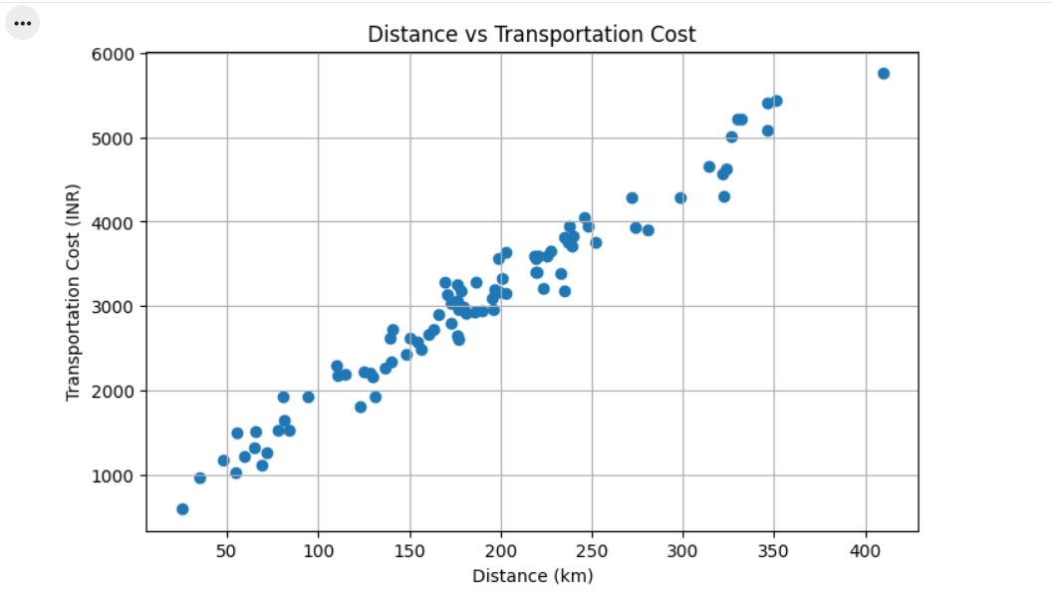
Figure 1: Distance Versus Transportation Cost.

5.3 Bar chart: Average delivery time by route
Python technique: groupby() with mean(), followed by a bar chart.
Why this visualization was selected: A bar chart makes it easy to compare average delivery times across categorical groups.
route_time = df.groupby("Route")["Delivery_Time_hours"].mean()
print(route_time)

import matplotlib.pyplot as plt
route_time = df.groupby("Route")["Delivery_Time_hours"].mean()
plt.figure(figsize=(8, 5))
route_time.plot(kind="bar")
plt.xlabel("Route")
plt.ylabel("Average Delivery Time (hours)")
plt.title("Average Delivery Time by Route")
plt.xticks(rotation=0)
plt.tight_layout()
plt.show()

Route | Average delivery time (hours)
Route A | 5.35
Route B | 6.30
Route C | 6.14
Route D | 6.26
Route E | 7.51
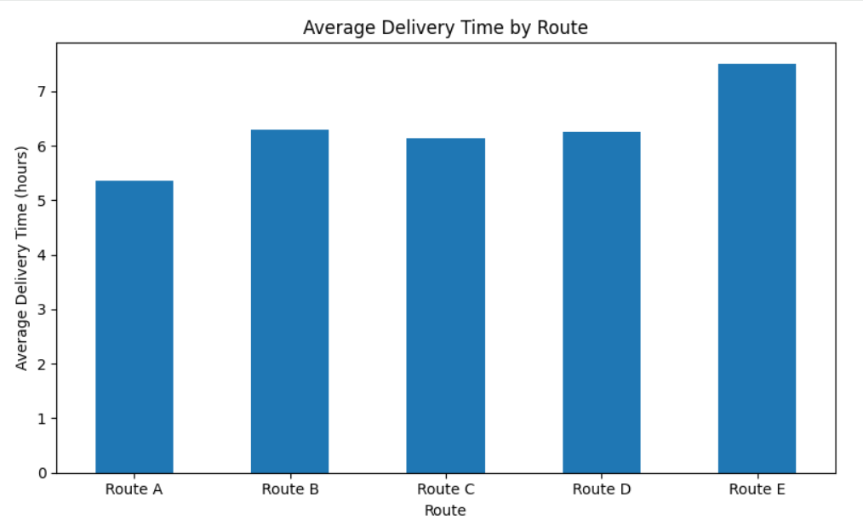
Figure 2: Average Delivery Time By Route.

Interpretation: Route E had the highest average delivery time, while Route A had the lowest. Route E should be investigated further, while considering differences in distance and other operational factors.

5.4 On-time delivery performance
Python technique: value_counts() and a bar chart.
Why this visualization was selected: A bar chart clearly compares the number of shipments in each delivery-status category.
Results: Out of 90 shipments, 46 were marked on time and 44 were marked not on time. The overall on-time delivery rate was 51.11%.
Interpretation: Approximately half of the simulated shipments met the assumed delivery-time threshold. This suggests that punctuality deserves further investigation. The classification uses a simulated threshold of 6.5 hours, not a verified industry standard.
on_time_count = (df["On_Time"] == "Yes").sum()
total_shipments = len(df)
on_time_percentage = (on_time_count / total_shipments) * 100

import matplotlib.pyplot as plt
status_counts = df["On_Time"].value_counts()
status_counts.plot(kind="bar")
plt.xlabel("Delivery Status")
plt.ylabel("Number of Shipments")
plt.title("On-Time vs Not-On-Time Shipments")
plt.xticks(rotation=0)
plt.tight_layout()
plt.show()

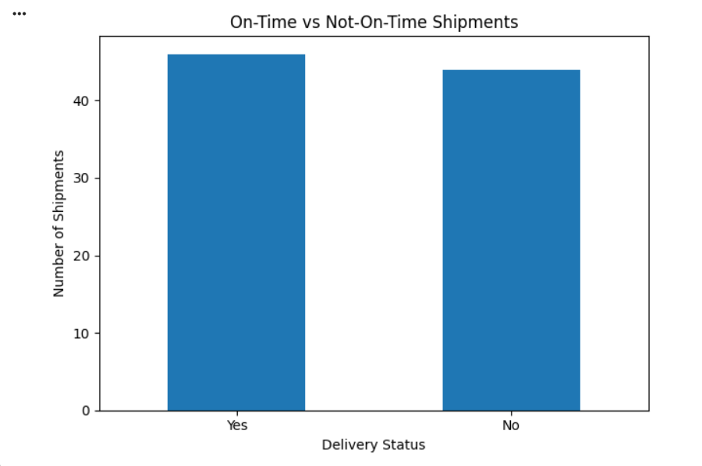
Figure 3:On-Time Versus Not-On-Time Shipments.

5.5 Histogram: Distribution of delivery times
Python technique: plt.hist() with 10 bins.
Why this visualization was selected: A histogram groups numerical values into intervals and shows how frequently observations fall within each interval.
Interpretation: Delivery times were concentrated mainly around the 5–8 hour range. Relatively few shipments took more than 9 hours. These longer delivery times may warrant investigation, but the histogram does not identify their causes.
plt.hist(df["Delivery_Time_hours"], bins=10)
plt.xlabel("Delivery Time (hours)")
plt.ylabel("Number of Shipments")
plt.title("Distribution of Delivery Times")
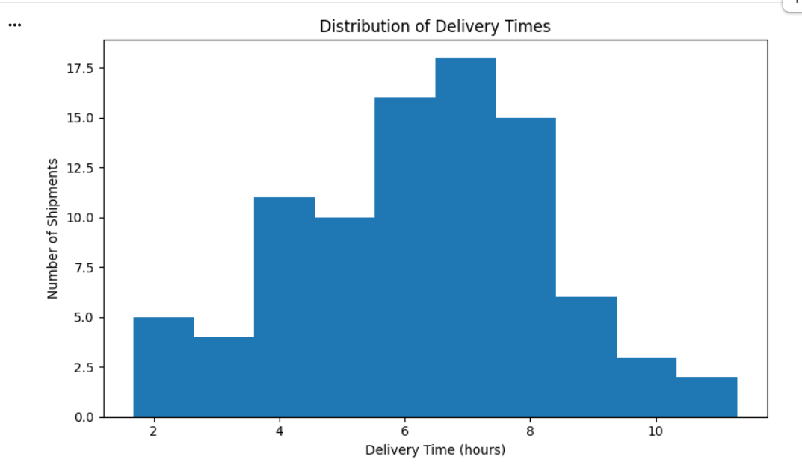
Figure 4: Distribution Of Delivery Times.

5.6 Box plot: Delivery-time spread and potential outliers
Python technique: plt.boxplot().
Why this visualization was selected: A box plot summarizes the median, quartiles, spread and potential outliers in numerical data.
Results: The median delivery time was approximately 6.43 hours and the middle 50% of deliveries fell between approximately 4.86 and 7.65 hours. No separate outlier points were visible in the plot.
Interpretation: The box plot summarizes the variation in delivery times. The absence of visible outlier points does not mean that no delayed shipments occurred.
plt.boxplot(df["Delivery_Time_hours"])
plt.ylabel("Delivery Time (hours)")
plt.title("Box Plot of Delivery Times")

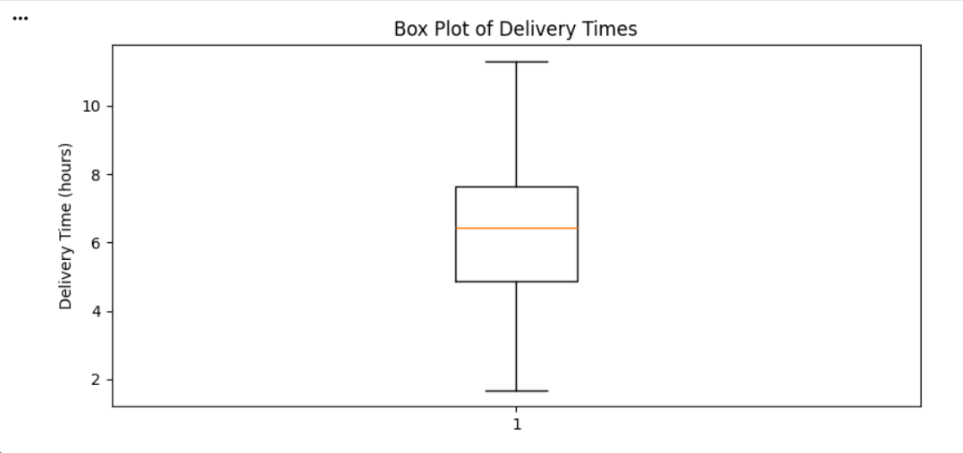

Figure 5: Distribution Of Delivery Times And Potential Outliers.

5.7 Correlation analysis and heatmap
Correlation coefficients were calculated to examine linear relationships among numeric variables. The heatmap summarizes these relationships in one chart. Distance and transportation cost had a correlation of 0.982; distance and delivery time had a correlation of 0.895; distance and fuel consumption had a correlation of about 0.96; and delivery time and transportation cost had a correlation of about 0.90. Shipment volume and distance had a correlation close to 0.01. These are associations, not proof of causation.
numeric_columns = [
"Shipment_Volume", "Distance_km", "Delivery_Time_hours",
"Transportation_Cost_INR", "Fuel_Consumed_L"
]
correlation_matrix = df[numeric_columns].corr()
sns.heatmap(correlation_matrix, annot=True, cmap="coolwarm",
vmin=-1, vmax=1, fmt=".2f")
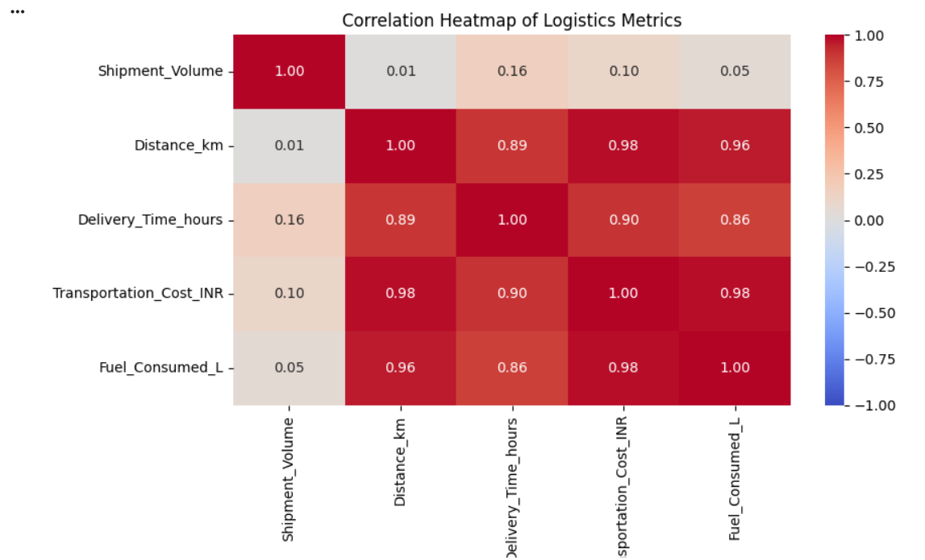
Figure 6: Correlation Heatmap Of Numerical Logistics Variables.

5.8 Implied average speed by route
Shipment-level implied speed was calculated as distance divided by delivery time and then averaged by route. Route D had the highest average implied speed at 31.33 km/h and Route C had the lowest at 25.44 km/h. Route E averaged 26.85 km/h. This is not necessarily actual driving speed because delivery time may include waiting, loading, unloading or other activities.
df["Average_Speed_kmh"] = df["Distance_km"] / df["Delivery_Time_hours"]
route_speed = df.groupby("Route")["Average_Speed_kmh"].mean()
print(route_speed.round(2))
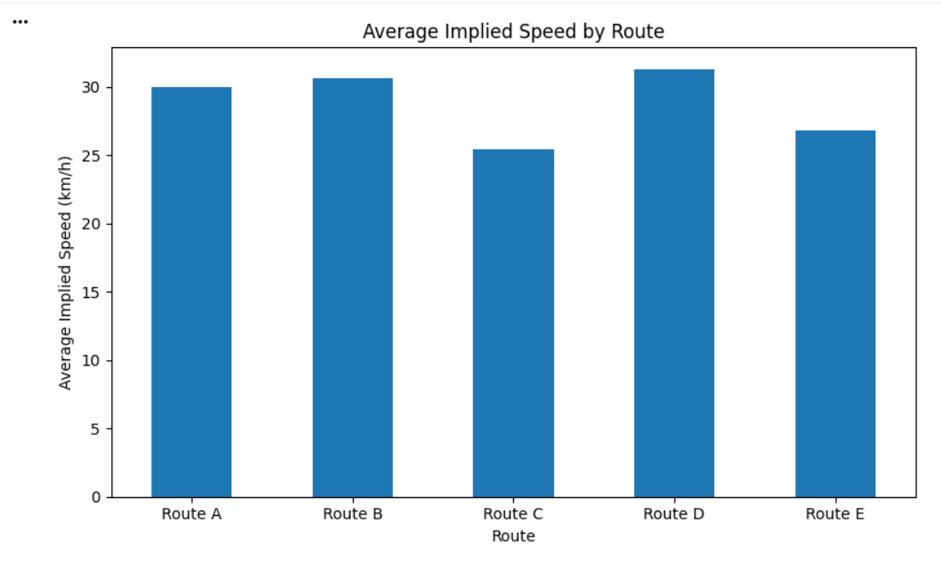
Figure 7: Average Implied Speed By Route.

6. Route-Wise and Vehicle-Wise Performance

6.1 Route-wise comparison
Route | Avg. time (h) | On-time rate | Cost/km (INR) | Fuel/km (L) | Avg. cost/shipment (INR)
Route A | 5.35 | 55.00% | 16.22 | 0.19 | 2730.03
Route B | 6.30 | 57.89% | 15.97 | 0.20 | 3131.94
Route C | 6.14 | 53.85% | 16.81 | 0.19 | 2660.20
Route D | 6.26 | 56.52% | 16.34 | 0.19 | 3265.31
Route E | 7.51 | 26.67% | 15.95 | 0.19 | 3336.74

The route-wise analysis compared average delivery time, on-time delivery rate, cost per kilometre and fuel consumption per kilometre.
Route A recorded the lowest average delivery time at 5.35 hours. Route B achieved the highest on-time delivery rate at 57.89% and a cost per kilometre of ₹15.97. Route E recorded the highest average delivery time at 7.51 hours and the lowest on-time delivery rate at 26.67%.
Although Route E had the lowest cost per kilometre at ₹15.95, its delivery punctuality was comparatively poor. Therefore, Route E should be prioritized for further investigation into possible delivery delays rather than automatically classified as inefficient.

6.2 Vehicle-wise comparison
Vehicle type | Shipments | Avg. distance (km) | Avg. time (h) | Avg. cost (INR) | On-time rate
Mini Truck | 22 | 193.86 | 6.47 | 3,208.01 | 45.45%
Truck | 32 | 185.64 | 6.20 | 2,856.62 | 43.75%
Van | 36 | 185.54 | 6.18 | 3,107.09 | 61.11%

The vehicle-wise analysis produced the following results:
- Vans: 61.11% on-time delivery rate and 6.18 hours average delivery time.
- Mini Trucks: 45.45% on-time delivery rate and 6.47 hours average delivery time.
- Trucks: 43.75% on-time delivery rate and 6.20 hours average delivery time.
Vans recorded the highest on-time delivery rate across the dataset. However, the vehicle types may have operated on different routes and distances. Consequently, these results show an association rather than proving that a particular vehicle type causes better delivery performance.

6.3 Route E vehicle-wise investigation
Vehicle type | Shipments | Avg. distance (km) | Avg. time (h) | On-time rate
Mini Truck | 5 | 223.26 | 7.86 | 20.00%
Truck | 7 | 185.90 | 7.01 | 28.57%
Van | 3 | 240.27 | 8.11 | 33.33%

Route E had a low on-time delivery rate across all three vehicle types. Mini Trucks had the lowest on-time rate (20.00%), while Vans had the highest (33.33%). However, the number of shipments is small for each vehicle type and their average distances differ. Therefore, we cannot conclude that the vehicle type alone caused the delays.
6.4 Potential Operational Bottlenecks
Route E is a priority for further investigation because its on-time delivery rate was 26.67%, compared with the overall rate of 51.11%. All three vehicle types also showed relatively low on-time rates on Route E.
The available dataset does not contain traffic conditions, waiting times, loading delays, or detailed route conditions. Therefore, these factors cannot be identified as confirmed causes. Collecting such information would support a more detailed root-cause analysis.

7. Recommendations
Based on the analysis, the following recommendations are proposed:
- Investigate Route E: Review route conditions, waiting times, loading and unloading processes and delivery schedules to understand its low on-time delivery rate.
- Monitor delivery punctuality: Track on-time delivery rate regularly and compare it with an agreed operational target.
- Compare similar shipments: Compare routes and vehicles using similar distances and operating conditions before making efficiency decisions.
- Monitor transportation costs: Use cost per kilometre alongside cost per shipment to avoid misleading comparisons between routes of different lengths.
- Track fuel efficiency: Compare fuel consumption per kilometre while accounting for vehicle type and operating conditions.
- Improve future data collection: Include traffic conditions, waiting time, loading time, failed deliveries and actual delivery targets in future datasets.
These recommendations should be validated against real operational data before implementation.

8. Limitations
This project uses a hypothetical dataset containing 90 simulated shipment records. The findings therefore demonstrate analytical techniques rather than actual company performance.
The on-time delivery status was generated using an assumed 6.5-hour threshold. This threshold is a simulation rule, not a verified industry standard.
The dataset does not include traffic conditions, waiting time, loading and unloading duration or other information that could explain delivery delays. Furthermore, correlation identifies relationships between variables but does not establish causation.
Additional real-world data and agreed performance targets would be needed to confirm the causes of delays and determine which routes are genuinely more efficient.

9. Conclusion
This project applied Python-based exploratory data analysis and visualization to a hypothetical logistics dataset containing 90 shipment records. Descriptive statistics, correlation analysis, histograms, box plots, scatter plots, bar charts and a correlation heatmap were used to examine delivery times, transportation costs, fuel consumption and route performance.
The analysis identified a strong positive correlation between distance and transportation cost (0.982), as well as between distance and delivery time (0.895). Route A recorded the lowest average delivery time at 5.35 hours, while Route B achieved the highest on-time delivery rate at 57.89%. Route E had the lowest on-time rate at 26.67% and the highest average delivery time at 7.51 hours, making it a priority for further investigation.
Overall, the project demonstrates how data analysis and visualization can support evidence-based logistics decisions. The findings should be treated as preliminary because the data is simulated and further operational information is required to confirm the causes of performance differences.

Appendix A: Example Python code used
# Descriptive statistics
print(df.describe())
# Correlation between distance and cost
print(df["Distance_km"].corr(df["Transportation_Cost_INR"]))
# Route-wise average delivery time
route_time = df.groupby("Route")["Delivery_Time_hours"].mean()
print(route_time)
# On-time delivery rate
on_time_count = (df["On_Time"] == "Yes").sum()
print((on_time_count / len(df)) * 100)
# Correlation heatmap
import seaborn as sns
import matplotlib.pyplot as plt
corr = df[["Shipment_Volume", "Distance_km", "Delivery_Time_hours",
"Transportation_Cost_INR", "Fuel_Consumed_L"]].corr()
sns.heatmap(corr, annot=True, cmap="coolwarm", vmin=-1, vmax=1, fmt=".2f")
plt.show()

Appendix B: Complete Python analysis and visualization snippets
The following snippets reproduce the main calculations and charts used in this report. Run them after loading the dataset into a pandas DataFrame named df.
import pandas as pd
import matplotlib.pyplot as plt
import seaborn as sns
# Load and inspect the dataset
df = pd.read_csv("Week3_Hypothetical_Logistics_Dataset.csv")
df["Date"] = pd.to_datetime(df["Date"], errors="coerce")
print(df.shape)
print(df.info())
print(df.isnull().sum())
print("Duplicate rows:", df.duplicated().sum())
print(df.describe())
# On-time delivery rate (simulation uses a 6.5-hour threshold)
on_time_count = (df["On_Time"] == "Yes").sum()
total_shipments = len(df)
print("On-time shipments:", on_time_count)
print("Not-on-time shipments:", total_shipments - on_time_count)
print("On-time rate (%):", round(on_time_count / total_shipments * 100, 2))
# Distance versus transportation cost
plt.figure(figsize=(7, 5))
sns.scatterplot(data=df, x="Distance_km", y="Transportation_Cost_INR")
plt.title("Distance vs Transportation Cost")
plt.tight_layout()
plt.show()
print("Distance-cost correlation:",
round(df["Distance_km"].corr(df["Transportation_Cost_INR"]), 3))
# Average delivery time by route
route_time = df.groupby("Route")["Delivery_Time_hours"].mean().sort_index()
route_time.plot(kind="bar", title="Average Delivery Time by Route",
ylabel="Average delivery time (hours)", xlabel="Route")
plt.tight_layout()
plt.show()
# On-time versus not-on-time chart
df["Delivery_Status"] = df["On_Time"].map({"Yes": "On time", "No": "Not on time"})
df["Delivery_Status"].value_counts().reindex(["On time", "Not on time"]).plot(
kind="bar", title="On-Time vs Not-On-Time Shipments",
ylabel="Number of shipments", xlabel="Delivery status")
plt.tight_layout()
plt.show()
# Delivery-time distribution and box plot
plt.figure(figsize=(7, 5))
plt.hist(df["Delivery_Time_hours"], bins=10, edgecolor="black")
plt.title("Distribution of Delivery Times")
plt.xlabel("Delivery time (hours)")
plt.ylabel("Number of shipments")
plt.tight_layout()
plt.show()
plt.figure(figsize=(5, 5))
plt.boxplot(df["Delivery_Time_hours"])
plt.title("Box Plot of Delivery Times")
plt.ylabel("Delivery time (hours)")
plt.tight_layout()
plt.show()
# Correlation heatmap
numeric_columns = ["Shipment_Volume", "Distance_km", "Delivery_Time_hours",
"Transportation_Cost_INR", "Fuel_Consumed_L"]
correlation_matrix = df[numeric_columns].corr()
plt.figure(figsize=(8, 6))
sns.heatmap(correlation_matrix, annot=True, cmap="coolwarm", fmt=".2f")
plt.title("Correlation Heatmap of Logistics Metrics")
plt.tight_layout()
plt.show()
# Route-wise cost and implied speed
df["Cost_per_km_INR"] = df["Transportation_Cost_INR"] / df["Distance_km"]
df["Fuel_per_km_L"] = df["Fuel_Consumed_L"] / df["Distance_km"]
df["Average_Speed_kmh"] = df["Distance_km"] / df["Delivery_Time_hours"]
df["Average_Cost_per_Shipment_INR"] = df["Transportation_Cost_INR"]
route_summary = df.groupby("Route").agg(
Total_Shipments=("Shipment_ID", "count"),
Average_Delivery_Time_h=("Delivery_Time_hours", "mean"),
Average_Cost_per_Shipment_INR=("Average_Cost_per_Shipment_INR", "mean"),
Cost_per_km_INR=("Cost_per_km_INR", "mean"),
Fuel_per_km_L=("Fuel_per_km_L", "mean"),
On_Time_Rate=("On_Time", lambda x: (x == "Yes").mean() * 100),
Average_Implied_Speed_kmh=("Average_Speed_kmh", "mean")
).round(2)
print(route_summary)
route_speed = df.groupby("Route")["Average_Speed_kmh"].mean().sort_index()
route_speed.plot(kind="bar", title="Average Implied Speed by Route",
ylabel="Average implied speed (km/h)", xlabel="Route")
plt.tight_layout()
plt.show()
# Vehicle-wise comparison
vehicle_summary = df.groupby("Vehicle_Type").agg(
Shipments=("Shipment_ID", "count"),
Average_Distance_km=("Distance_km", "mean"),
Average_Delivery_Time_h=("Delivery_Time_hours", "mean"),
Average_Cost_INR=("Transportation_Cost_INR", "mean"),
On_Time_Rate=("On_Time", lambda x: (x == "Yes").mean() * 100)
).round(2)
print(vehicle_summary)
Reporting note: This is a hypothetical dataset. The On_Time label was generated using an assumed 6.5-hour delivery threshold for demonstration, it is not a verified company service-level agreement. Implied speed is distance divided by total delivery time and is not necessarily actual driving speed.

