Software Architecture Document
(SAD) – Version 2.2
Budget Analysis — personal and group budgeting for students, on the web, iPhone and Android
Item | Value
Product | Budget Analysis (formerly BudgetBuddy)
Document | Software Architecture Document, 4+1 view model
Version | 2.2 — as-built architecture
Date | 31 October 2026
Status | Current. Describes the system as it runs after roadmap phases 0–6, the admin dashboard and the extra features F1–F13
Author and owner | Mouhammed Altaweel
Repository | github.com/M-ALTAWEEL/budget-analysis
Production | budgetanalysis.vercel.app (website) · budgetbuddy-api on Render (API)

Revision History
Version | Date | Author | Description
1.0 | 18 Oct 2026 | M. Altaweel | Design baseline for BudgetBuddy: single-user web application, Anthropic Claude API for advice and chat, Railway hosting.
2.0 | 27 Oct 2026 | M. Altaweel | Complete rewrite to the as-built system. Renamed to Budget Analysis. Added: staging and production environments, rebuilt accounts (sessions, 2FA, phone, Google, data rights), groups, budget month start day and Start fresh, performance and security work, iPhone/Android app (Expo), app lock and push notifications. Replaced the external LLM with in-house ML models and hosting with Vercel, Render and Neon.
2.1 | 28 Oct 2026 | M. Altaweel, R. Arslan | Admin dashboard (website only): platform admins granted from the command line, audit log, user support actions. Currencies moved from code into a table managed by admins. A currency the rates provider stops quoting no longer stops the others.
2.2 | 31 Oct 2026 | M. Altaweel | Extra features F1–F13: recurring expenses, personal debts, income, month report, PDF and Excel reports, savings challenges, household budget, inflation view, voice and receipt entry, offline adding. A daily job (GitHub Actions) for recurring expenses, reminders and the month-report notification.

Module ownership
Module | Location | Owner
API (FastAPI) | backend/ | M. Altaweel
Website (Next.js) | frontend/ | M. Altaweel
Mobile app (Expo) | mobile/ | M. Altaweel
Machine learning | ml/ and backend/app/ml/ | M. Altaweel
Admin dashboard and currencies | backend/app/domain/admin/, frontend/src/app/admin/ | R. Arslan
Load testing | loadtest/ | M. Altaweel
Documentation | docs/ | M. Altaweel

Contents

1. Introduction

1.1 Purpose
This document describes the architecture of Budget Analysis as it is built and deployed today. It is the reference for anyone who changes the system: which parts exist, how they talk to each other, where each rule lives, and why the main decisions were taken. It follows the 4+1 view model, adds a security view, and ends with a traceability matrix from requirements to code and tests.
The detailed product rules (limits, thresholds, rounding, permissions) are kept in a companion document, docs/BUSINESS_LOGIC.md, so this SAD stays focused on structure. Where the two overlap, the business-logic document is authoritative for the rule and this document for where it is implemented.

1.2 Scope
In scope: the API, the website, the iPhone/Android app, the machine-learning models that run inside the API, the database schema, the environments (local, staging, production), the CI pipeline and the release process.
Out of scope (planned): subscriptions and payments (roadmap phase 7), activation of paid services such as a custom domain, production email/SMS providers and Sign in with Apple (phase 8), and store releases. They are listed in section 9 as open items.

1.3 Definitions and abbreviations
Term | Meaning
Budget month | The user's spending period. Starts on the user's start day (1–28), e.g. 10 Oct – 9 Nov, and is named after the calendar month it starts in.
Start fresh | A date before which months are hidden (not deleted) from every screen and comparison.
Base currency | The currency a budget is kept in. Each expense is converted to it once, at the rate of the day (rate snapshot).
Share copy | A member's share of a group expense, copied into their personal expenses automatically or after confirmation.
Tank | The visual indicator of what is left of the month's budget.
Access / refresh token | Short-lived JWT (15 min) and long-lived rotating session token (stored hashed).
EAS | Expo Application Services: cloud builds and credential storage for the mobile app.
ASVS | OWASP Application Security Verification Standard; the target is Level 2.
p95 | 95th percentile response time.

The full glossary is in BUSINESS_LOGIC.md, section 2.

1.4 System overview
Budget Analysis helps students plan a monthly allowance, record spending in several currencies, see early warnings, save toward goals and share expenses with friends. One FastAPI service serves two clients, a Next.js website and an Expo (React Native) app for iPhone and Android, from a single PostgreSQL database. All intelligence (category suggestion, forecasts, tips and the question-answering assistant) runs inside the API with small in-house models and rules; no user data is sent to an external AI service.
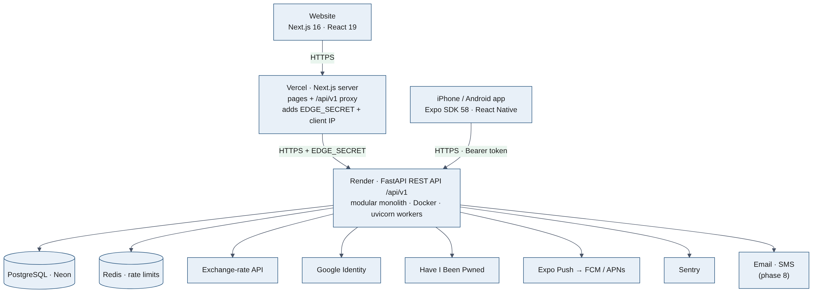
Figure 1. System context and runtime overview
The website is served by Vercel. Its server forwards /api/v1/* to the API (same-origin for the browser, so the session cookie is first-party), adding the visitor IP signed with EDGE_SECRET. The mobile app calls the API directly and keeps its refresh token in the iOS Keychain or Android Keystore.

1.5 Architectural representation
View | Audience | Question answered | Section
Use case view (+1) | Product, testers | What can each actor do? | 2
Logical view | Developers | Which layers, domains and data exist? | 3
Process view | Developers, operations | What happens at runtime, in which order, concurrently? | 4
Development view | Developers | How is the code organised, built and tested? | 5
Deployment view | Operations | Where does it run and how is it configured? | 6
Security view (added) | Everyone | How are accounts, data and secrets protected? | 7

1.6 Technical platform
Layer | Technology | Notes
API | Python 3.12, FastAPI, Uvicorn workers, Pydantic v2, pydantic-settings | Async throughout; versioned under /api/v1
Data access | SQLAlchemy 2 (async) with asyncpg, Alembic migrations | 18 migrations, each with a downgrade
Database | PostgreSQL 16 (Neon in staging and production, Docker locally) | Separate Neon branches per environment
Cache / limits | Redis (optional), in-process memory otherwise | Rate limits shared across workers when Redis is set
Security libraries | PyJWT, bcrypt, cryptography (Fernet), slowapi, phonenumbers, segno (QR) | TOTP keys encrypted at rest
Website | Next.js 16 (App Router), React 19, TypeScript 5, Tailwind CSS 4, TanStack Query 5, axios, Motion, sonner, lucide | Three languages, RTL for Arabic, dark mode
Mobile | Expo SDK 58, React Native 0.88, Expo Router, Reanimated 4, react-native-svg, expo-secure-store, expo-local-authentication, expo-notifications | Development builds via EAS; Android emulator tested
Machine learning | Models written from scratch in pure Python (softmax regression on character n-grams, TF-IDF); trained by ml/train_*.py and stored as JSON | scikit-learn used only in notebooks to cross-check
Observability | Structured JSON logs, request IDs, Server-Timing, Sentry | No personal data in logs
CI / quality | GitHub Actions, ruff, pytest (350+ tests), ESLint, tsc, CodeQL, Dependabot, pip-audit, npm audit, k6 | Mobile job checks shared-code drift
Hosting | Vercel (website), Render Frankfurt, Docker (API), Neon (database), Expo EAS (builds, push) | Free plans until activation

1.7 Data, transactions and persistence
- PostgreSQL is the only system of record. Every request runs in one database session; a service method commits once at the end, so a request either fully succeeds or leaves nothing behind.
- Money is stored as NUMERIC(12,2) and handled with Python Decimal, rounded half-up to 2 decimals. Exchange rates are stored with 8 decimals. Floats are never used for money.
- Every expense stores the original amount and currency, the converted amount_base and the fx_rate used, so history never changes when rates move.
- Public identifiers are UUIDs; integer primary keys never leave the API.
- Secrets are never stored in plain text: passwords (bcrypt), refresh tokens, one-time tokens, invite tokens and backup codes (SHA-256 hashes), TOTP keys (Fernet encryption).
- Schema changes go through Alembic, run on staging first, and production gets a Neon backup branch before each migration (docs/RECOVERY.md).

1.8 Quality attributes
Attribute | Target | How it is achieved | Evidence
Performance | p95 < 300 ms, errors < 1% | Async I/O, multiple workers, sized pool, per-process FX cache, query instrumentation | loadtest/REPORT.md: p95 75 ms at 390 req/s
Security | OWASP ASVS L2 | See section 7 | docs/security/ASVS.md; ZAP: zero high/medium
Correctness of money | Splits and conversions exact to the cent | Decimal, largest-remainder splitting, rate snapshots | test_group_split.py, test_money_dates.py
Privacy | A group never sees personal data | Separate group tables; share copies owned by the member | test_groups.py, test_pentest.py
Availability | Detect outages within 15 min | Health endpoints, uptime workflow every 14 min, Sentry | .github/workflows/keep-awake.yml
Maintainability | One rule, one place | Layered domains; shared client code synced to mobile with a CI drift check | mobile/scripts/sync-shared.mjs --check
Portability of clients | Old app versions keep working | Versioned API and additive changes only | docs/API_VERSIONING.md
Usability | Three languages, RTL, dark mode, parity web/mobile | Shared message catalogues | frontend/src/i18n

1.9 Key architectural decisions
# | Decision | Reason | Consequence
AD-1 | Modular monolith: one FastAPI service, domains as packages | One developer; simple deployment; transactions across domains (group share → personal expense) | Domains must not import each other's repositories; they call services
AD-2 | One API for web and mobile under /api/v1 | Same rules everywhere; mobile versions live for years | Only additive changes; breaking changes need /api/v2
AD-3 | Website proxies the API through Vercel | First-party httpOnly cookie, no CORS for the browser, trusted client IP | EDGE_SECRET shared between Vercel and Render
AD-4 | Native app sends tokens in the body, stores them in Keychain/Keystore | Cookies are unreliable in native HTTP clients | Login returns tokens in the body only for X-Client ios/android without an Origin header
AD-5 | In-house ML instead of an external LLM (changed from v1.0) | Cost, latency, privacy and explainability; answers come only from the database | Assistant answers a defined set of questions; numbers are never invented
AD-6 | Budget month as a server concept (start day 1–28) | Allowances are paid on a fixed day; all screens and insights must agree | BudgetCalendar in app/core/dates.py; clients mirror it in lib/month.ts
AD-7 | Start fresh hides, never deletes | Reversible; history stays exportable | Every query filters by the visible range
AD-8 | Pairwise group balances (no debt simplification) | Easier to understand and audit | May be revisited if users ask
AD-9 | Paid services have free stand-ins (console email/SMS/push) | Build and test everything before paying | Production refuses to start with console email or SMS
AD-10 | Shared client code is copied, not packaged | No monorepo tooling; Metro and Next stay simple | A sync script and CI check prevent drift
AD-11 | Scheduled work as one idempotent daily endpoint called by GitHub Actions | No worker to host or pay for on the free plan | Runs once a day; each step remembers what it already did
AD-12 | Receipt reading on our own server (Tesseract), not a cloud vision API | Receipts stay private; no per-image cost | Less accurate on crumpled photos; the person always checks the form
AD-13 | PDF reports drawn by ReportLab with our own Arabic shaping | No browser engine on the server | Single-line texts only; DejaVu Sans bundled with its licence

1.10 Changes since version 1.0
Area | Version 1.0 (design) | Version 2.0 (as built)
Name | BudgetBuddy | Budget Analysis
Clients | Website only | Website, iPhone and Android app with feature parity
AI | Anthropic Claude API for advice and chat | In-house models: categorizer, intent classifier, forecast and rule-based tips
Hosting | Railway | Vercel, Render (Frankfurt, Docker), Neon, Expo EAS
Environments | One | Local, staging and production with separate databases and secrets
Accounts | Email/password, cookie JWT | Email, Google and phone; DB sessions and devices; 2FA; breached-password check; export and deletion; security log
Social | None | Groups: invites, splits, share copies, balances, settlements, chat, push
Budget month | Calendar month | Start day 1–28 and Start fresh
Quality | Planned | Load-tested (k6) and security-audited (ASVS L2, ZAP)

2. Use Case View

2.1 Actors
Actor | Description
Guest | Not signed in. Can register, sign in, reset a password and open an invitation link.
Student | A signed-in user managing a personal budget. The main actor.
Group member | A student who belongs to a group. Sees the group's expenses and balances only.
Group admin / owner | Manages members, invitations, roles and group settings. The owner can hand over ownership.
Push service (Expo / FCM / APNs) | External system that delivers notifications to phones.
Email and SMS providers | External systems for verification, reset and security notices (console stand-ins until activation).
Platform admin | A member of the team, made admin only from the command line. Uses the website dashboard with 2FA on; sees account details, never money.
Google | Identity provider for Sign in with Google.

2.2 Use case catalogue
ID | Use case | Actor | API | Web / app screen
UC-01 | Register and verify email | Guest | POST /auth/register, /auth/verify-email | (auth)/register · verify-email
UC-02 | Sign in (password, Google, phone) with optional 2FA | Guest | POST /auth/login, /auth/google, /auth/phone/*, /auth/2fa/verify | (auth)/login
UC-03 | Stay signed in, manage devices, sign out | Student | POST /auth/refresh, /auth/logout; GET/DELETE /me/sessions | Settings › Security
UC-04 | Reset or change password, change email | Guest / Student | POST /auth/password/*, /auth/email/* | reset-password · Settings
UC-05 | Turn on two-factor authentication | Student | POST /me/2fa/setup, /me/2fa/enable | Settings › Security
UC-06 | Set profile: currency, language, username, month start day, Start fresh | Student | PATCH /users/me | Settings
UC-07 | Plan the month's budget and category limits | Student | PUT /budgets/{month}, /budgets/{month}/allocations | Budget
UC-08 | Record an expense with a suggested category | Student | GET /expenses/category-suggestion; POST /expenses | Expense sheet (+ button)
UC-09 | Edit or delete an expense, change its currency | Student | PATCH/DELETE /expenses/{id} | Expenses
UC-10 | View overview: tank, alerts, forecast, comparison | Student | GET /budgets/{month}, /daily | Overview
UC-11 | Get saving tips | Student | GET /budgets/{month}/tips | Overview / Budget
UC-12 | Ask the assistant a question | Student | POST /assistant/ask | Assistant
UC-13 | Manage savings goals and contributions | Student | /goals, /goals/{id}/contributions | Goals
UC-14 | Manage custom categories | Student | /categories | Categories
UC-15 | Export data or delete the account | Student | GET /me/export; DELETE /me | Settings › Privacy
UC-16 | Create and configure a group | Student | POST /groups; PATCH /groups/{id} | Groups
UC-17 | Invite by link/QR or by username; accept | Admin / Guest / Student | /groups/{id}/invites, /invites/{token}/accept, /groups/{id}/requests, /me/group-requests | Group › Members · join
UC-18 | Add a group expense and split it | Group member | POST/PUT/DELETE /groups/{id}/expenses | Group › Expenses
UC-19 | Receive a share in the personal budget | Group member | /me/group-shares, PUT /groups/{id}/auto-add | Overview banner · Group
UC-20 | See balances, mark 'I paid my share', settle up | Group member | GET /groups/{id}/balances; POST /settlements | Group › Balances
UC-21 | Group chat and activity | Group member | GET /groups/{id}/activity | Group › Chat
UC-22 | Manage members and roles, leave the group | Admin / owner / member | PUT .../role; DELETE .../members/{id} | Group › Members
UC-23 | Lock the app with biometrics | Student (mobile) | — (device only) | Settings › App lock
UC-24 | Receive push notifications for group activity | Group member, Push service | POST /me/push-devices, /remove | Settings › Notifications
UC-25 | Support a user: search, view account, disable/enable, sign out everywhere, resend confirmation | Platform admin | /admin/users, /admin/users/{id}/* | Website /admin/users
UC-26 | Manage currencies: add, hide, show | Platform admin | /admin/currencies; GET /currency/list | Website /admin/currencies
UC-27 | See product statistics, system status and the audit log | Platform admin | /admin/stats, /admin/system, /admin/audit | Website /admin
UC-28 | Set up recurring expenses and subscriptions (F1) | Student, daily job | /recurring; POST /internal/daily | Expenses › Recurring
UC-29 | Track money lent and borrowed, paid back in parts (F2) | Student | /debts, /debts/{id}/payments, /settle | Groups › Debts
UC-30 | Record income and see what is left (F3) | Student | /incomes/{month}, /incomes, /copy-previous | Budget › Income
UC-31 | See the month report and share it (F4) | Student, push service | GET /reports/{month}/wrapped | Budget › Month report
UC-32 | Download a month or year as PDF or Excel (F5) | Student | GET /reports/{month}/file, /reports/year/{year}/file | Month report › Download
UC-33 | Run savings challenges, alone or with a group (F6) | Student, group member | /challenges, /challenges/{id}/join | Goals › Challenges
UC-34 | Plan a household budget for a group (F7) | Group admin, member | /groups/{id}/budget/{month} | Group › Household budget
UC-35 | See spending in a steady currency and rising prices (F8) | Student | GET /insights/inflation | Budget › Inflation
UC-36 | Add an expense by voice or one sentence (F9) | Student | POST /expenses/quick | Expense sheet
UC-37 | Scan a receipt (F10) | Student | POST /expenses/receipt | Expense sheet › camera
UC-38 | Add expenses offline (F13) | Student | POST /expenses (client_id) | Expense sheet, overview

2.3 Use case diagram
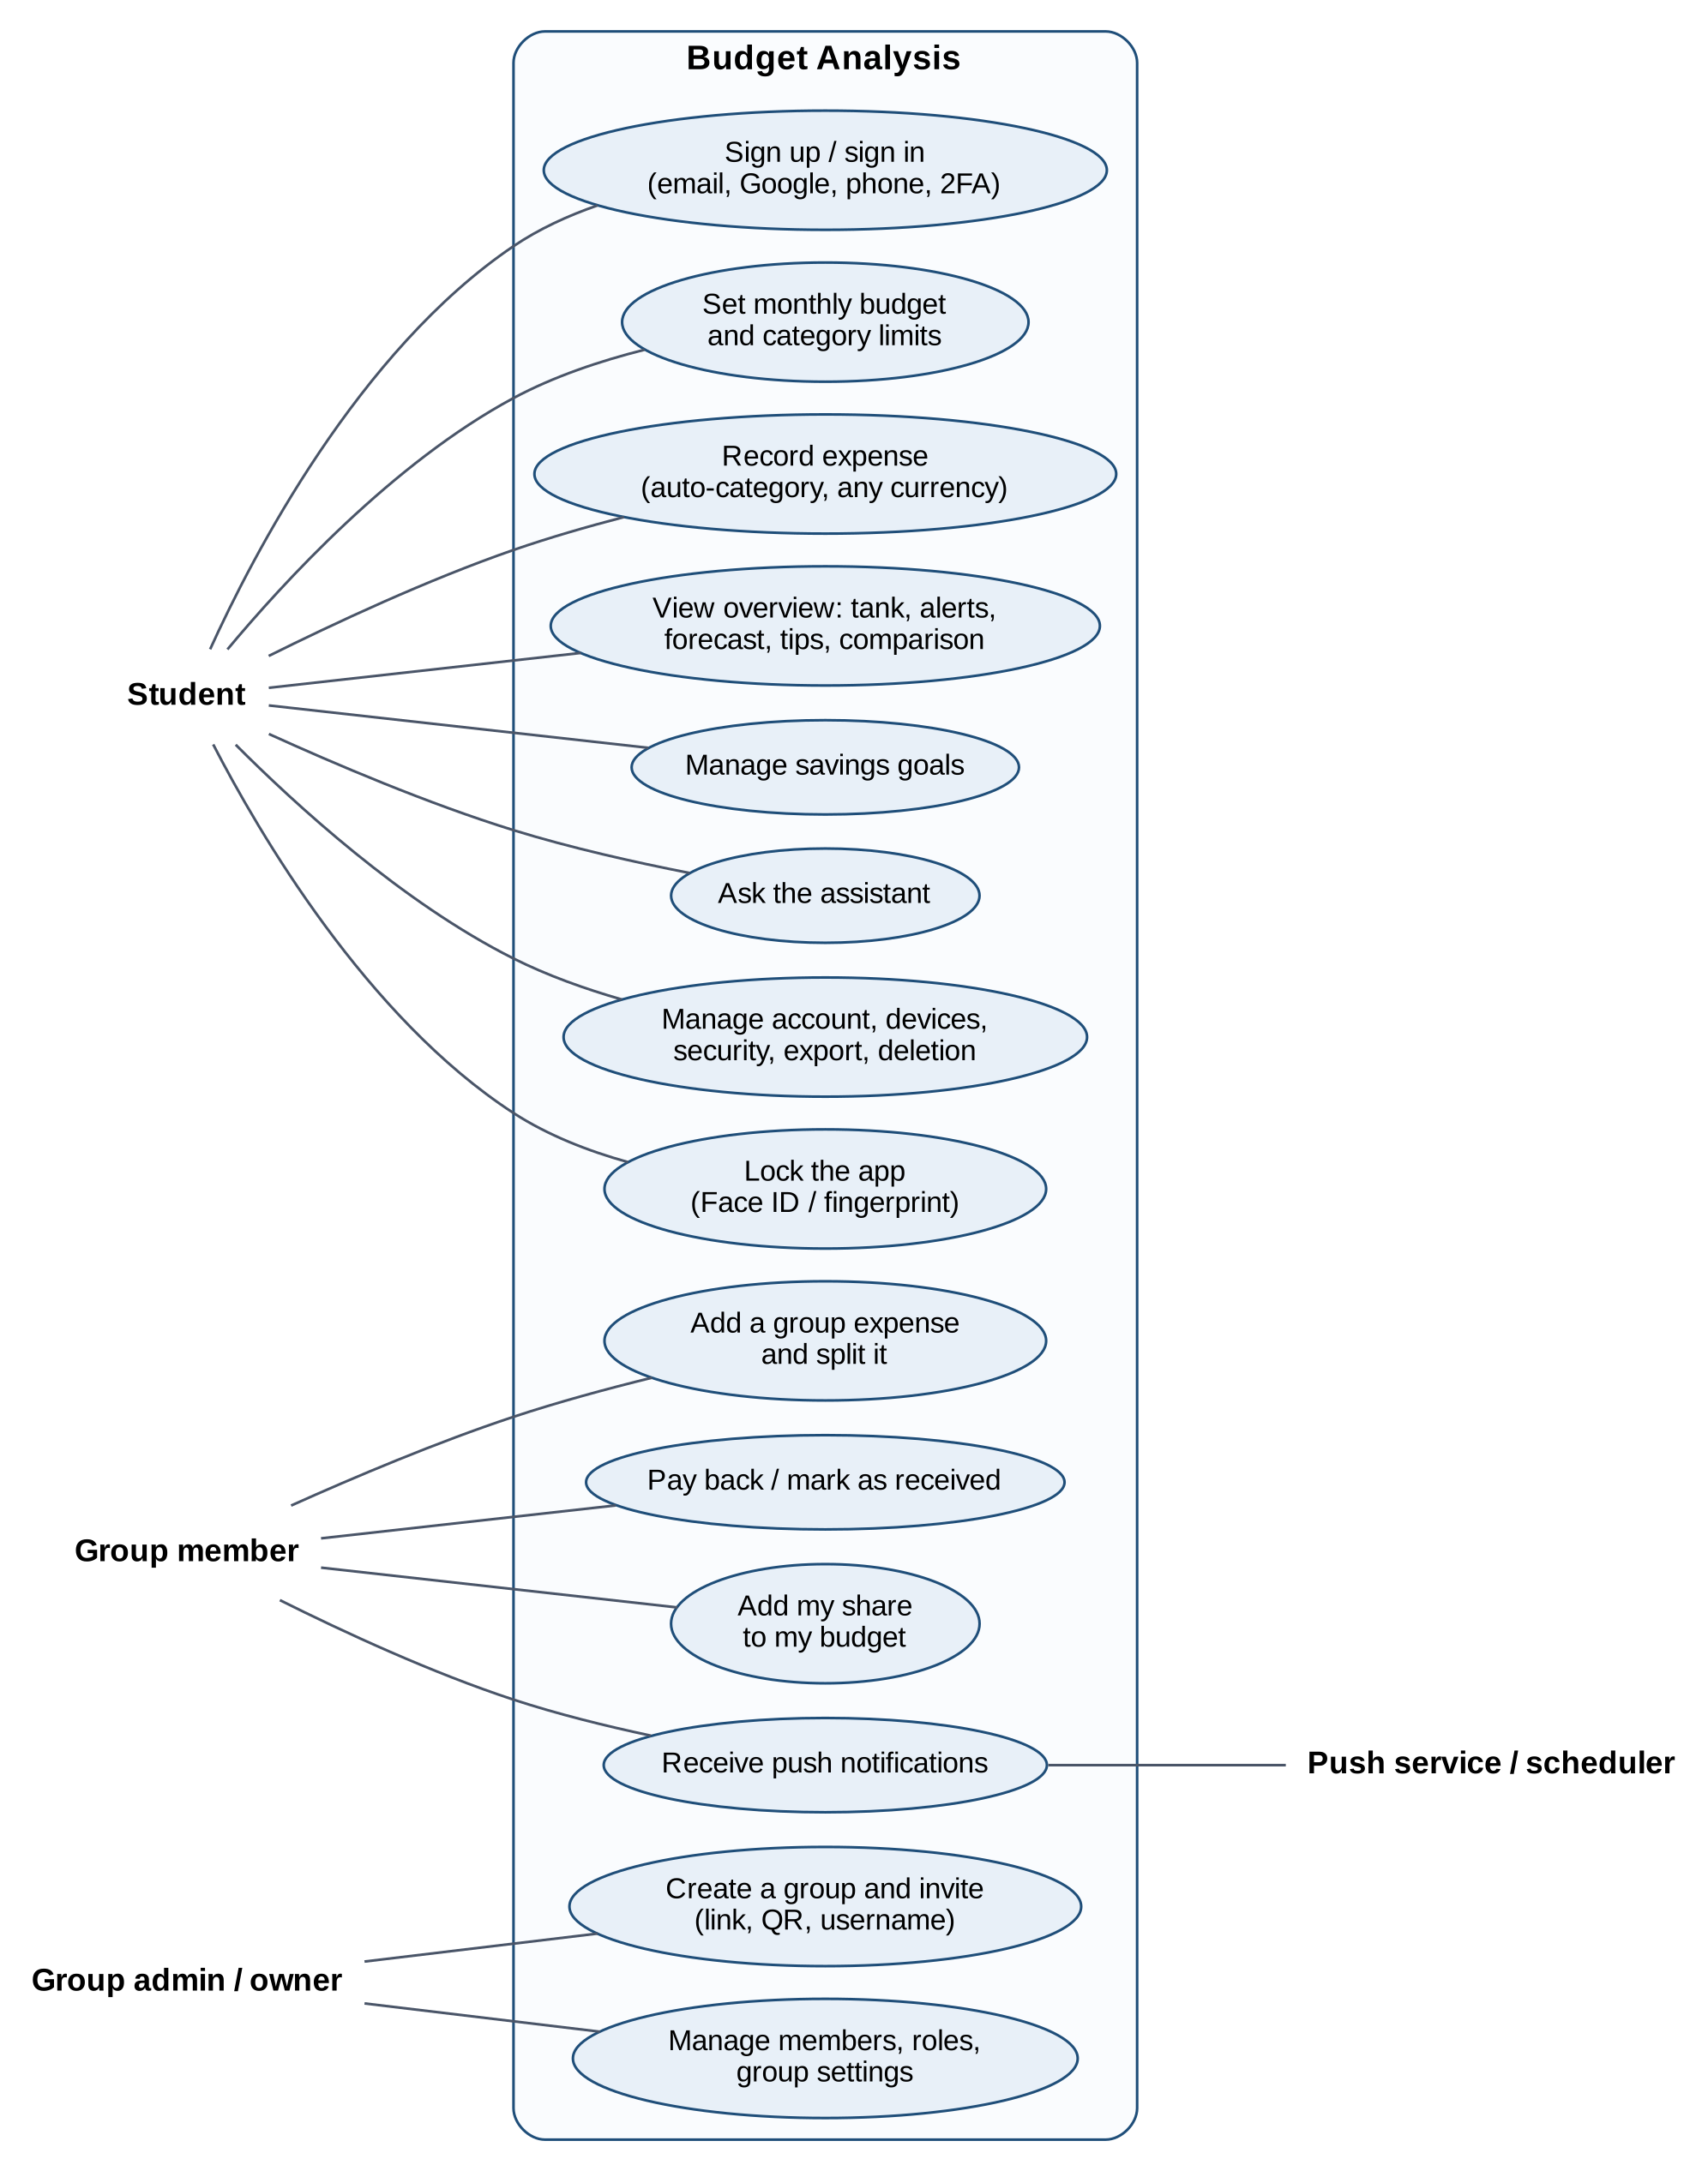
Figure 2. Main use cases and actors

2.4 Detailed use case descriptions

UC-08 Record an expense
Item | Description
Precondition | Signed in; a budget exists for the expense's budget month.
Main flow | 1. The student opens the expense sheet and types a description.  2. The client asks for a category suggestion; the API checks the student's own history first, then the categorizer model (accepted at confidence ≥ 0.60).  3. The student confirms amount, currency, date and category, and saves.  4. The API finds the budget month of the date, converts the amount to the budget currency at the day's rate and stores the snapshot.  5. The client refreshes the overview, tank and alerts.
Alternatives | No budget for that month → 409 with a 'set a budget first' message. Date in the future (beyond a 1-day time-zone tolerance) → 422. Date before Start fresh → 422.
Postcondition | The expense is stored with categorized_by = user, history or model.
Rules | BUSINESS_LOGIC.md §6–7

UC-18 Add a group expense and split it
Item | Description
Precondition | The payer is a current member; the group has at least two members.
Main flow | 1. A member enters amount, payer, participants and a split method (equal, exact, percentages or shares).  2. The API splits the amount with the largest-remainder method so the shares add up exactly.  3. For each participant a share row is created; if the member has auto-add on and a budget for that month, a personal expense (source = group) is created at once, otherwise the share waits as pending.  4. After the response, push notifications go to members with a non-zero share, in each reader's language.
Alternatives | Exact amounts that do not add up, percentages not equal to 100 → 422. Non-member → 404.
Postcondition | Balances change pairwise; the chat shows the event.
Rules | BUSINESS_LOGIC.md §11

UC-02 Sign in with two-factor authentication
Item | Description
Main flow | 1. The user submits email and password.  2. The API applies the per-IP and per-account limits, checks the bcrypt hash and records a security event.  3. If 2FA is on, it returns a 5-minute challenge token; the user sends the 6-digit code or a backup code.  4. The API creates a session and a refresh token (stored hashed) and returns a 15-minute access token: as httpOnly cookies on the web, in the body for the native app.
Alternatives | Wrong password or unknown email → the same generic error. 5 wrong codes end the challenge. Too many attempts → 429.
Rules | BUSINESS_LOGIC.md §12

UC-06 Set the budget month start day and Start fresh
Item | Description
Main flow | 1. In Settings the student picks a start day (1–28) or presses Start fresh.  2. The API stores month_start_day or fresh_start_on.  3. Every query, chart, comparison and forecast is computed from the new budget month boundaries; months before the fresh start answer 404.
Postcondition | Nothing is deleted; Start fresh can be undone, and export still contains all data.
Rules | BUSINESS_LOGIC.md §4

2.5 Use case realisations
Each use case is realised by one router function, which calls one service method in its domain; the sequence diagrams in section 4 show the three most important realisations (UC-08, UC-18, UC-02). The traceability matrix in section 8 maps every use case to code and tests.

3. Logical View

3.1 Overview
The API is a modular monolith. Each business area is a domain package under backend/app/domain/, and every domain has the same four layers. Cross-cutting concerns (security, dates, money, email, push, rate limits) live in backend/app/core/. The two clients share a client core (types, texts, API calls and the month and money rules) so that both apply the same rules as the server.

3.2 Layers
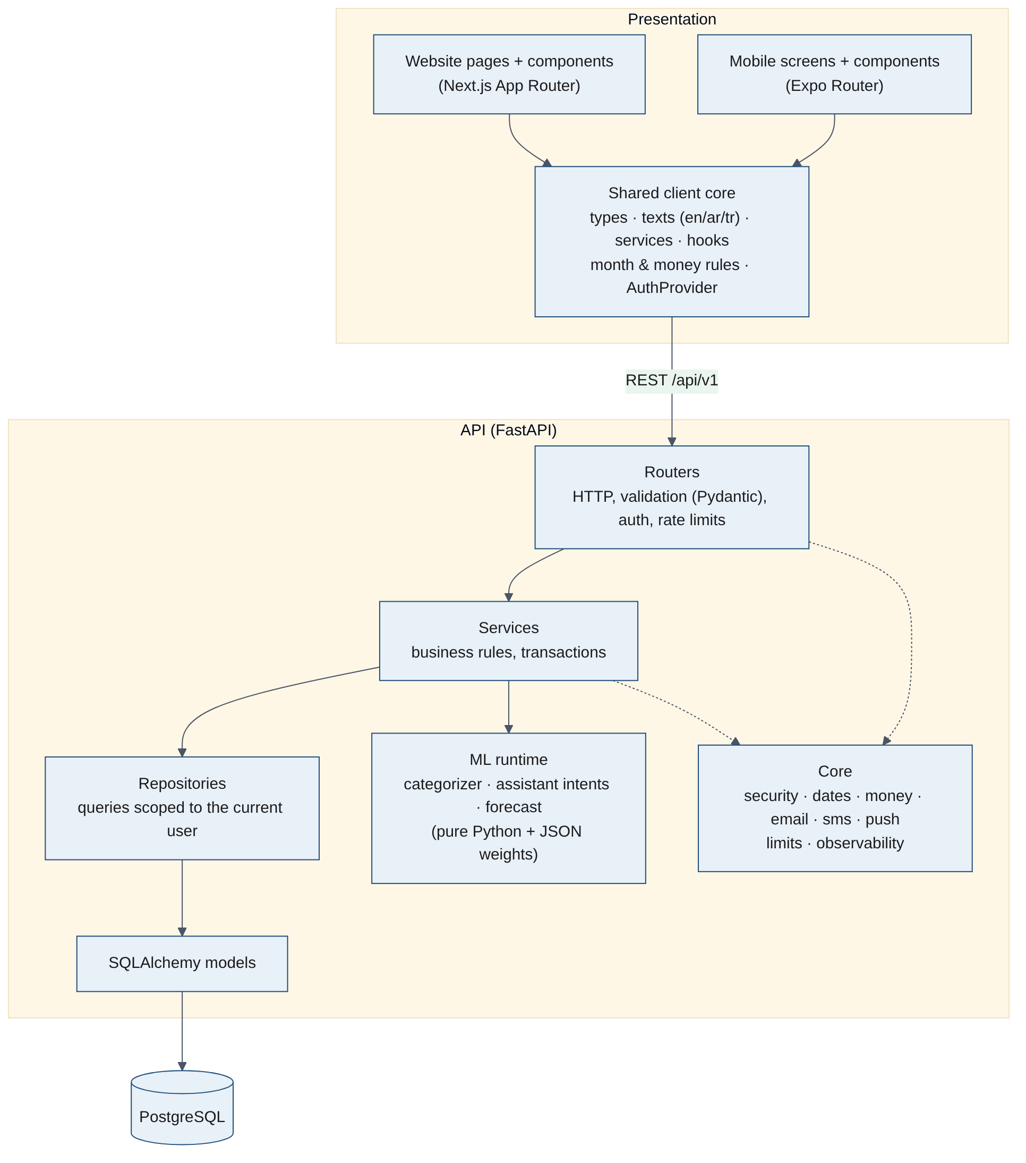
Figure 3. Layers of the system
Layer | Responsibility | Rules
Router (router.py) | HTTP: paths, status codes, dependencies (current user, rate limits, reauth) | No business logic, no SQL
Schemas (schemas.py) | Pydantic request/response models and validation | Response models never expose internal IDs or hashes
Service (service.py) | Business rules and transactions | The only layer that commits; may call other domains' services
Repository (repository.py) | SQL queries through SQLAlchemy | Always scoped by the owner (user or group membership)
Model (models.py) | Tables and constraints | Constraints back up the service rules (unique, check)

3.3 Domains
Domain | Responsibility | Main tables
user | Registration, sign-in methods, sessions, 2FA, phone codes, profile and settings, security log, export and deletion | users, user_identities, user_sessions, refresh_tokens, one_time_tokens, phone_codes, backup_codes, security_events
budget | Categories, monthly budgets, allocations, summary, daily series, alerts, forecast and tips | categories, budgets, budget_allocations
expense | Personal expenses, category suggestion, conversion | expenses
currency | Supported currencies (catalog with a 1-minute cache), exchange rates with cache and stale fallback | currencies, exchange_rates
goal | Savings goals, deposits and withdrawals | savings_goals, goal_contributions
group | Groups, members, roles, invites, username requests, expenses, splits, share copies, balances, settlements, activity, household budget | groups, group_members, group_invites, group_requests, group_expenses, group_expense_shares, group_settlements, group_budgets
assistant | Question answering: intent, period and category extraction, answers from the database | — (reads other domains)
notify | Push devices, notification texts in three languages, delivery | push_devices
recurring | Recurring expense rules, catch-up, reminders; the daily job endpoint | recurring_expenses
debt | Personal debts and payments back, due-day reminders | debts, debt_payments
income | Income by source and type, month totals, net after spending | incomes
report | Month report (Wrapped) and its notification; PDF and Excel files | — (reads other domains)
challenge | Savings challenges, progress from expenses, wins, badges, shared challenges | challenges
inflation | Spending in a steady currency at past rates; price changes of repeated purchases | past_rates
admin | Platform admins, statistics without amounts, user support actions, system status, currency management, append-only audit log | platform_admins, admin_audit_log

3.4 Domain model
The 34 tables fall into four groups (the extra features add recurring_expenses, debts, debt_payments, incomes, challenges, group_budgets and past_rates, and expenses gain recurring_id and client_id). A user owns all personal data; a group owns only group data. The single bridge between them is the share copy: a member's share can become a personal expense that the member owns, so the group never reads personal tables. The admin tables point at users only; admin queries never join budget, expense, goal or group tables.
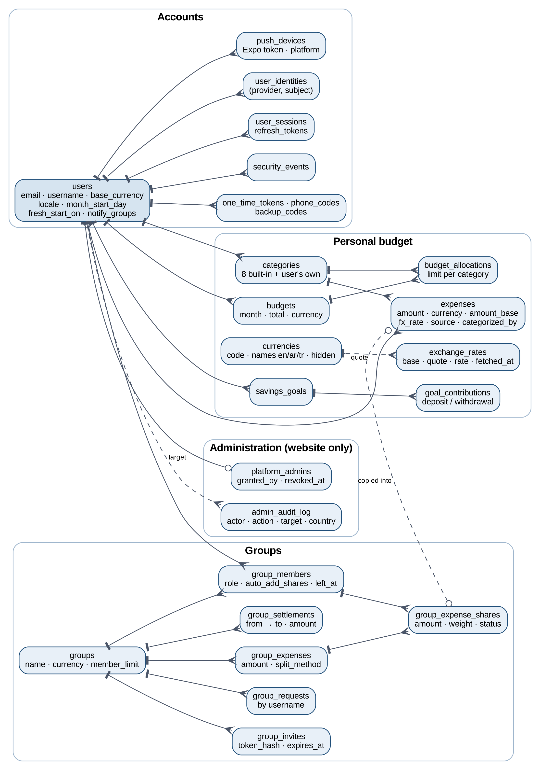
Figure 4. Domain model (entities and relationships)

3.5 Core services
Module (app/core) | Purpose
dates.py | BudgetCalendar: budget month boundaries, visible range after Start fresh, clamping
money.py | Decimal helpers, rounding, largest-remainder split
security.py, secret_box.py, totp.py | JWT, password hashing, token hashing, Fernet encryption, TOTP
breached.py | Have I Been Pwned k-anonymity check
limiter.py, account_limit.py, default_limit.py, body_limit.py, client_ip.py | Rate limits per IP, per account and per endpoint; 1 MB body limit; trusted client IP from the edge
google.py, sms.py, email.py, email_templates.py | Google ID-token verification; SMS and email backends with templates in three languages
push.py | PushSender interface with none, console and Expo implementations
observability.py | JSON logging, request IDs, Server-Timing, query counting, Sentry
device.py | Human-readable device names for the sessions list

3.6 Machine-learning components
Component | Model | Runtime behaviour
Expense categorizer | Softmax regression on TF-IDF character n-grams (3–5), C = 30; trained by ml/train_categorizer.py, analysed in ml/notebooks/01 | Used only when the user's own history has no match; accepted at confidence ≥ 0.60 (≈40% coverage, ≈81% correct)
Assistant intent classifier | Softmax regression on 470 questions in three languages, 7 intents; 87.9% cross-validated accuracy (ml/train_assistant.py) | Answers when confidence ≥ 0.40; period and category come from rules; every number comes from the database
Spending forecast | Daily run-rate from day 7 of the budget month, excluding one-off spends above 3× the median (ml/notebooks/02) | Shown as the projected month-end total and the day money runs out
Tips | Rules over the last 12 weeks (repeats, weekday patterns) | At most three tips, each with the saving it would bring
Quick add (F9) | Rules over normalized text: numbers in digits or words, currency words, days (app/ml/quick_add.py) | Fills the expense form from one sentence in three languages; never saves
Receipt reader (F10) | Tesseract OCR (tur+eng+ara) and rules for total, date and shop (app/ml/receipt.py) | Fills the form from a photo; the photo is never stored

Models are stored as JSON weight files in backend/app/ml/artifacts/ and loaded at start-up. The runtime is pure Python (no NumPy or scikit-learn), and explain.py can show which words led to a category.

4. Process View

4.1 Overview
- Each API instance runs several Uvicorn worker processes (WEB_CONCURRENCY); each worker runs an asyncio event loop. All I/O (database, Redis, HTTP to rates, Google, HIBP and Expo) is non-blocking.
- Each request gets its own database session from a pool sized by DB_POOL_SIZE. There is no shared mutable state between requests except the per-process caches (exchange rates, ML weights).
- Work that must not delay the user (push notifications, security notice emails) runs as FastAPI background tasks after the response is sent.
- The clients use TanStack Query: responses are cached per key and invalidated after each change; the access token is refreshed transparently on a 401, with a single in-flight refresh.

4.2 Recording an expense (UC-08)
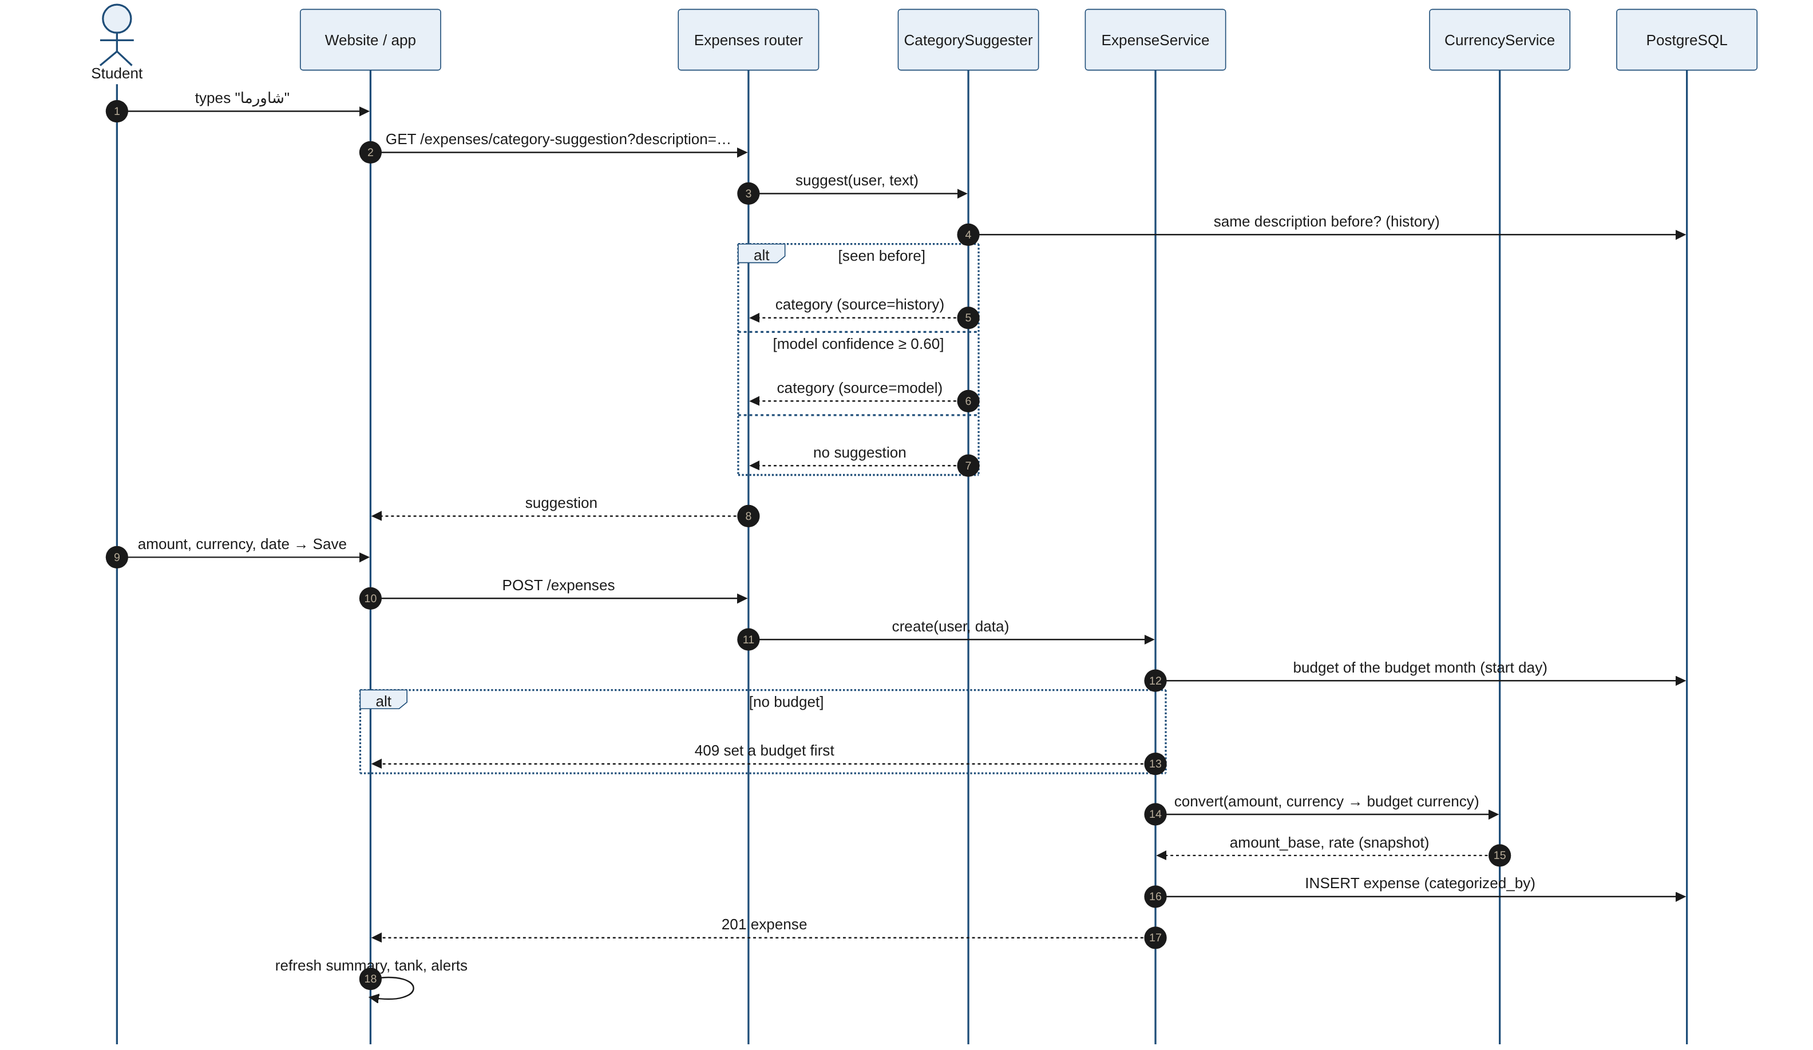
Figure 5. Sequence: category suggestion and expense creation

4.3 Adding a group expense (UC-18)
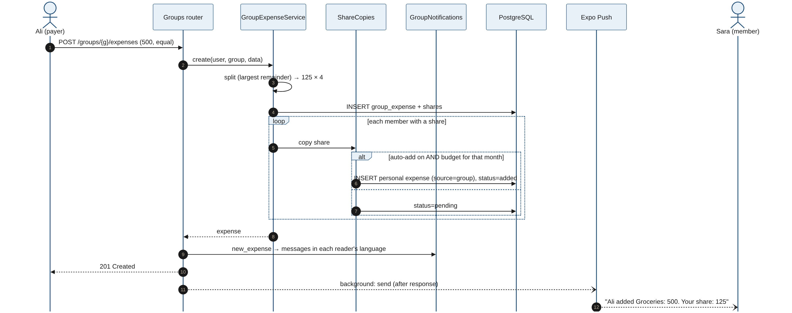
Figure 6. Sequence: group expense, split, share copies and push

4.4 Sign-in and token refresh (UC-02, UC-03)
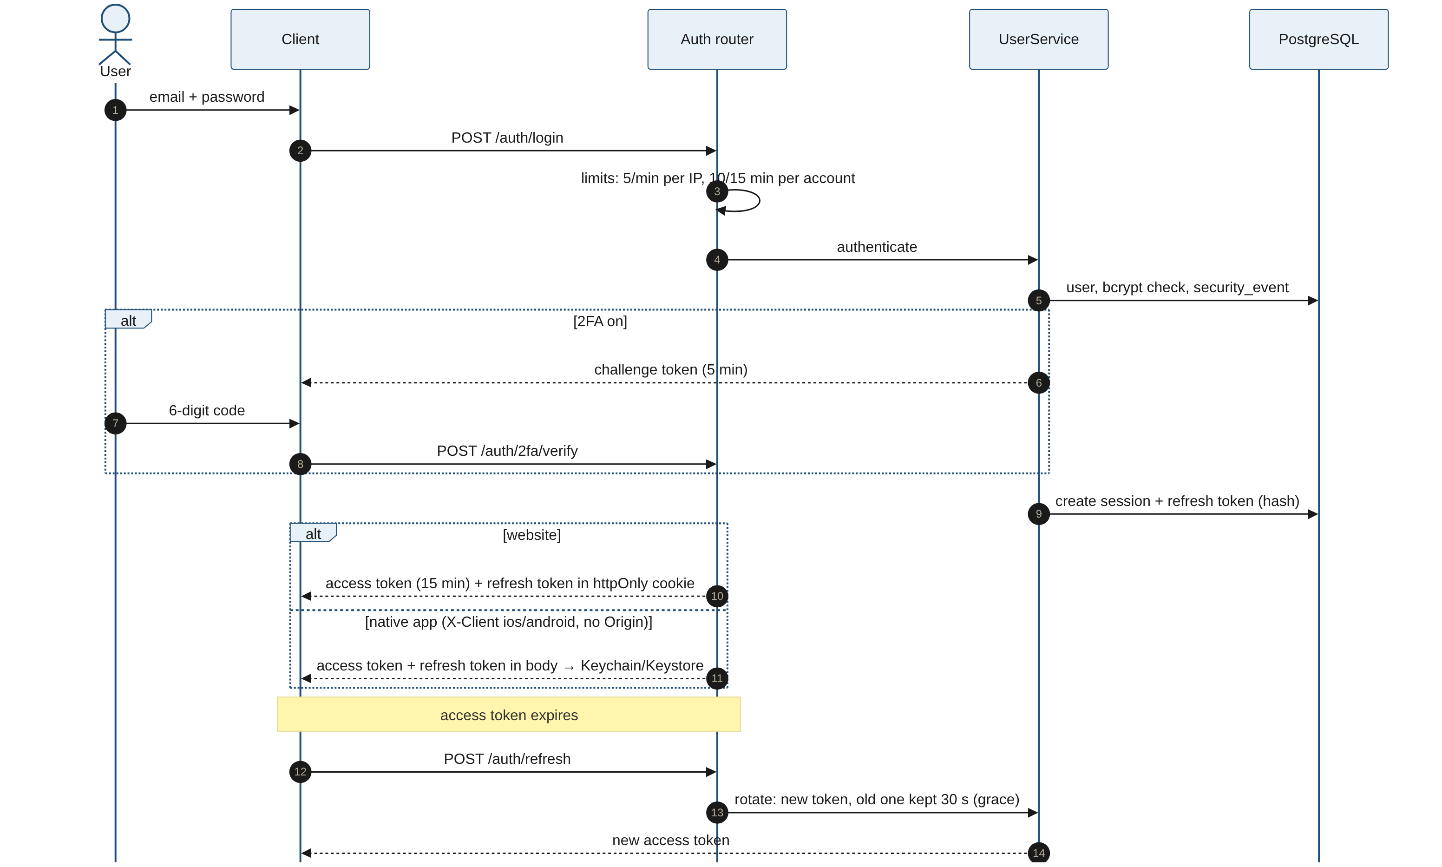
Figure 7. Sequence: sign-in with 2FA, web and native token delivery, refresh rotation

4.5 Concurrency and consistency
Concern | Approach
Two requests change the same data | Each request is one transaction; uniqueness is enforced by database constraints (one budget per month, unique category name, unique username, one membership per group), and conflicts become 409.
Refresh token used twice in parallel | Rotation keeps the previous token valid for a 30-second grace period, so parallel tabs or a retry do not sign the user out; reuse after the grace ends revokes the session.
Group split totals | Computed in one place with Decimal and the largest-remainder method; the shares are inserted in the same transaction as the expense.
Rate limits across workers | Stored in Redis when REDIS_URL is set; otherwise per process (acceptable for one instance).
Exchange rates | Cached for 12 hours per process; if the provider fails, the last stored rate is used and marked stale.
Push delivery | Best effort, after the response; tokens reported as DeviceNotRegistered are deleted.
Chat ordering | Ordered by server time; pages of 30 items.

4.6 Scheduled and background work
- Uptime check: a GitHub Actions workflow calls the API and the website every 14 minutes, keeps the free Render instance awake and emails on failure.
- Background tasks: push notifications and security notices, executed after the HTTP response.
- Daily job (F1, F2, F4): .github/workflows/daily.yml calls POST /internal/daily once a day with a shared secret (CRON_SECRET). It adds recurring expenses that fell due, sends tomorrow's bill reminders, today's debt reminders and the budget alerts they cause, and the month-report notification the day after a budget month ends. Each notification is remembered so it is sent once.
- Offline adding (F13): the clients keep new expenses that got no answer and send them again later; a client-made id (expenses.client_id, unique per user) makes the retry a no-op.
- There is still no separate worker or queue: the daily job is short and idempotent, and a missed day is caught up the next time.

5. Development View

5.1 Repository structure
Path | Contents
backend/app/main.py | Application factory, middleware, router registration
backend/app/cli.py | Operator commands: grant-admin, revoke-admin, list-admins
backend/app/domain/<name>/ | router.py, schemas.py, service.py, repository.py, models.py per domain
backend/app/core/ | Cross-cutting modules (section 3.5)
backend/app/ml/ | Model runtime and exported weights
backend/app/migrations/ | Alembic migrations (18)
backend/tests/ | pytest suite (350+ tests): unit, API, authorization and penetration tests
frontend/src/app/ | Next.js routes: (auth), (app)/overview, budget, expenses, categories, goals, groups, assistant, settings; admin (website only); join, privacy, terms
frontend/src/{services,hooks,lib,types,i18n,components} | API calls, queries, rules, types, messages in en/ar/tr, UI components
mobile/src/app/ | Expo Router: (auth), (app) stack with (tabs) and categories
mobile/src/lib/ | API client with SecureStore, push, app lock, shared copies
mobile/scripts/sync-shared.mjs | Copies the shared client core from frontend to mobile; --check fails on drift
ml/ | Datasets and notebooks for the categorizer, intents and forecast
loadtest/ | Seed script, k6 scenarios, summary tool and report
docs/ | SAD, business logic, roadmap, environments, recovery, API versioning, design and security documents
.github/workflows/ | ci.yml, codeql.yml, keep-awake.yml
render.yaml | Render blueprint for the production and staging API services

5.2 Shared client code
Types, translations, API service functions, query hooks and the month, money, insight and error rules are written once in the website and copied into the app. The copies are read-only; CI runs the sync script in check mode and fails if they differ.
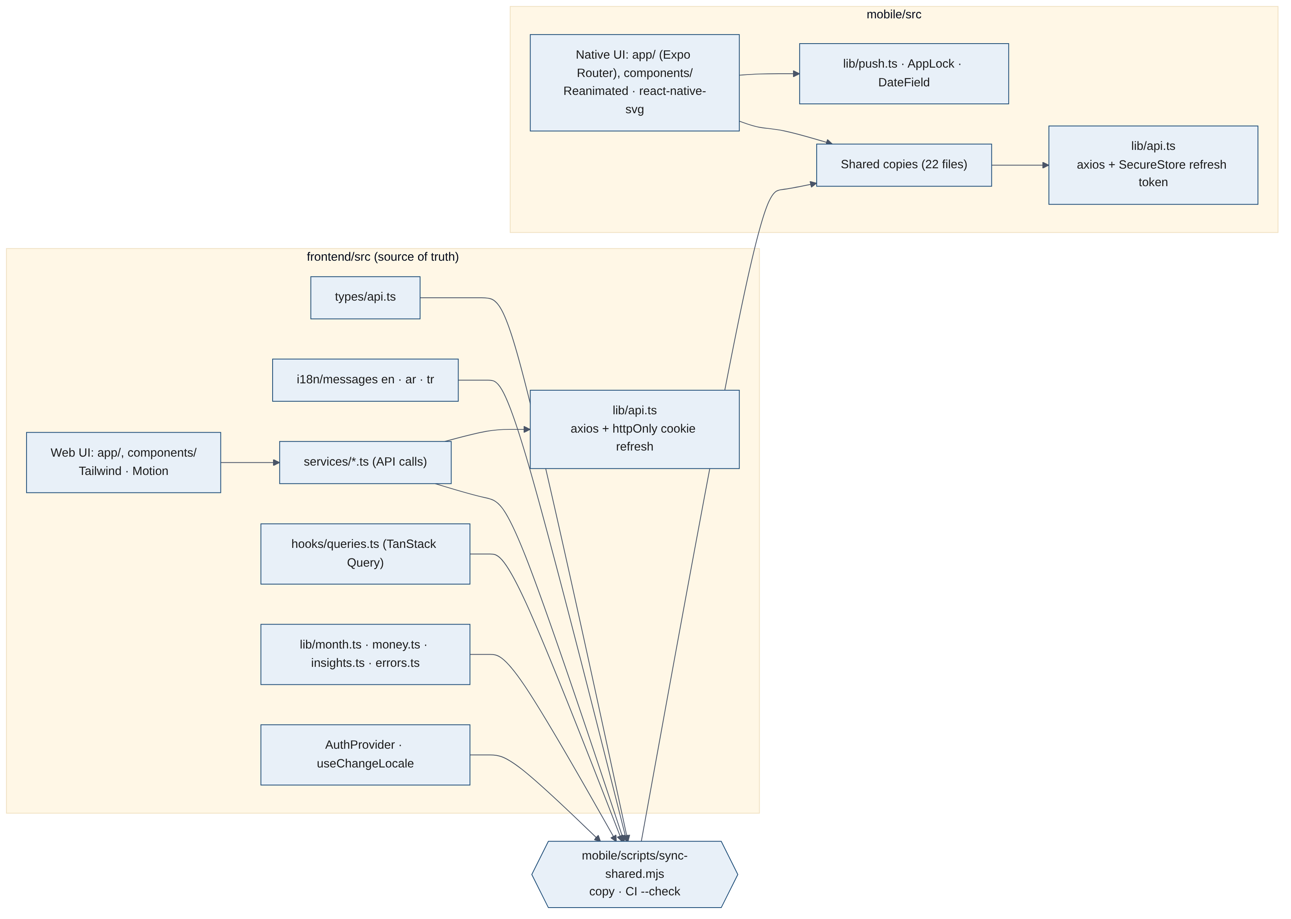
Figure 8. Client components and the shared core

5.3 Build, test and quality gates
CI job | Steps
backend | ruff lint and format check; Alembic upgrade on a fresh PostgreSQL; pytest
frontend | npm ci; ESLint; TypeScript check; production build
mobile | npm ci; generate Expo types; shared-code drift check; TypeScript check; ESLint
audit | pip-audit and npm audit for known vulnerabilities
codeql | Static security analysis of Python and TypeScript

Dependabot opens weekly update pull requests. A pull request can be merged into main only when all checks are green.

5.4 Coding conventions
- English for all code, comments and documentation; user-facing text lives in the message catalogues (English, Arabic, Turkish).
- Money is always Decimal in Python and a string in JSON; clients format it with the shared money helpers.
- Every endpoint has an authorization test proving that other users and non-members cannot reach the data.
- Errors use stable codes that clients translate; no internal detail is returned to the client.

5.5 Release workflow
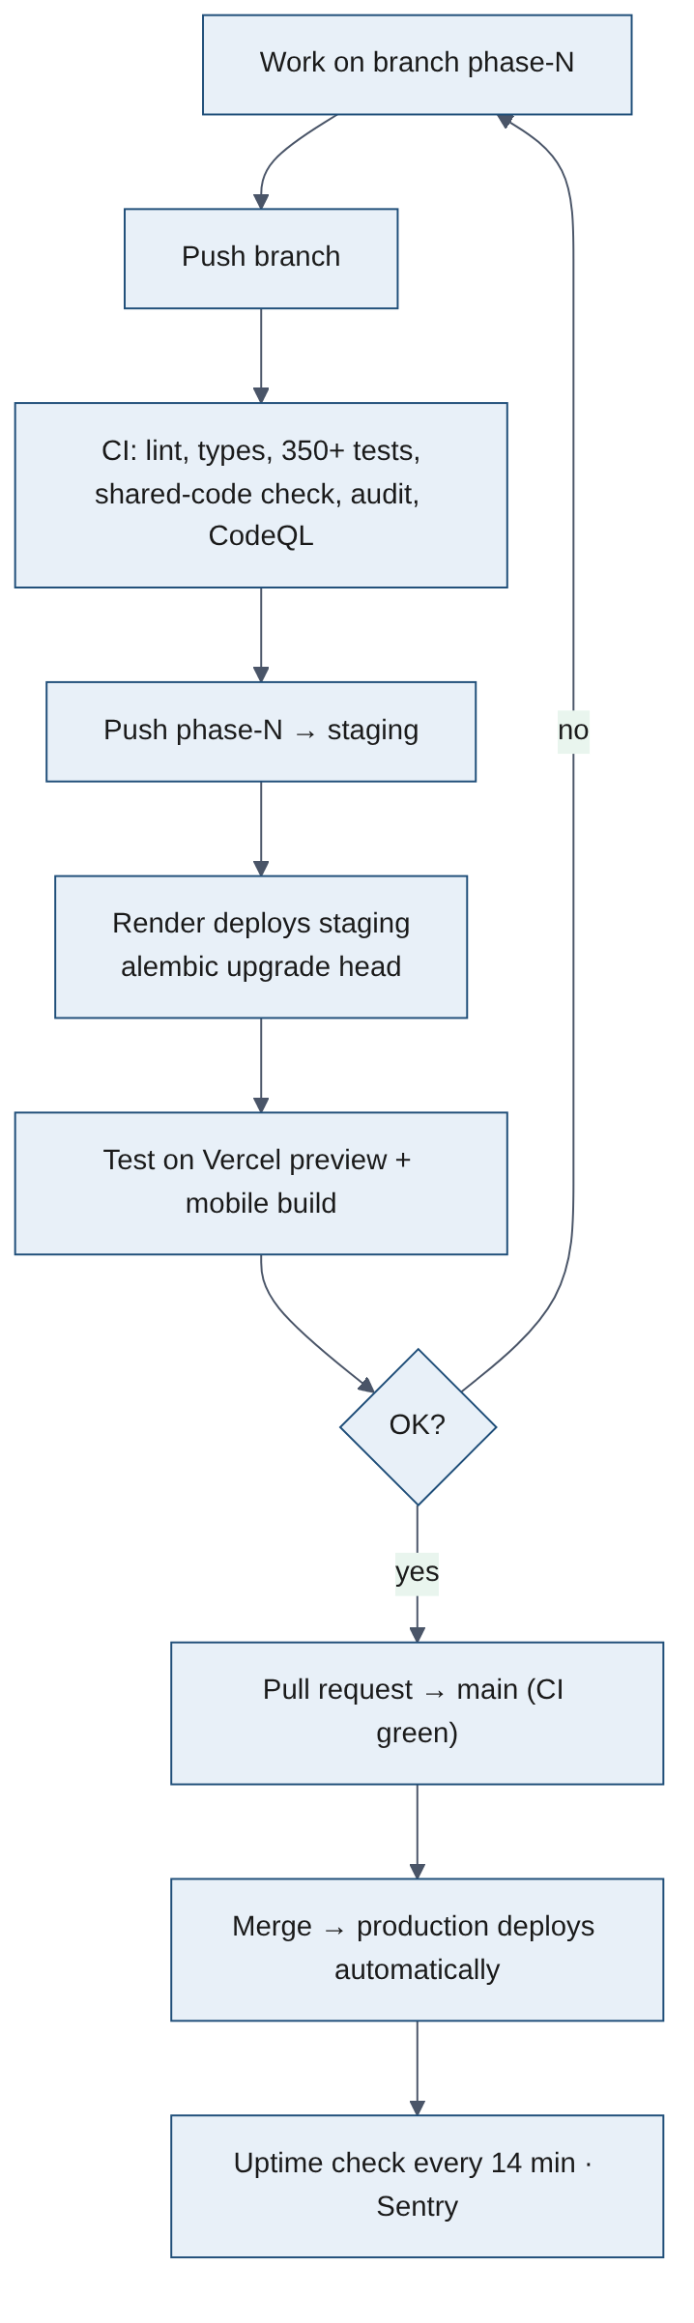
Figure 9. Activity: from a phase branch to production

6. Deployment View

6.1 Environments
 | Local | Staging | Production
Website | localhost:3000 | Vercel preview per branch | budgetanalysis.vercel.app
API | Docker | budget-analysis-api-staging (Render), branch staging | budgetbuddy-api (Render), branch main
Database | PostgreSQL in Docker | Neon branch staging | Neon branch main
Mobile | Development build or Expo Go | EAS development/preview builds | EAS production build (store)
Email / SMS / push | Mailpit / console / none or console | console / console / expo | none / none / none until activation

6.2 Deployment diagram
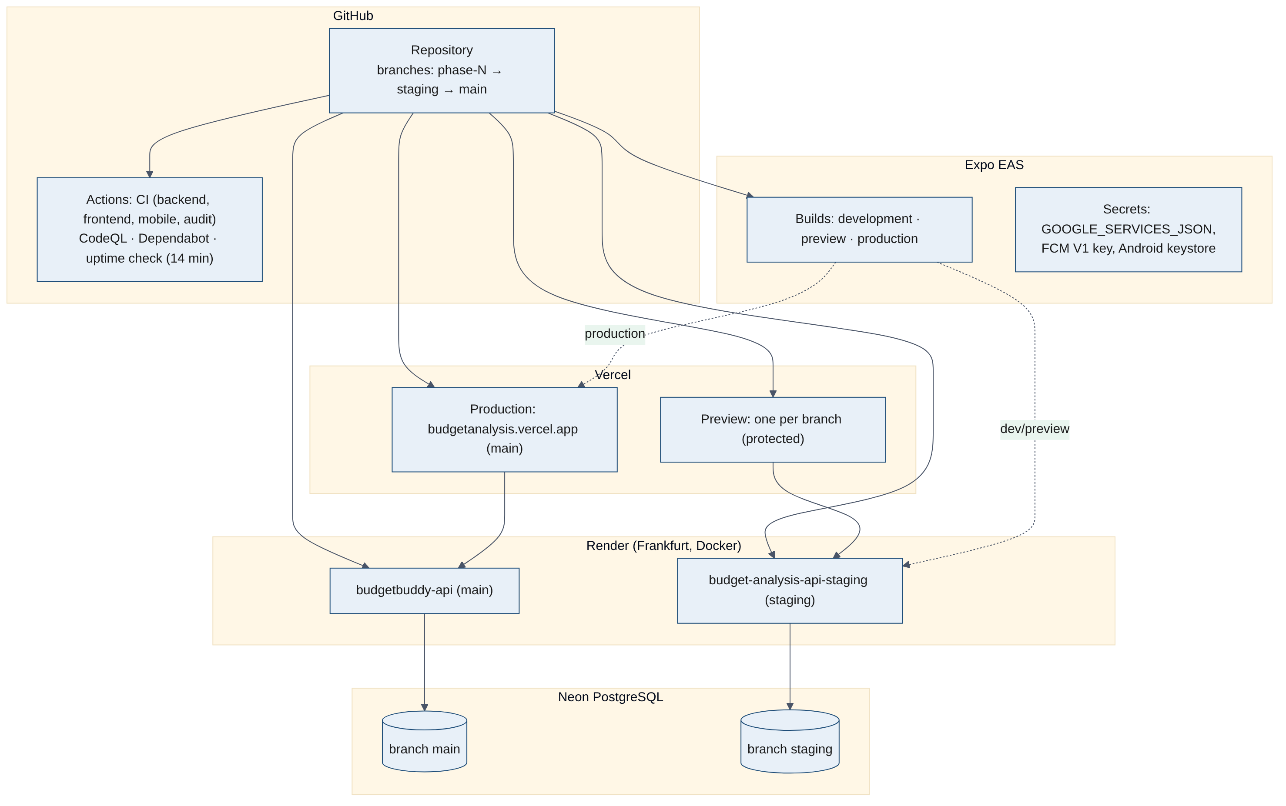
Figure 10. Deployment nodes and release paths

6.3 Nodes
Node | Platform | Details
Website | Vercel | Next.js server and static assets; rewrites /api/v1 to the API; security headers (CSP, HSTS)
API | Render, Frankfurt, Docker | Uvicorn with several workers; health check /api/v1/ping; auto-deploy from main (production) and staging
Database | Neon PostgreSQL | Branches main and staging; point-in-time restore; backup branch before migrations
Cache | Redis (optional) | Rate-limit storage; supported in code, not yet provisioned on the servers
Mobile builds | Expo EAS | Development, preview and production profiles; stores the Android keystore, FCM V1 key and google-services.json
Push | Expo Push → FCM (Android) / APNs (iOS) | Called by the API with the device's Expo token
Monitoring | Sentry (EU), GitHub Actions | Errors by environment; uptime emails

6.4 Configuration
All configuration comes from environment variables read by app/config.py (pydantic-settings). Secrets are set in Render, Vercel and EAS, never in the repository; backend/.env is used locally and is git-ignored.
Variable | Purpose
DATABASE_URL, DB_POOL_SIZE, DB_MAX_OVERFLOW | Database connection and pool
SECRET_KEY, ACCESS_TOKEN_MINUTES, SESSION_IDLE_DAYS, SESSION_ABSOLUTE_DAYS, REFRESH_GRACE_SECONDS | Tokens and session lifetime
FRONTEND_URL, APP_URL, EDGE_SECRET | Allowed origin, links in emails, trusted edge
GOOGLE_CLIENT_ID | Sign in with Google
TOTP_ENCRYPTION_KEY | Encryption of 2FA keys (2FA is hidden without it)
EMAIL_BACKEND, SMTP_HOST, SMTP_PORT, EMAIL_FROM | Email delivery (none, console, smtp)
SMS_BACKEND, SMS_ALLOWED_COUNTRIES, SMS_DAILY_CAP | Phone sign-in
PUSH_BACKEND, EXPO_ACCESS_TOKEN | Push notifications (none, console, expo)
REDIS_URL, RATE_LIMIT_DEFAULT | Rate limiting
FX_API_URL, FX_CACHE_HOURS, FX_TIMEOUT_SECONDS | Exchange rates
SENTRY_DSN, SENTRY_TRACES_SAMPLE_RATE, DEPLOY_ENV, GIT_COMMIT | Monitoring and version display
EXPO_PUBLIC_API_URL (mobile), API_ORIGIN (website) | Where each client finds the API

Full setup steps are in docs/ENVIRONMENTS.md.

6.5 Operations
- Version: /api/v1/version returns the commit; Settings shows the client and API versions side by side.
- Health: /api/v1/ping (process alive) and /api/v1/health (database reachable).
- Logs: JSON, one line per request with request ID, status, duration, query count and database time; no personal data.
- Recovery: tags for safe points, revert-based rollbacks, an offline git bundle and Neon backup branches (docs/RECOVERY.md).
- Capacity: measured at 390 requests/s with p95 75 ms on four workers (loadtest/REPORT.md).

7. Security View
The target is OWASP ASVS Level 2 plus the App Store and Google Play requirements. The threat model is in docs/security/THREAT_MODEL.md and the item-by-item verification in docs/security/ASVS.md.
Area | Controls
Authentication | bcrypt passwords (≥ 8 characters), breached-password check, Google ID-token verification, phone codes with SMS-pumping protection, TOTP 2FA with hashed backup codes
Sessions | 15-minute JWT access tokens; refresh tokens stored hashed, rotated on every use with a 30-second grace; idle 30 days, absolute 90 days; device list and remote sign-out
Token storage | Web: httpOnly, Secure, SameSite cookies on the same origin. Mobile: Keychain/Keystore via expo-secure-store; optional biometric app lock
Authorization | Every query scoped by owner or membership; non-members get 404, not 403, so groups cannot be discovered; recent sign-in (10 min) for sensitive actions
Administration | Admins only from the command line (no API grants it); 2FA required; 404 for non-admins; re-authentication for actions; 30 reads / 10 actions per minute; no action on oneself or another admin; append-only audit log; the person sees each action in their security activity; no amounts ever shown
Abuse | Per-IP, per-account and default rate limits; 1 MB body limit; no account enumeration
Data protection | TLS everywhere; secrets hashed or encrypted at rest; no personal data in logs or notifications beyond what a lock screen may show
Web hardening | CSP, HSTS, X-Frame-Options, Referrer-Policy, Permissions-Policy; API schema hidden in production
Supply chain | CodeQL, Dependabot, pip-audit, npm audit; secrets never in git; Firebase and signing keys only in EAS
Privacy rights | Data export and account deletion in web and app; privacy policy and terms in three languages
Verification | OWASP ZAP scans with zero high/medium findings; penetration tests written as automated tests (test_pentest.py)

8. Traceability Matrix
Requirement | Use cases | Code | Tests / evidence
Secure student accounts | UC-01–05 | domain/user, core/security.py, core/totp.py, core/breached.py | test_auth.py, test_sessions.py, test_two_factor.py, test_phone.py, test_google_sign_in.py, test_email_flows.py, test_pentest.py
Plan a monthly allowance on the user's own cycle | UC-06, UC-07 | domain/budget, core/dates.py | test_budgets.py, test_budget_cycle.py
Record spending in several currencies | UC-08, UC-09 | domain/expense, domain/currency, core/money.py | test_expenses.py, test_currency.py, test_money_dates.py
Automatic categorisation | UC-08 | domain/expense (suggestion), app/ml/logistic.py, text.py | test_category_suggestion.py, test_ml_logistic.py, test_ml_text.py
Early warnings and forecast | UC-10 | domain/budget (summary, alerts, forecast) | test_budgets.py, test_ml_forecast.py
Personal tips and assistant | UC-11, UC-12 | domain/budget (tips), domain/assistant, app/ml/assistant_entities.py | test_tips.py, test_assistant.py
Savings goals | UC-13 | domain/goal | test_goals.py
Custom categories | UC-14 | domain/budget (categories) | test_categories.py
Data rights | UC-15 | domain/user (export, delete) | test_account.py
Support and administration | UC-25–27 | domain/admin, app/cli.py, dependencies.py (get_admin) | test_admin.py, test_admin_currencies.py
Currencies managed as data | UC-26 | domain/currency (catalog, client, service) | test_admin_currencies.py, test_currency.py
Shared expenses with friends | UC-16–22 | domain/group | test_groups.py, test_group_expenses.py, test_group_split.py, test_group_shares.py, test_group_settle.py, test_usernames.py, test_pentest.py
Mobile security and notifications | UC-23, UC-24 | mobile/src/lib (AppLock, push), domain/notify, core/push.py | test_push.py, test_mobile.py; manual test on the Android emulator
Performance | All | core/observability.py, pool and worker settings | loadtest/REPORT.md

The invariants of BUSINESS_LOGIC.md section 16 list each business rule with the test file that protects it.

9. Assumptions, Limitations and Open Items

9.1 Assumptions
- Users are mainly students in Turkey and the Arab world; the six starting currencies (TRY, USD, EUR, AED, SAR, QAR) cover them, and admins can add more.
- A single API region (Frankfurt) is close enough for both markets.
- Free plans are sufficient until about a month before launch.

9.2 Known limitations
- Production email, SMS and push are off until activation, so 'Forgot password' and phone sign-in are hidden in production.
- The free Render instance sleeps without traffic; the uptime workflow keeps it awake but cold starts are possible.
- Redis is not provisioned yet, so rate limits are per process.
- Group balances are pairwise; debts are not simplified.
- iPhone builds need an Apple Developer account; only Android has been built and tested so far.

9.3 Open items
Item | Roadmap phase
Budget alerts as push notifications | 6
Invitation links that open the app (App Links / Universal Links) | 6
Native Sign in with Google in the app | 6
Store requirements, TestFlight and Google Play closed test | 6
Entitlements, subscriptions (RevenueCat), web payments and coupons | 7
Custom domain, Resend email, SMS provider, Sign in with Apple, paid plans | 8
Sentry for the website and the app; object storage | 1 (remaining)

10. References
Document | Location
Business logic (rules, limits, invariants) | docs/BUSINESS_LOGIC.md
Product roadmap | docs/ROADMAP.md
Environments and configuration | docs/ENVIRONMENTS.md
Recovery procedures | docs/RECOVERY.md
API versioning policy | docs/API_VERSIONING.md
Groups design | docs/design/groups.md
Accounts design | docs/design/accounts.md
Threat model | docs/security/THREAT_MODEL.md
ASVS Level 2 checklist | docs/security/ASVS.md
Load test method and report | loadtest/README.md, loadtest/REPORT.md
ML notebooks | ml/notebooks/01_expense_categorizer.ipynb, 02_spending_forecast.ipynb
Software Architecture Document v1.0 | Git history of docs/SAD.docx (18 Oct 2026)
Kruchten, P. The 4+1 View Model of Architecture. IEEE Software, 1995 | —
OWASP ASVS 4.0.3 | owasp.org/www-project-application-security-verification-standard

