**Hardware Required for CEP**

Following is the list of hardware that you will require for completing your CEP.

1. Tiva Board (TM4C1233H6PM/TM4C123G): Each group will buy their own board.
2. Robot Chassis: Two-wheeler robot with a third free wheel
3. DC motors (with encoder)

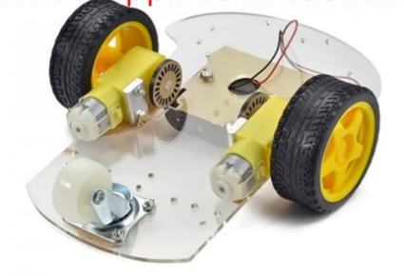

1. One - Power supply for your controller so it can work without your laptop powering it. (LiPo Battery around 5V 700mAh, you will require USB booster charger --J5019 Li ion charger with 4.5 to 24 volts boost --with it).
2. One - Power supply for H-bridge (LiPo Battery around 5V 1000mAh/2000mAh, you will require USB booster charger-- J5019 Li ion charger with 4.5 to 24 volts boost -- module with it).
3. H-bridge motor driver (L298N module not just the IC)
4. Array of 5 sensors (BFD-1000)
5. Optocouplers (4n25/4n35)
6. Jumpers
7. Male to female connectors
8. PCB/ Vero Board

The following two sites can hopefully provide you with these items.

<https://hallroad.org/>

<https://epro.pk/>