# SQL & Power BI Project

Reference Sheet

**KPI**

1. Total Revenue:

The sum of the total prize of all pizza orders.

Query is,

SELECT CAST(SUM(total_price) AS DECIMAL(10,2)) AS total_revenue from pizza_sales

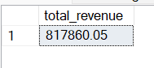

1. Average Order Value:

The average amount spent per order, calculated by dividing the total revenue by the total number of orders.

SELECT CAST(SUM(total_price) / COUNT(pizza_id) AS DECIMAL(10,2)) AS average_amount_spent_per_order from pizza_sales

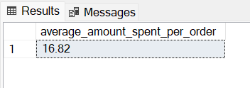

1. Total prizes Sold:

The sum of the quantities of all prizes sold.

SELECT SUM(quantity) AS total_pizzas_sold from pizza_sales

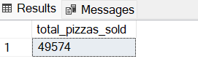

1. Total Orders:

The number of orders placed.

SELECT COUNT(Distinct order_id) AS total_orders from pizza_sales

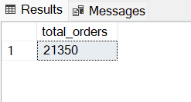

1. Average prizes per order:

The average number of prizes sold per order, calculated by dividing the total number of prizes sold by the total number of orders.

SELECT cast(CAST(SUM(quantity) as decimal(10,2)) /

cast(count(DIstinct order_id) as DECIMAL(10,2)) as decimal(10,2)) from pizza_sales

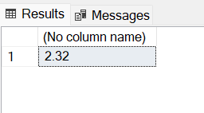

**Charts**

1. Daily Trends for Total Orders:

SELECT DATENAME(DW, order_date) as order_day, count(distinct order_id) as total_orders

from pizza_sales

group by DATENAME(DW, order_date)

Order by total_orders DESC

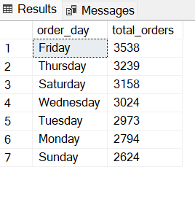

1. Monthly Trend for Total Orders:

SELECT DATENAME(MONTH, order_date) as order_month, count(distinct order_id) as total_orders

from pizza_sales

group by DATENAME(Month, order_date)

Order by total_orders DESC

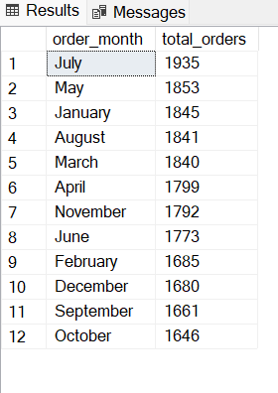

1. Percentage of Sales by Pizza Category:

SELECT pizza_category, sum(total_price) as total_sales, sum(total_price) * 100 / (select sum(total_price) from pizza_sales) as sales_PCT

from pizza_sales

group by pizza_category

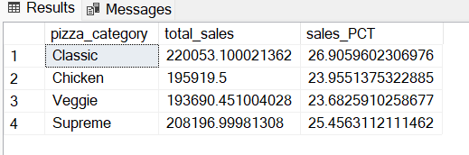

1. Percentage of Sales by Pizza Size:

SELECT pizza_size, sum(total_price) as total_sales, CAST(sum(total_price) * 100 /

(select sum(total_price) from pizza_sales) AS Decimal(10,2)) as sales_PCT

from pizza_sales

group by pizza_size

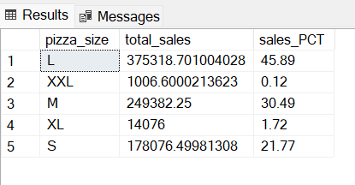

1. Total Pizza Sold by Pizza Category:

SELECT pizza_category, sum(Quantity) as total_pizza_sales

from pizza_sales

group by pizza_category

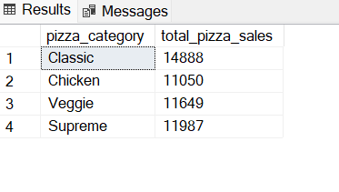

1. Top 5 best sellers by Revenue, Total Quantity, and Total Orders:

By Sales:

SELECT TOP 5 pizza_name, sum(total_price) as Total_Revenue

from pizza_sales

group by pizza_name

Order by Total_Revenue

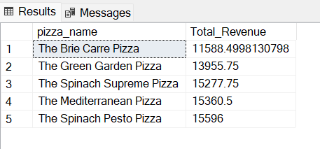

By Quantity:

SELECT TOP 5 pizza_name, sum(quantity) as Total_quantity

from pizza_sales

group by pizza_name

Order by Total_quantity DESC

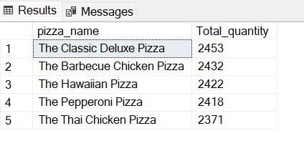

By Orders:

SELECT TOP 5 pizza_name, COunt(distinct order_id) as Total_orders

from pizza_sales

group by pizza_name

Order by Total_orders desc

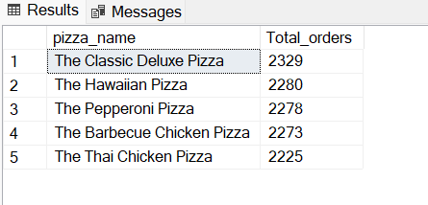

1. Bottom 5 best sellers by Revenue, Total Quantity, and Total Orders:

By Sales:

SELECT TOP 5 pizza_name, sum(total_price) as Total_Revenue

from pizza_sales

group by pizza_name

Order by Total_Revenue DESC

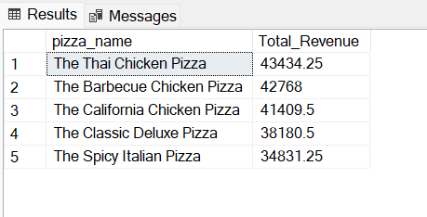

By Quantity:

SELECT TOP 5 pizza_name, sum(quantity) as Total_quantity

from pizza_sales

group by pizza_name

Order by Total_quantity aSC

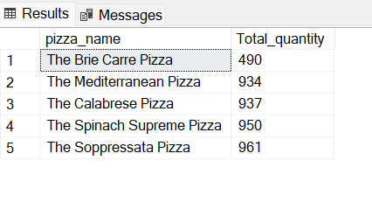

By Orders:

SELECT TOP 5 pizza_name, COunt(distinct order_id) as Total_orders

from pizza_sales

group by pizza_name

Order by Total_orders ASC

