National University of Computer and Emerging Sciences
CS 3009 – Software Engineering
PharmaX
Pharmaceutical Distribution Management System
Project Deliverable #2 — Iteration 1 / Sprint 1
Delivered To: Ms. Ansa Liaqat
Name | Roll No
Ali Hasan | 23L-0690
Muhammad Abdullah | 23L-0505
Sheraz Malik | 23L-0572

Department of Computer Science
FAST-NU, Lahore, Pakistan
Date: July 2025

1. Project Introduction
PharmaX is a desktop-based, centralised application engineered for Pakistani pharmaceutical wholesale distributors. It eliminates reliance on fragmented tools — spreadsheets, paper registers, and disconnected billing software — by providing a fully integrated platform for master data management, inventory tracking, purchase/sales processing, financial ledgering, and data export, all within a single, role-based desktop application.
The system is designed in full compliance with Pakistan's pharmaceutical regulatory framework: DRAP (Drug Regulatory Authority of Pakistan) for drug scheduling and batch tracking, and FBR (Federal Board of Revenue) for GST/tax invoicing. Key Pakistan-specific features include STRN/NTN identification for suppliers and customers, DRAP drug schedule classification (OTC / G / H / H1 / X), batch-level MRP (Maximum Retail Price as mandated by DRAP), and payment modes including JazzCash and EasyPaisa.
Sprint 1 focuses on the Foundation & Master Data module — covering Authentication, Product Master, Manufacturer Management, Supplier Management, Customer Management, Batch Management, and Stock Viewing. These modules form the backbone of the entire system.

2. Sprint Backlog — Sprint 1

2a. Module for Sprint 1
Module Name: Authentication & Master Data Management
This module establishes the complete data foundation of PharmaX. It covers:
• User Authentication (Login / Sign-Up with role-based access control)
• Manufacturer Master (Add, edit manufacturers with DRAP manufacturing licence and country of origin)
• Product Master (Add, Edit, Deactivate medicines — DRAP schedule, HSN code, FBR GST rate)
• Supplier Management (Register suppliers with STRN, NTN, DRAP wholesale drug licence, and payment terms)
• Customer Management (Register customers with credit limits, STRN, NTN, territory, and customer type)
• Batch Management (Add stock batches linked to products, suppliers, and GRNs; batch-level MRP enforced)
• Stock View (Real-time view of current stock levels by product and batch with expiry status)

2b. Sprint Backlog Table
Story ID | User Story | Priority | SP | Status
US-101 | Register and log in to system | Critical | 5 | Done
US-101a | Sign up with username and password | Critical | 3 | Done
US-101b | Login with credential validation | Critical | 3 | Done
US-101c | Role-based dashboard redirect | High | 2 | Done
US-102 | Add / Manage Products (medicine master) | Critical | 8 | Done
US-102a | Add product with all fields (name, category, HSN, DRAP schedule, FBR GST rate) | Critical | 5 | Done
US-102b | Edit and deactivate existing products | High | 3 | Done
US-103 | Add / Manage Suppliers | Critical | 6 | Done
US-103a | Register supplier with STRN, NTN, DRAP drug licence, payment terms | Critical | 4 | Done
US-103b | Edit/search/deactivate supplier records | High | 2 | Done
US-104 | Add / Manage Customers | Critical | 6 | Done
US-104a | Register customer with credit limit, territory, and customer type | Critical | 4 | Done
US-104b | Edit/search/deactivate customer records | High | 2 | Done
US-105 | Add Batches with manufacturing and expiry dates | Critical | 7 | Done
US-105a | Add batch linked to product & supplier with MRP and expiry info | Critical | 5 | Done
US-105b | View all batches and their current quantities | High | 2 | Done
US-106 | View current stock levels across all products | High | 5 | Done
US-106a | View stock summary per product with batch breakdown | High | 3 | Done
US-106b | Filter/search stock by product or category | Medium | 2 | Done

3. User Stories

US-101 — System Authentication
Use Case ID | UC-101
Use Case Name | User Login and Registration
Actor(s) | Distributor, Admin
Preconditions | 1. The PharmaX desktop application is running. 2. The user has a registered account in the system. 3. The user is on the Login screen.
Postconditions | 1. A session token is created for the duration of the session. 2. Failed login attempts are logged for security auditing.
User Story | As an admin, I want to register and securely log in to the system so that I can access PharmaX with my role-appropriate permissions and keep unauthorised users out.
Sub User Stories | • As a new user, I want to sign up by entering my username and password so that I can create my account. • As a registered user, I want to log in with my username and password so that I can access the system; invalid credentials should show a clear error. • As an Admin user, I want to be redirected to the Admin Dashboard upon login so that I see management-level options.
Acceptance Criteria | • Sign-up form must capture username and password fields. • Login must validate credentials and show a clear error for invalid inputs without revealing which field is wrong. • After 5 consecutive failed login attempts, the account is temporarily locked for 15 minutes.
Alt Flow A: Invalid Credentials | At step 7, password hash does not match. System displays: 'Invalid username or password. Please try again.' Login fields are cleared.
Alt Flow B: Account Locked | After 5 consecutive failures, account is locked for 15 minutes. System displays: 'Account temporarily locked. Please try again after 15 minutes.'
Exceptions | E1 – Empty Fields: If either field is empty on submit, display inline validation: 'This field is required.' E2 – Database Unavailable: Display 'Service unavailable. Contact administrator.' and prevent login.

US-102 — Add / Manage Products
Use Case ID | UC-102
Use Case Name | Add New Product
Actor(s) | Admin
Preconditions | 1. Admin is logged in and on the Products module. 2. At least one manufacturer and one category exist in the system.
Postconditions | 1. A new product record is saved to the products master table. 2. The product appears in the Products List with status Active. 3. The product is immediately available for batch and invoice creation.
User Story | As an admin, I want to add new medicines and manage the product master so that the system has accurate, complete product information for invoicing and inventory tracking.
Sub User Stories | • Add a product with name, category, manufacturer, pack size (UOM), HSN code, FBR GST rate, DRAP drug schedule, default sale rate, and default purchase rate. • Edit any product's details to correct errors or update pricing over time. • Deactivate a product so it no longer appears in sales/purchase screens without deleting historical records. • Search products by name, category, or manufacturer in real time.
Acceptance Criteria | • Add Product form must include all mandatory fields: name, manufacturer, category, HSN code, FBR GST rate, and DRAP drug schedule. • GST rate must be one of the FBR-approved slabs: 0 / 5 / 12 / 18 / 28. • Deactivated products must not appear in sales or purchase screens but historical records must be retained. • System must block saving a product with a duplicate name and display a clear error message.
Alt Flow A: Duplicate Name | At step 8, a product with the same name already exists. System highlights the name field and displays: 'A product with this name already exists.'
Exceptions | E1 – Mandatory Field Empty: Any mandatory field left blank triggers inline validation: 'This field is required.' E2 – Invalid GST Rate: If GST rate is not one of 0 / 5 / 12 / 18 / 28, system warns: 'Please select a valid FBR GST rate.'

US-103 — Add / Manage Suppliers
Use Case ID | UC-103
Use Case Name | Add / Manage Suppliers
Actor(s) | Admin
Preconditions | 1. Admin is logged in and on the Suppliers module.
Postconditions | 1. A new supplier record is stored in the suppliers table. 2. The supplier is available for use in GRNs (purchase invoices).
User Story | As an admin, I want to register and manage supplier profiles so that I can maintain reliable supplier records for purchasing and DRAP/FBR compliance.
Sub User Stories | • Add a supplier with name, contact number, email, STRN (Sales Tax Registration Number), NTN (National Tax Number), DRAP wholesale drug licence number, address, city, payment terms, and credit period. • Edit supplier details when contact information or terms change. • Search/filter suppliers by name, STRN, or NTN. • Deactivate a supplier while retaining all historical GRN and payment records.
Acceptance Criteria | • Supplier registration form must capture all required fields including STRN and DRAP drug licence number. • STRN format must be validated (13-digit numeric for Pakistani STRN) before saving. • Deactivated suppliers must not appear in GRN creation screens but historical data must be retained.
Alt Flow A: Duplicate STRN | At duplicate STRN check, system displays: 'This STRN is already registered for another supplier.'
Alt Flow B: Invalid STRN Format | System displays: 'Invalid STRN format. Please enter a valid 13-digit Pakistani Sales Tax Registration Number.'
Exceptions | E1 – Mandatory Fields Missing: System prevents save and highlights all empty required fields. E2 – Invalid NTN: System validates NTN format before saving.

US-104 — Add / Manage Customers
Use Case ID | UC-104
Use Case Name | Register New Customer
Actor(s) | Admin
Preconditions | 1. Admin is logged in and on the Customers module.
Postconditions | 1. A new customer record is stored in the customers table. 2. The customer is available for use in sales invoices and the customer ledger.
User Story | As an admin, I want to register customers with credit terms and contact details so that I can manage customer relationships, enforce credit policies, and ensure accurate billing.
Sub User Stories | • Add a customer with name, address, STRN, NTN, DRAP drug licence, credit limit, payment terms, city, territory, and customer type (retailer / wholesaler / hospital / clinic / government). • Edit customer details including credit limits. • Deactivate a customer without losing historical transaction records. • Search/filter customers by name, territory, city, or STRN.
Acceptance Criteria | • Customer registration form must capture all required fields including credit limit and territory. • STRN uniqueness must be enforced; duplicate STRN triggers a clear error. • Credit limit field must reject negative values. • Customer type selection is mandatory; defaults to 'retailer'.
Alt Flow A: Duplicate STRN | System highlights STRN field and shows: 'This STRN is already registered for another customer.'
Alt Flow B: Invalid STRN Format | System displays: 'Invalid STRN format. Please enter a valid 13-digit Pakistani STRN.'
Exceptions | E1 – Mandatory Fields Missing: System prevents save and highlights empty required fields. E2 – Negative Credit Limit: System rejects with: 'Credit limit cannot be negative.'

US-105 — Add / Manage Batches
Use Case ID | UC-105
Use Case Name | Add New Batch
Actor(s) | Distributor
Preconditions | 1. Distributor is logged in and at least one product and one supplier exist. 2. A purchase invoice (GRN) can be associated optionally.
Postconditions | 1. A new batch record is saved and linked to the selected product and supplier. 2. An opening stock movement is auto-created in the stock_movements ledger. 3. The batch quantity is reflected in the real-time stock view. 4. The batch becomes available for FEFO selection during sales invoice creation.
User Story | As a distributor, I want to add new stock batches with MRP, manufacturing and expiry date information so that I can track inventory accurately at the batch level in compliance with DRAP requirements.
Sub User Stories | • Add a batch by selecting product and supplier, entering batch number, manufacturing date, expiry date, MRP (DRAP-mandated), purchase cost per unit, and quantity. • View all batches for a product with quantities and expiry status (Critical / Warning / Watch). • System highlights batches expiring within 30 days in red (Critical), 31–60 days in amber (Warning), 61–90 days in yellow (Watch). • Search batches by product name or batch number.
Acceptance Criteria | • Add Batch form must include: product dropdown, supplier dropdown, batch number, manufacturing date, expiry date, MRP, purchase cost, and quantity. • System must reject any batch where expiry date is on or before manufacturing date. • Batch number must be unique per product; duplicates blocked with a clear error. • MRP field is mandatory and must be greater than 0 (DRAP mandate). • Expiry warning: set expiry date at least 90 days from today for receivable stock (DRAP guideline).
Alt Flow A: Expiry Before Manufacturing | System shows: 'Expiry date must be after manufacturing date.'
Alt Flow B: Duplicate Batch Number | System shows: 'This batch number already exists for this product. Please verify.'
Exceptions | E1 – Zero or Negative Quantity: 'Quantity must be a positive number.' E2 – Product/Supplier Not Found: 'Please add at least one product and supplier before creating a batch.'

US-106 — View Current Stock Levels
Use Case ID | UC-106
Use Case Name | View Current Stock Levels
Actor(s) | Distributor, Admin
Preconditions | 1. At least one batch has been added to the system.
Postconditions | 1. Distributor has an accurate real-time view of stock levels per product.
User Story | As a distributor, I want to view a consolidated real-time view of current stock levels across all products so that I know exactly what inventory is available at any time.
Sub User Stories | • View stock summary screen listing each product with total available quantity and stock value at MRP. • Click a product to expand batch-level details: batch number, expiry date, expiry status, and quantity. • Filter/search by product name, category, or manufacturer. • Zero-stock products visually highlighted (out-of-stock indicator).
Acceptance Criteria | • Stock summary screen must show each product with total available quantity and nearest expiry date. • Clicking a product must expand to show batch-level details. • Search/filter must work by product name or category in real time. • Zero-stock products must be visually highlighted. • Stock view must load within 2 seconds for up to 20,000 batch records.

4. Structured Specifications

4.5 Sub-Story Structured Specifications: Authentication (US-101)
US-101.1: Register a new account
Type | Specification
Functional | Sign-up form must capture username and password fields.
Functional | System must validate that all required fields are filled before allowing submission.
Security | Password must be stored as a salted bcrypt hash. Plain-text passwords must never be persisted in the database.
UX | System must show inline field-level validation errors on submit if any field is empty or invalid.

US-101.2: Login with credential validation
Type | Specification
Functional | Login form must accept username and password and validate them against stored credentials.
Security | After 5 consecutive failed login attempts, the account must be temporarily locked for 15 minutes.
UX | A clear error message must be displayed for invalid credentials without revealing which field is wrong.

US-101.3: Role-based dashboard redirect
Type | Specification
Functional | On successful login, Admin users must be redirected to the Admin Dashboard.
Functional | On successful login, Distributor users must be redirected to the Distributor Dashboard.
Security | Users must not be able to manually navigate to a dashboard outside their assigned role.

4.6 Sub-Story Structured Specifications: Products (US-102)
US-102.1: Add product with all required fields
Type | Specification
Functional | Add Product form must include: name, category, manufacturer, UOM (pack size), HSN code, FBR GST rate, DRAP drug schedule, default sale rate, and default purchase rate.
Functional | Mandatory fields: name, manufacturer, category, HSN code, FBR GST rate, and DRAP drug schedule. All must be validated before saving.
Functional | System must block saving a product with a duplicate name and display a clear error message.
Functional | FBR GST rate must be one of the valid slabs: 0 / 5 / 12 / 18 / 28.
UX | A success message must be displayed after a product is saved successfully.

US-102.2: Edit and deactivate existing products
Type | Specification
Functional | Edited product details must be saved and reflected immediately across the system.
Functional | Deactivated products must not appear in sales or purchase screens.
Data Integrity | Historical records referencing a deactivated product must be retained and remain accessible.

4.7 Sub-Story Structured Specifications: Suppliers (US-103)
US-103.1: Register supplier with STRN and DRAP drug licence
Type | Specification
Functional | Supplier registration form must capture: name, contact number, email, STRN, NTN, DRAP wholesale drug licence number, address, city, payment terms, and credit period.
Functional | System must validate STRN format (13-digit numeric) before allowing save and display an error for invalid formats.
UX | Edited supplier details must be saved and reflected immediately across the system.

US-103.2: Edit, search, and deactivate supplier records
Type | Specification
Functional | Search must filter suppliers by name, STRN, or NTN in real time.
Functional | Deactivated suppliers must not appear in GRN creation screens while historical data is retained.
UX | Search results must update dynamically as the user types without requiring a page reload.

4.8 Sub-Story Structured Specifications: Customers (US-104)
US-104.1: Register customer with credit limit and territory
Type | Specification
Functional | Customer form must capture: name, address, STRN, NTN, DRAP drug licence, credit limit, payment terms, city, territory, and customer type.
Functional | System must detect duplicate STRN on save and display a clear error message.
Functional | Credit limit field must reject negative values with an appropriate error message.
Functional | Customer type is mandatory (retailer / wholesaler / hospital / clinic / government).
UX | Territory must be selectable from a dropdown or entered as free text.

US-104.2: Edit, search, and deactivate customer records
Type | Specification
Functional | Edited customer details must be saved and reflected immediately.
Functional | Deactivated customers must not appear in new transaction screens; historical records must be retained.
Functional | Search must filter by customer name, territory, city, or STRN in real time.

4.9 Sub-Story Structured Specifications: Batches (US-105)
US-105.1: Add batch linked to product and supplier with expiry info
Type | Specification
Functional | Add Batch form must include: product dropdown, supplier dropdown, batch number, manufacturing date, expiry date, MRP (mandatory — DRAP mandate), purchase cost per unit, and quantity.
Functional | System must reject any batch where the expiry date is on or before the manufacturing date.
Functional | Batch number must be unique per product; duplicates must be blocked with a clear error.
Functional | An opening stock movement record is auto-created in the stock ledger on batch save.
UX | Batches expiring within 30 days must display a red (Critical) indicator; 31–60 days amber (Warning); 61–90 days yellow (Watch).

US-105.2: View all batches and their current quantities
Type | Specification
Functional | All batches for a product must be viewable with their quantities and expiry status.
Functional | Search must filter batches by product name or batch number.
Performance | Batch list must load within 2 seconds for up to 20,000 records.

4.10 Sub-Story Structured Specifications: Stock View (US-106)
US-106.1: View stock summary per product with batch breakdown
Type | Specification
Functional | Stock summary screen must list each product with its total available quantity and stock value at MRP.
Functional | Clicking a product must expand to show batch-level details: batch number, expiry date, expiry status, and quantity.
UX | Zero-stock products must be visually highlighted (out-of-stock row indicator) to signal replenishment need.

US-106.2: Filter and search stock by product or category
Type | Specification
Functional | Search/filter must work by product name, category, or manufacturer and update results in real time.
Performance | Stock view must load within 2 seconds on standard hardware.
UX | Filter controls must be clearly accessible at the top of the stock view screen at all times.

5. Scrum Board — Trello
The sprint backlog was managed using Trello. Three snapshots were captured at different stages of the sprint. The Trello board follows a Kanban-style layout with four columns: To Do, In Progress, In Review, and Done.

Snapshot 1 — Sprint Start (All Stories in 'To Do')
Trello Snapshot 1 — Sprint Start
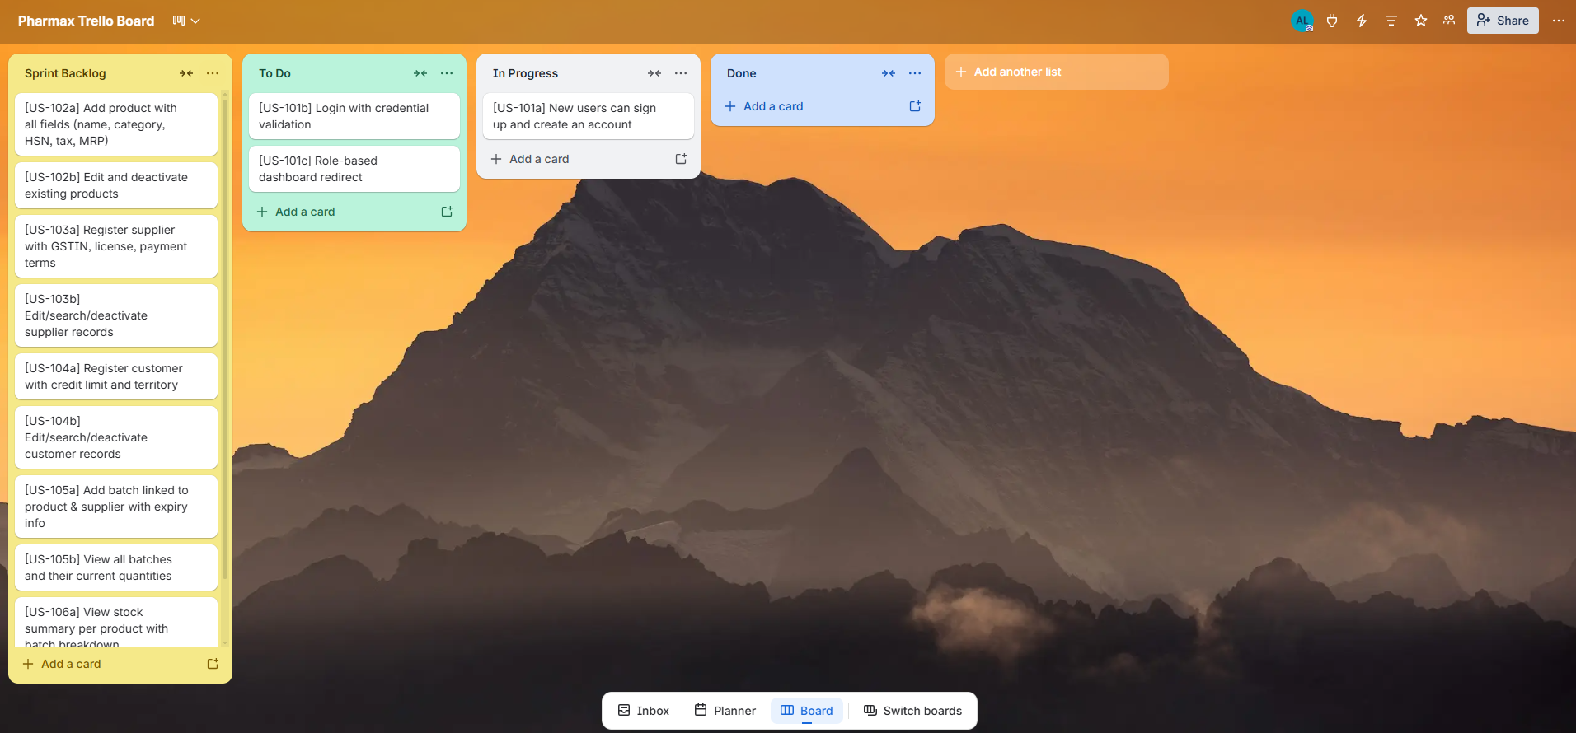

Snapshot 2 — Mid Sprint (US-101, US-102, US-103 Done; US-104 In Progress)
Trello Snapshot 2 — Mid Sprint
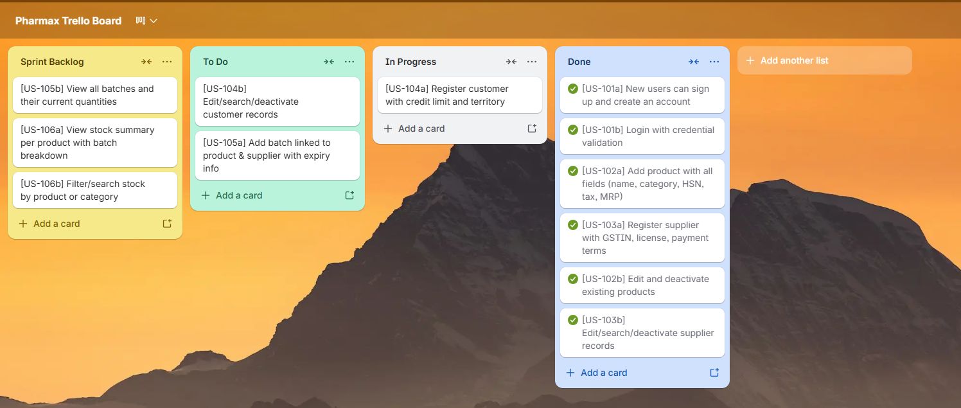

Snapshot 3 — Sprint End (All Stories Done)
Trello Snapshot 3 — Sprint End
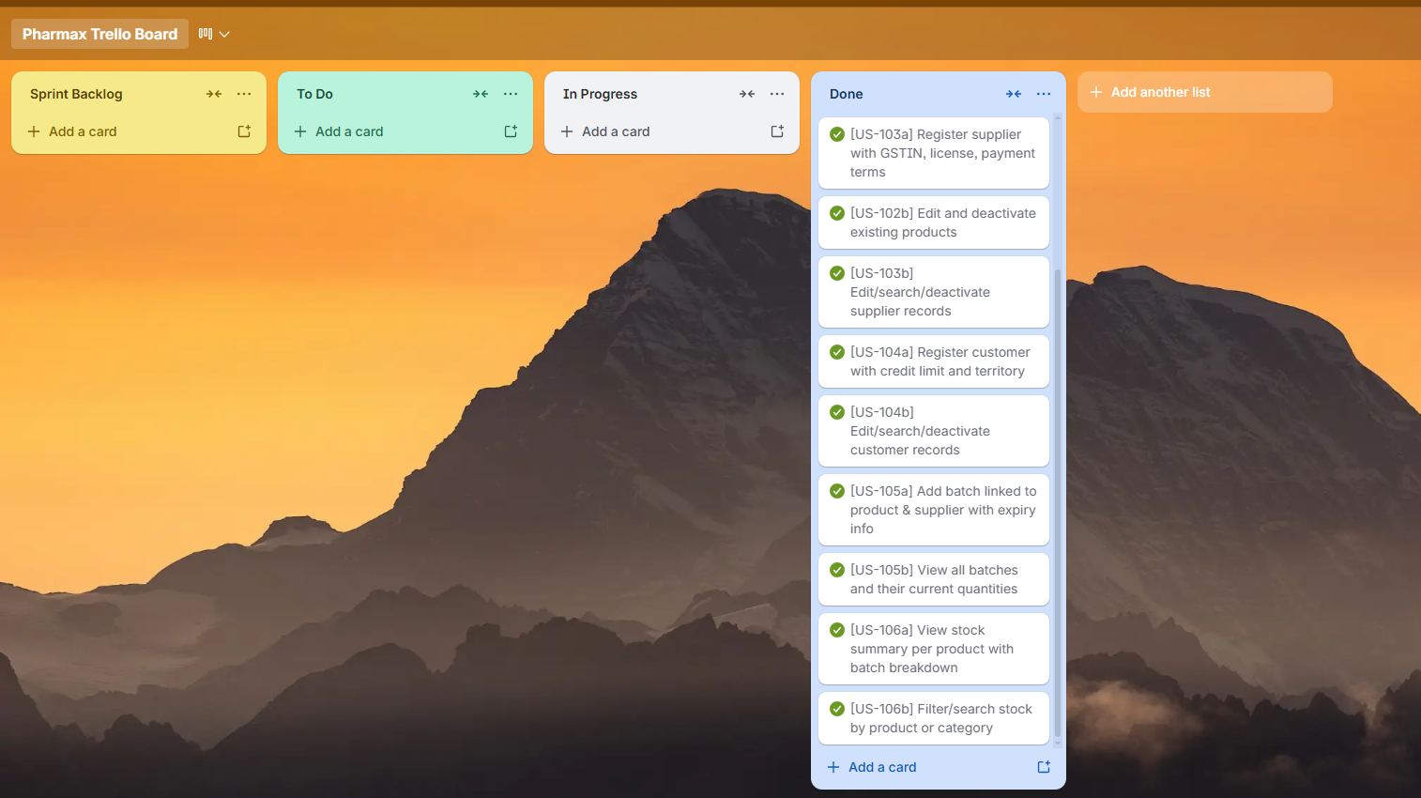

Product Burn-Down Chart — Sprint 1
The chart below shows planned versus completed story points over the sprint duration.

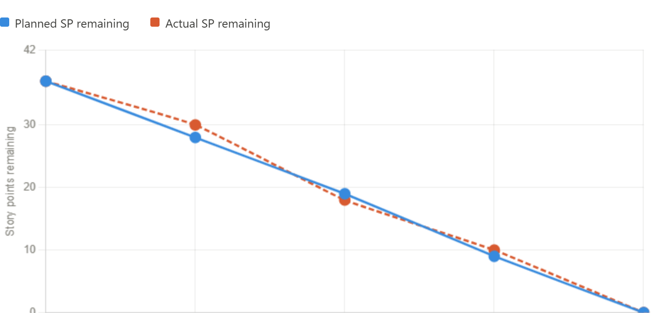
Total Story Points in Sprint 1: 37 SP. All story points were completed by Day 10 (end of sprint). The team closely tracked the ideal burn-down, with a slight deviation on Days 3–5 due to integration testing overhead on the Authentication module.

6. Non-Functional Requirements (NFR) Specification
The following NFRs apply specifically to the Sprint 1 modules (Authentication, Manufacturers, Products, Suppliers, Customers, Batches, Stock View) and are expressed using natural language specification.
NFR ID | Category | Requirement | Metric / Threshold
NFR-01 | Performance | The system shall load any module screen (Products, Customers, Suppliers, Batches, Stock) within 2 seconds on standard hardware. | < 2 seconds load time
NFR-02 | Security | All user passwords shall be stored as salted bcrypt hashes. No plain-text credentials shall ever be stored in the database. | 0 plain-text passwords in DB
NFR-03 | Security | Access to each module shall be restricted by role. Admin can access master data configuration; Distributor cannot access admin-only screens. | Role check enforced on every screen
NFR-04 | Usability | A new user with basic computer literacy shall be able to add a product record and a customer record within 5 minutes without training. | < 5 min task completion time
NFR-05 | Reliability | The system shall maintain 99% uptime during business hours (8 AM – 8 PM). Unplanned downtime shall not exceed 1 hour per month. | ≥ 99% uptime, ≤ 1 hr/month downtime
NFR-06 | Data Integrity | All master data entries shall be validated before saving. Duplicate product names, duplicate customer/supplier STRNs, and invalid DRAP drug schedules shall not be allowed. | 0 duplicates; 0 invalid schedules saved
NFR-07 | Scalability | The system shall handle up to 10,000 product records, 5,000 customers, and 20,000 batch records without performance degradation. | No degradation up to defined thresholds
NFR-08 | Maintainability | All modules shall follow a layered architecture (UI → Service → Repository → Database). No business logic shall reside in UI code. | Code review checklist passed

7. Iteration 1 — Implementation Screenshots
The following placeholders should be replaced with actual screenshots of the implemented modules:

Screen 1: Login Screen
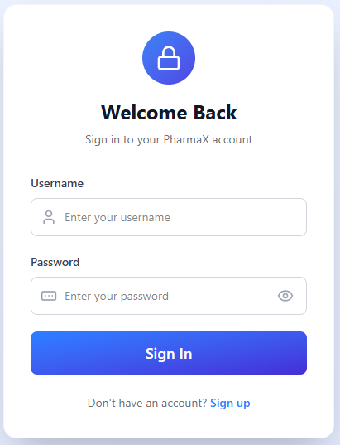
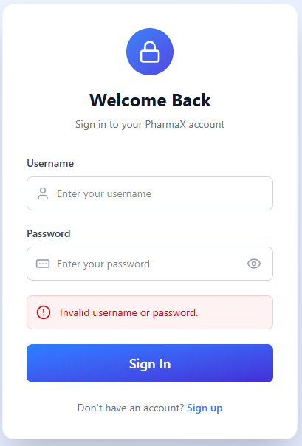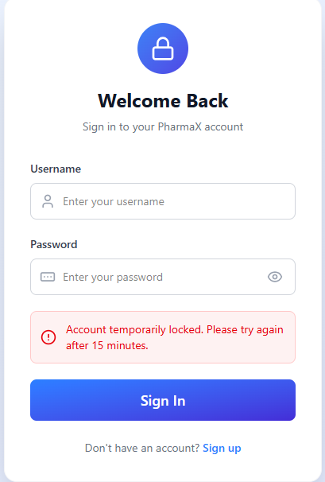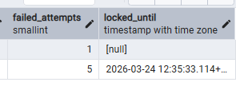

Screen 2: Sign-Up Screen
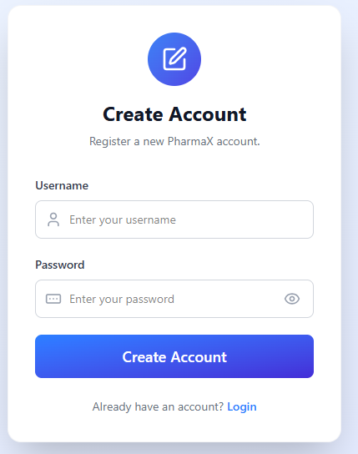
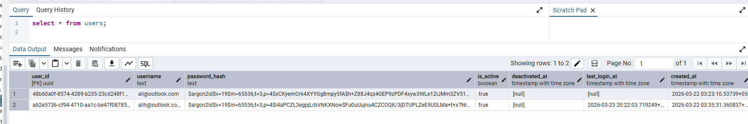

Screen 3: Admin Dashboard
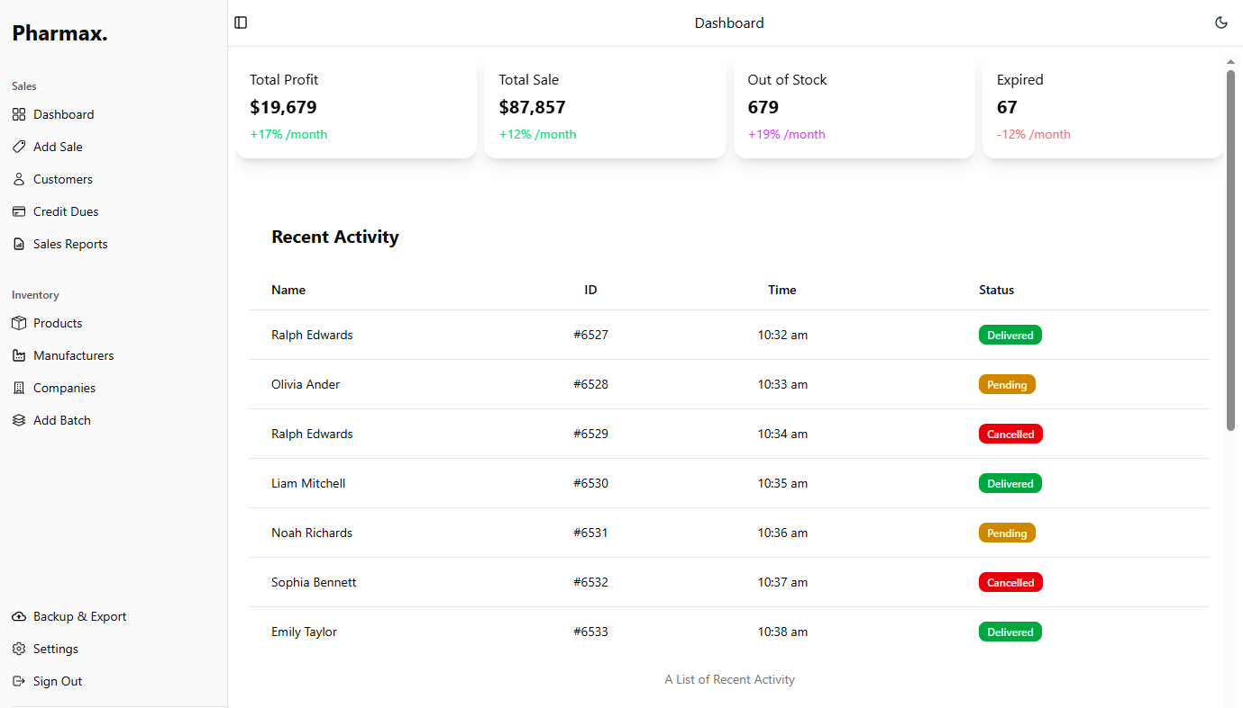

Screen 4: Products List
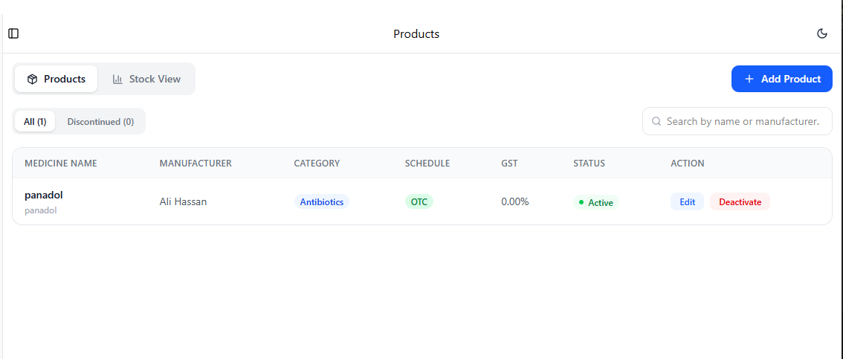

Screen 5: Add Product Form
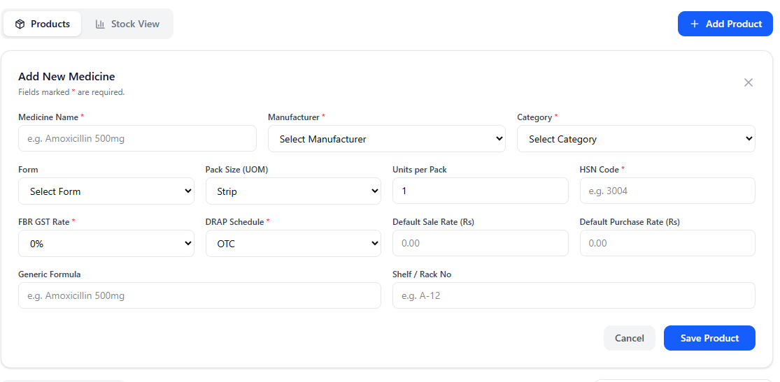

Screen 6: Suppliers List
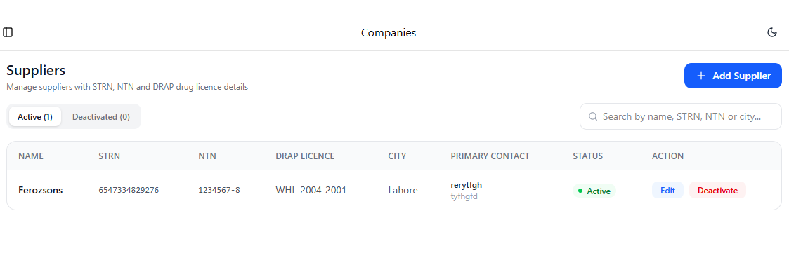
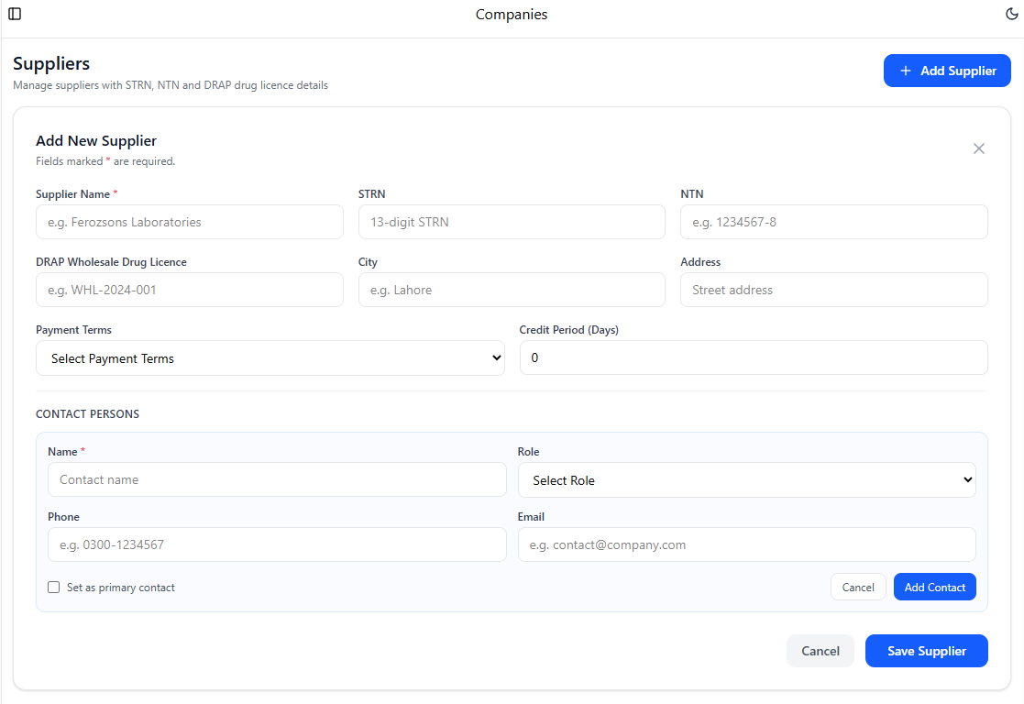

Screen 7: Customers List
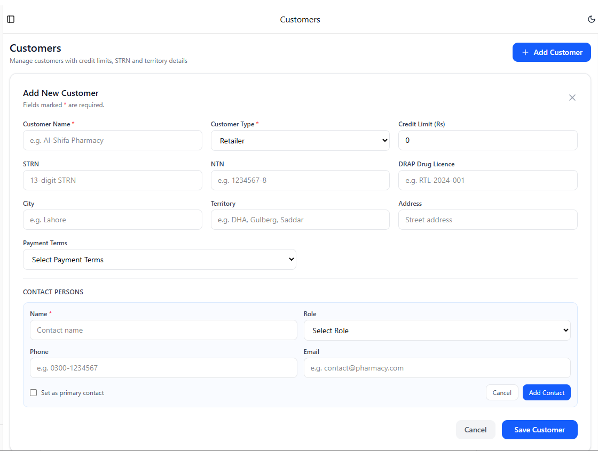
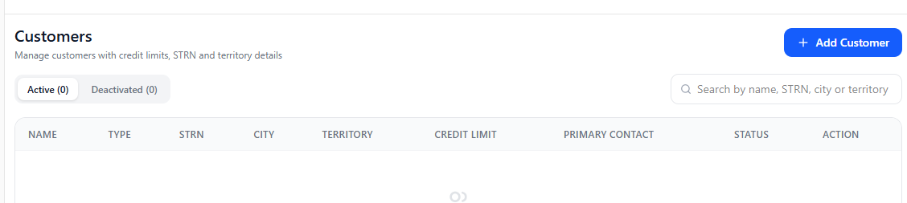

Screen 8: Add Batch Form
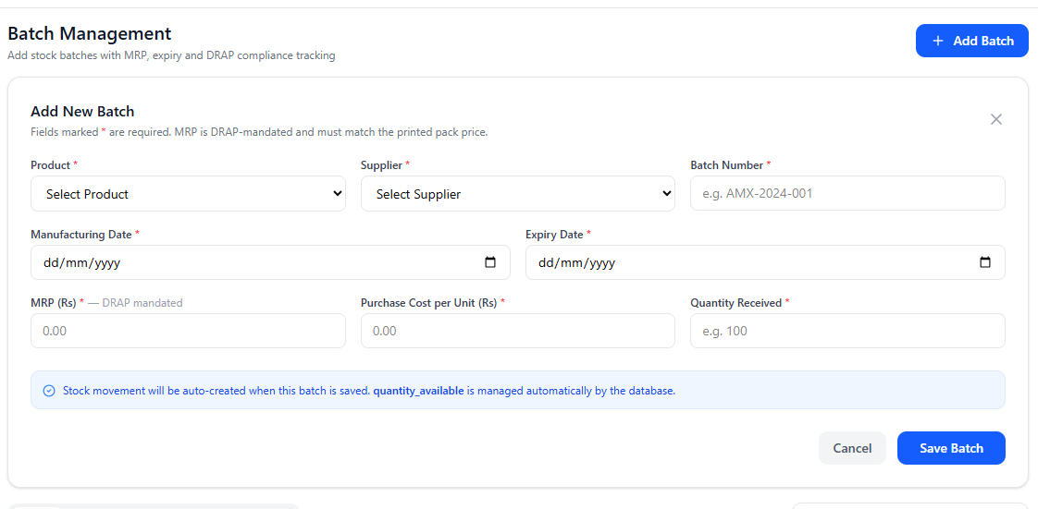

Screen 9: Batch List with Expiry Alerts
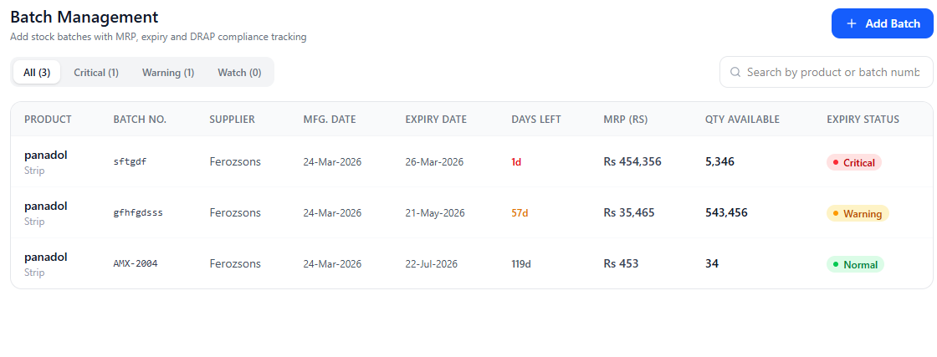

Screen 10: Stock View
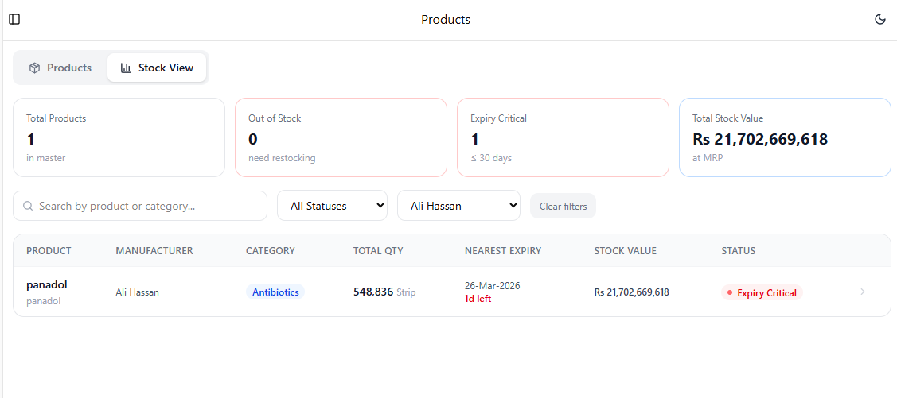

8. Work Division
The following table outlines the work breakdown among team members for Sprint 1.
Team Member | Roll No | Responsibilities in Sprint 1 | Deliverables
Muhammad Abdullah | 23L-0505 | Project lead, system architecture, PostgreSQL schema design, UI layout for Login & Dashboard, User Stories documentation | Login module, DB schema, Sprint backlog, Structured specs
Ali Hasan | 23L-0690 | Backend logic for Authentication, Products module, Batches module; database repository layer implementation | Auth module, Product CRUD, Batch management backend
Sheraz Malik | 23L-0572 | Suppliers & Customers module backend; Stock View screen; NFR specification; Trello board management | Supplier/Customer CRUD, Stock View, NFR table, Trello snapshots

