National University of Computer and Emerging Sciences
CS 3009 — Software Engineering

PharmaX
Pharmaceutical Distribution Management System

Project Deliverable #3 — Iteration 2 / Sprint 2
Delivered To: Ms. Ansa Liaqat

Name | Roll No
Ali Hasan | 23L-0690
Muhammad Abdullah | 23L-0505
Sheraz Malik | 23L-0572

Department of
Computer Science
FAST-NU, Lahore, Pakistan
Date: April 2026

1. Project Introduction
PharmaX is a desktop-based, centralised application engineered for Pakistani pharmaceutical wholesale distributors. It eliminates reliance on fragmented tools — spreadsheets, paper registers, and disconnected billing software — by providing a fully integrated platform for master data management, inventory tracking, purchase/sales processing, financial ledgering, and data export, all within a single, role-based desktop application.

The system is designed in full compliance with Pakistan’s pharmaceutical regulatory framework: DRAP (Drug Regulatory Authority of Pakistan) for drug scheduling and batch tracking, and FBR (Federal Board of Revenue) for GST/tax invoicing. Key Pakistan-specific features include STRN/NTN identification for suppliers and customers, DRAP drug schedule classification (OTC / G / H / H1 / X), batch-level MRP (Maximum Retail Price as mandated by DRAP), and payment modes including JazzCash and EasyPaisa.

Sprint 2 builds directly on the foundation established in Sprint 1 (Authentication & Master Data). Sprint 2 focuses on the Purchase & Sales Core module — covering Purchase Invoice (GRN) creation, Sales Invoice generation with automatic GST computation, Purchase Returns, Sales Returns, Near-Expiry Batch Alerts, Customer Ledger, and Supplier Ledger. Together these modules form the transactional engine of PharmaX.

2. Sprint Backlog — Sprint 2

2a. Module for Sprint 2
Module Name: Purchase & Sales Core

This module delivers the complete transactional engine of PharmaX. It covers:
- Purchase Invoice / GRN (Goods Receipt Note) creation with batch-wise stock update
- Sales Invoice generation with FEFO batch selection, scheme/discount support, and automatic GST computation
- Purchase Returns — recording returns to suppliers and adjusting stock and payables
- Sales Returns — processing customer returns, adjusting inventory and receivables
- Near-Expiry Alerts — automated warnings for batches expiring within 30, 60, and 90 days
- Customer Ledger — real-time account view per customer including dues, ageing, and credit limit status
- Supplier Ledger — outstanding payables, payment history, and reconciliation per supplier

2b. Sprint Backlog Table
Story ID | User Story | Priority | SP | Status
US-201 | Create Purchase Invoice (GRN) | Critical | 8 | Done
US-201a | Create GRN by selecting supplier and adding product lines with batch details | Critical | 5 | Done
US-201b | Auto-update stock on GRN save and link batch to purchase record | Critical | 3 | Done
US-202 | Generate Sales Invoice with GST | Critical | 9 | Done
US-202a | Create sales invoice with FEFO batch auto-selection per product line | Critical | 5 | Done
US-202b | Apply schemes/discounts and compute GST automatically; deduct stock on save | Critical | 4 | Done
US-203 | Record Purchase Returns | High | 5 | Done
US-203a | Record return against a purchase invoice, specify batch and quantity returned | High | 3 | Done
US-203b | Adjust stock and supplier payable automatically on return save | High | 2 | Done
US-204 | Process Sales Returns | High | 5 | Done
US-204a | Process sales return against a sales invoice and credit the customer account | High | 3 | Done
US-204b | Restore batch stock on sales return and update customer ledger | High | 2 | Done
US-205 | Near-Expiry Batch Alerts | High | 4 | Done
US-205a | Show dashboard alert for batches expiring within 30 days (Critical) | High | 2 | Done
US-205b | Show warning for batches 31-60 days from expiry; block sale of expired batches | High | 2 | Done
US-206 | View Customer Ledger & Outstanding Dues | High | 5 | Done
US-206a | View running account per customer with sales, returns, payments, and balance | High | 3 | Done
US-206b | Show ageing analysis (0-30, 31-60, 61-90, 90+ days overdue) and credit limit status | Medium | 2 | Done
US-207 | View Supplier Ledger & Outstanding Payables | High | 5 | Done
US-207a | View running account per supplier with purchases, returns, payments made, and balance | High | 3 | Done
US-207b | Filter supplier ledger by date range and export outstanding payables list | Medium | 2 | Done

3. User Stories

US-201 — Create Purchase Invoice (GRN)
Use Case ID | UC-201
Use Case Name | Create Purchase Invoice / Goods Receipt Note (GRN)
Actor(s) | Distributor, Admin
Preconditions | 1. Distributor is logged in. 2. At least one supplier, one product, and one batch exist in the system. 3. Distributor is on the Purchase Invoice screen.
Postconditions | 1. A GRN record is saved and linked to the selected supplier. 2. Batch-level stock is updated in real time. 3. Supplier payable ledger reflects the new outstanding amount.
User Story | As a distributor, I want to create purchase invoices from suppliers and record incoming batches so that I can accurately track stock arrivals and supplier liabilities.
Sub User Stories | • As a distributor, I want to create a GRN by selecting a supplier and adding product lines with batch, quantity, and purchase rate so that incoming stock is recorded precisely.• As a distributor, I want stock levels to update automatically when a GRN is saved so that inventory is always current without manual adjustment.
Acceptance Criteria | • GRN form must capture: supplier, invoice date, invoice number, and one or more product lines (product, batch, quantity, purchase rate, GST rate).• Stock must be updated in real time upon GRN save.• Supplier payable must increase by the GRN total on save.• Duplicate supplier invoice numbers must be blocked with a clear error.
Alt Flow A: Duplicate Invoice Number | System displays: 'A GRN with this supplier invoice number already exists. Please verify before saving.'
Alt Flow B: Insufficient Batch Stock | If a product line references a batch with zero or insufficient stock for editing purposes, system warns: 'Batch quantity cannot be negative.'
Exceptions | E1 — Mandatory Fields Empty: All required fields must be filled; system shows inline validation errors.E2 — Invalid Quantity: Quantity must be a positive integer; system rejects zero or negative values with a clear error.

US-202 — Generate Sales Invoice with GST
Use Case ID | UC-202
Use Case Name | Generate Sales Invoice with Automatic GST
Actor(s) | Distributor
Preconditions | 1. Distributor is logged in. 2. At least one customer and one product batch with available stock exist. 3. Distributor is on the Sales Invoice screen.
Postconditions | 1. A sales invoice is saved and linked to the selected customer. 2. Batch stock is deducted using FEFO logic. 3. Customer receivable ledger reflects the new outstanding amount. 4. A GST-compliant invoice is generated.
User Story | As a distributor, I want to generate sales invoices to customers with automatic GST calculation and FEFO batch selection so that customers are billed correctly and stock is reduced from the earliest expiry batch first.
Sub User Stories | • As a distributor, I want to add product lines to a sales invoice where the system automatically selects the earliest-expiry batch (FEFO) so that near-expiry stock is cleared first.• As a distributor, I want the system to apply any scheme or trade discount and compute the applicable GST automatically so that the invoice is accurate and FBR-compliant.
Acceptance Criteria | • Sales invoice form must capture: customer, invoice date, and one or more product lines (product, batch, quantity, sale rate, scheme/discount, GST rate).• FEFO batch selection must be the default; distributor may override manually.• GST must be computed per FBR slab linked to each product.• Stock deduction must occur immediately on invoice save.• System must block saving an invoice if stock is insufficient for any line item.
Alt Flow A: Insufficient Stock | System highlights the affected line and displays: 'Insufficient stock for [Product Name] — Batch [X]. Available: [Y] units.'
Alt Flow B: Expired Batch Selected | System blocks the selection and displays: 'Batch [X] has expired and cannot be sold.'
Exceptions | E1 — Customer Credit Limit Exceeded: System warns: 'This invoice will exceed the customer’s credit limit of PKR [X]. Proceed?' Admin override required.E2 — Mandatory Fields Empty: Inline validation triggers for any empty required field.

US-203 — Record Purchase Returns
Use Case ID | UC-203
Use Case Name | Record Purchase Return to Supplier
Actor(s) | Distributor, Admin
Preconditions | 1. Distributor is logged in. 2. A purchase invoice (GRN) exists against which the return will be recorded.
Postconditions | 1. A purchase return record is saved and linked to the original GRN. 2. Batch stock is reduced by the returned quantity. 3. Supplier payable is reduced by the return value.
User Story | As a distributor, I want to record purchase returns against supplier GRNs and automatically adjust inventory and payables so that stock and financial records remain accurate after returns.
Sub User Stories | • As a distributor, I want to select an existing GRN and specify the batch and quantity to return so that the return is traceable to its original purchase.• As a distributor, I want inventory and the supplier payable to update automatically on return save so that no manual reconciliation is needed.
Acceptance Criteria | • Purchase return form must reference an original GRN; open GRN lookup by supplier invoice number or GRN ID.• Returned quantity must not exceed the original purchased quantity for that batch.• Batch stock must decrease and supplier payable must decrease on save.• Return record must be auditable with GRN reference and timestamp.
Alt Flow A: Quantity Exceeds Purchased | System displays: 'Return quantity exceeds the purchased quantity for this batch. Maximum returnable: [X] units.'
Exceptions | E1 — GRN Not Found: System displays a search dialog to locate the GRN by supplier or invoice number.E2 — Zero Quantity: System rejects with 'Return quantity must be greater than zero.'

US-204 — Process Sales Returns
Use Case ID | UC-204
Use Case Name | Process Sales Return from Customer
Actor(s) | Distributor
Preconditions | 1. Distributor is logged in. 2. A sales invoice exists against which the return will be processed.
Postconditions | 1. A sales return (credit note) record is saved and linked to the original invoice. 2. Batch stock is restored. 3. Customer receivable is reduced by the return value.
User Story | As a distributor, I want to process sales returns from customers, restore stock, and adjust the customer’s outstanding balance so that inventory and receivables are always accurate.
Sub User Stories | • As a distributor, I want to select an original sales invoice and specify the batch and quantity being returned by the customer so that the return is fully traceable.• As a distributor, I want the returned batch stock to be restored and the customer’s ledger to be credited automatically on return save.
Acceptance Criteria | • Sales return form must reference an original sales invoice; lookup by invoice number or customer.• Returned quantity must not exceed the sold quantity on the original invoice line.• Batch stock must be restored and customer ledger credited on save.• Expired batch stock returned must be flagged for manual review before being added back to available stock.
Alt Flow A: Quantity Exceeds Sold | System displays: 'Return quantity exceeds the sold quantity on the original invoice. Maximum: [X] units.'
Alt Flow B: Returned Batch Expired | System flags the returned batch with a warning: 'This batch has expired. Returned stock will be quarantined pending review.'
Exceptions | E1 — Invoice Not Found: System provides a search dialog by customer name or invoice number.E2 — Zero Quantity: System rejects with 'Return quantity must be greater than zero.'

US-205 — Near-Expiry Batch Alerts
Use Case ID | UC-205
Use Case Name | Near-Expiry Batch Alert System
Actor(s) | Distributor, Admin
Preconditions | 1. At least one batch exists in the system with a future expiry date.
Postconditions | 1. Distributor is notified of near-expiry batches on login and from the dashboard. 2. Expired batches are blocked from appearing in sales invoice batch selection.
User Story | As a distributor, I want to receive automatic alerts for batches nearing expiry and be prevented from selling expired stock so that I can take timely action and avoid compliance violations.
Sub User Stories | • As a distributor, I want the dashboard to display a count of Critical (0–30 days), Warning (31–60 days), and Watch (61–90 days) batches upon login so that I can prioritise action.• As a distributor, I want the system to block selection of expired batches during sales invoice creation and display a clear error so that no expired medicine is inadvertently sold.
Acceptance Criteria | • Dashboard must display near-expiry summary: Critical (≤30 days), Warning (31–60 days), Watch (61–90 days).• Batch list must colour-code rows: red for Critical, amber for Warning, yellow for Watch.• Expired batches must not appear in the sales invoice batch dropdown.• Alert thresholds must be configurable by Admin (default: 30 / 60 / 90 days).
Alt Flow: All Batches Safe | If no batches fall within the alert thresholds, the dashboard displays: 'No near-expiry alerts at this time.'
Exceptions | E1 — Batch Data Unavailable: System logs the error and displays 'Unable to load expiry data. Contact administrator.'

US-206 — View Customer Ledger & Outstanding Dues
Use Case ID | UC-206
Use Case Name | Customer Ledger and Receivables View
Actor(s) | Distributor, Admin
Preconditions | 1. At least one customer with at least one sales transaction exists.
Postconditions | 1. Distributor has a complete view of a customer’s transaction history, current balance, ageing, and credit limit status.
User Story | As a distributor, I want to view each customer’s ledger showing all sales, returns, payments received, outstanding dues, and ageing analysis so that I can manage credit control effectively.
Sub User Stories | • As a distributor, I want to open a customer’s ledger and see a running account of all invoices, returns, and payments with a current outstanding balance.• As a distributor, I want to view an ageing analysis table showing how much of the customer’s balance falls in each ageing bucket (0–30, 31–60, 61–90, 90+ days) so that I can prioritise collection.
Acceptance Criteria | • Customer ledger must show: date, transaction type (invoice / return / payment), reference number, debit, credit, and running balance.• Ageing analysis must be displayed as a summary table: 0–30 days, 31–60 days, 61–90 days, 90+ days.• Credit limit utilisation must be shown as: Used / Total Limit and flagged if exceeded.• Ledger must load within 2 seconds for up to 5,000 transactions.
Alt Flow: No Transactions | If the customer has no transactions, the ledger screen displays: 'No transactions found for this customer.'
Exceptions | E1 — Customer Not Found: System provides a search dialog.E2 — Data Load Failure: System displays a retry prompt.

US-207 — View Supplier Ledger & Outstanding Payables
Use Case ID | UC-207
Use Case Name | Supplier Ledger and Payables View
Actor(s) | Distributor, Admin
Preconditions | 1. At least one supplier with at least one purchase transaction exists.
Postconditions | 1. Distributor has a full view of each supplier’s payable balance, transaction history, and payment status.
User Story | As a distributor, I want to view each supplier’s ledger showing purchases, returns, payments made, and outstanding payables so that I can manage cash flow and supplier relationships responsibly.
Sub User Stories | • As a distributor, I want to open a supplier’s ledger and see all GRNs, purchase returns, and payments with a running outstanding balance.• As a distributor, I want to filter the supplier ledger by date range so that I can view payables for any specific period.
Acceptance Criteria | • Supplier ledger must show: date, transaction type (GRN / return / payment), reference number, debit, credit, and running balance.• Date range filter must allow any custom from/to date selection.• Total outstanding payable must be prominently displayed at the top of the screen.• Ledger must load within 2 seconds for up to 5,000 records.
Alt Flow: No Transactions | If the supplier has no transactions, the ledger displays: 'No transactions found for this supplier.'
Exceptions | E1 — Supplier Not Found: Search dialog provided.E2 — Data Load Failure: System displays a retry prompt.

4. Structured Specifications

4.1 Sub-Story Structured Specifications: Purchase Invoice (US-201)
US-201.1: Create GRN by selecting supplier and adding product lines
Type | Specification
Functional | GRN form must capture: supplier (dropdown), invoice date, supplier invoice number, and one or more product lines (product, batch, quantity, purchase rate per unit, GST rate).
Functional | System must automatically calculate line totals (quantity × purchase rate) and the overall GRN total inclusive of GST.
Functional | Duplicate supplier invoice numbers must be detected on save and blocked with a clear error message.
UX | Product lines must be addable dynamically; each line must have a remove button.

US-201.2: Auto-update stock on GRN save
Type | Specification
Functional | On GRN save, each product batch’s quantity in the stock ledger must be increased by the GRN line quantity.
Functional | A stock movement record (type: Purchase) must be created for each GRN line, referencing the GRN ID.
Data Integrity | GRN save and stock update must occur within a single database transaction; partial saves are not permitted.

4.2 Sub-Story Structured Specifications: Sales Invoice (US-202)
US-202.1: Create sales invoice with FEFO batch auto-selection
Type | Specification
Functional | Sales invoice form must capture: customer (dropdown), invoice date, and one or more product lines (product, quantity, batch, sale rate, scheme/discount).
Functional | Default batch selection must follow FEFO (First Expired, First Out) logic; manual batch override must be permitted.
Functional | System must block saving if available batch stock is less than the invoiced quantity for any line.
Performance | Batch stock lookup and FEFO selection must complete within 1 second per product line addition.

US-202.2: Apply schemes/discounts and compute GST automatically
Type | Specification
Functional | System must compute GST per line using the FBR GST slab linked to each product (0 / 5 / 12 / 18 / 28%).
Functional | Scheme (e.g. 10+1 free) and trade discount (percentage or flat amount) must be supported per line and reflected in the taxable value.
Functional | Stock must be deducted from the selected batch on invoice save within a single database transaction.
Security | System must check customer credit limit before save; if exceeded, Admin override confirmation is required.

4.3 Sub-Story Structured Specifications: Purchase Returns (US-203)
US-203.1: Record return against a purchase invoice
Type | Specification
Functional | Purchase return form must reference an existing GRN; GRN lookup by supplier invoice number or GRN ID must be supported.
Functional | System must validate that returned quantity does not exceed the original purchased quantity for the selected batch.
Data Integrity | Return record must store: original GRN ID, batch, quantity returned, return date, and reason.

US-203.2: Adjust stock and supplier payable on return save
Type | Specification
Functional | Batch stock must decrease by the returned quantity on return save.
Functional | Supplier payable ledger must decrease by the return value (quantity × purchase rate) on return save.
Data Integrity | Stock reduction and payable adjustment must occur within a single database transaction.

4.4 Sub-Story Structured Specifications: Sales Returns (US-204)
US-204.1: Process return against a sales invoice and credit customer
Type | Specification
Functional | Sales return form must reference an existing sales invoice; lookup by invoice number or customer name must be supported.
Functional | System must validate that returned quantity does not exceed the sold quantity on the original invoice line.
Data Integrity | Return record must store: original invoice ID, batch, quantity returned, return date, and reason.

US-204.2: Restore batch stock and update customer ledger
Type | Specification
Functional | Batch stock must be restored by the returned quantity on save.
Functional | Customer receivable must decrease (credit entry) by the return value on save.
Functional | If the returned batch is expired, the system must quarantine the restored stock and flag it for manual review.
Data Integrity | Stock restoration and ledger credit must occur within a single database transaction.

4.5 Sub-Story Structured Specifications: Near-Expiry Alerts (US-205)
US-205.1: Dashboard alert for Critical batches (0-30 days)
Type | Specification
Functional | Dashboard must compute and display counts for Critical (≤30 days), Warning (31–60 days), and Watch (61–90 days) batches on login.
Functional | Batch list rows must be colour-coded: red (Critical), amber (Warning), yellow (Watch).
Performance | Alert counts must load within 2 seconds of login for up to 20,000 batch records.

US-205.2: Block sale of expired batches
Type | Specification
Functional | Expired batches must be excluded from the batch selection dropdown in the sales invoice screen.
Functional | If a distributor attempts to manually enter an expired batch number, the system must reject it with a clear error.
UX | Alert thresholds (30 / 60 / 90 days) must be configurable by Admin from the system settings screen.

4.6 Sub-Story Structured Specifications: Customer Ledger (US-206)
US-206.1: View running account per customer
Type | Specification
Functional | Customer ledger must display: date, transaction type, reference number, debit amount, credit amount, and running balance for all transactions.
Functional | Credit limit utilisation indicator must show: Amount Used / Total Credit Limit, highlighted in red if exceeded.
Performance | Ledger must load within 2 seconds for up to 5,000 customer transactions.

US-206.2: Ageing analysis
Type | Specification
Functional | Ageing table must categorise outstanding receivables into: 0–30 days, 31–60 days, 61–90 days, 90+ days.
Functional | Each bucket must show the total outstanding amount in PKR.
UX | Ageing summary must be displayed prominently at the top of the ledger screen before the transaction detail table.

4.7 Sub-Story Structured Specifications: Supplier Ledger (US-207)
US-207.1: View running account per supplier
Type | Specification
Functional | Supplier ledger must display: date, transaction type, reference number, debit, credit, and running balance.
Functional | Total outstanding payable must be prominently displayed at the top of the screen.
Performance | Ledger must load within 2 seconds for up to 5,000 records.

US-207.2: Filter by date range and export payables
Type | Specification
Functional | Date range filter (From / To date pickers) must restrict the displayed ledger transactions to the selected period.
Functional | An export function must allow exporting the filtered ledger view to Excel/CSV format.
UX | Filter controls must be accessible at the top of the supplier ledger screen at all times.

5. Scrum Board — Trello
The Sprint 2 backlog was managed using Trello following the same Kanban-style layout as Sprint 1, with four columns: To Do, In Progress, In Review, and Done. Three snapshots were captured at different stages of the sprint.

Snapshot 1 — Sprint Start (All Stories in 'To Do')
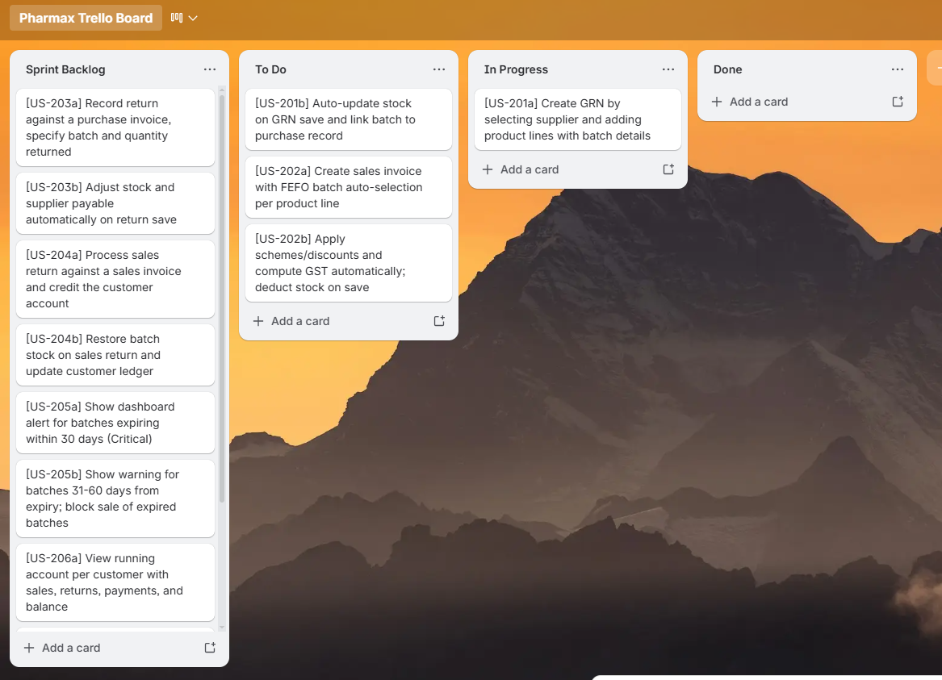

Snapshot 2 — Mid Sprint 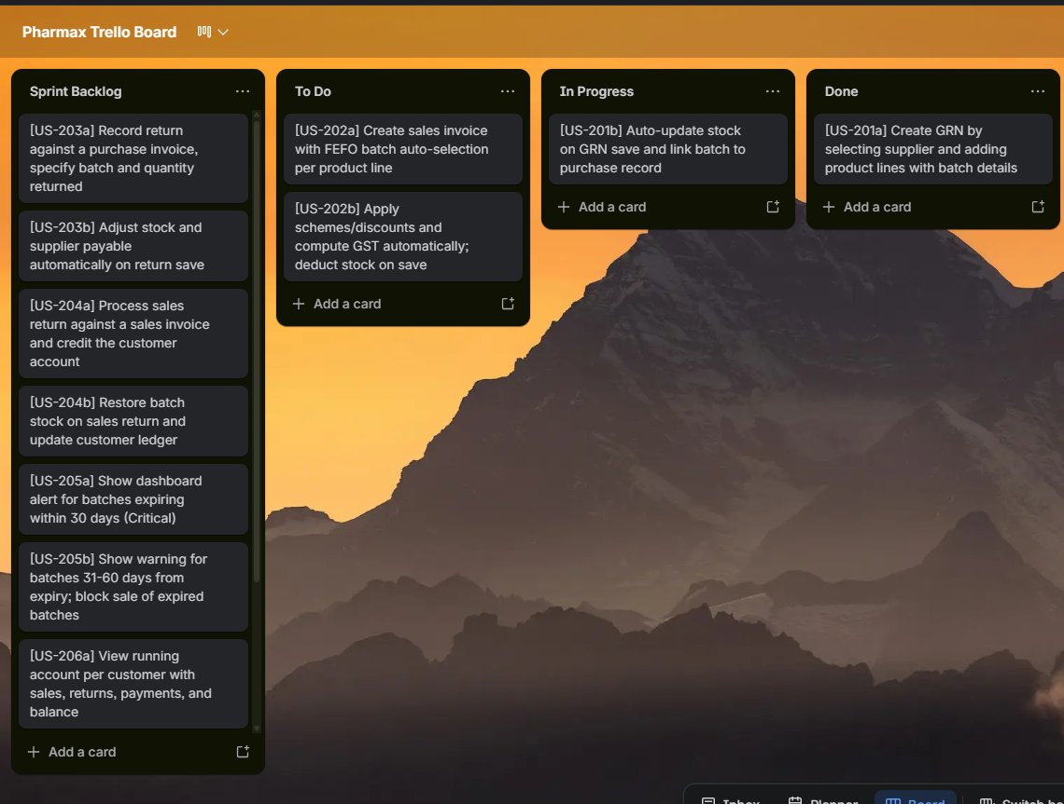

Snapshot 3 — Sprint End
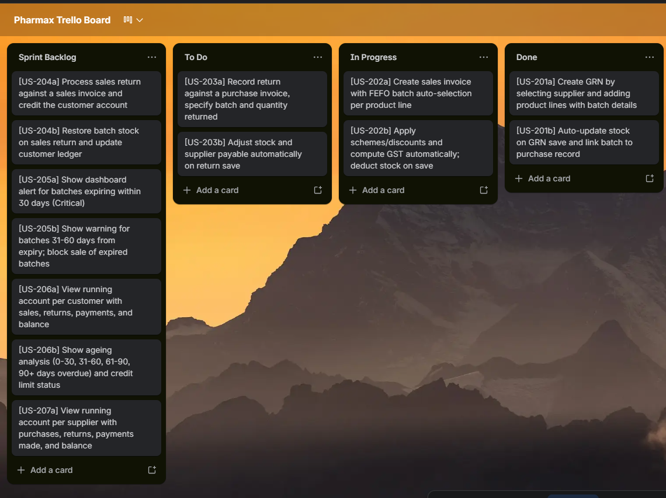

Product Burn-Down Chart — Sprint 2
Total Story Points in Sprint 2: 41 SP. All story points were completed by Day 14 (end of sprint). The burn-down chart below shows planned versus actual story points completed over the sprint duration.

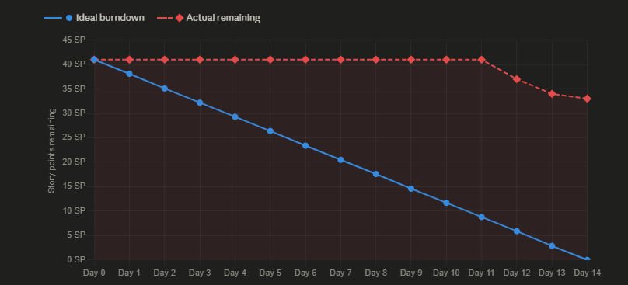

6. Iteration 2 — Implementation Screenshots
The following placeholders should be replaced with actual screenshots of the implemented Sprint 2 modules:

Screen 1: Purchase Invoice (GRN) — Create New
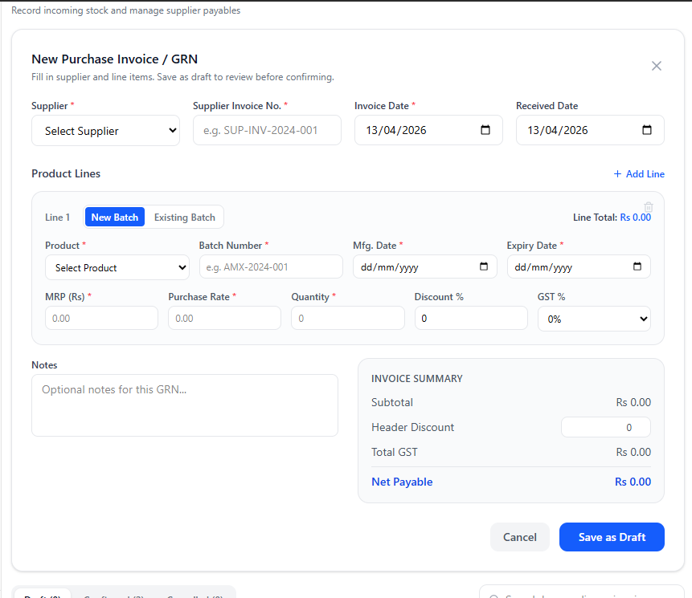

Screen 2: Purchase Invoice — GRN List
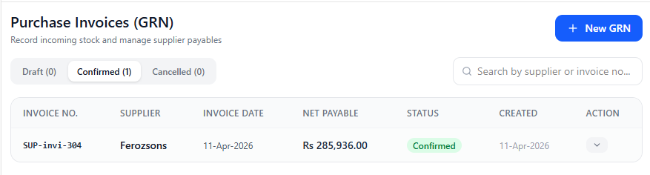

7. Work Division
The following table outlines the work breakdown among team members for Sprint 2.

Team Member | Roll No | Responsibilities in Sprint 2 | Deliverables
Muhammad Abdullah | 23L-0505 | Project lead; system architecture design; database schema for Sprint 2 tables (invoices, returns, ledgers); UI layout for Sales Invoice and Customer Ledger screens; User Stories documentation | Sales Invoice module, Customer Ledger screen, Sprint backlog, Structured specs, Architecture & class diagrams
Ali Hassan | 23L-0690 | Backend logic for Purchase Invoice (GRN) and Purchase Return modules; stock movement repository layer; FEFO batch selection algorithm implementation | GRN module, Purchase Return module, FEFO algorithm, stock movement records, DFD & sequence diagrams
Sheraz Malik | 23L-0572 | Sales Return module backend; Near-Expiry Alert service; Supplier Ledger screen; NFR specification for Sprint 2; Trello board management and snapshots | Sales Return module, Expiry Alert service, Supplier Ledger, NFR table, Trello snapshots, activity & use case diagrams

