University of Central Punjab – Faculty of Information Technology | DevOps Fundamentals – Spring, 2026
DevOps Fundamentals [Spring, 2026]
TERM PROJECT – Multi-Environment CI/CD Pipeline with Static Web Application
Total Marks: 100 | Weeks Covered: 1 – 16 | CLO: CLO1, CLO2, CLO3

OBJECTIVES
Teams will design and implement a complete, production-grade CI/CD pipeline for a containerized static web application across three isolated software environments: Development, Staging, and Production. Each environment has its own dedicated CI workflow (triggered on a Pull Request) and its own dedicated CD workflow (triggered on a merge/push), giving six GitHub Actions workflow files in total. Each team member authors exactly one workflow file and exactly one web page.

GROUP DETAILS
Table 1: Group Details – Each student must fill their own row (including Assigned Workflow File and Assigned Page) in the versioned copy inside the repository.

Sr # | Student Name | GitHub Username | Role (Lead/Member) | Assigned Workflow File | Assigned Page | Branch Worked On | Screenshots Added (Y/N)
1 | Muhammad Ahmad Zaheer | M-Ahmad561Zaheer | Team Lead | ci-dev.yml  ci-prod.yml | index.html | feature/M-Ahmad561Zaheer/index | Y
2 | Umer Akram | umerakramoffical | Member | cd-dev.yml | lahore.html | feature/UMERAKRAMOFFICIAL/lahore | Y
3 | Abdullah Naveed  Akbar | abdullahnaveedakbar | Member | ci-staging.yml | hunza.html | feature/abdullahnaveedakbar/hunza | Y
4 | Usama | Usama00150 | Member | cd-staging.yml | karachi.html  swat.html | feature/usama/south-north | Y

Group Repository URL: https://github.com/M-Ahmad561Zaheer/pakvista-cicd

Deployed Application URLs:
Development: https://pakvista-cicd-ppqeuptph-ahmad561s-projects.vercel.app/
Staging: pakvista-cicd-git-staging-ahmad561s-projects.vercel.app
Production: pakvista-cicd.vercel.app

SUBMISSION REQUIREMENTS
The Team Lead must submit the following on LMS:

- Completed Term Project document with all group details filled in (Table 1), including each member's Assigned Workflow File and Assigned Page.
- GitHub repository URL (must be public or shared with the instructor).
- All three Render live application URLs (Development, Staging, Production).
- Screenshot 1: GitHub repository showing all three GitHub Environments (development, staging, production) with their respective secrets configured.
- Screenshot 2: Each member's CI workflow run (ci-dev.yml) triggered by their individual PR – all steps green. One screenshot per member or a combined view showing all members' runs.
- Screenshot 3: Docker Hub repository page showing pushed images with all correct environment-specific tags (dev-latest, staging-latest, prod-latest, along with SHA-tagged variants).
- Screenshot 4: All three CD workflow runs (cd-dev.yml, cd-staging.yml, cd-prod.yml) – deploy step completed and confirmation echo visible.
- Screenshot 5: Live PakVista site on each of the three Render services showing all five pages are accessible (three screenshots total, one per environment).
- Screenshot 6: The Term Project .docx file visible in the GitHub repository file listing.
- Individual Reflection: Each team member must write 4–5 lines on what they learnt and any challenges they faced, especially regarding authoring a GitHub Actions workflow file and building their HTML page.

VERIFICATION SCREENSHOTS
Paste your verification screenshots in the table below. Label each one clearly.

Screenshot Label | Screenshot (Paste Here)
GitHub Environments (development, staging, production) & All Secrets | 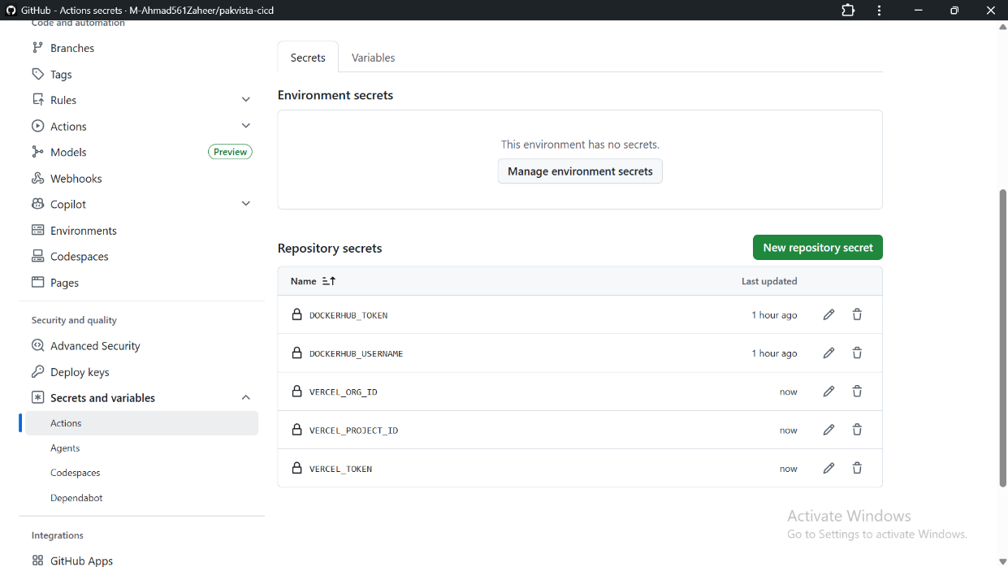  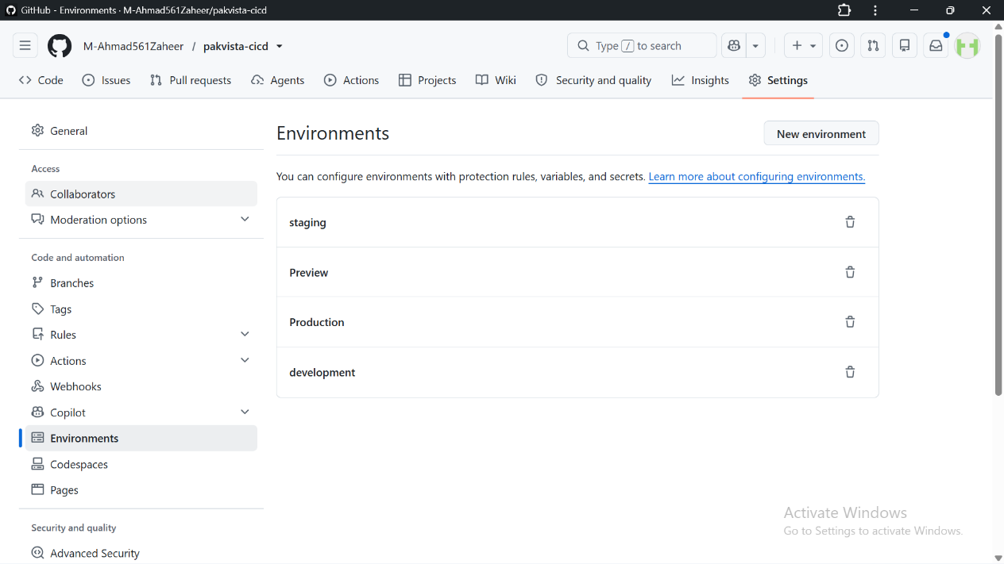
CI Workflow Runs – Triggered by each member's PR on develop (all steps green) | 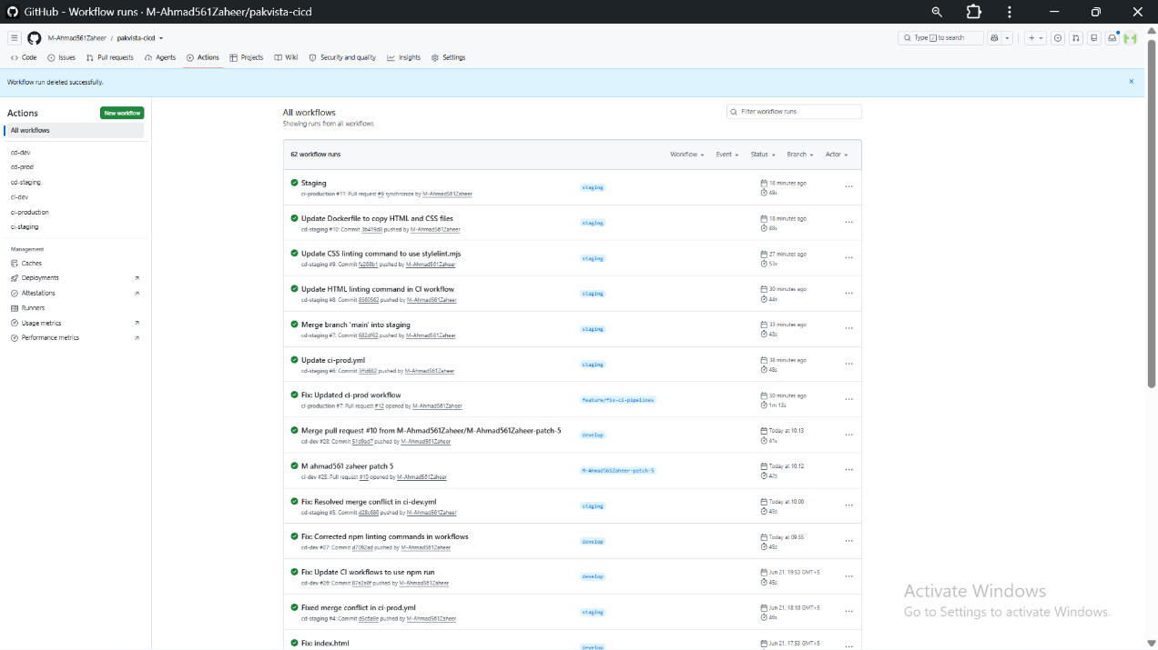
Docker Hub – Pushed Images with All Environment Tags (dev, staging, prod) | 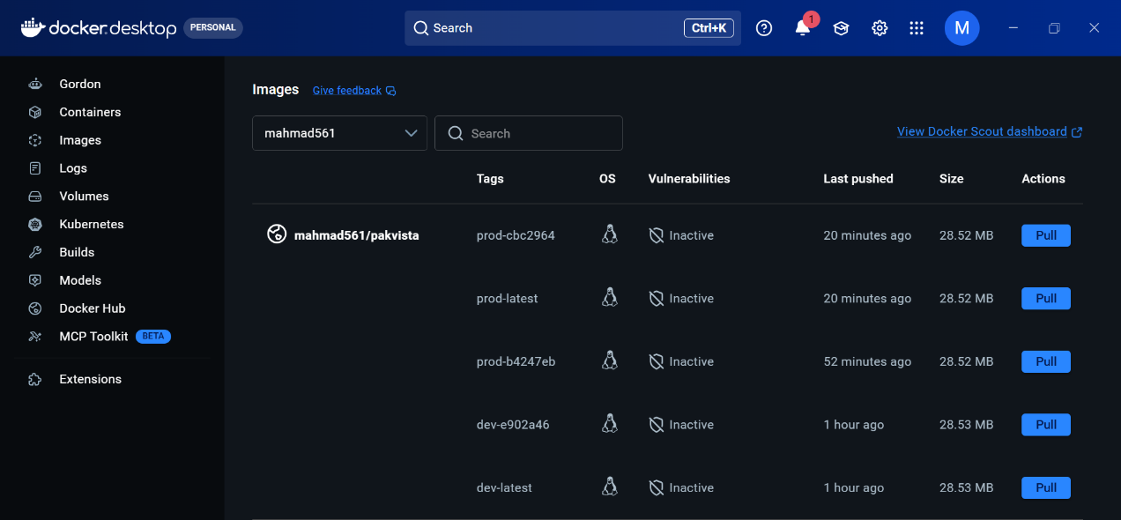
CD Workflow Runs – All three environments triggered by push events | 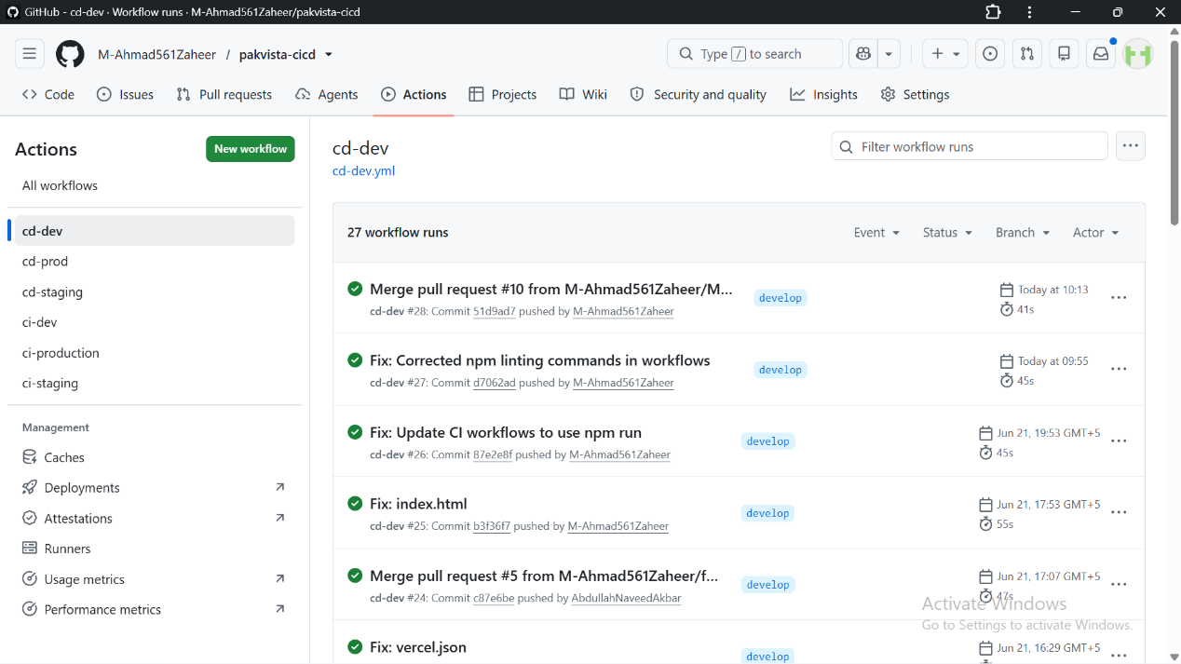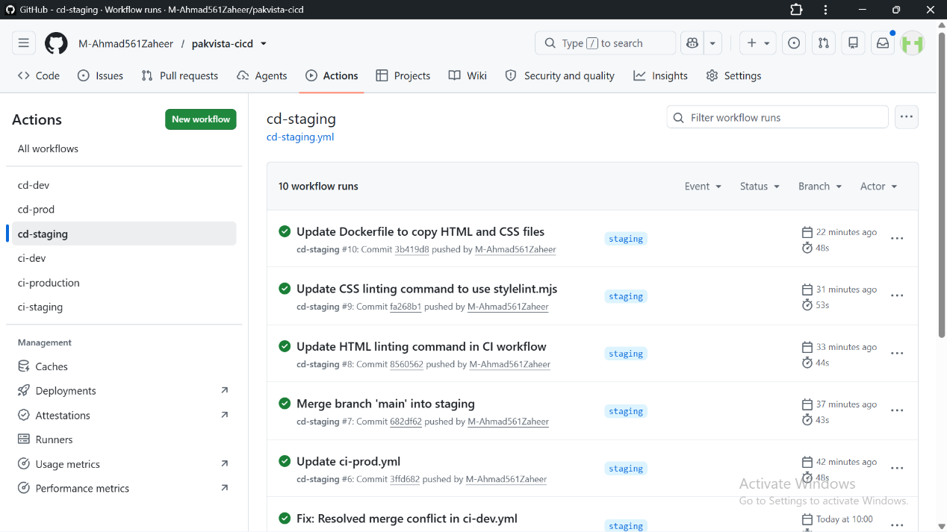
Live PakVista – Development Render Service (all 5 pages accessible) | 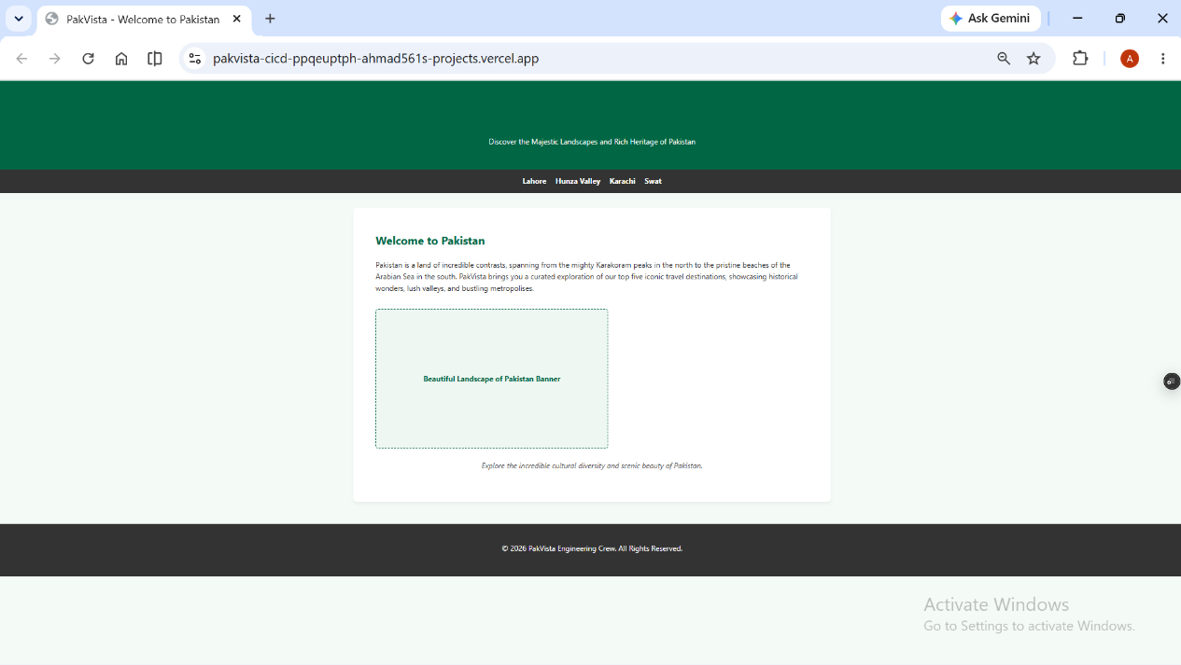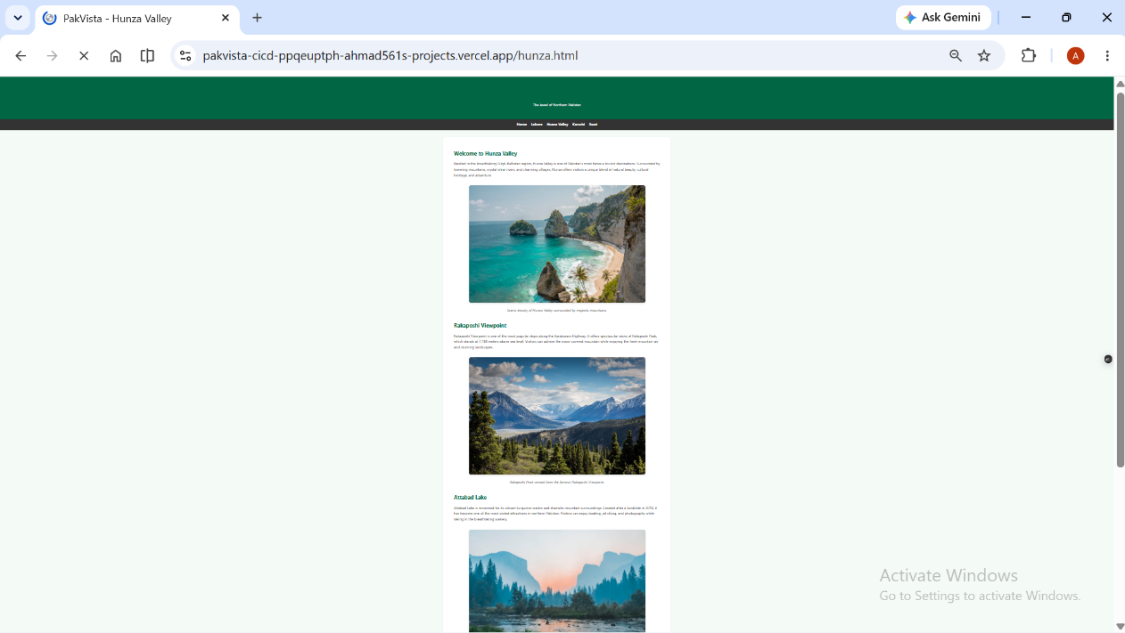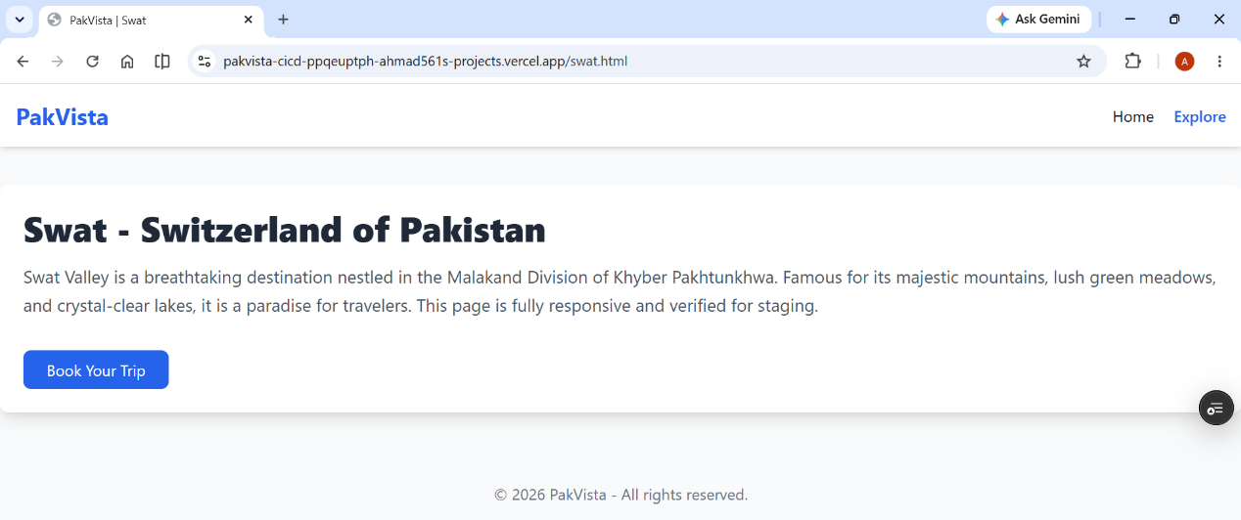  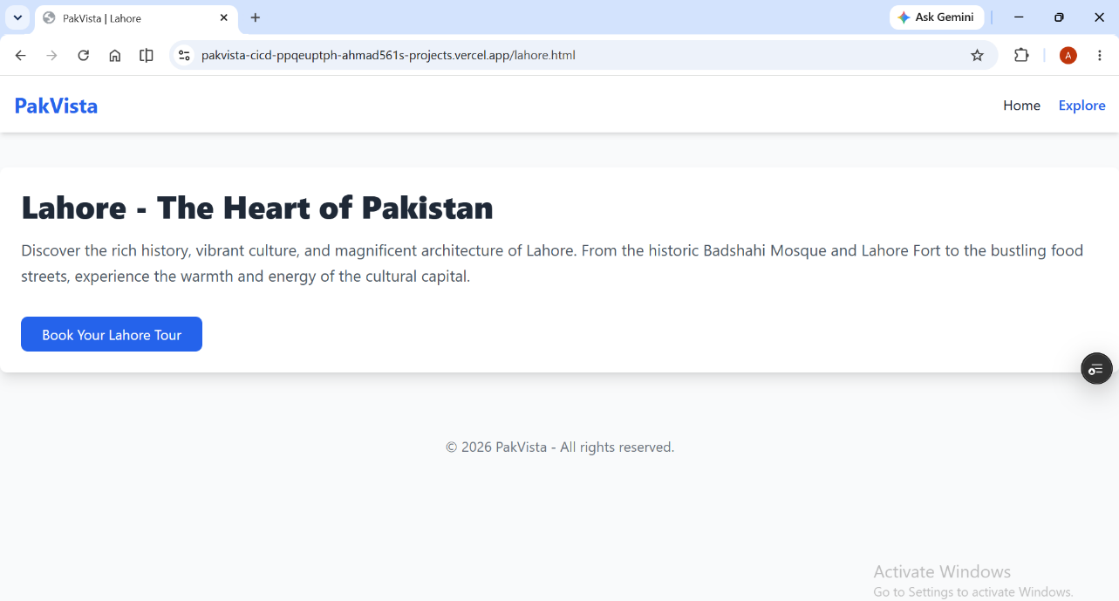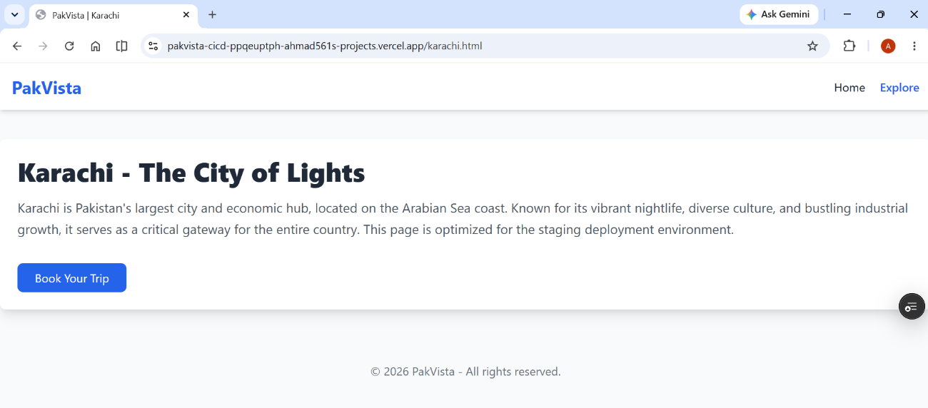
Live PakVista – Staging Render Service (all 5 pages accessible) | 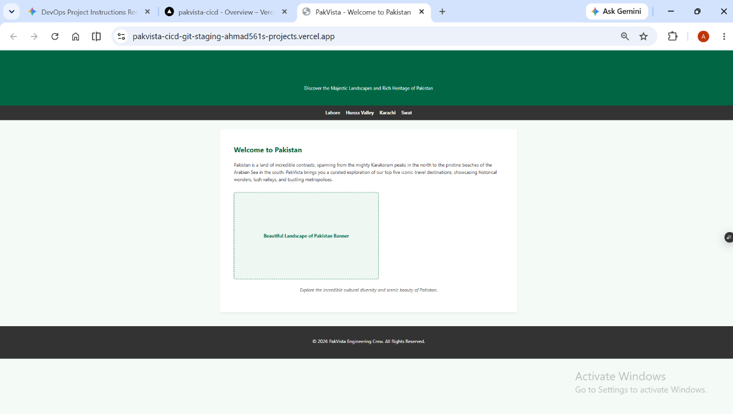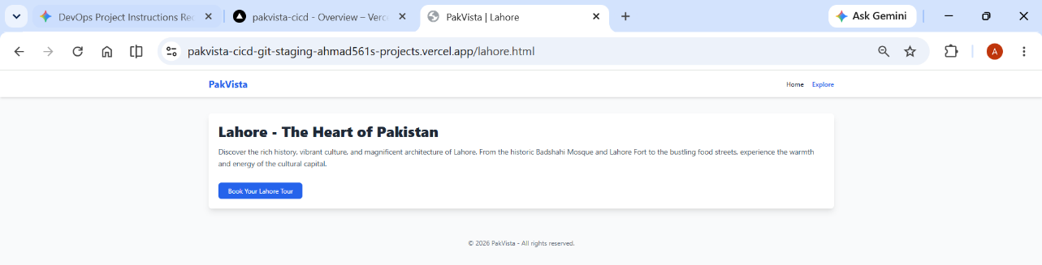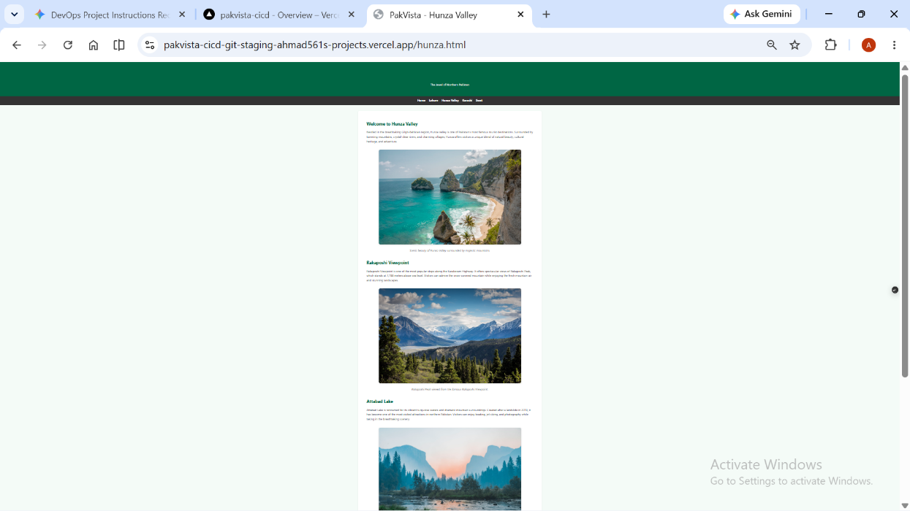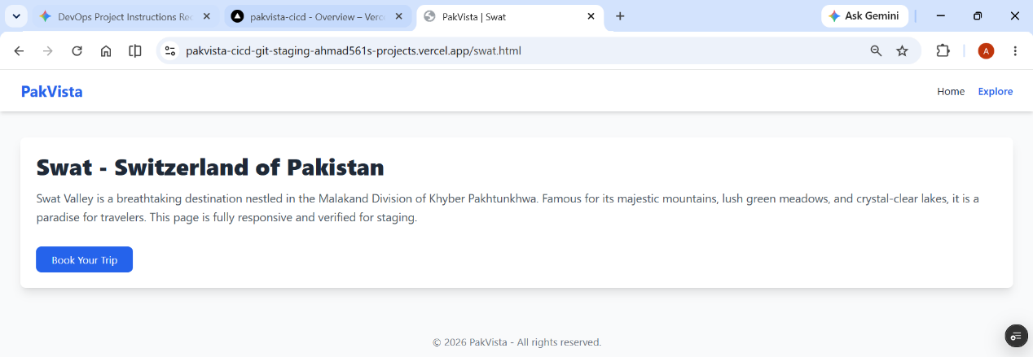  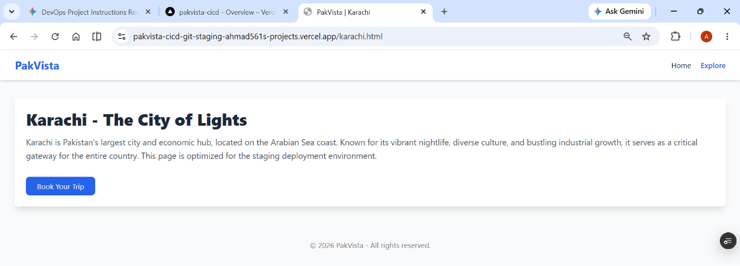
Live PakVista – Production Render Service (all 5 pages accessible) | 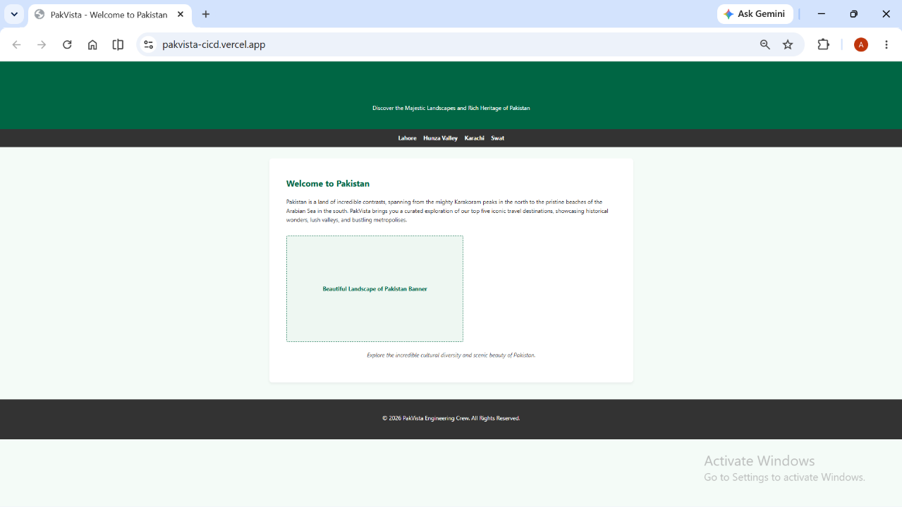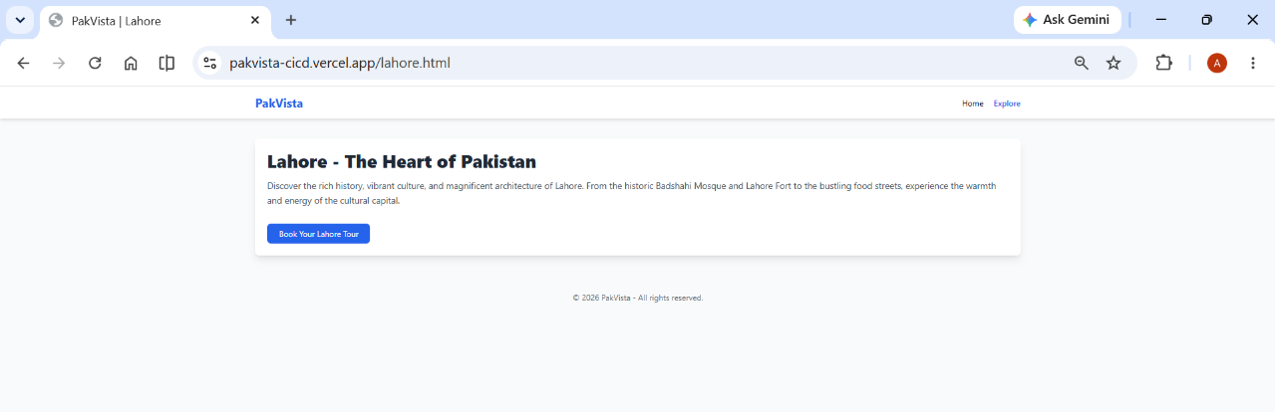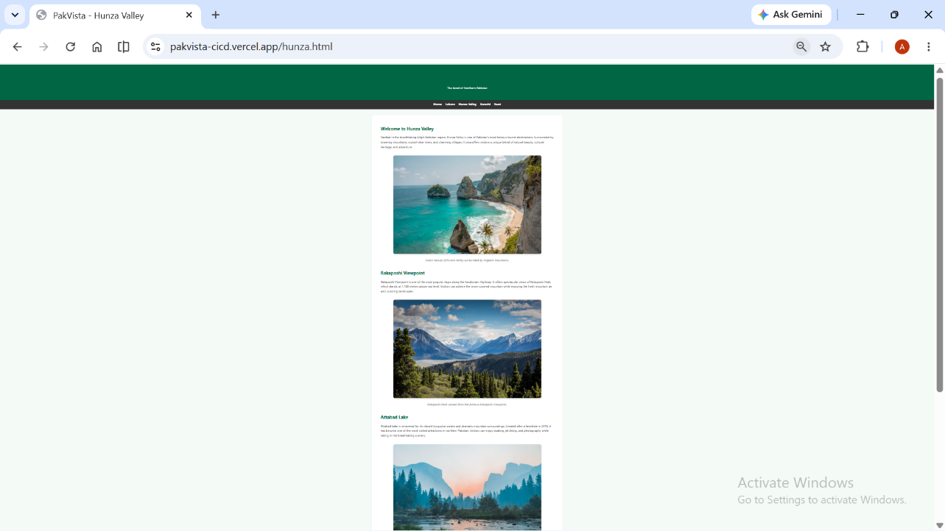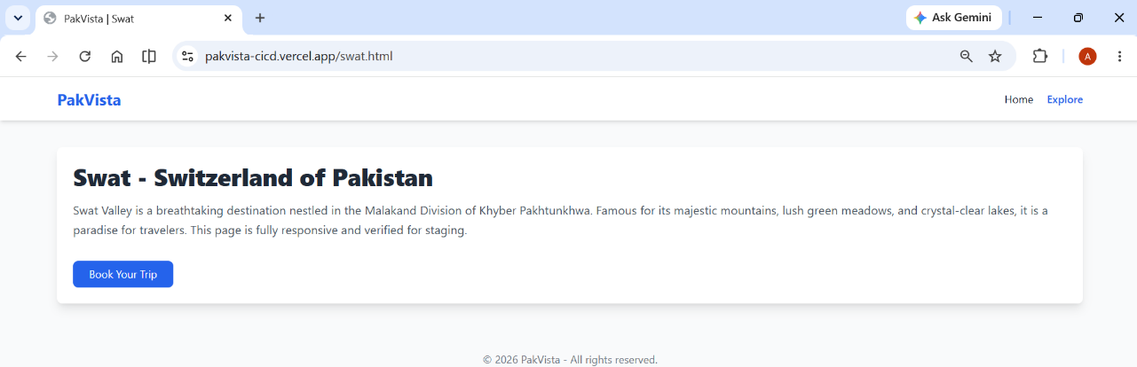  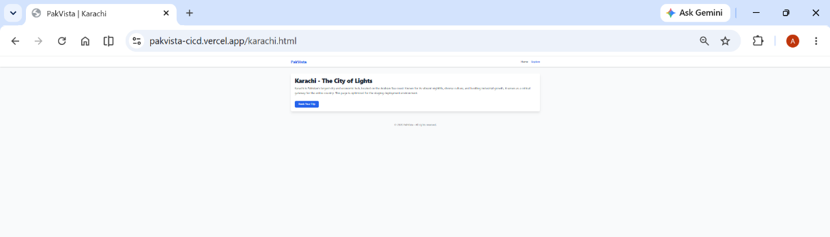
Term Project .docx visible in GitHub Repository file listing | 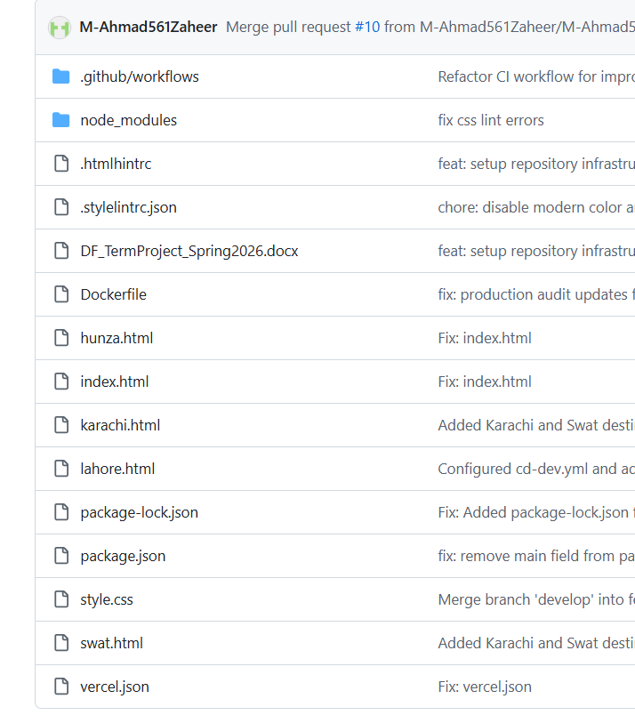

INDIVIDUAL REFLECTIONS
Each team member must write 4–5 lines below describing what they learnt during this Term Project, any challenges they encountered while authoring their workflow file and building their HTML page, and how they resolved those challenges.

Member 1: Muhammad Ahmad Zaheer – Reflection
During this project, I gained hands-on experience in implementing end-to-end CI/CD pipelines using GitHub Actions, Docker, and Parcel. The primary challenge was resolving persistent merge conflicts and handling "permission denied" errors within the Linux-based CI runner environment. I resolved these by implementing chmod +x commands for binary execution and effectively managing local branch rebasing to maintain a clean Git history. This project significantly improved my understanding of automated testing and DevOps best practices.

Member 2: Abdullah Naveed Akbar – Reflection
Working on this project taught me the importance of maintaining consistent code standards, particularly through HTML and CSS linting. I faced challenges while configuring the build artifacts, as ensuring that files were correctly uploaded and downloaded between different pipeline jobs required precise path mapping. By troubleshooting the actions/upload-artifact and actions/download-artifact configurations, I learned how to manage dependencies across multi-stage build processes, enhancing my skills in workflow optimization.

Member 3: Umer Akram – Reflection
This term project provided deep insights into modern web development workflows and the automation of production deployments. I encountered difficulties when integrating real estate dashboard features, specifically regarding responsive design and state management, which initially caused build failures. I overcame these issues by meticulously refactoring the CSS and ensuring that all project dependencies were locked in the package-lock.json file, ensuring build consistency across various environments.

Member 4: Usama – Reflection
Throughout the development of our web application, I learned how to bridge the gap between frontend development and deployment infrastructure. The biggest hurdle was aligning local development environments with the production CI/CD workflow, leading to unexpected build errors. I resolved this by standardizing our node environment versions and consistently using npm ci for reliable builds, which taught me the value of environmental parity in large-scale software engineering projects.

OFFICIAL REFERENCE DOCUMENTATION
All technical work must align with the official documentation listed below. Students are expected to consult these resources while building their workflow files, Dockerfile, and HTML pages.

Resource | Official URL
GitHub Actions – Workflow Syntax | https://docs.github.com/en/actions/writing-workflows/workflow-syntax-for-github-actions
GitHub Actions – Events that Trigger Workflows | https://docs.github.com/en/actions/writing-workflows/choosing-when-your-workflow-runs/events-that-trigger-workflows
GitHub Actions – Contexts (github.sha, secrets, etc.) | https://docs.github.com/en/actions/writing-workflows/choosing-what-your-workflow-does/accessing-contextual-information-about-workflow-runs
GitHub Actions – Encrypted Secrets | https://docs.github.com/en/actions/security-guides/encrypted-secrets
GitHub Actions – Environments for Deployment | https://docs.github.com/en/actions/deployment/targeting-different-environments/using-environments-for-deployment
GitHub Actions – Branch Protection Rules | https://docs.github.com/en/repositories/configuring-branches-and-merges-in-your-repository/managing-protected-branches/about-protected-branches
actions/checkout@v4 (Official Action) | https://github.com/actions/checkout
docker/login-action@v3 (Official Docker Action) | https://github.com/docker/login-action
docker/build-push-action@v5 (Official Docker Action) | https://github.com/docker/build-push-action
docker/metadata-action@v5 (Official Docker Action) | https://github.com/docker/metadata-action
Docker Hub – Repositories & Access Tokens | https://docs.docker.com/docker-hub/ | https://docs.docker.com/security/for-developers/access-tokens/
Docker Official nginx Image | https://hub.docker.com/_/nginx
Dockerfile Reference | https://docs.docker.com/reference/dockerfile/
Render.com – Deploy Hooks | https://docs.render.com/deploy-hooks
Render.com – Docker Deploys | https://docs.render.com/docker
HTML5 Specification (WHATWG) | https://html.spec.whatwg.org/
MDN Web Docs – HTML Reference | https://developer.mozilla.org/en-US/docs/Web/HTML
MDN Web Docs – CSS Reference | https://developer.mozilla.org/en-US/docs/Web/CSS
CSS Custom Properties (Variables) | https://developer.mozilla.org/en-US/docs/Web/CSS/Using_CSS_custom_properties

