**Google Home**

It is a line of smart speakers developed by Google under the Google Nest brand. The devices enable users to speak voice commands to interact with services through Google Assistant.

$49

<https://store.google.com/us/product/google_home?hl=en-US>

[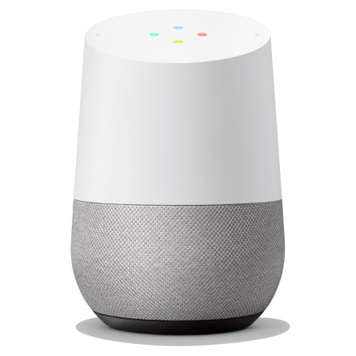](https://www.google.com/url?sa=i&url=https%3A%2F%2Fwww.walmart.com%2Fip%2FGoogle-Home-Smart-Speaker-Google-Assistant%2F54742302&psig=AOvVaw31ODrDSQnhqExDRGNqpBjE&ust=1586689245239000&source=images&cd=vfe&ved=0CAIQjRxqFwoTCKC-nbec4OgCFQAAAAAdAAAAABAD)[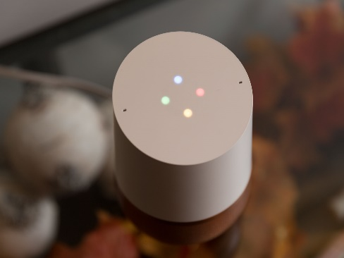](https://www.google.com/url?sa=i&url=https%3A%2F%2Fwww.cnet.com%2Freviews%2Fgoogle-home-review%2F&psig=AOvVaw31ODrDSQnhqExDRGNqpBjE&ust=1586689245239000&source=images&cd=vfe&ved=0CAIQjRxqFwoTCKC-nbec4OgCFQAAAAAdAAAAABAJ)

[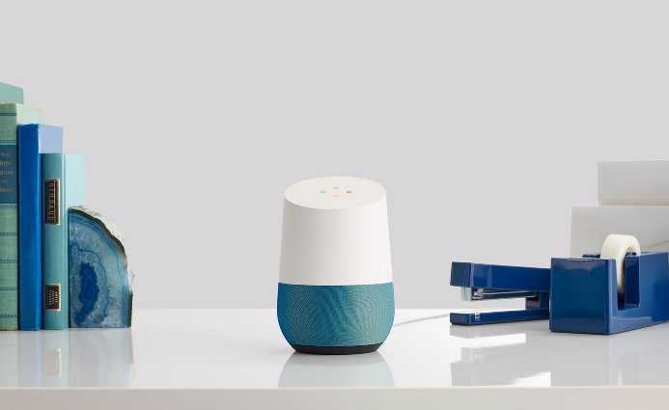](https://www.google.com/url?sa=i&url=https%3A%2F%2Fwww.wallpaper.com%2Flifestyle%2Fhey-google-we-chat-up-the-latest-home-connectivity-kit&psig=AOvVaw37YjUHSEOhh7VQZfXDf_3k&ust=1586689729680000&source=images&cd=vfe&ved=0CAIQjRxqFwoTCPDOhoGe4OgCFQAAAAAdAAAAABAD)[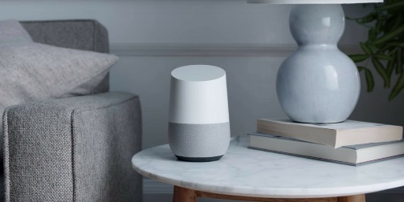](https://www.google.com/url?sa=i&url=https%3A%2F%2Fwww.dailydot.com%2Fdebug%2Fgoogle-home-multiple-users%2F&psig=AOvVaw37YjUHSEOhh7VQZfXDf_3k&ust=1586689729680000&source=images&cd=vfe&ved=0CAIQjRxqFwoTCPDOhoGe4OgCFQAAAAAdAAAAABAJ)

**Daydream**

it is a virtual reality (VR) platform which was developed by Google, primarily for use with a headset into which a smartphone is inserted. Daydream was built into Android itself and included enhanced features, including support for controllers.

$79

<https://store.google.com/us/product/daydream_view?hl=en-US>

[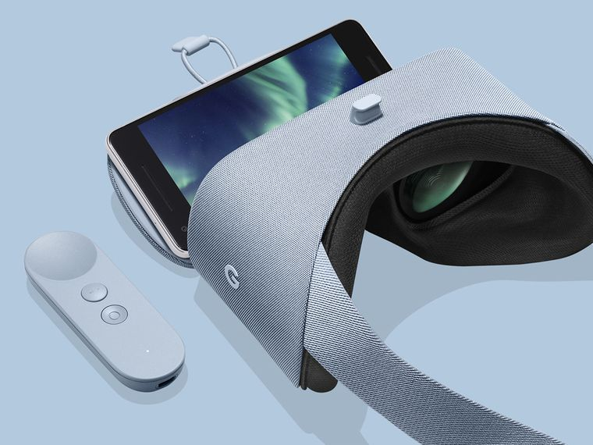](https://www.google.com/url?sa=i&url=https%3A%2F%2Fwww.popsci.com%2Fvirtual-reality-apps-google-daydream-view%2F&psig=AOvVaw34OZzGptiiG6UAK9_IeVGf&ust=1586690234292000&source=images&cd=vfe&ved=0CAIQjRxqFwoTCIC56fOf4OgCFQAAAAAdAAAAABAO)

[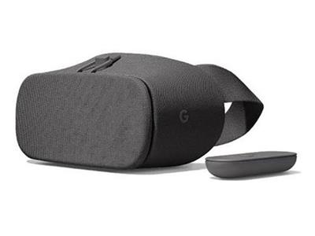](https://www.google.com/url?sa=i&url=https%3A%2F%2Fshop.bt.com%2Fproducts%2Fgoogle-daydream-view-2017-vr-headset---charcoal-ga00204-us-D69Y.html&psig=AOvVaw34OZzGptiiG6UAK9_IeVGf&ust=1586690234292000&source=images&cd=vfe&ved=0CAIQjRxqFwoTCIC56fOf4OgCFQAAAAAdAAAAABAd)[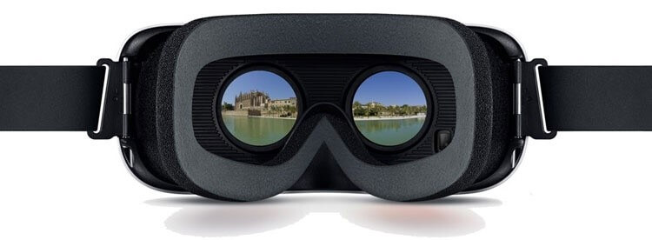](https://www.google.com/url?sa=i&url=https%3A%2F%2Fwww.instavr.co%2Farticles%2Fgeneral%2Fbest-practices-for-making-vr-tourism-and-travel-apps&psig=AOvVaw34OZzGptiiG6UAK9_IeVGf&ust=1586690234292000&source=images&cd=vfe&ved=0CAIQjRxqFwoTCIC56fOf4OgCFQAAAAAdAAAAABAn)

[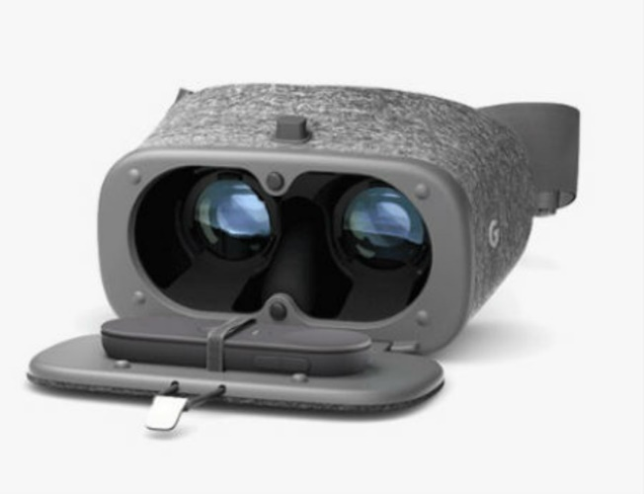](https://www.google.com/url?sa=i&url=https%3A%2F%2Fwww.multichannel.com%2Fnews%2Fgoogle-unveils-daydream-view-vr-headset-controller-408219&psig=AOvVaw34OZzGptiiG6UAK9_IeVGf&ust=1586690234292000&source=images&cd=vfe&ved=0CAIQjRxqGAoTCIC56fOf4OgCFQAAAAAdAAAAABCmAQ)

**Google wifi**

Google Wifi has surpassed its rivals by packing in more mesh units at a lower price than, and combining its attention to value with an easy setup and impressive network management through a streamlined mobile app. And, its minimalist yet appealing design that allows it to fit just about anywhere in your home

$99

<https://store.google.com/us/product/google_wifi_first_gen?hl=en-US>

[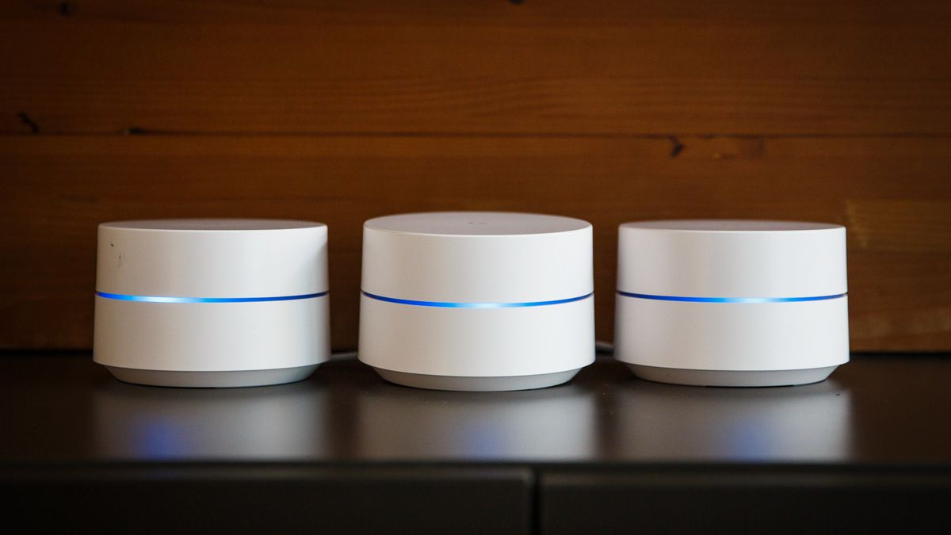](https://www.google.com/url?sa=i&url=https%3A%2F%2Fwww.cnet.com%2Freviews%2Fgoogle-wifi-review%2F&psig=AOvVaw2Bx2HKZlrQo-GFQUb3UZur&ust=1586692164890000&source=images&cd=vfe&ved=0CAIQjRxqFwoTCOjp0Zmn4OgCFQAAAAAdAAAAABAD)

[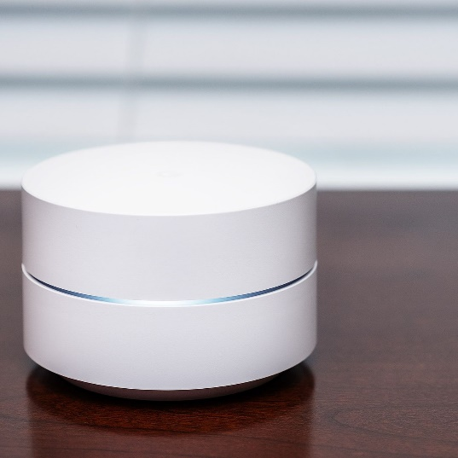](https://www.google.com/url?sa=i&url=https%3A%2F%2Fwww.theverge.com%2Fgood-deals%2F2018%2F7%2F18%2F17538414%2Fbest-tech-sales-amazon-deals&psig=AOvVaw2Bx2HKZlrQo-GFQUb3UZur&ust=1586692164890000&source=images&cd=vfe&ved=0CAIQjRxqFwoTCOjp0Zmn4OgCFQAAAAAdAAAAABAJ) [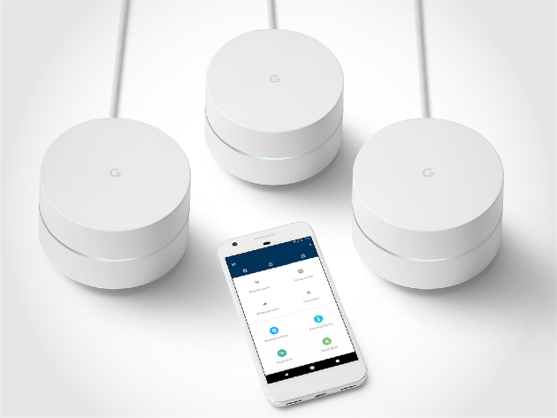](https://www.google.com/url?sa=i&url=https%3A%2F%2Fwww.amnaymag.com%2F5-%25D8%25A3%25D8%25B3%25D8%25A8%25D8%25A7%25D8%25A8-%25D9%2584%25D8%25B4%25D8%25B1%25D8%25A7%25D8%25A1-%25D8%25B1%25D8%25A7%25D9%2588%25D8%25AA%25D8%25B1-%25D8%25AC%25D9%2588%25D8%25AC%25D9%2584-google-wifi-%25D9%2588%25D8%25AD%25D9%2584-%25D9%2585%25D8%25B4%25D8%25A7%25D9%2583%25D9%2584-%25D8%25A7%25D9%2584%25D8%25A5%2F&psig=AOvVaw2Bx2HKZlrQo-GFQUb3UZur&ust=1586692164890000&source=images&cd=vfe&ved=0CAIQjRxqFwoTCOjp0Zmn4OgCFQAAAAAdAAAAABAP) [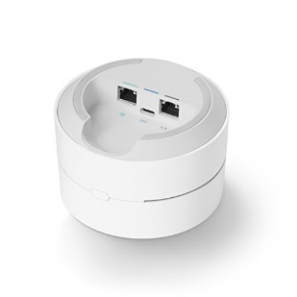](https://www.google.com/url?sa=i&url=https%3A%2F%2Faeropost.com%2Fsite%2Fen%2Fproductpage%3Fgtw%3DSJO%26prodSource%3Damz%26typeSearch%3Dkw%26prodId%3DB01MDJ0HVG%26gtw%3DBOG%26lang%3Den&psig=AOvVaw2Bx2HKZlrQo-GFQUb3UZur&ust=1586692164890000&source=images&cd=vfe&ved=0CAIQjRxqFwoTCOjp0Zmn4OgCFQAAAAAdAAAAABAU)

**Chromecast Ultra**

The ChromecastUltra is Google's drive for the 4K HDR crowd: a wafer-sized streaming device that can receive 4K HDR signal from any mobile device currently on your network.

$69

<https://store.google.com/us/product/chromecast_ultra?hl=en-US>

[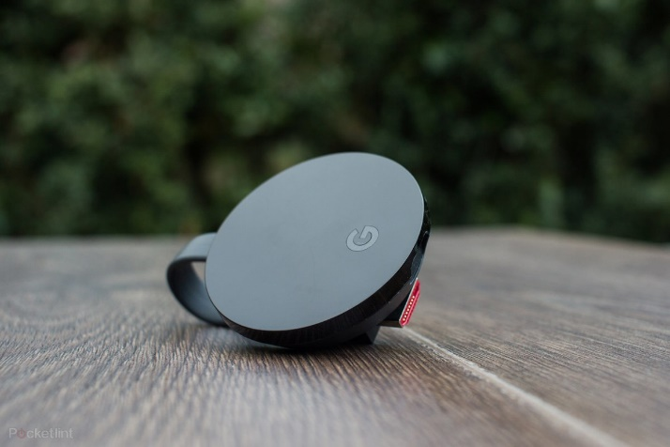](https://www.google.com/url?sa=i&url=https%3A%2F%2Fwww.pocket-lint.com%2Ftv%2Freviews%2Fgoogle%2F139684-google-chromecast-ultra-review-4k-casting-is-perfect-yet-pointless&psig=AOvVaw2mn7eoki-YU12Nv26qJ_gm&ust=1586692762612000&source=images&cd=vfe&ved=0CAIQjRxqFwoTCNjwyaip4OgCFQAAAAAdAAAAABAD) [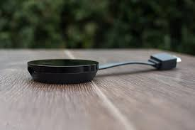](https://www.google.com/url?sa=i&url=https%3A%2F%2Fwww.pocket-lint.com%2Ftv%2Freviews%2Fgoogle%2F139684-google-chromecast-ultra-review-4k-casting-is-perfect-yet-pointless&psig=AOvVaw2mn7eoki-YU12Nv26qJ_gm&ust=1586692762612000&source=images&cd=vfe&ved=0CAIQjRxqFwoTCNjwyaip4OgCFQAAAAAdAAAAABAJ) [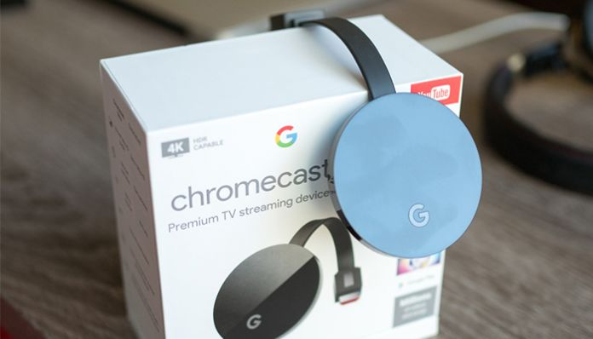](https://www.google.com/url?sa=i&url=https%3A%2F%2Fwww.technadu.com%2Fgoogle-chromecast-ultra-review%2F18403%2F&psig=AOvVaw2mn7eoki-YU12Nv26qJ_gm&ust=1586692762612000&source=images&cd=vfe&ved=0CAIQjRxqFwoTCNjwyaip4OgCFQAAAAAdAAAAABAN) [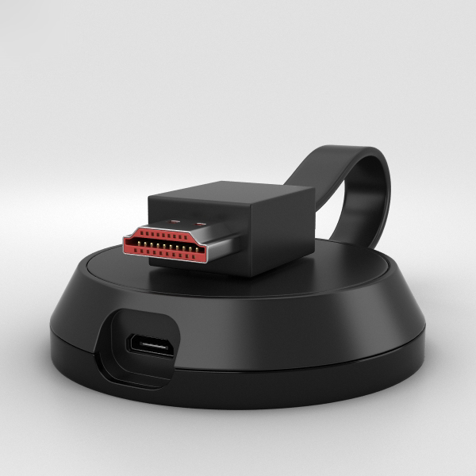](https://www.google.com/url?sa=i&url=https%3A%2F%2Fwww.turbosquid.com%2F3d-models%2Fgoogle-chromecast-ultra-3d-model-1321612&psig=AOvVaw2mn7eoki-YU12Nv26qJ_gm&ust=1586692762612000&source=images&cd=vfe&ved=0CAIQjRxqFwoTCNjwyaip4OgCFQAAAAAdAAAAABAS)

**Google pixel 4**

The Pixel 4 was designed to be Google's best and most impressive Pixel yet. It has an all-new 90Hz display, Motion Sense hand gestures, powerful face unlock, and dual rear cameras. There's also a revamped design and upgraded internals, all of which come together to create an enticing overall package

$799

<https://store.google.com/us/product/pixel_4?hl=en-US>

[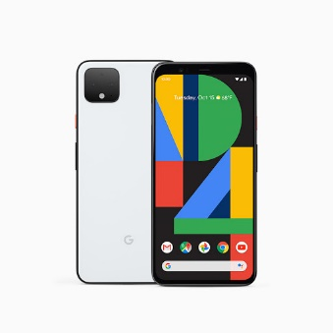](https://store.google.com/product/pixel_4) [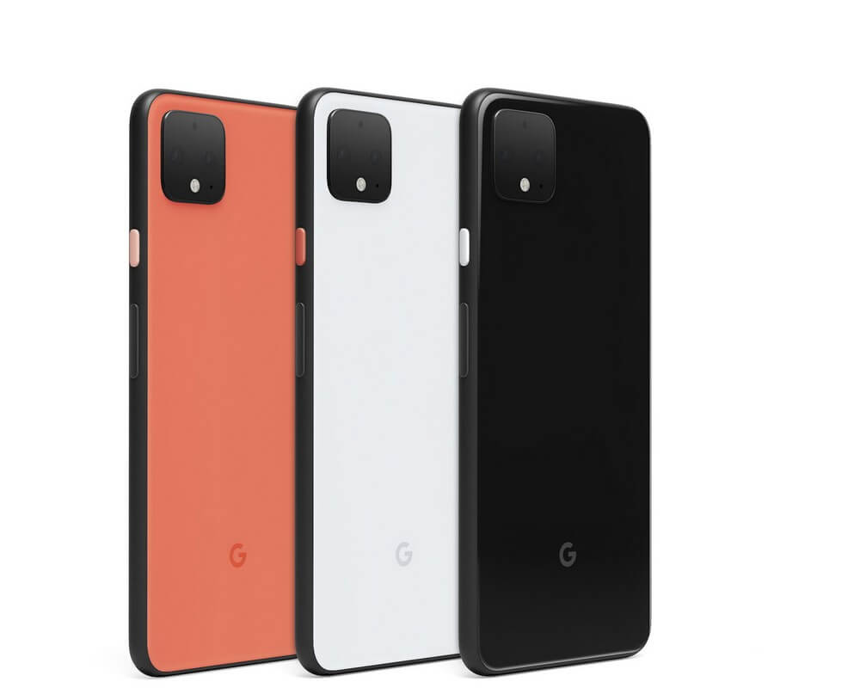](https://www.google.com/url?sa=i&url=https%3A%2F%2Fwww.techspot.com%2Fproducts%2Fsmartphones%2Fgoogle-pixel-4.190328%2F&psig=AOvVaw1KO44Vmk1HWB859RfIJFsa&ust=1586693034052000&source=images&cd=vfe&ved=0CAIQjRxqFwoTCMiG5K2q4OgCFQAAAAAdAAAAABAb) [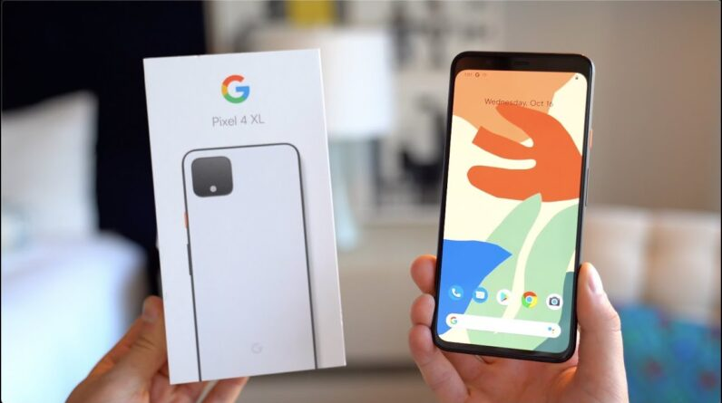](https://www.google.com/url?sa=i&url=https%3A%2F%2Fwww.avnblogfeed.com%2Fgoogle-pixel-4-xl-unboxing%2F&psig=AOvVaw1KO44Vmk1HWB859RfIJFsa&ust=1586693034052000&source=images&cd=vfe&ved=0CAIQjRxqFwoTCMiG5K2q4OgCFQAAAAAdAAAAABAW) [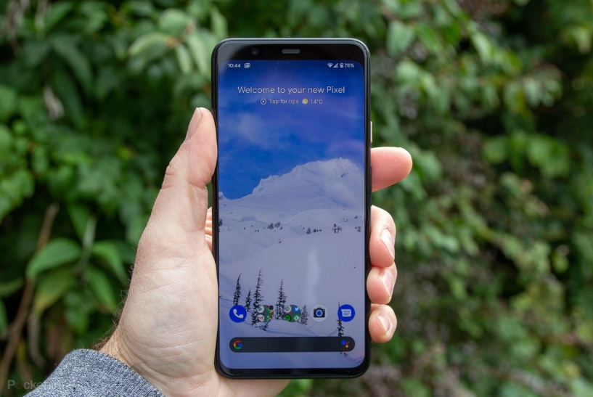](https://www.google.com/url?sa=i&url=https%3A%2F%2Fwww.pocket-lint.com%2Fphones%2Freviews%2Fgoogle%2F149771-google-pixel-4xl-review&psig=AOvVaw1KO44Vmk1HWB859RfIJFsa&ust=1586693034052000&source=images&cd=vfe&ved=0CAIQjRxqFwoTCMiG5K2q4OgCFQAAAAAdAAAAABAh)