

ASSIGNMENT 2

­

**MUHMMAD AITISAM AHMED**

230456

**THURSDAY: 9 JAN 2025**

BILAL KHAN

**TEACHER NAME:**

VIRTUAL PROGRAMMING

**SUBJECT**:

**Language Learning Flashcards**

**THURSDAY: 9 JAN 2025**

**Overview**

The Language Flashcard Application is an interactive tool designed to help users learn new vocabulary in various languages. It uses flashcards to display a word and its translation, allowing users to mark words as learned, skip them, or test themselves on learned words.

**Features**

1. **Flashcard Component**:
   * Displays one word at a time in the selected language.
   * Provides the ability to flip the card to reveal the translation.
2. **Language Selection**:
   * A dropdown menu to choose the language for flashcards.
3. **Word Interaction**:
   * Buttons for marking a word as "Learned" or skipping it.
4. **Progress Tracker**:
   * Tracks how many words have been learned.
5. **Quiz Mode**:
   * Tests users on previously learned words by asking them to translate words.
6. **Data Handling**:
   * Vocabulary words are stored in a JSON file or database.
7. **Dependency Injection**:
   * A service is injected to handle word retrieval and tracking learned words.

**Application Components**

**1. Data Setup**

We’ll use a JSON file or a database table to store vocabulary. Here’s an example JSON format:

Urdu & Spanish Language Add:

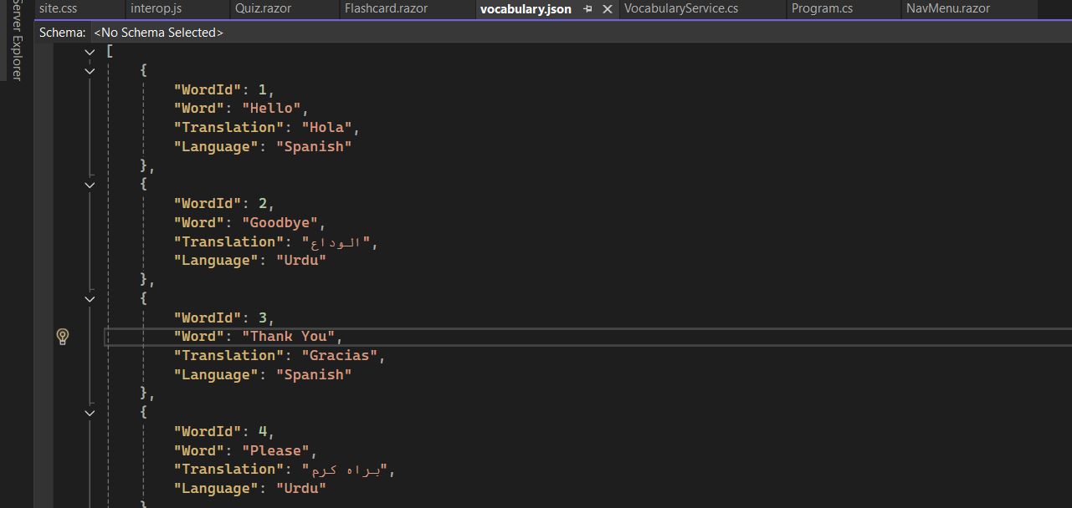

**1. Flashcard Page (/flash)**

**Functionality**

This page displays vocabulary flashcards for a selected language. Users can:

* Flip a flashcard to reveal its translation.
* Mark a word as learned.
* Skip to the next word.

**Key Code Components**

* **Language Selection Dropdown**:
  + Allows users to choose a language, dynamically updating the flashcards for the selected language.
  + Uses @onchange to trigger UpdateLanguage, which loads the corresponding vocabulary.

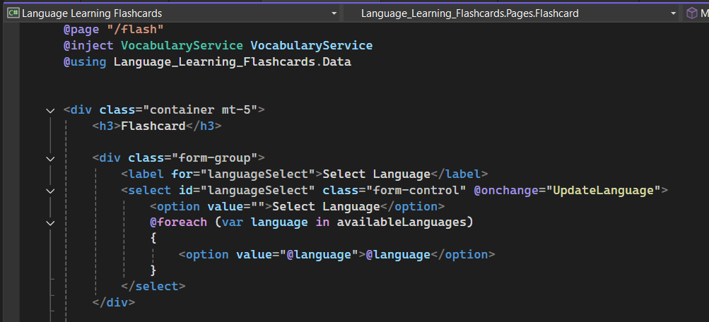

**Flashcard Display**:

* Uses a card UI to show either the word or its translation.
* Clicking the "Flip" button toggles the display between word and translation.

**Mark as Learned and Skip**:

* The "Mark as Learned" button records the word as learned by calling VocabularyService.MarkAsLearned.
* The "Skip" button loads the next word without marking it as learned.

**2. Quiz Page (/quiz)**

**Functionality**

The quiz page allows users to test their knowledge of the words they’ve marked as learned.

**Key Code Components**

* **Quiz Question**:
  + Displays a word and prompts the user to provide its translation.
  + Users can input their answer and submit it for evaluation.

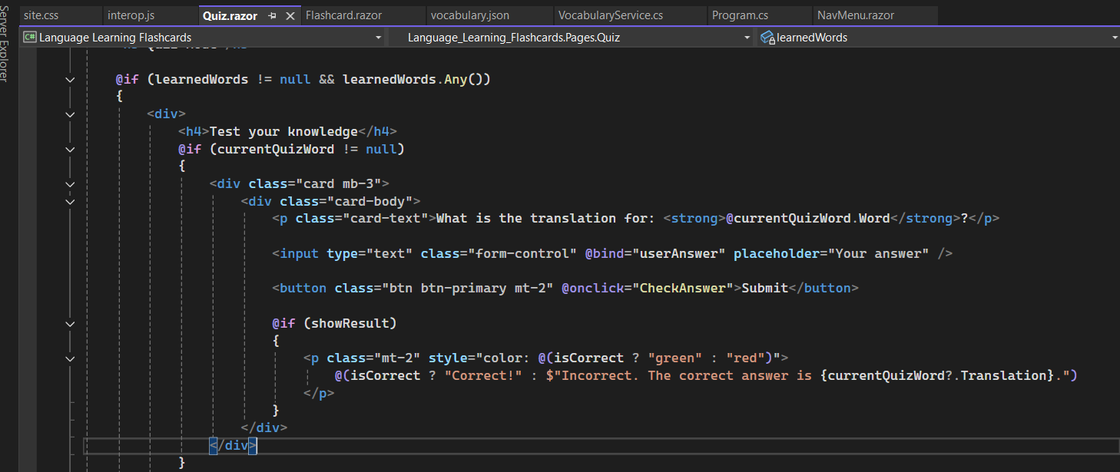

**Answer Evaluation**:

* CheckAnswer compares the user’s input to the correct translation.
* If correct, it loads the next quiz word; otherwise, it displays the correct answer.

**Quiz Completion**:

* When all learned words have been tested, the quiz ends with a completion message.

**3. Vocabulary Service (VocabularyService)**

**Purpose**

A service class to manage the vocabulary data, handle learned word tracking, and provide data to the application.

**Key Methods**

1. **GetAllWords**:
   * Returns all vocabulary words loaded from the JSON file.
2. **GetWordsByLanguage**:
   * Filters vocabulary words by the selected language.

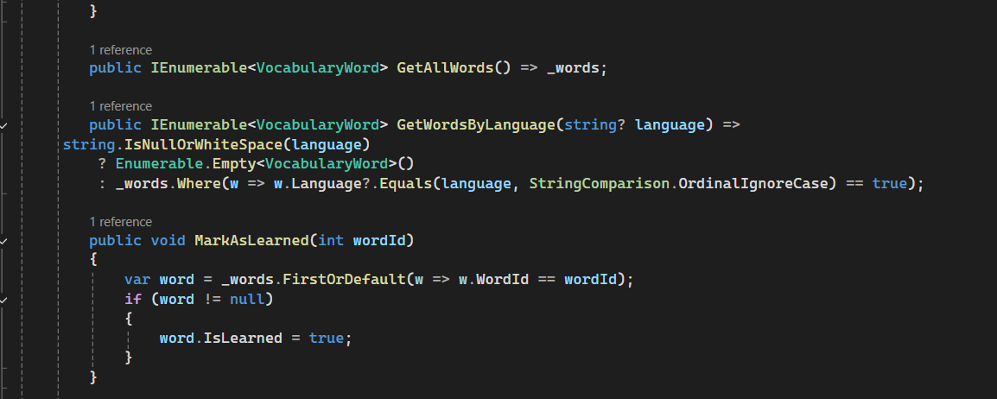

**MarkAsLearned**:

* Marks a word as learned by setting the IsLearned property to true.

### **VocabularyWord Model**

Defines the structure of a vocabulary word.

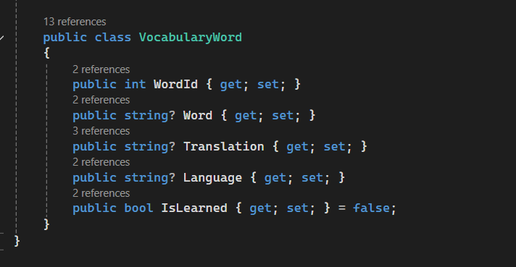

**5. JSON File (vocabulary.json)**

The vocabulary data is stored in a JSON file. Example:



**6. JavaScript for Flip Animation**

A simple JavaScript function to add a flip animation effect to the flashcard.

**7. Key Features of the Application**

* **Language Selection**: Dynamically updates the vocabulary displayed on the flashcards.
* **Interactive Flashcards**: Flip functionality to reveal translations.
* **Progress Tracking**: Tracks which words have been learned.
* **Quiz Mode**: Tests users on learned words with instant feedback.

**Output:**

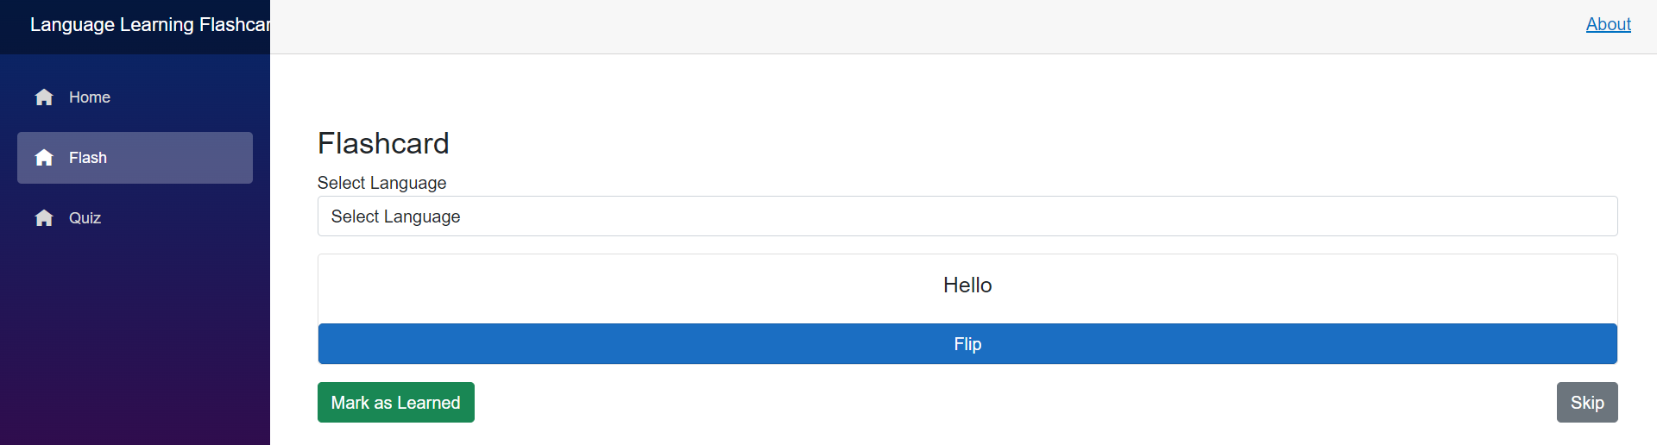

**When mark as completed:**

**Then in Spanish:**

**In Urdu:**

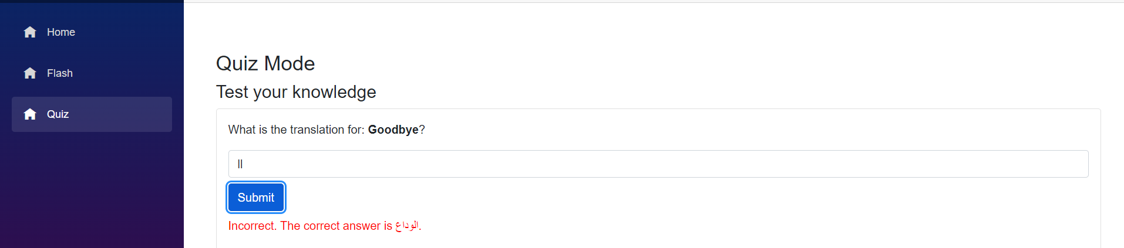

**Then next if correct answer you can add.  
**