SENTINEL-BMS
Technical Project Report
Battery Management System with Cell-Fault Handling for EV and BESS Prototypes
Team Voltedge · Hyderabad · State Level Hackathon · Problem #9 (Automotive)

Project evidence at a glance | Verified value / status
Project source | Sentinel_BMS_Voltedge_Final(1).pptx, 7-slide user-provided project deck [1]
Platform | QNX Neutrino 8.0 on Raspberry Pi 4/5; POSIX user-space processes [1][2]
Prototype sensors | INA219 over I²C (pack voltage/current); DHT11 on GPIO4 (temperature/humidity) [1][5][6]
Safety loop target | 10 ms fault-to-decision deadline; highest-priority fault_det thread at priority 60 [1]
Prototype thresholds | 12.60 V high, 9.00 V low, 3.00 A current, 55 °C temperature; 3 consecutive 100 ms ticks for debounce [1]
Safety rule | Stale data, failed I²C read, or failed process is treated as unsafe and drives the safe state [1]
Evidence status | Deck reports target/profiler plan and recovery observations; this report does not claim certification or independent reproduction.
Team members | Team Voltedge, Hyderabad. Individual names were not present in the supplied deck; roles are assigned in Section 3.

Scope statement: This report documents a proof-of-concept architecture and a production-oriented path. The prototype estimates cell values from pack ÷ 3, does not measure individual cell taps, has no wired hardware contactor cutoff, and uses CAN as a real message path/stub rather than a validated vehicle bus [1].

Contents and document control
Item | Value
Document ID | SV-BMS-QNX-TPR-001
Revision | 1.0
Date | 10 October 2026
Prepared for | Team Voltedge / State Level Hackathon
Platform | QNX Neutrino 8.0; Raspberry Pi 4/5 prototype
Primary question | How can QNX RTOS architecture improve deterministic cell-fault handling in EV and BESS battery systems?
Evidence basis | Project deck plus official QNX, UNECE, Texas Instruments, national-lab, DOE/Sandia, and peer-reviewed sources

Contents
- 1. Abstract
- 2. Problem statement and safety context
- 3. Project team, platform, and evidence
- 4. Project objectives and success criteria
- 5. System overview
- 6. Main system components
- 7. Overall operation and fault life cycle
- 8. QNX RTOS system design principles
- 9. Process isolation and IPC
- 10. Recovery manager and GPIO hardware interface
- 11. Failure isolation and BMS process model
- 12. Monitoring, evidence, and performance metrics
- 13. Fault conditions and response matrix
- 14. Verification and test plan
- 15. EV and BESS deployment pathway
- 16. Limitations, risks, and next steps
- 17. Conclusion
- References

1. Abstract
Sentinel-BMS is a real-time battery management prototype designed to detect and contain cell and pack-level faults in electric-vehicle (EV) and battery-energy-storage-system (BESS) use cases. The project uses QNX Neutrino 8.0 on a Raspberry Pi 4/5 and separates sensing, fault detection, core state management, telemetry, web/CLI access, and recovery into user-space processes. The safety path is led by a fixed-priority fault-detection thread and is intended to make the worst-case fault-to-decision time more important than average throughput.
The supplied project deck defines a 10 ms safety deadline, 100 ms INA219 sampling, 2 s DHT11 sampling, monotonic timestamps, a 500 ms stale-data limit, three consecutive critical samples for debounce, and a latched fail-safe state. It also reports an approximately one-second process restart target under a sensor-process kill test [1]. These values are treated here as project requirements or prototype observations, not as certification evidence.
The engineering argument is that QNX helps make the safety decision path more analyzable: the microkernel provides protected process address spaces, priority-based scheduling, synchronous message passing, pulses, timers, and instrumentation. QNX documentation describes message passing as the fundamental IPC mechanism and identifies trace instrumentation for observing kernel and thread behavior [2][3][4]. A failed user-space sensor process can therefore be restarted without corrupting the fault detector, while stale data is converted into a safety event rather than silently accepted.
The main conclusion is bounded and practical. QNX can materially improve fault containment, timing observability, and recovery structure, but it cannot compensate for missing cell-level sensors, absent independent hardware cutoff, unvalidated thresholds, or incomplete safety lifecycle evidence. For production EV or BESS deployment, the prototype must evolve to a multi-cell battery monitor, independent contactor/fuse path, watchdog strategy, qualified hardware, validated diagnostics, and a safety case aligned with applicable regulations and standards. UNECE R100 specifically expects documented thermal-event parameters, system diagrams, warning behavior, and risk-reduction analysis for REESS applications [7].
Core thesis: deterministic scheduling and isolation reduce the probability that a software fault or workload spike delays a safety decision; independent hardware protection is still required for defense in depth.

2. Problem statement and safety context
Lithium-ion cells can leave their safe operating window because of over-voltage, under-voltage, over-current, over-temperature, sensor faults, internal short circuits, manufacturing defects, aging, imbalance, or communication loss. A small cell-level abnormality can become a pack-level hazard when heat generation, gas release, electrical stress, or propagation is not detected early. A recent review emphasizes that minor cell faults can develop into catastrophic failures and that early detection and real-time diagnosis are central to battery safety [10].
The failure environment differs between EV and BESS applications. An EV BMS must protect occupants and propulsion hardware during fast transients, charging, crash-related events, and wide ambient conditions. A BESS controller must also handle larger stored energy, repeated cycling, rack and container interactions, alarm escalation, fire-system interfaces, and responder safety. Sandia/DOE material notes that safety complexity increases with battery size and identifies mechanical, thermal, and electrical abuse modes including penetration, crush, over-temperature, over-voltage, short circuit, over-discharge, and voltage reversal [9].
The software problem is not only incorrect arithmetic. A correct threshold algorithm is unsafe if it runs late, is blocked behind a dashboard workload, consumes a stale sensor value, or loses its state after a process crash. The project therefore treats freshness, deadline compliance, and fail-safe state control as first-class BMS outputs.
Hazard | Potential precursor | Required software response | Prototype handling
Over-voltage | High cell/pack voltage during charge | Inhibit charge; latch fault; record evidence | Pack high limit 12.60 V; cell estimate only [1]
Under-voltage | Deep discharge or weak cell | Inhibit discharge; latch fault | Pack low limit 9.00 V [1]
Over-current | Load or charge current above limit | Open/inhibit power path | 3.00 A threshold [1]
Over-temperature | Cell or enclosure heating | Derate, stop charge/discharge, alarm | 55 °C DHT11 threshold [1]
Stale/invalid data | I²C failure, process death, timeout | Treat as unsafe; safe state | 500 ms stale limit; restart supervisor [1]
Imbalance | Cell spread or drift | Balance/derate/maintenance action | Future true cell taps; prototype estimates [1]

3. Project team, platform, and evidence
The supplied deck identifies the team as Team Voltedge, Hyderabad. It does not list individual names. To keep the report accurate, the following role map is a project-organization template rather than an invented membership list; the team can replace role labels with names before submission.
Role | Accountability | Evidence / output
Project lead | Scope, schedule, integration decisions | Requirements baseline and demo narrative
QNX/RTOS lead | Process model, priorities, IPC, timers, trace | Architecture and timing evidence
BMS algorithms lead | Thresholds, debounce, SoC/SoH, imbalance | Fault logic and test vectors
Embedded hardware lead | INA219, DHT11, GPIO, contactor interface | Schematics, wiring, sensor calibration
Verification lead | Fault injection, profiler capture, acceptance tests | Trace logs, latency and recovery results
Documentation lead | Citations, limitations, safety case structure | This report and revision control

Platform baseline
Layer | Prototype choice | Production direction
Compute | Raspberry Pi 4/5 | Automotive-grade MCU/SoC with qualified power and watchdog design
RTOS | QNX Neutrino 8.0 | Safety-qualified QNX product/profile as required by target safety case
Pack | 3S Li-ion demonstrator | Multi-module EV/BESS pack with cell tap harness and isolation monitoring
Current/voltage | INA219, I²C, 0–26 V bus capability | Dedicated multi-cell AFE and calibrated current sensing
Temperature | DHT11 GPIO4, slow prototype sensor | Distributed thermistors/RTDs and faster qualified acquisition
Actuation | Contactor represented in software state | Independent contactor driver, pre-charge, fuse, welded-contactor feedback
Comms | CAN path stub | Validated CAN/CAN-FD network with diagnostics and gateway policy

Evidence discipline: every numerical value in this report is marked as one of three classes: (a) project-deck requirement or observation [1]; (b) manufacturer or regulator specification [5][6][7]; or (c) engineering proposal to be verified. This distinction prevents a prototype demo from being mistaken for product certification.

4. Project objectives and success criteria
The project objective is to demonstrate that a QNX-based BMS can continue to protect a battery when sensor data becomes invalid, a non-safety process is overloaded, or a sensor process is terminated. The objective is not to prove full automotive compliance. It is to show a credible architecture in which the safety path is isolated, timed, observable, and recoverable.
Objective | Acceptance measure | Status in supplied deck
Detect critical faults | Correct classification of voltage, current, temperature, stale data, and imbalance conditions | Implemented concept; thresholds specified [1]
Bound safety response | Maximum decision latency ≤10 ms; zero missed safety deadlines | Target and profiler evidence plan [1]
Debounce noise | Three consecutive 100 ms critical samples before latching | Specified [1]
Contain process faults | Sensor-process kill does not stop fault thread | Stress scenario described [1]
Recover service | Supervisor restarts failed process around 1 s | Reported target/observation [1]
Preserve fail-safe state | Fault remains latched until controlled re-arm | Architecture requirement [1]
Support scale-up | Clear path to true cell-level monitoring and hardware cutoff | Future-scope plan [1][6]

Requirement interpretation
A 10 ms deadline is a project-specific safety-loop budget, not a universal battery-safety limit. The correct deadline depends on pack energy, contactor response, sensor conversion time, protection electronics, and hazard analysis. The report retains 10 ms because it is the explicit project target, while recommending a timing budget that separately accounts for sensor acquisition, IPC, decision logic, GPIO actuation, contactor opening, and confirmation feedback.
The prototype’s 100 ms INA219 acquisition period is slower than the 10 ms decision loop. Therefore, the 10 ms loop can only decide quickly on the newest available sample or on the absence of a fresh sample; it cannot create new measurement information faster than the sensor path provides it. The design correctly addresses this by treating stale data as a fault. A production design should add hardware protection and faster/independent acquisition for hazards requiring sub-100 ms response.

5. System overview
Sentinel-BMS is organized as a safety-oriented pipeline: acquire → timestamp → validate → detect → decide → actuate → log → recover. The architecture separates critical and non-critical work so that a web dashboard, CAN reporting, or a crashed sensor client cannot directly overwrite the safety state.
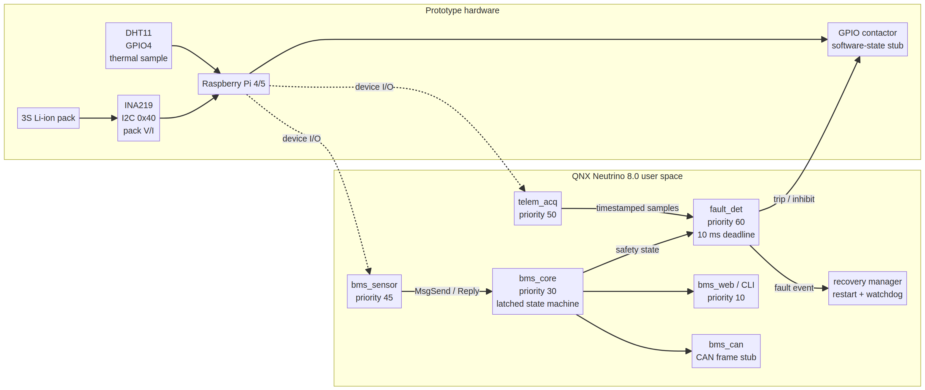
Figure 1. Proposed system architecture derived from the supplied Sentinel-BMS deck [1] and QNX process/IPC principles [2][3].
The data plane carries measurements and status. The control plane carries requests, pulses, fault events, and safe-state commands. The safety plane is the smallest path that must remain live: fault_det, the state machine, and the actuation interface. The user interface and telemetry are observers and must never be the authority for closing a fault or re-arming the pack.

EV versus BESS adaptation
Concern | EV interpretation | BESS interpretation
Safety boundary | Occupants, propulsion inverter, charger | Rack, enclosure, HVAC, fire detection, first responders
Transient profile | Acceleration, regenerative braking, DC fast charge | Grid dispatch, PCS steps, long dwell, thermal gradients
Comms | Vehicle CAN/CAN-FD and diagnostics | Rack controller, EMS/SCADA, alarm gateway
Safe state | Open contactors and inhibit torque/charge | Open rack contactors, inhibit PCS, escalate alarm
Evidence | Vehicle-level warning and crash-safe behavior | Site-level hazard analysis, alarm management and response plan

6. Main system components

6.1 Hardware and acquisition
The prototype uses an INA219 current-shunt and bus-voltage monitor over I²C. TI specifies a 0–26 V input-terminal range, selectable 16 V or 32 V bus ADC ranges, a 12-bit ADC, and I²C/SMBus-compatible communication [5]. The 3S pack is within the prototype’s intended bus range, but the part is not a substitute for a cell-tap AFE. DHT11 is used as a slow temperature demonstration sensor; the project deck schedules it at 2 s, while the sensor datasheet search evidence states that sampling intervals should be at least 1 s [1][8].

6.2 QNX processes
Process/thread | Priority in deck | Primary responsibility | Safety class
fault_det | 60 | Periodic pulse, validate freshness, evaluate critical limits, latch trip | Critical
telem_acq | 50 | Acquire and timestamp measurement frames | Important
bms_sensor | 45 | Sensor service and I²C/GPIO access | Important
ina219/charger | 40 | Device-specific measurement/charge service | Important
thermal | 35 | Thermal processing and trends | Important
bms_core | 30 | State machine, policy, SoC/SoH, shared status | Critical support
bms_web / CLI | 10 | Dashboard and operator observation | Non-critical
bms_can | 10–30 proposed | Pack/network frames and diagnostics | Non-critical until validated

6.3 Protection and storage
The logical contactor state is a prototype abstraction. A production interface must drive a qualified contactor or solid-state switch through a hardware interlock, include pre-charge sequencing, verify auxiliary contacts, detect welded contacts, and provide a secondary cutoff path. The BQ76952 is a useful scale-up reference because TI describes support for 3–16 series cells, cell voltage and current measurement, open-wire detection, over/under-voltage, over-current, over-temperature, balancing, and optional autonomous recovery [6].

7. Overall operation and fault life cycle
At startup, the supervisor starts the device, acquisition, core, fault, telemetry, and UI services. Each service announces readiness through a named channel or equivalent QNX service endpoint. The system enters MONITOR only after self-test and sample-validity checks pass. Otherwise, the default is SAFE_OPEN / INHIBIT.
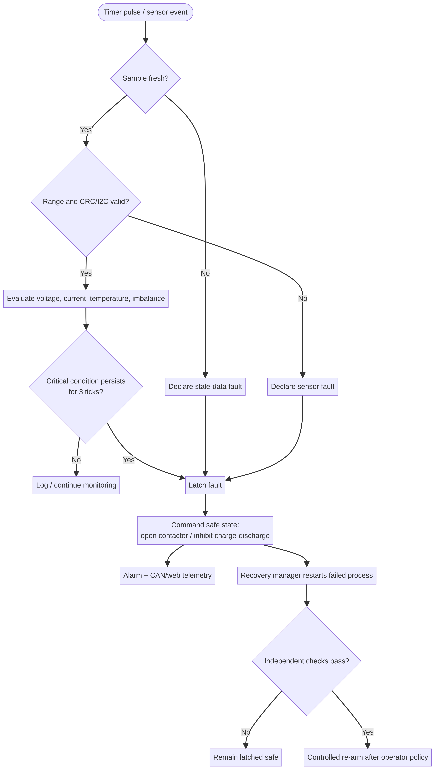
Figure 2. Fault-handling flow: a missing or invalid sample is itself a safety event.
The flow intentionally separates detection from recovery. Detection must be fast and monotonic: once a critical fault is latched, the state may move only toward a safe condition. Recovery is slower and policy-controlled. A restarted process may resume measurement, but it must not silently clear a fault. Re-arm requires fresh evidence, clear diagnostic records, and an explicit system policy.

Debounce and freshness
For a 100 ms acquisition tick, the deck’s three-tick debounce produces a nominal 300 ms persistence window before latching a threshold violation. This is appropriate for filtering a single noisy sample but must be justified against the hazard’s time-to-danger. Freshness is different: a sensor frame older than 500 ms is invalid, so the safety path does not wait for three stale ticks before taking the safe action [1].

8. QNX RTOS system design principles
QNX Neutrino implements core POSIX and message-passing services in a microkernel; file and device I/O are provided by processes and libraries outside the kernel [2]. This decomposition supports a BMS architecture in which device access, logging, dashboards, and network services can be restarted or constrained independently of the core scheduling and IPC mechanisms.

8.1 Deterministic scheduling
QNX schedules threads globally across processes. Its documentation states that the scheduler selects the next runnable thread by comparing priorities and that a higher-priority ready thread can preempt the running thread [3]. The project maps fault_det to the highest application priority, followed by acquisition and sensor services, with web/CLI at the bottom [1]. This priority scheme should be backed by a schedulability analysis that includes worst-case execution time, interrupt load, mutex blocking, message service time, and CPU affinity.

8.2 Periodic timing
The fault thread is released by a periodic timer pulse rather than by dashboard activity. A monotonic clock timestamp is recorded with every sample and decision. The implementation should use absolute-time release points or an equivalent drift-free pattern, detect missed releases, and record the release-to-decision interval. Timer design is not a guarantee by itself: the trace must show actual dispatch latency under load.

8.3 Small critical path
The safety decision should avoid dynamic allocation, unbounded loops, blocking network calls, lengthy logging, and dependency on UI state. It should read a bounded sample snapshot, run fixed-cost comparisons, update a latched state, assert the safe output, and emit a compact event. Detailed analytics can run outside the critical path.
Design rule: “fast on average” is insufficient. The acceptance argument must use worst-case timing, not mean latency, and must include the time to move the physical power path to a safe state.

9. Process isolation and IPC
QNX process separation gives each user-space process its own protected address space. A defect in the dashboard or device service therefore should not directly corrupt fault_det memory. QNX describes resource managers and device drivers as separate processes; a driver defect does not require the entire OS to shut down [4]. This is the basis for the prototype’s “kill the sensor process” stress case.

Message passing
QNX identifies synchronous message passing as the main IPC form. MsgSend(), MsgReceive(), and MsgReply() implement a copy-based, synchronous transaction; channels and connections direct the transaction to a server, while pulses provide a small non-blocking event mechanism [3]. The deck maps bms_web → bms_core → bms_sensor with MsgSend, and uses a timer pulse to release fault_det [1].
IPC path | Payload | Boundedness rule | Failure behavior
Sensor → acquisition | Timestamped V/I/T frame | Fixed-size structure; sequence number | Timeout/stale frame becomes fault
Core → fault_det | Policy and state snapshot | No unbounded queue; latest valid snapshot | Missing snapshot = unsafe
fault_det → actuation | Trip/inhibit command | Single compact command | Retry once, then keep safe
Fault → recovery manager | Process identity and reason | Event log with monotonic time | Restart and revalidate
Core → web/CAN | Telemetry/status | Best-effort, rate-limited | Drop telemetry, never safety decision

Shared memory caution
The deck mentions a mutex-guarded shared structure. Shared memory can be appropriate for high-rate telemetry, but it increases coupling and makes consistency rules essential. Use a double-buffer or sequence-lock pattern for snapshots, keep the writer bounded, and use priority-inheriting mutexes when a mutex is unavoidable. The safety decision should never depend on a UI-held lock. QNX also documents priority inheritance for message passing to help avoid priority inversion [3].

10. Recovery manager and GPIO hardware interface

10.1 Recovery manager
The recovery manager supervises process liveness, channel availability, heartbeat freshness, and exit status. If bms_sensor terminates, the supervisor records the failure, forces the safe state through the independent actuation path, restarts the service, and waits for self-test plus fresh evidence. The deck reports a roughly one-second restart target and a sub-one-safety-tick fail-safe reaction [1]. These are separate measures: restart time is not allowed to delay the initial safe action.
Recovery stage | Action | Required evidence
Detect | Heartbeat timeout, process exit, channel error | Monotonic timestamp and process ID
Contain | Latch fault; inhibit charge/discharge | Actuation acknowledgment or independent cutoff
Restart | Re-launch service with bounded retry policy | Exit code, restart count, boot reason
Revalidate | Check sensor ID, bus, range, sequence, freshness | At least N valid frames; no active critical fault
Re-arm | Only by policy and operator/system command | Audit record and state-transition authorization

10.2 GPIO and resource-manager design
QNX resource managers register pathname interfaces and run as separate processes. QNX explains that a resource manager can present hardware through open/read/write-style interfaces and that it remains outside the kernel address space [4]. A GPIO/I²C service should therefore expose a narrow interface such as /dev/sentinel/gpio and /dev/sentinel/ina219, validate every request, and keep device-specific complexity out of fault_det.
The prototype’s logical contactor output should be replaced by a hardware-safe interface: a GPIO command requests OPEN, a driver applies interlock conditions, an auxiliary contact returns actual contactor position, and a watchdog or hardware supervisor opens the path if software stops servicing it. GPIO output assertion must be fail-safe on boot, reset, brownout, and process death.

11. Failure isolation and BMS process model
Failure isolation means limiting both the blast radius and the recovery ambiguity of a fault. The architecture uses three barriers: memory isolation between processes, priority separation between critical and non-critical work, and state-machine latching between detection and re-arm.
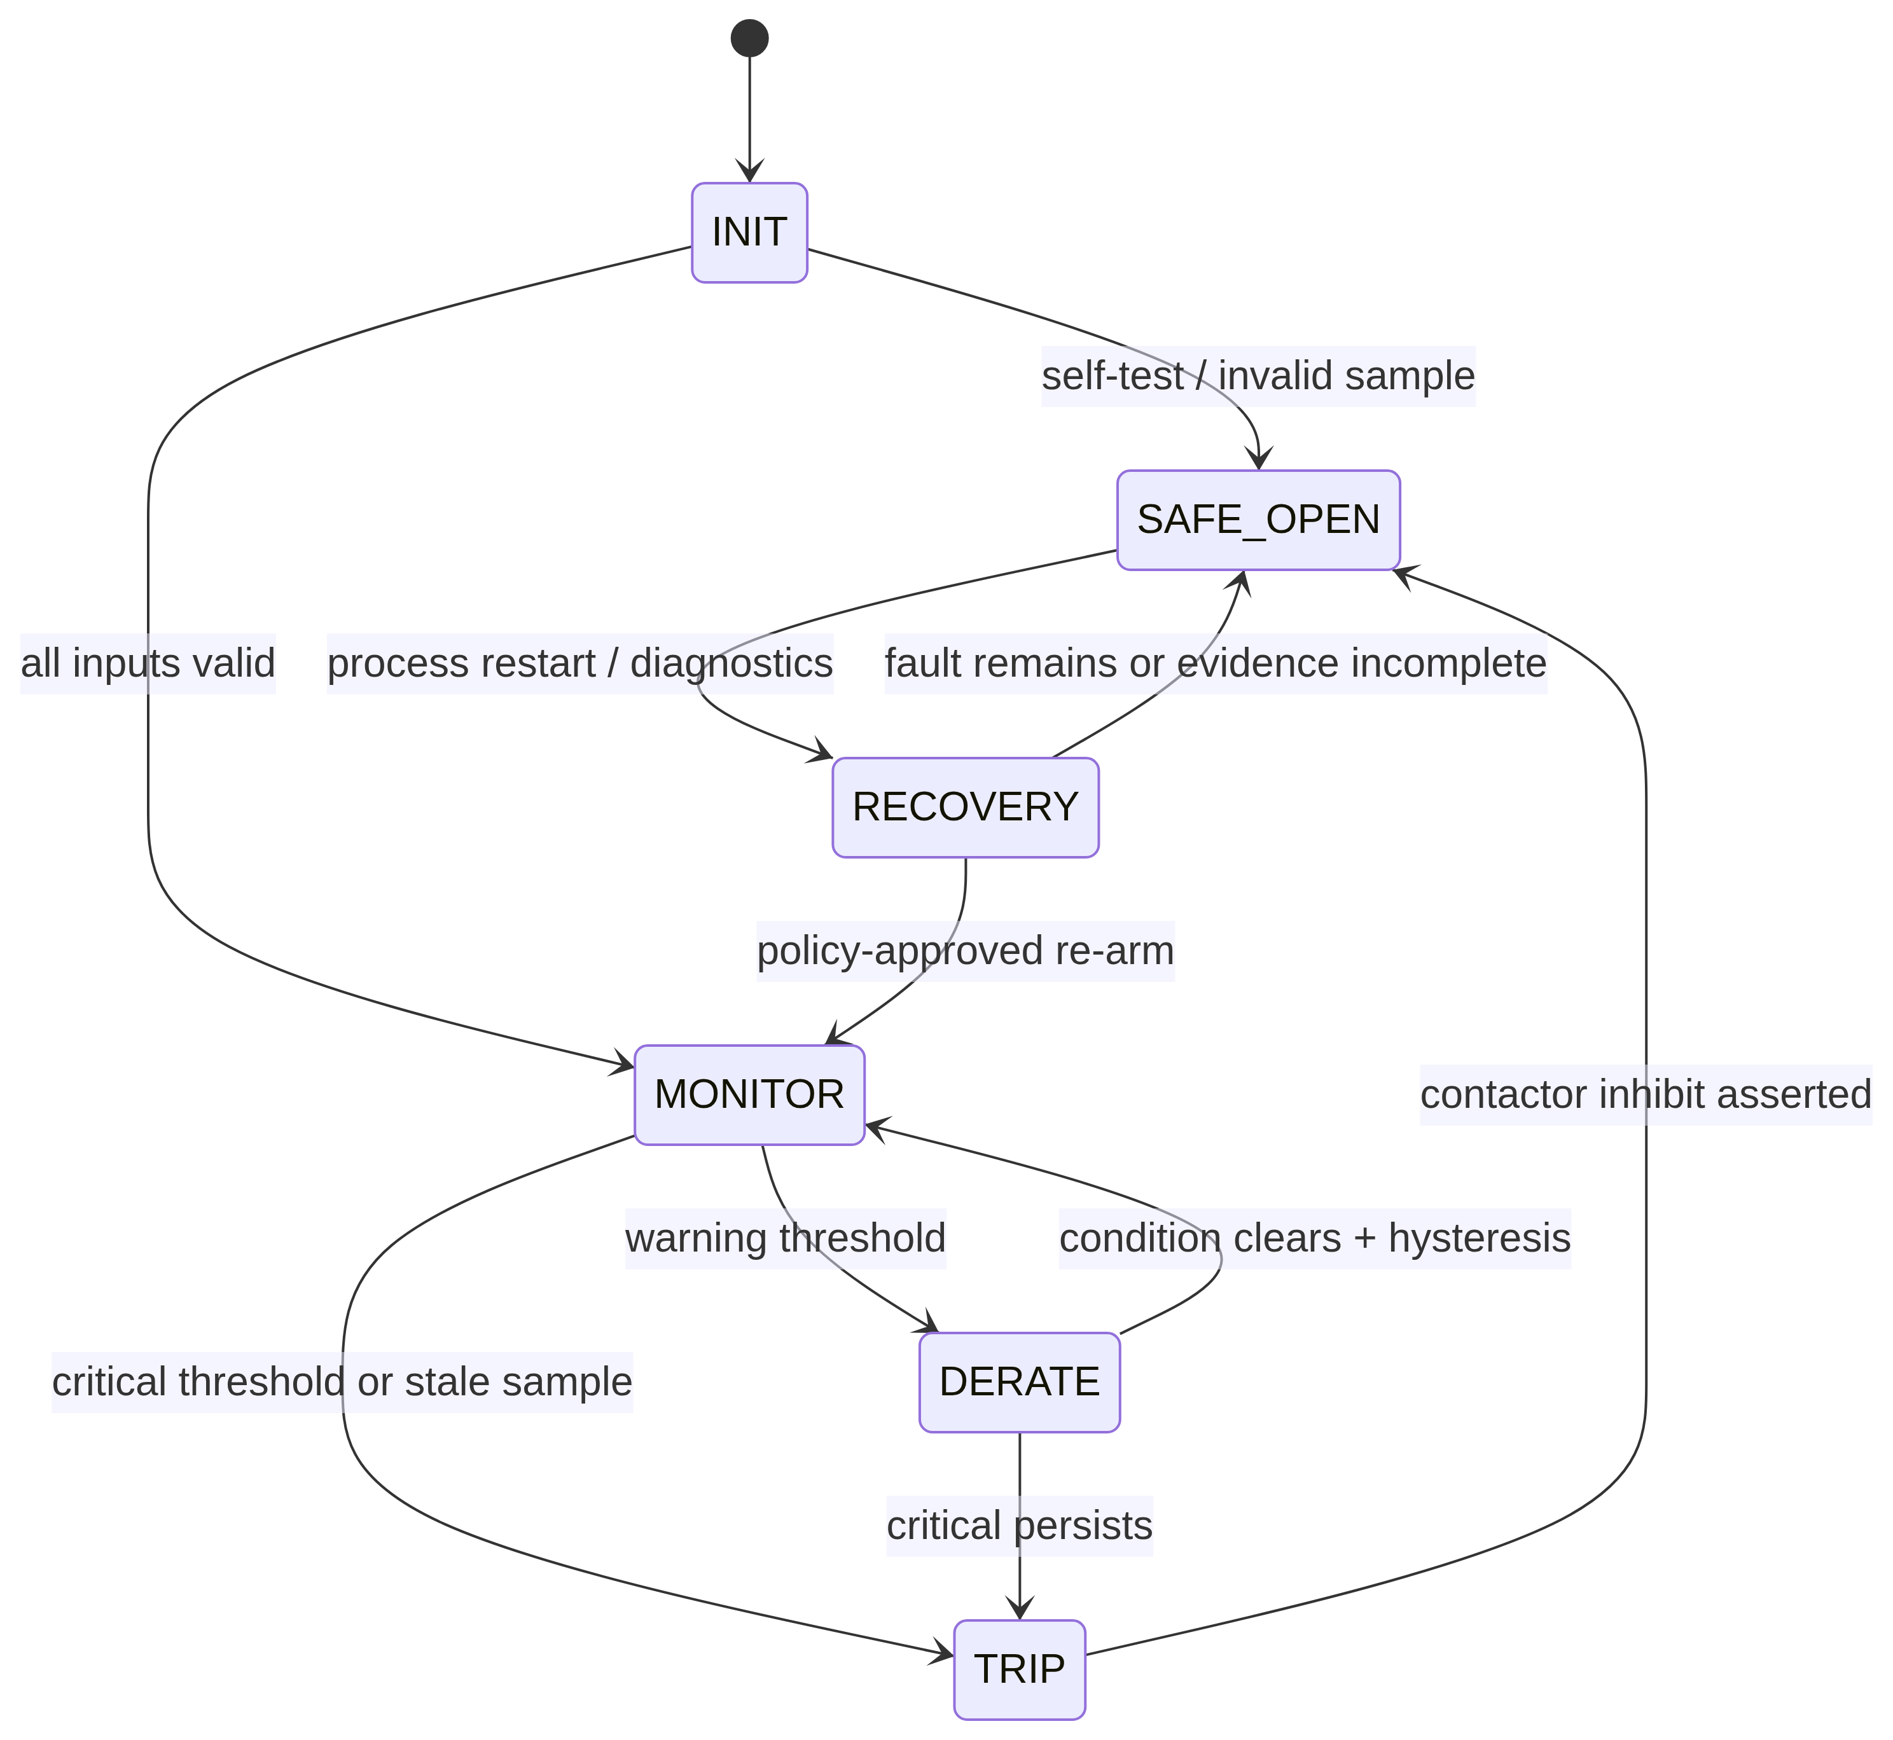
Figure 3. Safety state machine for monitor, derate, trip, safe-open, and controlled recovery.

BMS process responsibilities
Function | Input | Output | Isolation rule
Acquisition | I²C/GPIO samples | Timestamped raw frame | No direct state mutation
Validation | Raw frame + monotonic time | Valid/invalid frame | Invalid is explicit, not zero-filled
Fault detection | Latest valid frame + freshness | Fault code and trip decision | No dependency on UI/network
Core policy | Fault events, SoC/SoH | Latched system state | Only core/state owner can re-arm
Actuation | Trip/inhibit request | Physical output + feedback | Independent driver and feedback
Telemetry | State snapshot | Web/CAN/log | Loss of telemetry cannot clear fault
Recovery | Liveness and fault record | Restart/revalidate | Never auto-clears a latched safety fault

A cell-level BMS must distinguish “no measurement” from “normal measurement.” An absent cell frame is not equivalent to 0 V or nominal V. Sequence counters, sensor identity, range checks, and plausibility checks are required to prevent stale or corrupted values from entering the estimator. The peer-reviewed review notes that cell-level sensing offers high accuracy but is also susceptible to sensor errors, while pack/system-level methods may miss minor cell faults [10].

12. Monitoring, evidence, and performance metrics
QNX microkernel instrumentation is designed for real-time tracing and profiling. QNX states that instrumentation can monitor processes, threads, kernel calls, state changes, and interrupts with high-precision timestamps [4]. The project deck requires a System Profiler or tracelog capture showing CPU usage and per-thread timing [1].
Metric | Definition | Target / interpretation | Evidence artifact
Decision latency | Timestamp of fault input to safe decision | ≤10 ms project target; report max, p99, min | Trace correlation
Deadline misses | Safety releases not completed within period | 0 in acceptance run | Profiler counter
Jitter | Variation in periodic release or completion | Low and bounded; set threshold before test | Per-thread timing table
Sample age | Decision time minus sample timestamp | <500 ms or immediate stale fault | Frame log
CPU utilization | Busy time / wall time by process/thread | Headroom under worst load | System profiler
IPC time | MsgSend/pulse handling duration | Bounded, no unexpected blocking | Trace events
Recovery time | Process exit to revalidated service | ~1 s prototype target; not safety latency | Supervisor log
Fault coverage | Injected faults detected and contained | 100% of specified prototype cases | Test matrix

Evidence quality
A plot or live table is not enough unless the test setup is recorded. Each run should capture software build ID, QNX image ID, sensor configuration, threshold configuration, CPU load, injected fault, start/end timestamps, and pass/fail result. For the 10 ms claim, the report should show the maximum observed latency, not only the average. For restart, distinguish the time to assert SAFE_OPEN from the time to restart and validate the process.
The instrumentation path must not become the hazard. Use bounded trace buffers, rate limits, and a non-blocking telemetry path. If tracing is disabled in a production image, retain a minimal health counter and fault record so that post-event analysis remains possible.

13. Fault conditions and response matrix
The following matrix combines the supplied prototype thresholds with production-oriented fault classes. Thresholds are demonstration values and must be recalculated from cell chemistry, pack configuration, sensor accuracy, temperature, and hazard analysis before deployment.
Fault condition | Detection logic | Immediate action | Latched? | Production note
Pack over-voltage | Vpack >12.60 V for 3 ticks | Inhibit charging; open contactor | Yes | Use individual cell OV limits and charger coordination
Pack under-voltage | Vpack <9.00 V for 3 ticks | Inhibit discharge | Yes | Cell reversal risk requires cell taps
Over-current | I >3.00 A for 3 ticks or hardware comparator | Open/inhibit path | Yes | Separate charge/discharge limits and short-circuit path
Over-temperature | T >55 °C for 3 ticks | Stop charge/discharge; alarm | Yes | Multiple sensors and rate-of-rise logic
Stale INA219 | Age >500 ms or sequence gap | Immediate safe state | Yes | Check I²C bus recovery and independent monitor
I²C read failure | NACK, timeout, invalid register | Immediate safe state | Yes | Use bus reset and device health counter
Sensor process death | Exit/heartbeat timeout | Immediate safe state; restart | Yes | Restart does not clear fault
Cell imbalance | max(cell)-min(cell) above limit | Derate/balance/maintenance | Policy | Requires true cell measurements
Contactor welded | Command OPEN but feedback CLOSED | Remove drive; isolate upstream | Yes | Hardware feedback and fuse strategy
Thermal runaway indicators | Rapid ΔT, voltage collapse, gas/smoke input | Emergency alarm and site/vehicle policy | Yes | UNECE R100 expects warning parameters/system explanation [7]

Safety priority ordering: hardware comparator/fuse > qualified AFE protection > fault_det software > bms_core policy > telemetry/UI. Lower layers must not be able to override a higher-layer trip.

14. Verification and test plan
Verification should proceed from deterministic unit tests to integrated fault injection and then to hardware-in-the-loop. The goal is to prove both functional correctness and timing behavior under contention.
Test ID | Test method | Expected result | Pass evidence
V-01 | Inject high/low voltage values at boundary and beyond | Correct warning/trip, hysteresis, and latch behavior | Input/output log
V-02 | Inject 1–2 bad samples then persistent fault | No trip for configured debounce; trip after 3rd tick | State transition log
V-03 | Stop INA219 updates | Fault within stale-data policy; safe state | Sample-age trace
V-04 | Kill bms_sensor with SIGKILL | fault_det remains alive; safe state; supervisor restarts | Process and trace logs
V-05 | Flood web/CLI requests | No safety deadline misses; UI may drop responses | CPU/latency trace
V-06 | Force I²C NACK/bus stuck | Driver reports error; no stale sample accepted | Device log
V-07 | Simulate over-temperature ramp | Alarm/trip based on threshold and rate policy | Thermal trace
V-08 | Contactor feedback mismatch | Latched actuator fault and escalation | GPIO/feedback capture
V-09 | Power-cycle/reset during fault | Boots to safe-open and retains diagnostic reason | Startup log
V-10 | Worst-case load and trace enabled | Max decision latency ≤10 ms; 0 misses | Profiler report

Test governance
Every test must identify the injected condition, expected state, actual state, timestamps, threshold version, and whether the physical safe state was observed. Tests that only inspect an in-memory contactor variable are prototype tests, not power-path safety tests. A production acceptance test must include contactor driver behavior, auxiliary feedback, pre-charge, welded-contact detection, and independent cutoff.
The final verification report should preserve raw traces, not just screenshots. A reviewer must be able to reproduce the maximum-latency calculation and determine whether the safety loop was measured with the same workload, sensor periods, and trace settings as the demo.

15. EV and BESS deployment pathway
The prototype architecture can scale conceptually, but deployment requires a larger safety boundary. UNECE R100’s current text includes requirements related to thermal-event warning, thermal propagation, over-temperature protection, and over-current protection, and asks manufacturers to document parameters, thresholds, system diagrams, and risk-reduction analysis [7]. This aligns with the report’s emphasis on evidence rather than a single benchmark number.

Recommended scale-up architecture
- Replace pack ÷ 3 estimation with a qualified multi-cell AFE such as a BQ76952-class device; TI documents 3–16 series support, open-wire detection, protection features, cell balancing, and autonomous or host-controlled operation [6].
- Add independent over-voltage, under-voltage, over-current, and over-temperature hardware paths. Software should supervise and report them, not be the only line of defense.
- Use distributed temperature sensors and validate placement, thermal lag, sensor drift, and rate-of-rise detection.
- Add isolation monitoring, pre-charge, contactor auxiliary feedback, fuse/pyro-fuse strategy, and a dual watchdog.
- Use CAN/CAN-FD with message authentication/diagnostics as required by the product threat model; keep network traffic outside the minimum safe decision path.
- Build the safety case around hazard analysis, diagnostic coverage, fault-tolerant time interval, independence, traceability, and change control.

EV-specific and BESS-specific controls
Deployment | Additional control
EV | Crash signal handling, service disconnect, charger coordination, torque inhibit, passenger warning, water ingress and isolation fault logic
BESS | Rack-to-container hierarchy, HVAC interlock, gas/smoke/pressure detection, fire-system interface, emergency stop, responder alarm policy, site hazard analysis
Both | Cell-level data integrity, calibration, secure boot/update process, event retention, maintenance diagnostics and field-return analysis

16. Limitations, risks, and next steps

Known limitations
- The prototype does not individually measure cells; cell voltage and imbalance are estimated from pack voltage divided by three [1].
- The contactor is a software state in the supplied scope; no cutoff hardware is wired [1].
- CAN is described as a stub, so bus timing, error handling, interoperability, and diagnostics are not demonstrated [1].
- DHT11 is a slow, low-cost demonstration sensor and is not a production thermal sensor [1][8].
- The deck references profiler evidence and recovery observations, but independent raw trace files were not supplied with the report request.
- No claim is made for ISO 26262, IEC 61508, UNECE approval, UL/NFPA compliance, or production safety integrity.

Risk register
Risk | Impact | Mitigation
False negative from pack-only voltage | Missed weak cell | Cell taps/AFE and open-wire diagnostics
Stale data treated as normal | Unsafe charge/discharge | Freshness watchdog and fail-safe invalid state
UI/network load delays trip | Deadline miss | Priority separation, bounded IPC, load test
Software-only cutoff | Energy remains connected | Independent hardware contactor/fuse/comparator
Threshold not chemistry-specific | Over/under-protection | Validated limits, calibration and hazard analysis
Auto-restart clears fault | Unsafe re-arm | Latched state and explicit re-arm policy

Next implementation sprint
First, wire and test an independent contactor driver with feedback. Second, replace pack-level estimation with cell-level measurement and inject open-wire, missing-cell, and imbalance faults. Third, capture repeatable QNX profiler traces under dashboard flood, sensor failure, and high CPU load. Fourth, build a requirements-to-test traceability matrix and update the safety case. Finally, migrate from a hackathon demonstrator to a qualified hardware and lifecycle plan.

17. Conclusion
Sentinel-BMS presents a credible prototype pattern for real-time cell-fault handling: separate the safety decision from the dashboard, make stale data unsafe, drive the decision thread with a timer, latch dangerous states, and measure worst-case timing. QNX Neutrino supports this pattern through microkernel services, protected processes, priority-based scheduling, synchronous IPC, pulses, resource-manager interfaces, and trace instrumentation [2][3][4].
The architecture is strongest where it makes failures explicit. A dead sensor is not a quiet absence. A missing sample is not a valid zero. A restarted process is not permission to re-arm. A profiler average is not proof of a deadline. These rules make the prototype easier to test and the production path easier to review.
The architecture is not complete battery protection. True EV/BESS safety requires cell-level measurement, independent hardware cutoff, qualified thermal and current sensing, contactor feedback, watchdogs, calibration, hazard analysis, and regulatory evidence. UNECE R100 and the broader battery-safety literature reinforce that system diagrams, thresholds, warning behavior, propagation risk, and risk reduction must be documented [7][10].
Final assessment: QNX can solve the software-architecture portion of the problem—deterministic scheduling, process isolation, IPC discipline, observability, and recoverable services. It cannot solve missing sensors, missing power-path hardware, or missing safety evidence. Sentinel-BMS should therefore be presented as a verified real-time prototype and a foundation for a production BMS safety case, not as a certified BMS.

Acceptance statement
This report is complete when the team replaces role placeholders with names, attaches raw profiler/tracelog captures, links each acceptance test to a build and threshold version, and demonstrates a physical safe-state transition with an independent cutoff path.

References
[1] Sentinel-BMS / Voltedge project deck, “Sentinel_BMS_Voltedge_Final(1).pptx,” user-provided 7-slide presentation, 2026.
[2] QNX Software Systems, “The QNX OS Microkernel,” QNX SDP 8.0 System Architecture Developer User, updated June 11, 2026. https://www.qnx.com/developers/docs/8.0/com.qnx.doc.neutrino.sys_arch/topic/kernel.html
[3] QNX Software Systems, “Interprocess Communication” and “Thread scheduling,” QNX SDP 8.0 System Architecture Developer User, updated June 11, 2026. https://www.qnx.com/developers/docs/8.0/com.qnx.doc.neutrino.sys_arch/topic/ipc.html ; https://www.qnx.com/developers/docs/8.0/com.qnx.doc.neutrino.sys_arch/topic/kernel_SCHEDULING.html
[4] QNX Software Systems, “The Microkernel Instrumentation” and “What Is a Resource Manager?,” QNX SDP 8.0 documentation, updated June 11, 2026. https://www.qnx.com/developers/docs/8.0/com.qnx.doc.neutrino.sys_arch/topic/trace.html ; https://www.qnx.com/developers/docs/8.0/com.qnx.doc.neutrino.resmgr/topic/overview.html
[5] Texas Instruments, “INA219 26-V, 12-bit, I2C output current/voltage/power monitor,” datasheet SBOS448G, revised December 2015. https://www.ti.com/lit/ds/symlink/ina219.pdf
[6] Texas Instruments, “BQ76952 3-Series to 16-Series High Accuracy Battery Monitor and Protector,” product page and datasheet links. https://www.ti.com/product/BQ76952
[7] United Nations Economic Commission for Europe, “UN Regulation No. 100: Uniform provisions concerning the approval of vehicles with regard to specific requirements for the electric power train,” Rev.2/Add.99/Amend.5, 2025. https://unece.org/sites/default/files/2025-05/R100r2am5e.pdf
[8] Mouser / DHT11 technical data sheet, “DHT11 Humidity & Temperature Sensor,” sampling interval guidance. https://www.mouser.com/datasheet/2/758/DHT11-Technical-Data-Sheet-Translated-Version-1143054.pdf
[9] J. Lamb and Y. Preger, Sandia National Laboratories, “Battery Safety and Reliability: Tools to understand risk in grid-scale energy storage systems,” DOE 2021 Lunch & Learn Series, SAND2021-6800PE. https://www.osti.gov/servlets/purl/1872307
[10] J. Zhao et al., “Battery safety: Fault diagnosis from laboratory to real world,” Journal of Power Sources, 2024, article PII S0378775324000624. https://www.sciencedirect.com/science/article/pii/S0378775324000624
[11] National Laboratory of the Rockies, “Battery Failure Databank,” updated January 2, 2026; data from hundreds of abuse tests on commercial lithium-ion batteries. https://www.nlr.gov/transportation/battery-failure

Appendix A — terminology
Term | Meaning
AFE | Analog front end for cell measurement and protection
BESS | Battery energy storage system
BMS | Battery management system
IPC | Interprocess communication
RTO | Recovery time objective
REESS | Rechargeable electrical energy storage system
SoC / SoH | State of charge / state of health
Stale data | A sample older than the configured freshness limit
Thermal runaway | Self-accelerating battery failure involving rapid heat generation and hazardous propagation risk

