

Crop production analysis

Using Power BI

**GOVERNMENT ARTS AND**

**SCIENCE COLLEGE**

|  |  |
| --- | --- |
| **NM ID(USER NAME)** | **NAME** |
| 9193F20E92039B6AD434911579F1E0C2 | M.AKALYA |

|  |  |
| --- | --- |
|  |  |
|  |  |
|  |  |

**Abstract**

Micronutrient deficiency is considered as one of the major causes of the declining productivity trends observed in rice-growing countries. The submergence created for rice cultivation influences electrochemical and biochemical reactions, and alters pH, pCO2 and the concentration of certain ions. This environment increases the availability of Fe and with concomitant decrease in Zn and Cu. It is well known that Zn deficiency is predominant in lowland ecosystems and upland soils and calcareous coarse-textured soils with low organic matter content suffer from Fe deficiency, besides Zn and Cu deficiencies.

**INDEX**

|  |  |  |
| --- | --- | --- |
| **Sr. No.** | **Table of Contents** | **Page No.** |
| 1 | Chapter 1: Introduction | 1 |
| 2 | Chapter 2: Services and Tools Required | 2 |
| 3 | Chapter 3: Project Architecture | 3 |
| 4 | Chapter 4: Modeling and Result | 5 |
| 5 | Conclusion | 9 |
| 6 | Future Scope | 10 |
| 7 | References | 11 |
| 8 | Links | 11 |

**CHAPTER 1**

**INTRODUCTION**

* 1. **Problem Statement**

INDIA has the largest area under rice (75 million acres) among the rice growing countries of the world, and her production, about 25 million tons of white rice, is the second largest. Rice is the most important staple food of the country and contributes to over 45 per cent. of the total cereal production. The average acre yield of about 800 lb. of rice is perhaps the lowest in Asia, the only other country that records still lower yields being the Philippines. India and Japan are the two largest rice deficit countries of Asia. During and immediately after World War II, world rice production was considerably short of requirements, price shot up and rice deficit countries experienced great difficulties.

* 1. **Proposed Solution**

Arsenic (As) is a toxic metalloid classified as group 1 carcinogen. The presence of As in high concentrations in paddy soil and irrigation water results into high As accumulation in rice grains posing a threat to the health of millions of people worldwide. The main reason for As contamination is the biogeochemical weathering of rocks and the release of bound As into groundwater. Human interventions through intensive agricultural practices and excessive groundwater consumption have contributed greatly to the prevailing contamination. The flooded cultivation practice of rice favors the accumulation in grains.

* 1. **Feature**

The objectives of this study are (1) to develop a scaling-up scheme of a plot-based crop model to an area-based rice production forecasting system suitable for the Korean situation, with an emphasis on the weather data preparation, and (2) to test the applicability of the system by comparison of the simulated yield data with the actual yield data at the 162 crop reporting districts in Korea for the recent 3 years.

* 1. **Advantages**

#### The advantages of growing rice in submerged soils include a general amelioration of chemical fertility, preferential accumulation of organic matter and improved availability of major, secondary and selected micronutrients. These soil fertility advantages benefit the long-term maintenance of soil fertility and sustainability of wetland rice systems. The paper emphasizes the potential of growing wetland rice in monsoon Asia, specifically in poorly drained, waterlogging-prone areas where the water table is shallow (within 30 cm of the soil surface).

* 1. **Scope**

The scope of this project extends to all banking institutions that aim to leverage data for decision-making and customer engagement. The project can be further extended to incorporate more data sources and advanced analytics techniques, such as machine learning and artificial intelligence, to provide more sophisticated insights into customer behavior. The project also has the potential to be adapted for other sectors, such as retail, healthcare, and telecommunications, where understanding customer behavior is crucial. Furthermore, the project contributes to the broader goal of digital transformation in the banking sector, promoting efficiency, innovation, and customer-centricity.

**CHAPTER 2**

**SERVICES AND TOOLS REQUIRED**

**2.1 Services Used**

This book collects all the latest technologies with their implications on the global rice cultivation. It discusses all aspects of rice production and puts together the latest trends and best practices in the rice production. Rice is produced and consumed worldwide and especially an important crop for Asia. It is a staple food in majority of population living is this continent which distinguishes this from rest of the world. Climatic fluctuations, elevated concentrations of carbon dioxide, enhanced temperature have created extreme weather conditions for rice cultivation. Also, increasing pest attacks make situation complicated for the farmers. Therefore, rice production technology also has to be adjusted accordingly.

This book is of interest to teachers, researchers, plant biotechnologists, pathologists, agronomists, soil scientists, food technologists from different part of the globe. Also, the book serves as additional reading material for students of agriculture, soil science, and environmental sciences. National and international agricultural scientists, policy makers will also find this to be a useful read

**2.2 Tools and Software used**

 Lack of Harvest Area (hectares), 2). Productivity (quintal / hectare) and 3). Production (ton). Cluster results using 3 clusters: (C1) high production cluster, (C2) normal production cluster and (C3) low production cluster. Based on the research results obtained (C1) high production cluster = 3 provinces, (C2) normal production cluster = 23 provinces and (C3) low production cluster = 8 provinces. This study also uses "% performance" to see the accuracy of the algorithm used with the research topic. From the result of accuracy using parameter average within centroid distance and Davies Bouldin obtained Davies-Bouldin index for rice plant is -0.392. Based on these performance results can be summed up as the best algorithm based on criteria. The lowest cluster clustering (C3): Aceh, North Sumatera, West Sumatera, South Sumatera, Lampung, West Nusa Tenggara, South Kalimantan, and South Sulawesi are input inputs to the government, to provide socialization to the province to increase rice production, is one of the commodities of Indonesian people, especially rice.

**CHAPTER 3**

**PROJECT ARCHITECTURE**

**3.1 Architecture**

**USER FRONTEND BACKEND**

|  |  |  |
| --- | --- | --- |
|  | **HTML 5** | **NODEJS 14.0**  **Database** |

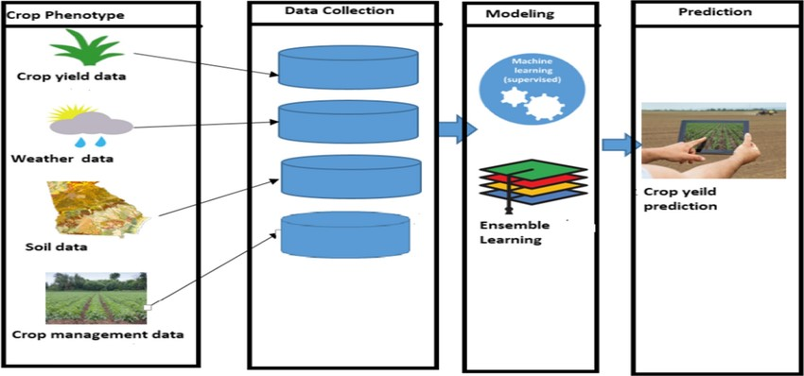

The results showed that more light could reach to the leaves under the panicle in the *CRISPR*-*dep1* population compared with the WT. The canopy of the CRISPR-*dep1* population exhibited higher temperature and lower humidity compared with the WT after heading. A subsequent survey showed that the CO2 concentration in the *CRISPR*-*dep1* population was significantly lower than that in the WT population from full heading to 15 days after heading. Moreover, the increase of biomass in the *CRISPR*-*dep1* population was greater than that in the WT. We noticed that the CRISPR-*dep1* mutant could achieve higher yield under low fertilization application compared with the WT under high fertilizer application through increased transplant density. These traits could contribute to an agricultural sustainable development strategy. The quality investigation showed that the *dep1* allele increased the yield along with imposing a penalty on grain quality. Our study not only elucidated the mechanism of yield improvement in an erect panicle architecture variety from the perspective of population structure optimization but also provides a theoretical basis for supporting cultivation systems with the erect panicle architecture.

• Key Results The relationships between the nodal positions and leaf lengths, leaf angles and tiller angles were analysed and used to determine growth functions for the models. The ‘3D virtual rice’ reproduces the structural development of isolated plants and provides a good estimation of the tillering process, and of the accumulation of leaves.

**CHAPTER 4**

**MODELING AND RESULT**

**Manage relationship**

## Location and cropping in the study regions

Three of the intensive rice producing areas of Bangladesh, Jamalpur, Jessore and Comilla, were selected for this study. Jamalpur is located within Jamalpur Sadar Thana (central administrative sub-district), in the south-eastern part of Jamalpur district. The study area is 180 km northwest from Dhaka. Jessore is located in Manirampur Thana in the southern part of Jessore district, 290 km southwest from Dhaka. Comilla is located in Matlab Thana in the south-eastern part of Chandpur district, 120 km

**Edit Relationship**

Nowadays, agriculture is facing a special challenge – to produce more food for a growing population, while reducing greenhouse gas emissions caused by food production. This piece of research is focused on the impact of agriculture on climate change, starting from the assumption that agriculture is affected by climate variability, but also it contributes to it by emitting greenhouse gases, under the restriction of less per capita land. The paper analyses the connection between agricultural emissions and agricultural output, using a simple regression model, which includes variables corresponding to agricultural production and to greenhouse gas emissions. The results of the research highlight the fact that agricultural production has direct effects on greenhouse gas emissions and, thereby, on climate change. The relevance of the research consists in rising awareness of the emergency to integrate climate change in policies and actions related to food security at all levels. Moreover, the paper contributes to the enrichment of scientific literature, because it presents empirical evidence supporting the different effects of agricultural practices on the environment in Romania, with implications for climate change, a scientific direction that has been little studied in other papers.

**Crop Production Loan**

The crop loan is provided to meet all expenses involved in raising a particular crop including various agronomic practices. Farmers cultivating owned/Registered leased lands/share croppers. As per the scale of finance fixed by the Technical Committee of each district..

**Replacing values**

| **Code:** |  |
| --- | --- |
| **Result Level:** | * Outcome |
| **Objectives:** | * Productivity enhancement * Increase and diversification of incomes |
| **Description:** | Value of crop production per household Valuation in financial terms of HH agricultural production An increase in total value represents an increase in the wealth of a HH. Takes inflation into account. |
| **Disaggregated By:** | Geography/Livelihoods zone; Head of household’s gender, age, disabilities, chronic diseases, dependency ratio, and any other relevant criteria, such as urban/rural context, religious, ethnic or political identities; Wealth groups; Livelihoods group (e.g. pastoralist, farmers, traders); Period to achieve the objective; |
| **Direction of change:** | Increase (number) |
| **Data source:** | Both secondary and primary data collection can be used according to context. Baseline/Endline. If multiyear programme depending on comparison requirements between lean season and other seasons, consider an interim reporting/evaluation; Secondary data. Reliable/relevant sources from other actors, clusters or government. Data Collection methods: Secondary data analysis; Households Survey, Focus Group Discussion; Productive Organizations records |
| **Sector/Subsector:** | * Primary production * Access to Market and Services |
| **Source:** | CWW-2 |
| **Examples:** |  |
| **Measure Notes:** | Total production of each crop, farm gate price (price at harvest) for each crop. Using Farm gate prices is a conservative valuation |

**Grouping of age by ranges**

The Neolithic Revolution or referred to as the first agricultural revolution during the late 19th century CE by historians. It covered the period ranging from around 7,000 B. C. to 1,000 B.C. in India. The period provided a remarkable change in the lifestyle of Homo sapiens in various fields.

**Credit Rating and Loan Status**

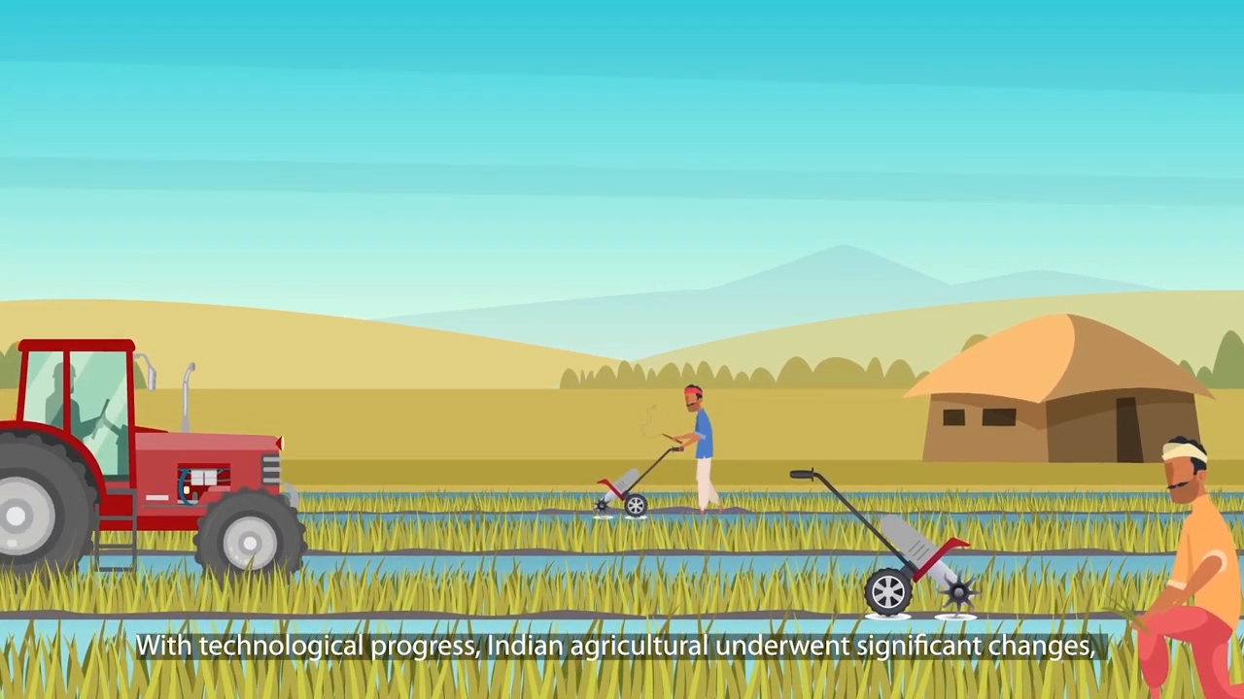

**Dashboard**

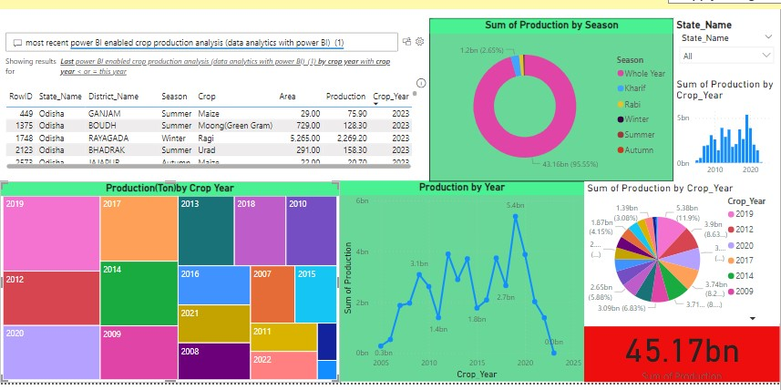

**CONCLUSION**

We suggested a way to link a crop model with spatially explicit weather data to project crop production at a sub-county scale in mountainous regions like Korea. Emphasis was put on preparation of the site-specific weather data for the model input. A seasonal variation of the lapse rate was adopted for daily temperature interpolation, which has practical implications in mountainous regions. Land cover effects were also taken into account by applying the cooling rate to the rice paddies.

**FUTURE SCOPE**

Climate change has many facets, which include changes in longterm trends in temperature and rainfall regimes with increasing year-to-year variability and a greater prevalence of extreme events. The effects of these changing conditions on agriculture are obvious, but considerable gaps exist in our knowledge of how agricultural systems can be affected by both short- and long-term changes in climate and what implications these changes will have for rural livelihoods, particularly among the most vulnerable. For some regions and crops, opportunities for increased production exist, but, for most, there is simply not enough information available regarding impacts at scales that are relevant to decision making and research prioritization, and this has an adverse effect on the global net agricultural production (IPCC 2007).

**REFERENCE**

**https://www.atharvasystem.com/powerbi-agricultural-analytics-dashboard/**

**LINK**