COE 292 – Final Project Report
Course: COE 292 – Introduction to Artificial Intelligence
Team ID: S4_2
Team Members: MOHAMMAD ABUALSAUD, MOHAMMED ALFARAJ, YOUSEF ALMAZROEI
Dataset Selected: 20_Mobile_Price_Classification.csv, Mobile Price Classification from Kaggle, used to classify mobile phones into four price ranges based on their specifications.
1. Dataset Exploration and Preparation
- Number of samples: 2000
- Number of features: 20
- Number of classes: 4 (price_range = 0, 1, 2, 3)
- Class distribution (samples per class): 500 samples for each class
Preprocessing and scaling steps applied:
- No missing values were found in the dataset, so no action was needed.
- All features were numerical, so no encoding was needed
- StandardScaler was used to apply feature scaling for data normalization, which is necessary for distance-based methods and margin-based methods like K-NN and SVM respectively.
5-fold (stratified) cross-validation setup:
Stratified Cross Validation (5-fold) was used to achieve approximately the same distribution of samples within each fold as in the original dataset. Thus, the dataset was divided into 5 separate sets where one was reserved for testing and the others were used for training on each of the 5 sets. Each set functions as a test set once.
Data Visualization:
The relationship between RAM and battery power is shown in Figure 1. RAM is clearly correlated with price category. As the price range increases of the mobile device, the more RAM will be inside. Which means that RAM is a strong indicator for classifying the price categories of mobile devices.
Figure 2 illustrates a relationship between pixel width and pixel height, and it shows that there seems to be a relationship between these two variables. But the separation between the classes for each price is unclear. Therefore, it indicates that these two features alone are not sufficient to classify mobile devices by price category.
The relationship between internal memory and RAM is illustrated in Figure 3. All high-priced categories have large internal memories and large amounts of RAM. Internal memory and RAM overlap for all classifications regardless of price.
The relationship between mobile phone weight and battery power is illustrated in Figure 4. Weight and battery power are not clearly distinguished in either of these two indicators of classification by price ranges.
Overall, while some features such as RAM show clear separability, other show a significant overlap, which means that combining multiple features is important for a more accurate classification.
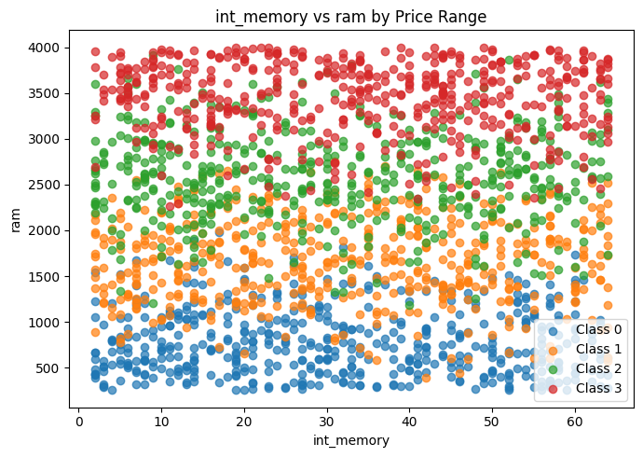
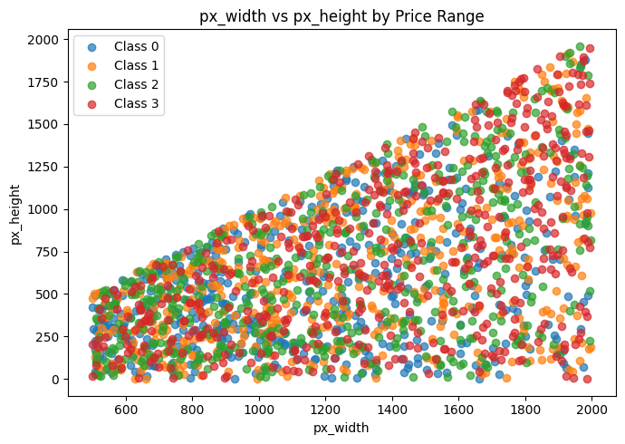
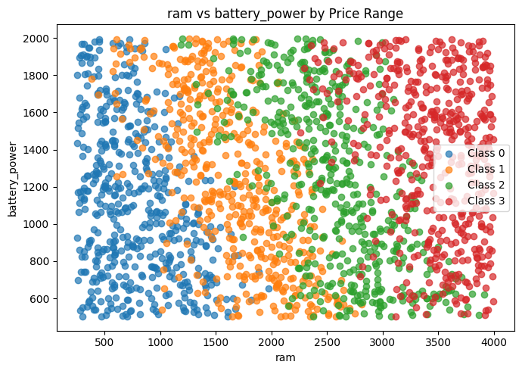
Figure 2: Pixel Width vs Pixel Height
Figure 1: RAM vs Battery Power
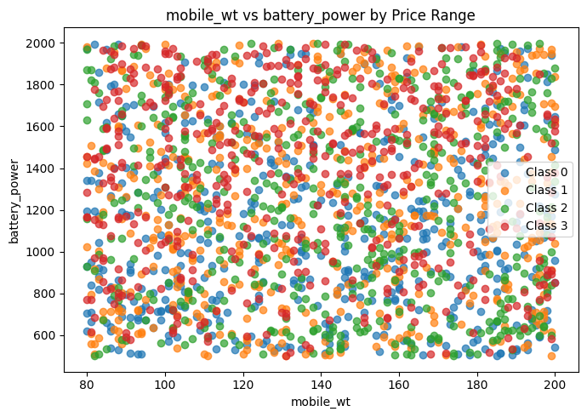

Figure 3: Internal Memory VS RAM
Figure 4: Mobile Weight vs Battery Power
2. Classification Algorithm 1 – K-Nearest Neighbors
The implementation for K-NN was done using the Euclidean Distance to calculate similarity between points and applied StandardScaler to make sure features are equally scaled when determining distance. A number of different values for K from 3 to 13 were tested, K = 11 had high accuracy, but K = 13 produced the highest accuracy of the different K values tested. Table 1 illustrates the accuracy results produced during 5-fold stratified cross-validation, once everything was complete for k = 13, it resulted in: Accuracy=0.5775±0.0147; Precision=0.5874±0.0122; Recall=0.5775±0.0147; Sensitivity=0.5775±0.0147; Specificity=0.8592±0.0049; and F1 Score=0.5798±0.0137. With the information presented in Figure 5, it can be noted that as K increases so does accuracy; which explains why the best overall result came at K=13 with respect to reliability across all tested K values. From Figure 6, the K-NN model shows many misclassifications between neighboring classes which indicates that K-NN has trouble separating the classes that are overlapping.

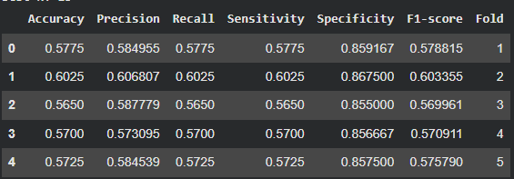
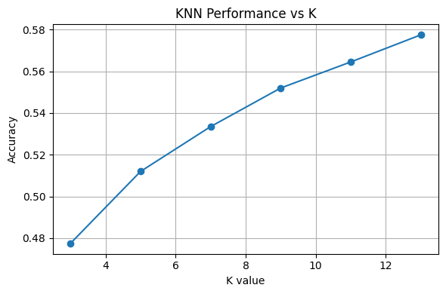
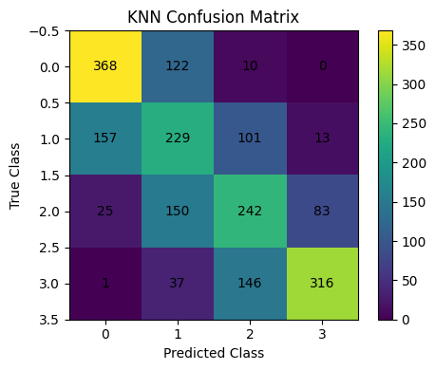
Table 1: K-NN fold results
Figure 5: K vs Accuracy
Figure 6: K-NN Confusion Matrix

3. Classification Algorithm 2 – Support Vector Machine
Experimenting with SVM and various types of kernels enabled deriving a decision boundary between classes. The features were scaled using StandardScaler for proper margins. The three types of kernels used were linear, rbf, and poly. The C values used were 1 and 10. The best performing configuration was C = 1, which produced the highest accuracy relative to the test configurations. For this configuration (C = 1), the model produced the following results: Accuracy = 0.9615 +/- 0.0078; Precision = 0.9623 +/- 0.0076; Recall = 0.9615 +/- 0.0078; Sensitivity = 0.9615 +/- 0.0078; Specificity = 0.9872 +/- 0.0026; and F1-score = 0.9614 +/- 0.0078. The results from the 5 k-fold cross validation are shown in Table 2. The SVM was superior to all other models, supporting the conclusion that there are a large number of linearly separable class instances. As seen in Figure 7, the linear kernel was the most effective of the kernels. As presented in Figure 8; few classification errors were made, supporting the confidence in the model's abilities.
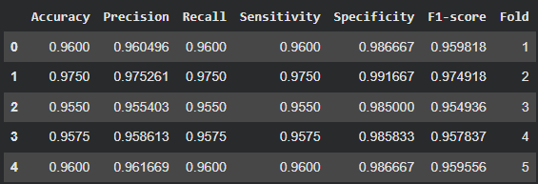
Table 2: SVM fold results
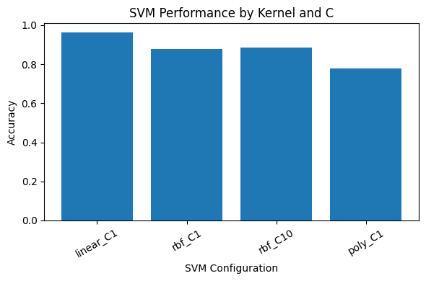
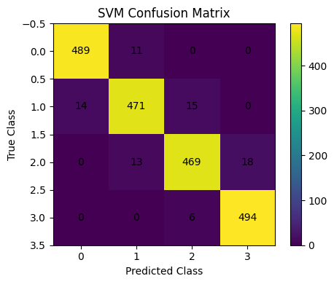
4. Classification Algorithm 3 – Deep Learning (MLP)
Figure 7: SVM kernel comparison plot
Figure 8: SVM Confusion Matrix
MLP was utilized to learn complex non-linear decision boundaries based on the dataset used for the analysis in runtime. For analysis, four different architectures of MLP were tested, including: (100,), (64,), (100, 50), and (64, 32). To guarantee that all of the features of the dataset were on the same scale for training purposes, the features were scaled using the StandardScaler function. The best-performing architecture (64, 32) achieved the highest overall performance between all of the architectures tested. As shown in Table 3, the MLP model achieved the following statistical results: Accuracy: 0.9230 ± 0.0115; Precision: 0.9245 ± 0.0113; Recall: 0.9230 ± 0.0115; Sensitivity: 0.9230 ± 0.0115; Specificity: 0.9743 ± 0.0038; F1-score: 0.9231 ± 0.0114. The statistical results have been obtained using 5-fold cross-validation. Figure 9 presents the comparison of each architecture being tested against one another, finding that more layers within the architecture provide higher performance than fewer layers within the architecture. The confusion matrix shown in Figure 10 demonstrates that the MLP produces a significant number of correct classifications (i.e., few misclassifications) and thus demonstrates effective classification of highly complex patterns within the dataset used to build the MLP.
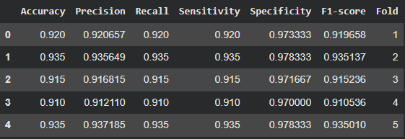
Table 3: MLP fold results
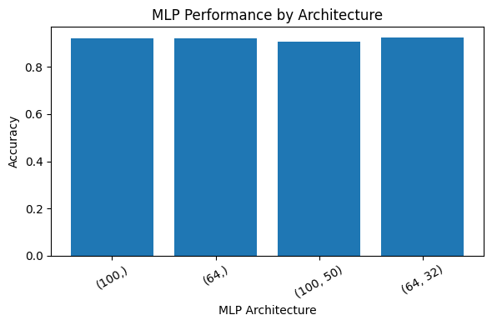
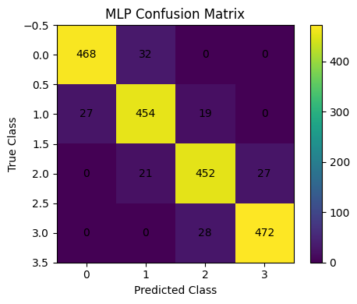
Figure 10: MLP confusion Matrix
Figure 9: MLP Architecture Comparison plot
5. Comparison and Conclusion
Table 4 shows the comparison between all models. The best preforming model was SVM with an accuracy of 0.9615 and F1 score of 0.9614, and followed by MLP with accuracy of 0.9230 and F1 score of 0.9231. K-NN performed the weakest with an accuracy of 0.5775 and F1 score of 0.5798 because it is a distance-based model, which relies on distance calculation and it leads to overlapping between classes.
Model | Accuracy | Precision | Recall | Sensitivity | Specificity | F1-score
K-NN | 0.5775 | 0.5874 | 0.5775 | 0.5775 | 0.8592 | 0.5798
SVM | 0.9615 | 0.9623 | 0.9615 | 0.9615 | 0.9872 | 0.9614
MLP | 0.9230 | 0.9245 | 0.9230 | 0.9230 | 0.9743 | 0.9231
Table 4: Model Comparison Results
6. Video Demonstration
Video Link
Instructor Evaluation Checklist
Section | Max | Awarded | Criteria Met
Dataset Exploration and Preparation | 10 | [ ] | Dataset details, scaling, visualization, 5-fold setup
K-Nearest Neighbors (KNN) | 10 | [ ] | Scaling, K selection, cross-validation, metrics
Support Vector Machine (SVM) | 10 | [ ] | Scaling, kernel tests, support vectors, metrics
Deep Learning (MLP) | 10 | [ ] | Architecture, training params, cross-validation, metrics
Comparison and Conclusion | 2 | [ ] | Comparative table/plot + discussion and insights
Video Demonstration | 8 | [ ] | Clear and complete demo within 5 minutes
Total | 50

