PSO Lubricants
Competitive Pricing Intelligence Report
Generated: 07 July 2026
Data source: Daraz.pk | Products scraped: 578

1. Executive Summary

This report benchmarks PSO Carient's pricing against 17 competing brands across 8 grades for petrol and diesel engine oils. All prices are median observed retail prices in PKR per litre on Daraz.pk.

- Grades where PSO is priced BELOW market median (>10%): 10W-30 (-66%) — potential margin capture opportunity
- Grades priced at market: 0W-20, 20W-50

2. Market Coverage

Total listings analysed: 578

Brand | Listings | Own / Competitor
Caltex Delo | 13 | Competitor
Caltex Havoline | 12 | Competitor
Kixx | 55 | Competitor
Kixx G1 | 44 | Competitor
Kixx PAO | 5 | Competitor
PSO | 1 | PSO (Own)
PSO Carient | 2 | PSO (Own)
PSO Carient Plus | 3 | PSO (Own)
PSO Carient Ultra | 2 | PSO (Own)
Shell | 5 | Competitor
Shell Helix HX7 | 2 | Competitor
Shell Helix Ultra | 1 | Competitor
Shell Rimula | 3 | Competitor
Total | 16 | Competitor
Total Quartz | 2 | Competitor
Total Quartz 5000 | 1 | Competitor
Total Quartz 9000 | 8 | Competitor
ZIC | 50 | Competitor
ZIC X5 | 54 | Competitor
ZIC X7 | 89 | Competitor
ZIC X9 | 3 | Competitor

3. Competitive Price Analysis

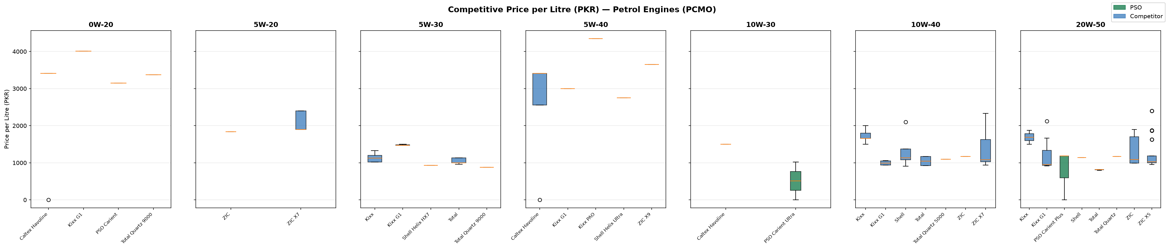
Figure 1: Price/L Distribution — Petrol Engine Oils (PCMO) by Grade

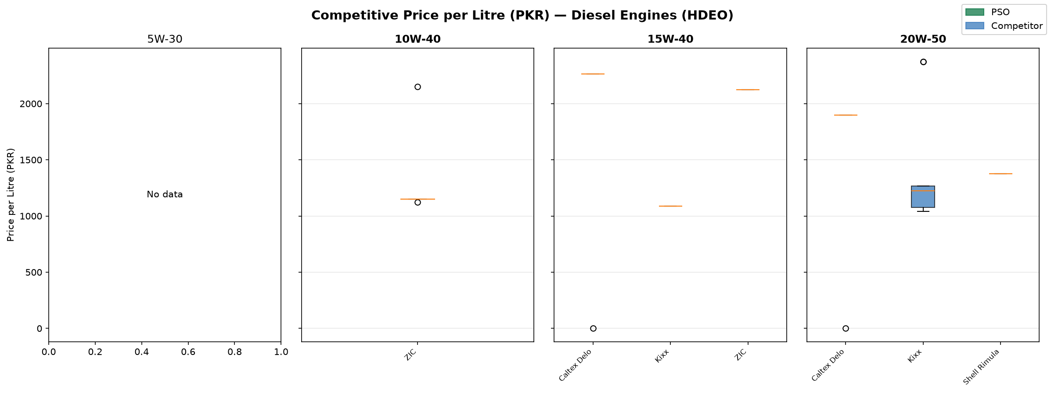
Figure 2: Price/L Distribution — Diesel Engine Oils (HDEO) by Grade

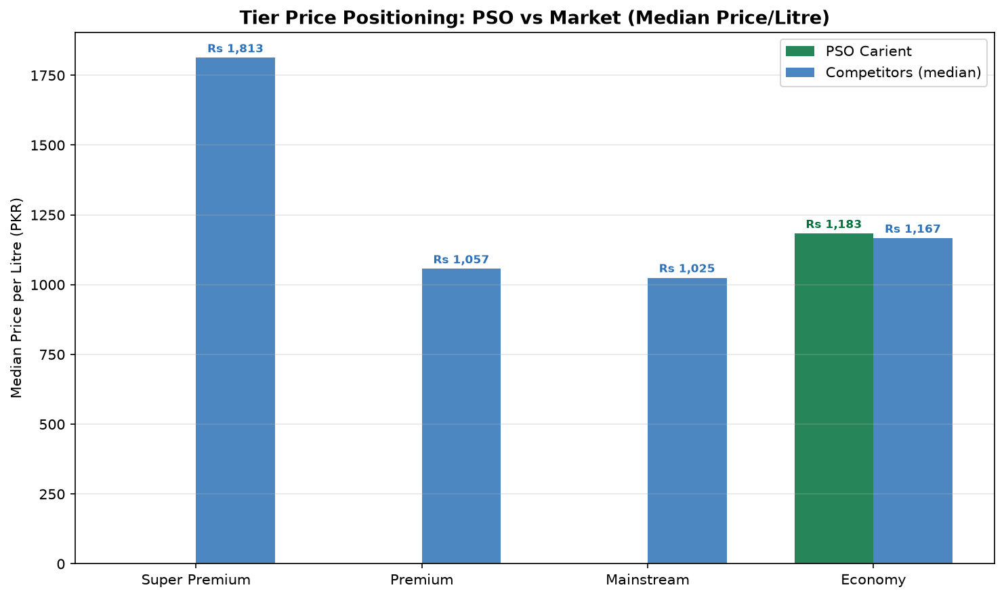
Figure 3: Tier Price Positioning — PSO vs Market Median

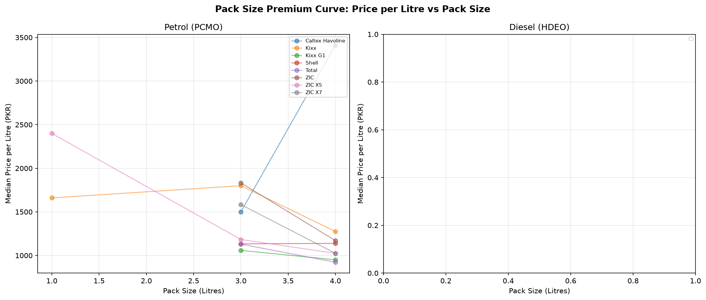
Figure 4: Pack Size Premium Curve — Price/L by Pack Size

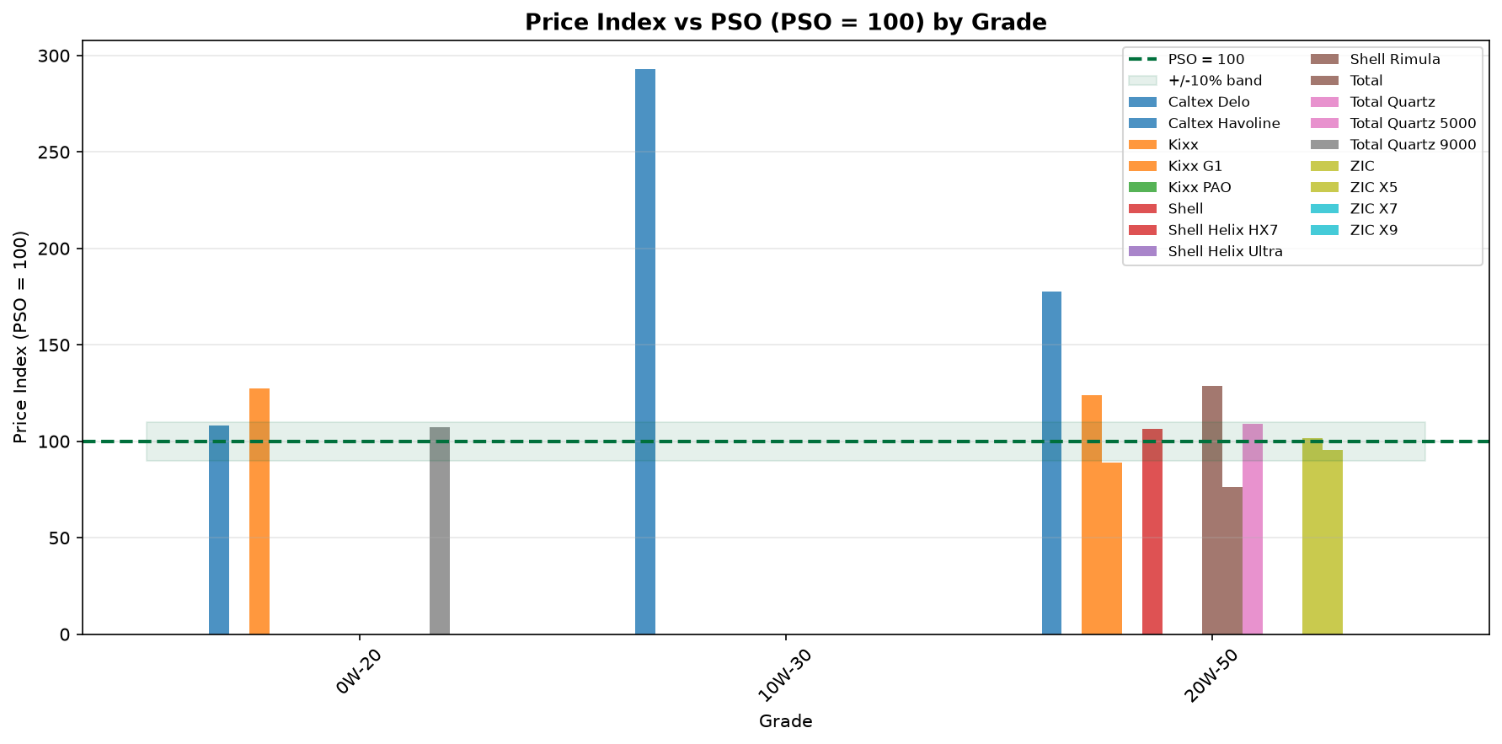
Figure 5: Price Index (PSO = 100) by Grade

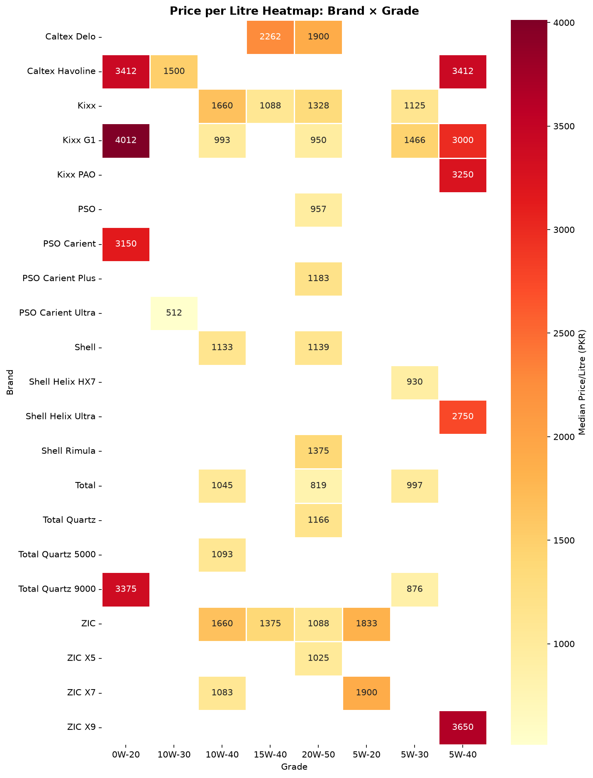
Figure 6: Full Price Heatmap — Brand x Grade

4. Grade-Level Pricing Findings

Grade: 0W-20
PSO median price/L: Rs 3,150 | Range: Rs 3,150 – Rs 3,150
Market median price/L: Rs 3,375 | Range: Rs 0 – Rs 4,012
Cheapest competitor: nan @ Rs 0/L
Most expensive: Kixx G1 @ Rs 4,012/L
PSO is within 10% of market median for 0W-20 — priced competitively.

Grade: 10W-30
PSO median price/L: Rs 512 | Range: Rs 0 – Rs 1,023
Market median price/L: Rs 1,500 | Range: Rs 1,000 – Rs 1,875
Cheapest competitor: nan @ Rs 1,000/L
Most expensive: nan @ Rs 1,875/L
PSO is 65.9% below market median for 10W-30. Scope to increase price without losing position.

Grade: 10W-40
Market median price/L: Rs 1,066 | Range: Rs 909 – Rs 2,887
Cheapest competitor: Shell @ Rs 909/L
Most expensive: nan @ Rs 2,887/L

Grade: 15W-40
Market median price/L: Rs 1,266 | Range: Rs 0 – Rs 2,262
Cheapest competitor: Caltex Delo @ Rs 0/L
Most expensive: Caltex Delo @ Rs 2,262/L

Grade: 20W-50
PSO median price/L: Rs 1,070 | Range: Rs 0 – Rs 1,183
Market median price/L: Rs 1,076 | Range: Rs 0 – Rs 11,143
Cheapest competitor: nan @ Rs 0/L
Most expensive: nan @ Rs 11,143/L
PSO is within 10% of market median for 20W-50 — priced competitively.

Grade: 5W-20
Market median price/L: Rs 1,900 | Range: Rs 1,833 – Rs 2,400
Cheapest competitor: ZIC @ Rs 1,833/L
Most expensive: ZIC X7 @ Rs 2,400/L

Grade: 5W-30
Market median price/L: Rs 1,130 | Range: Rs 0 – Rs 5,650
Cheapest competitor: nan @ Rs 0/L
Most expensive: nan @ Rs 5,650/L

Grade: 5W-40
Market median price/L: Rs 3,412 | Range: Rs 0 – Rs 5,650
Cheapest competitor: nan @ Rs 0/L
Most expensive: nan @ Rs 5,650/L

5. Pricing Strategy Recommendations

Recommendations are derived entirely from observed market prices. PSO's cost structure, channel margins, and strategic objectives should be overlaid before finalising any list price changes.

1. Anchor pricing to the 4L pack
The 4L/5L pack is the market reference for workshops. Set this as the anchor and derive 1L (premium uplift) and 10L+ (discount) from it. Ensures pack-price architecture is legible to buyers.

2. Widen the Ultra-to-SPRO price gap
If the gap between Carient Ultra and SPRO is less than 35-40%, consumers perceive low differentiation and trade down in recessions. International practice (Shell, Castrol) maintains 2.5-4x gap across the full tier ladder.

3. Price 5W-30 at a premium to 10W-40
5W-30 is a modern, fuel-economy grade requiring Group III base oil. It should command 15-25% premium vs 10W-40 across all brands. If PSO's spread is narrower, it signals a pricing gap.

4. Match ZIC/Kixx for imported brand positioning
Imported brands (ZIC, Kixx, Equimoli) often undercut on price while claiming import quality perception. PSO should price Carient FS at or slightly below ZIC X7 equivalent to compete on value, not just brand.

5. Review DEO 15W-40 drum pricing vs retail
210L drum price/L should be 25-35% below 4L retail. If the gap is narrower, fleet buyers have little incentive to commit to bulk contracts vs spot retail purchase.

6. Run quarterly scrape cadence
Competitor prices on Daraz shift during Ramadan, Eid, budget cycles, and base oil import cost changes. A quarterly scrape run will surface these movements before PSO's list price cycle.

7. Populate own-brand listings on Daraz
If PSO Carient is absent from Daraz, the competitive benchmark will be skewed. Listing Carient on Daraz also captures the direct-to-consumer channel and provides price transparency.

6. Methodology & Limitations

All prices scraped from Daraz.pk (Pakistan's largest e-commerce marketplace). Prices reflect active listings and may include third-party sellers, promotional prices, or bulk offers. Median price per litre is used throughout to reduce outlier distortion. Grade and pack size are extracted from product titles using pattern matching — accuracy depends on seller title quality. PSO pump prices or distributor list prices may differ.

