

**دانشگاه اصفهان**

**دانشکده مهندسی کامپیوتر**

گزارش پروژه اول پایگاه داده

**Hospital**

پدیدآورندگان:

**محمد ­امین کیانی**

**4003613052**

**محمد خرسندی**

**993613025**

دانشجویان کارشناسی، دانشکده‌ی کامپیوتر، دانشگاه اصفهان، اصفهان،

استاد درس: سرکار خانم دکترعاشوری

نیمسال اول تحصیلی 04-1403

فهرست مطالب

مستندات 3

جداول 3

کوئری‌ها 7

سوالات: 7

امتیازی‌ها: 15

# مستندات

## جداول

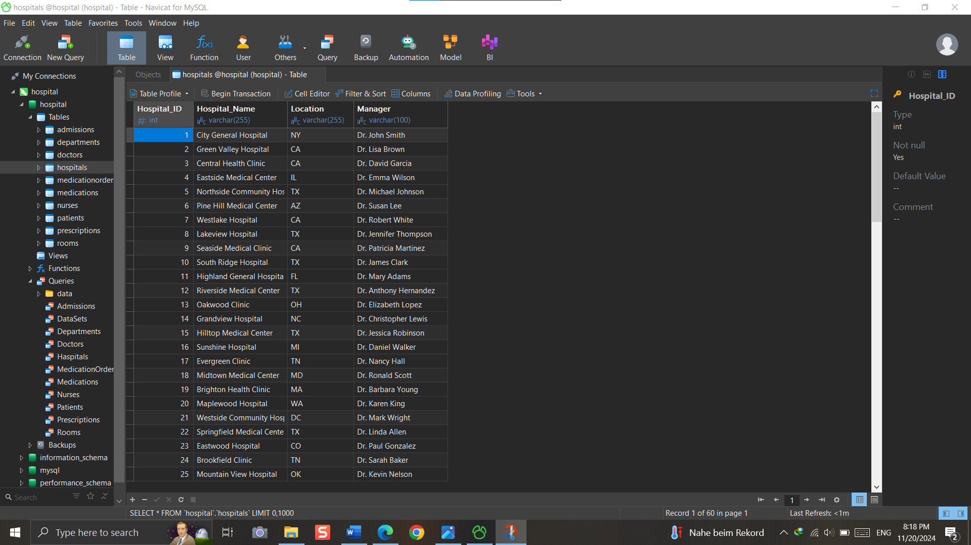

CREATE TABLE Hospitals (

Hospital_ID INT PRIMARY KEY,

Hospital_Name VARCHAR(255),

Location VARCHAR(255),

Manager VARCHAR(100)

);

CREATE TABLE Departments (

Department_ID INT PRIMARY KEY,

Hospital_ID INT,

Department_Name VARCHAR(255),

Create_Year DATE,

Budget INT,

FOREIGN KEY (Hospital_ID) REFERENCES Hospitals(Hospital_ID)

);

CREATE TABLE Patients (

Patient_ID INT PRIMARY KEY,

Hospital_ID INT,

First_Name VARCHAR(255),

Last_Name VARCHAR(255),

Gender VARCHAR(10),

Birth_Date DATE,

Address VARCHAR(255),

Age INT,

Phone_Number VARCHAR(15),

Blood_Group VARCHAR(5),

FOREIGN KEY (Hospital_ID) REFERENCES Hospitals(Hospital_ID)

);

CREATE TABLE Doctors (

Doctor_ID INT PRIMARY KEY,

Hospital_ID INT,

Department_ID INT,

First_Name VARCHAR(255),

Last_Name VARCHAR(255),

Specialization VARCHAR(50),

Age INT,

Phone_Number VARCHAR(15),

FOREIGN KEY (Hospital_ID) REFERENCES Hospitals(Hospital_ID),

FOREIGN KEY (Department_ID) REFERENCES Departments(Department_ID)

);

CREATE TABLE Nurses (

Nurse_ID INT PRIMARY KEY,

Hospital_ID INT,

Department_ID INT,

First_Name VARCHAR(255),

Last_Name VARCHAR(255),

Phone_Number VARCHAR(15),

FOREIGN KEY (Hospital_ID) REFERENCES Hospitals(Hospital_ID),

FOREIGN KEY (Department_ID) REFERENCES Departments(Department_ID)

);

CREATE TABLE Rooms (

Room_ID INT PRIMARY KEY,

Hospital_ID INT,

Room_Number INT,

Room_Type VARCHAR(100),

Is_Full BOOLEAN,

FOREIGN KEY (Hospital_ID) REFERENCES Hospitals(Hospital_ID)

);

CREATE TABLE Admissions (

Admission_ID INT PRIMARY KEY,

Hospital_ID INT,

Doctor_ID INT,

Patient_ID INT,

Nurse_ID INT,

Room_ID INT,

Admission_Date DATE,

FOREIGN KEY (Hospital_ID) REFERENCES Hospitals(Hospital_ID),

FOREIGN KEY (Doctor_ID) REFERENCES Doctors(Doctor_ID),

FOREIGN KEY (Patient_ID) REFERENCES Patients(Patient_ID),

FOREIGN KEY (Nurse_ID) REFERENCES Nurses(Nurse_ID),

FOREIGN KEY (Room_ID) REFERENCES Rooms(Room_ID)

);

CREATE TABLE Prescriptions (

Prescription_ID INT PRIMARY KEY,

Patient_ID INT,

Doctor_ID INT,

Description TEXT,

Date DATE,

FOREIGN KEY (Patient_ID) REFERENCES Patients(Patient_ID),

FOREIGN KEY (Doctor_ID) REFERENCES Doctors(Doctor_ID)

);

CREATE TABLE Medications (

Medication_ID INT PRIMARY KEY,

Medication_Name VARCHAR(100),

Description TEXT,

Dosage INT

);

CREATE TABLE MedicationOrders (

Order_ID INT PRIMARY KEY,

Prescription_ID INT,

Medication_ID INT,

Quantity INT,

Order_Date DATE,

FOREIGN KEY (Prescription_ID) REFERENCES Prescriptions(Prescription_ID),

FOREIGN KEY (Medication_ID) REFERENCES Medications(Medication_ID) );

## کوئری‌ها

### سوالات:

-------------------------------------------------------------------------------------------------------//1

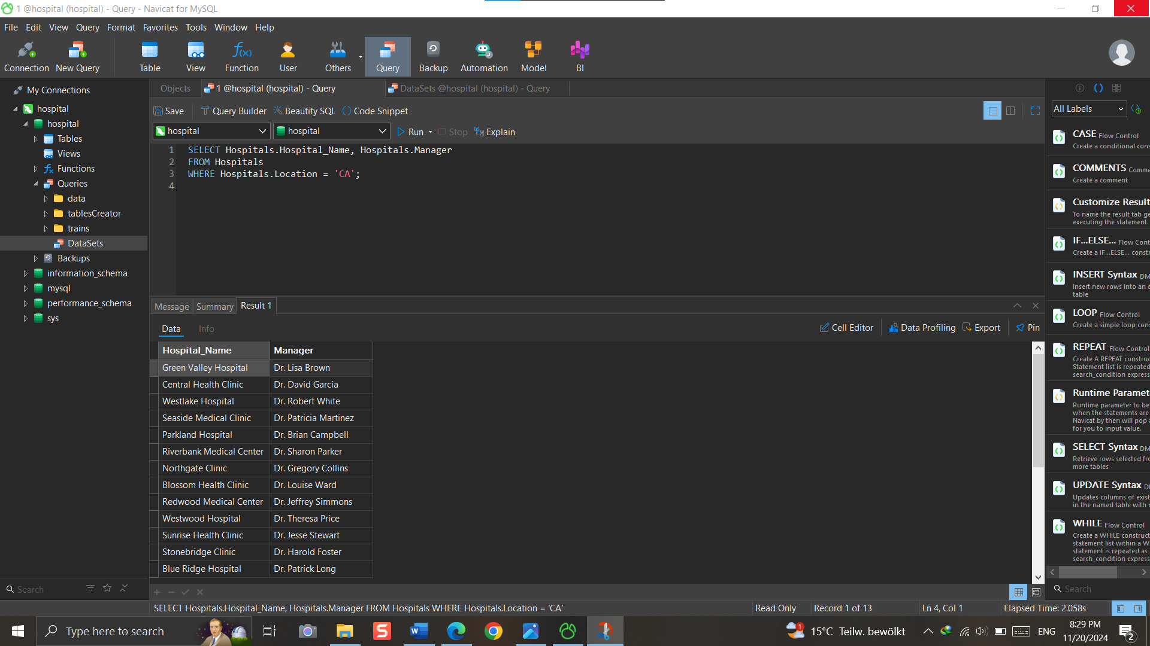--------------------------------------------------------------------------------------------------------//2

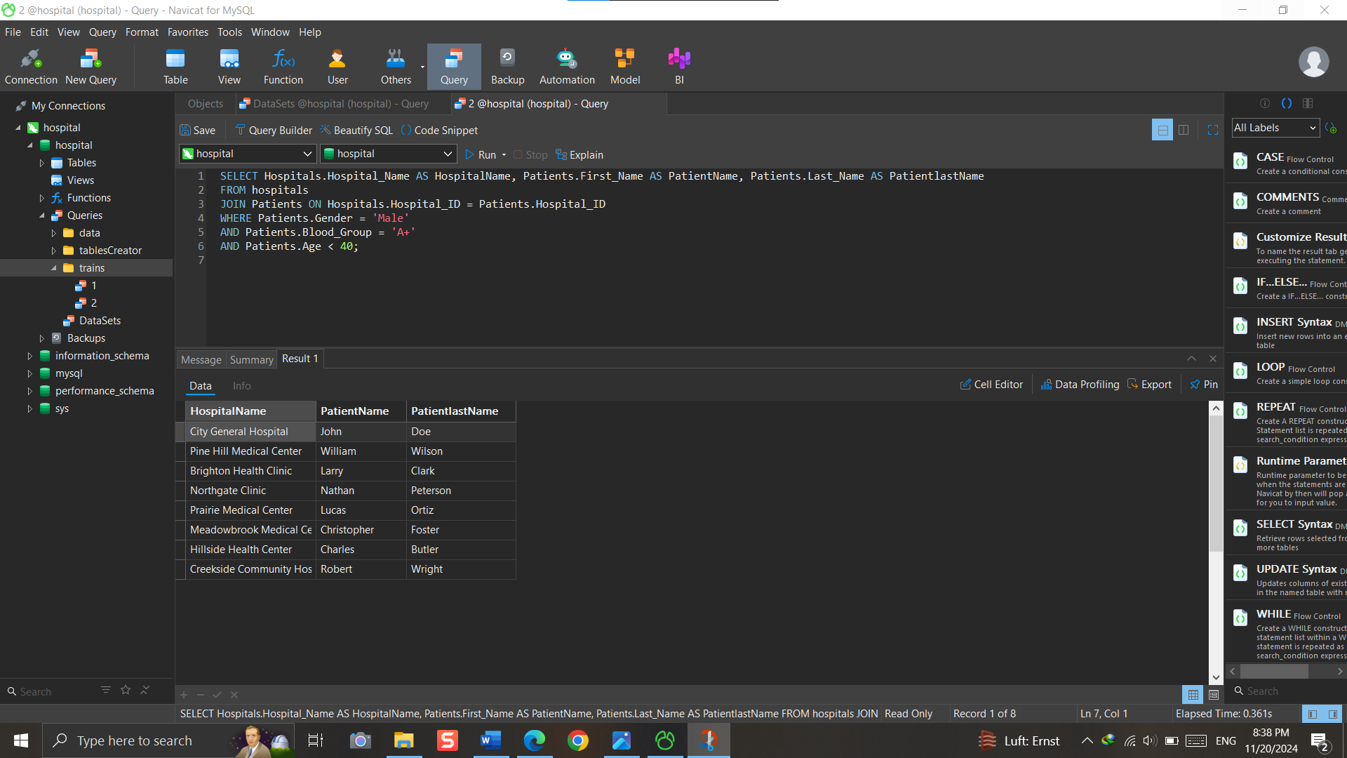

--------------------------------------------------------------------------------------------------------//3

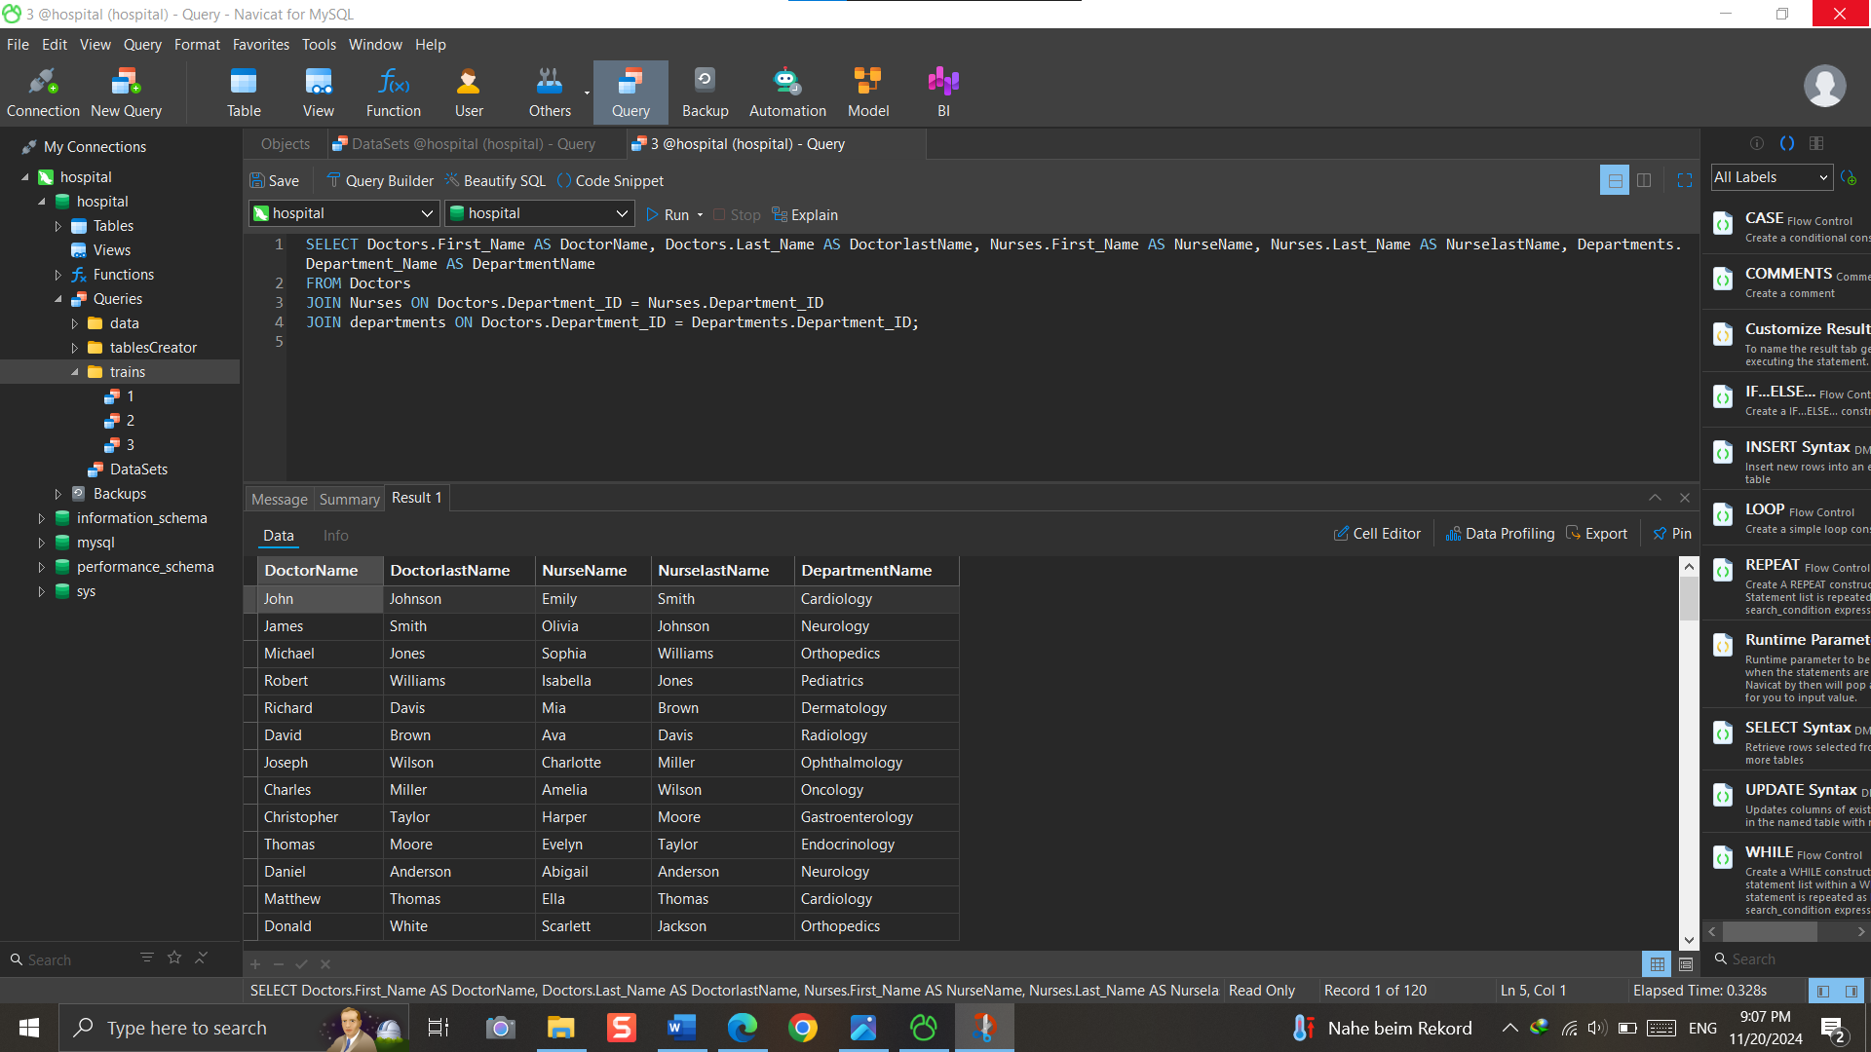--------------------------------------------------------------------------------------------------------//4

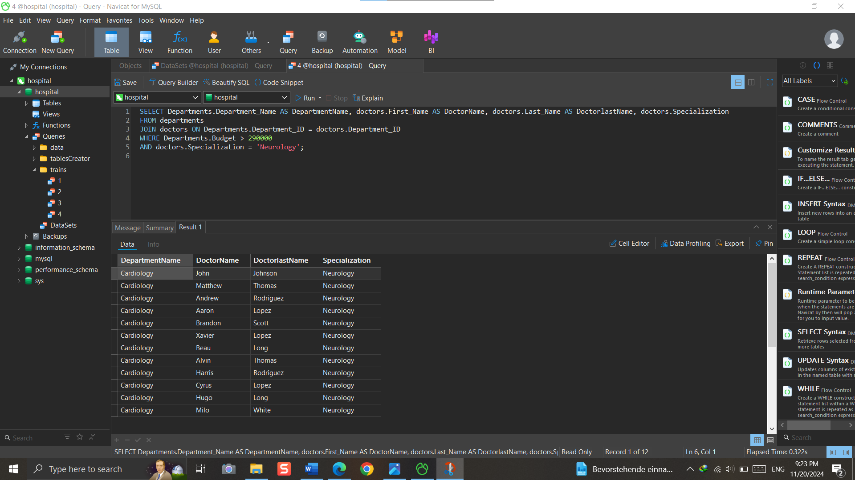

--------------------------------------------------------------------------------------------------------//5

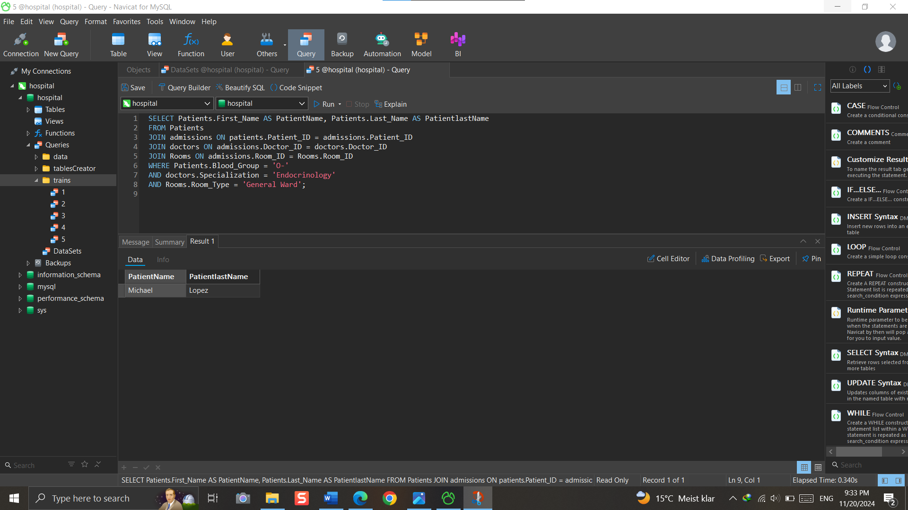

--------------------------------------------------------------------------------------------------------//6

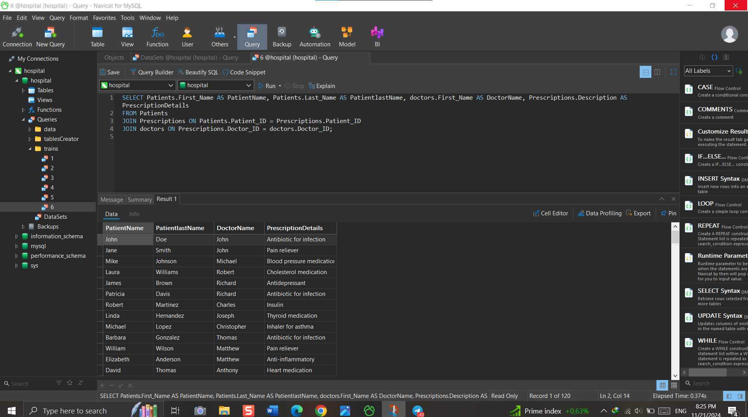

--------------------------------------------------------------------------------------------------------//7

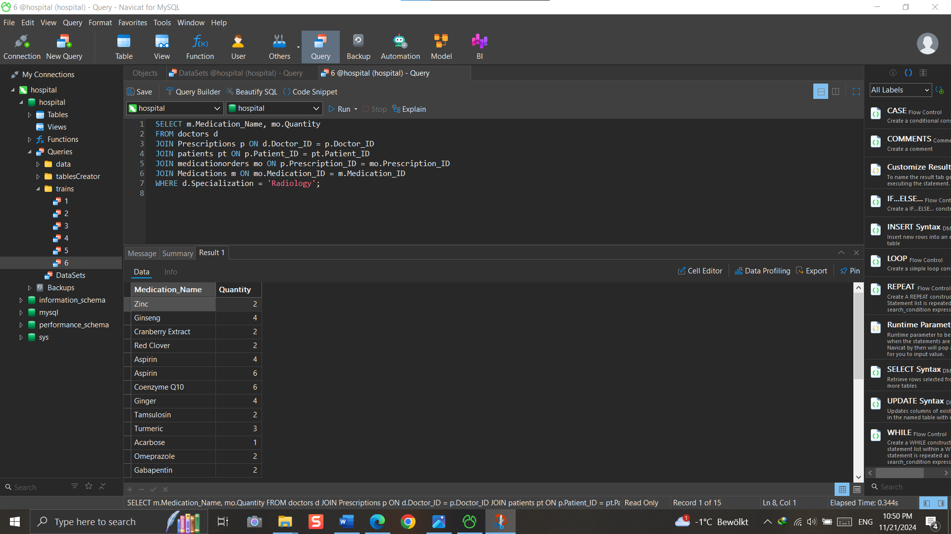

--------------------------------------------------------------------------------------------------------//8

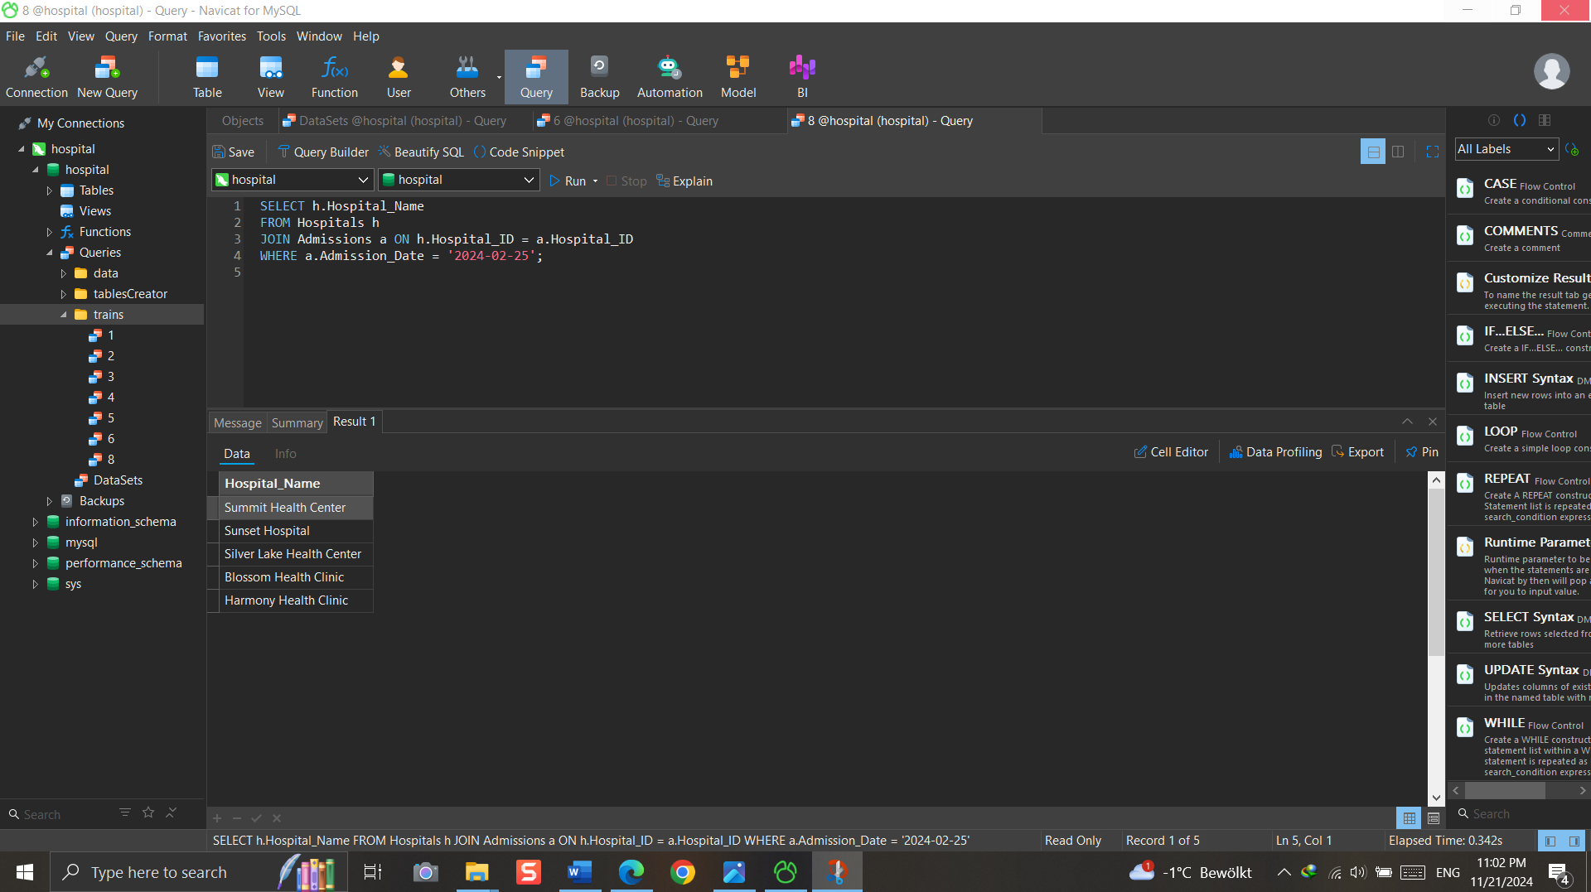

--------------------------------------------------------------------------------------------------------//9

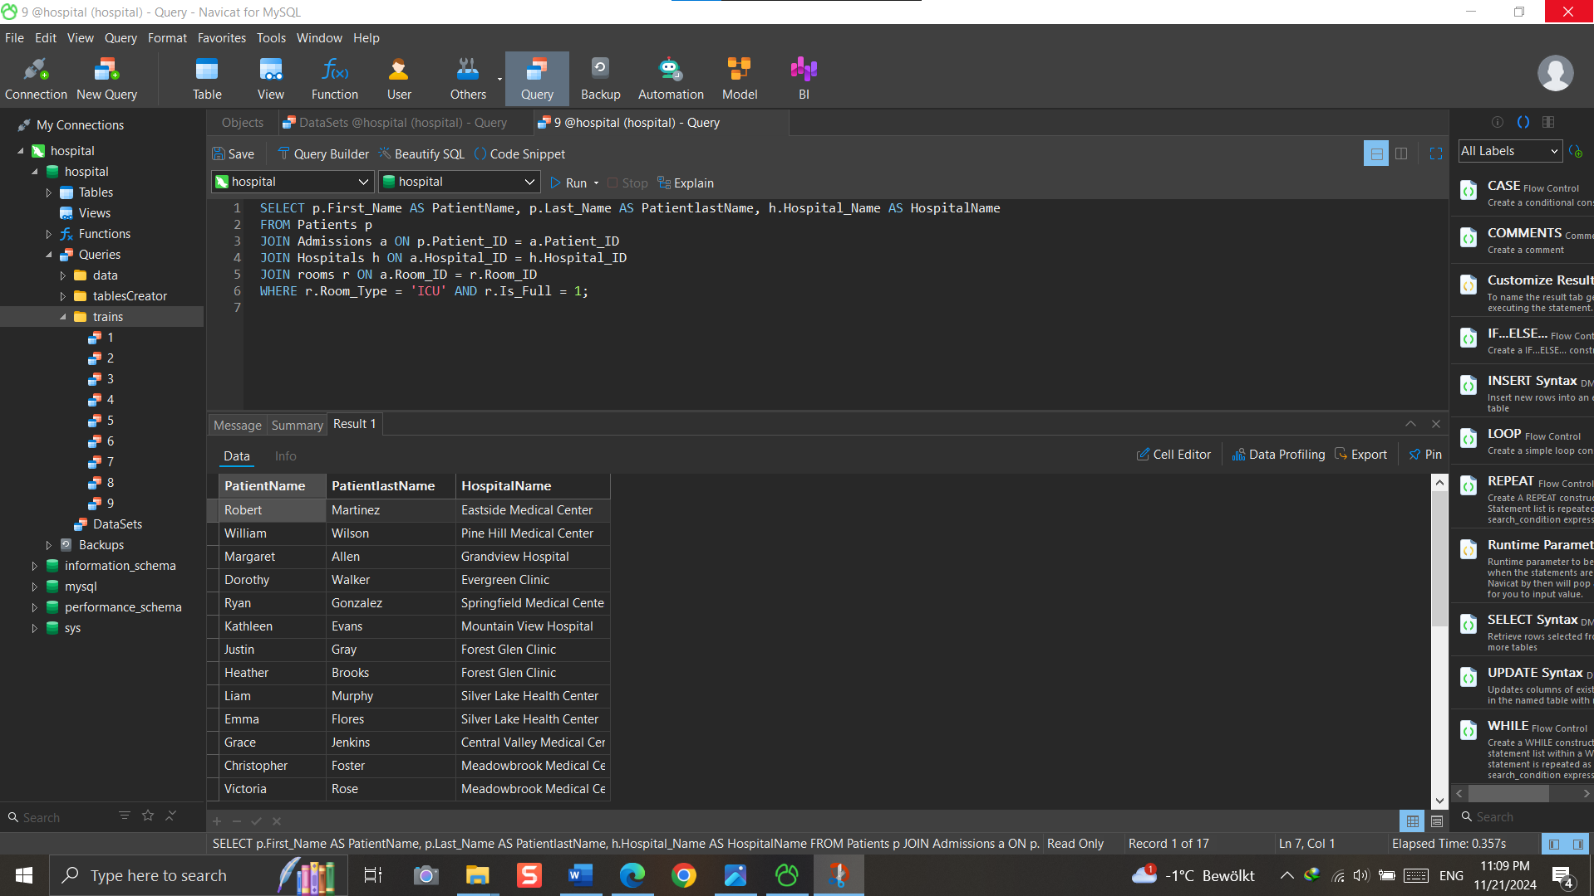

--------------------------------------------------------------------------------------------------------//10

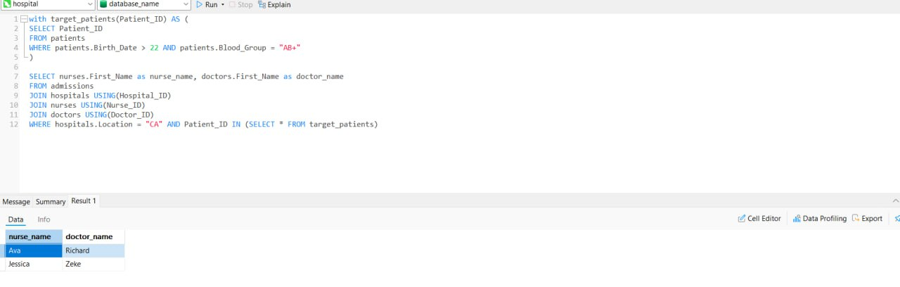

--------------------------------------------------------------------------------------------------------//11

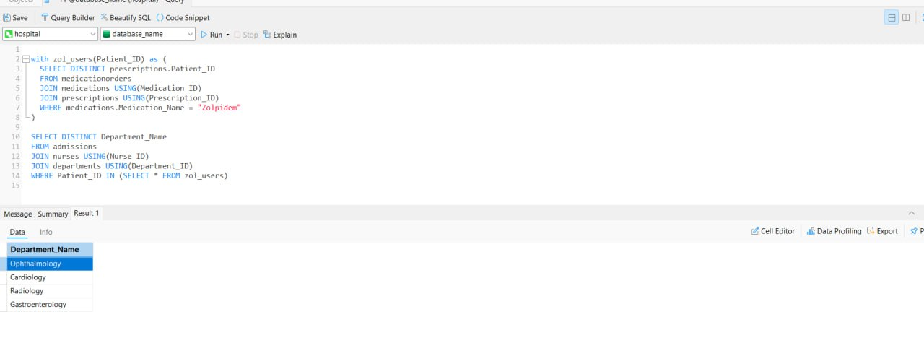

--------------------------------------------------------------------------------------------------------//12

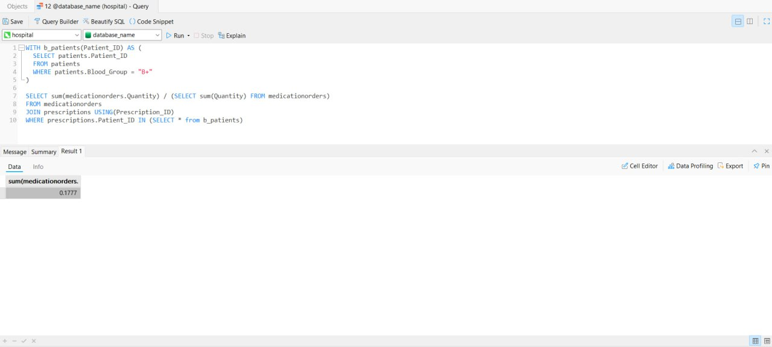

--------------------------------------------------------------------------------------------------------//13

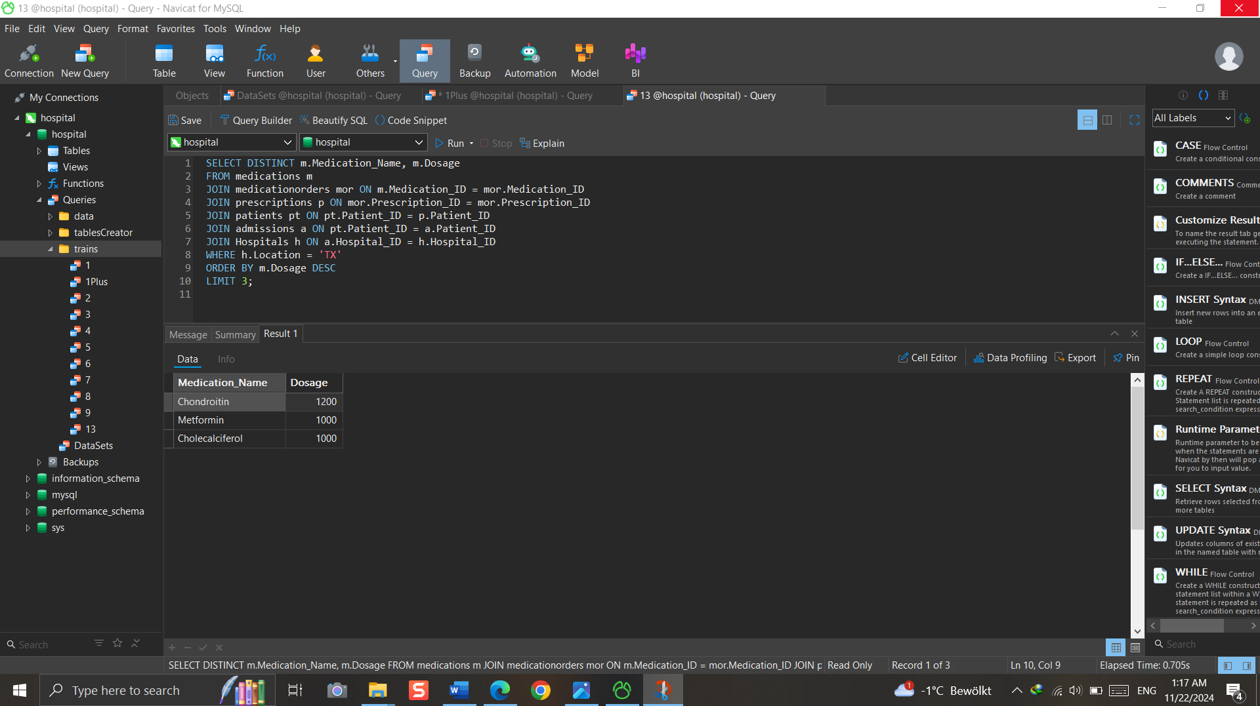

--------------------------------------------------------------------------------------------------------//14

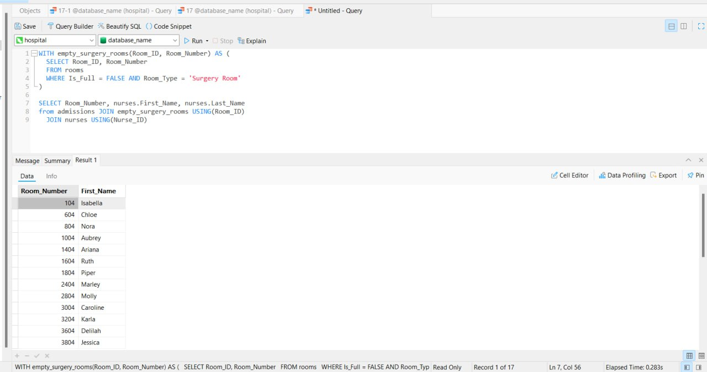

--------------------------------------------------------------------------------------------------------//15

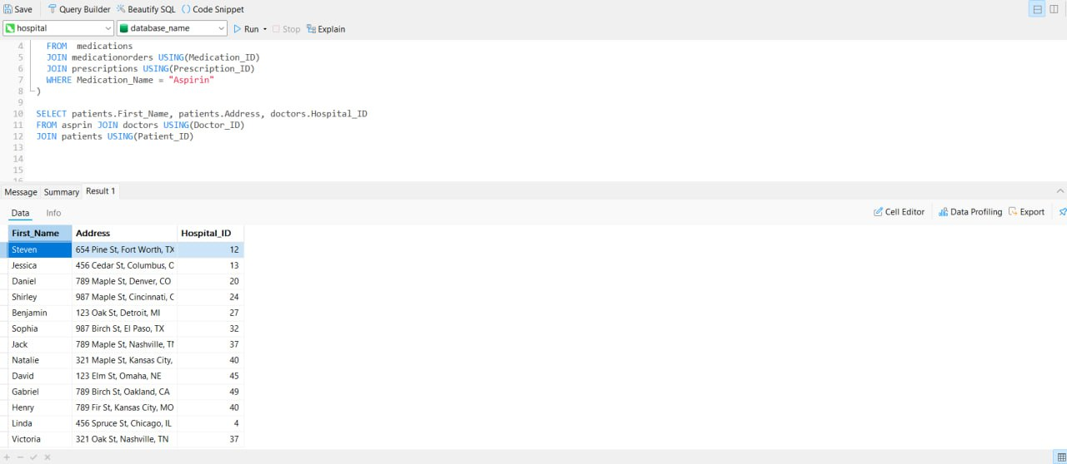

--------------------------------------------------------------------------------------------------------//16

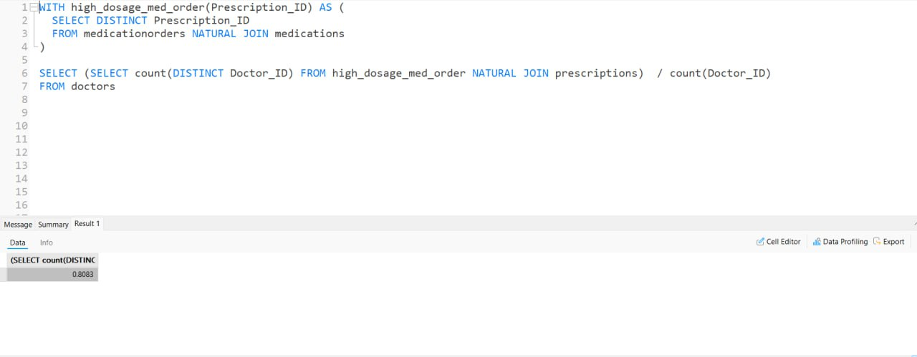

--------------------------------------------------------------------------------------------------------//17

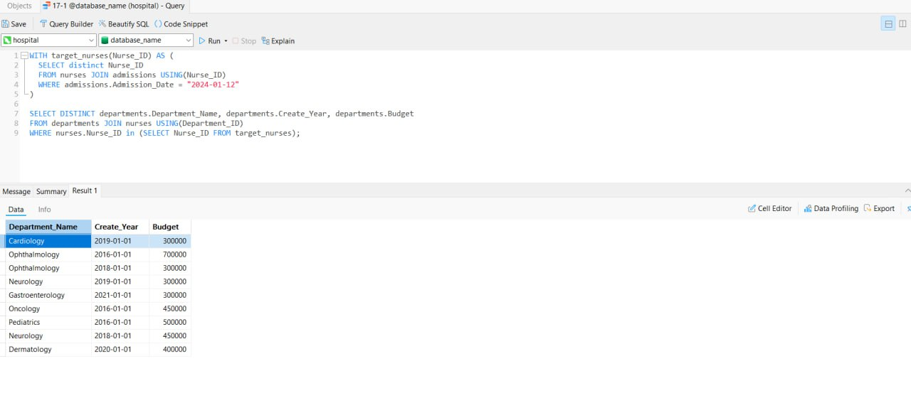

### امتیازی‌ها:

--------------------------------------------------------------------------------------------------------//1Plus

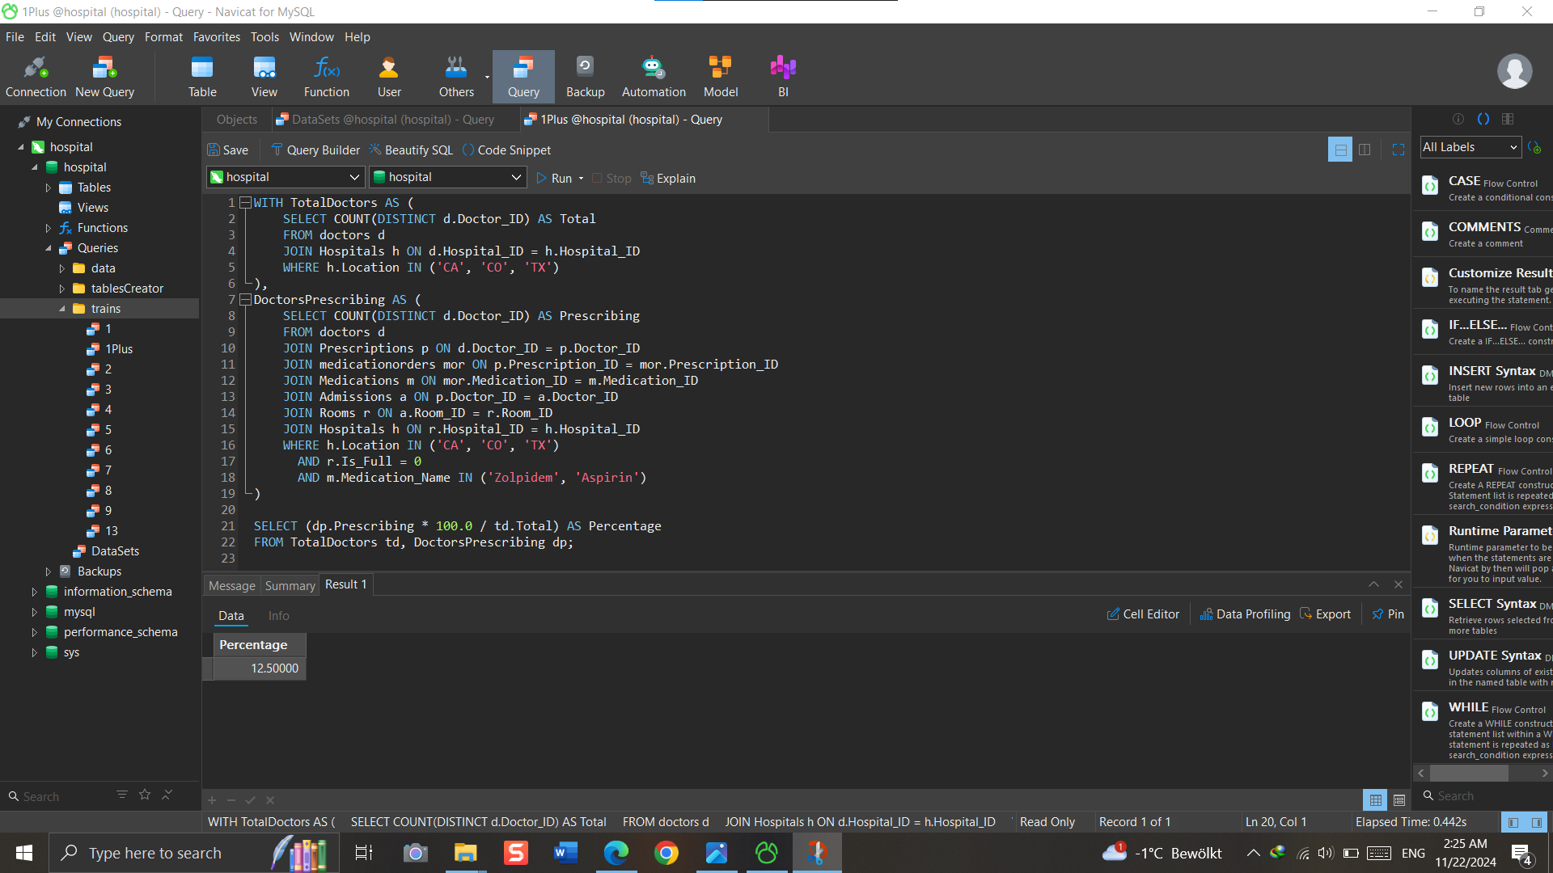

--------------------------------------------------------------------------------------------------------//2Plus

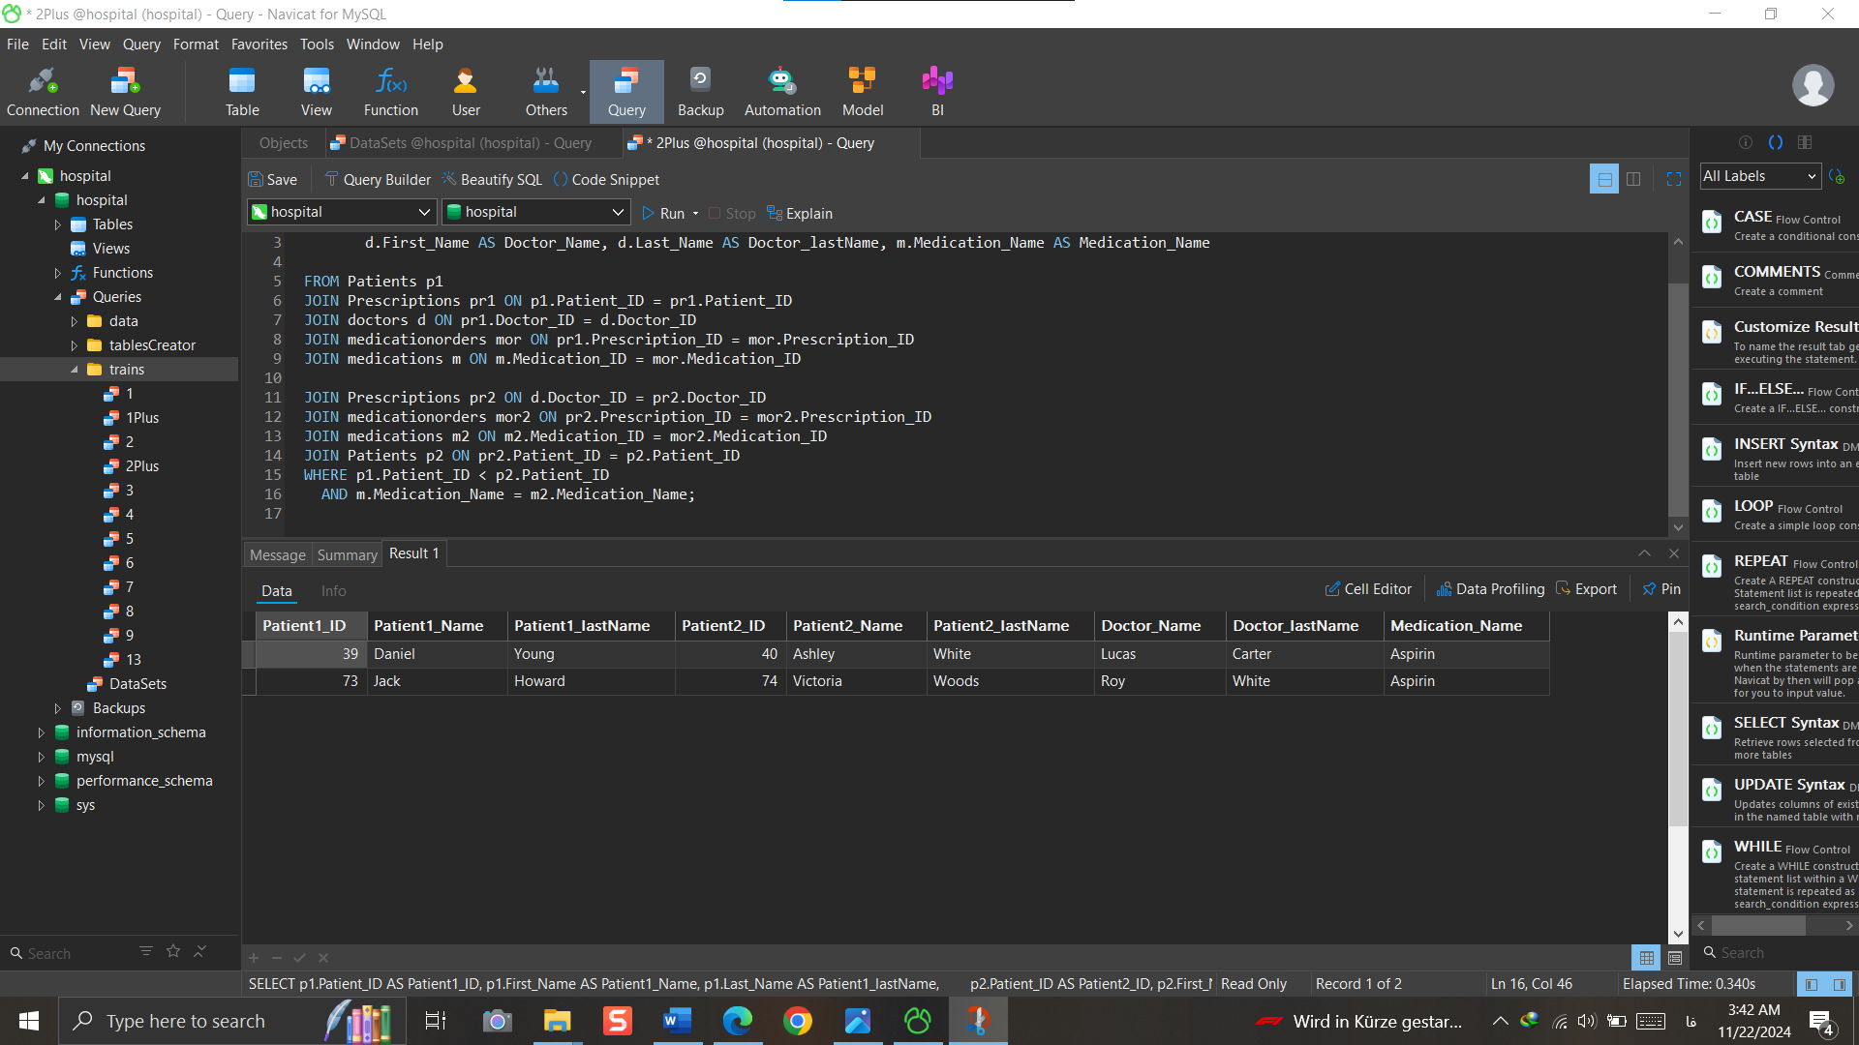

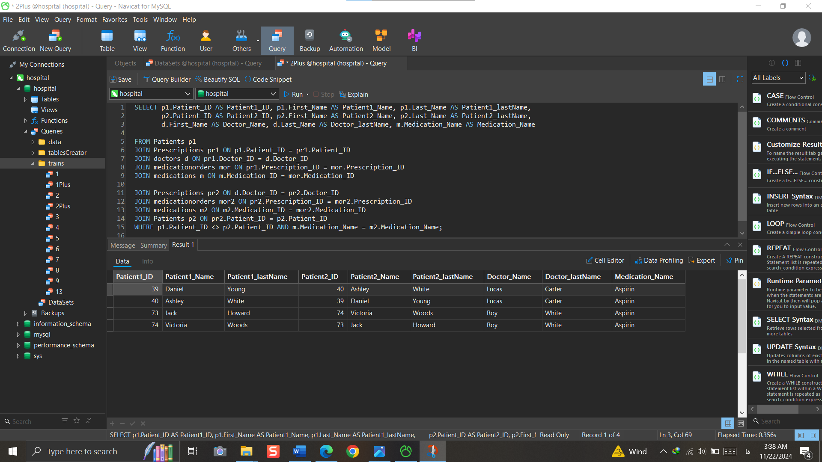

--------------------------------------------------------------------------------------------------------//3Plus

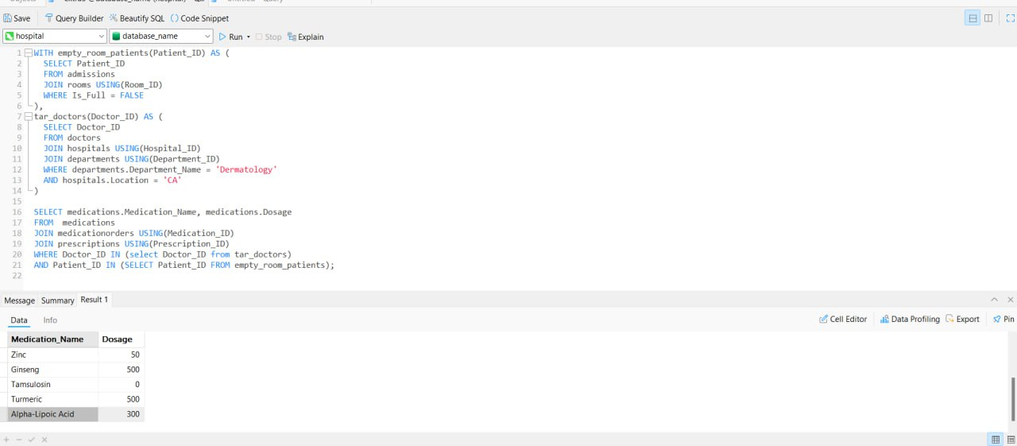

--------------------------------------------------------------------------------------------------------//4Plus

