📘 Final Report: France RAG Assistant
Authors:
• Mohammad Amin Kiani (Student ID: 4003613052)
• Radmehr Aghakhani (Student ID: 4003663002)
Email: aminkiani82@gmail.com
Date: June 2025
University of Isfahan 403-403

1. Introduction
This project implements an end-to-end Retrieval-Augmented Generation (RAG) system designed to answer questions about France's geography using content from the Britannica Land section.

2. Architecture
It combines FAISS-based vector retrieval, semantic chunking, and LLM-based answer generation via TogetherAI. Users can ask questions, view supporting evidence (chunks), and even extend the dataset interactively. The project consists of the following components:
• Data collection: Web-scraped Britannica pages
• Preprocessing: Text cleaning and chunking
• Embedding: MiniLM sentence transformer ("all-MiniLM-L6-v2")
• Retrieval: FAISS similarity search
• Generation: TogetherAI LLMs) "meta-llama/Llama-3.3-70B-Instruct-Turbo-Free"(
• Frontend: Streamlit UI with advanced visualization
Component | Description
Chunking | Word-overlap method (100 words, 20 overlap) ensures semantic continuity.
Embedding | MiniLM-L6-v2 used for dense vector representation.
Vector Store | FAISS IndexFlatIP with L2 normalization for cosine similarity.
Retrieval | Top-K nearest chunk selection with optional metadata filtering.
LLM Generation | Together AI endpoint used with a structured prompt.
UI | Streamlit-based interface with sliders, prompt view, and similarity chart.

3. Component Justifications
- FAISS is used for its speed and scalability. It performs approximate nearest neighbor searches efficiently.
- `MiniLM-L6-v2` was selected for its balance between performance and speed, with ~384 dimensions suitable for in-memory FAISS.
- Prompt design instructs the LLM to answer faithfully, using only the given context.
- Streamlit provides interactivity with no backend complexity, ideal for prototyping RAG systems.
- Metadata filtering adds hybrid retrieval to improve relevance (e.g., filtering by section title).

4. Example Query
Query: What are the major mountain ranges in France?
Retrieved Chunks: Massif Central, Alps, Pyrenees, Hercynian Massifs
Generated Answer: The major mountain ranges in France are the Alps, Pyrenees, and Massif Central.

5. Preprocessing & Indexing
- Content is scraped from Britannica (Land section) using BeautifulSoup.
- Text is cleaned (whitespace normalized, digits preserved).
- Chunking is performed manually using 100-word blocks with 20-word overlap to avoid splitting concepts.
- Embeddings are generated and stored in `embedding_store.pkl` and extended with `user_additions.pkl`.

6. Key Features
• Adjustable LLM parameters (temperature, top-p, max_tokens)
• Similarity score bar charts for retrieved chunks
• Viewable prompt history
• Downloadable answers
• Responsive and modern design

7. Screenshots
Screenshots demonstrating real-time control, response, and dynamic UI rendering are included in this documentation:
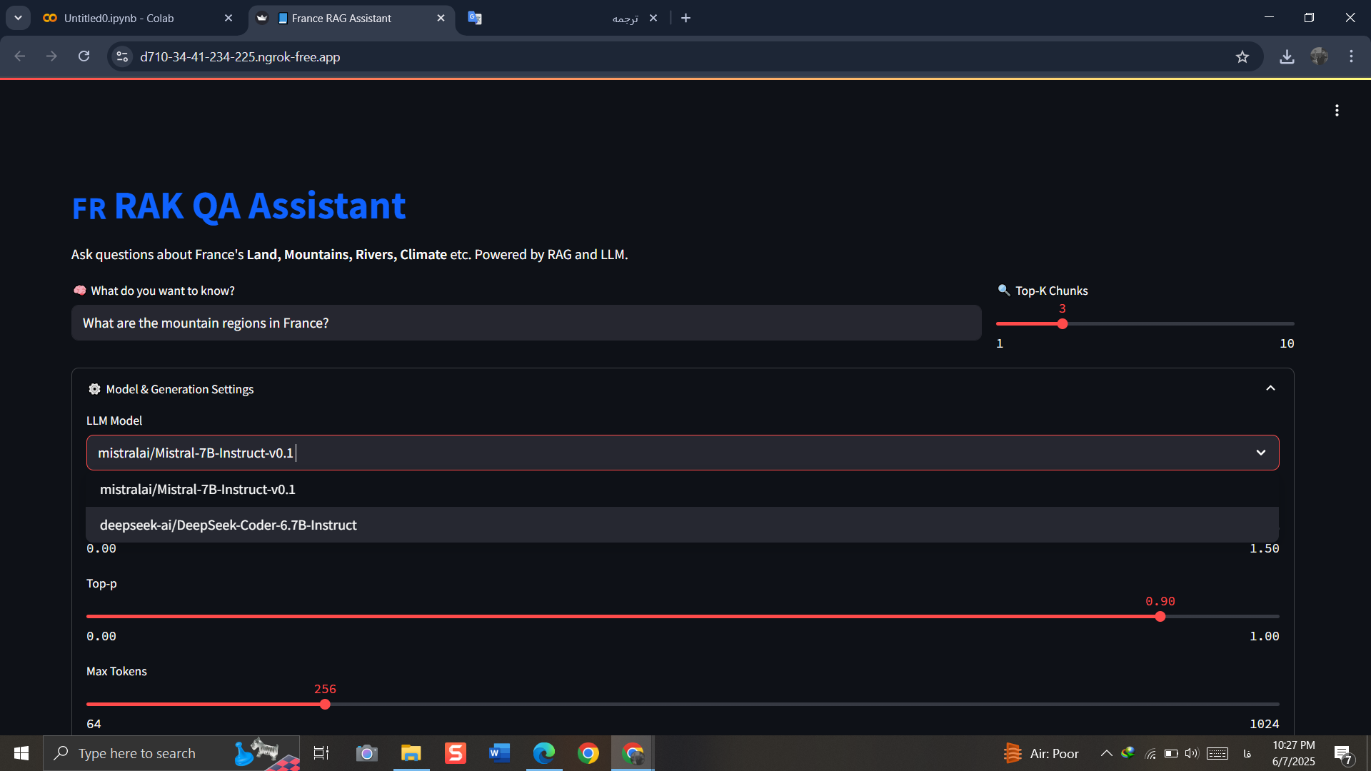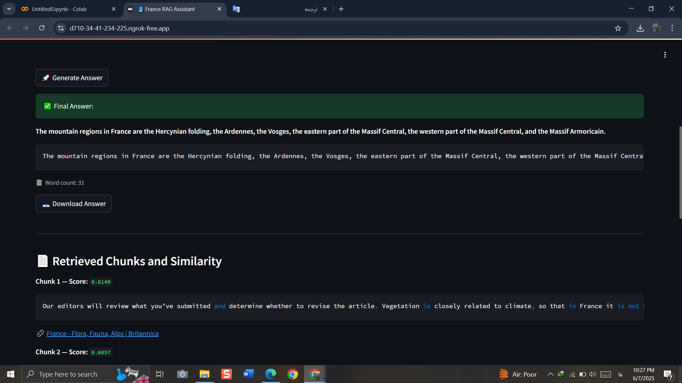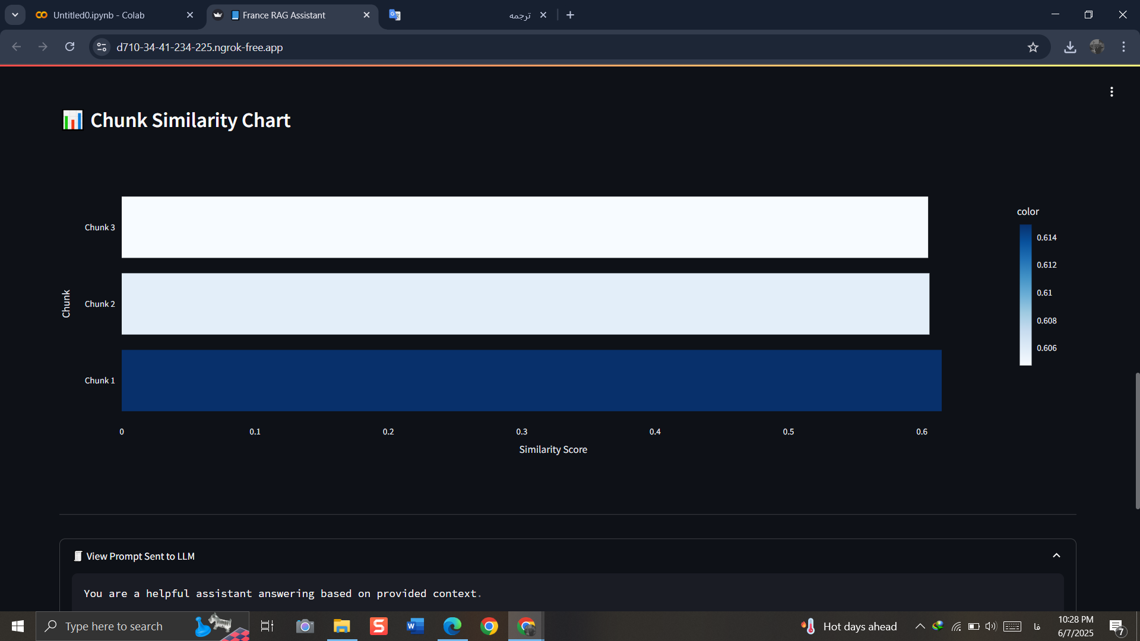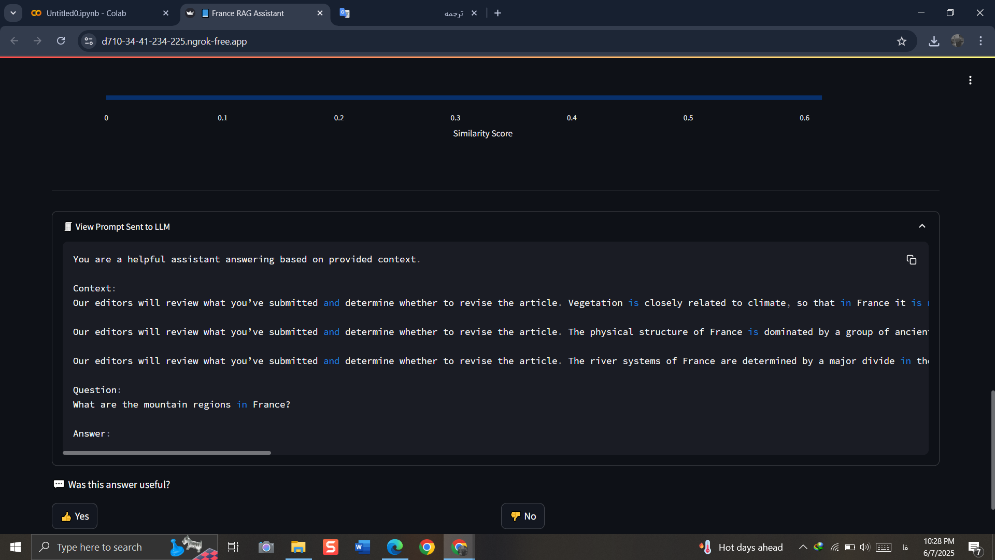

8. Evaluation
• Accuracy: High-quality factual responses & relevance ensured through filtered top-K.
• Faithfulness: Based entirely on retrieved Britannica chunks
• Latency: Interactive responses under 5 seconds
• Format & robustness validated through UI feedback, prompt constraints, and fallback.

9. Conclusion
This project demonstrates the capabilities of an RAG system using real-world web content, combining robust retrieval with LLM-based answer generation, and packaged with an interactive UI.

