Q1:

Solution:

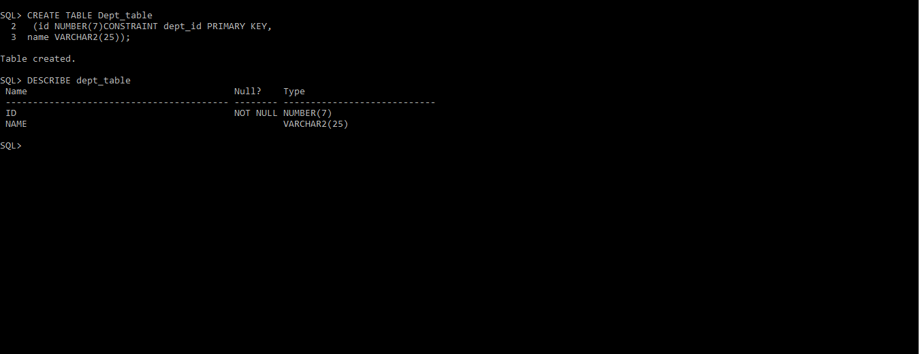

Q2:

Solution:



Q3:

Solution:

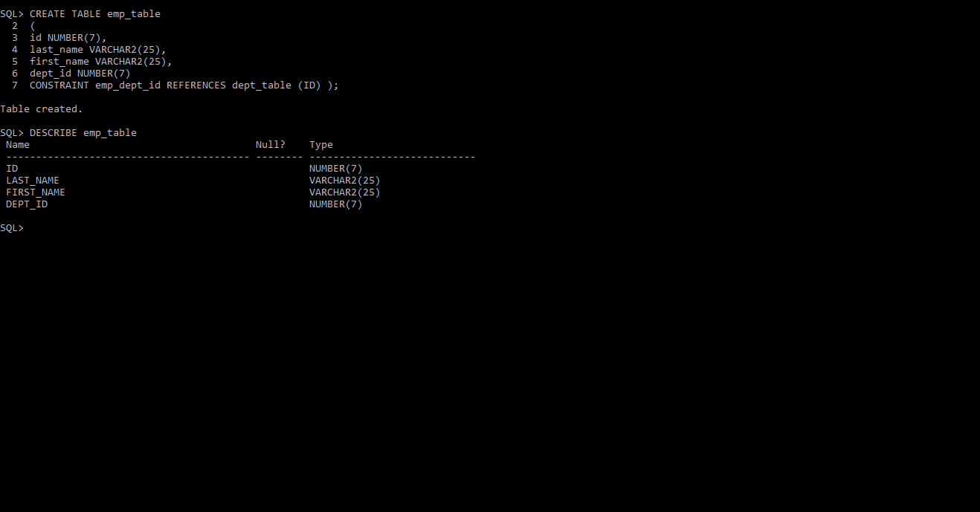

Q4:

Solution:

Q4:

Solution:

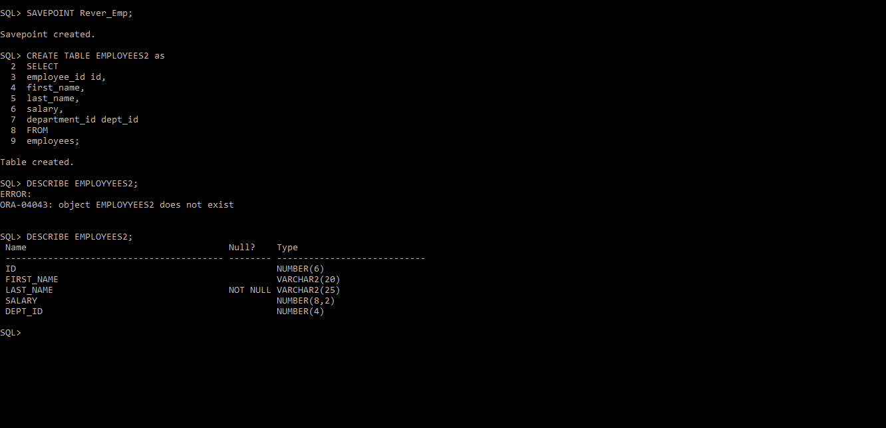

Q5:

Solution:

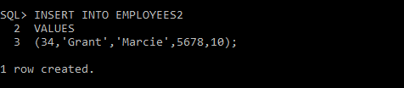

Verifying:



Q6:

Solution:



Q7:

Solution:

