LAB: 13

Q1:

Select operation have been provided before and after to verify that **JOB_ID** has been changed.

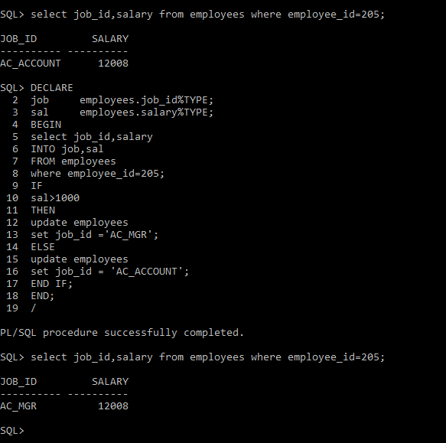

Q2:

Select operation have been provided before and after to verify that **COMMISSION_PCT** has been changed.

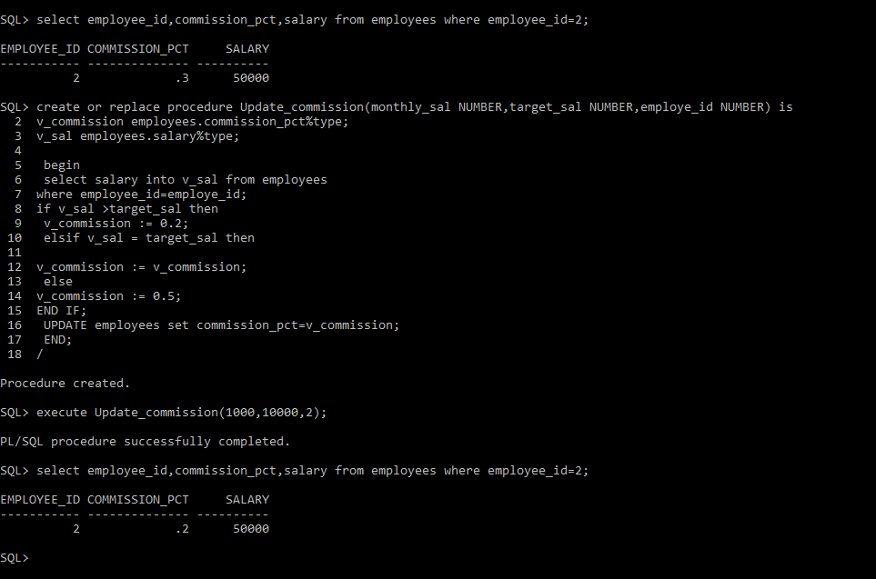

Q3:

Select operation have been provided after the trigger creation to verify that trigger is running.

