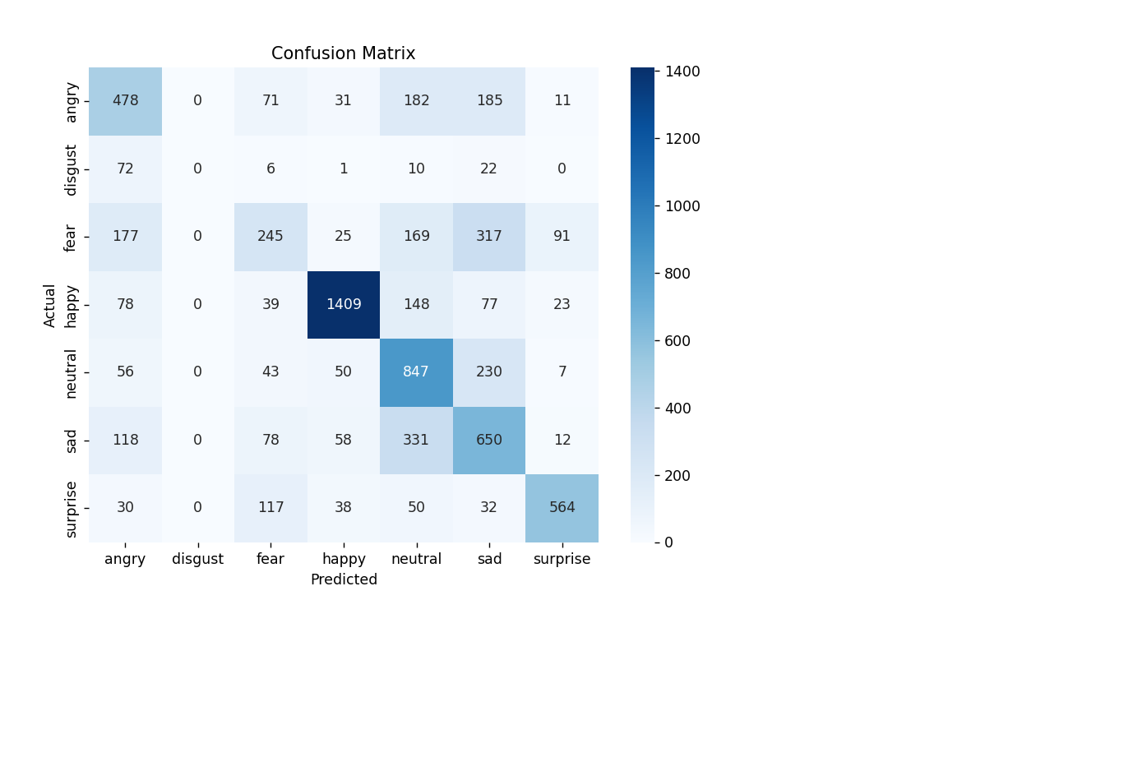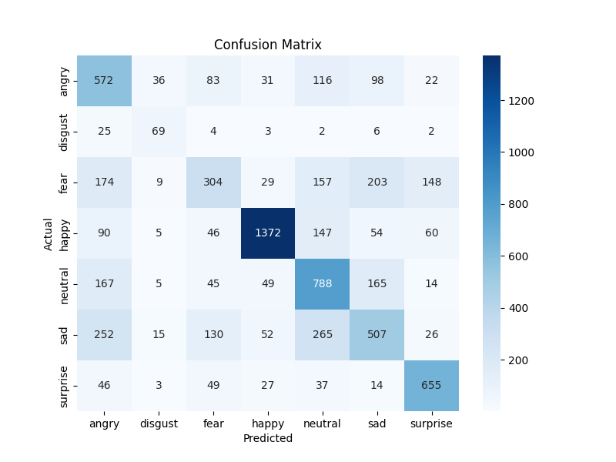

ARCHITECTURE
Input (48x48 grayscale)
↓
Conv2D (32 filters)
↓
Conv2D (64 filters)
↓
Conv2D (128 filters)
↓
Flatten
↓
Dense (128)
↓
Softmax (7 emotions)

Mobilev2 architecture:
