# Introduction

The objective of the research project was to better understand the demographics, attitudes and professional concerns of public health professionals in Canada with particular emphasis on the interaction between scientific evidence and policymakers. The COVID-19 pandemic has accentuated the challenging environment of balancing the optimal public health and public interest outcomes. The limitations of scientific evidence include the adjudication of competing normative values and protecting civil liberties. While public health professionals have been relied upon by policymakers to provide expert advice and policy recommendations, the science underpinning these recommendations is complex and evolving.

The Canadian Public Health Association (CPHA) is the national scientific organization of the public health discipline, and the professional voice for many of those who work in public health across Canada. In the context of the COVID-19 pandemic, the CPHA is struggling to understand better how experts (specifically its own members) interpret scientific evidence, advise elected policymakers and reconcile expert public health advice with competing public values. The CPHA has therefore partnered with our research team to determine the demographics, attitudes and professional concerns of the public health professionals in Canada with a particular emphasis on how they interact with scientific evidence and policymakers. Based on these needs, three research questions will guide this research project.

1. How do public health professionals assess their relationships with their politically accountable superiors (e.g. premiers, mayors, city councilors, ministers)?

2. What political attitudes do Canada’s public health professionals hold, and are there identifiable divisions among them?

3. How do these attitudes and potential divisions compare with those found in the broader public?

To answer these questions, we designed and executed a pair of surveys that was fielded to two different populations: Canadian public health professionals and the general population. These surveys asked questions that solicit respondents’ experiences with the COVID-19 pandemic, their general political attitudes and demographic characteristics. Public health professionals were also asked unique questions about how they interacted with policy makers and political leaders during the COVID-19 pandemic. The information gleaned from this analysis will improve the capacity to advocate for public health measures and provide effective advice to the public and policymakers.

# Research Design and Methodology

In order to accomplish our aforementioned goals, a survey was developed and distributed to members of the public health workforce. A parallel survey was distributed to the general population. The survey was developed by a team of veteran researchers that included Drs. Erick Lachapelle, Simon Kiss, Patrick Fafard, Ketan Shankardass & Andrea Perrella. The respective surveys were distributed in February and March 2021 by Dynata. The general population version consisted of a representative sample of 2,000 Canadians at least 18 years old. The survey of the public health workforce consisted of 202 surveys of the Canadian public workforce. This survey was distributed through the following membership networks: Public Health Physicians of Canada (PHPC), Canadian Public Health Association (CPHA), Health Promotion Canada and several provincial associations (Ontario, Quebec, Manitoba and New Brunswick/Prince Edward Island).

# Juxtaposing General Population and Public Health Professions

## Most Important Problem after COVID-19

Respondents were asked what they believe are the two most important public health issues facing Canada, aside from COVID-19. Respondents were able to choose two issues from eight different options, including obesity, vaccine hesitancy, smoking, vaping, poverty, excessive opioid use, excessive alcohol use, racial inequalities and other. The most important public health problems among the public health group is poverty (58%), excessive opioid use (39%) and racial inequality (39%). Among the general population, the most important problems are poverty (47%), excessive opioid use (40%) and vaccine hesitancy (32%). Vaping, smoking and excessive alcohol use were rated as lowest importance by both public health and general population samples. Thus, one major distinction that emerges is the relative importance of racial inequalities and vaccine hesitancy.

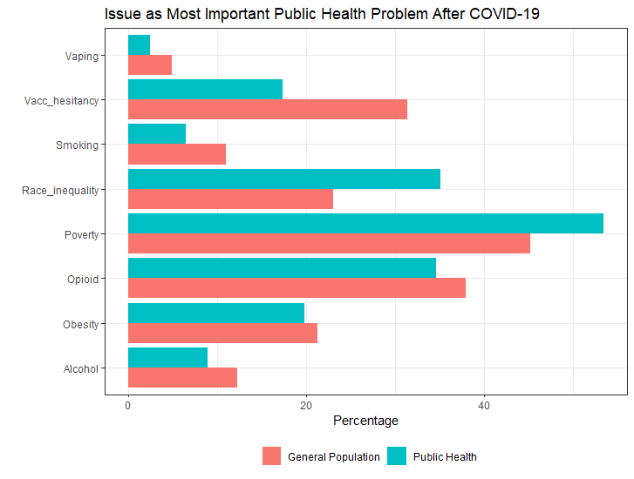

## Federal Government Management of COVID-19

Respondents were asked to evaluate how well the federal government has done in managing the consequences of COVID-19 across three different areas: (1) preventing the spread of COVID-19, (2) ensuring speedy access to vaccines as they become available and (3) managing the economic disruptions associated with the pandemic. Respondents were asked to rate the performance of the federal government on a scale from 1 (very poorly) to 7 (very well). The general population sample rated the performance of the federal government higher than the public health professional sample in the area of preventing the spread of COVID-19 (x̄ = 4.10), while lower in ensuring speedy access to vaccines (x̄ = 3.56) and managing the economic disruptions (x̄ = 4.19). This can be compared to the average scores of public health professionals for preventing the spread of COVID-19 (x̄ = 3.92), ensuring speedy access to vaccines (x̄ = 3.77) and managing economic disruptions associated with the pandemic (x̄ = 4.42). The only area that was found to have statistically significant differences in means is satisfaction with the federal government preventing the spread of COVID-19 (*p* = 0.03523).

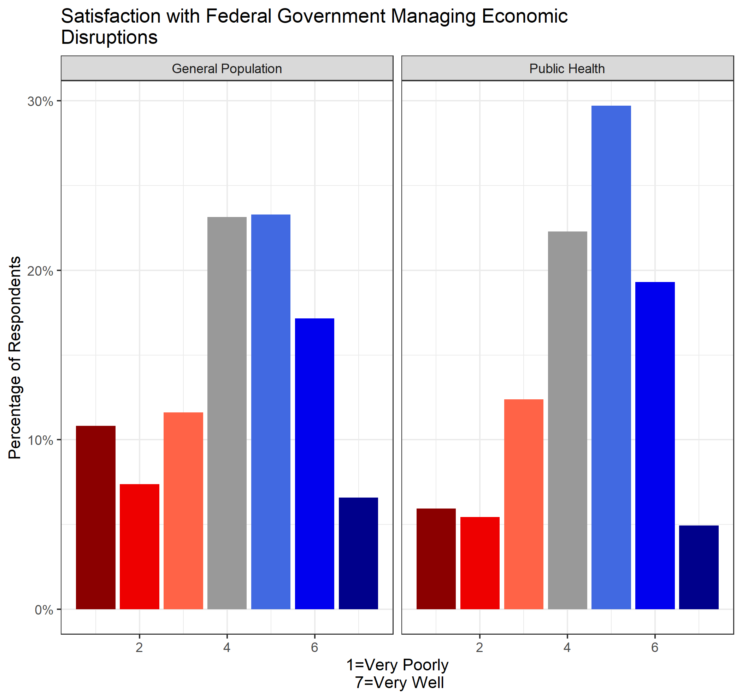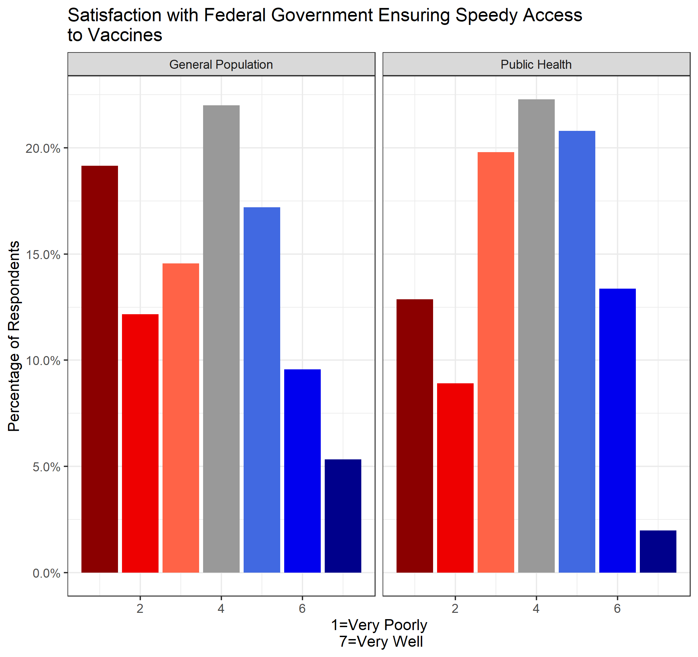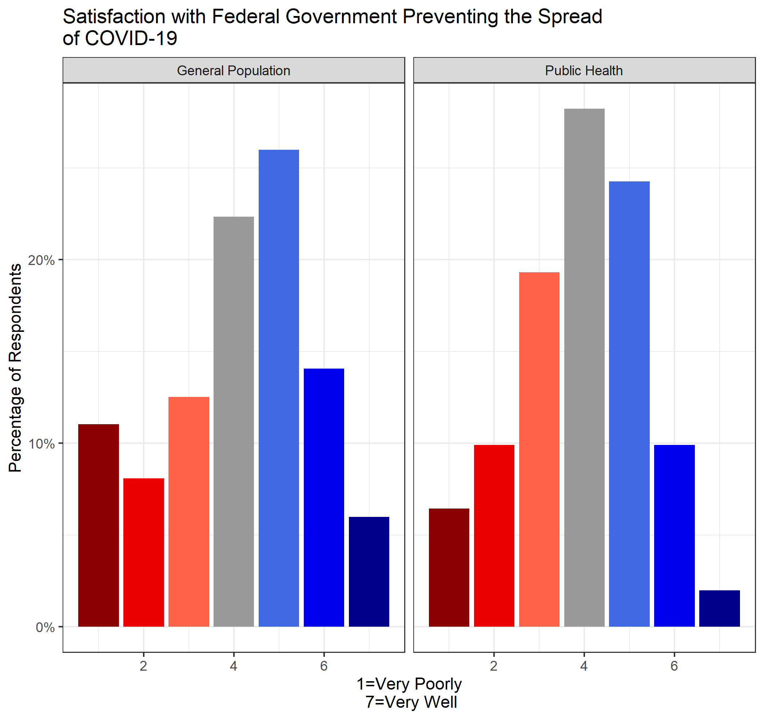

## Influences Affecting Government Decision-making

Respondents were asked which of the following influences do they think most affect and *should* most affect government decision-making about COVID-19. Respondents were allowed to choose up to three different options from the following: (1) scientific evidence, (2) economic considerations, (3) political considerations, (4) advice from public health experts, (5) international influences, (6) minimizing disruptions to normal life and (7) public opinion.

Among public health professionals, economic and political considerations (65%) were overwhelmingly believed to affect government decision-making, with advice from public health professionals (56%). For the general population sample, respondents believe that advice from public health officials (55%), economic considerations (47%) and political considerations (41%) affect government decision-making about COVID-19. Over 2/3 of both the general population and public health sample agreed that the most important influences *should* be scientific evidence and advice from public health experts.

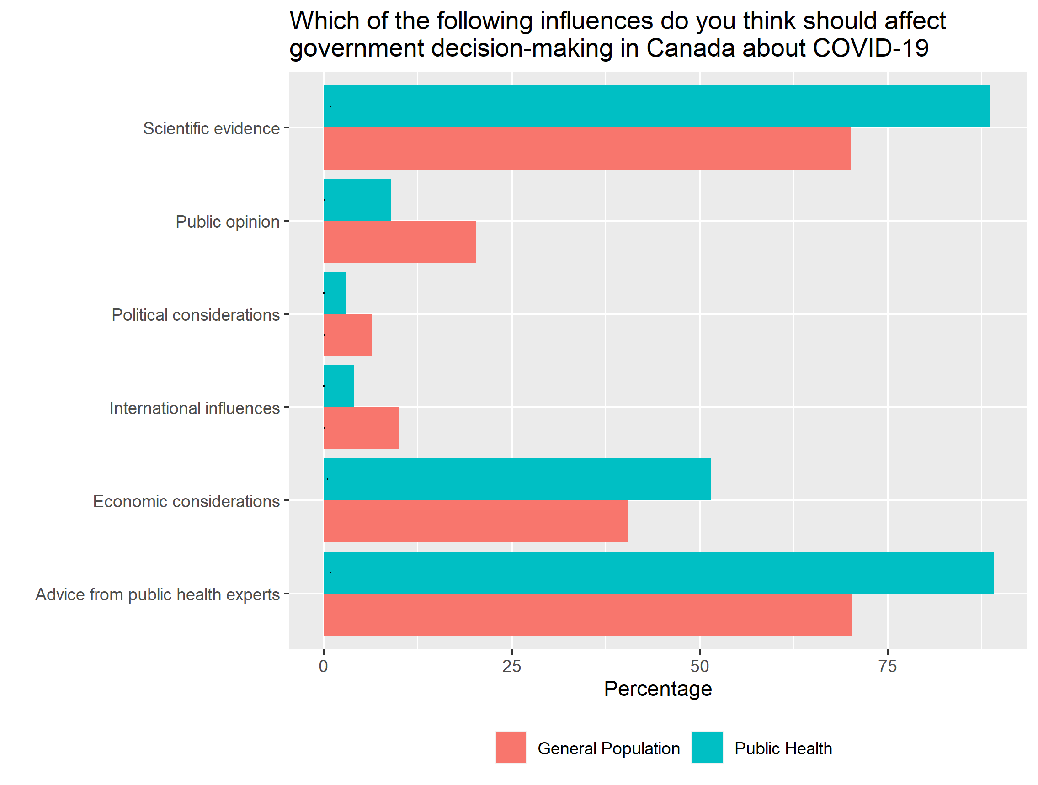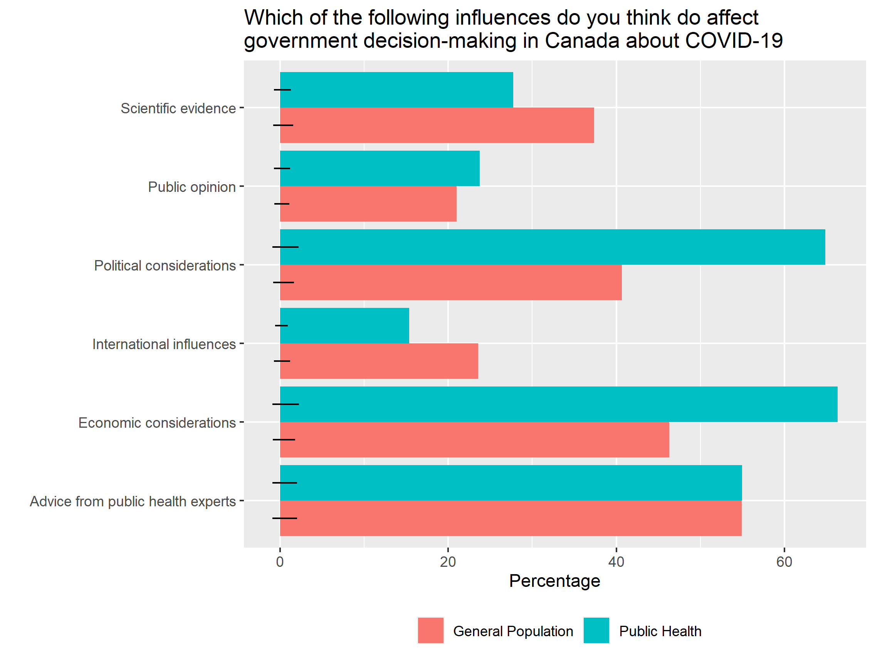

## Views on Chief Medical Officer

Respondents were asked about the role of their provincial Chief Medical Officer of Health, which included five different options: (1) senior policy advisor to the Minister of Health and the Premier, (2) public health expert who helps us understand the pandemic, (3) a technical advisor in the Ministry of Health, (4) an advocate for public health and (5) senior executive in charge of managing public health. Nearly 2/3 of the general population and public health groups agree that the role of the Chief Medical Officer is a senior policy advisor to the Minister of Health and the Premier or a public health expert who helps us understand the pandemic.

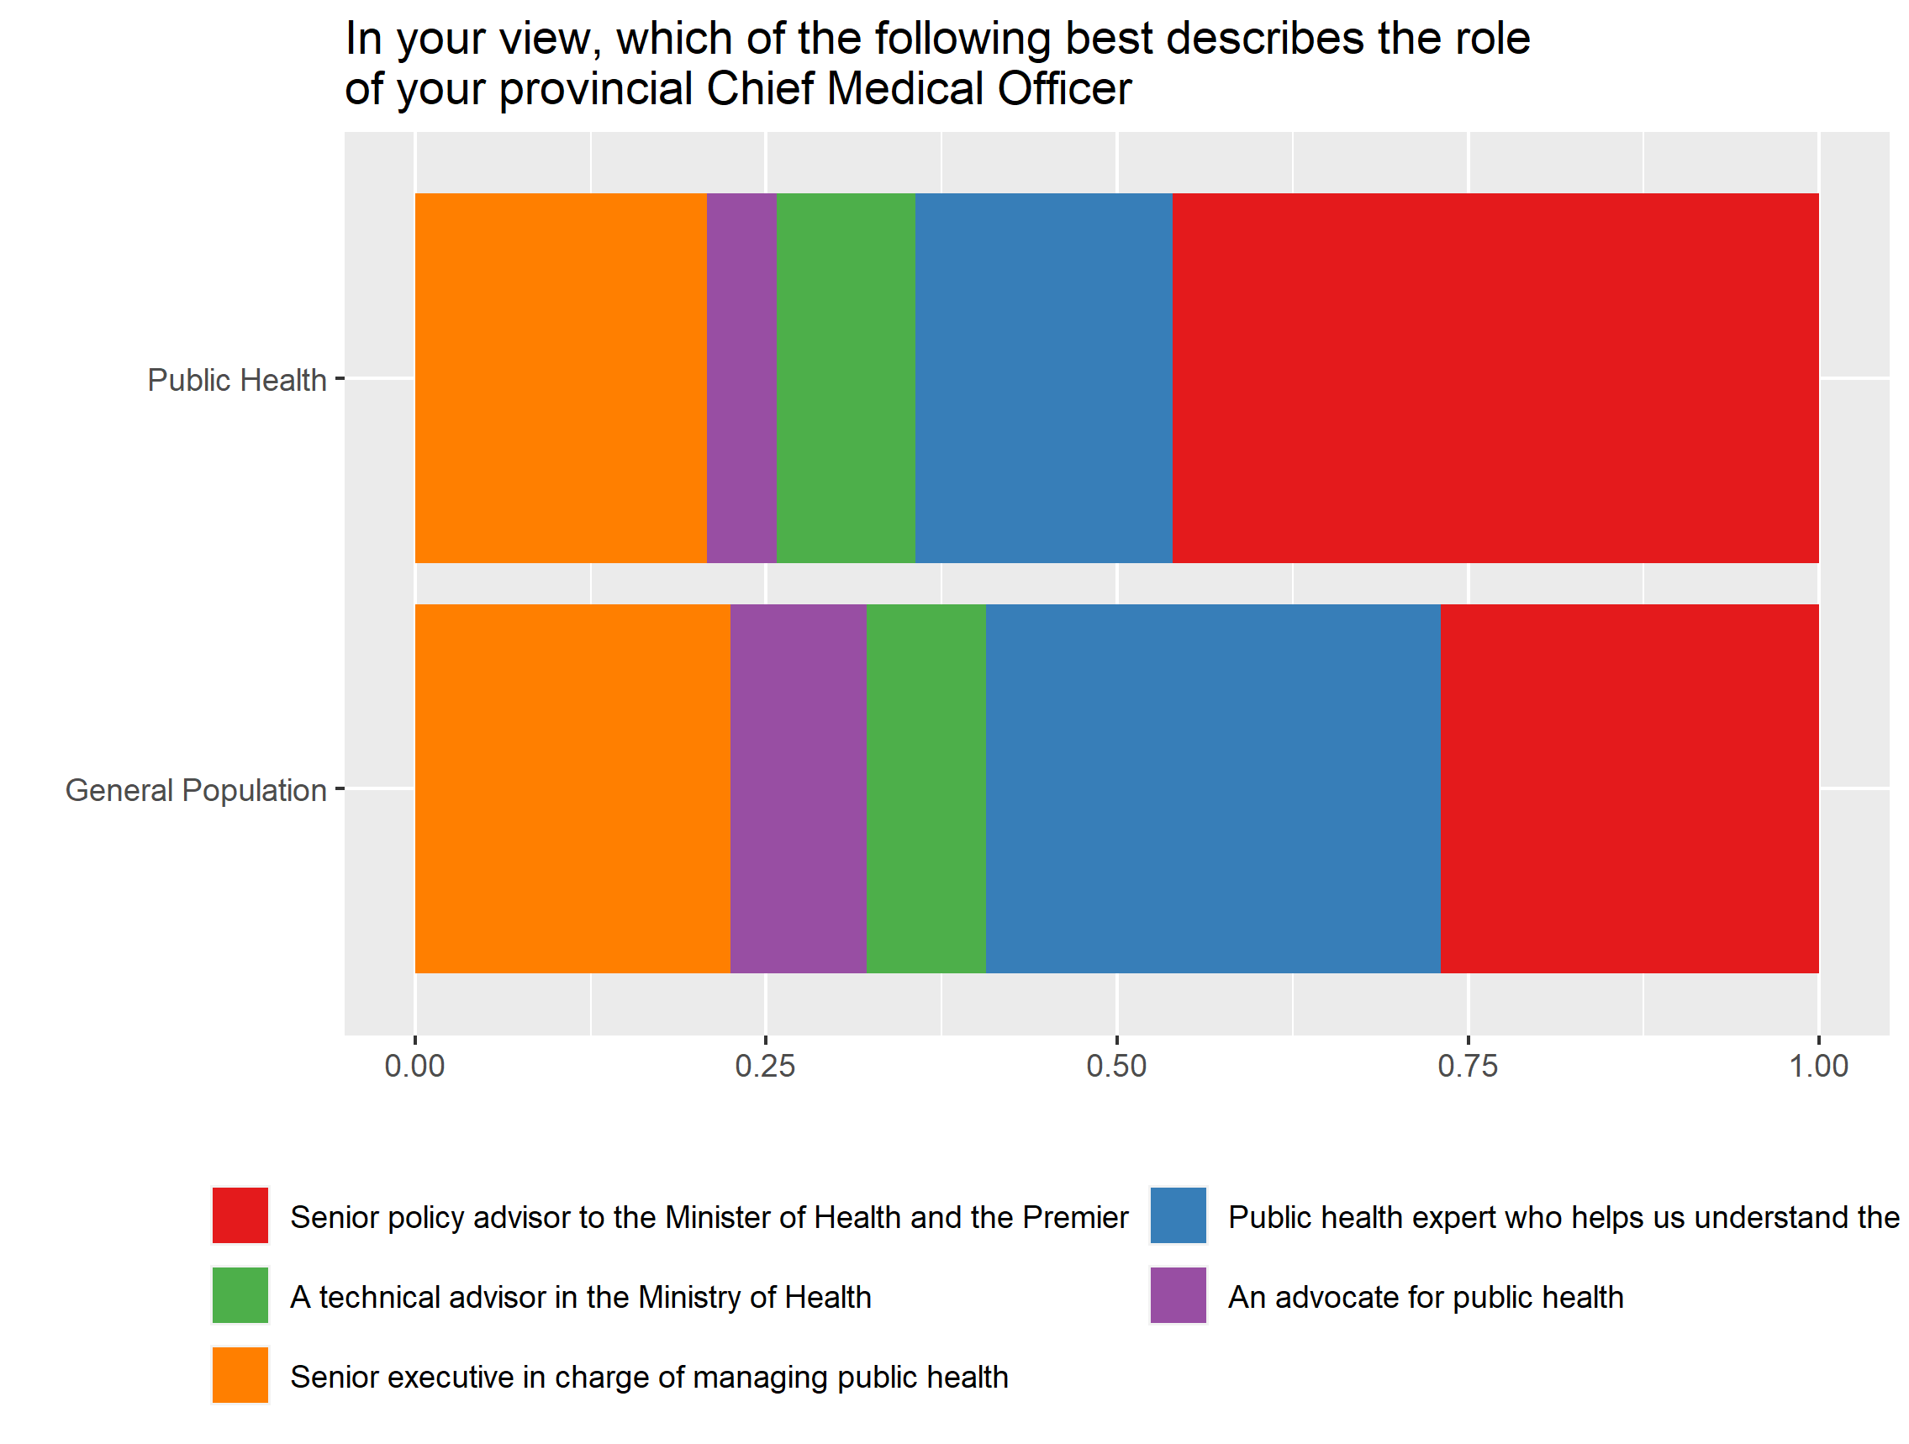

## COVID-19 Trust

Respondents were asked to rate different organizations on a scale from one (cannot be trusted at all) to five (can be trusted a lot). The different organizations included the following: (1) federal government, (2) provincial government, (3) Chinese Centre for Disease Control and Preventing, (4) United States Centre for Disease Control and Prevention, (5) World Health Organization, (6) Chief Public Health Officer of Canada and (7) Chief Medical Officer of Health in your province.

The only group that was rated below average in trust scores was the Chinese Centres for Disease Control and Prevention. Public health professionals were generally more trusting of all organizations compared to the general population sample, with the notable exception of the provincial government. The difference in means between sample groups is found to be statistically significant for each of the seven organizations.[1]

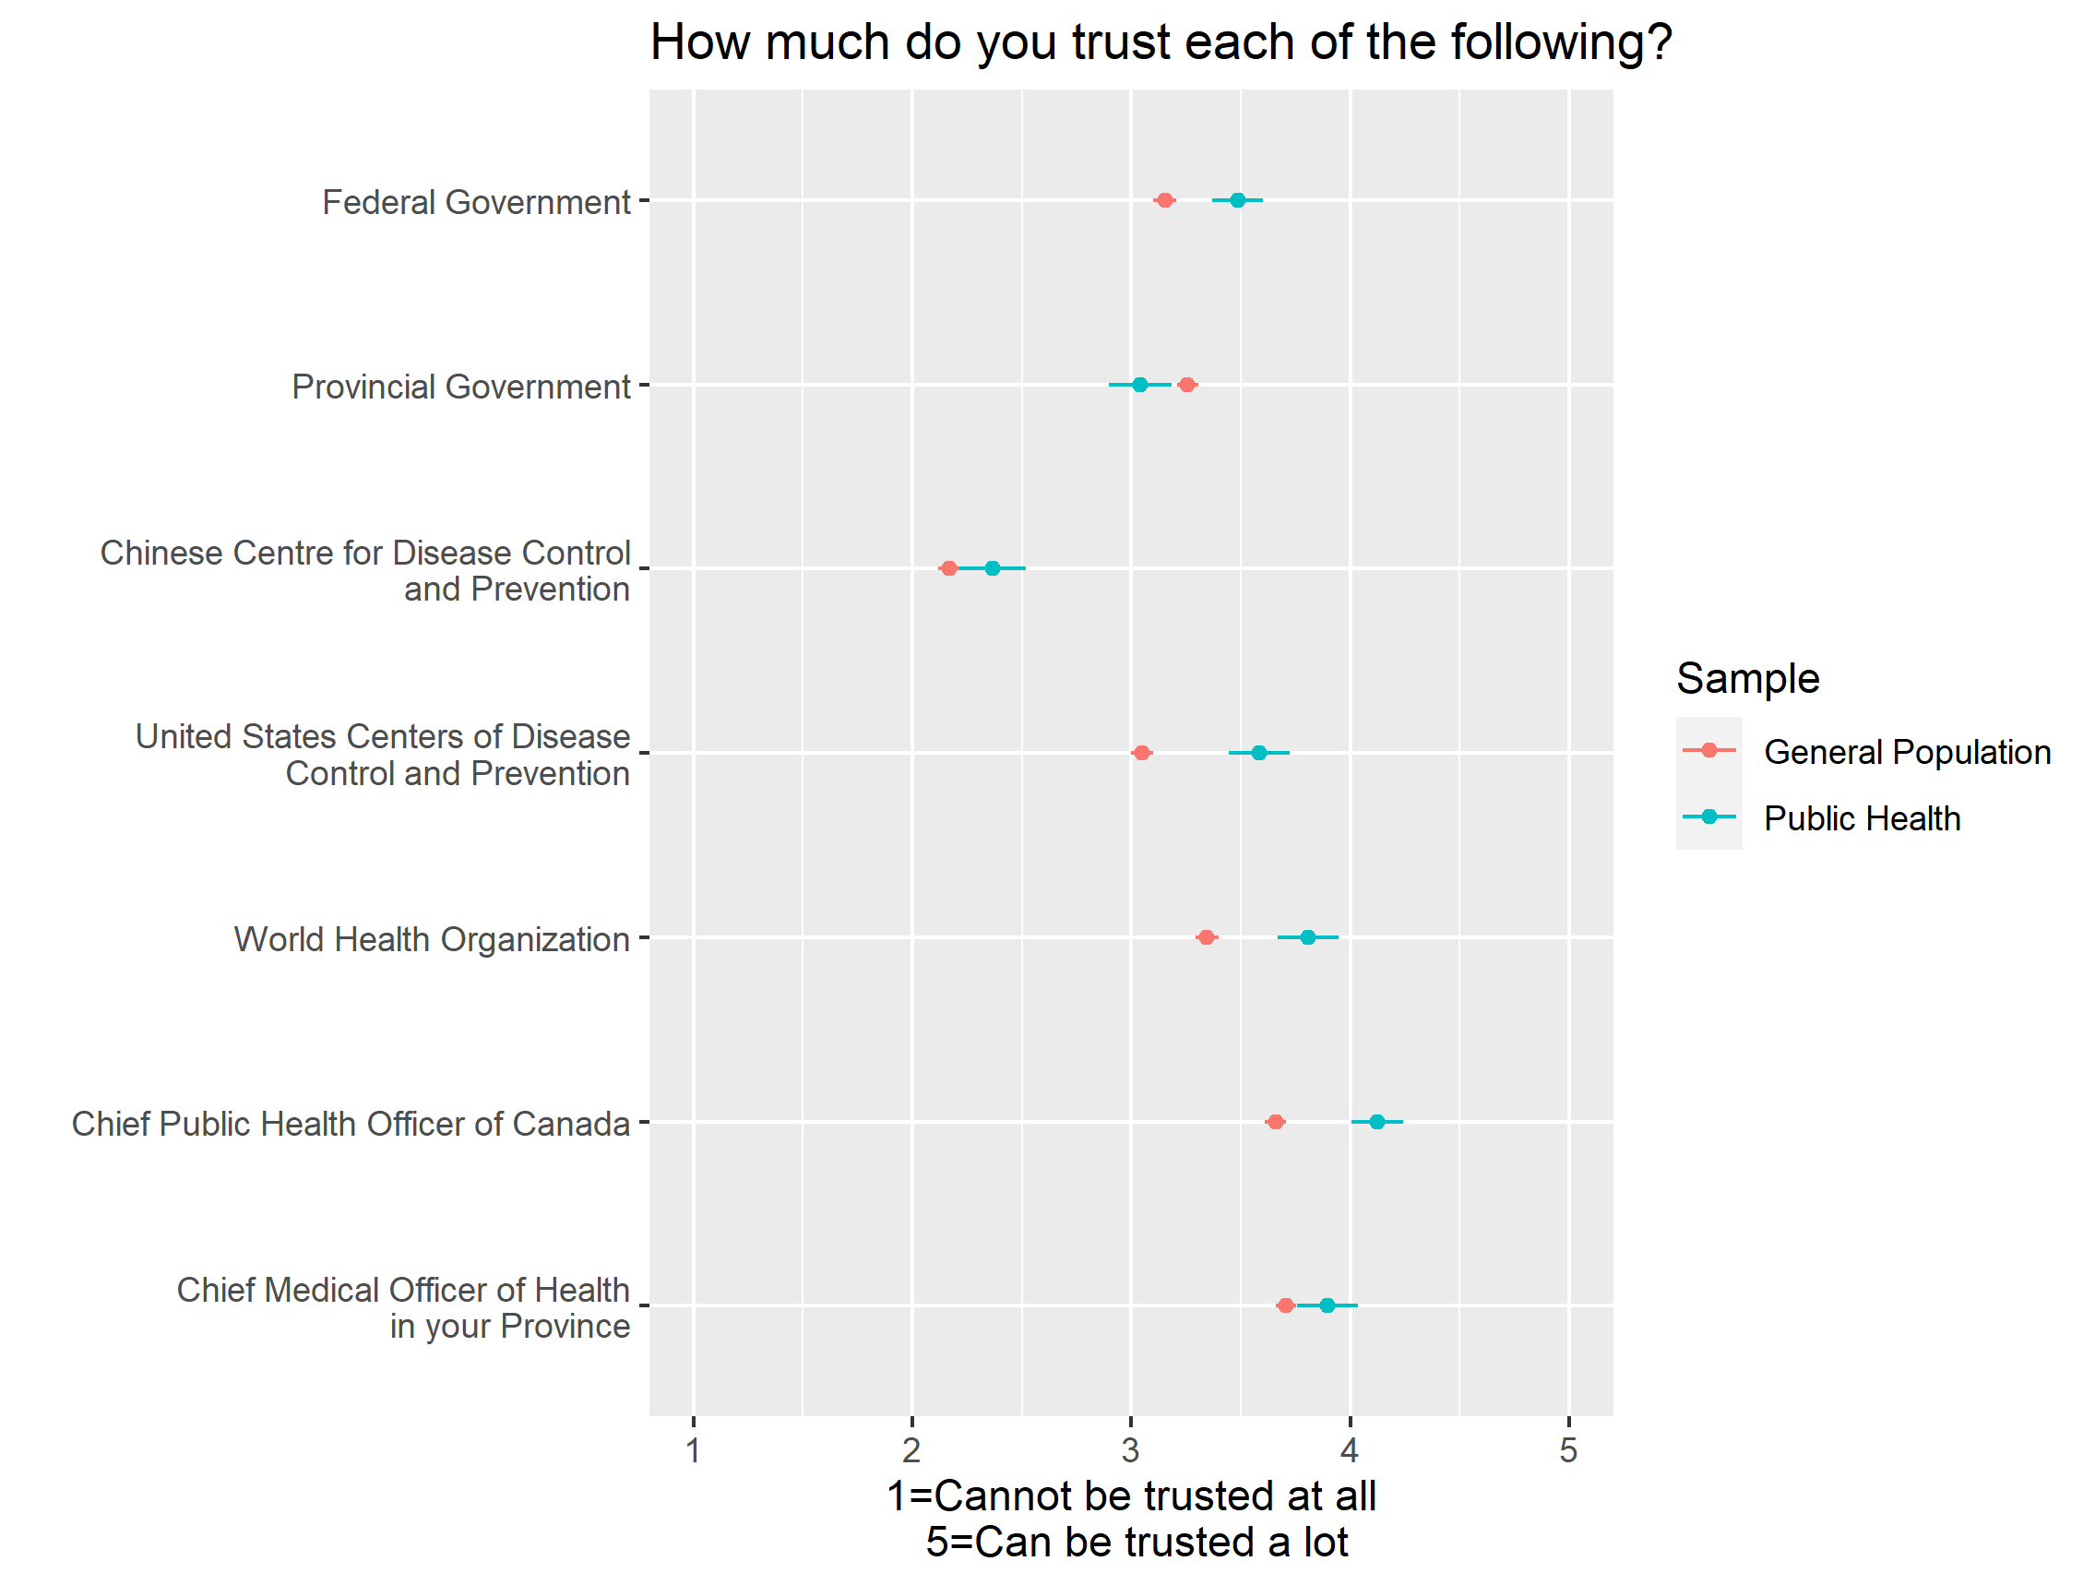

## Preventing the Spread of COVID-19

Respondents were asked to rate a variety of different groups on their efforts to prevent the spread of COVID-19 on a scale from one (very poorly) to five (very well). In general, the public health sample rated nearly all groups higher than the general population group, with the provincial government as the only notable exception. Public health professionals were rated by both samples as the best at preventing the spread of COVID-19. Alternatively, young people were rated as the worst at preventing the spread of COVID-19. The difference in means between samples was statistically significant, except for the evaluation of ‘your neighbours’.[2]

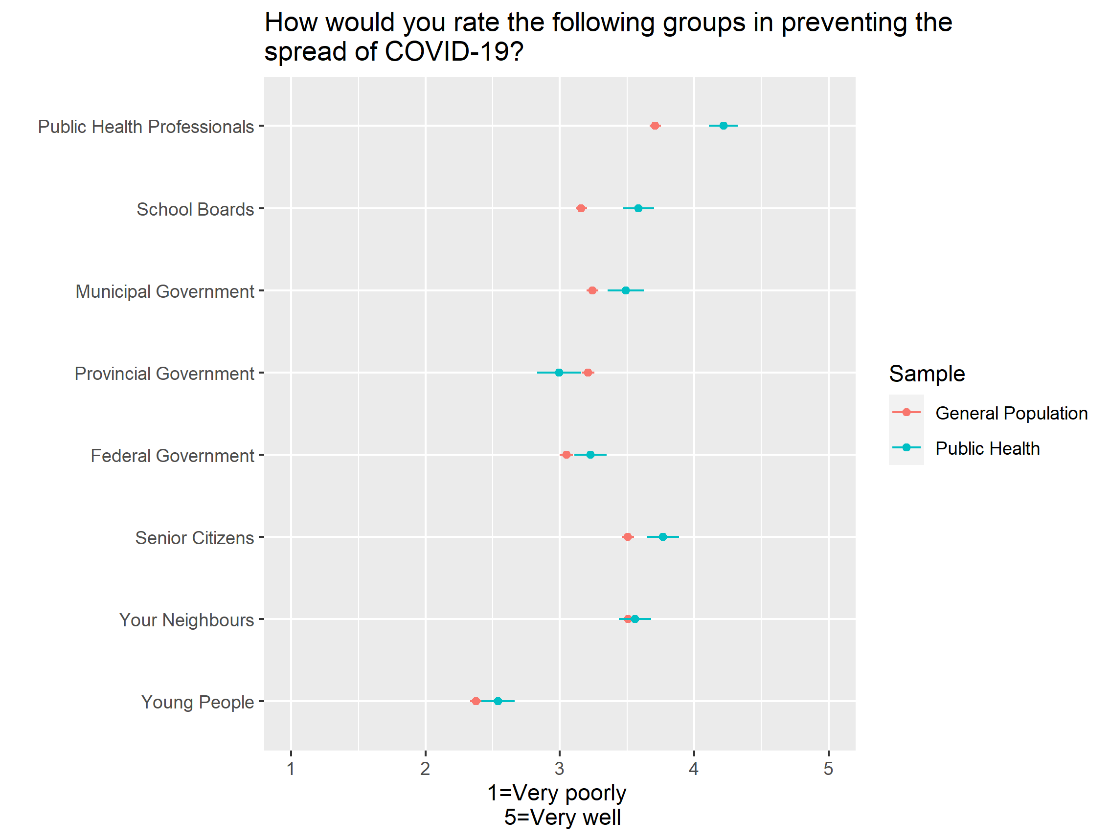

## Short-term Restrictions

Respondents were asked how strongly they support or oppose three (3) different measures to contain the COVID-19 pandemic in the short-term. Respondents rated support for intervention from 1 (strongly opposed) to 7 (strongly support). The three different interventions included the following: (1) mandatory vaccinations, (2) bar and restaurant closures and (3) fines for not wearing masks indoors.

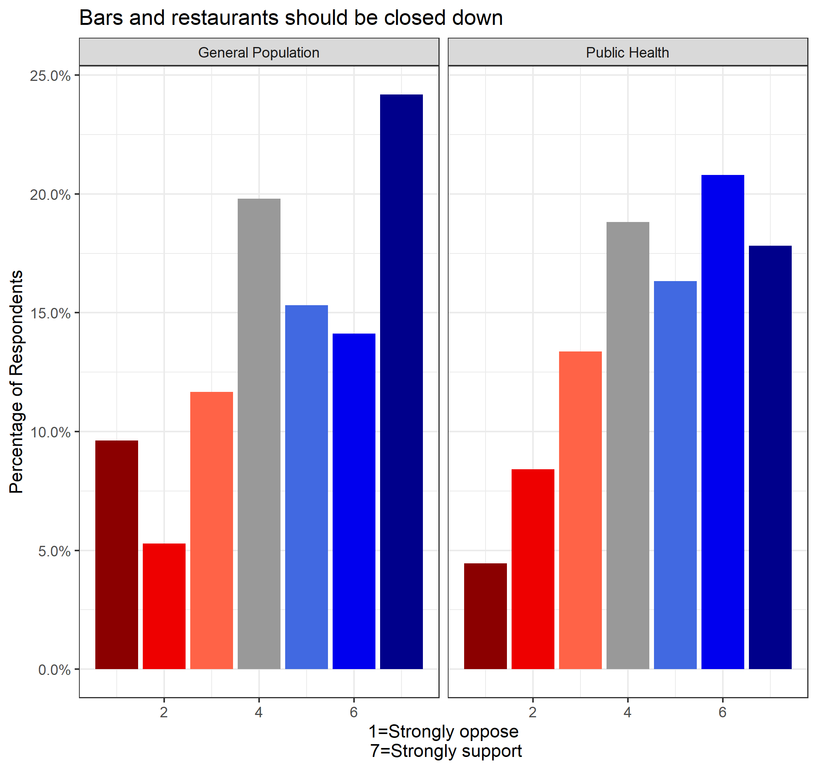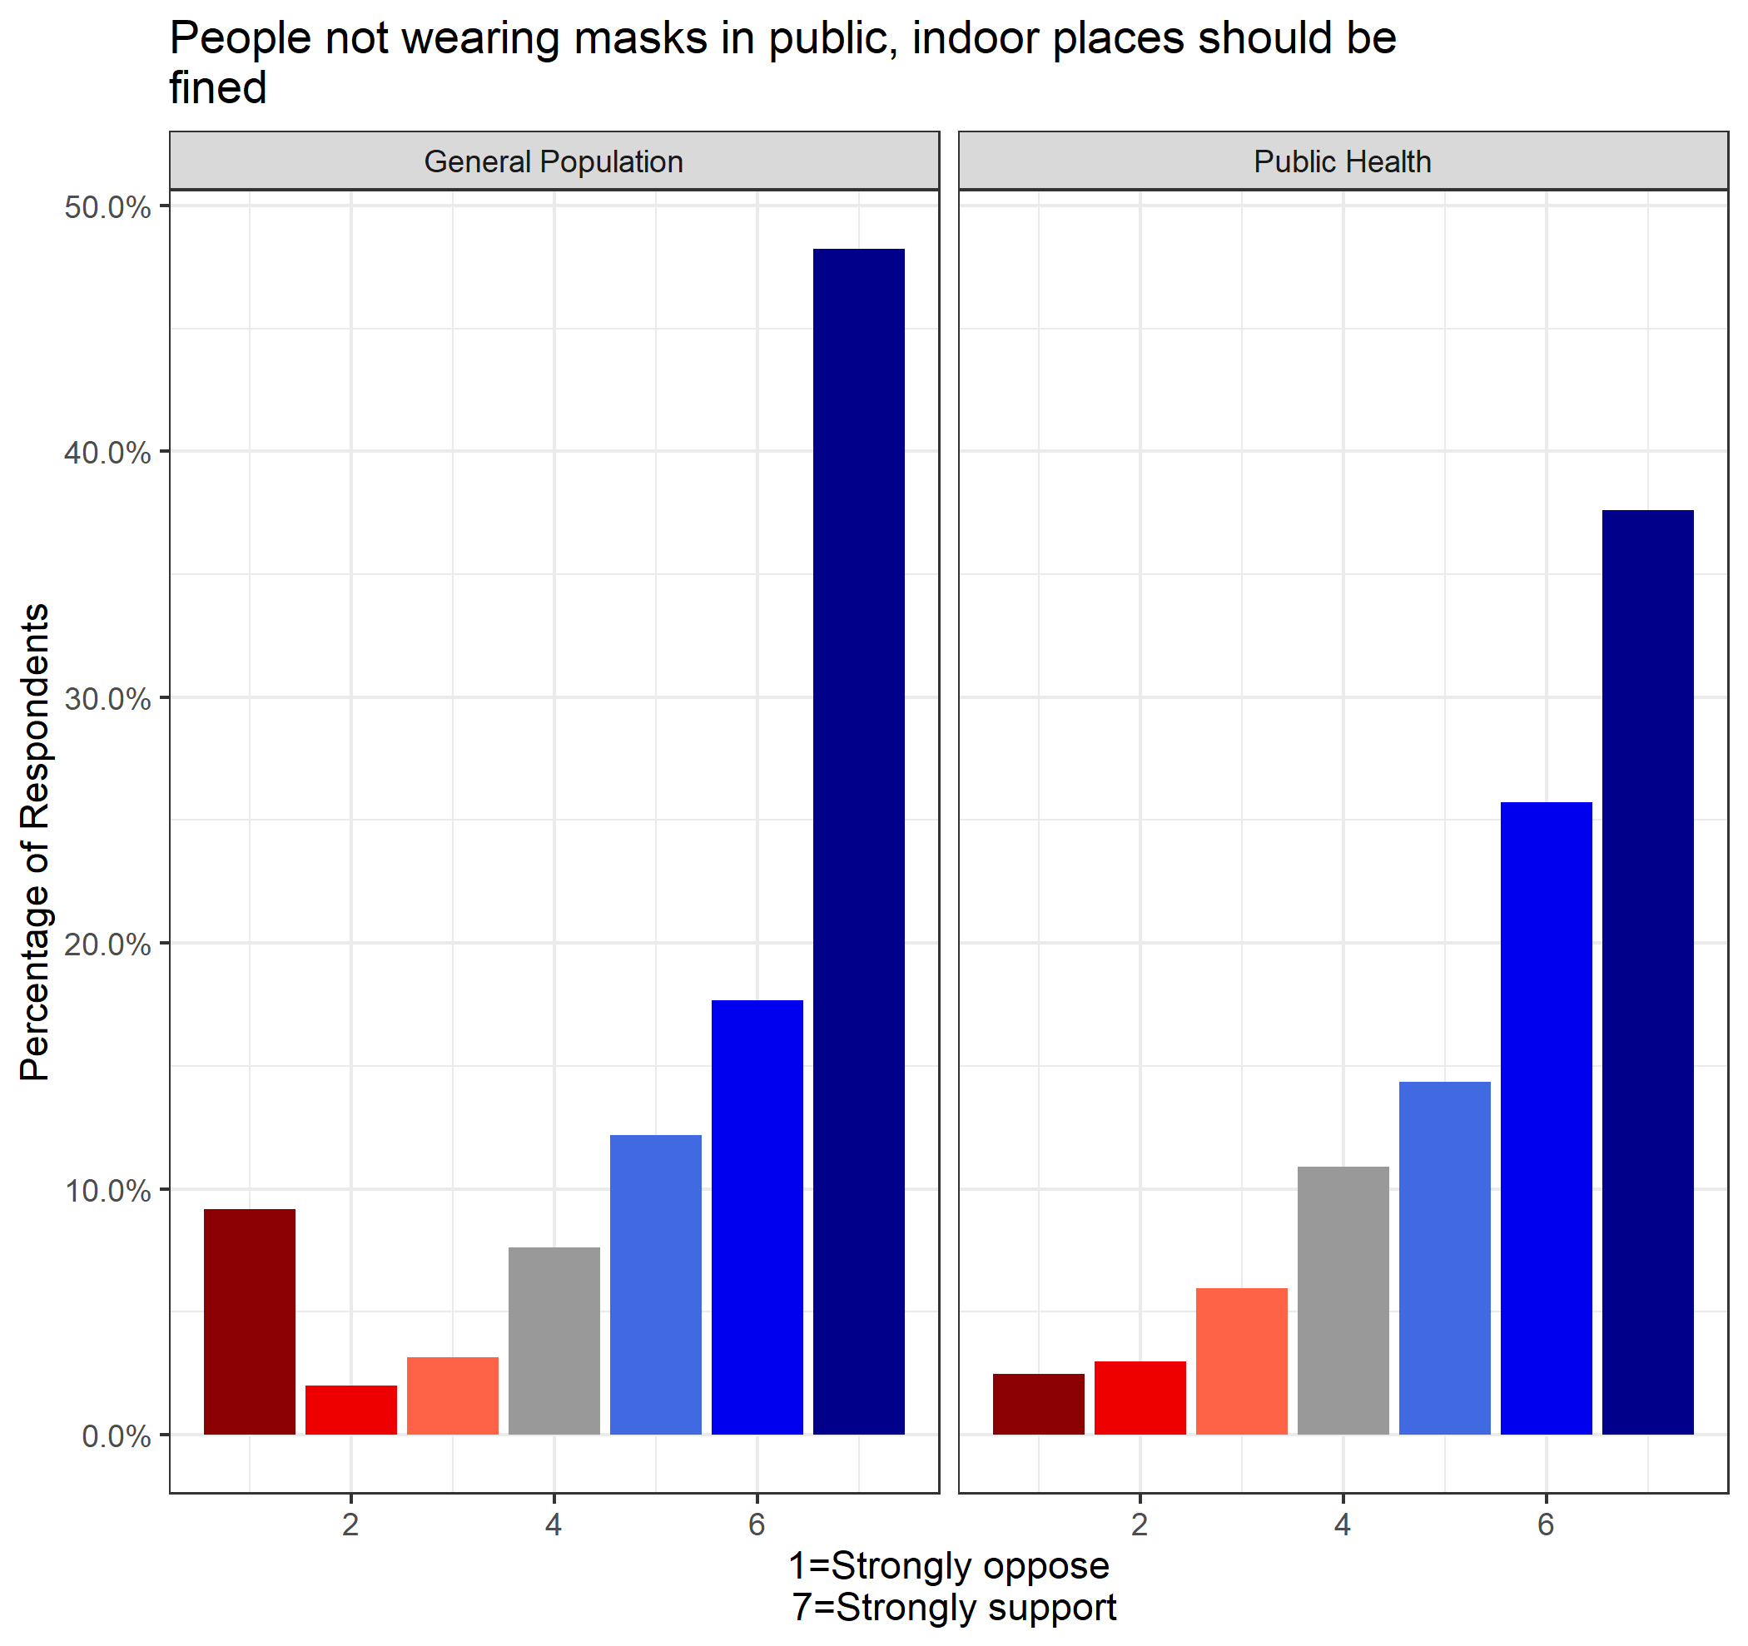

There was a general consensus between the general population and public health on their views about bar/restaurant closures and fines for those not wearing a mask indoors. The average rating among general population respondents was 4.65 and 5.58 for bar/restaurant closures and fines, respectively. This can be compared to the average of public health respondents, which was 4.68 and 5.59, respectively.

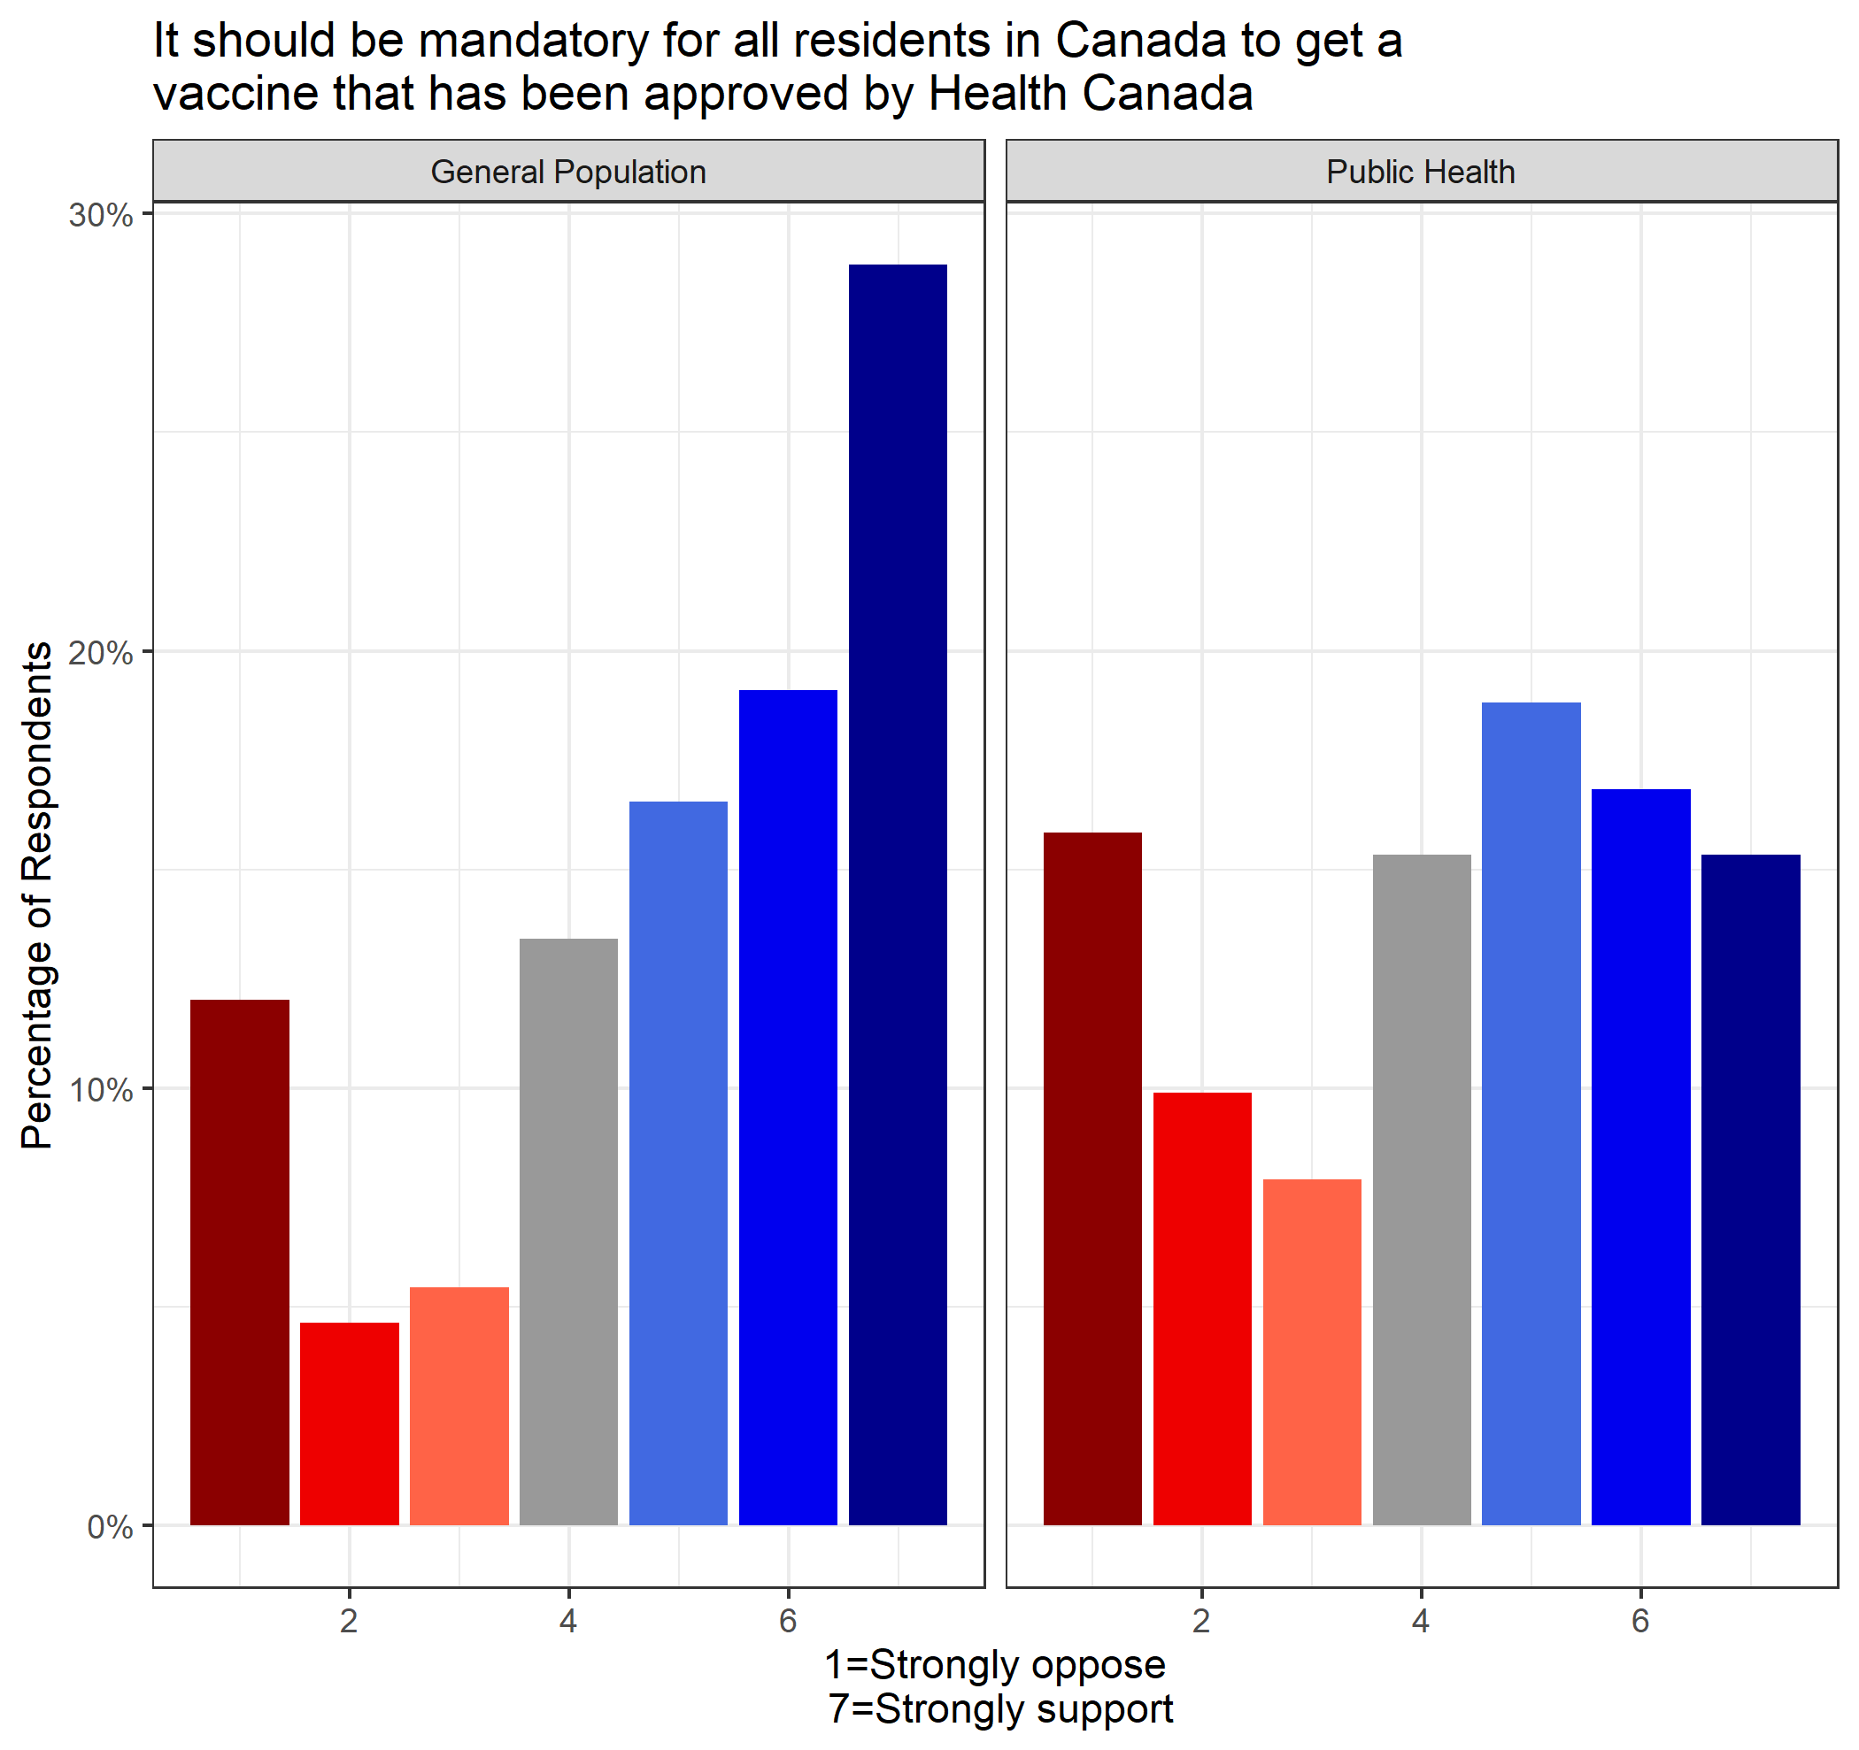

The divergence between the general population and public health groups centered around mandatory vaccinations. Over 2/3 of all general population respondents (64%) agreed with mandatory vaccinations, which is compared to only 51% of public health professionals surveyed. The average score among the general population was higher (x̄ = 4.90) than public health (x̄ = 4.23), which was found to be statistically significant (*p* = 2.061e-06).

## Outcomes/Trade-offs

Respondents were asked a series of trade-off questions on four different dimensions: economy, social isolation, schools and LTC isolation. Respondents were asked to rate each dimension between 0 (stopping the spread of COVID-19, even at the expense of a particular dimension) and 10 (promoting the dimension, even at the expense of increased COVID-19 infections). Both samples erred on the side of preventing the spread of COVID-19, even if it meant negative consequences in a specific dimension. Public health professionals were more amenable to a balanced approach for school closures and the general population was more considered about economic repercussions. The difference in mean values between samples was found to be significant for LTC isolation (*p* = 0.02599), school openings (*p* = 3.903e-06) and economic considerations (*p* = 0.04001).

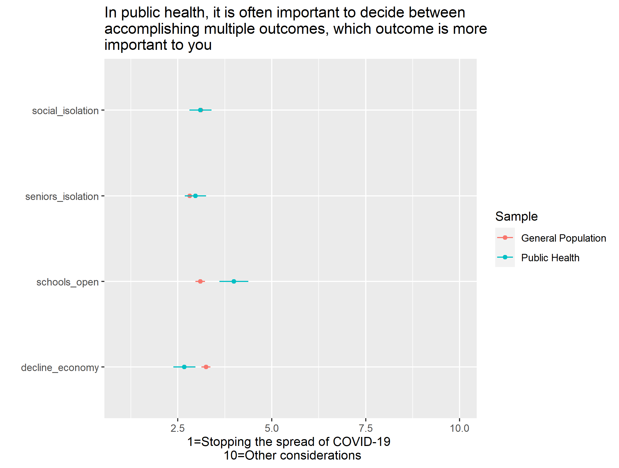

## Increasing Federal Power

Respondents were asked a series of four (4) questions regarding granting the federal government additional powers, even if it would mean acting in the area of provincial responsibility. These four questions focused on the following areas: (1) monitoring the spread of diseases, (2) emergency response, (3) control over vaccine supply chain and (4) population mental health. Respondents were asked to choose from the following options: strongly disagree, somewhat disagree, somewhat agree and strongly agree. For each of the four areas, the general population was more supportive of increased federal powers than public health professionals. The greatest disparity was in the area of increased federal power in the area of mental health, with over 43% of public health professionals in disagreement.

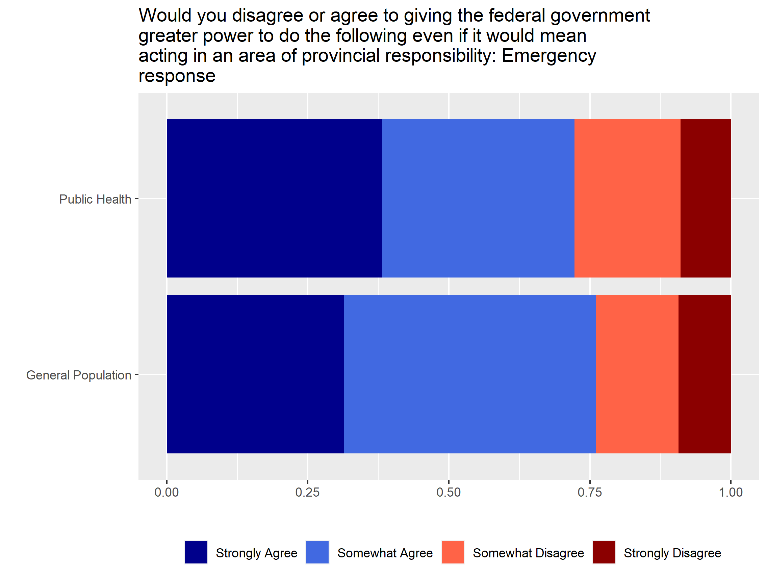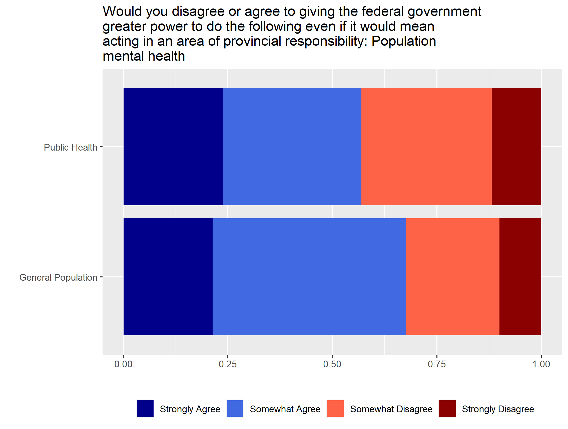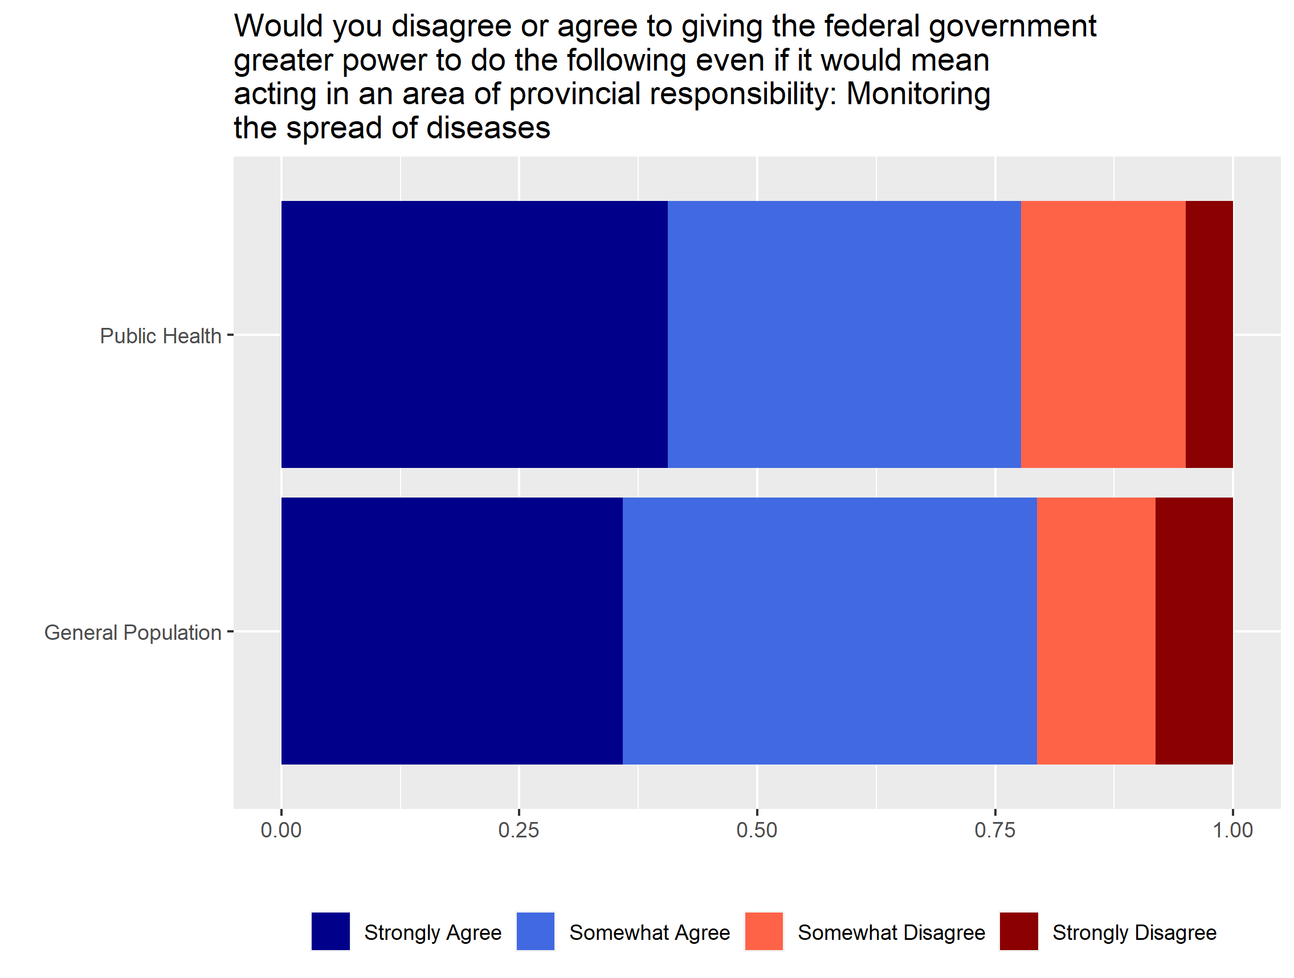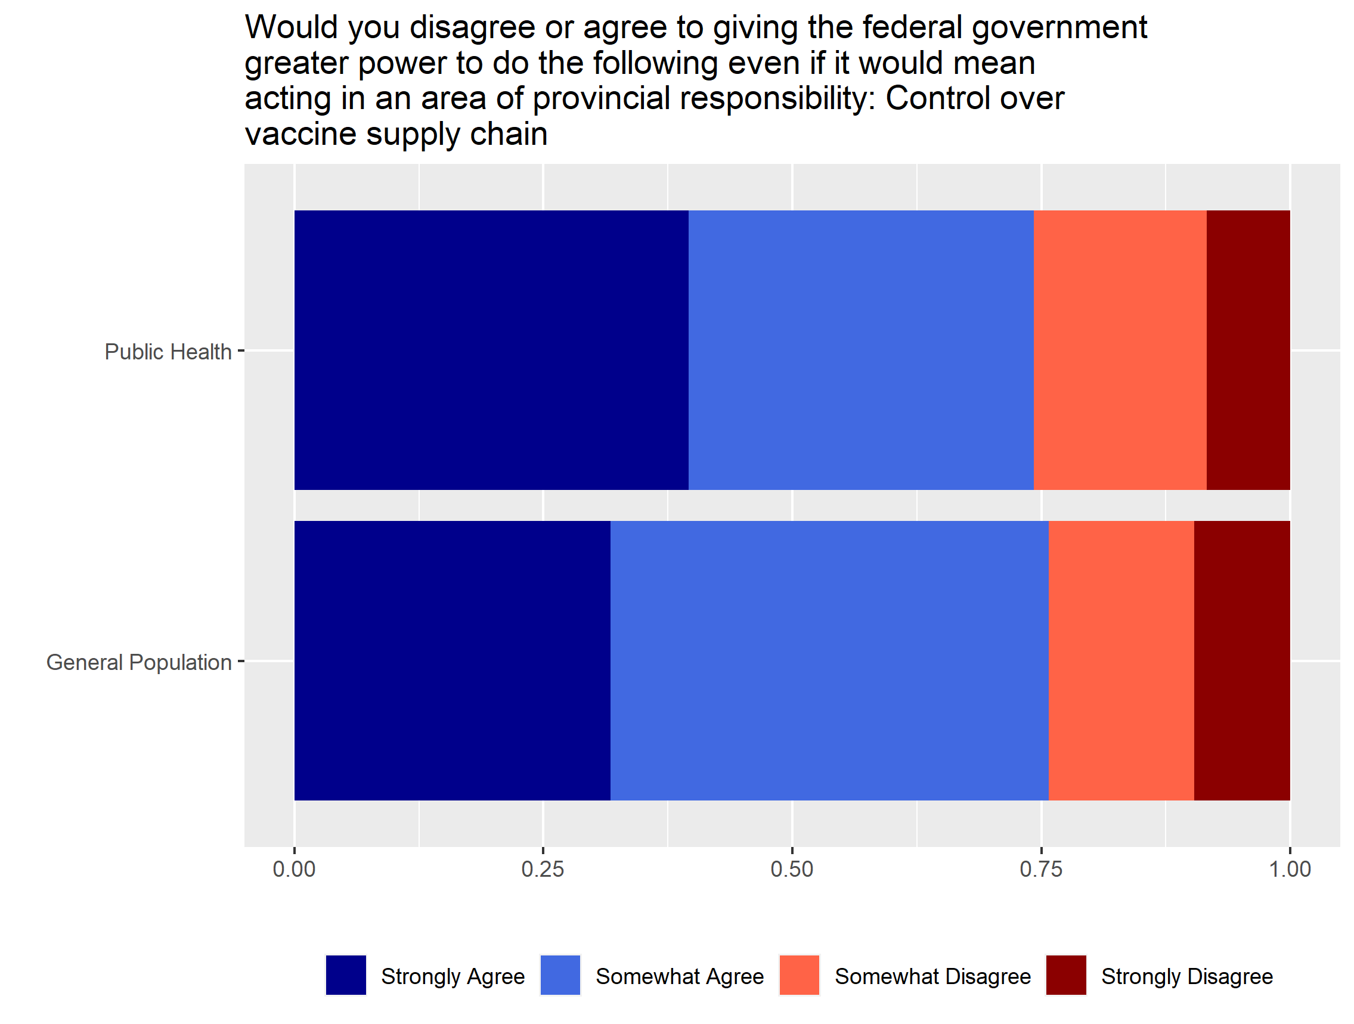

## Government Priority to Ensure Speedy Recovery

Respondents were asked what they believe governments should prioritize to ensure a speedy recovery. They were offered four different options, which included: (1) Invest in social programs, (2) cut taxes, (3) improve income support and (4) reduce the debt accumulated in the pandemic. The most popular answer among public health respondents was investing in social programs (42%), which was the least popular choice among the general population sample (17%). The most popular answer among the general population was improving income support (36%), which was also the second most popular response (35%) of public health respondents.

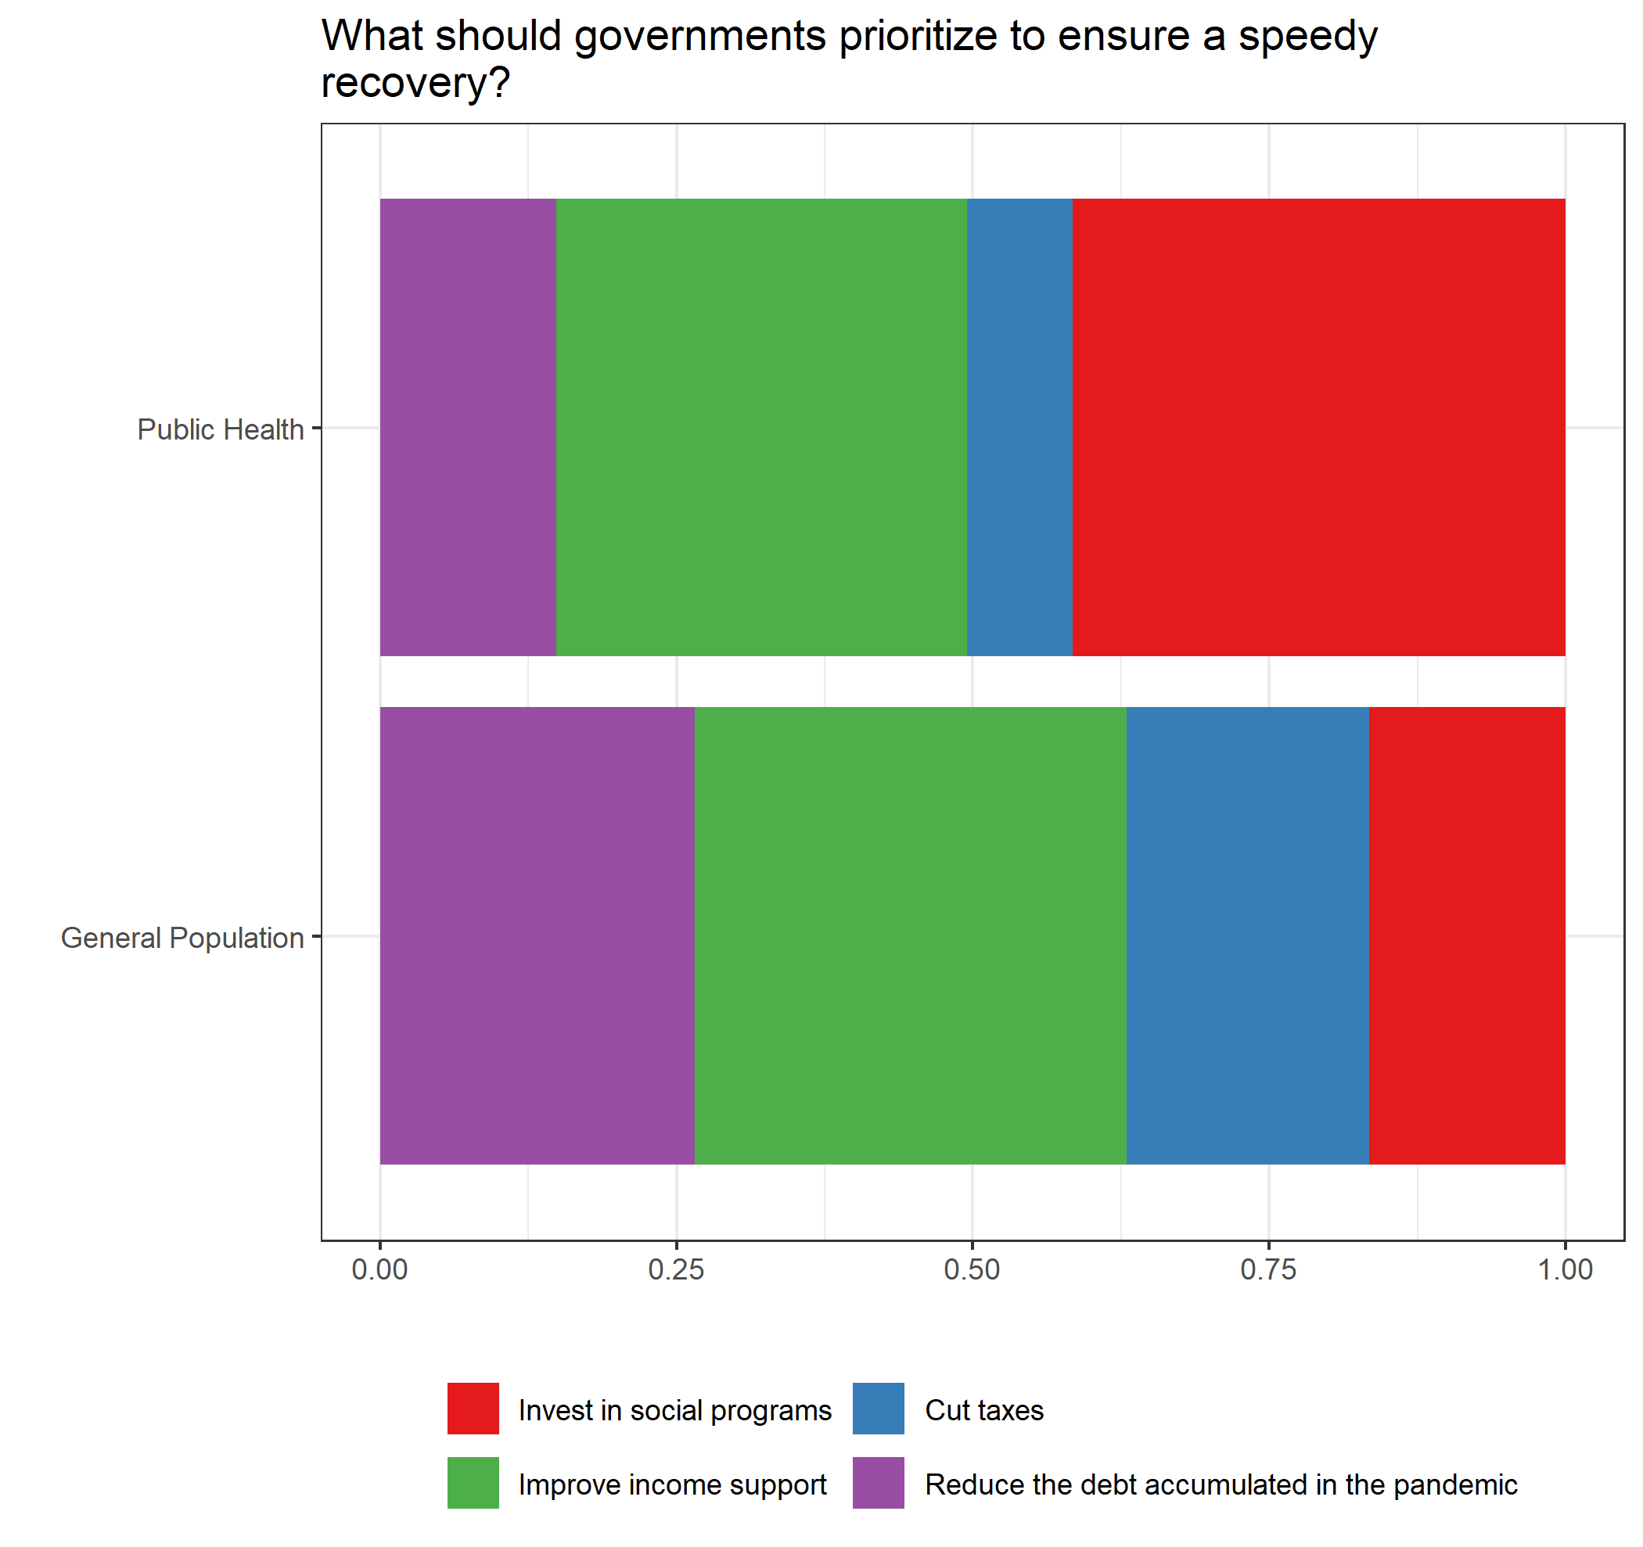

## Views on Science in Policy

Respondents were asked how important they believe scientific evidence is in making public policy. Respondents are asked to indicate their preference on a scale of 1 (best available scientific evidence should dictate public policy) to 7 (scientific evidence should be one of many factors that go into making public policy). Both the general population (x̄ = 4.49) and public health (x̄ = 4.03) samples lean toward a compromise between scientific evidence and other factors, with the greatest concentrations slightly above average.

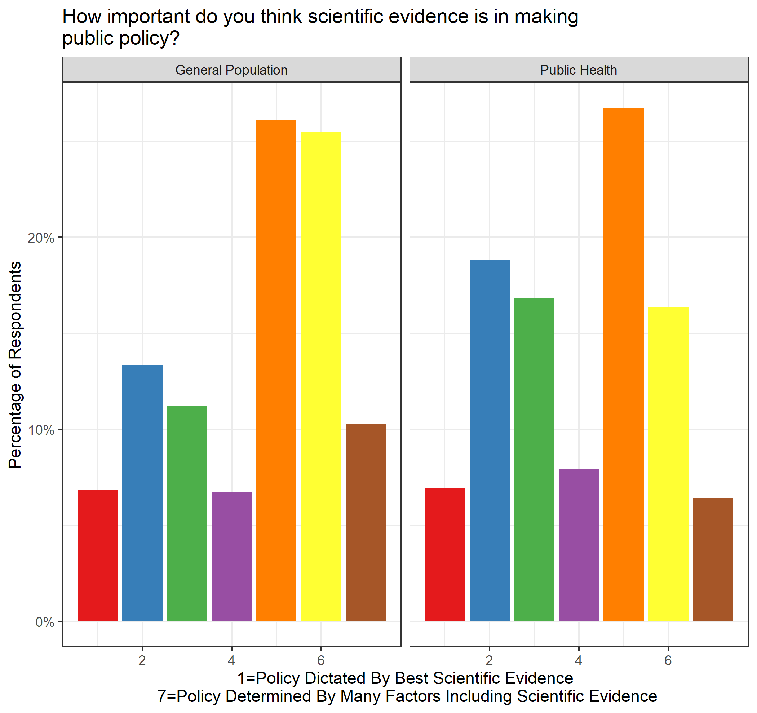

## Trust in Other People

Respondents were asked a series of questions to determine the extent in which they trust other people, government and politicians. When asked if the government is run for the benefit of all people or big interests, over half of the general population and public health samples are pessimistic about government. When asked if most people can be trusted, the general population is divided, while a majority of public health believe that most people can be trusted. When asked if people in government waste a lot of tax money, over half of the general population believe that government wastes a lot of money. This can be compared to less than a quarter of public health professionals.

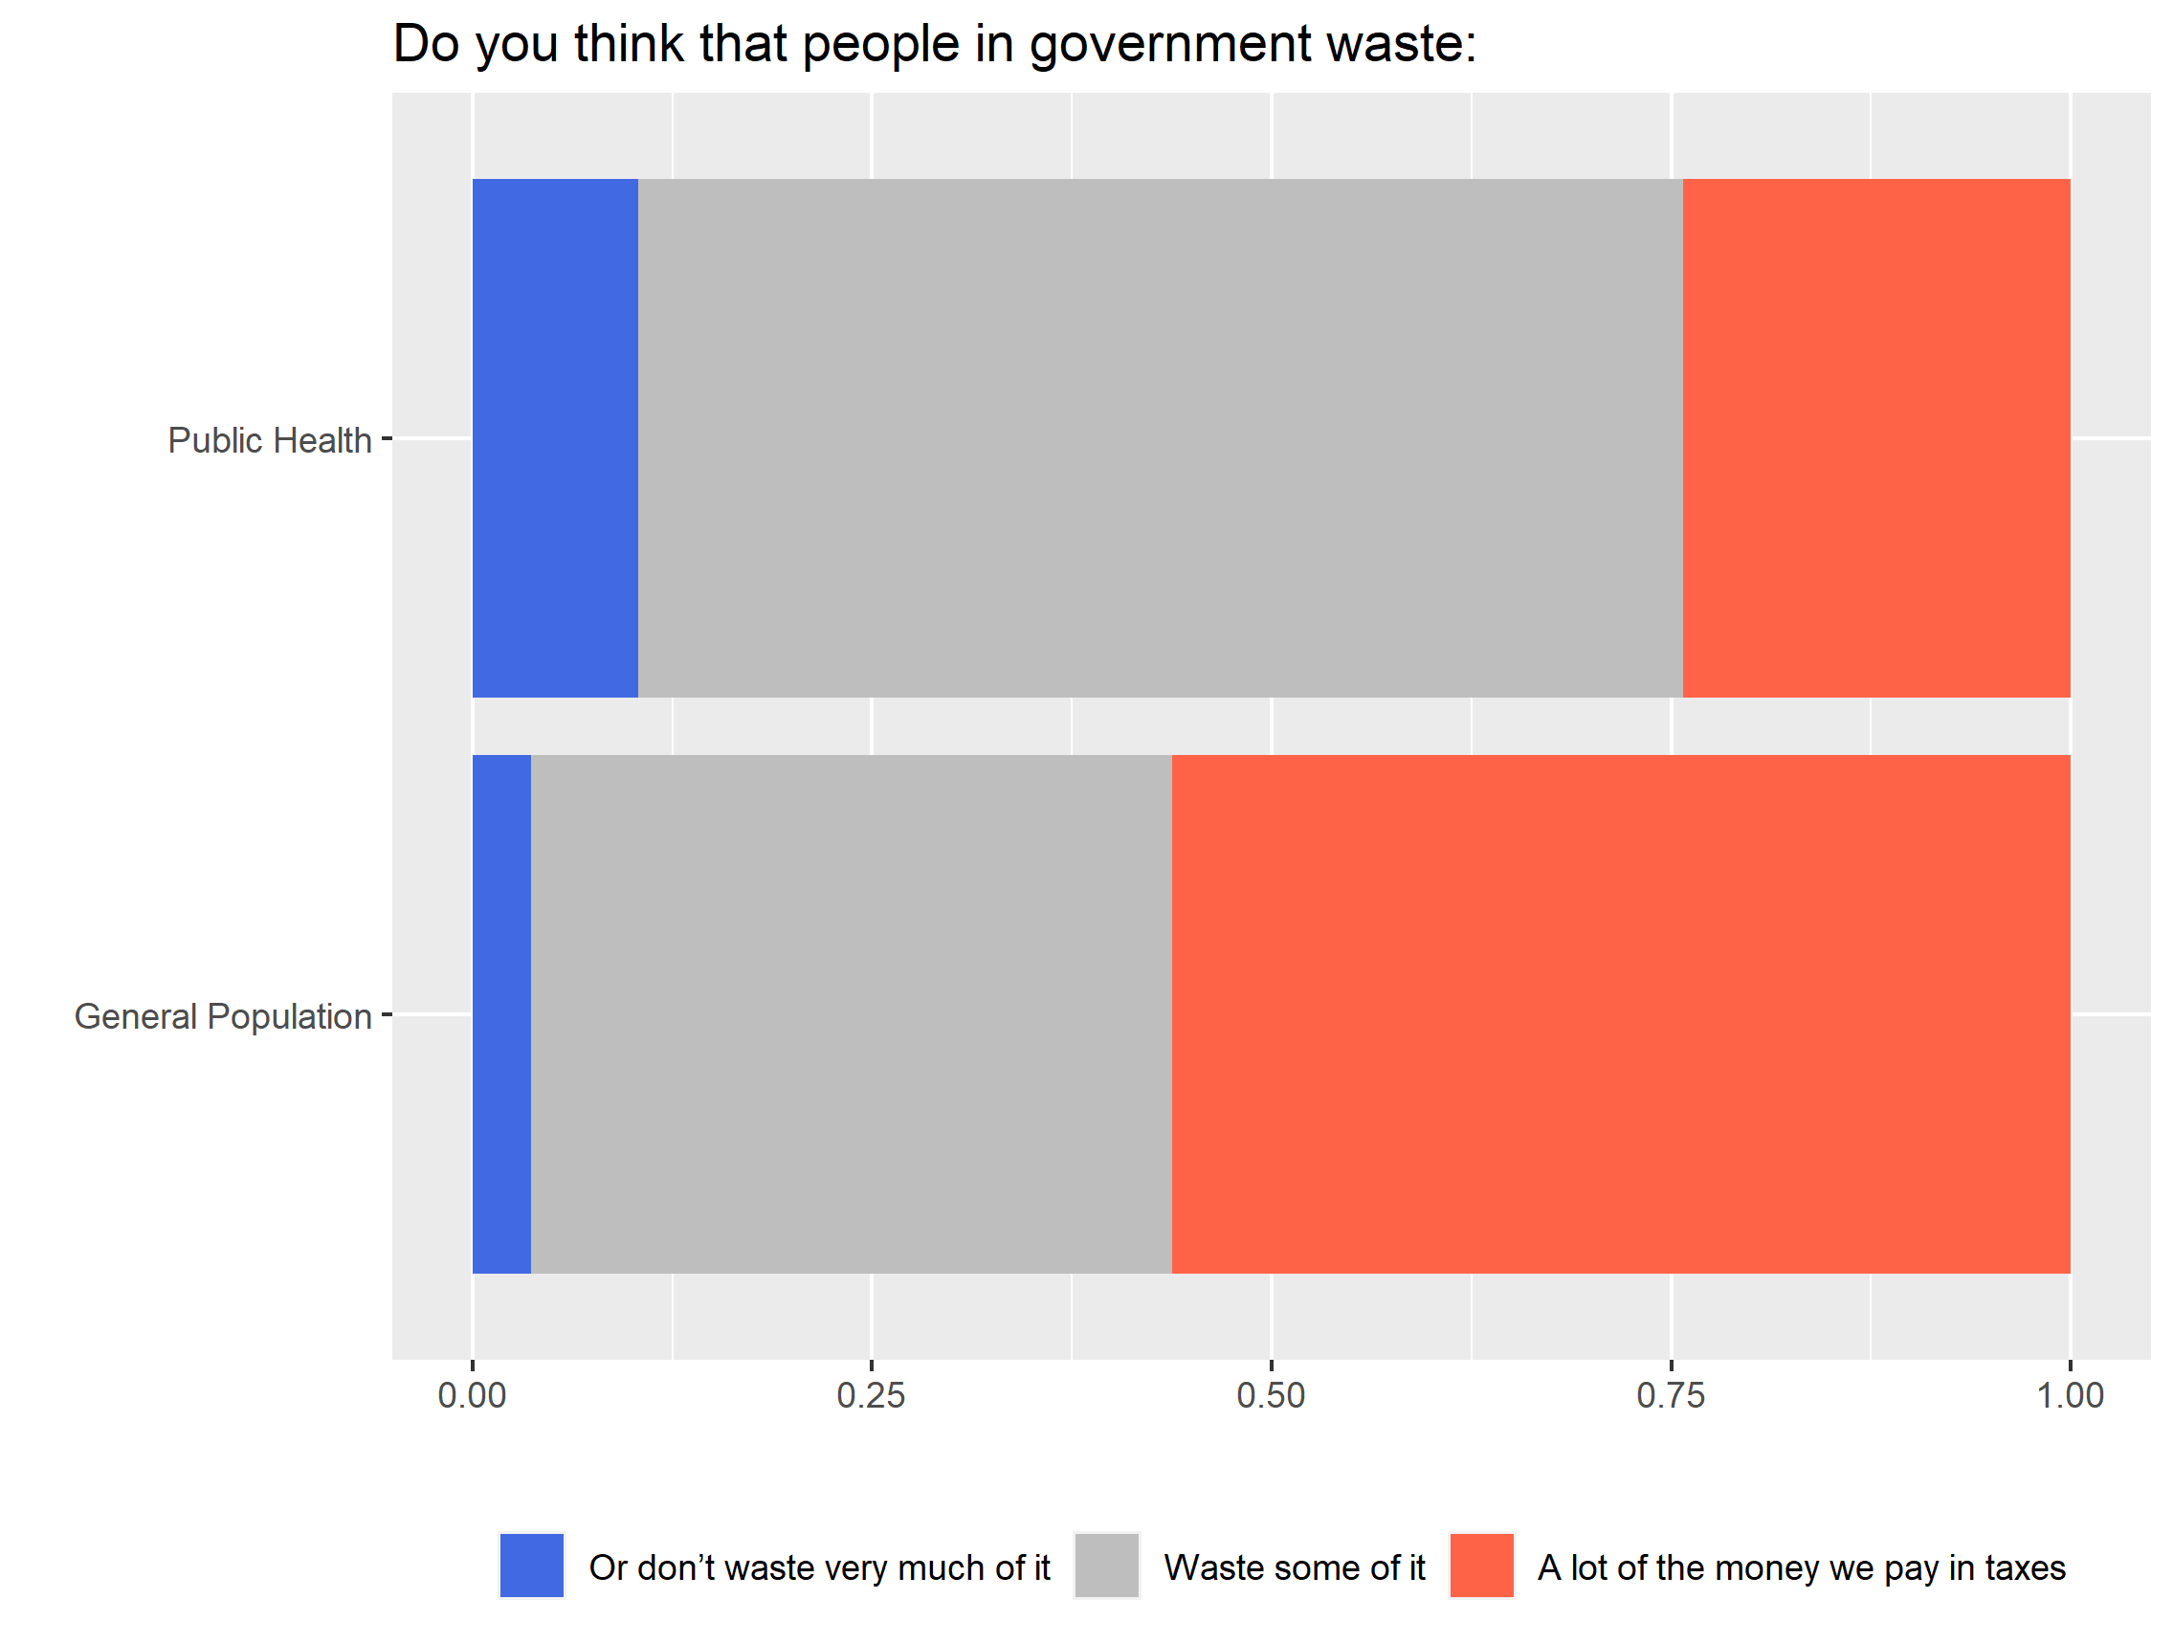

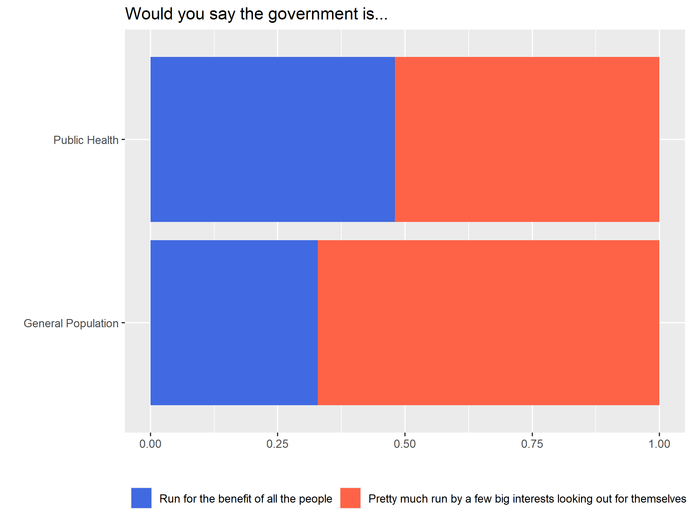

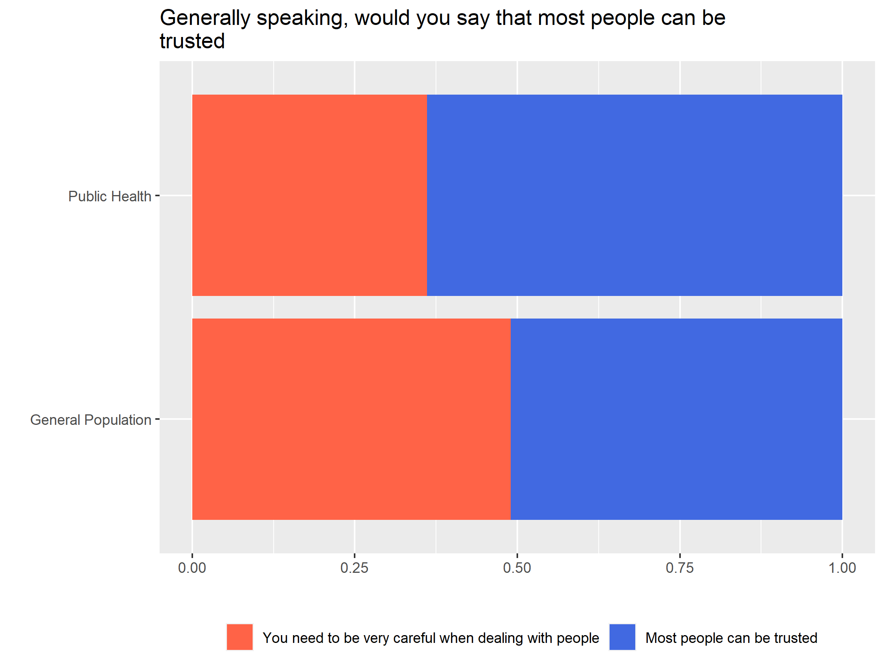

Respondents were asked how much of the time the federal government could be trusted to do what is right. The mean value for both public health (x̄ = 3.32) and general population (x̄ = 2.98) was above average, albeit the range for the general population sample was larger. A vast majority of both public health (89%) and general population (91%) strongly or somewhat agreed that politicians are ready to lie to get elected.

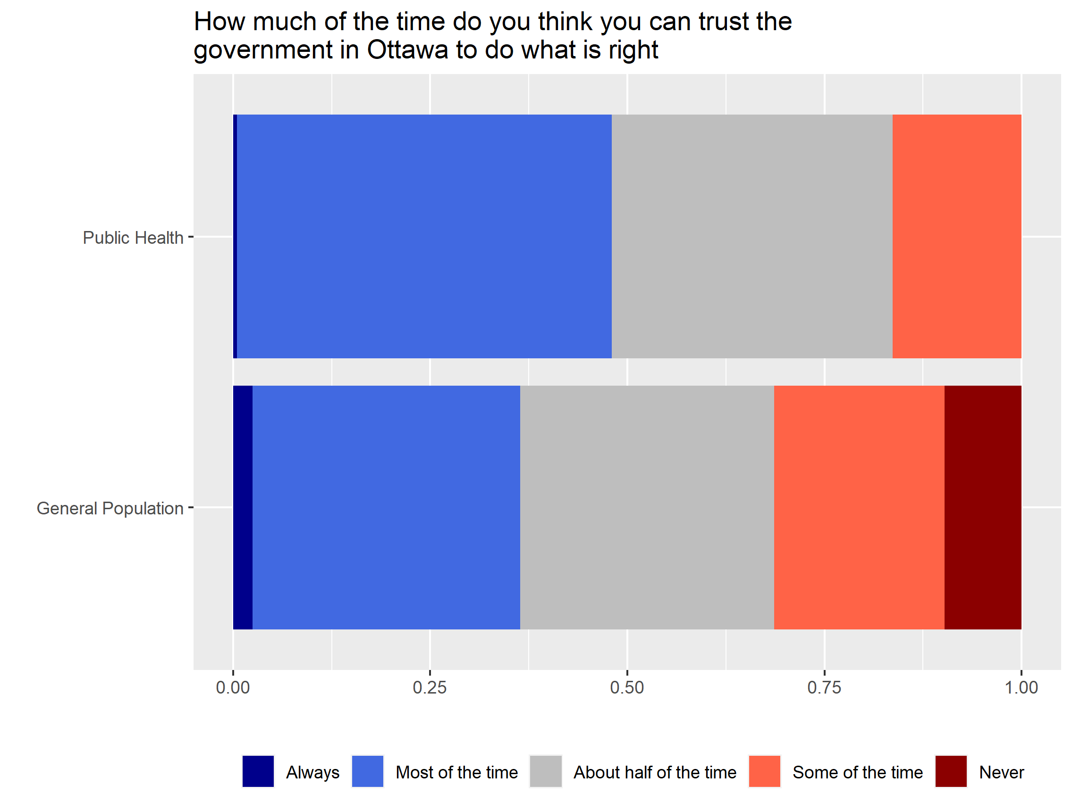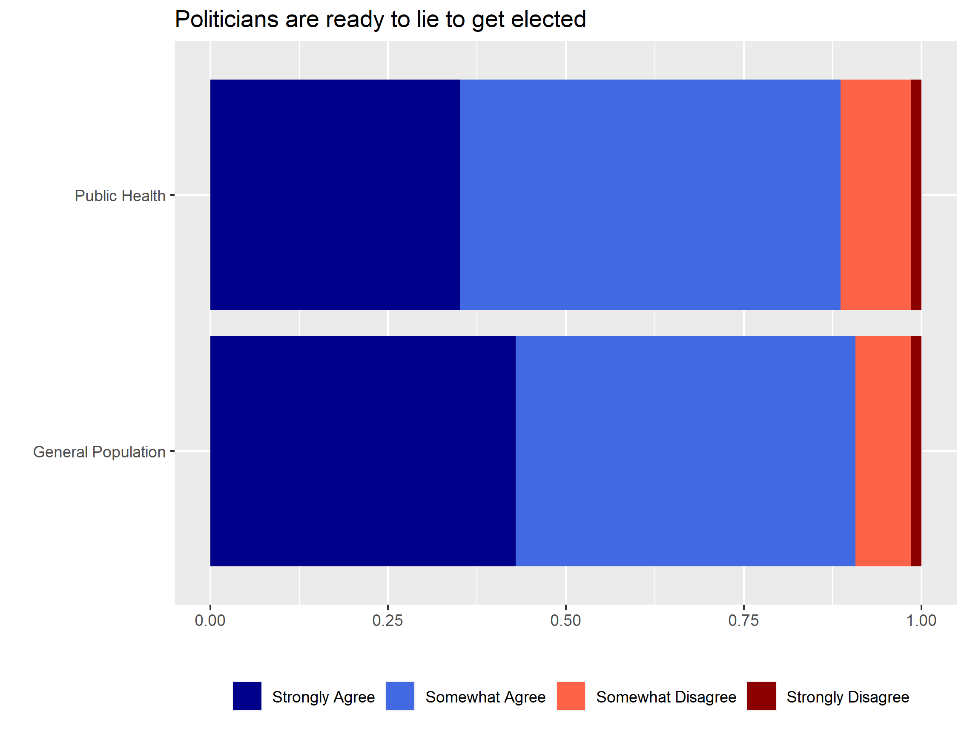

## Individualism

Respondents were asked four different questions about individualism that included the following topics: (1) Free market, (2) Moral obligation to help less fortunate, (3) Government limitations on personal freedoms and (4) Private sector job creation. Respondents were asked to rate each topic on a scale from 1 (strongly disagree) to 7 (strongly agree). When asked if government programs – not free markets – are the best way to supply people with the things they need, the most common response among both samples was neutral (>30%). The average rating among public health professionals (x̄ = 4.51) was higher compared to the general population (x̄ = 4.08) and the difference was found to be statistically significant (*p* = 0.0001776).

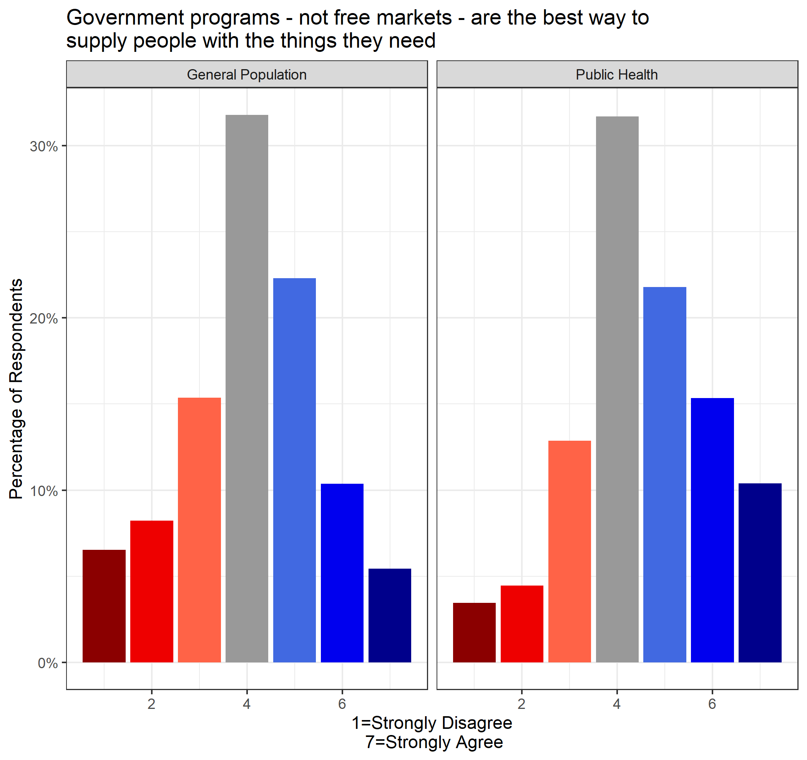

When respondents were asked about the moral obligation of people who make lots of money to share with others, public health respondents (x̄ = 4.66) were in stronger agreement compared to the general population (x̄ = 4.20) and the difference was found to be statistically significant (*p* = 0.0003065).

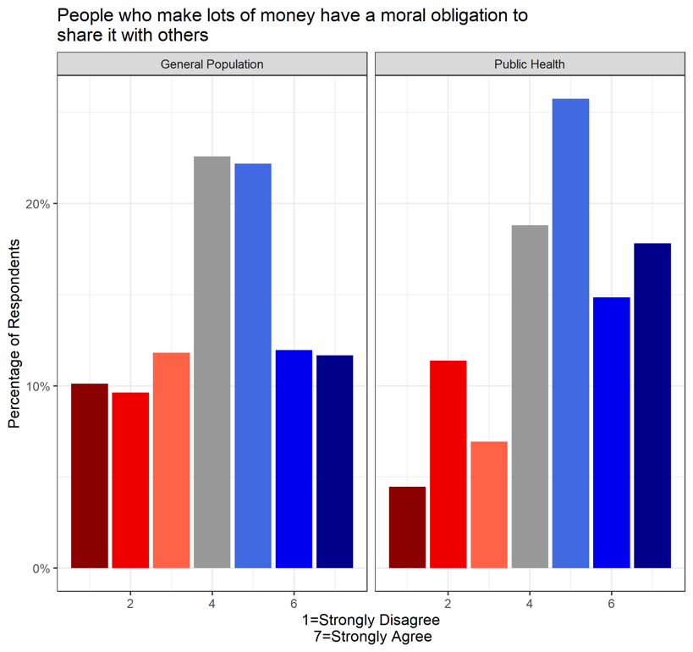

When respondents were asked about government limiting people’s choices to keep them from hurting themselves, a vast majority of public health professionals – 87% – were in agreement compared to 73% of general population. This was reflected in the average responses for public health (x̄ = 5.75) and general population samples (x̄ = 5.17), with the difference was found to be statistically significant (*p* = 1.592e-07).

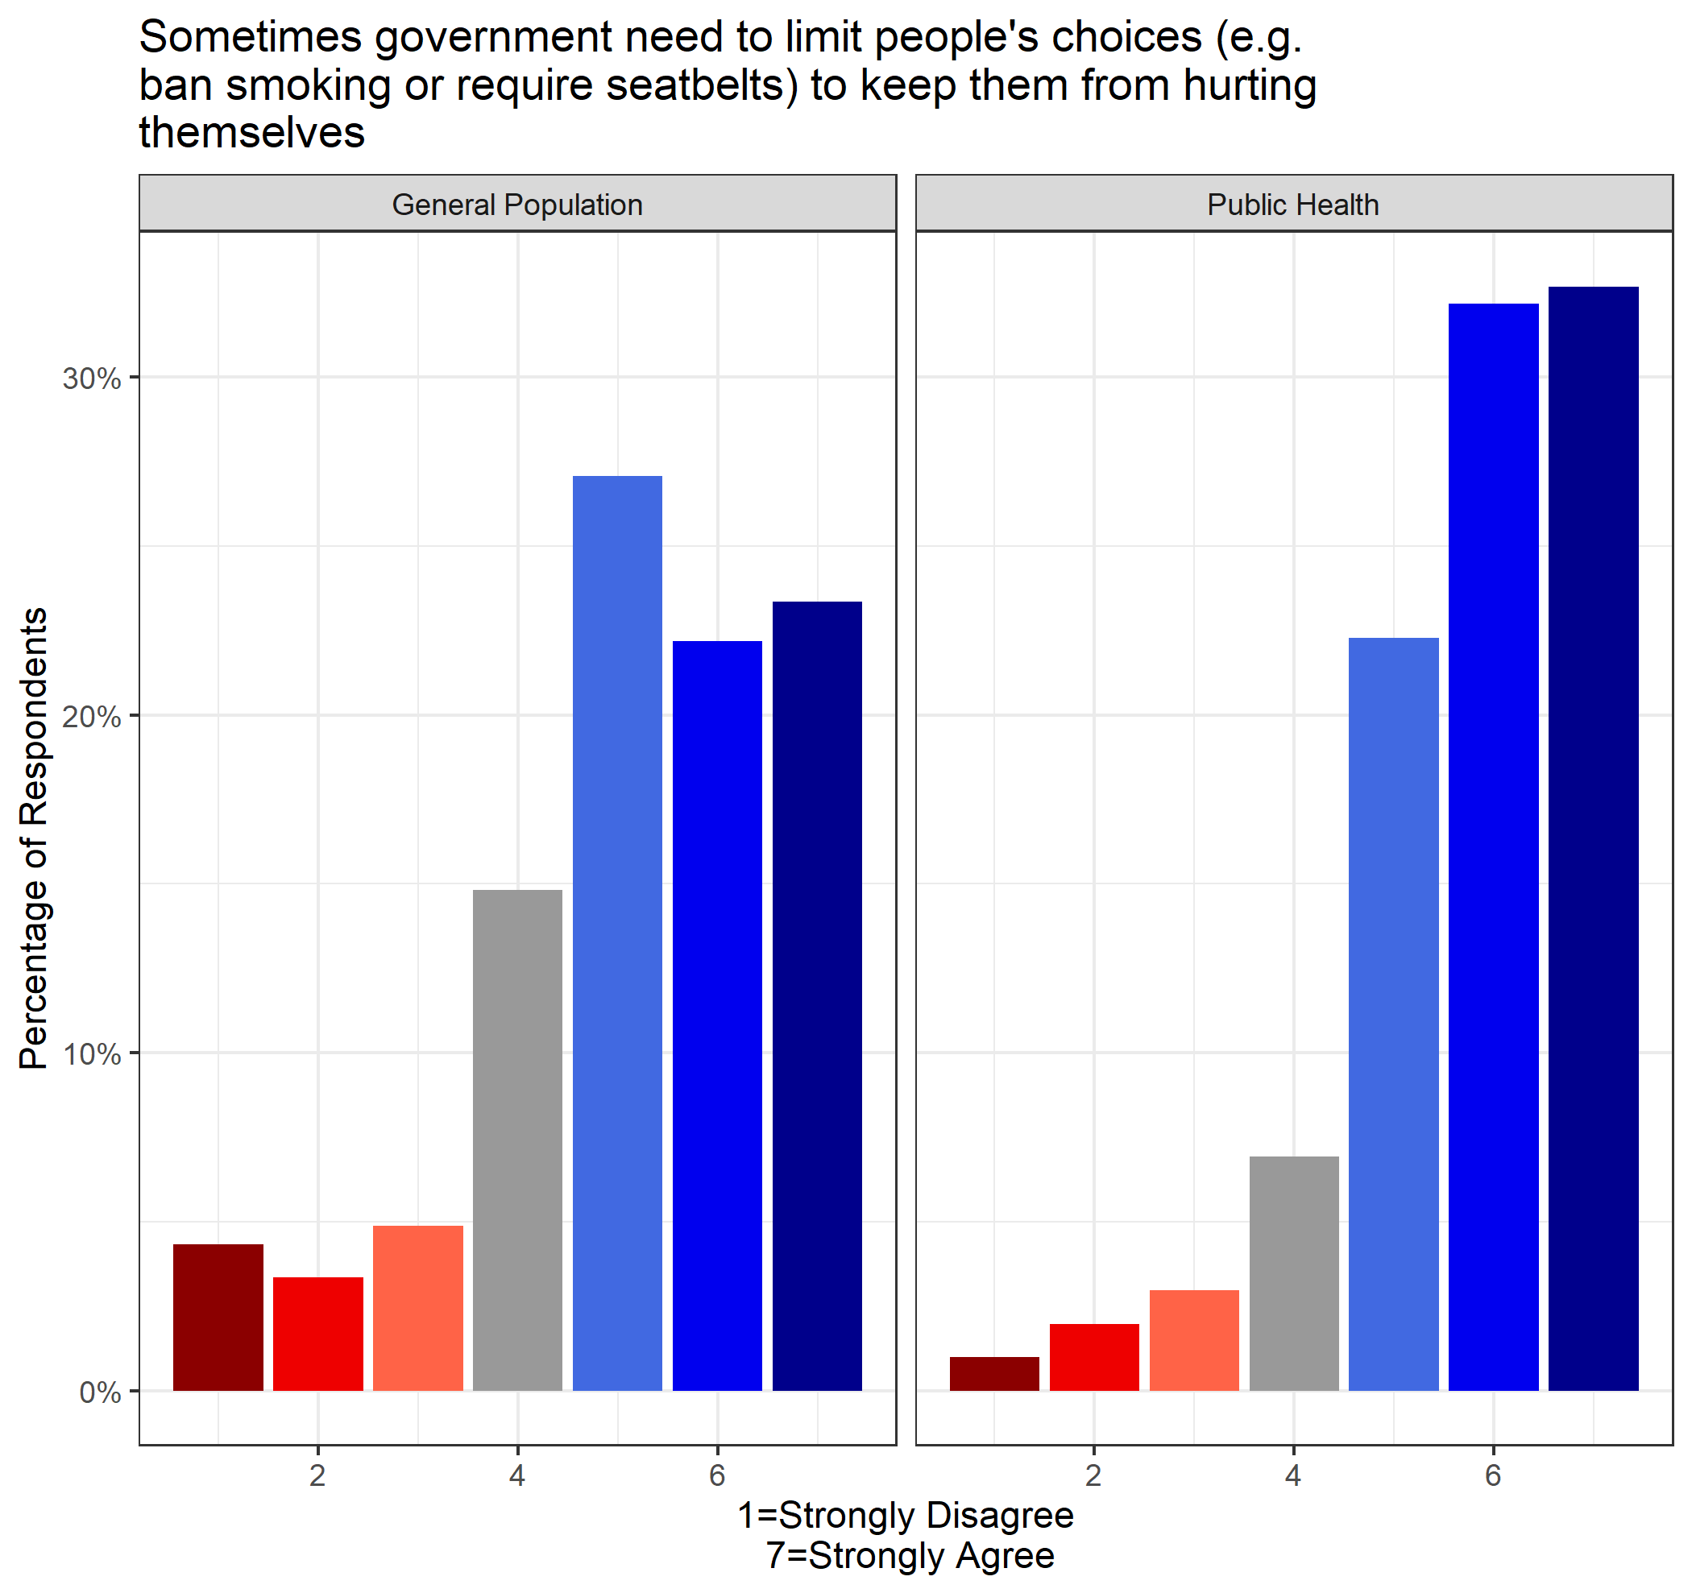

When respondents were asked if the government should leave it entirely to the private sector to create jobs, a vast majority of public health professionals disagreed (85%), compared to less than half of general population that disagreed (48%). This is reflected in the average rating among public health professionals (x̄ = 2.35) and general population (x̄ = 3.53), which is found to have statistically significant difference in mean (*p* < 2.2e-16).

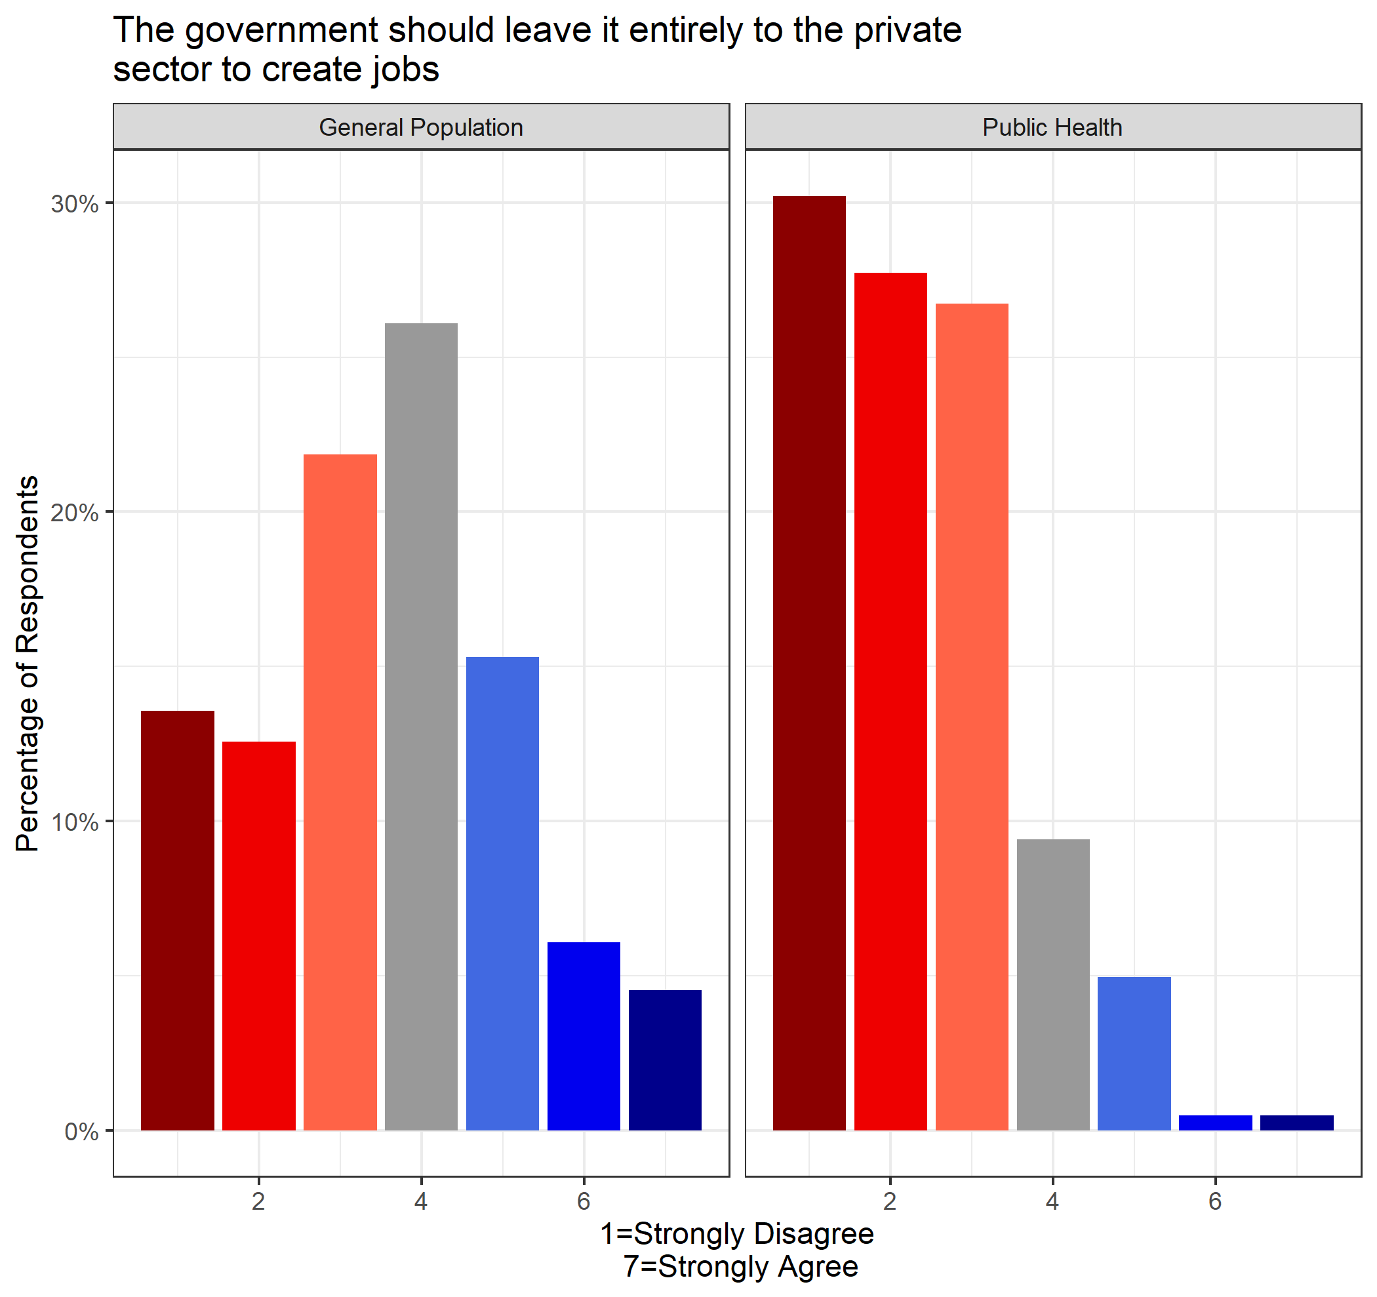

## Equality and Discrimination

Respondents were asked three different questions about their views on equality and discrimination, which included the following topics: (1) Inequality between rich and poor, (2) discrimination against visible minorities and (3) Inequality between men and women. Respondents were asked to rate each topic on a scale from 1 (strongly disagree) to 7 (strongly agree). When asked if inequalities between rich and poor needs to be dramatically reduced, nearly half of public health answered “strongly agree” (84% agreed in total), which can be compared to only 26% of general population respondents (67% agreed in total). The average response for public health professionals (x̄ = 5.89) was significantly higher than the general population (x̄ = 5.15), which was found to be statistically significant (*p* = 2.58e-11).

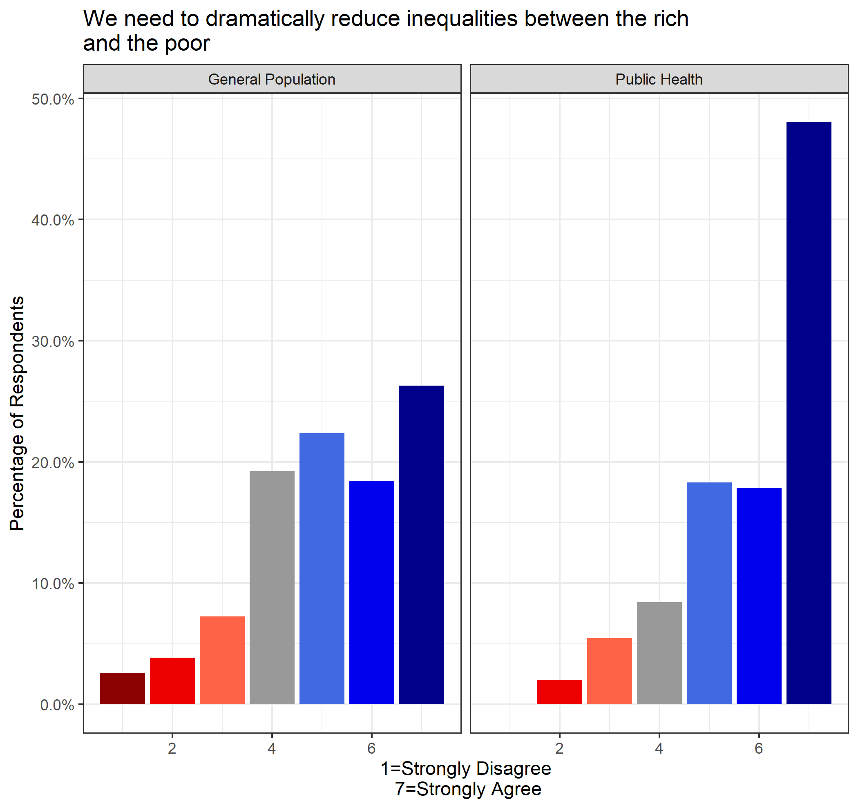

Respondents were asked if discrimination against visible minorities is still a serious problem in society. Nearly half of public health respondents strongly agree that discrimination against visible minorities is a serious problem (88% agreed in total), compared to 28% of the general population surveyed (71% agreed in total). The average score among public health professionals was much higher (x̄ = 6.02) than the general population (x̄ = 5.23), which was found to be statistically significant (*p* = 1.068e-13).

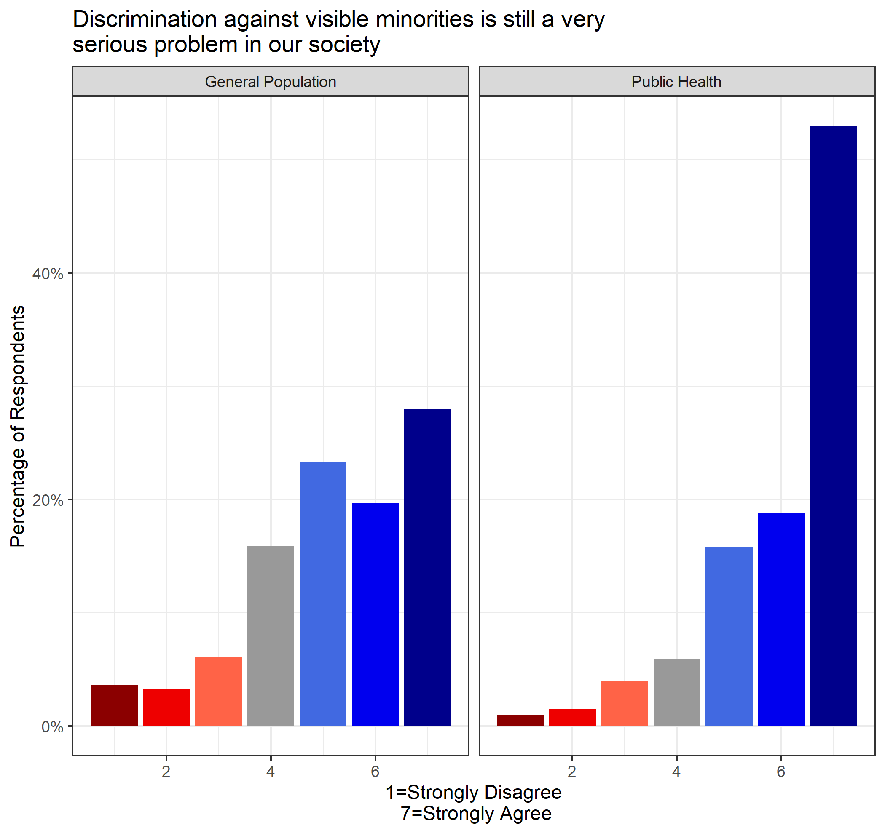

Respondents were asked if more needed to be done to reduce inequalities between men and women. Over 85% of public health professionals agreed that more needed to be done to reduce inequalities between men and women, which can be compared to nearly 73% of the general population sample. This is reflected in a higher average response among public health professionals (x̄ = 5.89) compared to the general population (x̄ = 5.32), which is found to be statistically significant (*p* = 1.167e-07)

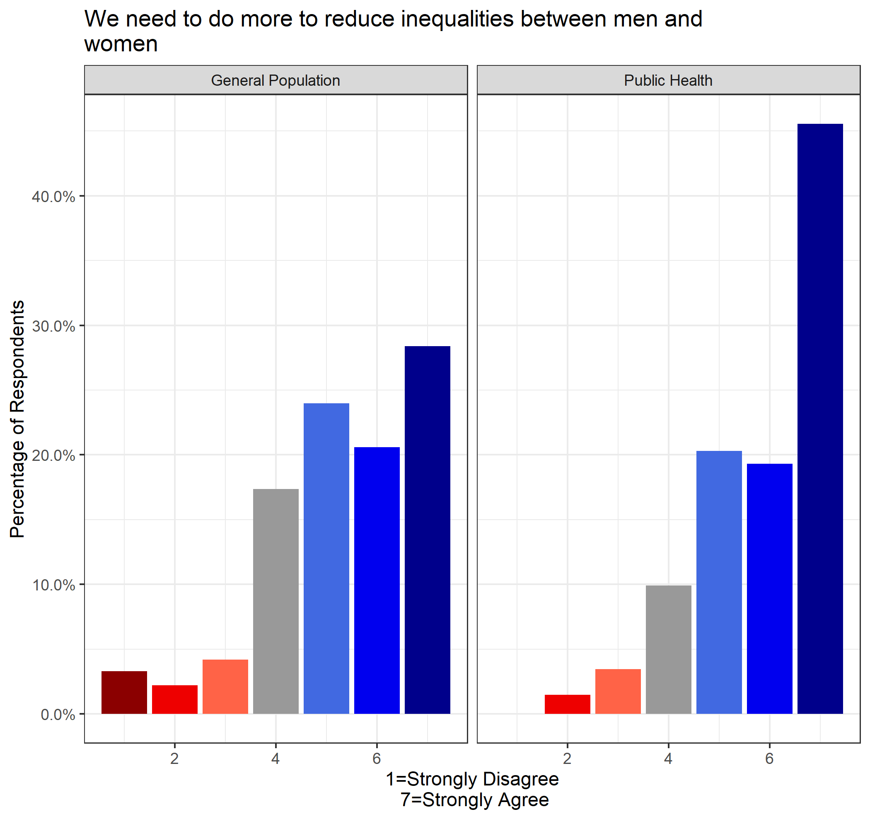

## Institutions and Law

Respondents were asked three different questions related to institutions and the law, which included the following topics: (1) Stricter punishments for lawbreakers, (2) Respect for authority and (3) First Nations rights. Respondents were asked to rate each topic on a scale from 1 (strongly disagree) to 7 (strongly agree). When asked if authorities should impose stricter punishments on those who break the law, the general population was much stronger in agreement (71%) compared to public health professionals (36%). The average score among public health professionals (x̄ = 3.97) was lower than the general population (x̄ = 5.24), which was found to be statistically significant (*p* < 2.2e-16).

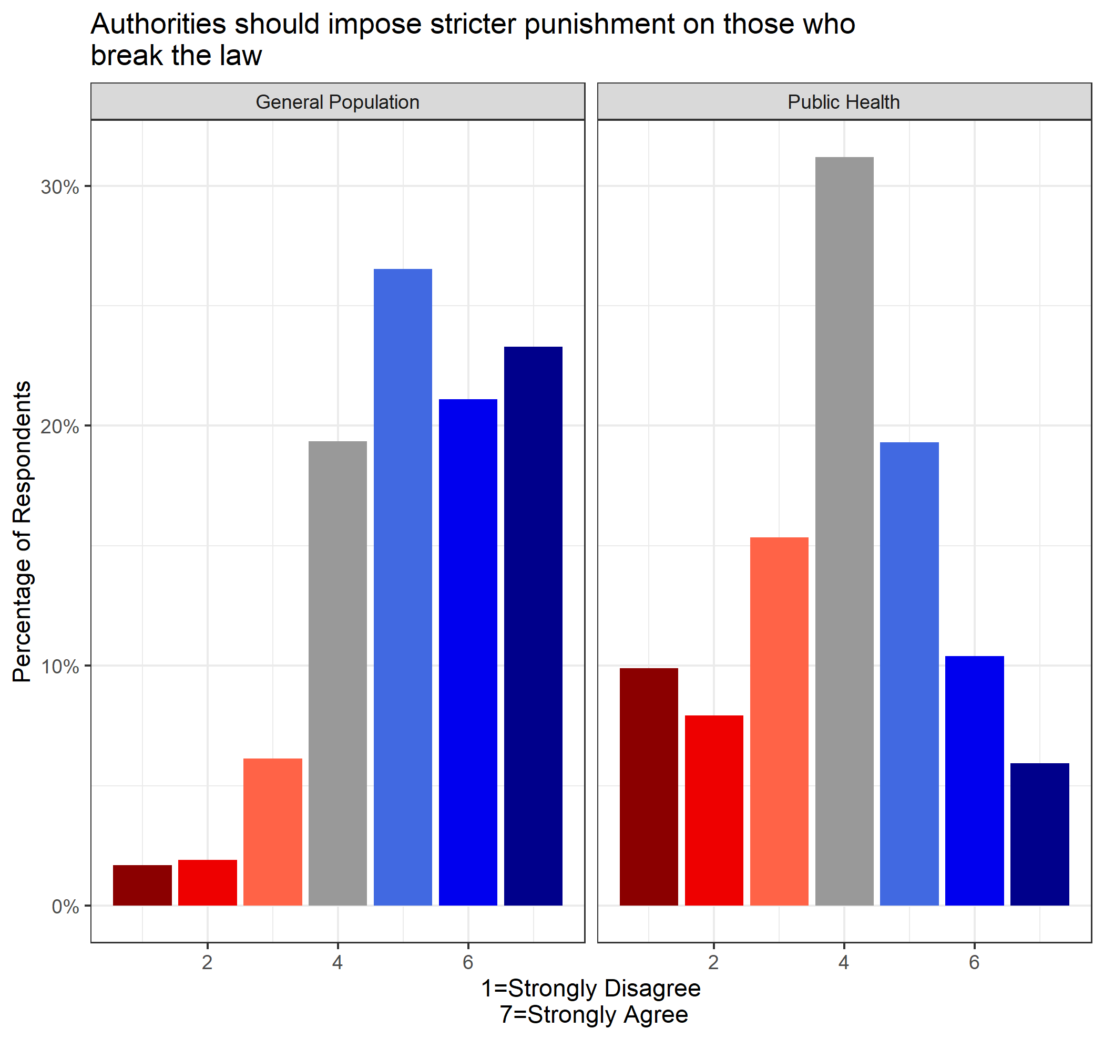

When respondents were asked if respect for authority should be a fundamental right in society, the general population sample exhibited stronger agreement (72%) compared to public health professionals (51%). This was reflected in the average response among general population (x̄ = 5.27) and public health (x̄ = 4.38), which was found to be statistically significant (*p* = 4.197e-16).

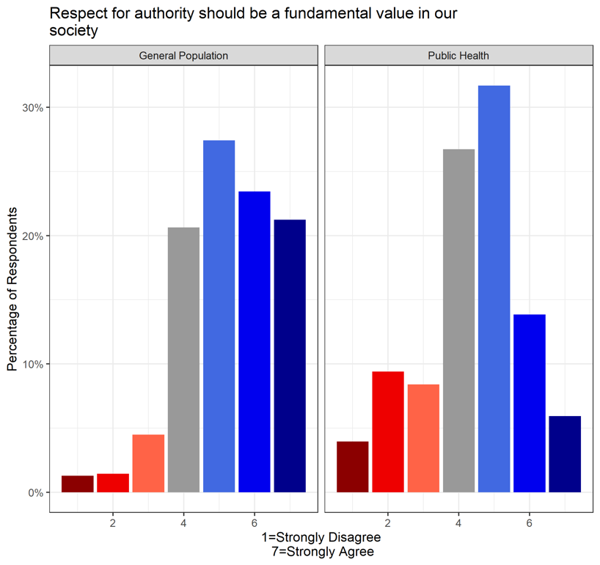

When respondents were asked if First Nations have too many special rights compared to regular citizens, a vast majority (78%) of public health professionals disagreed, compared to only 35% of general population respondents. The average among public health professionals was much lower (x̄ = 2.31) than the general population (x̄ = 4.13), which was found to be statistically significant (*p* < 2.2e-16).

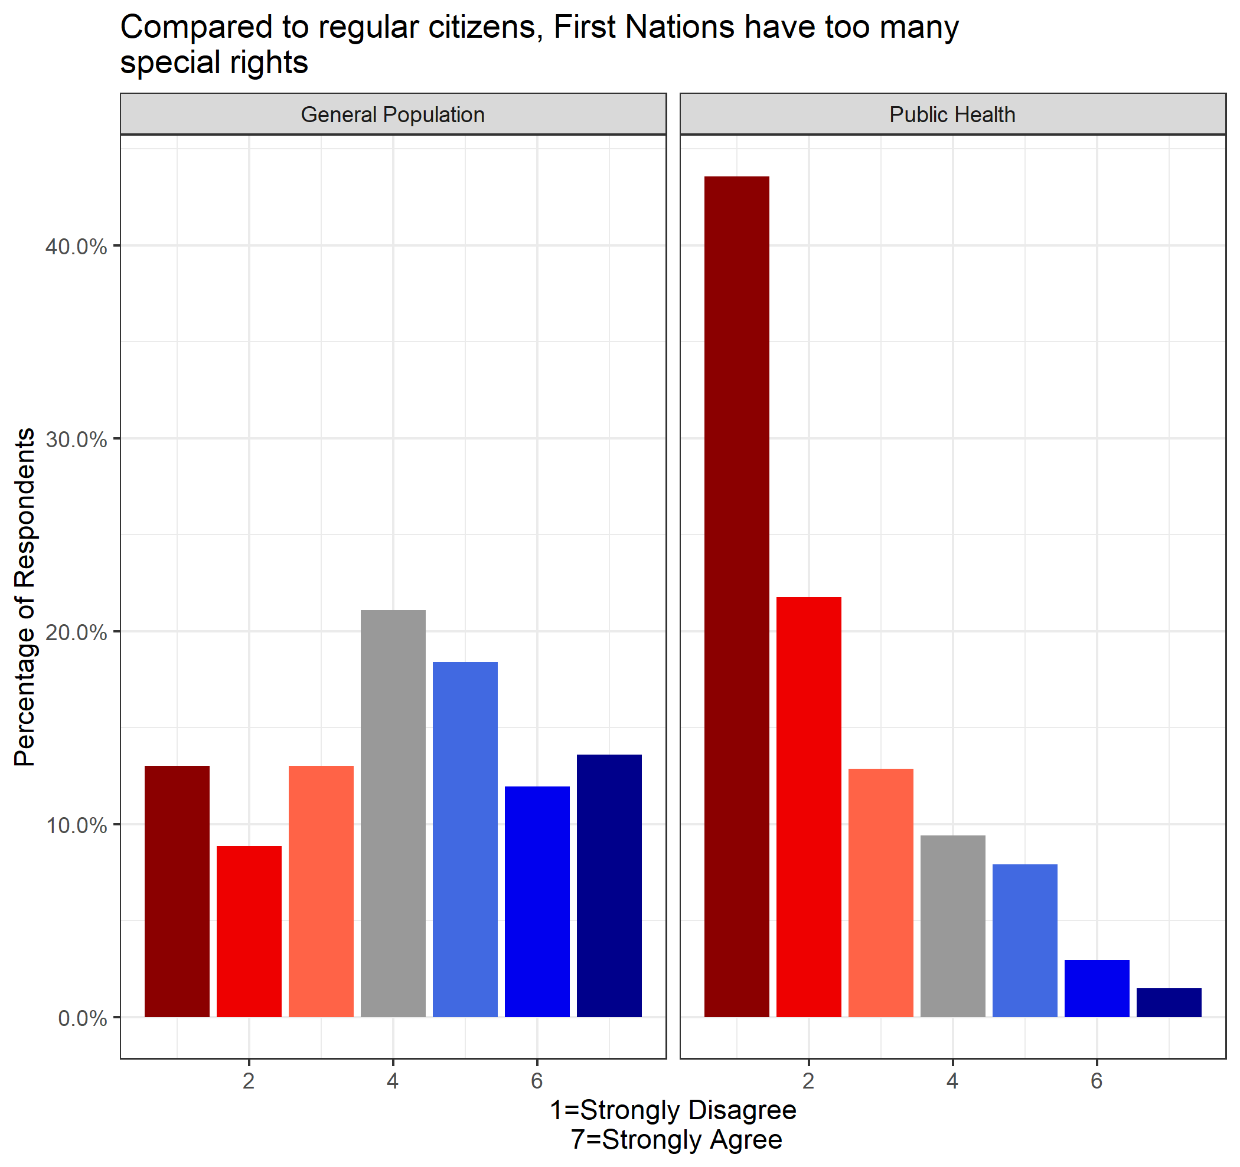

## Free Will

Respondents were asked a series of three questions regarding the amount of control they have over their own lives, which included the following topics: (1) Random chance of important events, (2) Life is determined by outside forces and (3) Uncertainty of the future. Respondents were asked to rate each topic on a scale from 1 (strongly disagree) to 7 (strongly agree). When asked if most of the important things that take place in life happen by random chance, responses from the general population were much more normally distributed than the public health group, which skewed towards disagreement (64%). This was reflected in the group averages, which was lower among public health (x̄ = 2.87) than general population (x̄ = 3.87) respondents, which was found to be statistically significant (*p* < 2.2e-16)

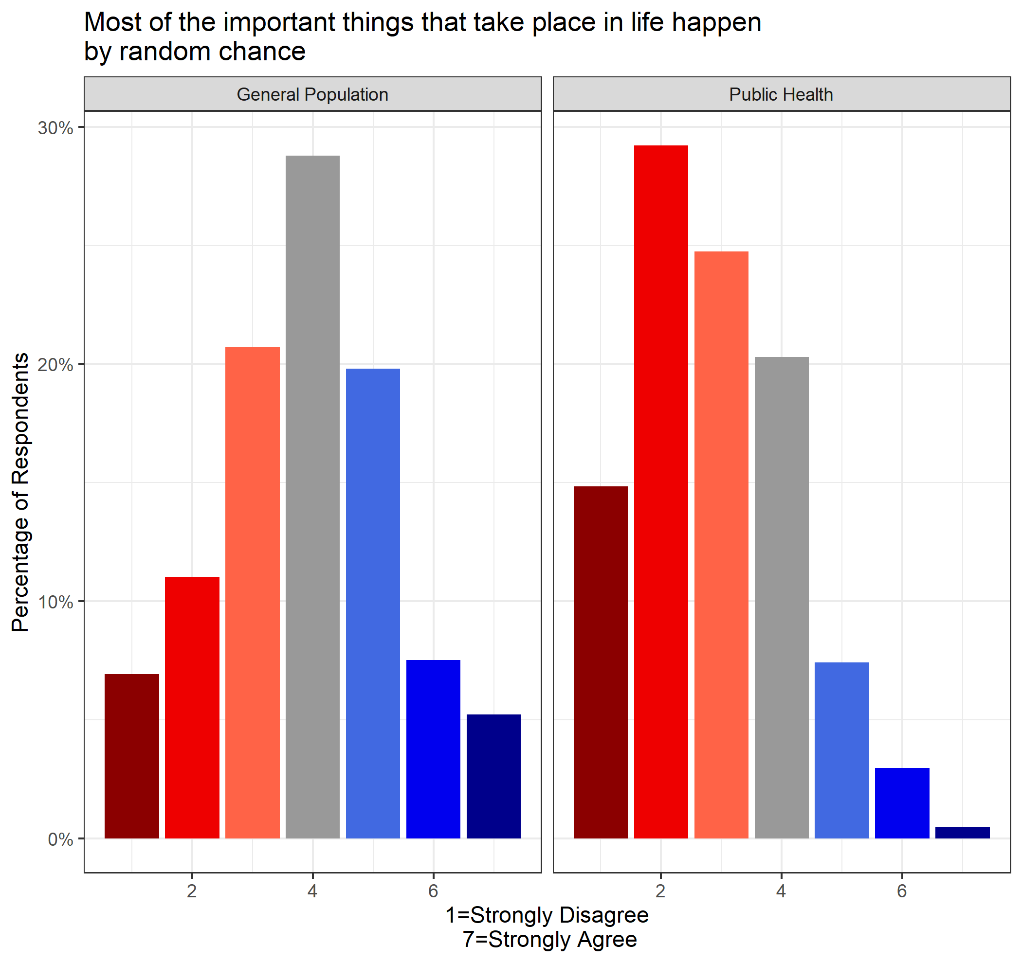

When respondents were asked if the course of their lives is largely determined by forces beyond their control, the general population was normally distributed, while the public health group skewed slightly towards disagreement (55%). This was reflected in the average score being higher among the general population (x̄ = 4.01) than public health (x̄ = 3.36), which was found to be statistically significant (*p* = 9.748e-09).

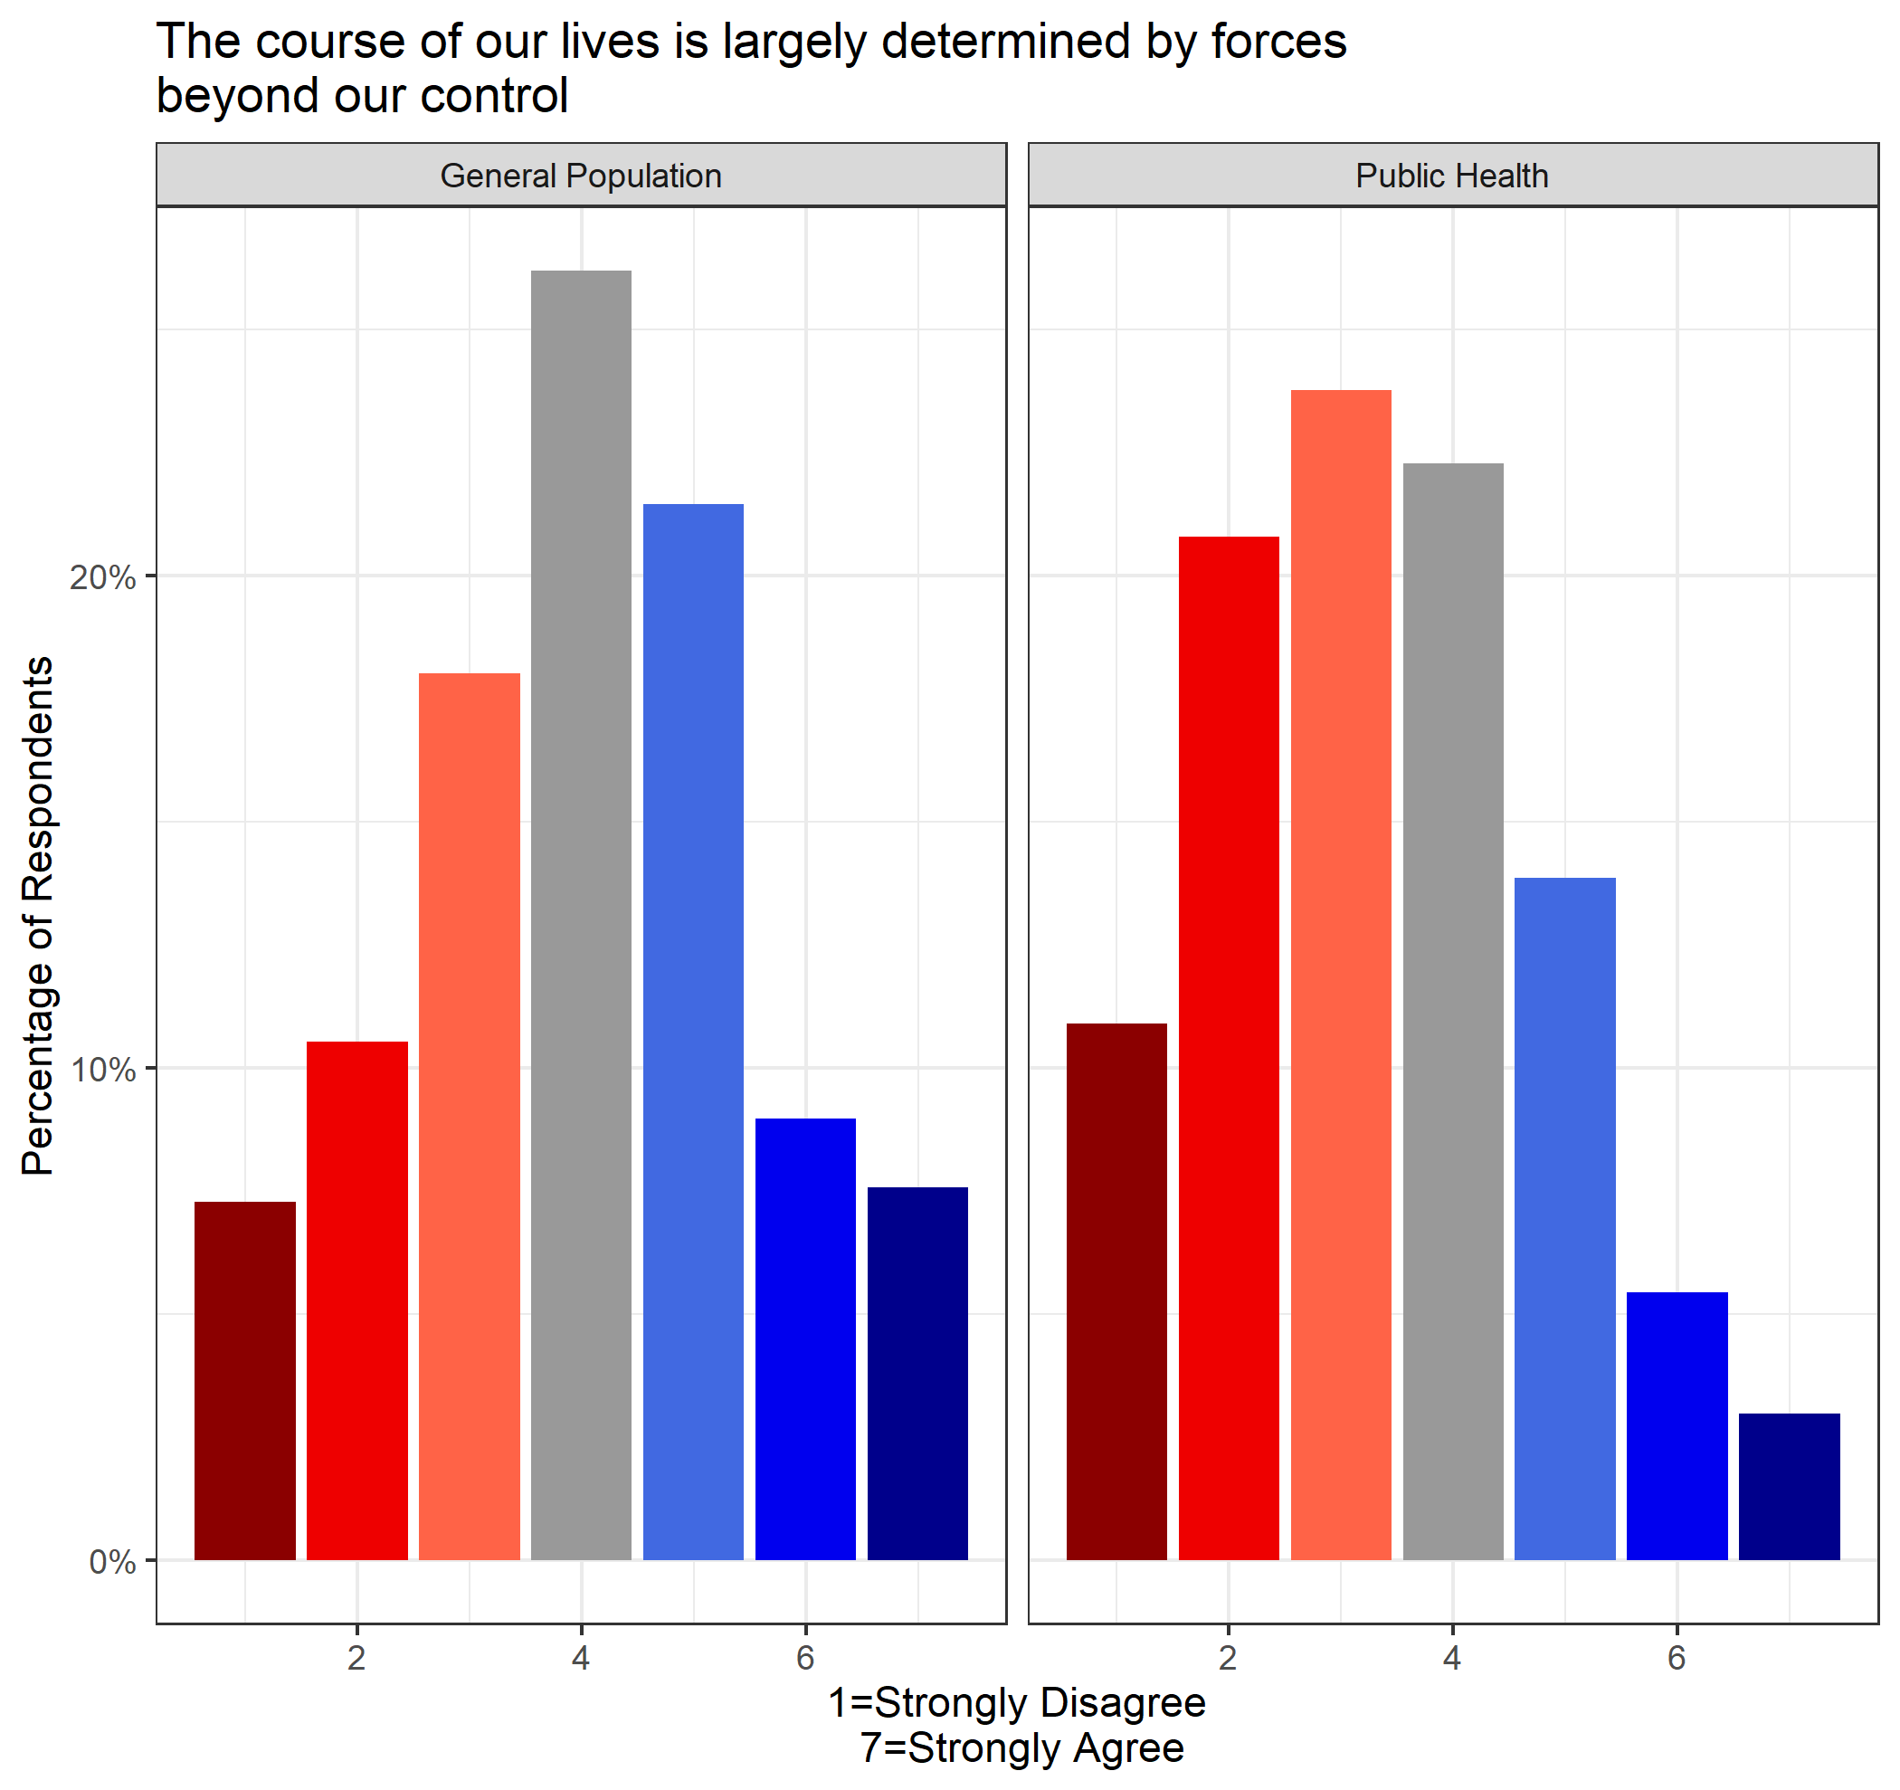

When asked if the future is too uncertain for people to make any long-term plans, a majority of the public health sample disagreed (73%), compared to only 38% of general population respondents. The average score among public health was lower (x̄ = 2.84) than the general population (x̄ = 4.01), which was found to be statistically significant (*p* < 2.2e-16).

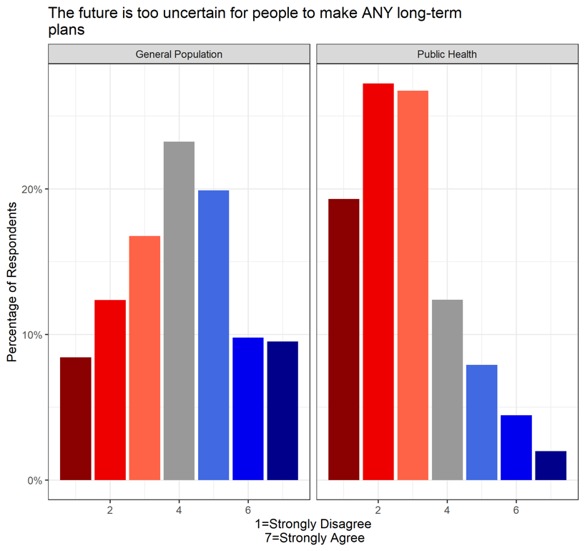

## Ideology

Respondents were asked to place themselves on the political spectrum between 0 (very left wing) and 10 (very right wing). The most common answer among the general population group was five (37%), with the average response slightly right-leaning (x̄ = 5.13). This may be compared to the public health group, with 68% of respondents self-identifying as liberal and the average (x̄ = 3.50).

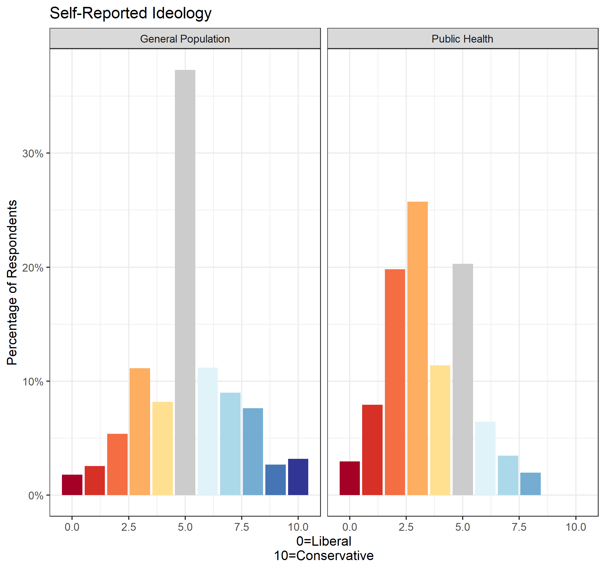

# Generational Divide

# Rural vs. Urban

# Conclusion

The goal of this report is to juxtapose and elucidate any differences that may exist between public health and the general population. Regarding the COVID-19 pandemic, the similarities and differences between public health and general population samples were minimal. However, many differences were present in questions less specific to COVID-19, including trust measures, social/political preferences and worldview.

With respect to the COVID-19 public health outcomes, both groups were aligned on the handling of the pandemic by the federal government, economic disruptions and speedy access to vaccines. Both groups perceive that role of scientific evidence and advice from public health officials *should* be more influential in governmental policy than it actually has been. Short-term restrictions, such as bar/restaurant closures and fines for non-mask wearers were preferred by respondents from both samples.

A few topics were found to have significant disagreement between public health and general population samples. This included the role of the federal government in preventing the spread of COVID-19. Additionally, the public health sample was generally more trusting of a variety of information sources as well as the behavior of different groups. The notable exception was provincial governments, which was consistently trusted at higher levels by general population respondents than public health professionals. Additionally, vaccine hesitancy was of much greater emphasis for general population respondents than public health professionals. Among general population respondents, vaccine hesitancy was seen as the 3rd most important public health issue aside from COVID-19. Additionally, the general population was much more supportive of vaccine mandates compared to public health professionals.

Most of the disagreement between sampled groups was related to non-COVID-19 specific questions regarding their perspective on the world. Public health professionals were generally more optimistic about a wide variety of other social/political topics, including (1) trust towards other people & government, (2) promotion of social welfare, (3) faith in institutions, (4) promoting equality for marginalized communities and (5) having a non-deterministic view of the world.

1. Federal government: *p* = 0.0003485; Provincial government: *p* = 0.003482; Chinese CDC: *p* = 0.007338; US CDC: *p* = 1.876e-10; WHO: *p* = 1.006e-07; Chief Public Health Officer: *p* = 1.776e-08; Provincial Chief Public Health Officer: *p* = 0.01768
2. Public Health: *p* =1.108e-13; School Boards: *p* = 9.529e-10; Municipal: *p* = 0.0009629; Provincial: *p* = 0.006931

   Federal: *p* = 0.04725; Seniors: *p* = 0.000448; Neighbours: *p* = 0.4895; Young People: *p* = 0.008423