Tasks assigned
- Implementing the basic 3D stochastic L-System class to support the building generation.
- Implementing wall generation based on L-System rules.
- Implementing the Ear-Clipping algorithm to triangulate building floor whose shape can be a concave polygon.
- Implementing a doubly-linked and circular list as a data container to optimized the Ear-Clipping algorithm.
- Implementing a font-helper class to output text information of hotkeys onto the screen.
- Implementing a camera control class to enable viewing buildings in the scene with mouse or keyboard.

Class

LSystem_building_app

LSystem_building

circular_list

camera_control

state

stochastic_rule

font_helper

class LSystem_building_app
This is a custom app class derived from class app that maintains shader instance, font helper instance, LSystem_building instance, camera_control instance, responds keyboard and mouse messages, prepares rendering states and renders meshes in the LSystem_building instance.

class LSystem_building
This class is the core class for generating the building according to the rules and parameters loaded from files or changed after the loading operation.
It mainly holds two groups of data. The first group of data are used to hold the L-System parameter, resulting string generated by the iterative process of L-System. The second group of data are to hold the vertex information of different part of the building such as floor board, window, balcony etc. for rendering.
Except for offering the member functions to create the basic L-system functions such as loading the configuration file containing the rules and parameters, iterating a certain times to generate the final string with axiom and rules, and parsing each letter the final string, it also includes member functions that help generate the building while the final string is being parsed. These member functions can be classified as several main processes such as extending, triangulating the polygon of the floor board, cutting window out of walls, and generating the mesh of floor boards, walls, window frames, and balcony.

class circular_list
This class is the auxiliary data container used in Ear-Clipping algorithm.
It is a doubly-linked and circular list which improves the efficiency during the Ear-Clipping operation. In Ear-Clipping algorithm, one of the basic operation is to remove a vertex from the polygon and connect its two neighbor up after an ‘ear’ is found and cut. As it is fast for an array to position rather than insert or remove data(Figure 1),
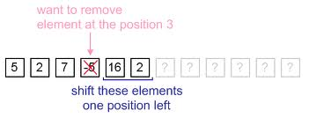
Figure 1
we instead use the doubly-linked list to remove vertex and get its predecessor and successor conveniently. In Addition, as the removing operation can happen on each node of the doubly-linked list, a doubly-linked and circular list is made to avoid checking if the node to be removed is the head or the tail node(Figure 2).
2
-5
5
16
2
7
2
5
16
2
7

Figure 2
class camera_control
This is an auxiliary class that maintains camera_to_world matrix. It offers member functions to change the distance between the camera position and the object being viewed, and rotate the camera around the object. All the changes will be applied to the matrix straight away rather than construct the matrix each frame as the frequency of the change of camera parameters is relatively low compared to the frame rate.

struct state
This is a structure that is used to be pushed in and poped out through stack in LSystem_building. It holds the current operational position, rotation matrix, wall length and the u coordinate for texture sampling which makes it possible to ensure all walls have continuous u coordinate.

class stochastic_rule
This class is mainly designed to store stochastic rules(degenerate as normal rule when there is only one rule stored) from which it picks rule randomly when it is asked to offer a rule. The probability of each rule is equal which means the probability of each rule is 1 / rules count

class font_helper
This is a singleton helper class to output text in opengl based project. It is mainly implemented using wglUseFontBitmaps and glCallLists. The basic features it offers are configuring the font properties such as the font type, font size, etc, and formatting drawing a string with different colors onto any position of the screen.

Implementation Details
main functions of LSystem_building class
void load()
Load configuration file containing rules and parameters which are used to initialize the L-System instance. The table below lists parameters and their meanings respectively.

Semantic String | Meaning
angle | angle for each turn
branch length | the width of each wall
extension length | the width of the outside part of the floor
floor thickness | the floor thickness
wall height | the wall height
floor count | the floor count
branch length decrement | decrement of wall length for each‘F’operation
world position | the world position of the building
iteration | iteration count
axiom | initial string
letters | letters to be replaced by strings during each iteration
rules | strings to replace letters

void render()
Combine the world, view, and projection matrix and render the generated building mesh which consist of wall mesh, floor mesh, balcony mesh, and window frame mesh.

translate_building_to_origin()
Translate the building, and attach the approximate centre of the ground floor to the origin. The idea is to get the centre point of the bounding rectangle.

void generate_output_str()
Generate the final string with current rules and letters. Letters which occur more than once corresponds to different rules, which makes them have probability to be chosen for the next substitution. This is the basic idea how the stochasticity is implemented.

void generate_mesh()
Generate wall mesh, floor mesh, balcony mesh, and window frame mesh according to the output string. This is the function to parse the final L-System string and construct a complete floor of a building. It will invoke several functions to finish the construction of each component of the building.
Letter | Meaning
+ | Rotate around axis y by angle δ
- | Rotate around axis y by angle –δ
K | Cut window out of a wall
( | Set the window size
F | Make a branch
B | Add a balcony to the wall
[ | push current state onto the stack
] | pop out state from the stack, and make it current state

void extend_floor_polygon()
Extend the floor polygon outward by a certain distance to form the extension part of the floor coming out from the inside of the building(Figure 1).
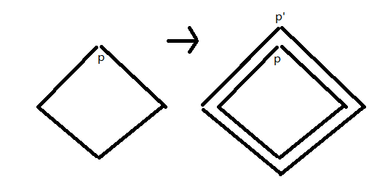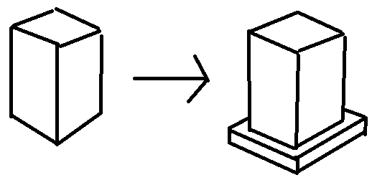
Figure 3
void extend()
Generate one wall whose width and height is obtained from the member variable. Instead of generating a line segment like how it does in using 2D L-System to draw a tree, it generate a rectangle surface(Figure 2).
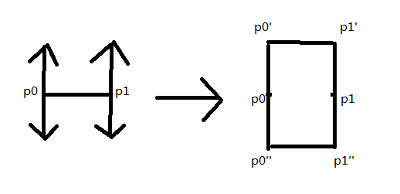
Figure 4
void enclose()
Connect the end point and the starting point and create a wall in between. The operation is executed only if the final rule does not close the wall itself. This is simply implemented by checking if the accumulated angle has exceeded 360 degrees.

void ear_clipping_triangulation()
Triangulate the floor board and roof which can be concave polygon using Ear-Clipping algorithm.
One way to triangulate a simple polygon is based on the fact that any simple polygon with at least 4 vertices without holes has at least two ’ears’, which are triangles with two sides being the edges of the polygon and the third one completely inside it. The algorithm then consists of finding such an ear, removing it from the polygon (which results in a new polygon that still meets the conditions) and repeating until there is only one triangle left.
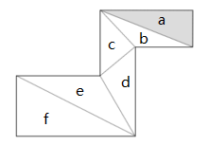
Figure 5
The algorithm starts scanning all vertices of the polygon by sweeping a line from any side of the polygon. In Figure 3, it starts from the top side. For each vertex it meets, a triangle will be constructed from the vertex, and its two neighbor vertices on the polygon. Other vertices on the polygon will be checked to see if they are inside the triangle. If any of them is inside the triangle, then the triangle isn’t the ear, the sweep line keeps going and do the same check for the next vertex it meets. If all points on the polygon except for the three making up the triangle are not inside triangle, it means the ear is found, and it will be removed from the polygon as a triangulated triangle. The corresponding point on the polygon will also be removed. The algorithm keeps repeating the operation until all points on the polygon have been removed.

In Figure 3, First, the vertex on the top right corner will be met, the triangle on which it is is triangle a. Then other points on the polygon which don’t belong to triangle a will be checked to see if any of them is inside triangle a. The result is that no other points is inside the triangle, so this is one of the ear which can be cut down. The same goes for triangle b, c, d, e and f. So all these triangles in Figure 3 are the final triangles after the Ear-Clipping triangulation.

Pseudocode:
void ear_clipping(polygon, output_triangle_list)
{
while(polygon.size() > 3)
{

for(i = 0; i < polygon.size(); i++)
{
triangle tri = triangle(polygon[i]->next, polygon[i], polygon[i]->prev);
point = polygon[i]->next->next;
for(j = 0; j < polygon.size() - 3; j++)
{
if(is_point_inside(point, tri))
{
break;
}
point = point->next;
}
if(j == polygon.size() - 3)
{
output_triangle_list.push_back(tri);
polygon.remove(i);
break;
}
}
}
output_triangle_list.push_back(triangle(polygon[0], polygon[1], polygon[2]));
}

void create_horizontal_surface_for_each_floor()
void create_side_surface_for_each_floor()
Create horizontal and side surface for each floor board. The horizontal surface of the floor board will be triangulated by using Ear-Clipping algorithm, and the side surface of the floor board will be generated by creating new vertices along y coordinate of vertices on floor polygon, and combining old and new vertices. Once the first floor board is generated, all other floors will be produced by simply translating the first floor board along y coordinate, which optimizes the efficiency of the code.

