Appendix

Appendix A

Tank Geometry Relations
Covers the four tank shapes the class supports: spherical, cylindrical with hemispherical domes, cylindrical with 2:1 semi-elliptical (ellipsoidal) domes, and fully ellipsoidal.

Table 1. Nomenclature
$d$ | Tank diameter
$r=d/2$ | Tank radius
$H$ | Overall tank length (pole to pole)
$$h_{d}$$ | Dome/head height (depth of one end cap)
$h_{b}$ ($h_{b}=H-2h_{d}$) | Cylindrical barrel length
$Vand$ $A$ | Total tank volume and surface area.
$V_{l} and V_{g}$ | Instantaneous liquid volume and ullage (vapor) volume.
$h$ | Liquid height from the tank’s lowest point.
$w$ | Free-surface (liquid-vapor interface) width.
$A_{int} and$ $L_{int}$ | Interface area and characteristic length.
$SA_{wet}$ and $SA_{dry}$ | Wetted and dry internal surface area

A.1 Spherical tank
$$r=d/2, h_{d}=r$$
$$V=\frac{4}{3}πr^{3} SA=4πr^{2}$$
Liquid height, $0≤h≤2r$:
$$V_{l}=πrh^{2}-\frac{π}{3}h^{3}$$
Free-surface width:
$$w=2\sqrt{h\left(2r-h\right)}$$
Wetted area:
$$A_{wet}=2πrh, SA_{dry}=SA-SA_{wet}$$

A.2 Cylindrical tank with hemispherical domes
$$r=d/2, h_{d}=r, h_{b}=H-2r$$
$$V=πr^{2}h_{b}+\frac{4}{3}πr^{3} SA=2πrh_{b}+4πr^{2}$$
$$V_{cap}=\frac{2}{3}πr^{3}, V_{barrel}=πr^{2}h_{b}$$
Region 1, bottom dome ($0≤V_{l}≤V_{cap}$):
$$V_{l}=πrh^{2}-\frac{π}{3}h^{3}, w=2\sqrt{h\left(2r-h\right)}$$
Region 2, barrel ($V_{cap}<V_{l}≤V_{cap}+V_{barrel}$):
$$h=\frac{V_{l}-V_{cap}}{πr^{2}}+r, w=2r$$
Region 3, top dome ($V_{l}>V_{cap}+V_{barrel}$), with $V_{c}=V_{l}-V_{barrel}$ and auxiliary height $y$:
$$V_{c}=πry^{2}-\frac{π}{3}y^{3}, h=y+h_{b}, w=2\sqrt{y\left(2r-y\right)}$$
Wetted area:
$$A_{wet}=\left\{\begin{matrix}2πrh, & h≤r \\ 2πr^{2}+2πr\left(h-r\right), & r<h≤r+h_{b} \\ 2πr\left(h-h_{b}\right)+2πrh_{b}, & h>r+h_{b}\end{matrix}\right.$$
$$SA_{dry}=SA-SA_{wet}$$

A.3 Cylindrical tank with 2:1 semi-elliptical domes
$$r=d/2, h_{d}=d/4, h_{b}=H-2h_{d}$$
Dome semi-axes: $a=b=r$, $c=h_{d}$.
$$V=πr^{2}h_{b}+\frac{4}{3}πr^{2}h_{d}$$
$$A=2πrh_{b}+4π{\left[\frac{{\left(r⋅r\right)}^{1.6}+{\left(r⋅h_{d}\right)}^{1.6}+{\left(r⋅h_{d}\right)}^{1.6}}{3}\right]}^{1/1.6}$$
$$V_{cap}=\frac{2}{3}πh_{d}^{3}, V_{barrel}=πr^{2}h_{b}$$
Region 1, bottom dome ($0≤V_{l}≤V_{cap}$):
$$V_{l}=\frac{πd^{3}}{16h_{d}^{2}}h^{2}-\frac{πd^{3}}{48h_{d}^{3}}h^{3}, w=2r$$
Region 2, barrel:
$$h=\frac{V_{l}-V_{cap}}{πr^{2}}+h_{d}, w=2r$$
Region 3, top dome, with $V_{f}=V-V_{l}$ and auxiliary height $y$:
$$V_{f}=\frac{πd^{3}}{16h_{d}^{2}}y^{2}-\frac{πd^{3}}{48h_{d}^{3}}y^{3}, h=2h_{d}+h_{b}-y, w=2r$$
Shorthand:
$$R_{e}=\sqrt{r^{2}-h_{d}^{2}}$$
Region 1 ($h≤h_{d}$):
$$SA_{wet}=πr^{2}-\frac{πr}{h_{d}^{2}}\left(h_{d}-h\right)\sqrt{h_{d}^{4}+{\left(h_{d}-h\right)}^{2}R_{e}^{2}}+\frac{πh_{d}^{2}r}{R_{e}}ln\left[\frac{h_{d}\left(R_{e}+r\right)}{\left(h_{d}-h\right)R_{e}+\sqrt{h_{d}^{4}+{\left(h_{d}-h\right)}^{2}R_{e}^{2}}}\right]$$
Region 2 ($h_{d}<h≤h_{d}+h_{b}$):
$$A_{wet}=πr^{2}+\frac{πh_{d}^{2}r}{2R_{e}}ln\left[\frac{r+R_{e}}{r-R_{e}}\right]+2πr\left(h-h_{d}\right)$$
Region 3 ($h>h_{d}+h_{b}$), with $f=h_{b}+2h_{d}-h$:
$$A_{dry,cap}=πr^{2}-\frac{πr}{h_{d}^{2}}f\sqrt{h_{d}^{4}+f^{2}R_{e}^{2}}+\frac{πh_{d}^{2}r}{R_{e}}ln\left[\frac{h_{d}\left(R_{e}+r\right)}{fR_{e}+\sqrt{h_{d}^{4}+f^{2}R_{e}^{2}}}\right]$$
$$A_{wet}=2πr^{2}-SA_{dry,cap}, SA_{dry}=SA-SA_{wet}$$

A.4 Ellipsoidal (spheroidal) tank
$$a=b=d/2, c=H/2$$
$$V=\frac{4}{3}π{\left(\frac{d}{2}\right)}^{2}\left(\frac{H}{2}\right)$$
$$A=4π{\left[\frac{{\left(ab\right)}^{p}+{\left(ac\right)}^{p}+{\left(bc\right)}^{p}}{3}\right]}^{1/p}, p=1.6075$$
With $R_{h}=d/2$ and $F\left(z\right)=πR_{h}^{2}\left(z-\frac{z^{3}}{3c^{2}}\right)$:
$$V_{cap}\left(h\right)=F\left(h-c\right)-F\left(-c\right)=V_{l} \text{(solved numerically for }h\text{)}$$
Free-surface width:
$$w=2R_{h}\sqrt{1-{\left(\frac{h-c}{c}\right)}^{2}}$$
With $ρ\left(z\right)=R_{h}\sqrt{1-{\left(z/c\right)}^{2}}$ and $ρ'\left(z\right)=-\frac{R_{h}z}{c^{2}\sqrt{1-{\left(z/c\right)}^{2}}}$:
$$A_{wet}=\int_{-c}^{h-c}{2}π ρ\left(z\right)\sqrt{1+ρ'{\left(z\right)}^{2}} dz$$
$$SA_{dry}=SA-SA_{wet}$$

A.5 Common relations (all shapes)
$$A_{int}=π{\left(\frac{w}{2}\right)}^{2}, L_{int}=\frac{A_{int}}{πw}$$
$$h_{ullage}=\left\{\begin{matrix}V_{g}/A_{int}, & \text{cylinder case} \\ H-h_{int}, & \text{general case}\end{matrix}\right.$$

Appendix B

B.1 Liquid Hydrogen Fitted Fluid Properties Correlations
The saturated fluid properties were obtained from the National Institute of Standards and Technology (NIST) Chemistry WebBook [1–3] and correlated using third-degree polynomial fits. The correlations were developed over a temperature range of $18\text{–}33 K$, with the critical temperature of hydrogen taken as $T_{c}=33.145 K$, and a pressure range of $0.1\text{–}0.8 MPa$. Depending on the specific fluid property and the available thermophysical data, the correlations were formulated as functions of temperature $T$and pressure $P$, while the density correlation additionally incorporated the parameter $τ$.
The general form of the third-degree polynomial correlation is given by
$$y=a_{0}+a_{1}x+a_{2}x^{2}+a_{3}x^{3},$$
where $y$represents the corresponding saturated fluid property, $x$denotes the independent variable used in the correlation ($T$, $P$, or $τ$, as applicable), and $a_{0}$, $a_{1}$, $a_{2}$, and $a_{3}$are the fitted polynomial coefficients. A separate polynomial correlation was developed for each saturated fluid property based on the NIST thermophysical data within the specified temperature and pressure ranges.
Coefficient table
Liquid hydrogen saturation properties at 18-33K ($T_{c}= 33.145 K, τ=1-\frac{T}{T_{c}}$)
Parameter | Units | $$a_{0}$$ | $$a_{1}$$ | $$a_{2}$$ | $$a_{3}$$ | $$R^{2}$$ | RMSE
$$ρ_{l}\left(τ\right)$$ | $$kg/m^{3}$$ | 45.289261 | 114.26525 | -175.36288 | 131.61077 | - | -
$$P_{sat}$$ | $$MPa$$ | -0.37539036 | 0.074328435 | -0.005318205 | 0.00013836551 | - | -
$$V_{l}$$ | $$m^{3}/kg$$ | -0.0040798056 | 0.0023067368 | -0.00010592399 | 1.795401e-06 | - | -
$$u_{l}$$ | $$kJ/kg$$ | -268.11783 | 24.026933 | -0.90085605 | 0.017890514 | - | -
$$h_{l}$$ | $$kJ/kg$$ | -310.44796 | 30.369102 | -1.2285984 | 0.023877159 | - | -
$$s_{l}$$ | $$J/\left(g⋅K\right)$$ | -15.487598 | 1.3174483 | -0.040535915 | 0.0006478982 | - | -
$$cv_{l}$$ | $$J/\left(g⋅K\right)$$ | 1.2252082 | 0.48075706 | -0.018320169 | 0.0002658936 | - | -
$$cp_{l}$$ | $$J/\left(g⋅K\right)$$ | -137.72187 | 19.835175 | -0.90728735 | 0.01420863 | - | -
$$vs_{l}$$ | $$m/s$$ | 1927.5301 | -79.051212 | 3.289686 | -0.066723465 | - | -
$$JT_{l}$$ | $$K/MPa$$ | -11.489421 | 1.3182398 | -0.058297093 | 0.00093250884 | - | -
$$µ_{l}$$ | $$Pa⋅s$$ | 8.60965e-05 | -7.1309416e-06 | 2.3012752e-07 | -2.7007579e-09 | - | -
$$k_{l}$$ | $$kJ/\left(m⋅K\right)$$ | 0.075561753 | 0.0016744237 | 2.787619e-05 | -2.0783363e-06 | - | -
Gaseous hydrogen (Vapor) saturation properties at 18-33K ($T_{c}= 33.145 K, τ=1-\frac{T}{T_{c}}$)
$$ρ_{v}(τ)$$ | $$kg/m^{3}$$ | 17.660638 | -93.969718 | 188.84445 | -142.03836 | - | -
$$P_{sat}$$ | $$MPa$$ | -0.37539036 | 0.074328435 | -0.005318205 | 0.00013836551 | - | -
$$V_{v}$$ | $$m^{3}/kg$$ | 28.580044 | -3.1043675 | 0.11409545 | -0.0014100093 | - | -
$$u_{v}$$ | $$kJ/kg$$ | 423.36206 | -18.013427 | 1.2400147 | -0.023483178 | - | -
$$h_{v}$$ | $$kJ/kg$$ | 474.18803 | -21.350443 | 1.641935 | -0.032193718 | - | -
$$s_{v}$$ | $$J/\left(g⋅K\right)$$ | 66.905101 | -4.327337 | 0.14147932 | -0.0018261022 | - | -
$$cv_{v}$$ | $$J/\left(g⋅K\right)$$ | 4.3458941 | 0.30053071 | -0.016346277 | 0.00032721158 | - | -
$$cp_{v}$$ | $$J/\left(g⋅K\right)$$ | -187.1303 | 27.475674 | -1.2758862 | 0.020012343 | - | -
$$vs_{v}$$ | $$m/s$$ | 104.76949 | 18.985554 | -0.32000673 | -0.00026982876 | - | -
$$JT_{v}$$ | $$K/MPa$$ | 79.880405 | -5.9983053 | 0.19447902 | -0.0023787768 | - | -
$$μ_{v}$$ | $$Pa⋅s$$ | -2.110857e-06 | 3.4092853e-07 | -1.3731752e-08 | 2.2033704e-10 | - | -
$$k_{v}$$ | $$kJ/\left(m⋅K\right)$$ | -0.077904577 | 0.01162638 | -0.00051269526 | 8.4422435e-06 | - | -
Liquid hydrogen saturation properties at 0.1-0.8 MPa
$$T_{sat}$$ | K | 16.59013 | 41.262621 | -56.08262 | 32.283884 | - | -
$$V_{l}$$ | $$m^{3}/kg$$ | 0.013398015 | 0.0077685385 | -0.0056689917 | 0.0045590486 | - | -
$$u_{l}$$ | $$kJ/kg$$ | -30.910439 | 329.83255 | -303.51939 | 171.04307 | - | -
$$h_{l}$$ | $$kJ/kg$$ | -30.982374 | 344.2248 | -300.15303 | 173.04202 | - | -
$$s_{l}$$ | $$J/\left(g⋅K\right)$$ | -1.3862659 | 16.014974 | -17.776774 | 9.9275611 | - | -
$$cv_{l}$$ | $$J/\left(g⋅K\right)$$ | 5.4699923 | 2.2497081 | -2.9152097 | 1.8666268 | - | -
$$cp_{l}$$ | $$J/\left(g⋅K\right)$$ | 7.7808106 | 21.713057 | -23.118197 | 28.342789 | - | -
$$vs_{l}$$ | not stated | 1206.6239 | -968.82974 | 812.35613 | -468.42907 | - | -
$$JT_{l}$$ | $$K/MPa$$ | -1.2670114 | 3.504617 | -3.2220159 | 2.5903203 | - | -
$$μ_{l}$$ | $$Pa⋅s$$ | 1.6266559e-05 | -3.4591383e-05 | 5.0714548e-05 | -2.9214549e-05 | - | -
$$k_{l}$$ | $$kJ/\left(m⋅K\right)$$ | 0.10380407 | 0.0039625463 | -0.031392614 | 0.015666705 | - | -
Gaseous hydrogen saturation properties at 0.1-0.8 MPa
$$T_{sat}$$ | K | 16.59013 | 41.262621 | -56.08262 | 32.283884 | - | -
$$V_{v}$$ | $$m^{3}/kg$$ | 1.1068405 | -4.9570723 | 8.8392336 | -5.4053178 | - | -
$$u_{v}$$ | $$kJ/kg$$ | 364.34132 | 110.7788 | -214.20356 | 97.316123 | - | -
$$h_{v}$$ | $$kJ/kg$$ | 434.73423 | 184.61704 | -347.89395 | 163.63532 | - | -
$$s_{v}$$ | $$J/\left(g⋅K\right)$$ | 24.264661 | -26.928259 | 35.308996 | -20.301053 | - | -
$$cv_{v}$$ | $$J/\left(g⋅K\right)$$ | 6.3030629 | 1.4433011 | -0.16891883 | 0.26345511 | - | -
$$cp_{v}$$ | $$J/\left(g⋅K\right)$$ | 10.318169 | 17.844555 | -17.630057 | 32.131225 | - | -
$$vs_{v}$$ | $$m/s$$ | 341.81871 | 185.62638 | -307.21186 | 170.10013 | - | -
$$JT_{v}$$ | $$K/MPa$$ | 20.959339 | -32.770819 | 45.61897 | -26.253129 | - | -
$$μ_{v}$$ | $$Pa⋅s$$ | 8.388579e-07 | 1.8099075e-06 | -1.7615907e-06 | 1.0875333e-06 | - | -
$$k_{v}$$ | $$kJ/\left(m⋅K\right)$$ | 0.013519624 | 0.043672174 | -0.040572309 | 0.029790846 | - | -

Appendix C

C.1 Stochl tank insulation properties
Table 2. Stochl tank, and insulation properties sourced from NASA’s Stoch et al.[4,5] experiments
Item | Material | Emissivity | Unit weight [kg/m²]
Radiation shield | 0.0064 mm (¼-mil) double-aluminized Mylar | <0.04 both sides | 0.00884
Shield spacer | 4.7×7.1 mesh/cm² silk net, thickness ≤0.010 cm | - | ≤0.00732 (per layer)
Blanket cover sheet  (a)  (b)  (c) | Schjeldahl X-850 laminate: | ≤0.05 both sides | 0.0780
Blanket cover sheet  (a)  (b)  (c) | 0.0064 mm single-aluminized Mylar | ≤0.05 alum. surface | 0.00884
Blanket cover sheet  (a)  (b)  (c) | Dacron scrim | - | 0.0200
Blanket cover sheet  (a)  (b)  (c) | 0.013 mm single-aluminized Mylar | ≤0.05 alum. surface | 0.0177

Appendix D

D.1 MHTB Tank insulation properties
Table 3. MHTB tank, and insulation properties sourced from NASA’s Hastings et al.[6–8] experiments
Component | Parameter | Symbol | Value | Unit | Description / Source
Dacron net spacer | Spacer material | - | Dacron | - | B4A Dacron net spacer
Dacron net spacer | Spacer thickness | $$D_{x}$$ | $$1.0×{10}^{-4}$$ | m | Same construction across all regions
Dacron net spacer | Spacer density | $$f_{sp}$$ | 0.0087 | - | Hastings, Table 1
Dacron net spacer | Thermal conductivity | $$k_{sp}$$ | 0.0075 | W/(m·K) | Assumption
Dacron net spacer | Spacer conduction coefficient | $$C_{2}$$ | 0.008 | - | Empirical coefficient, Hastings, Table 1
Radiation shields | Shield material | - | Double-aluminized Mylar (DAM) | - | Radiation shield
Radiation shields | Shield thickness | $$δ_{ins}$$ | $$6.4×{10}^{-6}$$ | m | ¼-mil Mylar
Radiation shields | Volumetric density | $$ρ_{ins}$$ | 1390 | kg/m³ | Hastings, Table 1
Radiation shields | Specific heat capacity | $$c_{p,ins}$$ | 1000 | J/(kg·K) | Mylar
Radiation shields | Emissivity | $$ε_{ins}$$ | 0.03 | - | Hastings, Table 1
Residual gas | Gas species | - | N₂ | - | Residual gas
Residual gas | Thermal conductivity | $$k_{gas}$$ | 0.0095 | W/(m·K) | At mean MLI temperature
Residual gas | Molar mass | $$M_{g}$$ | 0.028 | kg/mol | Hastings, Table 1
Residual gas | Accommodation coefficient | $$θ$$ | 0.8 | - | Hastings, Table 1
Residual gas | Degrees of freedom | $$ζ$$ | 2.0 | - | Diatomic N₂
Residual gas | Specific heat ratio | $$γ$$ | 1.4 | - | Hastings, Table 1
Residual gas | Residual gas pressure | $$P_{res}$$ | $$1.33×{10}^{-5}$$ | Pa | Hastings, Table 1
Residual gas | Nusselt number | $$Nu_{gas}$$ | 1.0 | - | Assumed
Outer shroud | Shroud thickness | $$δ_{Se}$$ | 0.01 | m | Outer boundary
Outer shroud | Shroud density | $$ρ_{Se}$$ | 2700 | kg/m³ | -
Outer shroud | Shroud specific heat | $$c_{p,Se}$$ | 900 | J/(kg·K) | -
Outer shroud | Shroud emissivity | $$ε_{Se}$$ | 0.04 | - | Hastings, Table 1
Outer shroud | Environment emissivity | $$ε_{env}$$ | 1.0 | - | LN₂ shroud approximated as blackbody
Outer shroud | Convective heat-transfer coefficient | $$h_{conv}$$ | 0 | W/(m²·K) | No convection
Outer shroud | Ambient temperature | $$T_{∞}$$ | 305 | K | Warm-side boundary; varied for validation
Inner tank wall | Material | - | 5083 Aluminum | - | Inner tank wall
Inner tank wall | Wall thickness | $$δ_{Si}$$ | $$1.25×{10}^{-2}$$ | m | NASA MHTB report
Inner tank wall | Density | $$ρ_{Si}$$ | 2660 | kg/m³ | Corrected 5083-Al density
Inner tank wall | Specific heat capacity | $$c_{p,Si}$$ | 900 | J/(kg·K) | At room temperature
SOFI foam | Foam type | - | Isofoam / polyurethane spray-on foam | - | Spray-on foam insulation
SOFI foam | Foam thickness | $$t_{foam}$$ | 0.0353 | m | Hastings, Table 1
SOFI foam | Thermal conductivity | $$k_{foam}$$ | 0.000866 | W/(m·K) | Hastings, Table 1
SOFI foam | Density | $$ρ_{foam}$$ | 32.0 | kg/m³ | Typical polyurethane foam density
SOFI foam | Specific heat capacity | $$c_{p,foam}$$ | 1400 | J/(kg·K) | SOFI specific heat capacity
SOFI foam | Emissivity | $$ε_{foam}$$ | 0.80 | - | Hastings, Table 1

Appendix E

E.1 VCS Properties
Table 4. Assumed input parameters for the VCS
Component | Parameter | Symbol | Value | Unit | Description | Source
VCS | VCS status | - | Disabled | - | Disabled for insulation-only validation | Assumption
VCS | VCS thickness | $$δ_{VCS}$$ | $$2.0×{10}^{-3}$$ | m | VCS layer thickness | Assumption
VCS | Density | $$ρ_{VCS}$$ | 2840 | kg/m³ | VCS material density | Assumption
VCS | Specific heat capacity | $$c_{p,VCS}$$ | 864 | J/(kg·K) | VCS material specific heat capacity | Assumption
VCS | VCS fraction | $$f_{VCS}$$ | 0.10 | - | VCS flow fraction | Assumption
VCS | Configuration | - | Series | - | VCS thermal configuration | Assumption
VCS | Partition parameter | $$α$$ | 0.5 | - | VCS parallel flow fraction split | Assumption
VCS | VCS 1 location | - | LD–MD | - | Location between low-density and medium-density MLI | Assumption
VCS | VCS 2 location | - | MD–HD | - | Location between medium-density and high-density MLI | Assumption

Appendix F

F.1 Venting parameters
Table 5. Assumed model venting parameters
Component | Parameter | Symbol | Value | Unit | Description | Source
Vent system | Vent status | - | Enabled | - | Pressure-controlled venting is active | Model configuration
Vent system | Maximum pressure | $$P_{max}$$ | $$1.33×{10}^{5}$$ | Pa | Upper pressure limit for venting | Model parameter
Vent system | Minimum pressure | $$P_{min}$$ | $$1.20×{10}^{5}$$ | Pa | Lower pressure limit / vent shut-off pressure | Model parameter
Vent system | Pressure smoothing | $$ΔP_{smooth}$$ | $$4.0×{10}^{3}$$ | Pa | Smoothing parameter controlling vent pressure transition | Model parameter
Vent system | Vent path | - | VCS | - | Venting path through the VCS configuration | Model configuration
Vent system | Flow model | - | Orifice | - | Orifice-based vent-flow model | Model configuration
Vent system | Discharge coefficient | $$C_{d}$$ | 0.62 | - | Orifice discharge coefficient | Model parameter
Vent system | Vent area | $$A_{vent}$$ | $$1.0×{10}^{-5}$$ | m² | Orifice area | Model parameter
Vent system | Back pressure | $$P_{back}$$ | $$1.01325×{10}^{5}$$ | Pa | Downstream/back pressure | Model parameter
Vent system | Maximum solver step | $$Δt_{vent,max}$$ | 5.0 | s | Maximum time step during venting; solver guard | Solver parameter
Vent system | Maximum vent events | $$N_{events,max}$$ | 5000 | - | Maximum number of permitted venting events | Solver parameter
Vent system | Minimum dwell time | $$t_{dwell,min}$$ | 30 | s | Minimum time between successive venting events | Solver parameter

Appendix G

G.1 Stochl tank insulation temperature profile validation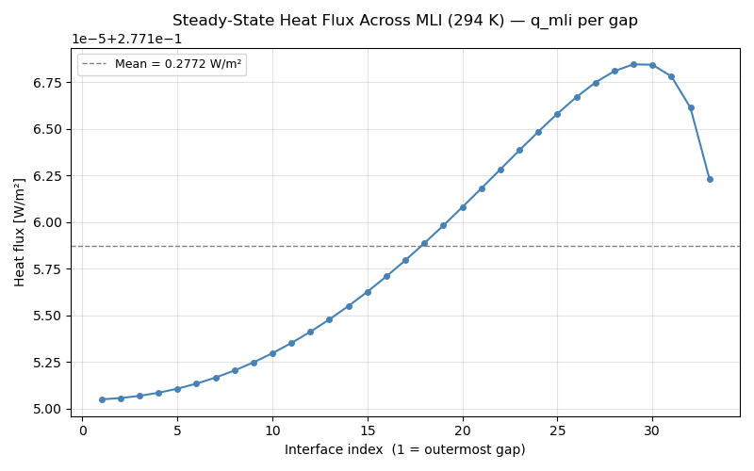
Figure 1. Steady state heat flux across the MLI at 294 K for the Stochl tank

Appendix H
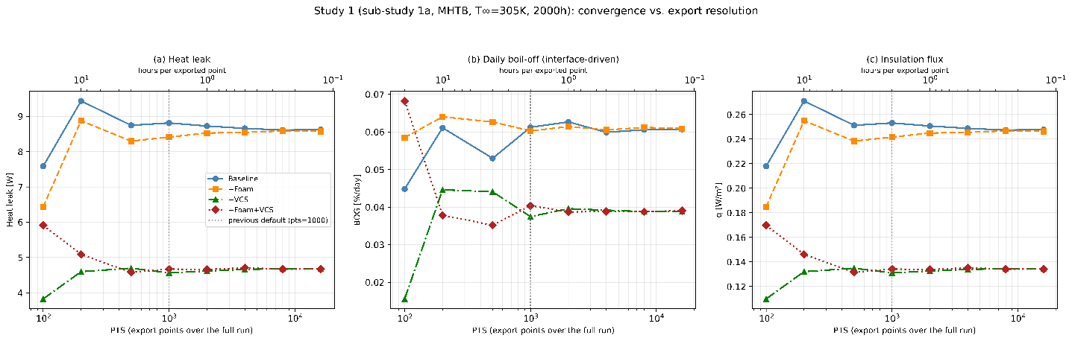
Figure 2. Study 1 integration points convergence study

H.1 Parametric study 1: Insulation configuration comparison
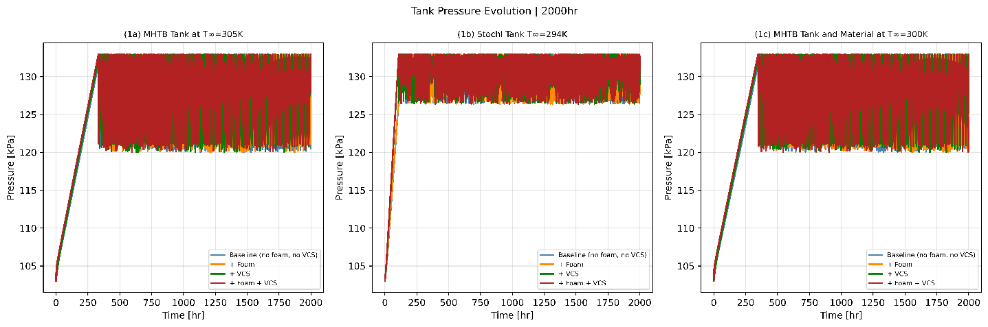
Figure 3. MHTB and Stochl tank pressure history at 305 and 294 K respectively.

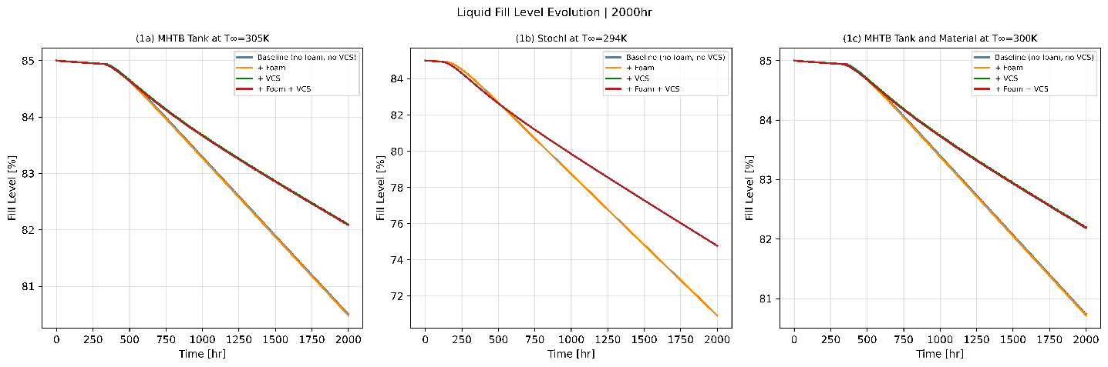
Figure 4. MHTB and Stochl tank liquid hydrogen fill level history at 305 and 294 K respectively.

Appendix I

I.1 Parametric study 2: Ambient temperature sensitivity
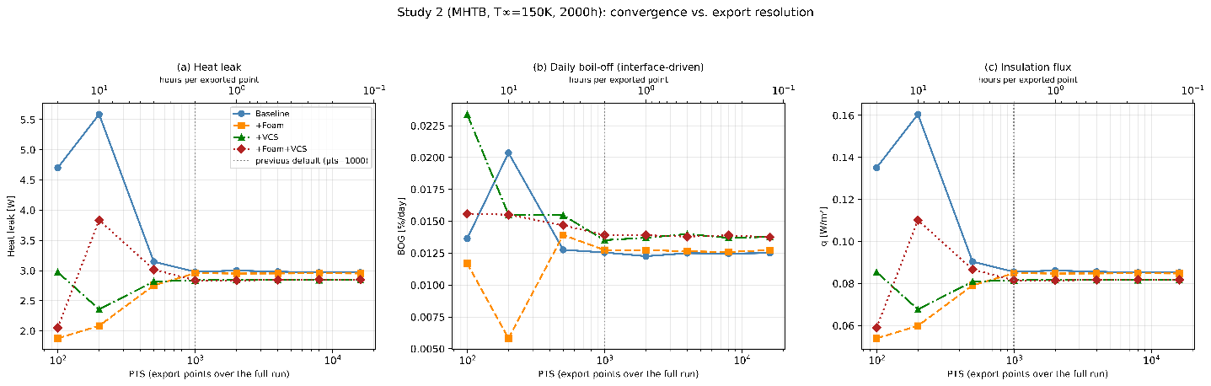
Figure 5. Study 2 model integration points convergence study at 150 K.
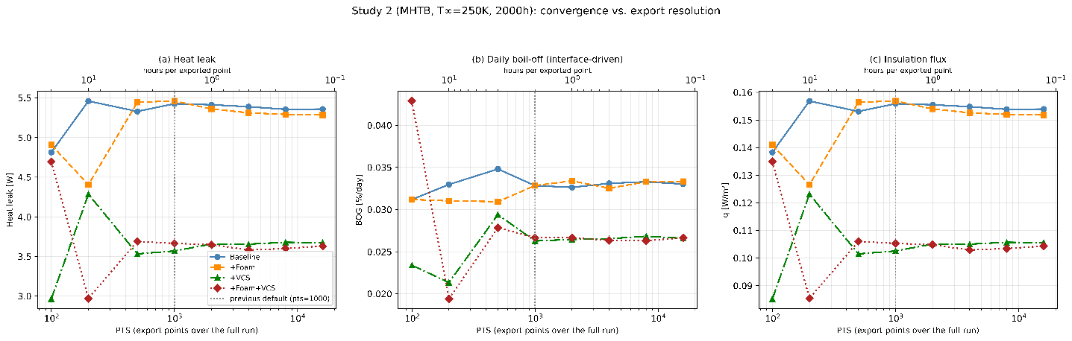
Figure 6. Study 2 model integration points convergence study at 250 K.
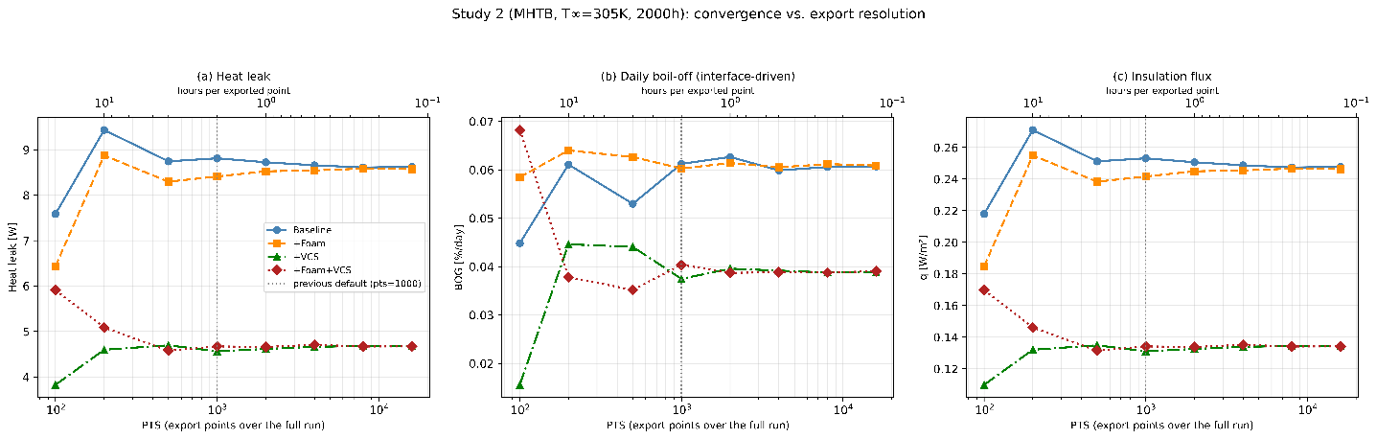
Figure 7. Study 2 model integration points convergence study at 305 K.
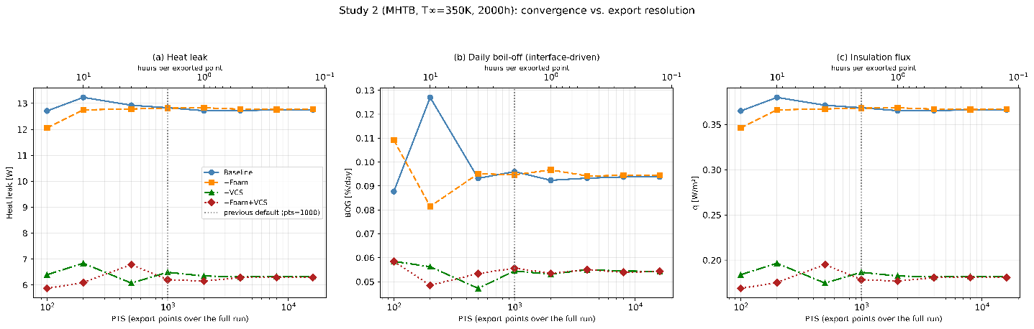
Figure 8. Study 2 model integration points convergence study at 350 K.
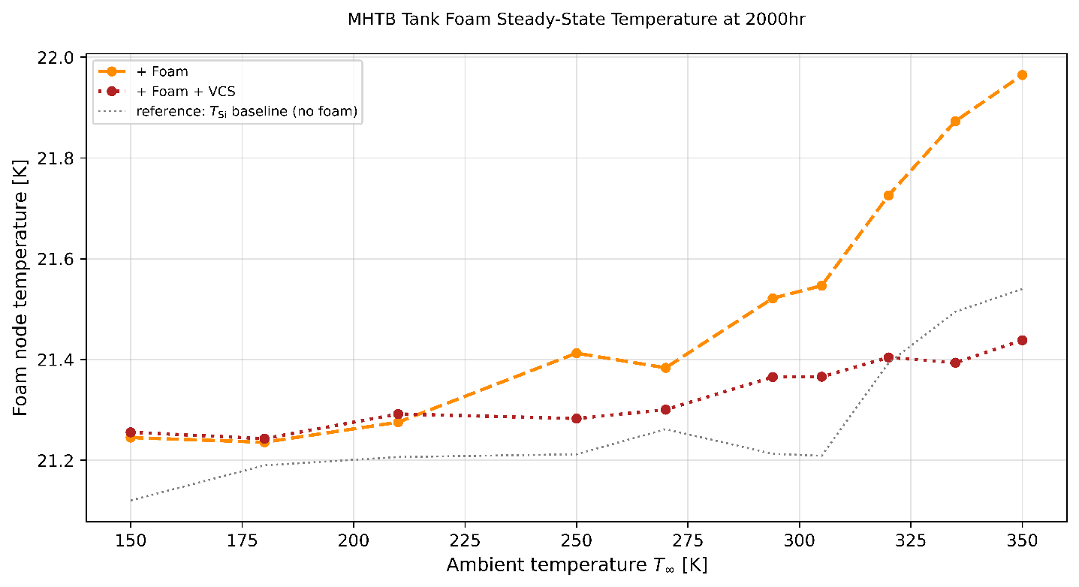
Figure 9. MHTB tank foam steady state temperature from low to high temperatures
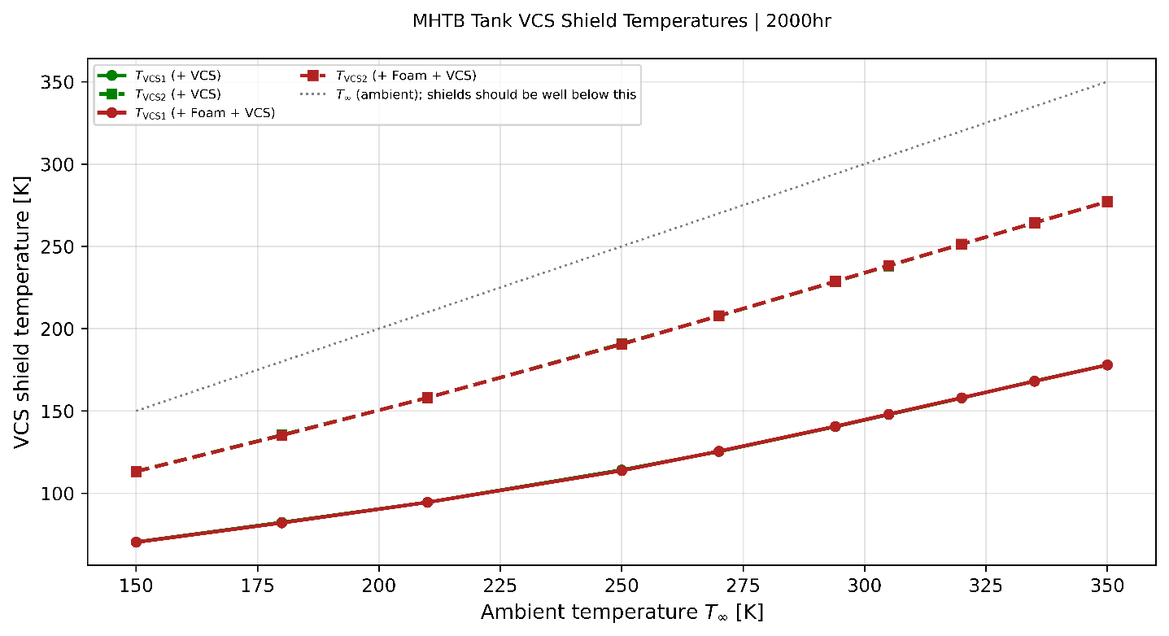
Figure 10. MHTB tank VCS steady state temperature at various ambient temperatures
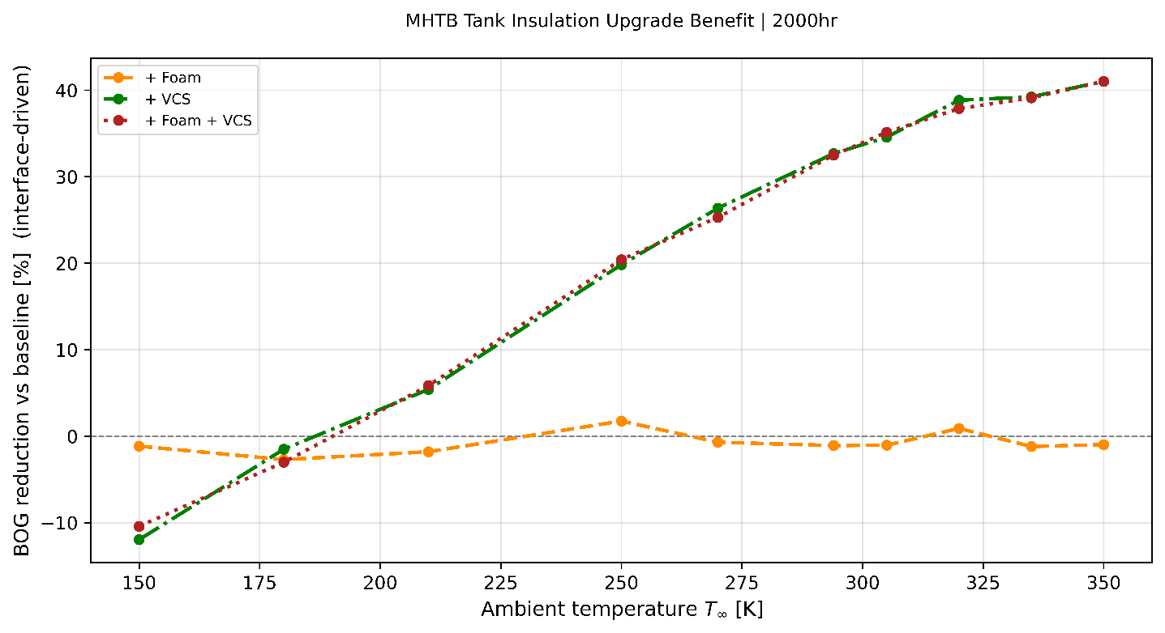
Figure 11. BO reduction with reference to the Base insulation of the MHTB tank at different ambient temperature.
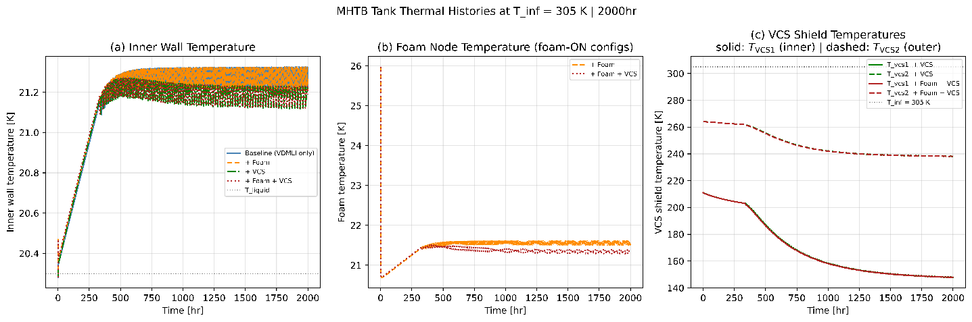
Figure 12. MHTB tank thermal history , (a) inner wall temperature , (b) foam temperature , and (c) VCS shield temperature at 2000 hours

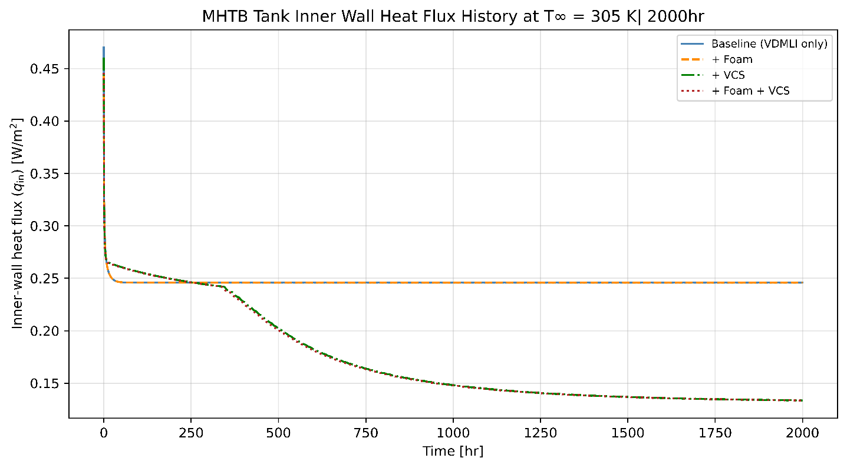
Figure 13. MHTB tank inner wall heat flux history at 305K ambient temperature.

Appendix J

J.1 Parametric study 3: Foam thickness optimization
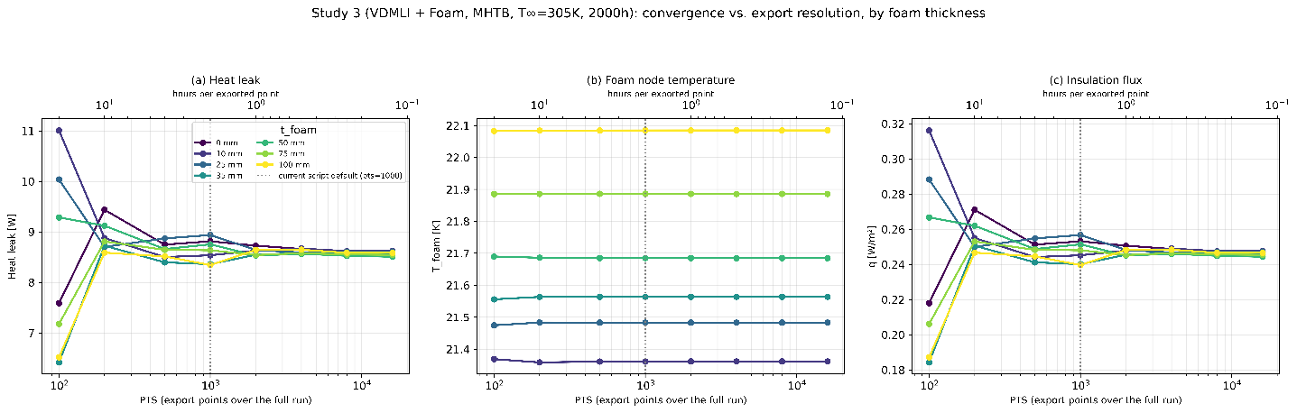
Figure 14. Model integration points convergence study at 305 K with varying foam thickness.
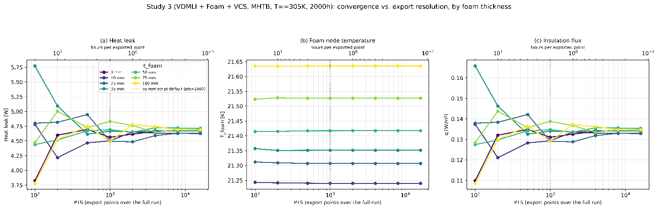
Figure 15. Model integration points convergence study at 305 K with varying foam thickness and VCS.
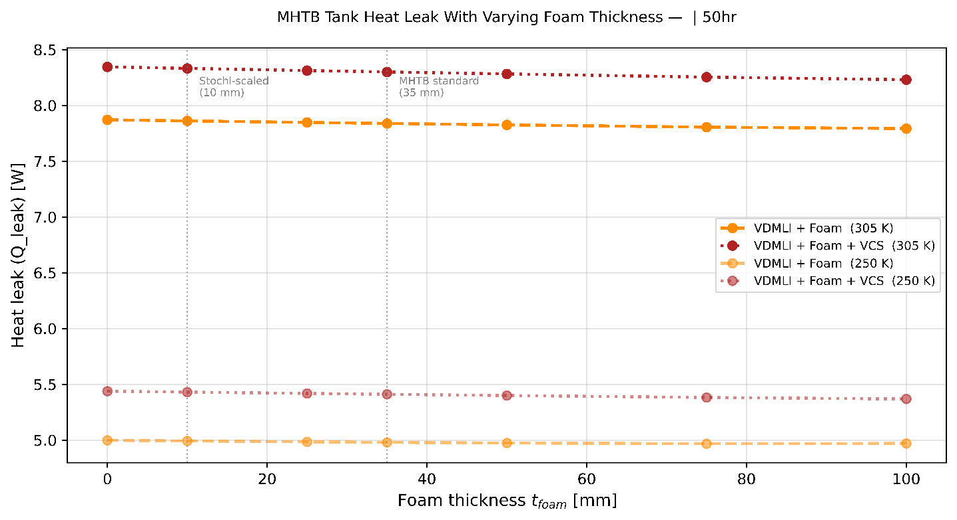
Figure 16. MHTB tank foam temperature with increasing foam thickness at 50 hr
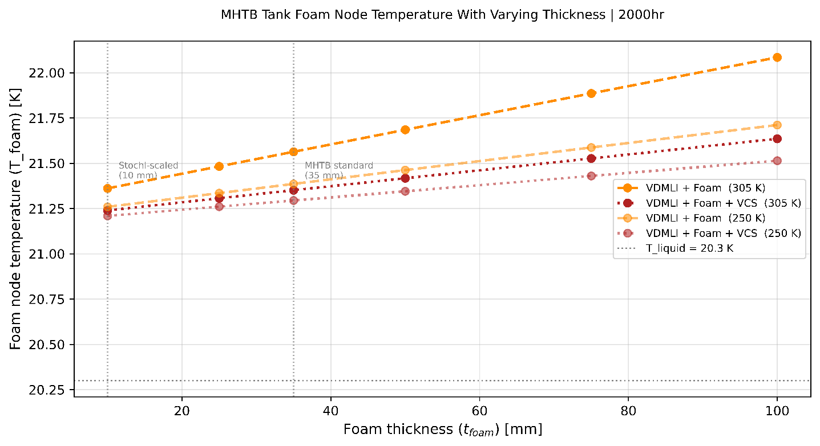
Figure 17. MHTB tank foam temperature with increasing foam thickness

Appendix K

K.1 Parametric study 4: VCS flow fraction parametric
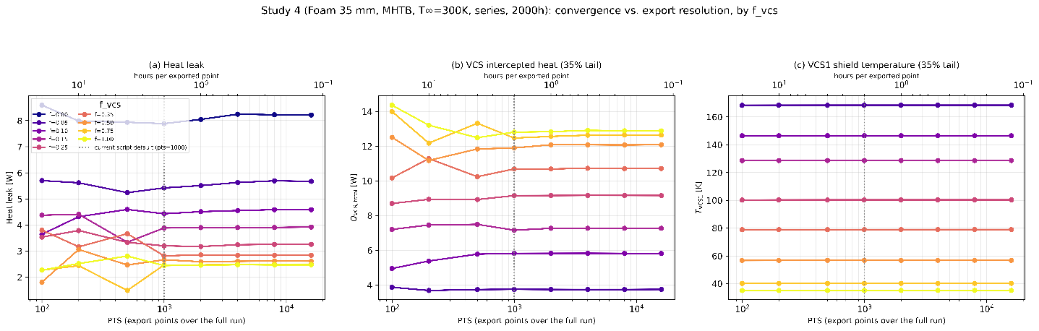
Figure 18. Model integration points convergence study at 300 K with varying VCS flow fraction and with 35 mm foam thickness.

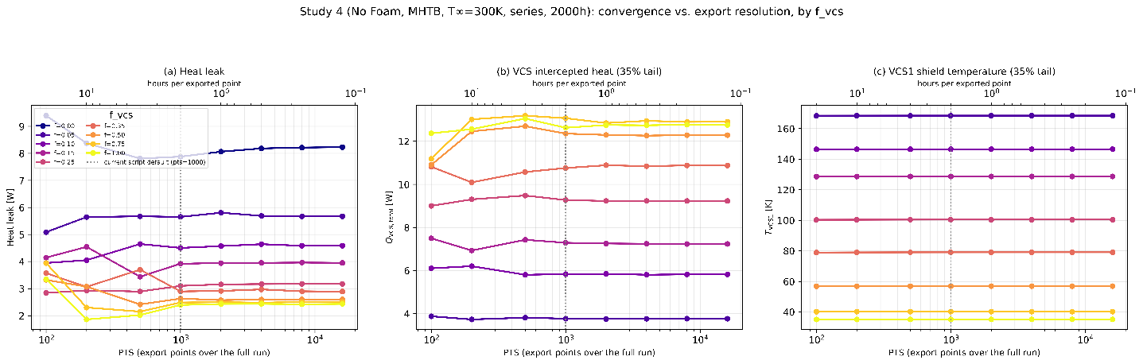
Figure 19. Model integration points convergence study at 300 K with varying VCS flow fraction and without foam.

Appendix L

L.1 Parametric study 5: Mission performance and hold time
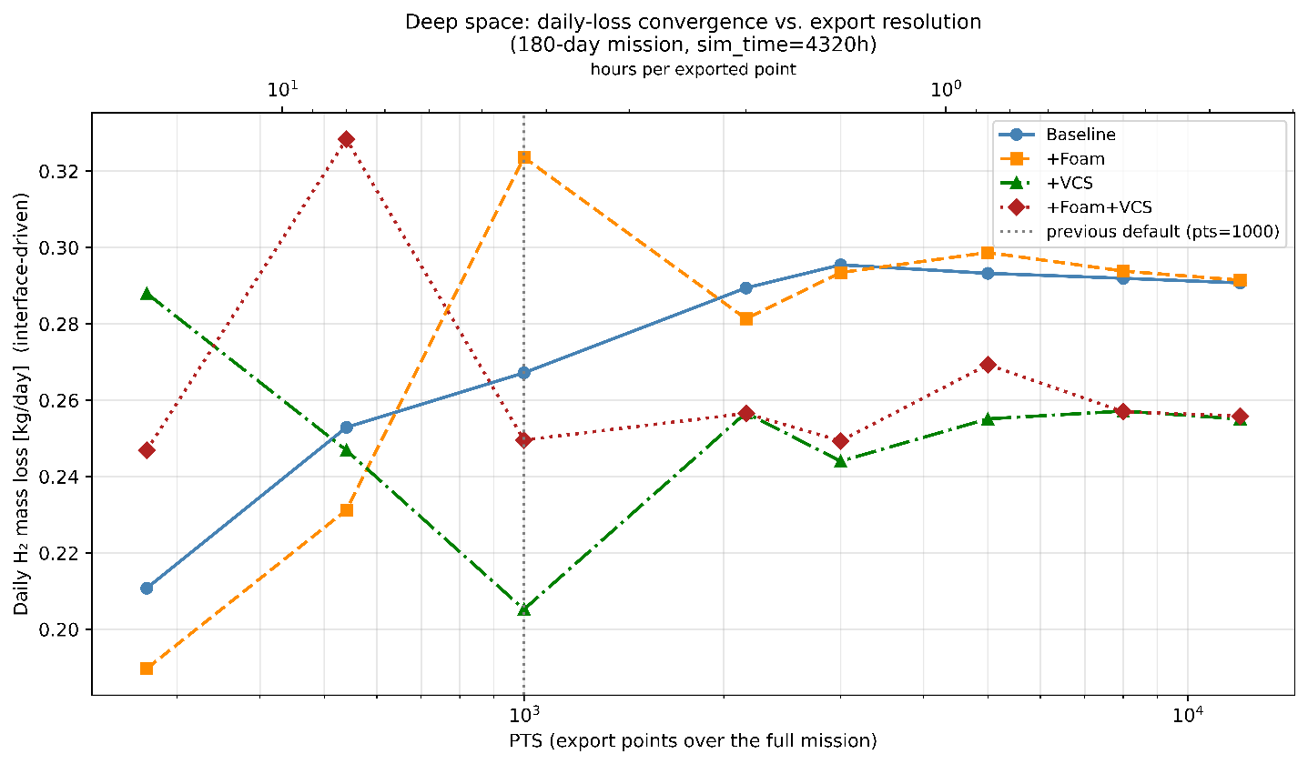
Figure 20. Deep space convergence study

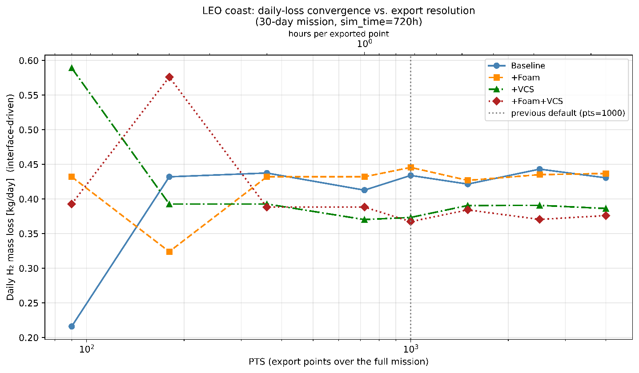
Figure 21. LEO coast convergence study.
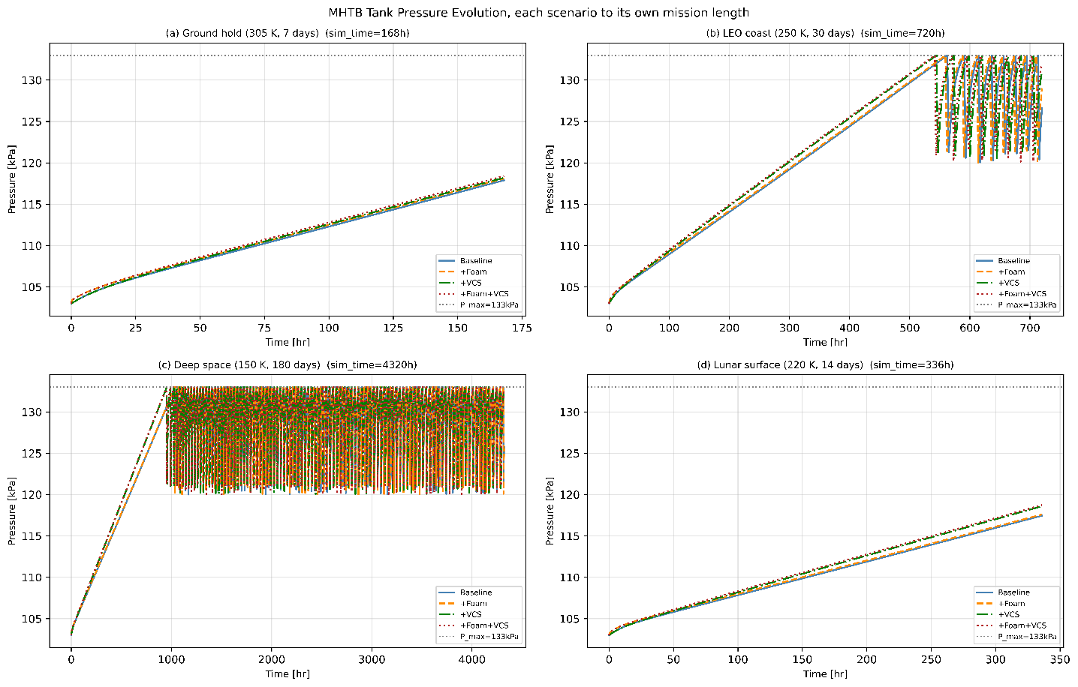
Figure 22. MHTB tank pressure history, (a) Ground hold( 305 K, 7 days), (c) LEO cost (250 K, 30 days), (c) Deep space ( 150 K, 180 days) , and (d) Lunar surface ( 220 K, 14 days )

References
[1] Leachman JW, Jacobsen RT, Penoncello SG, Lemmon EW. Fundamental equations of state for parahydrogen, normal hydrogen, and orthohydrogen. J Phys Chem Ref Data 2009;38:721–48. https://doi.org/10.1063/1.3160306.
[2] Saturation Properties for Hydrogen n.d. https://webbook.nist.gov/cgi/fluid.cgi?PLow=0.10&PHigh=0.75&PInc=0.01&Digits=5&ID=C1333740&Action=Load&Type=SatT&TUnit=K&PUnit=MPa&DUnit=kg%2Fm3&HUnit=kJ%2Fkg&WUnit=m%2Fs&VisUnit=Pa*s&STUnit=N%2Fm&RefState=DEF (accessed September 21, 2026).
[3] Saturation Properties for Hydrogen n.d. https://webbook.nist.gov/cgi/fluid.cgi?TLow=18&THigh=30&TInc=0.03&Digits=5&ID=C1333740&Action=Load&Type=SatP&TUnit=K&PUnit=MPa&DUnit=kg%2Fm3&HUnit=kJ%2Fkg&WUnit=m%2Fs&VisUnit=Pa*s&STUnit=N%2Fm&RefState=DEF#Auxiliary (accessed September 21, 2026).
[4] Stochl RJ. BASIC PERFORMANCE OF A MULTILAYER INSULATION SYSTEM CONTAINING 20 T O 160 LAYERS. n.d.
[5] Stochl RJ, Knoll RH. NASA Technical Memorandum 104476. n.d.
[6] Martin JJ, Marshall LH. Large-Scale Liquid Hydrogen Testing of a Variable Density Multilayer Insulation With a Foam Substrate. n.d.
[7] Hastings LJ, Hedayat A, Brown TM, Marshall GC. Analytical Modeling and Test Correlation of Variable Density Multilayer Insulation for Cryogenic Storage. 2004.
[8] Hastings LJ, Flachbart RH, Martin JJ, Hedayat A, Fazah M, Lak T, et al. Spray Bar Zero-Gravity Vent System for On-Orbit Liquid Hydrogen Storage. 2003.

