Kinesis
Smarter Therapy, One Move at a Time.

A MINI-PROJECT REPORT

Submitted by

Divya Palanisamy (715523106029)
Dousik Manokaran (715523106030)
Gaurav V.R. (715523106032)
Jasmitaa G (715523106040)

BACHELOR OF ENGINEERING
in
ELECTRONICS AND COMMUNICATION ENGINEERING



PSG INSTITUTE OF TECHNOLOGY AND APPLIED RESEARCH

ABSTRACT

This project aims to reduce the current gap in physiotherapy and guided exercise programs where there is a heavy reliance on correct movement patterns but continuous monitoring by practitioners is often impractical. It achieves this through the introduction of a compact, wearable, edge-AI powered prototype that validates exercise performance in real time.

The device integrates Electromyography (EMG) sensors and an Inertial Measurement Unit (IMU) to capture both muscle activation and limb orientation during wrist curl exercises. Data is processed locally on an ESP32 microcontroller running an Edge Impulse machine learning model to classify movements into four categories: good form, bad form, rest, and uncertainty. Real-time feedback is delivered, enabling users to self-correct without practitioner supervision.

While demonstrated here as a minimal viable product (MVP), the system establishes a scalable framework for full-body smart clothing capable of monitoring multiple muscle groups and joints. By combining unobtrusive sensing, edge intelligence, and intuitive feedback, Kinesis paves the way for accessible, personalized, and data-driven physiotherapy and fitness monitoring solutions.

PROBLEM STATEMENT AND OBJECTIVE

Patients must follow the right movement patterns during physiotherapy and guided exercises programs in order to recover fully or to avoid injury. However, it’s practically impossible for the practitioners to provide constant supervisions leaving patients subject to poor form and ineffective outcomes. The existing solutions lack real-time injury prevention capabilities and concentrate more on the metrics instead of the patient's technique, which may have negative effects on their recovery process and may even cause a re-injury.

This project intends to create a wearable, small, edge-AI-powered prototype called kinesis that verifies exercises performance real-time in order to address these issues. The system will track motion and orientation using an IMU sensor and measure the electrical muscle activity using an EMG sensor. The device will show the probability that a hand movement is at rest, with a poor form or with a good form based on the hand movements. The goal of the device is to offer a real-time solution for performance validation and injury prevention by concentrating on evaluating and validating exercise techniques rather than just measuring metrics. By ensuring patients maintain proper form, the goal is to increase the efficiency of guided exercise programs and physiotherapy.

United Nations SDG(s) Mapped to the Project

1. SDG 3 – Good Health and Well-being

- Helps patients recovering from injuries perform physiotherapy exercises correctly.
- Reduces risk of wrong movements that can worsen health conditions.
- Encourages preventive healthcare by ensuring safe exercise practices.

2. SDG 4 – Quality Education

- Provides accessible, tech-enabled training tools for physiotherapists and fitness instructors.
- Assists patients in learning correct techniques with clear feedback outside clinic sessions.

3. SDG 9 – Industry, Innovation, and Infrastructure

- Promotes affordable healthcare innovation using IoT + AI on edge devices.
- Bridges technology with healthcare services, fostering low-cost, portable rehabilitation tools.

4. SDG 10 – Reduced Inequalities

- Makes guided physiotherapy more accessible to people in rural/underserved areas who cannot frequently visit hospitals.
- Reduces dependency on continuous in-person supervision.

DESCRIPTION OF COMPONENTS USED

Software

- Arduino IDE: Used for programming the ESP32. It provided a user-friendly environment for writing, uploading, and debugging code.
- Edge impulse: Used to train and validate the classification model that distinguishes between good form, bad form and at rest.

Hardware

- ESP32: Primary microcontroller for data acquisition and processing. It runs the Edge-AI model, collects the signals from the IMU sensor and EMG sensor and provides real-time classification output.
- EMG: EMG sensors detect the electrical signals produced by muscle contraction then these signals are analysed to understand the muscle activity and function.
- IMU (Accelerometer + Gyroscope): Tracks arm orientation, acceleration and angular motion to identify movement patterns and proper form during exercises.
- EMG electrodes: White adhesive electrodes that’s attached to skin detect muscle activation signals and produce accurate EMG readings.
- USB / Battery Module: Provides power to the ESP32 and sensors, ensuring portability of the wearable system.

Communication Interface

- I2C: Used for communication between the ESP32 and the IMU sensor.
- Analog Input: The EMG sensor provides analog muscle activity signals directly to the ESP32.
- Serial (UART/USB): Used during debugging and initial calibration for real-time monitoring via Arduino IDE’s Serial Monitor.

Code Written for the Model

#include <Adafruit_MPU6050.h>
#include <Adafruit_Sensor.h>
#include <Wire.h>
#include <TBD_inferencing.h> // Edge Impulse model
Adafruit_MPU6050 mpu;
const int emgPin = 33;
#define EMG_WINDOW 20
#define EMG_SAMPLE_DELAY 1
int emgBuffer[EMG_WINDOW];
int emgIndex = 0;
bool emgReady = false;
// EI expects 3000ms window -> ~150 rows * 9 features = 1350 values
static float features[EI_CLASSIFIER_DSP_INPUT_FRAME_SIZE];
static int featureIndex = 0;
float computeRMS(int *buf, int len) {
long sumSq = 0;
for (int i = 0; i < len; i++) sumSq += (long)buf[i] * buf[i];
return sqrt((float)sumSq / len);
}
float computeMAV(int *buf, int len) {
long sum = 0;
for (int i = 0; i < len; i++) sum += abs(buf[i]);
return (float)sum / len;
}
float computeWL(int *buf, int len) {
long wl = 0;
for (int i = 1; i < len; i++) wl += abs(buf[i] - buf[i - 1]);
return (float)wl;
}
void setup() {
Serial.begin(115200);
while (!Serial) delay(10);
if (!mpu.begin()) {
Serial.println("Failed to find MPU6050 chip");
while (1) delay(10);
}
mpu.setAccelerometerRange(MPU6050_RANGE_8_G);
mpu.setGyroRange(MPU6050_RANGE_500_DEG);
mpu.setFilterBandwidth(MPU6050_BAND_21_HZ);
Serial.println("System ready: IMU + EMG + Model");
}
void loop() {
emgBuffer[emgIndex++] = analogRead(emgPin);
if (emgIndex >= EMG_WINDOW) {
emgIndex = 0;
emgReady = true;
}
if (emgReady) {
emgReady = false;
float rms = computeRMS(emgBuffer, EMG_WINDOW);
float mav = computeMAV(emgBuffer, EMG_WINDOW);
float wl = computeWL(emgBuffer, EMG_WINDOW);
sensors_event_t a, g, temp;
mpu.getEvent(&a, &g, &temp);
// Push 9 features into the buffer
features[featureIndex++] = a.acceleration.x;
features[featureIndex++] = a.acceleration.y;
features[featureIndex++] = a.acceleration.z;
features[featureIndex++] = g.gyro.x;
features[featureIndex++] = g.gyro.y;
features[featureIndex++] = g.gyro.z;
features[featureIndex++] = rms;
features[featureIndex++] = mav;
features[featureIndex++] = wl;
// When enough data (3000ms window) is collected → run inference
if (featureIndex >= EI_CLASSIFIER_DSP_INPUT_FRAME_SIZE) {
signal_t signal;
numpy::signal_from_buffer(features, EI_CLASSIFIER_DSP_INPUT_FRAME_SIZE, &signal);
ei_impulse_result_t result;
EI_IMPULSE_ERROR res = run_classifier(&signal, &result, false);
if (res != EI_IMPULSE_OK) {
Serial.print("ERR: Failed to run classifier (");
Serial.print(res);
Serial.println(")");
}
else {
// Print results
for (size_t ix = 0; ix < EI_CLASSIFIER_LABEL_COUNT; ix++) {
Serial.print(result.classification[ix].label);
Serial.print(": ");
Serial.println(result.classification[ix].value, 6);
}
}
// Reset buffer for next 3s window
featureIndex = 0;
}
}
delay(EMG_SAMPLE_DELAY);
}

OUTPUT

Hardware Setup:
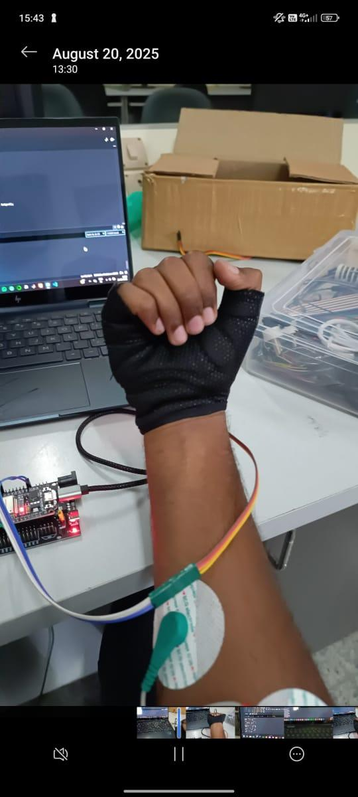

Software:

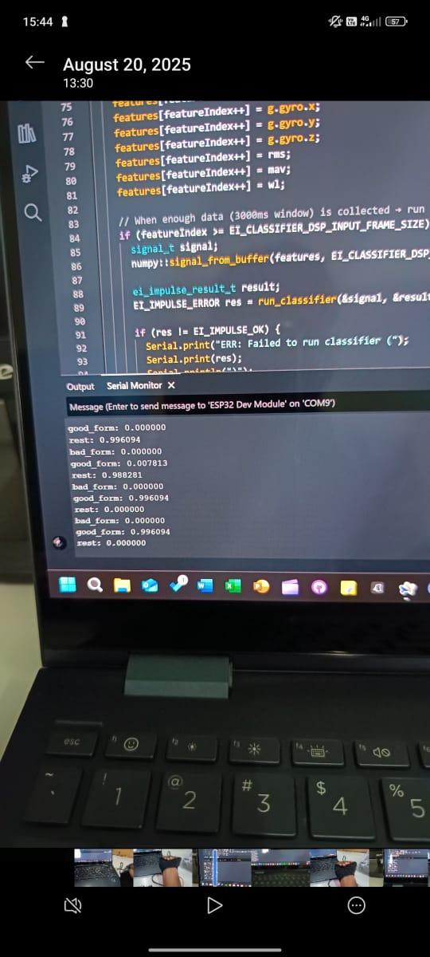

APPLICATIONS AND USE CASES

- Physiotherapy & Rehabilitation

The system can help patients who have faced surgeries, fractures, and other such injuries that require recovery through rehabilitation exercises. Often many do the exercise wrong, causing slow recovery, or even potential worsening of the pain. A physical therapist can not do one on one sessions on a daily basis with all patients, but with our technology there will be a constant way to monitor and validate the physiotherapeutic exercises. The device gives real-time corrective feedback, thereby improving treatment outcomes.

- Fitness Training

During fitness training, people who do not perform exercises correctly either due to lack of supervision or improper knowledge will have minimal efficiency. Often incorrect posture can lead to muscle strains, ligament tears, or long-term joint damage.

- Elderly Care

Elderly people often face balance issues, muscle weakness, or joint stiffness. This wearable can track their daily physical activity and gently alert them if movements exceed safe limits. It supports fall prevention, mobility monitoring, and safe exercise routines, allowing older adults to remain independent for longer.

- Remote Healthcare

As the need for telemedicine increases, physiotherapists and doctors can not always physically supervise their patients. Our technology bridges this gap, by transmitting exercise data and posture accuracy in real time enabling remote monitoring and reducing the need for frequent hospital visits.

- Sports and Athletics

Even minor posture errors can lead to long-term implications on their careers and physical fitness. This device allows fine tuning of athletic performance, thereby minimizing the risk for injury.

Future Scope

Currently the system we have designed has limited scope as it targets a specific body part and can only make a decision on the kind of positions, i.e. if it is a good, bad or rest position. In the future, we would like to expand our vision to a full fledged smart clothing that tracks the posture and movement of all body parts

Moreover, with the incorporation of advanced AI models, the system can provide more accurate feedback along with a complete movement analysis. Smart clothing can also be taken a step further by adding virtual/augment reality features to increase the engagement and effectiveness of the user’s movements.

In the future, the system can even be available for general consumer use to correct postures before they lead to chronic pain, such as a back/neck pain. Future versions can leverage flexible, washable, and stretchable electronics to improve comfort and durability. This would make smart clothing practical for long-term, daily use, addressing one of the biggest barriers to adoption today.

Conclusion

The project successfully demonstrates an efficient wearable system that can be implemented for physiotherapy applications for validating body posture in real time. Sensors such as IMU and EMG were integrated along with embedded systems to detect and classify body positions into good, bad or rest categories.

While the system tracks movement, it also provides feedback making it a useful tool for physiotherapists, fitness trainers, and patients during recovery. The device ensures accessibility, ease of use and accuracy making it an efficient tool to incorporate in real time.
This is a cost effective, modular solution with a great scope for future expansion. Our project highlights how wearable technology can be used to address critical healthcare needs in physiotherapy.

