**An Arduino based multi-modal Attendance system using RFID, OpenCV and PIR sensor**

**A PROJECT REPORT**

Submitted by

DILLI MARAN. K

DOUSIK. M

GAURAV. VR

*in partial fulfillment for the award of the degree*

*of*

**BACHELOR OF ENGINEERING**

in

**ELECTRONICS & COMMUNICATION ENGINEERING**

**PSG Institute of Technology and Applied Research**

**ANNA UNIVERSITY: CHENNAI 600 025**

FEBRUARY 2024

**ANNA UNIVERSITY: CHENNAI 600 025**

**BONAFIDE CERTIFICATE**

Certified that this project report “An Arduino based multi-modal Attendance system using RFID, OpenCV and PIR sensor” is the bonafide work of “Dilli Maran K, Dousik M, Gaurav VR ” who carried out the project work under my supervision.

**Signature Signature**

Prof.Selvakumar D

Dr. Vijayakumar P Prof. Rajaraja R

**HEAD OF THE DEPARTMENT SUPERVISOR**

<<Academic Designation>>

Electronics & Communication Engineering Electronics & Communication Engineering

Salem, Highway, Avinashi Rd, Coimbatore, Salem, Highway, Avinashi Rd, Coimbatore, Neelambur, Tamil Nadu 641062 Neelambur, Tamil Nadu 641062

TABLE OF CONTENTS

**CHAPTER NO. TITLE PAGE NO.**

**ABSTRACT iii**

**LIST OF FIGURES xviii**

**LIST OF SYMBOLS xxvii**

1. **INTRODUCTION 1** 
   1. RFID and OpenCV:

Addressing Attendance System Drawbacks

* 1. Components Required
  2. Circuit Diagram

1. RFID Attendance Management System
2. Uses and Merits

3.1 For Educational Institutions

3.2 For Teachers

3.3 For Administrators

3.4 For Students

3.5 For Parent

4. Conclusion

**ABSTRACT**

The RFID-based smart attendance system presents a modernized approach to attendance management in educational institutions. Traditional methods of attendance tracking, such as using RFID technology, are susceptible to misuse by students. To overcome this challenge, this project integrates OpenCV, a computer vision library, with RFID technology. By leveraging OpenCV, the system enhances security and accuracy in attendance recording processes. The RFID-based smart attendance system operates on radio frequency identification (RFID) technology, where each student is provided with a unique RFID tag containing their identification information. However, RFID tags can be susceptible to misuse or tampering, leading to inaccurate attendance records. To address this issue, OpenCV is utilized to enhance the security and reliability of the attendance tracking system. OpenCV allows for the implementation of facial recognition technology, enabling the system to verify the identity of students in real-time. By combining RFID technology with OpenCV, the system ensures that attendance records are not only accurate but also resistant to manipulation. This report provides an in-depth exploration of the system's functionality, components, implementation, and benefits. By leveraging Arduino UNO microcontroller board, RFID technology, and OpenCV, the system streamlines attendance tracking processes, enhances security, and offers convenience for students, teachers, administrators, and parents.

**List of Figures**

-Figure 1: Arduino setup with RFID & PIR sensor

. **List of Symbols, Abbreviations and Nomenclature**

1. OpenCV – Open Computer Vision
2. RFID – Radio-Frequency Identification
3. PIR - Passive Infrared sensor

**Chapters**

1. **Introduction**

Attendance management plays a pivotal role in the smooth functioning of educational institutions, serving as a fundamental aspect of academic governance and student welfare. The accurate recording of student attendance not only ensures compliance with institutional policies but also facilitates effective teaching and learning practices. Traditionally, attendance tracking has relied on manual methods such as paper-based registers or barcode scanning systems. However, these methods are often labor-intensive, prone to errors, and lack the scalability required to meet the evolving needs of modern educational environments.

Moreover, traditional attendance tracking methods, including those utilizing RFID technology, are susceptible to various drawbacks, notably the potential for misuse or tampering by students. While RFID-based systems offer convenience and efficiency in capturing attendance data, the inherent vulnerabilities of RFID tags pose significant challenges to the integrity and reliability of attendance records. Unauthorized duplication or manipulation of RFID tags can lead to instances of proxy attendance, thereby compromising the accuracy and fairness of attendance tracking processes.

In recognition of these challenges, there is a growing imperative for educational institutions to explore innovative solutions that address the limitations of traditional attendance management systems. One such solution lies in the integration of OpenCV, a powerful computer vision library, with RFID technology to augment the security and accuracy of attendance tracking processes. By harnessing the capabilities of OpenCV for facial recognition, educational institutions can mitigate the risks associated with RFID-based systems and establish robust mechanisms for verifying the identity of students in real-time.

The integration of OpenCV with RFID technology represents a paradigm shift in attendance management, offering a holistic approach that combines the convenience of RFID-based identification with the reliability of facial recognition technology. This synergy not only enhances the security and integrity of attendance records but also enables educational institutions to leverage advanced analytics and insights for informed decision-making and strategic planning.

In light of these developments, this project endeavors to explore the potential of integrating OpenCV with RFID technology to create a smart attendance system that addresses the shortcomings of traditional methods. By elucidating the underlying principles, functionalities, and benefits of this integrated approach, this report aims to provide valuable insights into the transformative impact of technology on attendance management practices in educational institutions.

**1.1 RFID and OpenCV: Addressing Attendance System Drawbacks**

Traditional RFID-based systems are not without their drawbacks, particularly in terms of security, accuracy, and susceptibility to misuse. One of the primary challenges associated with RFID technology is the potential for unauthorized duplication or tampering of RFID tags, leading to instances of proxy attendance and compromising the integrity of attendance records.

To overcome these limitations and enhance the security and accuracy of attendance tracking processes, this project integrates OpenCV, a computer vision library, with RFID technology. OpenCV offers sophisticated capabilities for facial recognition, enabling the system to verify the identity of students in real-time based on their facial features. By leveraging OpenCV alongside RFID technology, the system establishes a multi-layered authentication mechanism that significantly reduces the risk of unauthorized access and manipulation of attendance records.

The integration of OpenCV with RFID technology introduces several key advantages that address the shortcomings of traditional attendance tracking systems:

1. Enhanced Security: OpenCV-based facial recognition adds an additional layer of security to the attendance system by verifying the identity of students based on their unique facial features. This significantly reduces the risk of unauthorized access and proxy attendance, ensuring that attendance records are accurate and reliable.

2. Improved Accuracy: By incorporating facial recognition technology, the system can accurately identify and record student attendance in real-time, regardless of the presence or absence of RFID tags. This improves the overall accuracy of attendance tracking processes and minimizes the likelihood of errors or discrepancies in attendance records.

3. Resilience to Misuse: The integration of OpenCV with RFID technology makes the attendance system more resilient to misuse or tampering. Even in scenarios where RFID tags are lost, stolen, or duplicated, the system can still verify the identity of students through facial recognition, mitigating the risk of fraudulent attendance practices.

4. Real-time Authentication: OpenCV enables the system to perform real-time authentication of student identities, ensuring that attendance records are updated promptly and accurately. This facilitates proactive interventions in cases of unauthorized access or suspicious attendance patterns, allowing educational institutions to maintain a secure and accountable learning environment.

5. Scalability and Flexibility: The modular architecture of the integrated RFID and OpenCV system allows for scalability and flexibility in deployment across different educational settings. Whether in classrooms, lecture halls, or examination centers, the system can adapt to varying attendance tracking requirements and accommodate diverse student populations.

**1.2 Components Required**

The RFID-based smart attendance system with OpenCV integration requires the following components:

-Arduino UNO: Microcontroller board for system control and data processing.

- RC522 RFID module: Reads RFID tags and communicates with the Arduino UNO.

- RFID tags: Unique identification tags assigned to each student.

- Jumper wires and breadboard: For connecting components and circuit assembly.

- Red and green LEDs: Visual indicators for attendance status.

- Buzzer and 220-ohm resistor: Auditory alert for unregistered tags.

- I2C module: For interfacing with the 16x2 LCD display.

- 16x2 LCD display: Displays system prompts and attendance information.

- OpenCV library: Computer vision library for implementing facial recognition technology.

**1.3 Circuit Diagram:**

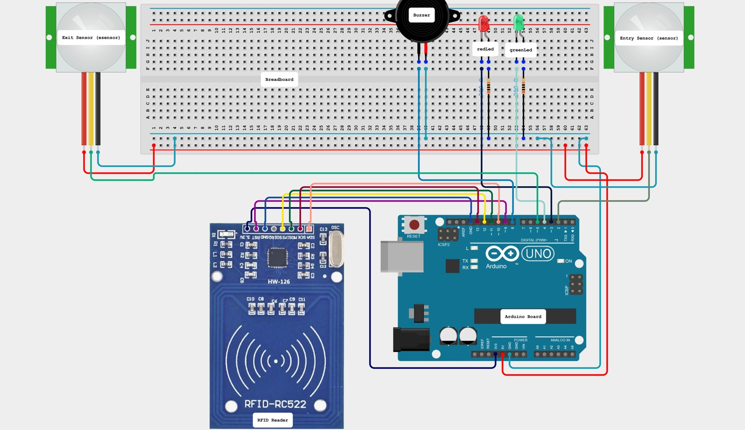

**Fig 1** Arduino setup with RFID & PIR sensor

**2. RFID Attendance Management System:**

1. RFID Tag Assignment:

Each student is assigned a unique RFID tag containing their identification information.

The RFID tag is encoded with the student's details, such as name and ID number, during enrollment.

2. RFID Reader Initialization:

The RFID reader is initialized to detect the presence of RFID tags within its proximity range.

It continuously scans for RFID tags and communicates with the Arduino UNO microcontroller board.

3. Tag Detection and Authentication:

When a student enters the attendance area, the RFID reader detects the presence of their RFID tag.

The RFID reader reads the unique identification number (UIN) stored in the tag and sends it to the Arduino UNO for processing.

4. OpenCV Facial Recognition:

Simultaneously, the OpenCV module captures images of the students within the attendance area.

OpenCV analyzes facial features and compares them against a database of registered students' faces.

5. Multi-Layered Authentication:

The system performs multi-layered authentication by cross-referencing the RFID tag's UIN with the registered student database and verifying the student's identity through facial recognition.

If the RFID tag is registered and the facial recognition matches, the student's attendance is recorded as present.

6. Real-Time Attendance Recording:

The attendance status, along with the student's details, is recorded in real-time by the Arduino UNO.

The attendance data is stored in a centralized database for further analysis and reporting.

7. Attendance Monitoring and Reporting:

Educators and administrators can monitor attendance data in real-time through a user-friendly interface.

The system generates comprehensive reports on attendance trends, absenteeism rates, and student participation.

8. Proactive Intervention and Decision-Making:

Based on attendance data insights, educators can identify patterns of absenteeism and intervene proactively to support students.

Administrators can make data-driven decisions to optimize resource allocation and improve institutional effectiveness.

9. Scalability and Flexibility:

The system's modular architecture allows for scalability and flexibility to accommodate varying attendance tracking requirements.

It can be deployed across different educational settings, from classrooms to examination centers, with ease.

10. Continuous Improvement and Innovation:

The RFID Attendance Management System undergoes continuous improvement and innovation to stay aligned with evolving technological advancements and educational needs. Updates and enhancements are rolled out regularly to enhance security, accuracy, and user experience.

**3. Uses and Merits:**

The RFID-based smart attendance system with OpenCV integration offers numerous benefits for educational institutions, teachers, administrators, students, and parents:

3.1 For Educational Institutions: Enhances punctuality, minimizes absenteeism, and simplifies attendance tracking processes. Provides real-time data for analysis and decision-making.

3.2 For Teachers: Minimizes paperwork, automates attendance recording, and sends automatic alerts for absent students. Facilitates the generation of management information system (MIS) reports for monitoring and evaluation.

3.3 For Administrators: Streamlines attendance management, reduces manual effort, and ensures accurate record-keeping. Enables proactive measures for addressing attendance-related issues and improving institutional efficiency.

3.4 For Students: Provides a seamless attendance recording process, eliminates the need for manual roll calls, and offers real-time feedback on attendance status. Promotes accountability and responsibility among students.

3.5 For Parents: Enables real-time monitoring of students' attendance, facilitates communication with teachers and administrators, and provides insights into students' academic engagement. Supports parental involvement in students' educational journey.

1. **Conclusion: Transforming Attendance Management**

The fusion of RFID technology with OpenCV marks a significant advancement in attendance management for educational institutions. Throughout this report, we've explored the innovative integration of these technologies, highlighting its benefits and implications.

By combining RFID's convenience with OpenCV's facial recognition capabilities, this integrated system offers heightened security and accuracy in attendance tracking. It addresses the limitations of traditional methods, such as susceptibility to misuse, by introducing multi-layered authentication.

Moreover, this system not only streamlines attendance processes but also provides valuable insights into student behavior and engagement levels. It empowers educators to make informed decisions and tailor support services to meet students' diverse needs.

In conclusion, the RFID-OpenCV integration revolutionizes attendance management, paving the way for a more efficient, secure, and data-driven educational environment. It represents a significant step forward in leveraging technology to enhance learning outcomes and institutional effectiveness.

As we embrace this transformative solution, let us continue to harness the power of innovation to shape the future of education.

**References:**

1. Augus Bejo, Ricky Winata, Sri Suning Kusumawardani (2018) “Prototyping of

Class-Attendance System Using Mifare 1K Smart Card and Raspberry PI 3” - IEEE [10.1109/ISESD.2018.8605442](https://doi.org/10.1109/ISESD.2018.8605442)

2. Trio Adiono, Didi Setiawan, Maurizfa, Jason William, Nana Sutisna (2021) “Cloud Based User Interface Design for Smart Student Attendance System” - IEEE [10.1109/ISESD53023.2021.9501878](https://doi.org/10.1109/ISESD53023.2021.9501878)

3. Paval Zlatarov (2023) “Design and Development of a Smartphone-Enabled Smart Card-Based Attendance Tracking Module for Personalized Education” - IEEE [10.1109/ISMSIT58785.2023.10304892](https://doi.org/10.1109/ISMSIT58785.2023.10304892)