MDPortfolio Admin User Guide:

MDPortfolio is a portfolio website that gives you a place to list your skills, talk about your projects, provide contact details, and provide links to your social-media accounts.

Once you have setup the site, and it is connected to your database, you will be able to login to the admin system at http://<your site's domain>/admin

Setting up your user account:

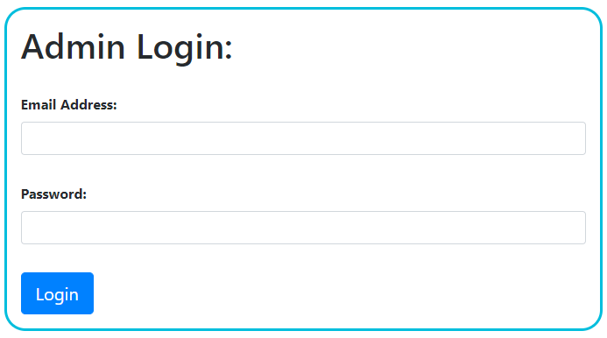
When the site is first set up (assuming the database migrations and seeder have been run correctly), the admin login details will be admin@admin.com, with a password of admin123. You will need to change this once you have first logged in.

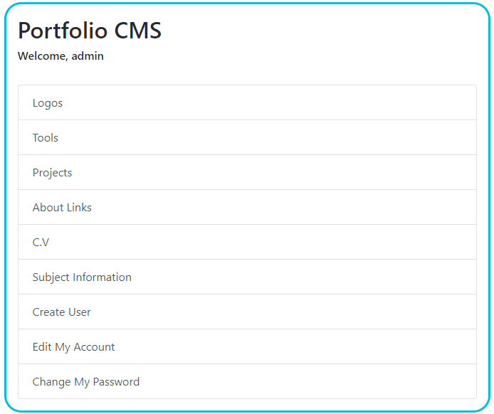
At the main menu screen, the last 2 options on the list are Edit My Account and Change My Password. Select Edit My Account.

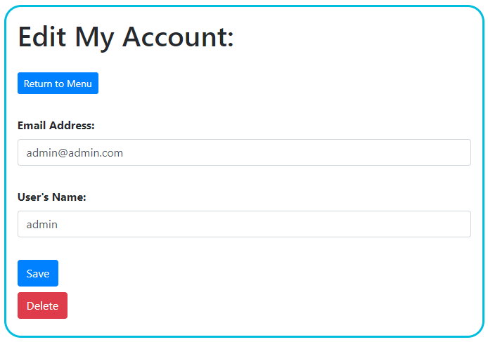
On this screen, you can update your email address and name. You can also delete your account here (say, if your account was created by another user, and you no longer needed it).

After changing these details, go back to the main menu and select Change My Password.

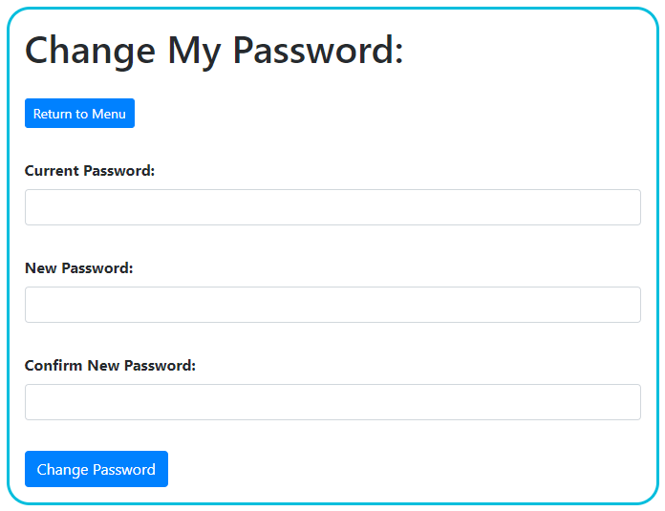

Here you can change the password for your account.

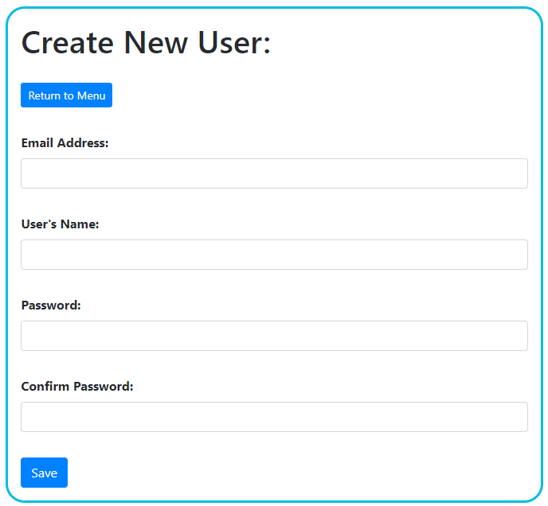
On the main menu, there is also an option to create a new user. Once a user has been created, they can then edit their own details, or delete their account.

Setting up the subject of the website:

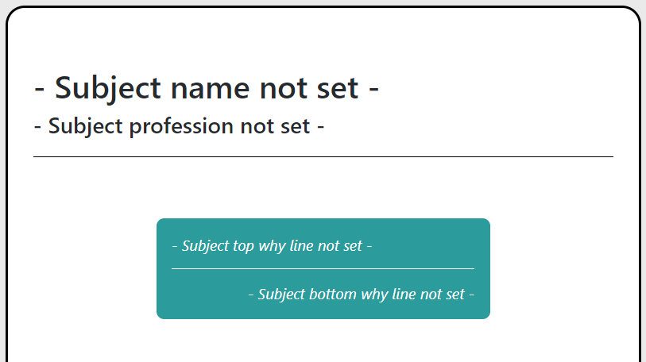
When the site is first setup, the home page will mainly be placeholder text. You will need to provide your details on the Subject Information option on the main menu.

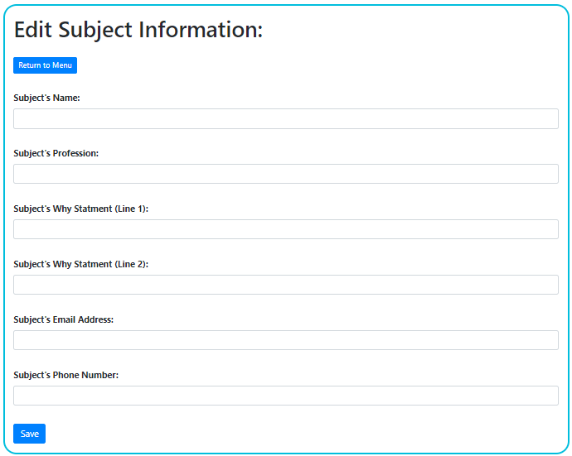
Here, you will need to set your name (which is used as the top line on the homepage header) and your profession (say “Developer”, “Designer”, etc – this will be the sub-title on the header).

You can also provide a 2 line “Why Statement”. Use this to tell your readers why you do what you do. You can use <em> and <strong> html tags (but no others) in these fields.

Finally, you are also able to provide an email address and phone number. If either of these are provided, they will be displayed in the More About Me section at the bottom of the homepage.

Uploading logos for use on the site:

Every piece of content will require a logo. You can view logos, upload new ones, and remove any that are no longer in use, from the Logos menu.

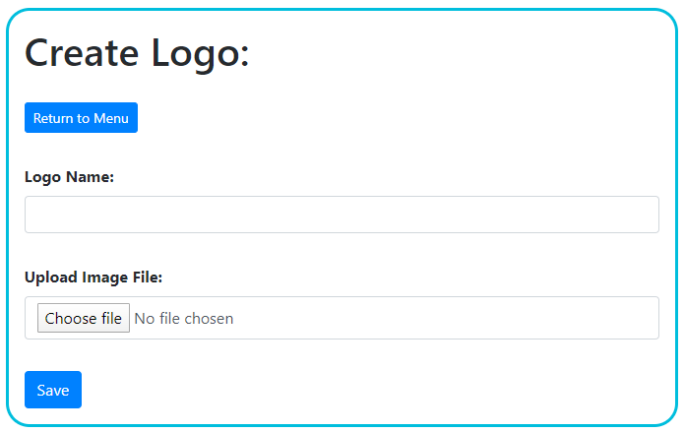
On the logo creation screen, you can upload an image file, and also give it a name for your reference. Prior to uploading the file, it is best to ensure the logo is a square (so it isn't stretched when it is displayed). You will then be able to select this logo when adding new content.

Adding Tools to the My Tools section:

The My Tools section gives you a space to tell your reader what tools and technologies you are able to use. You can add, edit, and remove tools from the Tools menu.

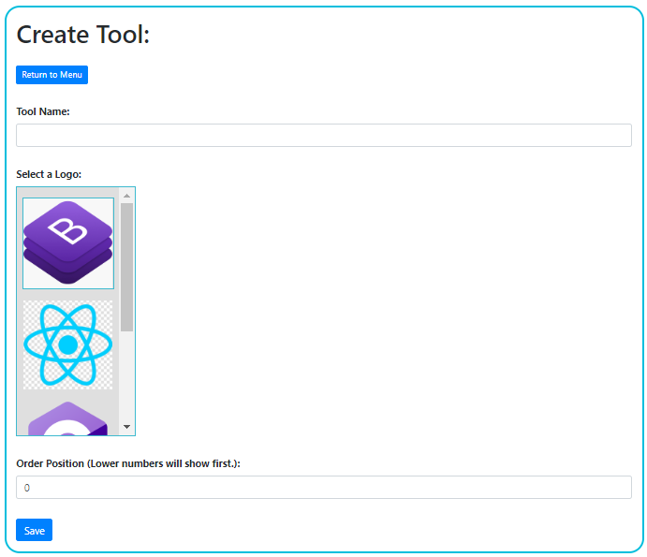
When creating a tool, you will need to provide a name, and then select one of your uploaded logos from the logo selector. You can then set a number that will be used when determining the order that the tools should be displayed in.

Adding projects to the site:

You can add projects to the site, and they will all be displayed on the /projects page. Also, the first 3 projects in the display order will be shown in the My Work section of the homepage.

When adding a project from the Projects menu, there are a number of fields to be entered.

- Title: This is a required field. It is the title of your project.
- Small Description: This is a required field. It is used in the My Work section and the /projects page, as a quick description of your work. You can use <em> and <strong> html tags (but no others) in this field.
- Full Description: This is a required field. This text will be displayed on the project's page, and is where you can tell the reader everything about the project. You can use <em> and <strong> html tags (but no others) in this field.
- Select a Logo: This is a required field. This is where you select the project's logo, from the logos you have previously uploaded.
- GitHub URL: Here, you can add a link to the project's GitHub page.
- App URL: If the project is online and useable (such as a web app), then you can add the link to it here.
- Upload Zip File: If you would like to give the reader the option of downloading the project files directly from your website, you can upload a ZIP file here.
- Order Position: Here, you can set a number that will be used when determining the order that the projects should be displayed in. This is important, as only the first 3 projects will be displayed in the My Work section on the homepage, so you want to make sure your 3 main projects come first.

Adding About Links to the More About Me section:

The About Links are links to your social-media accounts.

You can also setup a GitHub link, and it will be given a special position next to the link to your C.V. To do this, just set the link name to “github”.

- Link Name: This is a required field. It is the name of the link.
- Link Caption: This is a required field. It will be used on the image's alternative text for the logo. Also, if this is the GitHub link, it will be displayed beneath the logo.
- Link URL: This is a required field. This is the address for the link.
- Select Logo: This is a required field. This is where you select the logo that you had uploaded for the link.
- Order Position: This is where you can control the order that the links will be displayed in.

Uploading a C.V:

From the main menu, there is an option to upload a C.V. From this page you can upload the C.V file, and set the logo that you have previously uploaded for the C.V link.

The C.V link will appear in the More About Me section, above the About Links.

