SchemaShovelWeb – User Guide

SchemaShovelWeb is a web-based application, designed to make it easier to analyse and document a database's structure, when you don't have any pre-existing documentation for it.

Firstly, you need to generate a JSON representation of the database's structure. You can do this with one of the schema-generation SQL scripts.

In the home-page of the application, You can select Add New Database to go to the database-addition screen.
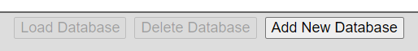
Firstly, you need to generate a JSON representation of the database's structure. You can do this with one of the schema-generation SQL scripts (the download links are at the bottom of the database addition page).
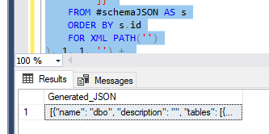

You can paste the JSON into the text-area (or use the Choose File button to load the JSON from a file). You will also need to add a name for the database here.
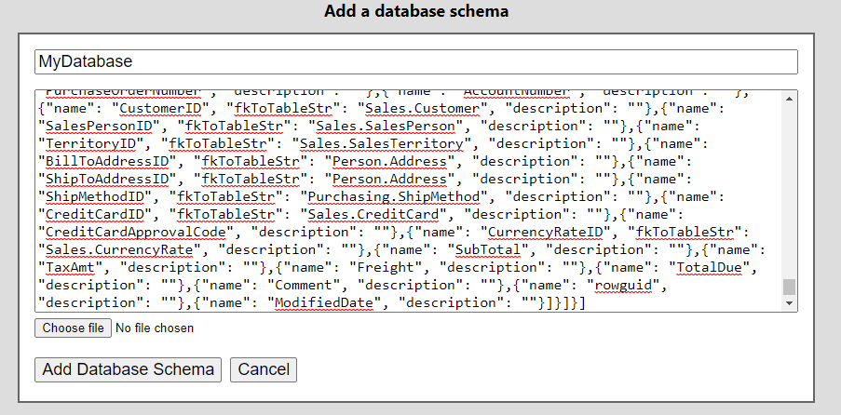
Once you have added the database into the system, you will be taken back to the home-page of the application. There, you will see the new database listed. By selecting the Edit button next to the database, you will be able to change its name.
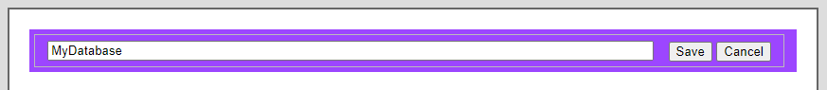

If you select the database record in the list, the options bar will allow you to load or delete it.
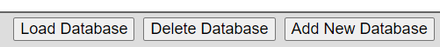

If you select Load Database, then the database record will be loaded and displayed.
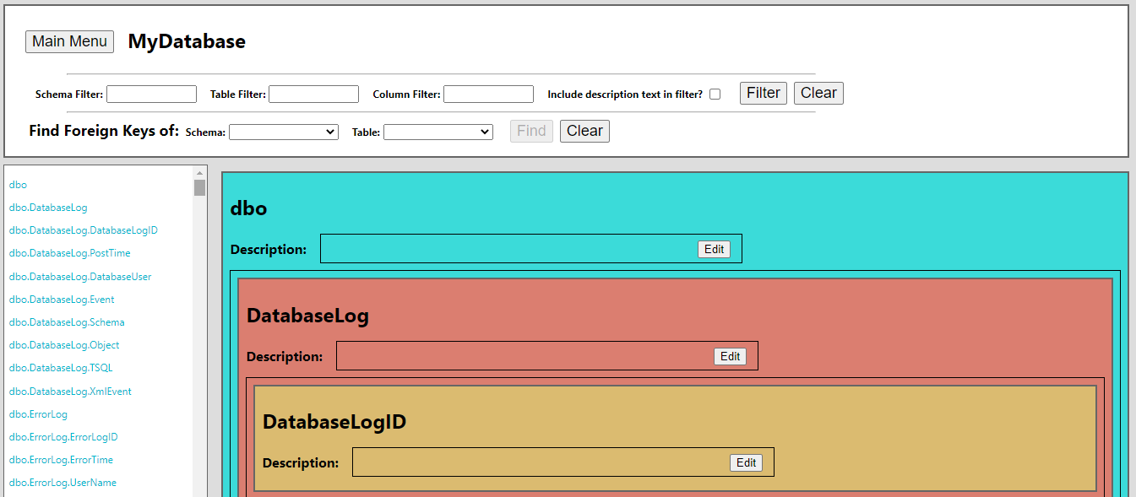

This screen is split into 3 sections:
- At the top is the filter options, and also a button to take you back to the database-selection screen.
- On the left (unless you are using this application on a smaller sized screen), is the complete list of database entities (schemas/tables/columns). Selecting one of these will take you to the position of that entity on the page.
- In the center-right are the entities in the database. These are represented in layers (So the schemas contain their tables, and the tables contain their columns). The entities will display their names and descriptions (you can edit the descriptions with the Edit buttons). If a column had a foreign-key constraint, then the table that it pointed to will be displayed beneath the description.

The bar at the top provides 2 kinds of filter, to help in analysing the database structure:
- The text filters allow you to filter for entities with names that match specific strings of text. These filters can also be set to search the descriptions.
- The foreign-key filter allows you to find all of the tables that have foreign-key constraints to a selected table. The first table displayed will be the table that was selected, and the tables after that will all have foreign-key columns to that table.

