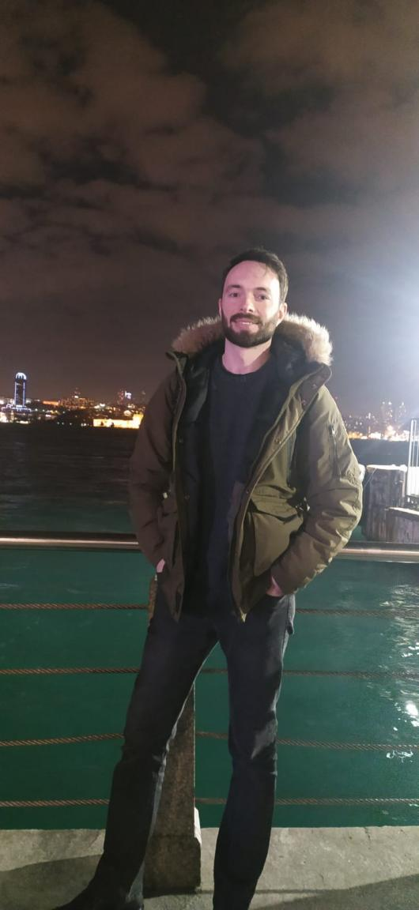**MUHAMMED EROĞLU** - **Frontend Developer**

* **Phone :** +90 (551) 2202435
* **Adress :** Sancaktepe / İstanbul / TR
* **E-mail :** [m.eroglu.dev@gmail.com](mailto:ahmetbeler1739@gmail.com)
* **Portfolio page :** https://medev.netlify.app/
* **Linkedin :** <https://www.linkedin.com/in/muhammed-eroglu-dev/>
* **Github :** https://github.com/M-E-Dev

SUMMARY

I have allways been the practical, solution finder, fast learner and the negotiater one all my life. Most of the time, find myself while translating Turkish to Turkish and solving team members communication problems. Eager to use those qualities in development process as a good member of Frontend Development team.

I am interested in **JavaScript, ReactJs** and excited to learn full lifecycle of Frontend Development process. I feel comfortable with English speaking, listening and communicating, able to learn from English documents and solve my problems. You can review my projects on my GitHub account and my portfolio page.

After working and improving myself about the Frontend development, gaining Backend skills and to be a Full Stack Developer is my mid term planning.

SKILLS

**Hard Skills**

* English reading and speaking skills. (upper intermediate)
* React, JavaScript, HTML, CSS
* Redux, Context, Firebase
* SCSS, Bootstrap, Material-UI
* Git, GitHub
* Rest API, Linux, VS Code

**Soft Skills**

* Analytical thinking
* Problem-solving abilities
* Self-motivated
* Strong and clear communication skills
* Music lover and Instrument player.

**PROJECTS**

To see all of my React and JS projects and github links from my portfolio page -> <https://medev.netlify.app/>

Or some of the latest projects one by one:

1)React Context Firebase Blog App : <https://firebase-blog-app.netlify.app/>

( Github link : <https://github.com/M-E-Dev/React-firebase-blog-app> )

2)Basic React Redux Todo App github link : <https://github.com/M-E-Dev/React-basic-redux-counter>

3)React Firebase Movie App : https://medev-firebase-movie-app.herokuapp.com/

( Github link : https://github.com/M-E-Dev/React-movie-app )

**CERTIFICATIONS**

* Clarusway HTML & CSS Certificate (https://c11n.clarusway.com/en/verify/51167050890066)
* Clarusway Javascript Certificate (https://c11n.clarusway.com/en/verify/95745202927542)
* Clarusway React Certificate (https://c11n.clarusway.com/en/verify/82960288879067)
* Clarusway Frontend Developer Certificate (https://c11n.clarusway.com/en/verify/54375798128873)

**EDUCATION**

**Science Highschool**          2005 – 2010

**Turkish Military Academy**         2010 – 2015

- Public Administration Degree

- Forensic Law Enforcement Specialist

**Clarusway IT Training School**

- IT Fundamentals/ Frontend Developer

Dynamic learning experience on understanding & applying the Frontend Programming Languages, developing projects and accessing to the competence level to work with project management systems, different programming languages, frameworks and libraries including HTML, CSS, JavaScript, React.js, Context, Python, React.js, SQL, Github, JIRA, Agile.

WORK EXPERIENCE

Accountant Assistant

LANGUAGE COMPETENCIES

* Turkish: Native
* English: B2