MUHAMMED EROĞLU

**Frontend Developer**

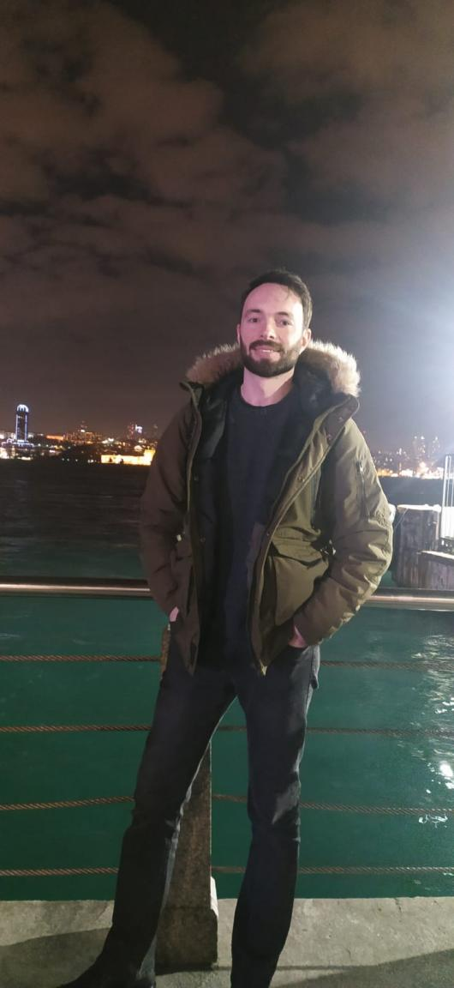**------------------------------------------------------------**

* **Phone :** +90 (551) 2202435
* **Adress :** Samandıra / Sancaktepe / İstanbul/ TR
* **E-mail :** [m.eroglu.dev@gmail.com](mailto:ahmetbeler1739@gmail.com)
* **Portfolio page :** https://medev.netlify.app/
* **Linkedin :** <https://www.linkedin.com/in/muhammed-eroglu-dev/>
* **Github :** https://github.com/M-E-Dev

SUMMARY

I am setting my new career as a Frontend developer. Finding practical solutions for different problems was mostly be my difference from my friends all the time. Now I am in the process of being skilled at Frontend development and getting sharp at the topic. Besides the coding skills, I always interact positively and communicate well with team members. Most of the time I find myself while translating Turkish to Turkish and solving team members communication problems.

I am a quick learner about new technologies and concepts to develop innovative and creative solutions to problems. I am interested in **JavaScript, ReactJs** mostly and excited to learn full lifecycle of Frontend development process. I did not take an examination but I feel comfortable with English speaking, listening and communicating. I am able to learn from English documents and solve my problems. You can review my projects on my GitHub account and my portfolio page.

PROFESSIONAL SKILLS

**Hard Skills**

* Good English reading and speaking skills. (upper intermediate)
* HTML5, CSS3, JavaScript
* React with Redux, Context, Firebase
* SCSS, Bootstrap, Material-UI
* Git, GitHub
* Rest API
* Linux, VS Code

**Soft Skills**

* Analytical thinking
* Problem-solving abilities
* Self-motivated
* Strong and clear communication skills
* Music lover and Instrument player.

**PROJECTS**

My projects are mostly done with React.js, Context, Redux, Firebase, Bootstrap, Material UI. Etc. Lastest one is a blog app done with React, Firebase, Context and MUI.  
To see my projects live -> https://medev.netlify.app/

**CERTIFICATIONS**

* Clarusway HTML & CSS Certificate
* (https://c11n.clarusway.com/en/verify/51167050890066)
* Clarusway Javascript Certificate
* (https://c11n.clarusway.com/en/verify/95745202927542)
* Clarusway React Certificate
* (https://c11n.clarusway.com/en/verify/82960288879067)
* Clarusway Frontend Developer Certificate
* (https://c11n.clarusway.com/en/verify/54375798128873)

**EDUCATION**

**Science Highschool**          2005 – 2010

**Turkish Military Academy**         2010 – 2015

- Public Administration Degree

- Forensic Law Enforcement Specialist

**Clarusway IT Training School**

- IT Fundamentals/ Frontend Developer

Dynamic learning experience on understanding & applying the Frontend Programming Languages, developing projects and accessing to the competence level to work with project management systems, different programming languages, frameworks and libraries including HTML, CSS, JavaScript, React.js, Context, Python, React.js, SQL, Github, JIRA, Agile.

WORK EXPERIENCE

Accountant Assistant

LANGUAGE COMPETENCIES

* Turkish: Native
* English: B2