Goofy Fruits

OOP Assignment (4)



2011

**Developed By** :

Hatem Moustafa Salah (30)

Mahmoud Nabil AbdelAziz El- Maghraby (68)

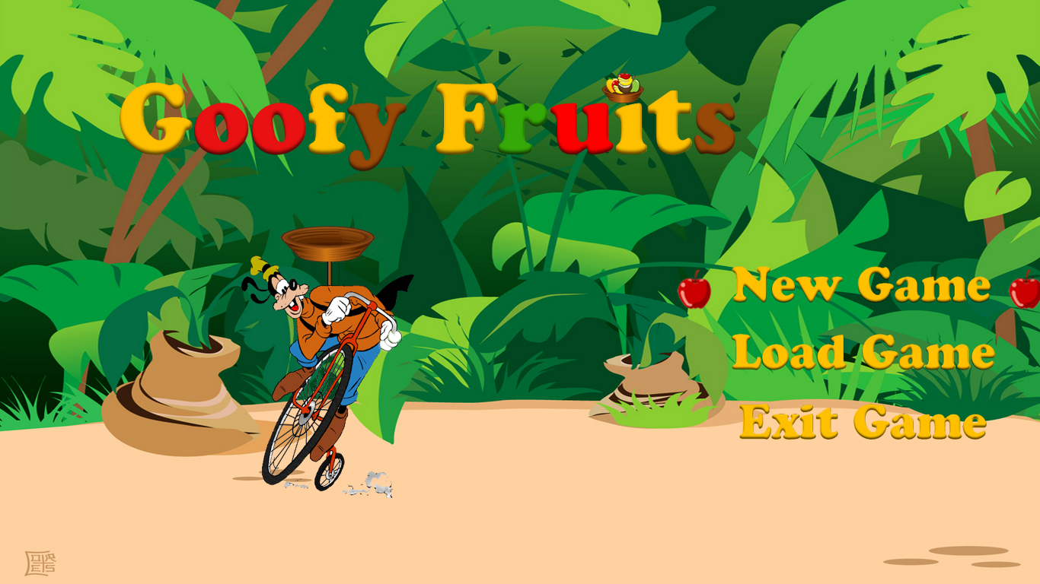**Section (1) : User Guide:**

**"Goofy Fruits Main Menu"**

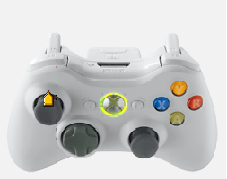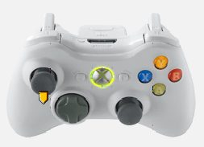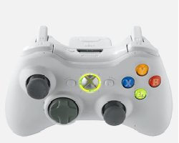

**"Go Up" "Go Down" "Select Action"**

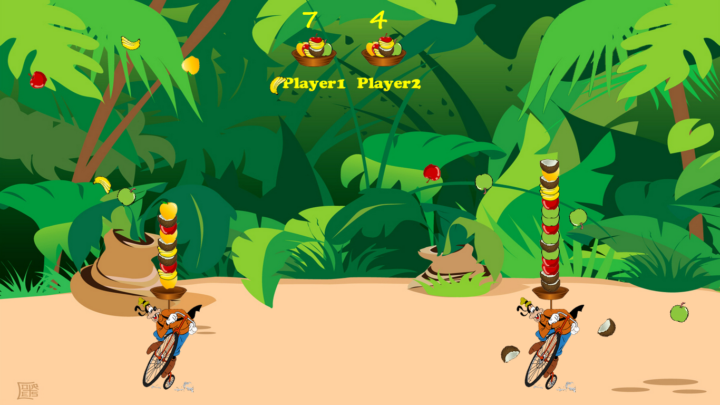**Game PLay:**

**"Goofy Fruits Game Play"**

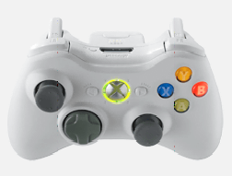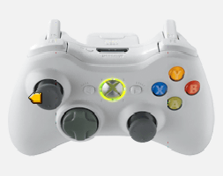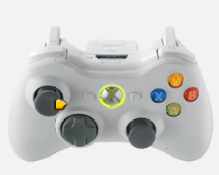

**"Go Right" "Go Left" "Exit Game"**

**Game Flow:**

* Try to collect 3 fruits from the same type and color and see your score increasing .
* **You win when you get 20 points or the other player gets 20 fruits** on his basket.

**Section (2) Design Patterns:**

**Pattern(1): Dynamic Linkage**

Used for dynamically loading the shapes "fruits" classes from the hard disk to the game.

**Pattern(2): Factory Method**

Used to get a specific shape from the shapes classes, it's implemented such that the shape being loaded by it is random.

**Pattern(3): Object Pool**

Used to limit the creation of new shapes by using reusable shapes . The game engine "Controller Class" only use the object pool two main methods ,acquire and release, to create and release the falling shapes.

**Pattern(4): Singleton**

Used in the Object Pool class to guarantee only one creation of the class object. The Audio Clip Manager class also implemented using the singleton pattern to guarantee that only one sound clip would be played.

**Pattern(5): Iterator**

Used in looping on the different data structures used in the game implementation.

**Pattern(6): MVC**

The game is designed mainly according to the MVC design pattern. The controller class "GoofyFruitsEngine" is the class that controls everything in the game flow; it makes the calculations, collision detection and links between the model classes and viewer classes. The controller uses the model classes to acquire shapes, update the basket of the player and calculate the score. The viewer classes are used to view different objects of the game during the game play. It's worthy say that both model and controller classes knows nothing about the viewer classes.

**Pattern(7): Snapshot**

Most of the game classes implements the "java.io.Serializable" interface which is used mainly to make the save and load operations easier.