Handwritten Sudoku Reader and Solver
A neural network, search and constraint-satisfaction system (Project P7)
[Mohamed Ahmed Saed Elrouie| [Intelligent Systems] | November 2026

1. Problem and overview
A person writes a Sudoku with handwritten digits. A computer must read the grid and solve it. The difficulty is that the digit reader sometimes makes a mistake, and a single misread digit can make the whole puzzle unsolvable. For example, the network may read a 7 as a 1 (52% against 45%). Two 1s then appear in the same row and the puzzle looks broken. The system should notice this, work out which digits were most likely misread, correct them, and solve the puzzle. If it cannot, it should say so clearly instead of returning a wrong answer.
The system combines three techniques from the course, each doing a different job:
- Neural network. Classifies every handwritten cell (digits 1 to 9) and outputs a probability for each digit. These probabilities become the cost of changing a cell.
- Search. Looks for the cheapest set of corrections to the first reading, using Uniform-Cost Search (UCS), Greedy search and A*.
- Constraint satisfaction (CSP). Solves the Sudoku with Backtracking, Forward Checking and AC-3, and tests every corrected puzzle.

NN reads the grid (probabilities) | → | AC-3 finds a conflict | → | Search tries cheapest corrections | → | CSP tests each; first solvable wins
Figure 1. How the three parts cooperate. If no correction within the limit works, the output is "unreadable".

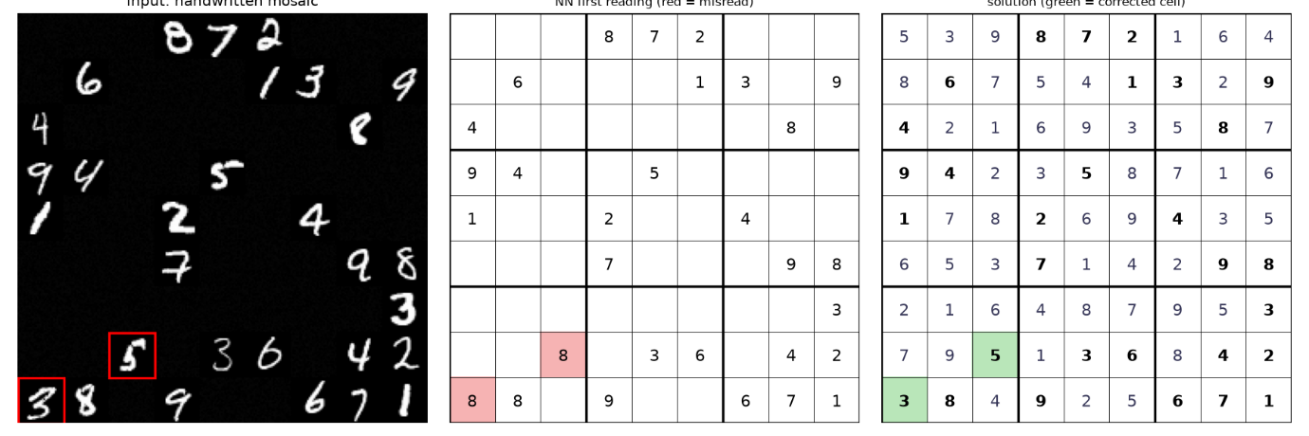
Figure 2. Demo with two injected misreads. Left: the handwritten mosaic with the misread cells boxed in red. Middle: the network’s first reading. Right: the solution after the two corrections (green).

2. Data
The digits come from the MNIST database (LeCun et al.): 60,000 training and 10,000 test images of 28x28 pixels, written by different people in the two sets. Digit 0 is dropped because Sudoku has no 0. A seeded split of the training set gives 50,000 training and 10,000 validation images; after dropping 0 the sizes are 45,053 training, 9,024 validation and 9,020 test images. The test set is not used for training or tuning.
Real versus generated. Digit images and labels are real. Everything else is generated with fixed seeds: the Sudoku puzzles (a full grid built by randomised backtracking, then cells removed in random order while the solution stays unique, until 25, 30 or 35 givens remain), the 9x9 mosaics (a 252x252 image of 81 cells; blank cells are low-level noise) and the injected hard digits. This is therefore not a photograph of real handwritten Sudoku. A cell is declared blank by a simple brightness rule (no pixel brighter than 0.3), not by the network.
Injected misreads. A well-trained network almost never misreads, so there would be nothing to correct. To control the experiments, "misread level k" means that k randomly chosen given cells receive a hard image: a test image of the right digit that the network gets wrong while still ranking the true digit in its top three. All other cells use correctly classified images. The number of real misreads therefore equals the level, which was verified in every experiment (the logged actual_misreads equals the level).

3. Design choices

3.1 CSP solver
The Sudoku has 81 variables (cells), domains of digits 1 to 9 (stored as bitmasks), and the constraint that any two cells in the same row, column or box differ. The three techniques are separate switches of one solver, so they can be compared on the same puzzles:
- Backtracking (BT). Fills empty cells in row-major order and checks each digit against the cells that were already assigned.
- Forward Checking (FC). After each assignment, removes that digit from the domains of the cell’s peers, and backtracks if a domain becomes empty.
- AC-3. Runs at the root and again after every assignment. For "not equal" constraints it contains forward checking and also propagates chains of cells whose domain shrinks to one value. Two equal givens in the same row empty a domain, which is how it detects a broken reading.
Counters are kept for assignments, backtracks (undone assignments), AC-3 revisions and pruned values. For fair comparison all variants use the same variable order, and a cap of 100,000 assignments stops runs that would take too long; capped runs are counted as "aborted".

3.2 Correction search
State: the grid after a set of corrections. Action: change one uncertain cell to one of its top alternative digits. Cost: ln p(read) − ln p(new), which is never negative because the read digit is the network’s arg-max (0.125 for a cell where the network was almost as sure of the alternative, 1.17 where it was much less sure). Limit: at most 3 corrections. Goal: the CSP finds the corrected puzzle solvable, or, in the stricter version, finds exactly one solution.
The candidates are the 12 least confident given cells with 2 alternatives each. Each correction set is generated exactly once, because a node may only correct cells with a larger index than its last correction. This makes the search a tree, so no closed list is needed and A* with an admissible heuristic stays optimal. The three algorithms share the same code and differ only in the priority: UCS uses g, Greedy uses h and A* uses g + h. Counters record nodes expanded and generated.

3.3 A* heuristic and why it is admissible
If k cells of one row, column or box hold the same digit, at least k − 1 of them must change for the puzzle to become valid. Each change of a cell costs at least that cell’s cheapest alternative. The heuristic takes a greedy packing of such conflict groups that share no cell, and for each group adds the k − 1 smallest cheapest-change costs. Because the groups are disjoint, no changed cell is counted twice, so the sum can never exceed the true cost of fixing the conflicts. If the groups need more changes than corrections remain, or need cells that cannot change, the node is a dead end and is discarded. The tests check on several cases that h at the root is never above the optimal cost found by UCS, and that A* and UCS return the same cost.

3.4 Goal test: solvable versus unique
The minimum goal is "the corrected puzzle is solvable". A misread digit can, however, leave a puzzle that is still solvable but with the wrong answer. The extension therefore requires exactly one solution (the solver stops counting at two). Duplicate digits are rejected by a cheap check before the full CSP runs; this is exactly what root AC-3 detects. Section 6 compares both goals.

4. Neural network
The classifier is a multilayer perceptron with one hidden layer of 128 ReLU units (784-128-9), written in numpy and trained with Adam (learning rate 0.001, batch size 128, L2 weight decay 1e-5, 10 epochs, seed 0). The baseline is multinomial logistic regression, which is the same code without the hidden layer, so the comparison is fair. Probabilities are optionally rescaled by temperature scaling, fitted on the validation set only.
Model | Temperature T | Test accuracy | NLL | ECE
MLP (raw probabilities) | 1.00 | 0.9763 | 0.0759 | 0.0027
MLP (temperature-scaled) | 1.04 | 0.9763 | 0.0758 | 0.0037
Logistic regression (baseline) | 1.00 | 0.9198 | 0.2790 | 0.0236
Table 1. Test results (9,020 images). NLL = negative log-likelihood; ECE = expected calibration error (15 bins).
The MLP beats the baseline by about 5.6 percentage points of accuracy and has a much lower NLL. Its ECE is already very small (0.0027), so the probabilities can be used directly as costs. Temperature scaling found T = 1.04, which changes almost nothing; the test ECE even rose slightly (0.0027 to 0.0037), a difference too small to matter. The extension was therefore tried but not needed. Accuracy is identical in both MLP rows because rescaling never changes which digit has the highest probability.
true \ pred | 1 | 2 | 3 | 4 | 5 | 6 | 7 | 8 | 9
1 | 1124 | 2 | 1 | 0 | 0 | 2 | 0 | 6 | 0
2 | 3 | 1005 | 4 | 4 | 0 | 4 | 5 | 6 | 1
3 | 0 | 1 | 989 | 1 | 7 | 0 | 4 | 4 | 4
4 | 0 | 4 | 1 | 956 | 0 | 3 | 4 | 3 | 11
5 | 0 | 0 | 5 | 1 | 874 | 6 | 0 | 3 | 3
6 | 3 | 1 | 1 | 7 | 5 | 936 | 0 | 5 | 0
7 | 6 | 10 | 7 | 1 | 0 | 0 | 998 | 1 | 5
8 | 0 | 3 | 3 | 4 | 5 | 3 | 2 | 948 | 6
9 | 5 | 0 | 5 | 10 | 3 | 2 | 5 | 3 | 976
Table 2. Confusion matrix of the MLP on the test set (rows: true digit, columns: predicted digit).
Digit 1 is easiest (about 99.0% correct) and digit 9 hardest (about 96.7%). The largest confusions are plausible: 4 read as 9 (11 times), 7 read as 2 (10 times) and 9 read as 4 (10 times). About 214 test images are misread, which gives a real pool of hard digits for the experiments.

5. Integration
The pipeline cuts the mosaic into 81 cells, applies the brightness rule to find blanks and lets the network read the rest. AC-3 then checks the first reading. If the reading is already solvable (or uniquely solvable), the puzzle is solved with no corrections. Otherwise the search proposes correction sets in order of cost and the CSP tests each one; the first success wins. For every solved puzzle the system produces a correction log (cell, read digit, new digit, cost). If no reading works within 3 corrections it prints an "UNREADABLE" message and lists the least confident cells.

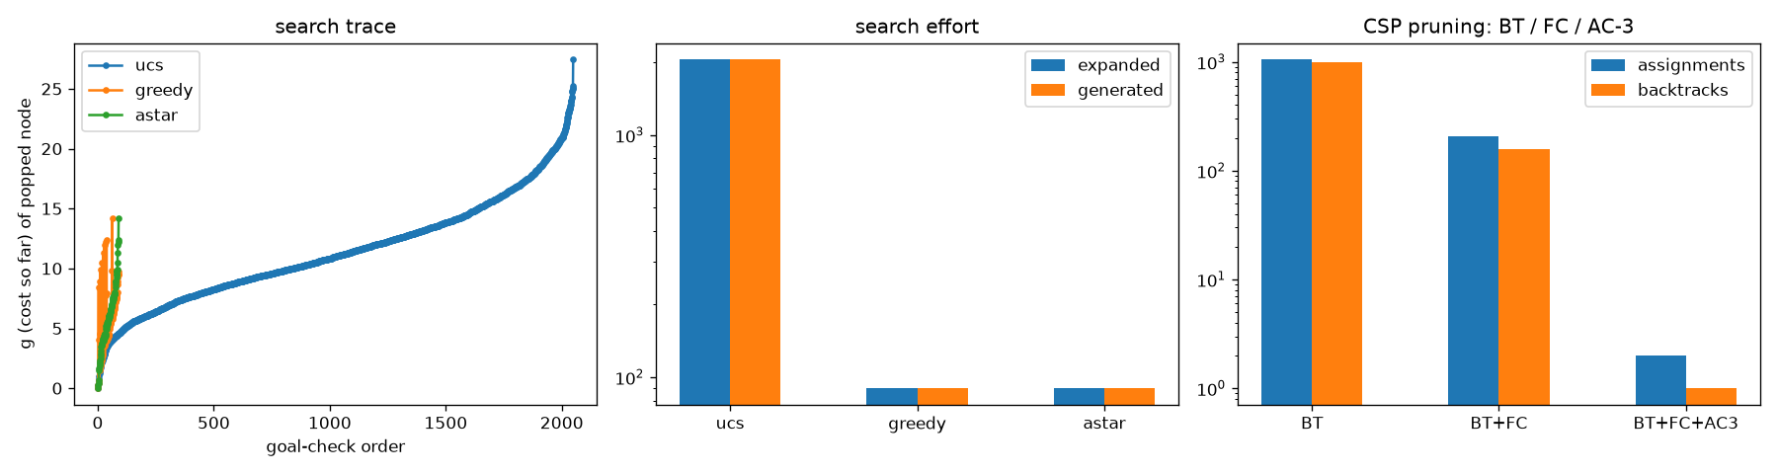
Figure 3. Cooperation on the demo puzzle. Left: cost of each node popped by UCS, Greedy and A* (Greedy and A* coincide on this instance). Middle: nodes expanded and generated. Right: CSP assignments and backtracks for BT, BT+FC and BT+FC+AC-3.

On the demo puzzle (two misreads, 30 givens) all three algorithms found the same corrections (8 → 5 at cost 1.170 and 8 → 3 at cost 0.125, total 1.294). UCS expanded 6 nodes, and Greedy and A* expanded 2. With the correction switched off the system reports "unreadable"; with it on, it recovers the exact solution. This is one instance and is only an illustration; Section 6 gives the averaged evidence.

6. Experiments
All experiments use 5 seeds. The seeds change the puzzles and the chosen images; the trained network is the same, so the standard deviations show variation across puzzles and images, not across training runs. Experiments 1 and 3 use 100 puzzles per misread level per seed with 30 givens (500 per level); Experiment 2 uses 20 puzzles per difficulty per seed (100 per cell). Tables show mean ± standard deviation across seeds. "Recovered" means that the returned solution equals the true solution exactly.

6.1 Experiment 1: UCS vs Greedy vs A*
Goal: exactly one solution (results_unique).
Misreads | UCS expanded | Greedy expanded | A* expanded | Recovered (UCS = A*) | Recovered (Greedy)
0 | 0 | 0 | 0 | 1.000 | 1.000
1 | 28.1 ± 22.7 | 1.70 ± 0.92 | 1.75 ± 0.90 | 0.956 ± 0.025 | 0.956 ± 0.025
2 | 44.5 ± 31.5 | 6.13 ± 0.83 | 3.97 ± 0.78 | 0.872 ± 0.044 | 0.838 ± 0.044
3 | 142.7 ± 35.6 | 10.2 ± 1.4 | 7.53 ± 0.69 | 0.802 ± 0.022 | 0.750 ± 0.040
4 | 1658 ± 83 | 21.9 ± 3.4 | 21.9 ± 3.7 | 0.000 | 0.000
Table 3. Search effort (nodes expanded) and exact-solution recovery, goal "exactly one solution".
Goal: solvable (results).
Misreads | UCS expanded | Greedy expanded | A* expanded | Recovered (UCS = A*) | Recovered (Greedy)
0 | 0 | 0 | 0 | 1.000 | 1.000
1 | 23.5 ± 14.9 | 1.39 ± 0.86 | 1.44 ± 0.84 | 0.844 ± 0.034 | 0.844 ± 0.034
2 | 35.9 ± 25.4 | 3.83 ± 0.48 | 2.72 ± 0.23 | 0.678 ± 0.060 | 0.646 ± 0.050
3 | 119.6 ± 34.6 | 6.69 ± 1.33 | 5.19 ± 0.66 | 0.544 ± 0.027 | 0.500 ± 0.037
4 | 1067 ± 64 | 12.1 ± 3.3 | 12.2 ± 3.4 | 0.000 | 0.000
Table 4. The same experiment with goal "solvable".
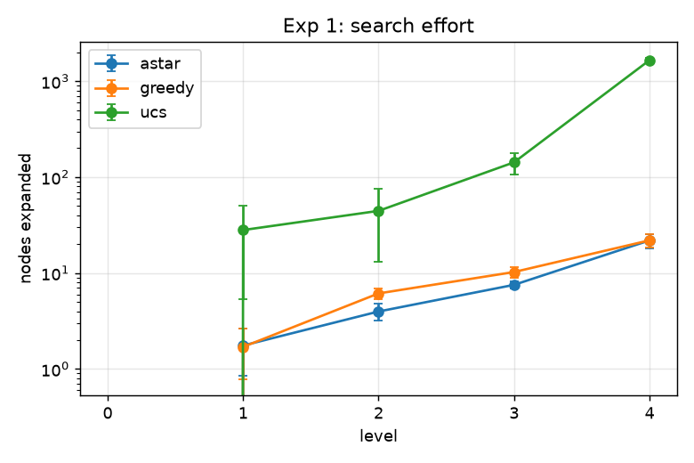 | 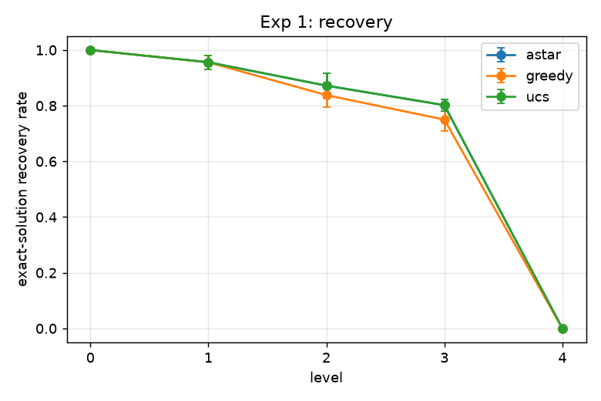  .
Figure 4a. Nodes expanded (log scale). | Figure 4b. Exact-solution recovery

- UCS and A* are both optimal, so they recover exactly the same fraction at every level; they differ only in effort. A* expands about 16 times fewer nodes than UCS with one misread, 19 times fewer with three and 76 times fewer with four (goal "unique").
- Greedy expands about as few nodes as A*, but recovers less at two and three misreads (0.838 and 0.750 against 0.872 and 0.802). It takes the first fix it finds, which is not always the cheapest. With one misread Greedy and A* are practically equal, so the advantage of A* over Greedy appears only for several misreads.
- Level 4 recovers nothing for every method because it exceeds the 3-correction limit; this is by design. What differs is how much work each method does before giving up, and UCS does far more.

6.2 Experiment 2: Backtracking vs Forward Checking vs AC-3
Givens | Variant | Assignments | Backtracks | AC-3 revisions | Time (ms) | Aborted
25 | BT | 33,075 ± 8,826 | 33,023 ± 8,829 | 0 | 255.5 ± 74.8 | 0.130
25 | BT+FC | 9,741 ± 1,928 | 9,685 ± 1,928 | 0 | 36.6 ± 7.1 | 0
25 | BT+FC+AC-3 | 80.5 ± 27.6 | 75.2 ± 26.9 | 29,924 ± 7,485 | 10.5 ± 2.1 | 0
30 | BT | 7,864 ± 3,270 | 7,813 ± 3,270 | 0 | 59.3 ± 24.8 | 0.010
30 | BT+FC | 1,817 ± 653 | 1,766 ± 653 | 0 | 7.1 ± 2.3 | 0
30 | BT+FC+AC-3 | 10.8 ± 4.4 | 8.6 ± 4.2 | 11,579 ± 1,049 | 3.9 ± 0.4 | 0
35 | BT | 734 ± 105 | 688 ± 105 | 0 | 5.6 ± 1.2 | 0
35 | BT+FC | 258 ± 48 | 212 ± 48 | 0 | 1.1 ± 0.2 | 0
35 | BT+FC+AC-3 | 1.5 ± 1.1 | 1.1 ± 0.9 | 8,839 ± 96 | 3.1 ± 0.2 | 0
Table 5. CSP effort on unique-solution puzzles. "Aborted" is the fraction of runs that hit the 100,000-assignment cap.
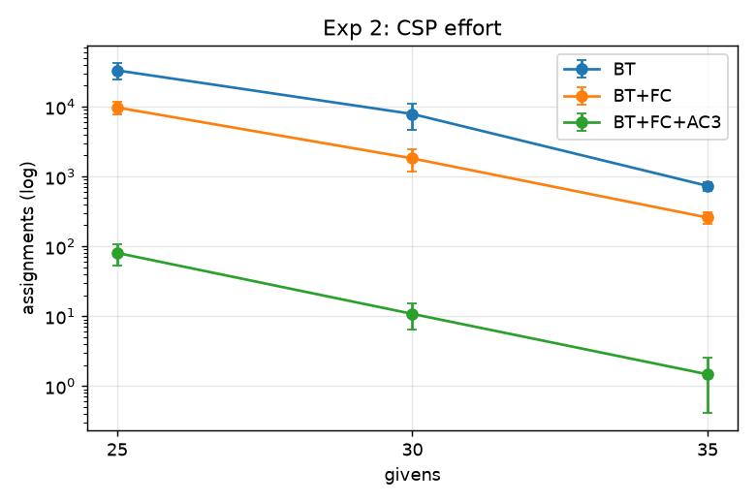 | 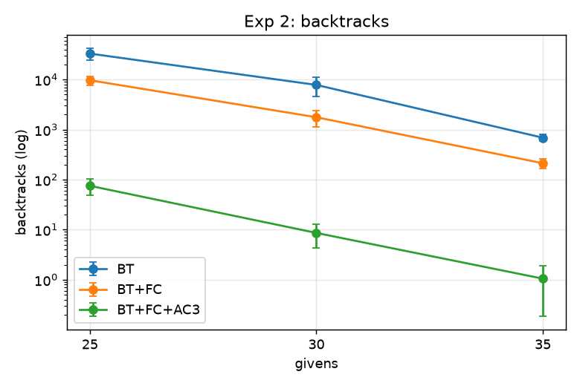  Figure 5b. Backtracks (log scale).
Figure 5a. Assignments (log scale).

- Each added technique reduces assignments and backtracks at every difficulty. With 25 givens the mean goes from about 33,000 assignments (BT) to about 9,700 (FC) to about 80 (FC+AC-3).
- Plain BT reached the cap on 13% of the 25-given puzzles, so its true mean is higher than reported (a lower bound).
- AC-3 is not free. It performs thousands of cheap revisions on every puzzle. It is the fastest variant at 25 and 30 givens, but at 35 givens it is slower than FC (3.1 ms against 1.1 ms) although it needs only about 1.5 assignments. The pruning pays off on harder puzzles. Times depend on the machine and on Python, so compare ratios, not absolute values.

6.3 Experiment 3: NN-guided vs no correction vs random correction
Goal "exactly one solution". Random correction tries up to 300 random correction sets (random cells, random digits, one to three cells); "none" solves the first reading as it is.
Mode | 0 misreads | 1 | 2 | 3 | 4
NN-guided (A*) | 1.000 | 0.956 ± 0.025 | 0.872 ± 0.044 | 0.802 ± 0.022 | 0.000
No correction | 1.000 | 0.000 | 0.000 | 0.000 | 0.000
Random (300 tries) | 1.000 | 0.298 ± 0.044 | 0.004 ± 0.005 | 0.000 | 0.000
Table 6. Exact-solution recovery rate.
Mode | 0 misreads | 1 | 2 | 3 | 4
NN-guided (A*) | 1.00 | 2.24 ± 0.82 | 3.24 ± 0.87 | 4.86 ± 0.61 | 13.96 ± 3.57
No correction | 1.00 | 0.32 ± 0.03 | 0.12 ± 0.05 | 0.05 ± 0.02 | 0.01 ± 0.01
Random (300 tries) | 1.00 | 10.42 ± 0.73 | 7.07 ± 2.03 | 3.07 ± 1.55 | 1.21 ± 0.76
Table 7. Full CSP solves per puzzle. Puzzles with duplicate digits are rejected by a cheap check first and do not reach the CSP, so this column undercounts total work.
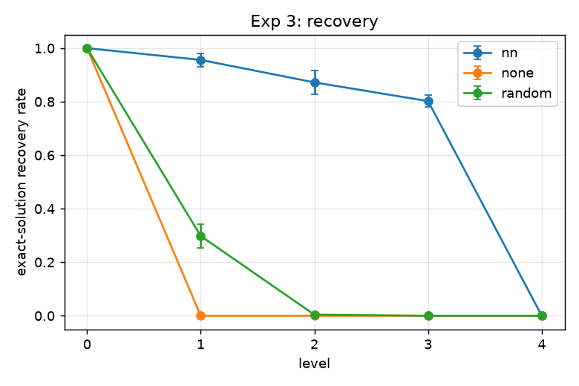 | 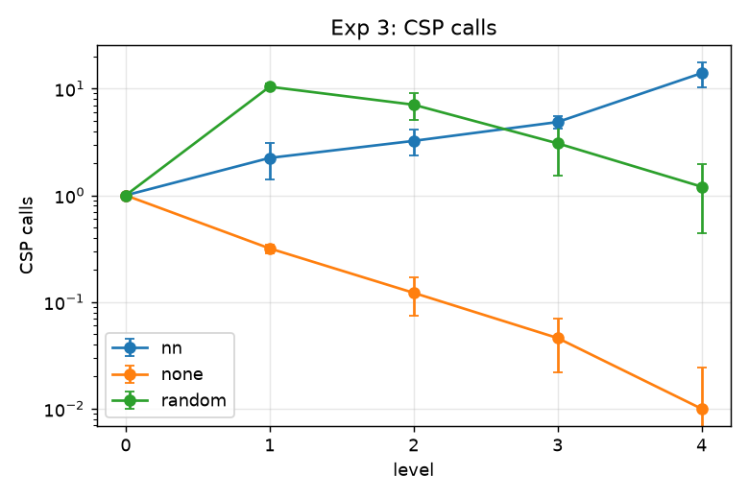
Figure 6a. Recovery rate. | Figure 6b. CSP calls (log scale).

- NN-guided correction is clearly the best: 0.956, 0.872 and 0.802 at one to three misreads, against 0.298, 0.004 and 0.000 for random correction. The network’s probabilities are what make the search efficient.
- "No correction" scores 0 by construction: once any cell is misread, a solution that agrees with the misread given cannot be the true solution. It is a floor and not a competitive baseline.
- Random correction depends on its budget (300 tries); a different budget would change its numbers, though not the conclusion.

6.4 Where the failures come from
To see why recovery is not 100%, every failure of A* was classified (500 puzzles per level):
Misreads | Goal | Recovered | Solved but wrong | Unreadable
1 | solvable | 422 | 73 | 5
1 | unique | 478 | 16 | 6
2 | solvable | 339 | 156 | 5
2 | unique | 436 | 59 | 5
3 | solvable | 272 | 213 | 15
3 | unique | 401 | 83 | 16
Table 8. Outcomes for A* (counts out of 500 puzzles per level).
Almost all failures are not "unreadable" but silent wrong answers: the corrected puzzle is solvable, or even uniquely solvable, but is not the true one. With goal "solvable" this happened in 73, 156 and 213 of 500 puzzles; requiring a unique solution cut it by about 78% at one misread and about 61 to 62% at two and three, which lifts recovery by 11 to 26 percentage points. The system said "unreadable" in only 5 to 16 of 500 puzzles under both goals, so the candidate limits (12 cells, 2 alternatives) are not the main bottleneck, although larger limits were not tested. The price of the stricter goal is more search work (more nodes expanded at every level).

7. Limits
- Silent wrong answers. Correcting by lowest cost can accept a confident wrong puzzle. The uniqueness goal reduces this (16, 59 and 83 of 500 remain) but does not remove it. These remaining cases were not split by cause (for example, a misread that already leaves a unique puzzle, against a cheaper wrong fix beating the true one), which is open.
- Correction limit. At most 3 corrections, so 4 or more misreads are always reported as unreadable.
- Stress-test levels. With a real misread rate of about 2.4% per digit, a 30-given puzzle has about 0.7 expected misreads. Levels 2 to 4 are deliberately harder than normal use, and the injected hard digits are test images the network actually gets wrong.
- Synthetic puzzles. The Sudokus are generated mosaics of MNIST digits, not photographs of real handwriting, and the network is a small MLP and not a CNN.
- Experimental design. One trained network is used for all seeds. The random baseline has a fixed budget. Plain backtracking was capped, so its results are lower bounds. Experiment 3 was run only with goal "unique". CPU times depend on the machine.
- Temperature scaling. It did not help because the network was already well calibrated, so its effect on the search is untested.

8. Conclusions
The three techniques work together as intended. The network supplies probabilities that serve as correction costs, AC-3 detects broken readings, A* finds the cheapest correction set with far fewer nodes than UCS, and forward checking with AC-3 reduces the CSP work by orders of magnitude. On real MNIST the MLP reaches 97.6% test accuracy against 92.0% for logistic regression, and NN-guided correction recovers the exact solution for 95.6%, 87.2% and 80.2% of puzzles with one, two and three misreads, against at most 29.8% for random correction. The main weakness is the silent wrong answer, which the uniqueness goal reduces but does not eliminate. Possible next steps are a CNN, testing larger candidate limits, and analysing the remaining wrong answers by cause.

References
LeCun, Y., Cortes, C., Burges, C. The MNIST database of handwritten digits. http://yann.lecun.com/exdb/mnist/
Russell, S., Norvig, P. Artificial Intelligence: A Modern Approach (search, A*, constraint satisfaction, AC-3).

