Ain Shams University

CESS -CHEP

Mohammed Ehab Elsaeed

16P8160

CSE385

Data Mining and Business Intelligence

Instructor: Dr Mahmoud Mounir

End Term Assessment Research Paper

A decision tree is a flowchart-like tree structure, where each node denotes a test on an attribute value, each branch represents an outcome of the test, and tree leaves represent classes or class distributions. Decision trees can easily be converted to classification rules.

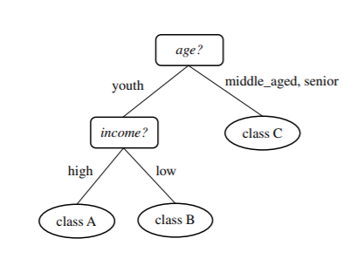

(1.4.3)