

object Oreinted Analysis and Design

Project Report



Made By:

Mohammed Ehab Elsaeed 16P8160

Ahmed Sameh Shahin 16P6063

Youssef Assem Mohammed 16P6064

To Be Submitted To:

Dr. Islam El Maddah

Eng. Sarah Abdelazim

# Use cases Used

1. Graph Equations
2. Operate on Matrices
3. Evaluate Arithmetic Expressions
4. Evaluate Logarithmic Expressions
5. Evaluate Exponential Expressions
6. Evaluate Trigonometric Expressions
7. Evaluate Calculus Expressions
8. Show History of calculations

# Use Case Diagram

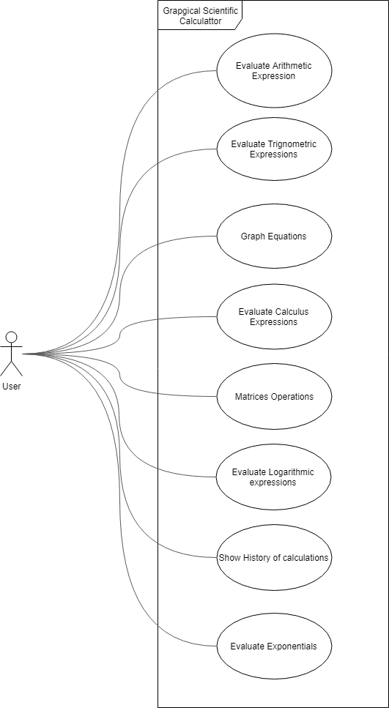

# Analysis Classes

1. Controller
2. ArithmeticController
   1. arithmeticForm
3. TrigonometricController
   1. trigonometricForm
4. GraphController
   1. graphForm
5. CalculusController
   1. calculusForm
6. MatricesController
   1. matrix
   2. matrixForm
7. LogarithmicController
   1. logarithmicForm
8. ExponentialController
   1. exponentialForm
9. HistoryController
   1. historyForm
10. Matrix
    1. values
11. ArithmeticForm
12. TrigonometricForm
13. GraphForm
14. CalculusForm
15. MatricesForm
16. LogarithmicForm
17. HistoryForm
18. ExponentialForm