Team number:105
Repo URL: https://github.com/M-Elshamy3/OS_Project.git
1) SJF vs Priority Scheduler Comparison

A CPU scheduling simulator that compares Shortest Job First (SJF) and Priority Scheduling algorithms to help understand the trade-offs between efficiency and urgency.

2) What This Project Does
This program lets you compare two different ways a computer decides which task to run next:
SJF (Shortest Job First): Runs the quickest jobs first to minimize average waiting time
Priority Scheduling: Runs the most important jobs first, regardless of how long they take

You can test both algorithms in preemptive (can interrupt) and non-preemptive (runs to completion) modes to see how they behave differently.

3) Team Members

| Name | ID | What I Worked On |
|Mahmoud Alaa |20240909|Added Comparison Service|
|Mazen Ashraf |20240762|Added Scheduler Service|
|Mohamed Ahmed Abdelhamid| 20240787 |Added AppState,InputPanelFactory and SectionsFactory| |Loay Hossam 20240744 | |Added SchedulerModels and SimulationController|
|Mohamed Aly | 20240860 |Added ConclusionService|
|Aly Shukry | 20241215 |Added UIFactory and SchedulerApp|
|Yousef Karam | 20241174 |Added ScenarioService and ValidationService|

4) Features

- Enter processes with arrival time, burst time, and priority
- Choose preemptive or non-preemptive mode for each algorithm
- See visual Gantt charts showing execution timeline
- Compare waiting time, turnaround time, and response time
- Get automatic analysis and recommendations
- Test with 4 built-in scenarios including edge cases

5) What You Need

- Java 11 or newer
- JavaFX 11 or newer
- Any IDE (IntelliJ, Eclipse, NetBeans) or just command line

6) How to Run
Quick Start with IDE

1. Clone this repo
2. Open in your IDE (IntelliJ recommended)
3. Add JavaFX library to your project
4. Add these VM options:

--module-path /path/to/jfx-17.0.19_windows-x64_bin-sdk\javafx-sdk-17.0.19/lib --add-modules javafx.controls

7) Run `Main.java`
Command Line

Compile
javac --module-path /path/to/jfx-17.0.19_windows-x64_bin-sdk\javafx-sdk-17.0.19/lib --add-modules javafx.controls -d bin src/*.java src/**/*.java

8) Run
java --module-path /path/to/javafx-sdk/lib --add-modules javafx.controls -cp bin Main

9) How to Use It

1. Set number of processes and click Create Rows
2. Choose your mode - Preemptive or Non-preemptive for both algorithms
3. Enter process details:
- PID: Process name (like P1, P2, P3...)
- Arrival Time: When it shows up (0 or positive number)
- Burst Time: How long it needs to run (must be > 0)
- Priority: How important it is (lower number = more important)
4. Click "Run Comparison" to see results
5. Check out the Gantt charts, metrics, and recommendations

Or just click one of the scenario buttons (A, B, C, D) to load pre-made examples!

10)Test Scenarios

1- Scenario A - Normal Mix
Just a regular workload to see how both algorithms handle typical situations.

2-Scenario B - Short vs Important
What happens when a short job has low priority, but a long job is super important? This reveals the core trade-off.

3- Scenario C - Fairness Test
Can one process get stuck waiting forever? This scenario tests starvation risk.

4- Scenario D - Validation
Tests what happens with bad input (duplicate IDs, negative numbers, etc.).

11) What the Metrics Mean

- Waiting Time (WT): How long a process waits before getting CPU time
- Turnaround Time (TAT): Total time from arrival to finish
- Response Time (RT): Time until the process first gets the CPU

Lower is better for all of these

12) How the Algorithms Work

1- SJF (Shortest Job First)

Preemptive (SRTF): If a shorter job arrives, pause the current job and run the shorter one.

Non-preemptive: Once a job starts, let it finish. Then pick the shortest waiting job.

When to use it: When you want to minimize average waiting time and all jobs are equally important.

2- Priority Scheduling

Preemptive: If a more important job arrives, pause whatever's running and handle the urgent one.

Non-preemptive: Once started, finish the current job. Then pick the highest priority waiting job.

Priority rule: Lower number = higher priority (1 beats 5)

When to use it: When some tasks are more urgent than others, like system processes vs user programs.

3- Key Findings

SJF is great for efficiency - it gets the most jobs done quickly and keeps average waiting time low. But long jobs can get stuck waiting behind a stream of short jobs.

Priority is great for urgency - important tasks get done first. But if high-priority tasks keep coming, low-priority ones might wait forever (starvation).

The trade-off: Do you want efficient throughput (SJF) or guaranteed service for important tasks (Priority)?

4- What We Assumed

- All times are in some arbitrary unit (could be milliseconds, seconds, whatever)
- Switching between processes takes zero time (not realistic, but keeps it simple)
- We magically know how long each job will take (SJF's biggest weakness in real life)
- No I/O operations, just pure CPU work
- Priorities don't change over time

5- Known Limitations

1. SJF isn't realistic - In the real world, you can't predict exactly how long a program will run
2. Starvation is possible - Low priority jobs can wait forever if high priority jobs keep arriving
3. No aging- We didn't implement a system to gradually increase priority of waiting processes
4. No I/O modeling - Real programs often wait for disk/network, we ignored that

## Project Structure

```
src/
├── Main.java # Entry point
├── SchedulerApp.java # Main application window
├── AppState.java # Shared state
├── InputPanelFactory.java # Input UI
├── SectionsFactory.java # Output sections
├── SimulationController.java # Main logic controller
├── model/
│ └── SchedulerModels.java # Data classes
├── service/
│ ├── SchedulerService.java # Algorithm implementations
│ ├── ComparisonService.java # Comparison logic
│ ├── ConclusionService.java # Conclusion generator
│ ├── ScenarioService.java # Test scenarios
│ └── ValidationService.java # Input validation
└── ui/
└── UIFactory.java # UI components

13) Troubleshooting

"JavaFX not found"
Make sure you've added the JavaFX library and the --module-path VM option points to the right folder.

"Application won't start"
Check your Java version with `java -version`. Needs to be 11+.

"My inputs aren't working"
Make sure PIDs are unique, burst times are positive, and no fields are empty.

14) Screenshots
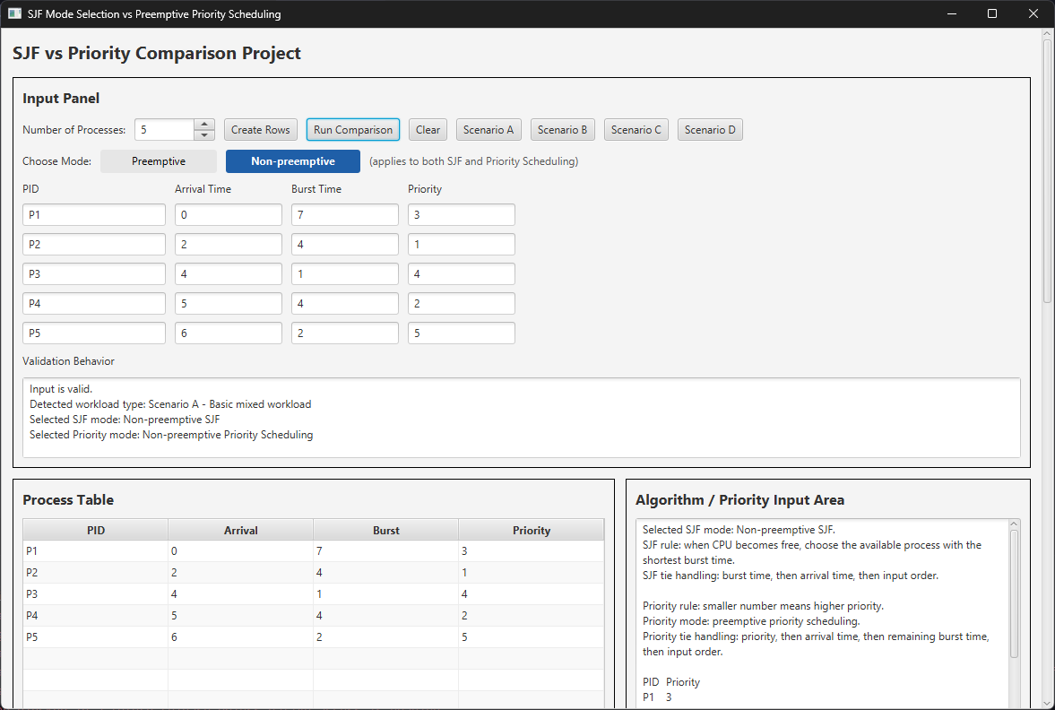

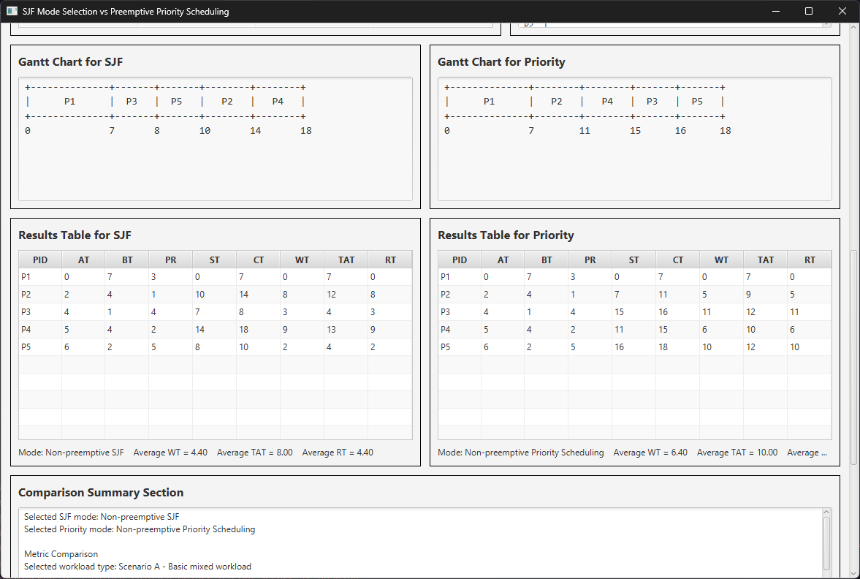

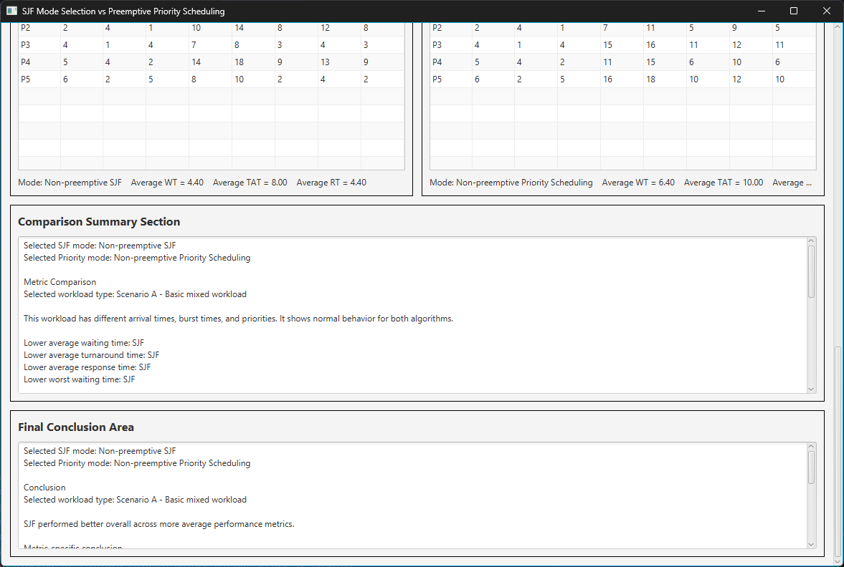
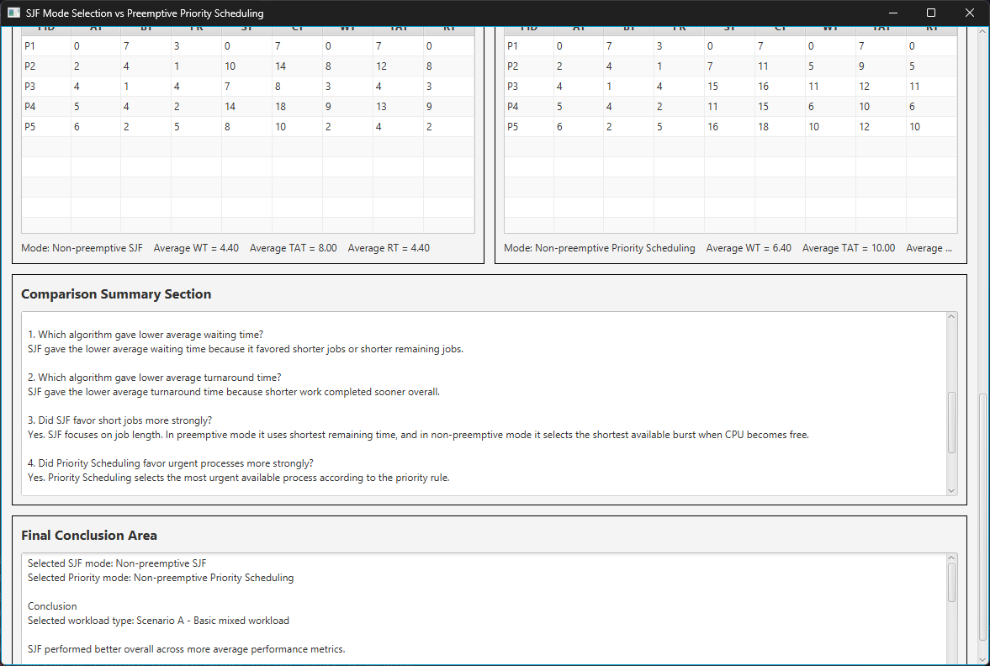

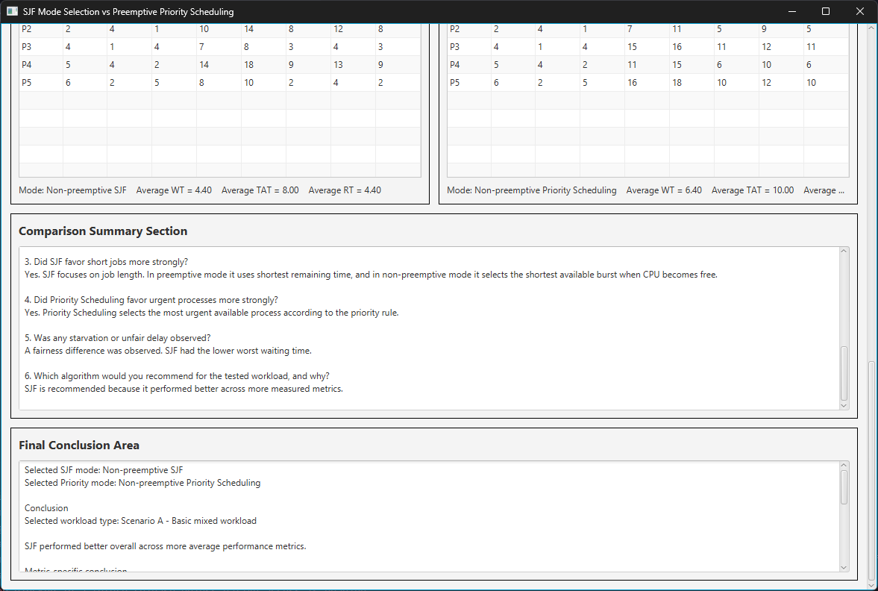
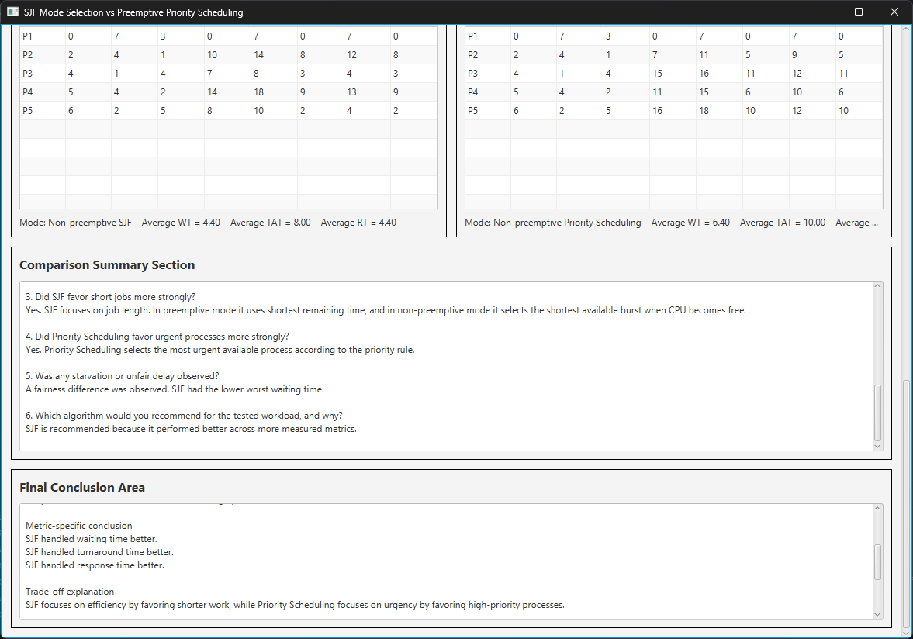

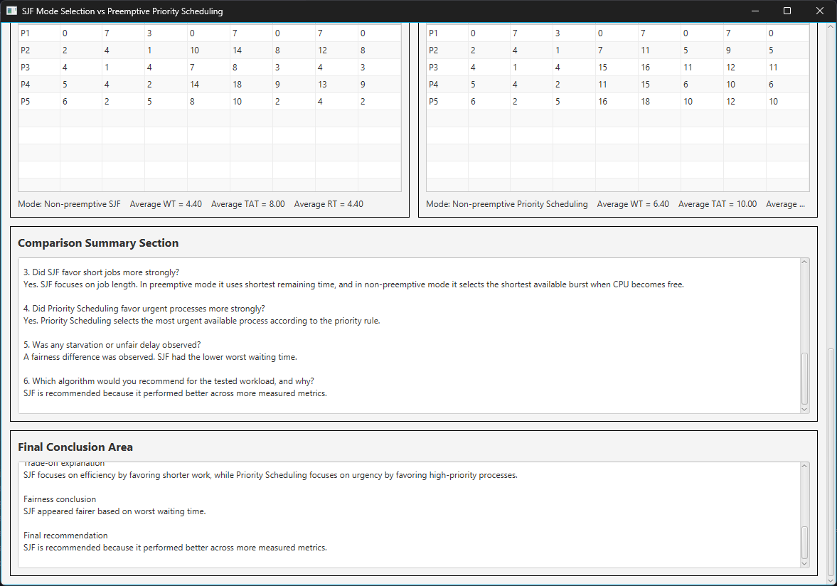
15)Future Ideas

If we had more time, we could add:
- Aging mechanism to prevent starvation
- Export charts as images
- Save/load test cases
- Animated Gantt chart showing execution in real-time
- Statistics like variance and standard deviation

## Notes for Evaluation

This project implements:
- Both preemptive and non-preemptive modes for SJF and Priority
- Clean GUI with clear input/output sections
- Input validation that catches bad data
- Gantt charts showing execution timeline
- Accurate WT, TAT, RT calculations
- All 4 required test scenarios
- Detailed comparison and recommendation system
- Trade-off analysis between efficiency and urgency

Priority rule: We chose lower number = higher priority (more intuitive)
Tie breaking: When values are equal, we use arrival time, then input order

