Web Technologies — Lab 1
CampusConnect
A Mini University Web Portal
Project Report & Final Deliverables
Submitted by
 | Student Name | Roll Number
Student 1 | Muhammad Farhan Bhatti | FA24-BSE-128
Student 2 | Muhammad Akif Naveed | FA24-BSE-129

Live Website
https://campus-connect-rose-nine.vercel.app/ (deployed link to the working CampusConnect website)
Source Code Repository
https://github.com/AkifNaveed12/campus-connect
Course | Web Technologies (5th Semester)
Assignment | Lab 1 — CampusConnect: One-/Two-/N-Tier Web Project
Instructor | Muhammad Shahid Khan
Submission Date | 9/15/2026

Table of Contents
1. Project Overview 3
1.1 Requirements from the lab manual 3
1.2 Technology stack 3
1.3 Project structure 4
1.4 Deliverables covered in this report 4
2. Deliverable 1 — Working CampusConnect Website 5
2.1 Pages and features 5
2.2 Page screenshots (desktop, 1440 px) 5
2.3 Interactive features (JavaScript) 9
2.4 Responsive behaviour 14
3. Deliverable 2 — Sitemap 15
3.1 Sitemap as a list 15
3.2 Navigation rules 16
4. Deliverable 3 — Home-page Wireframe 17
4.1 Home page wireframe (required) 17
4.2 User flow 18
4.3 Wireframes of the remaining pages 19
4.4 Contact page, dialog and toast wireframes 20
5. Deliverable 4 — HTML, CSS and JavaScript Files 21
5.1 HTML — shared structure on every page 21
5.2 CSS — design tokens and responsive rules 22
5.3 JavaScript — one script, page-safe features 22
6. Deliverable 5 — One-Tier, Two-Tier and N-Tier Diagrams 24
6.1 One-tier architecture (current prototype) 24
6.2 Two-tier architecture (client + web server) 24
6.3 N-tier architecture (presentation, logic, data access, database) 25
6.4 Comparison 26
7. Deliverable 6 — Development Environment 27
7.1 Workflow used 27
7.2 How to run the website 27
8. Deliverable 7 — Short Demonstration 29
8.1 Demonstration script 29
8.2 Testing checklist (results) 29
8.3 Exit questions — prepared answers 30
Appendix A — Complete Source Code 31

1. Project Overview
CampusConnect is a small, modern, responsive university web portal built for the Web Technologies lab. Its purpose is to help students quickly find information about academic departments, courses, student services and contact details, and to submit a Student Enquiry through a validated form.
The website is implemented with standard front-end technologies only — HTML5, CSS3 and vanilla JavaScript — with one shared stylesheet and one shared script used by every page. No framework, build tool, database or server-side code is required to run it, which makes it a true one-tier prototype; the same project is then used to explain the two-tier and N-tier architectures required by the lab.

1.1 Requirements from the lab manual
Requirement | How CampusConnect meets it
Minimum pages: Home, Departments, Courses, Student Services, Contact | All five pages implemented (index, departments, courses, services, contact).
Standard HTML structure and meaningful elements | Semantic header, nav, main, section, article, form, label, button and footer on every page.
CSS kept separate from HTML | Single css/style.css linked from every page; no inline styles.
Clear and consistent navigation | Identical header and footer navigation on all pages with an active-page indicator and mobile menu.
Different browsers and screen sizes | Tested in Chrome and Edge; responsive layouts for desktop, tablet and mobile (see Section 2.4).
Avoid unnecessarily large files | No raster images — icons are a web font, the hero illustration is inline SVG; CSS 21 KB, JS 30 KB.
Information easy to find; simple, user-friendly interface | Flat site structure: every page is one click away; cards, search/filter and a contact CTA.
Optional Student Enquiry form with JavaScript validation | Implemented on contact.html with per-field errors and a success message.
Sitemap, wireframe, tier diagrams, dev-environment explanation, demo | Sections 3 to 8 of this report.
Table 1: Lab requirements and where they are satisfied

1.2 Technology stack
Layer | Technology | Used for
Structure | HTML5 | Page content, semantic sections, navigation, forms, accessible labels
Presentation | CSS3 (custom properties, Flexbox, Grid, media queries) | Layout, design tokens, cards, buttons, responsive behaviour, modal and toast styling
Behaviour | Vanilla JavaScript (ES5-compatible, one IIFE) | Mobile navigation, course search/filter, detail dialogs, enquiry-form validation, toast messages
Assets | Google Fonts (Inter) + Material Symbols icon font | Typography and icons without shipping image files
Tooling | VS Code, Chrome/Edge DevTools, Git + GitHub, WampServer (optional) | Editing, testing, version control, localhost demonstration
Table 2: Technology stack

1.3 Project structure
campus-connect/
├── index.html Home – hero, quick access, previews, enquiry CTA
├── departments.html Six department cards
├── courses.html Programme cards + JavaScript search / filter + detail modal
├── services.html Six service cards + detail modal
├── contact.html Campus information + validated Student Enquiry form
├── css/
│ └── style.css ONE shared stylesheet (tokens, layout, components, responsive)
├── js/
│ └── script.js ONE shared script (nav, filter, modal, validation, toast)
├── wireframes/
│ └── student-portal-wireframes.excalidraw Low-fidelity wireframes + user flow
└── docs/
├── IDEA.md Product specification (scope, pages, features)
└── DESIGN.md Design system (colours, typography, components)

This follows the structure suggested in Section 8 of the lab manual. The assets/ folder is intentionally empty: the site does not need any local images, which keeps every page light to download.

1.4 Deliverables covered in this report
In the order required by Section 16 of the lab manual:
1. Working CampusConnect website — Section 2
2. Sitemap — Section 3
3. Home-page wireframe (plus user flow and the remaining page wireframes) — Section 4
4. HTML, CSS and JavaScript files — Section 5 and Appendix A
5. One-tier, two-tier and N-tier architecture diagrams — Section 6
6. Short explanation of the development environment — Section 7
7. Short demonstration to the instructor — Section 8

2. Deliverable 1 — Working CampusConnect Website
The complete website is deployed at https://campus-connect-rose-nine.vercel.app/ and the source is available at https://github.com/AkifNaveed12/campus-connect. It can also be opened directly from the project folder (double-click index.html) or through WampServer on localhost — see Section 7 for all three ways of running it.

2.1 Pages and features
Page | File | Main content | JavaScript interaction
Home | index.html | Hero with two calls to action, Quick Access cards, 'Why CampusConnect' features, Popular Departments, Student Services preview, enquiry CTA | Mobile menu, Login placeholder toast
Departments | departments.html | Page hero + six department cards (CS, SE, IT, EE, BBA, Mathematics) with icons, descriptions and links | Mobile menu, Download Catalog placeholder toast
Courses | courses.html | Search box, department filter, live result count, six programme cards, empty state | Case-insensitive search + department filter working together, 'Clear Filters', programme detail dialog
Student Services | services.html | Six service cards: Academic Advising, Library, Career Services, Student Affairs, IT Support, Admissions | Service detail dialog (what it offers, how to access, hours, contact)
Contact | contact.html | Campus address, phone, email, office hours and the Student Enquiry form (5 fields) | Client-side validation with per-field messages, error summary and success alert
Table 3: Pages of the CampusConnect website

2.2 Page screenshots (desktop, 1440 px)
Each page is shown first as it appears on loading (above the fold) and then as a full-page capture.

Home page
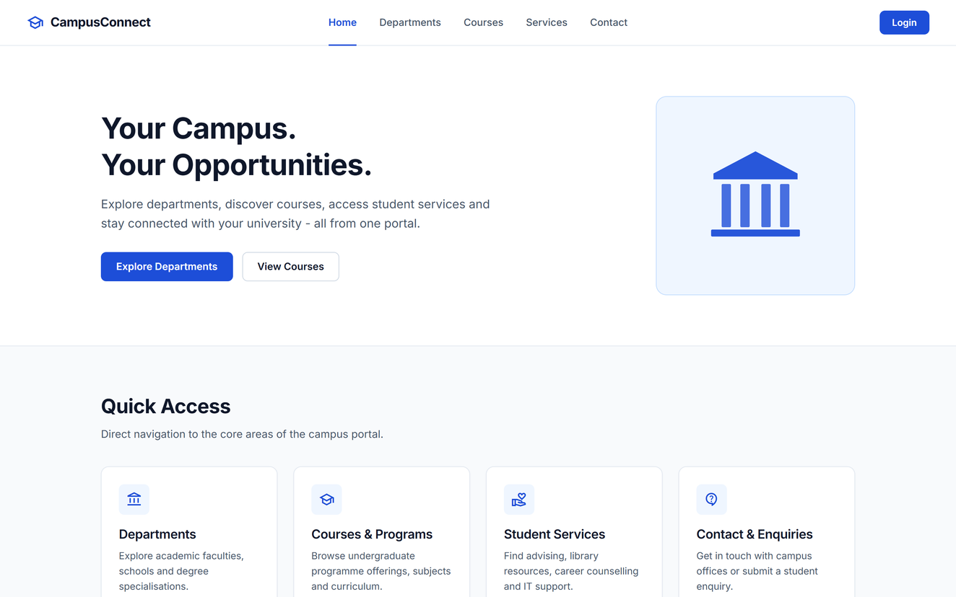
Figure 1: Home page — first screen on a 1440 px desktop viewport

Departments page
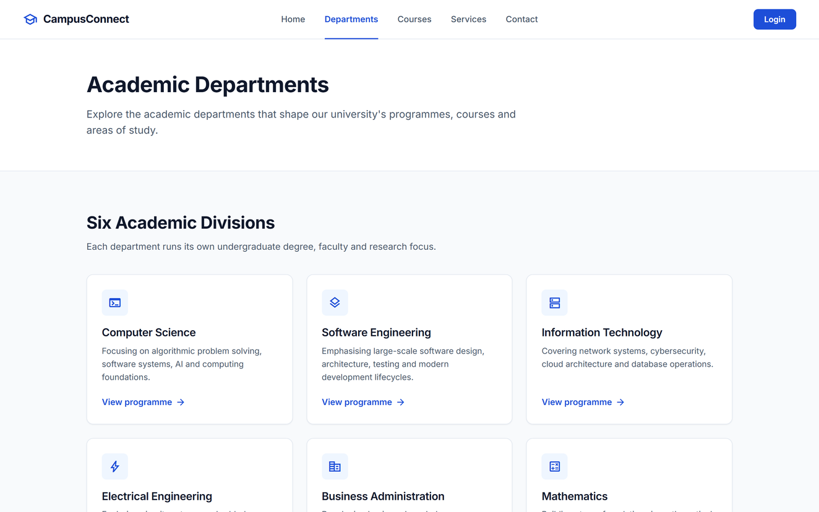
Figure 2: Departments page — first screen on a 1440 px desktop viewport

Courses page
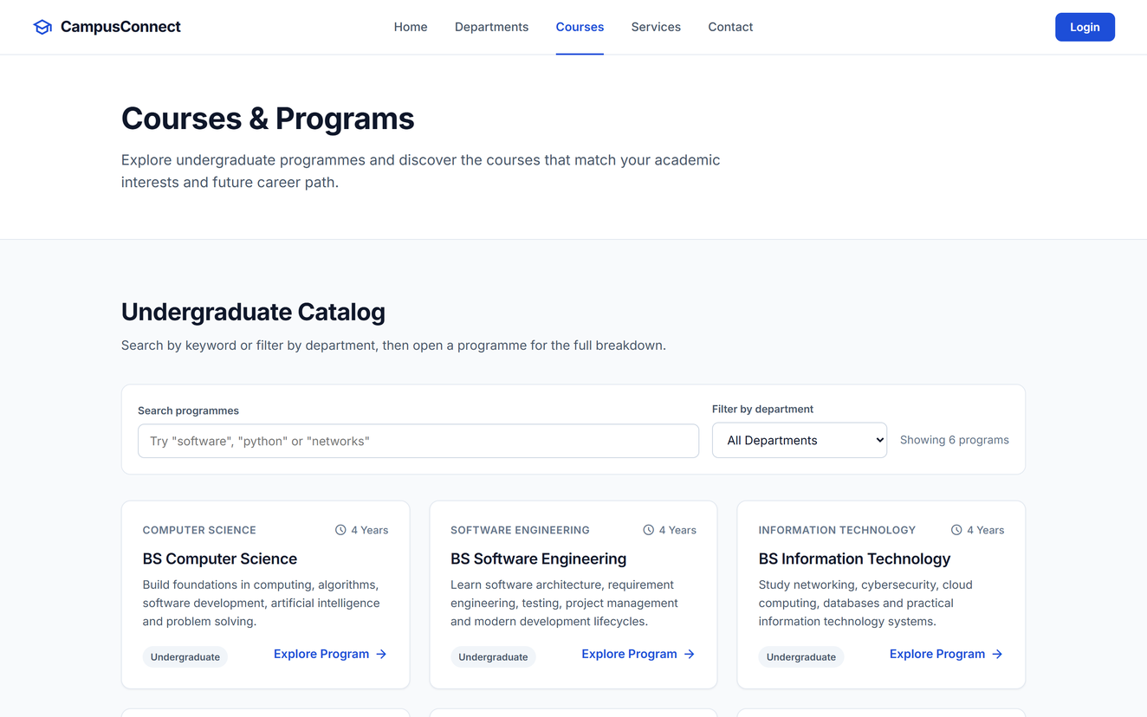
Figure 3: Courses page — first screen on a 1440 px desktop viewport

Student Services page
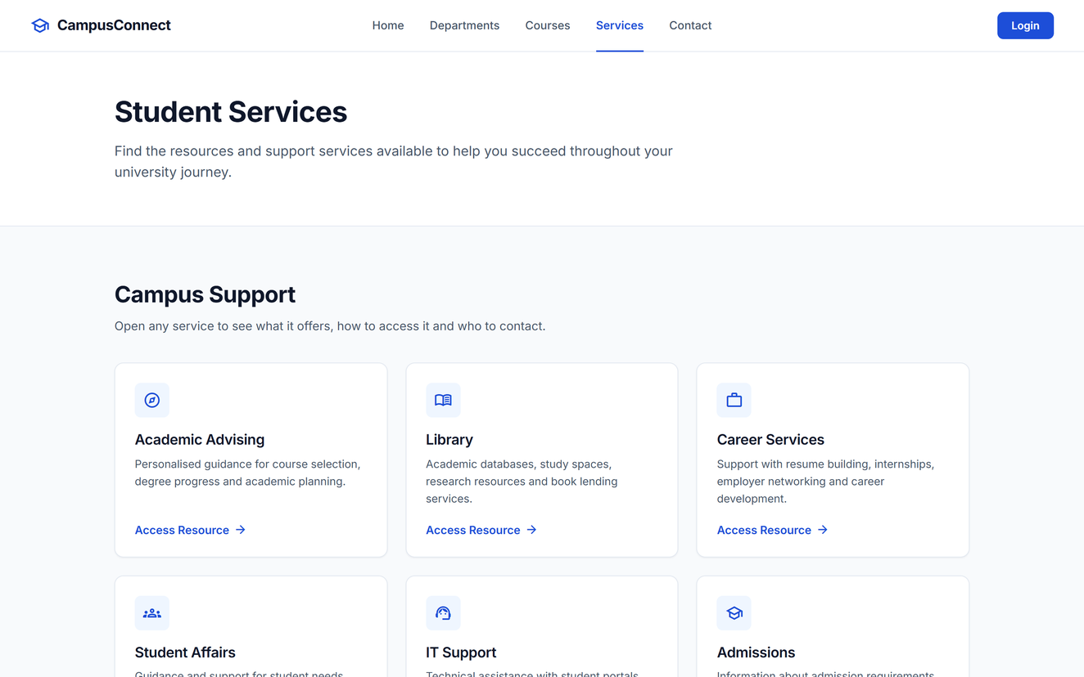
Figure 4: Student Services page — first screen on a 1440 px desktop viewport

Contact page
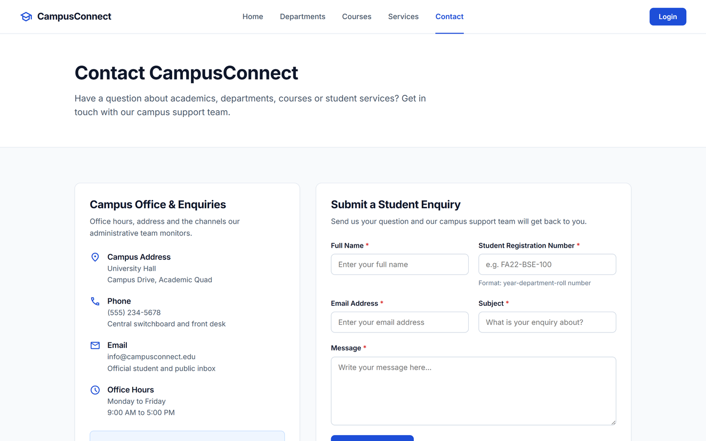
Figure 5: Contact page — first screen on a 1440 px desktop viewport

Full-page captures
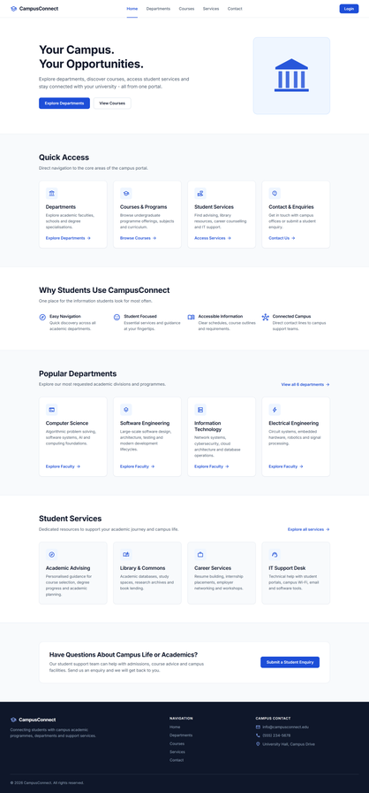 | 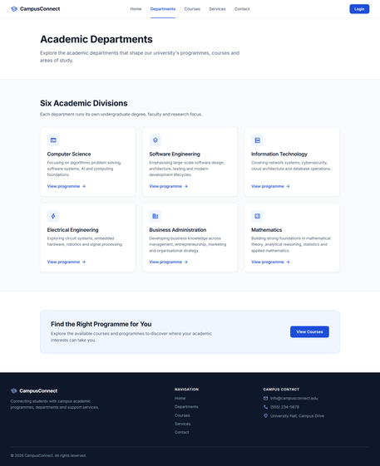 | 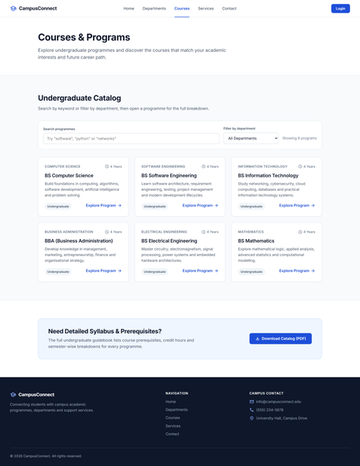
Figure 6: Home page — full page | Figure 7: Departments page — full page | Figure 8: Courses page — full page

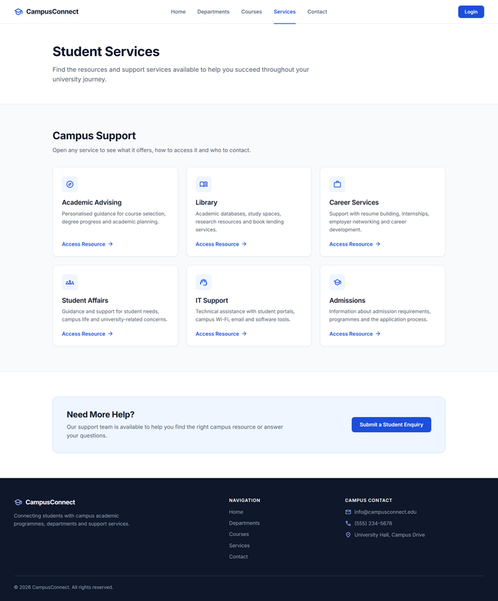 | 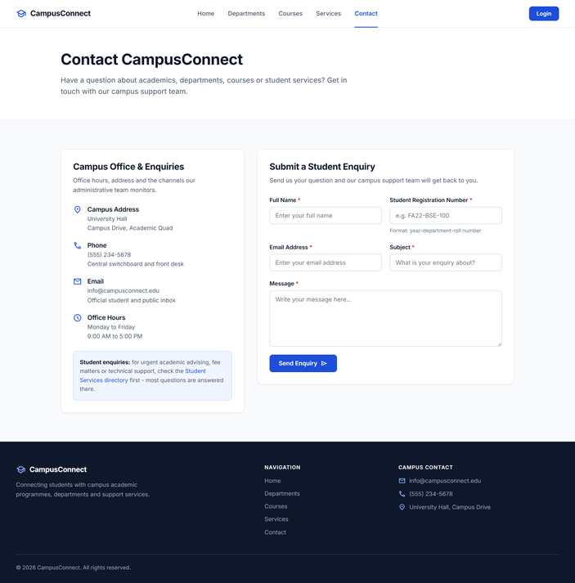
Figure 9: Student Services page — full page | Figure 10: Contact page — full page

2.3 Interactive features (JavaScript)
All behaviour lives in js/script.js. Each feature checks that its HTML exists before attaching listeners, so the single script is safe to load on every page.

Course search and department filter
Typing in the search box filters the programme cards instantly; the department drop-down narrows the results further. Both work together and the result count updates live. When nothing matches, a friendly empty state with a 'Clear Filters' button is shown.
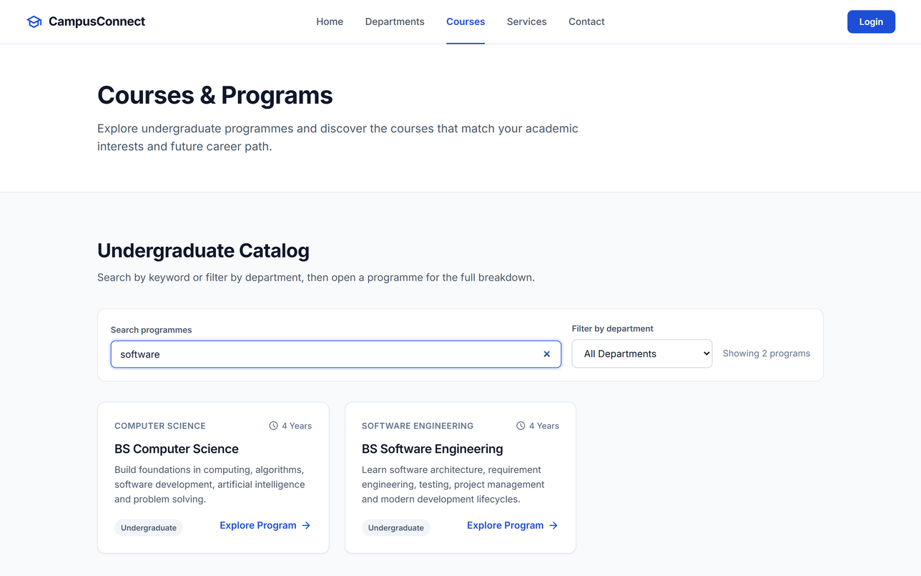
Figure 11: Searching for "software" shows only BS Software Engineering
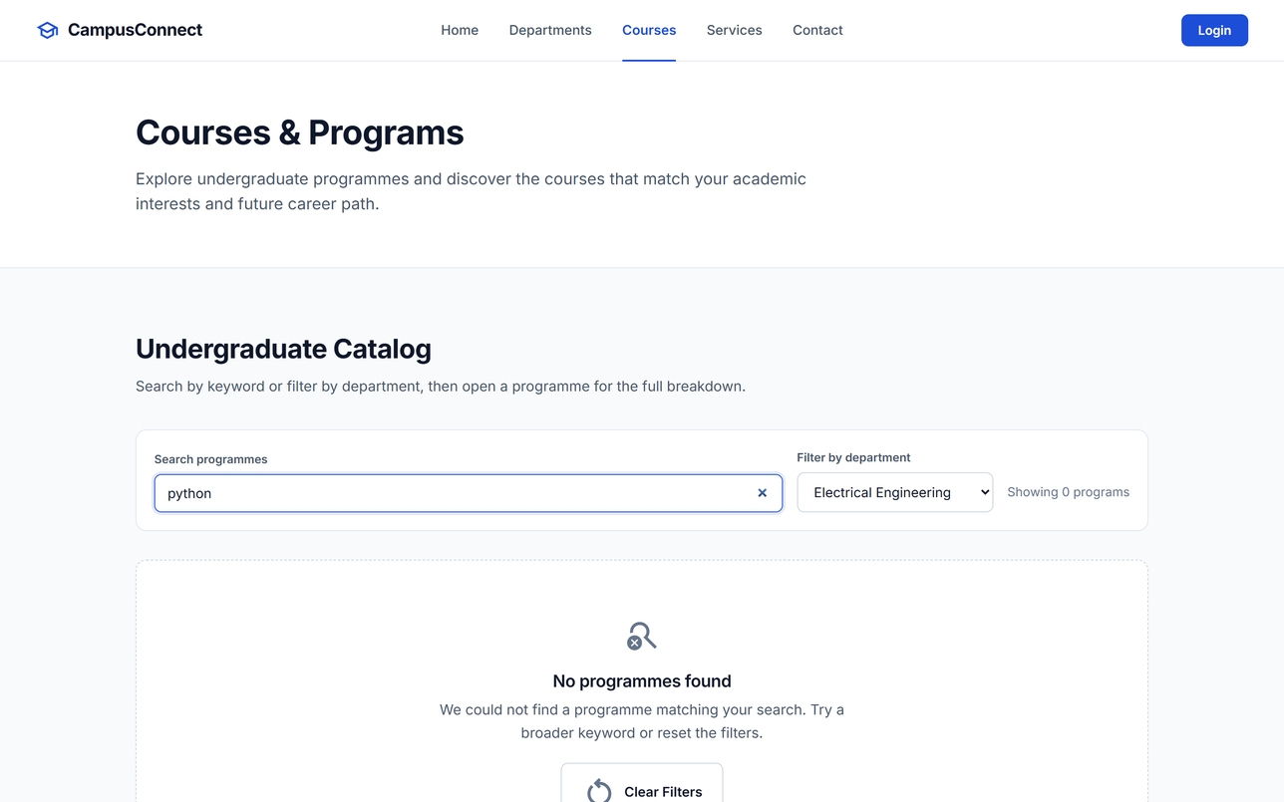
Figure 12: No match for "python" in Electrical Engineering — empty state with Clear Filters

Programme and service detail dialogs
Every course and service card has an 'Explore Program' / 'Access Resource' button that opens a dialog rendered from a data object in script.js. The dialog closes with the × button, the Escape key, or by clicking the backdrop, and returns focus to the card.
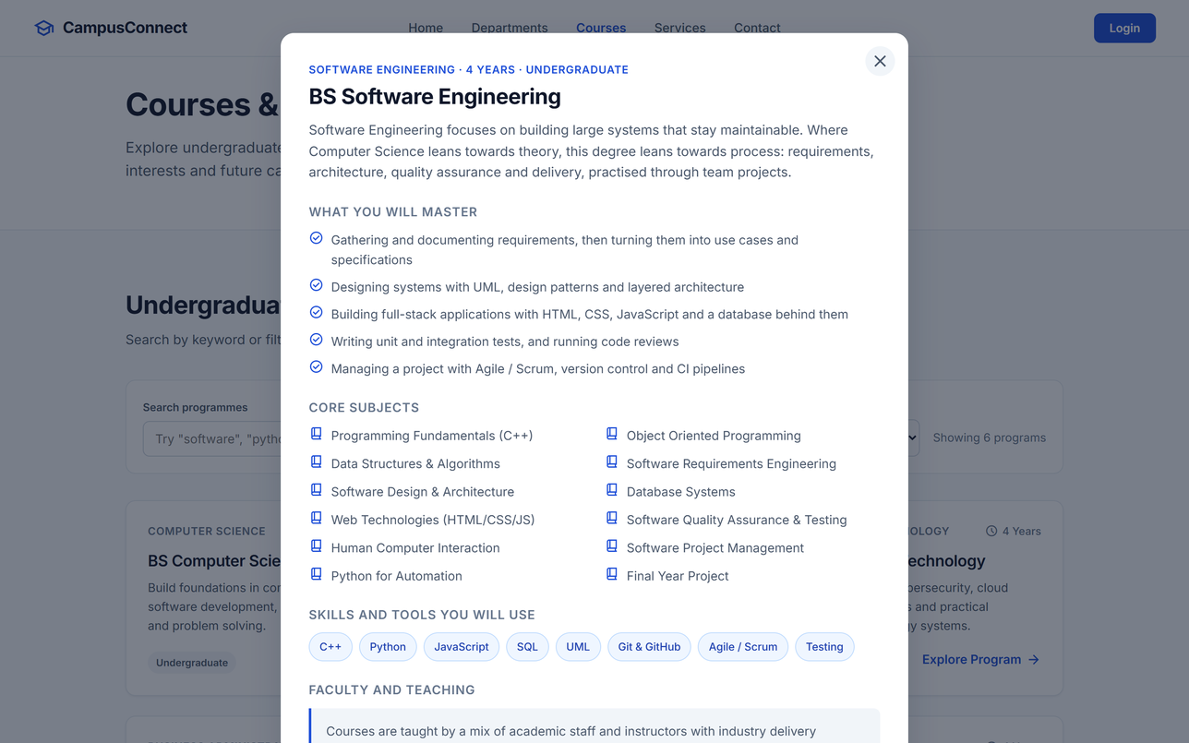
Figure 13: Programme detail dialog for BS Software Engineering (subjects, skills, faculty, careers)
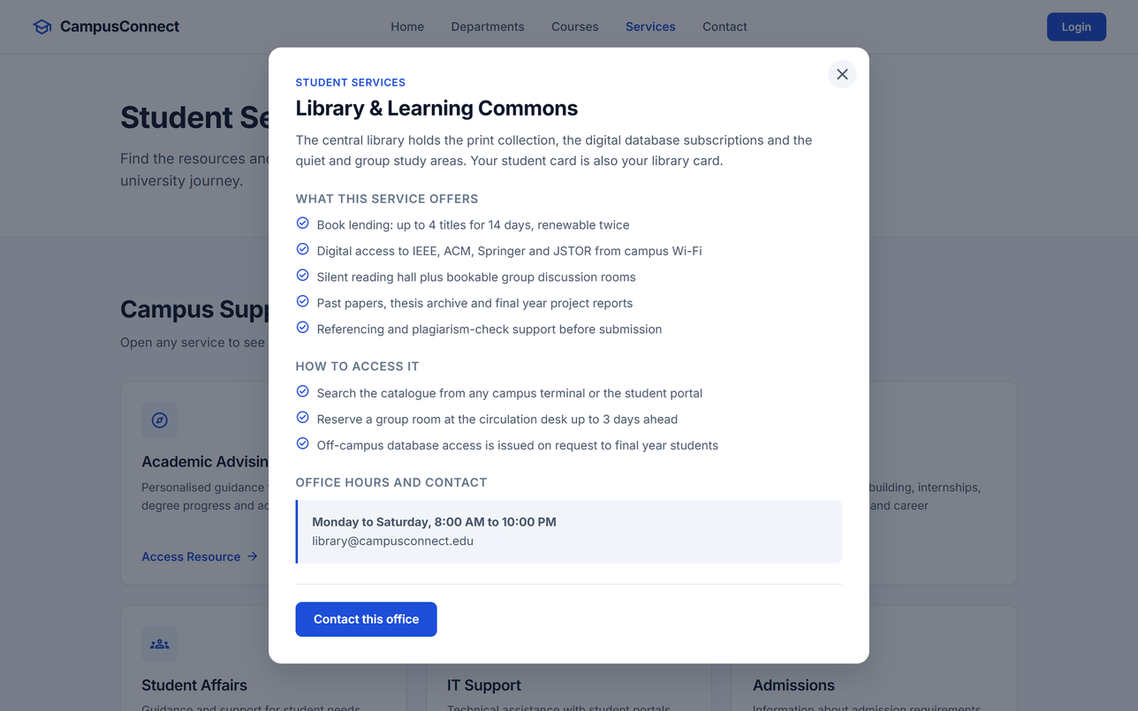
Figure 14: Service detail dialog for the Library & Learning Commons

Student Enquiry form validation
The form has five required fields: Full Name, Student Registration Number, Email, Subject and Message. Submitting with invalid data highlights each faulty field with a specific message, and the error is cleared as soon as the student fixes it. A valid submission shows a success alert and resets the form. Because this is a one-tier prototype nothing is sent to a server.
Field | Rule | Message when invalid
Full Name | at least 3 characters | Please enter your name (at least 3 characters).
Registration Number | pattern year-dept-roll, e.g. FA22-BSE-100 or 2023-SE-045 | Enter a valid registration number, e.g. FA22-BSE-100 or 2023-SE-045.
Email | must look like name@domain.tld | Please enter a valid email address.
Subject | at least 3 characters | Please enter a subject.
Message | at least 10 characters | Please enter your message (at least 10 characters).
Table 4: Validation rules of the Student Enquiry form
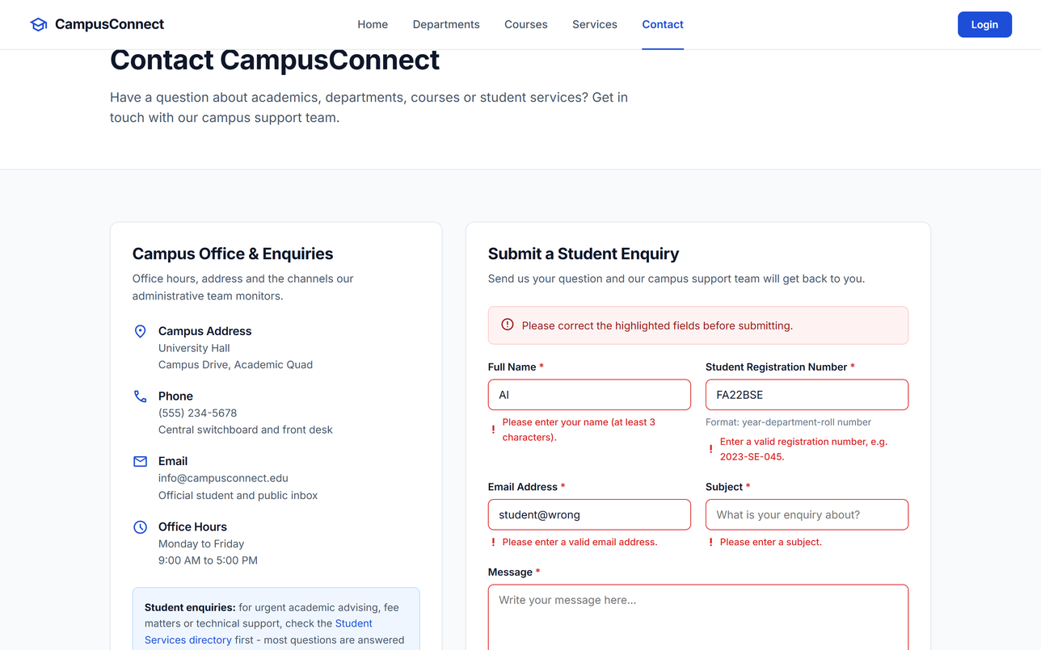
Figure 15: Invalid submission — summary alert plus per-field error messages
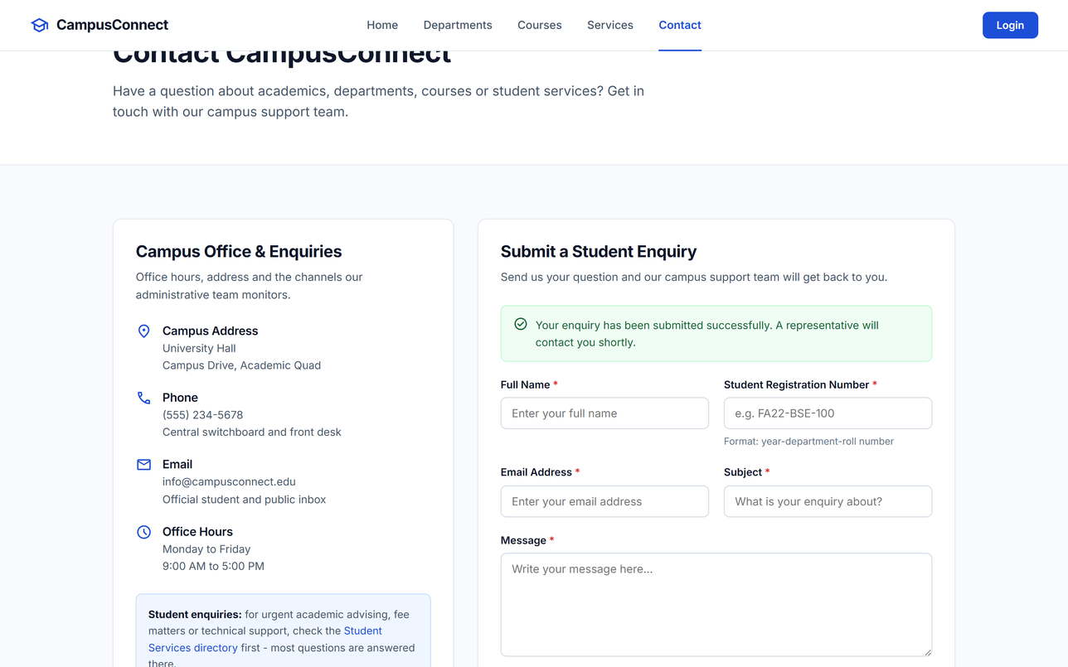
Figure 16: Valid submission — success message; the form is cleared

Mobile navigation and toast messages
Below 900 px the navigation collapses behind a menu button that JavaScript toggles (with aria-expanded for screen readers). Actions that belong to a later tier — Login and Download Catalog — show a short toast explaining that the feature arrives with the database tier instead of leading to a dead link.
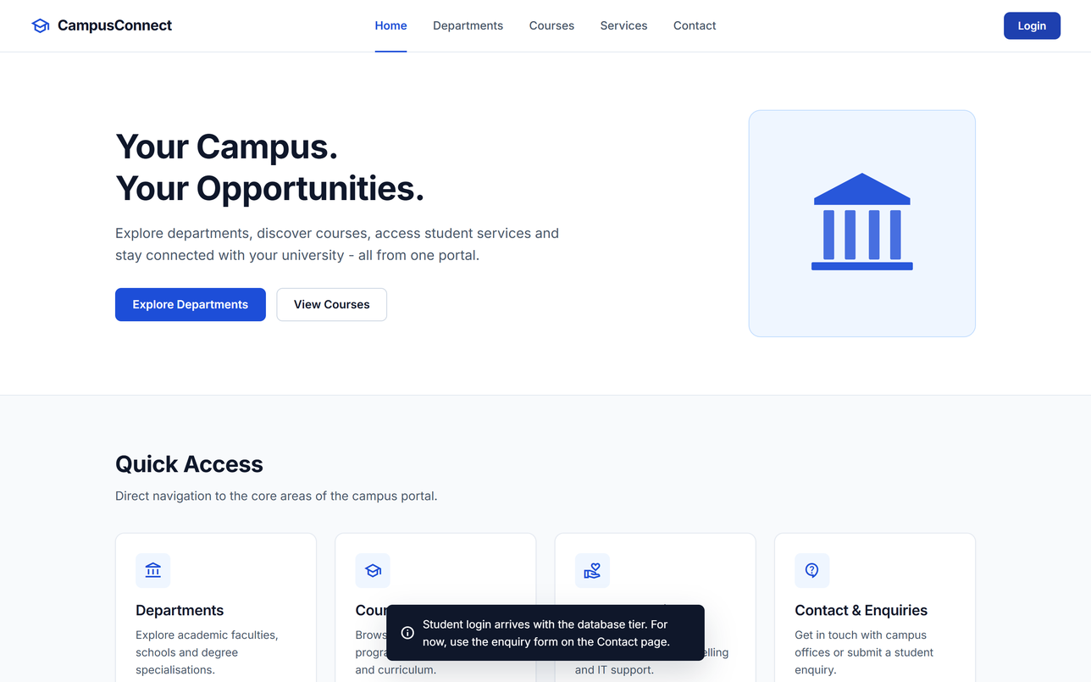
Figure 17: Login placeholder — toast message shown instead of a broken link

2.4 Responsive behaviour
Layouts were tested by resizing the browser and with device emulation in DevTools. Card grids drop from four columns (desktop) to two (tablet) to one (mobile); the form stacks vertically; no horizontal scrolling appears at any width.
 | 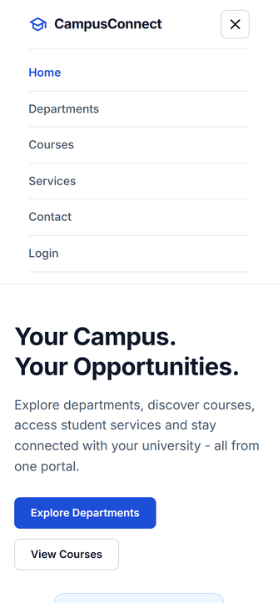 | 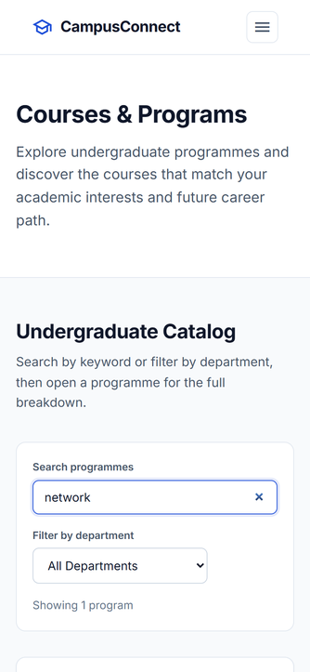 | 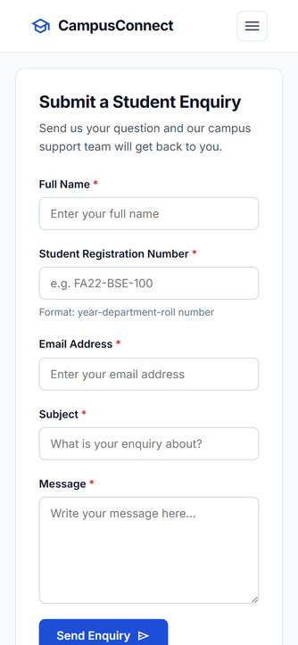
Figure 18: Mobile (390 px) — Home | Figure 19: Mobile — menu open | Figure 20: Mobile — Courses search "network" | Figure 21: Mobile — enquiry form stacked

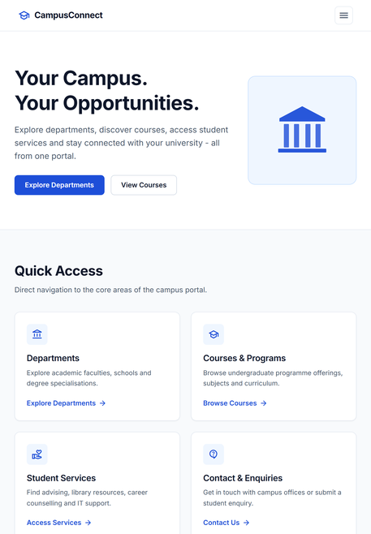 | 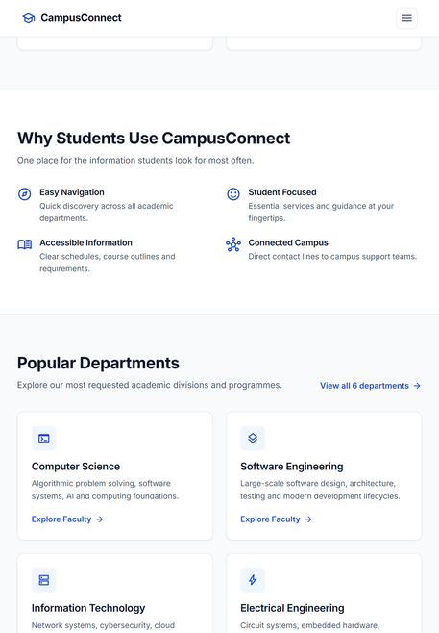 | 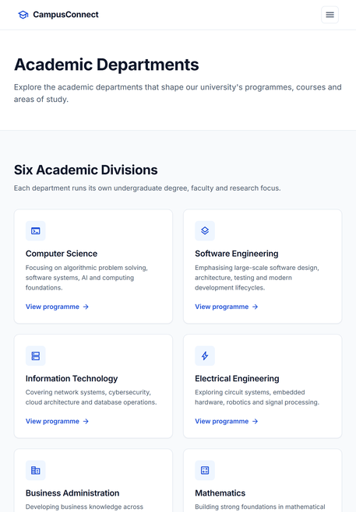
Figure 22: Tablet (820 px) — Home | Figure 23: Tablet — two-column card grids | Figure 24: Tablet — Departments page

3. Deliverable 2 — Sitemap
CampusConnect uses a flat information architecture: every main page is reachable in one click from the header navigation and again from the footer, and the Home page acts as the central entry point. The sitemap below shows the five pages, the content blocks inside each one, and the JavaScript-driven states (dialogs, toasts, alerts) that do not have their own URL.
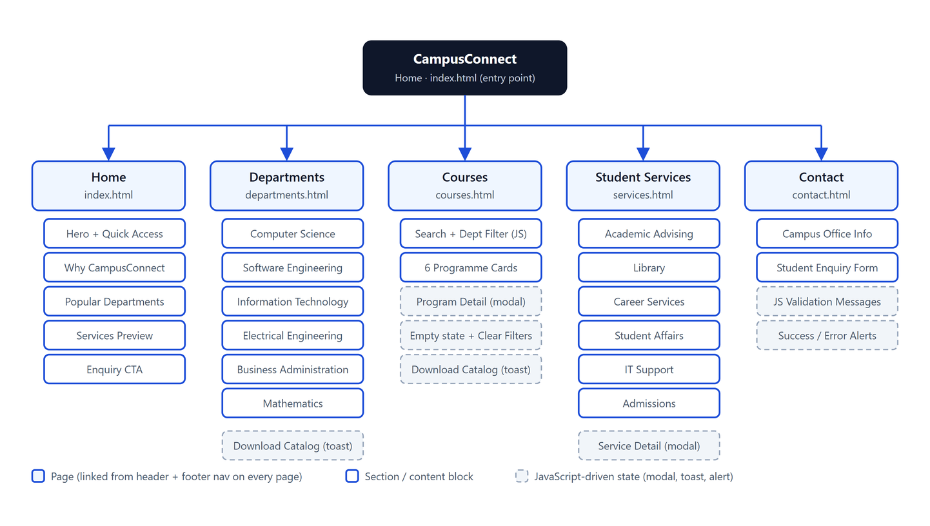
Figure 25: CampusConnect sitemap

3.1 Sitemap as a list
CampusConnect (index.html)
│
├── Home ............................ index.html
│ ├── Hero: "Your Campus. Your Opportunities." [Explore Departments] [View Courses]
│ ├── Quick Access (Departments · Courses · Services · Contact)
│ ├── Why Students Use CampusConnect
│ ├── Popular Departments → departments.html
│ ├── Student Services preview → services.html
│ └── Enquiry call-to-action → contact.html
│
├── Departments ..................... departments.html
│ ├── Computer Science · Software Engineering · Information Technology
│ ├── Electrical Engineering · Business Administration · Mathematics
│ └── Download Catalog (placeholder toast)
│
├── Courses ......................... courses.html
│ ├── Search + Department filter (JavaScript)
│ ├── 6 programme cards → Program Detail dialog
│ └── Empty state + Clear Filters
│
├── Student Services ................ services.html
│ ├── Academic Advising · Library · Career Services
│ ├── Student Affairs · IT Support · Admissions
│ └── Service Detail dialog
│
└── Contact ......................... contact.html
├── Campus office information
└── Student Enquiry form → JS validation → success / error alert

3.2 Navigation rules
- The same header (brand + five links + Login) and the same footer (brand, navigation, contact) appear on every page.
- The current page is highlighted in the navigation (class active and aria-current="page").
- All links are relative (e.g. href="courses.html"), so the site works from a folder, from localhost and from a live host without changes.
- Every call-to-action on the Home page leads to one of the four other pages; no link leads to a missing page.
- On screens narrower than 900 px the navigation collapses into a hamburger menu controlled by JavaScript.

4. Deliverable 3 — Home-page Wireframe
The lab asks for a rough Home-page wireframe containing the header/university name, navigation menu, main content area, important links or services, and footer. Low-fidelity wireframes were drawn in Excalidraw before coding (wireframes/student-portal-wireframes.excalidraw). The Home-page wireframe is the required deliverable; the user flow and the wireframes of the remaining pages and dialogs are included as well because they guided the implementation.

4.1 Home page wireframe (required)
Required wireframe element | Where it appears in the wireframe / final page
Header / university name | Top bar with logo, 'CampusConnect' name, Login button and menu icon
Navigation menu | Home · Departments · Courses · Services · Contact (header) and repeated in the footer
Main content area | Hero (H1 + paragraph + two buttons) followed by Quick Access, Why CampusConnect, Popular Departments and Student Services sections
Important links or services | Four Quick Access cards, four department cards, four service cards, 'View all' links and the enquiry CTA
Footer | Three columns: brand + blurb, navigation links, campus contact; copyright line
Table 5: Mapping of the lab's wireframe checklist to the Home page
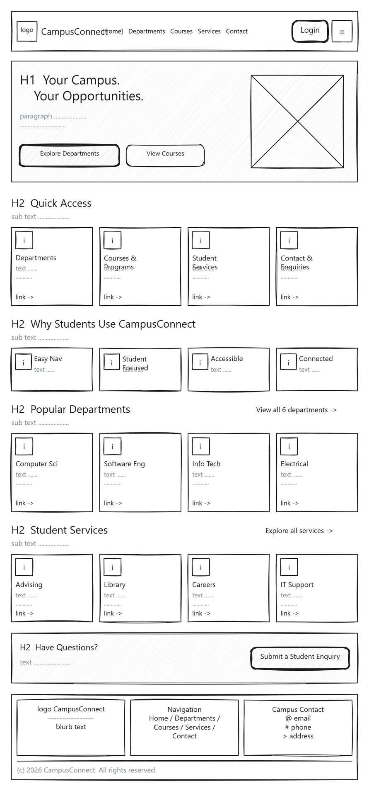
Figure 26: Home page wireframe — header, navigation, hero, quick access, department and service cards, CTA, footer

4.2 User flow
The user-flow diagram shows how a visitor moves from the Home page to each section, and what happens on every interactive element: searching and filtering courses, opening programme and service dialogs, submitting the enquiry form (valid and invalid paths) and the placeholder actions that show a toast.
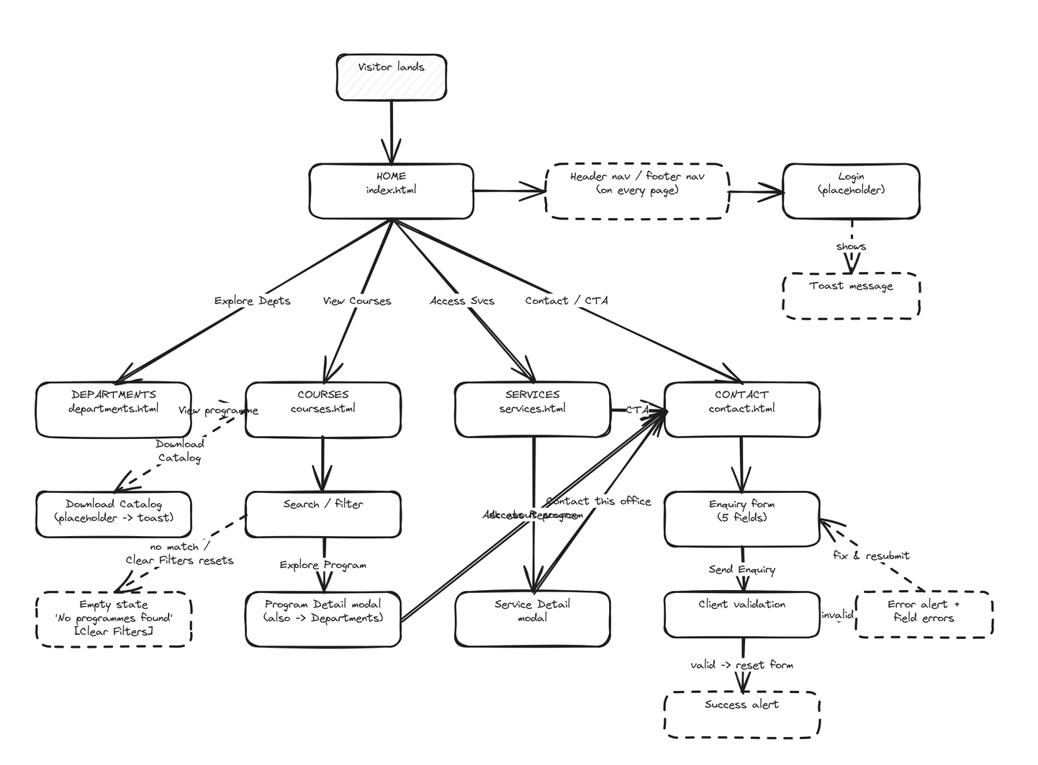
Figure 27: User flow — navigation paths and interaction outcomes across the portal

4.3 Wireframes of the remaining pages
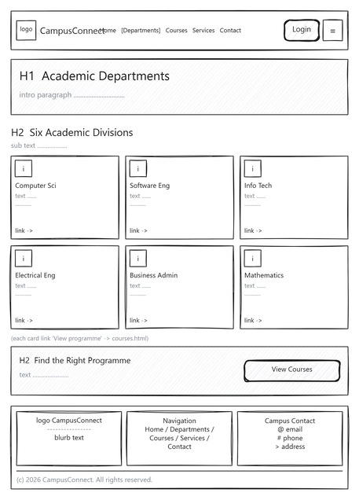 | 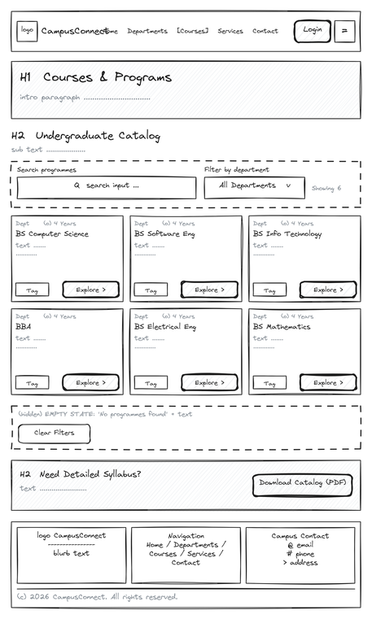 | 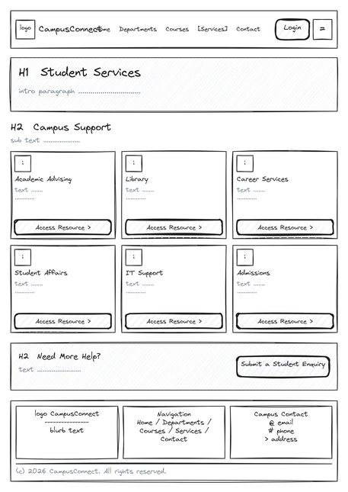
Figure 28: Departments page wireframe | Figure 29: Courses page wireframe (search + filter) | Figure 30: Student Services page wireframe

4.4 Contact page, dialog and toast wireframes
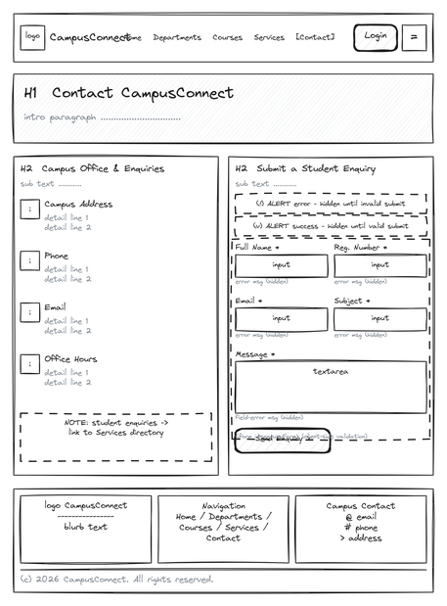 | 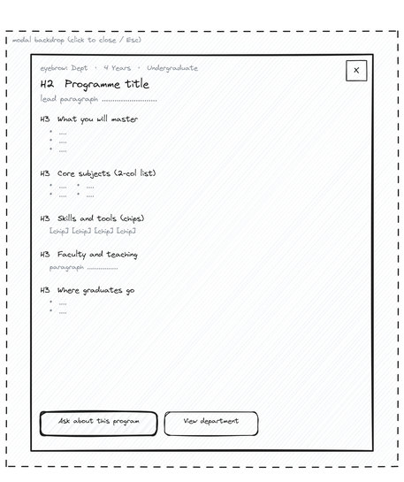 | 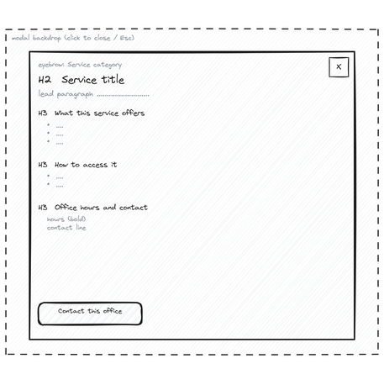
Figure 31: Contact page wireframe (enquiry form) | Figure 32: Programme detail dialog wireframe | Figure 33: Service detail dialog wireframe

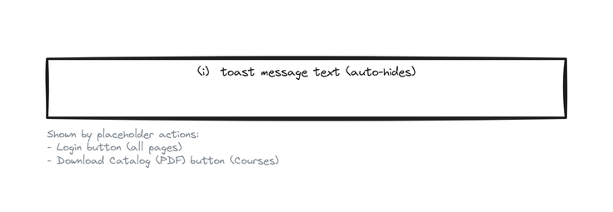
Figure 34: Toast message wireframe (used by the Login and Download Catalog placeholders)

5. Deliverable 4 — HTML, CSS and JavaScript Files
The website consists of five HTML pages, one stylesheet and one script. The complete source code of every file is reproduced in Appendix A; this section explains how the files are organised and highlights the most important parts.
File | Lines | Responsibility
index.html | 313 | Home page: shared header/footer, hero, quick access, features, department and service previews, CTA, toast container
departments.html | 186 | Page hero + six department cards + catalog CTA
courses.html | 288 | Filter bar (search input, select), result count, six programme cards with data-keywords / data-department attributes, empty state, detail dialog markup
services.html | 209 | Six service cards with data-service buttons, help CTA, detail dialog markup
contact.html | 239 | Contact information cards and the Student Enquiry form with labels, hints, per-field error spans and alert boxes
css/style.css | 846 | 13 sections: design tokens, base/reset, header, buttons, sections, hero, grids & cards, courses filter, forms, dialog, toast, footer, responsive rules
js/script.js | 758 | 10 sections: helpers, mobile nav, toast, programme data, service data, dialog renderer, course filter, form validation, footer year, boot
Table 6: Source files of the project

5.1 HTML — shared structure on every page
Every page starts with the same head (viewport meta, fonts, the single stylesheet) and the same header and footer markup, and ends by loading the single script. Semantic elements give the page a clear outline for browsers and screen readers.
<!DOCTYPE html>
<html lang="en">
<head>
<meta charset="utf-8">
<meta name="viewport" content="width=device-width, initial-scale=1.0">
<title>CampusConnect - Home</title>
<link rel="stylesheet" href="css/style.css"> <!-- one shared stylesheet -->
</head>
<body>
<a class="skip-link" href="#main">Skip to main content</a>

<header class="site-header">
<div class="container header-inner">
<a class="brand" href="index.html">…CampusConnect</a>
<nav class="main-nav" aria-label="Main navigation">
<a class="active" href="index.html" aria-current="page">Home</a>
<a href="departments.html">Departments</a>
<a href="courses.html">Courses</a>
<a href="services.html">Services</a>
<a href="contact.html">Contact</a>
</nav>
<button class="nav-toggle" id="navToggle" aria-expanded="false">…</button>
</div>
<nav class="mobile-nav" id="mobileNav" aria-label="Mobile navigation">…</nav>
</header>

<main id="main"> …page sections… </main>

<footer class="site-footer"> …brand · navigation · contact · copyright… </footer>
<script src="js/script.js"></script> <!-- one shared script -->
</body>
</html>

Course cards carry the data the filter needs directly in the markup, so JavaScript does not have to know about the content:
<article class="card course-card" data-department="se"
data-keywords="bs software engineering se design architecture testing agile">
<p class="eyebrow">Software Engineering</p>
<h3>BS Software Engineering</h3>
…
<button class="card-action" type="button" data-program="se">Explore Program</button>
</article>

5.2 CSS — design tokens and responsive rules
All repeated design values are defined once as CSS custom properties, so the whole site can be re-themed by editing a few lines. Layout uses Flexbox and CSS Grid; three breakpoints adapt the layout to tablet and mobile widths.
:root {
--brand: #1d4ed8; --brand-hover: #1e40af; --brand-soft: #eff6ff;
--ink: #0f172a; --ink-2: #475569; --bg: #f8fafc; --surface: #ffffff;
--line: #e2e8f0; --danger: #dc2626; --radius: 12px; --container: 1200px;
}

.grid { display: grid; gap: var(--gap); }
.grid-4 { grid-template-columns: repeat(4, 1fr); }

.card { background: var(--surface); border: 1px solid var(--line); border-radius: var(--radius);
padding: 24px; box-shadow: var(--shadow-sm); transition: transform .15s, box-shadow .15s; }
.card:hover { transform: translateY(-2px); box-shadow: var(--shadow); }

/* Responsive breakpoints */
@media (max-width: 1024px) { .grid-4 { grid-template-columns: repeat(2, 1fr); } }
@media (max-width: 900px) { .main-nav { display: none; } .nav-toggle { display: inline-flex; } }
@media (max-width: 760px) { .grid-4, .grid-3, .grid-2 { grid-template-columns: 1fr; }
.form-row { grid-template-columns: 1fr; }
.hero-inner { flex-direction: column; } }

5.3 JavaScript — one script, page-safe features
The script is wrapped in an IIFE so no globals leak. On DOMContentLoaded each feature is initialised; every init function returns early if the elements it needs are not on the current page (Section 24 of the project specification).
document.addEventListener("DOMContentLoaded", function () {
initMobileNav(); // header menu button (all pages)
initToastTriggers(); // [data-toast] placeholders (Login, Download Catalog)
initDetailModal(); // programme / service dialogs (courses, services)
initCourseFilter(); // search + department filter (courses)
initEnquiryForm(); // validation (contact)
initFooterYear(); // © year (all pages)
});

Course search and filter — both conditions are combined for every card and the empty state toggles automatically:
function apply() {
var term = search.value.trim().toLowerCase();
var dept = department.value;
var visible = 0;
cards.forEach(function (card) {
var haystack = card.getAttribute("data-keywords").toLowerCase();
var matchesTerm = term === "" || haystack.indexOf(term) !== -1;
var matchesDept = dept === "all" || card.getAttribute("data-department") === dept;
var show = matchesTerm && matchesDept;
card.style.display = show ? "" : "none";
if (show) visible++;
});
count.textContent = "Showing " + visible + (visible === 1 ? " program" : " programs");
empty.hidden = visible !== 0;
}
search.addEventListener("input", apply);
department.addEventListener("change", apply);

Enquiry-form validation — declarative rules, per-field messages, and no submission to a server:
// accepts 2023-SE-045 or FA22-BSE-100
var REG_PATTERN = /^(\d{4}|[A-Za-z]{2}\d{2})-[A-Za-z]{2,4}-\d{2,4}$/;
var EMAIL_PATTERN = /^[^\s@]+@[^\s@]+\.[^\s@]{2,}$/;

var rules = [
{ id: "fullName", test: function (v) { return v.length >= 3; } },
{ id: "regNumber", test: function (v) { return REG_PATTERN.test(v); } },
{ id: "email", test: function (v) { return EMAIL_PATTERN.test(v); } },
{ id: "subject", test: function (v) { return v.length >= 3; } },
{ id: "message", test: function (v) { return v.length >= 10; } }
];

form.addEventListener("submit", function (event) {
event.preventDefault(); // one-tier: never leaves the browser
var valid = validate(true); // marks each invalid field + message
errorAlert.classList.toggle("show", !valid);
successAlert.classList.toggle("show", valid);
if (valid) form.reset();
});

6. Deliverable 5 — One-Tier, Two-Tier and N-Tier Diagrams
The lab manual asks for three diagrams showing how the same CampusConnect project would work as a one-tier, two-tier and N-tier system. A tier is a logical separation of responsibilities; N-tier does not require exactly three tiers.

6.1 One-tier architecture (current prototype)
In the one-tier version everything — presentation, interaction logic and the data that is displayed — runs inside the browser. The HTML, CSS and JavaScript files are opened straight from disk (file:///…/index.html). The programme and service details are plain JavaScript objects in script.js, the course filter works on the cards already in the page, and the enquiry form is validated and answered without contacting any server. This is exactly how CampusConnect is delivered for this lab.
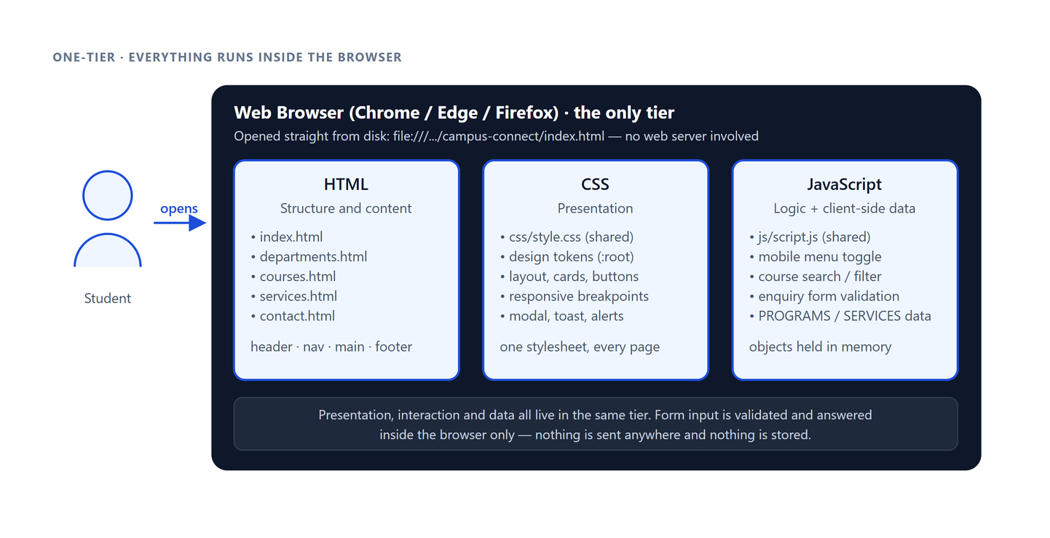
Figure 35: One-tier architecture — browser + HTML/CSS/JS + client-side data

6.2 Two-tier architecture (client + web server)
In the two-tier version the browser (client) no longer reads files from its own disk. It sends an HTTP request such as GET /campus-connect/index.html to a web server — Apache running inside WampServer on localhost, or the live host where the site is deployed — and the server sends the file back in an HTTP response. The browser then requests style.css, script.js and the fonts the same way. The files themselves are unchanged; what changes is that a separate server process is now responsible for storing and delivering them, which can be seen in the DevTools Network tab.
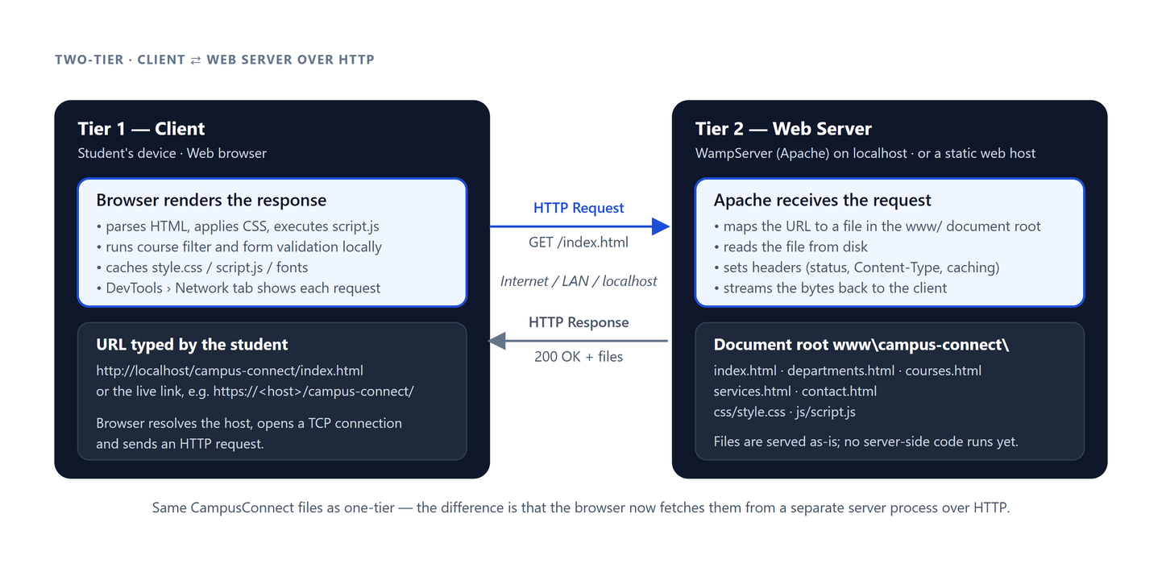
Figure 36: Two-tier architecture — client (browser) ⇄ web server over HTTP

6.3 N-tier architecture (presentation, logic, data access, database)
To turn CampusConnect into a real portal — student login, enquiries that are actually stored, courses maintained by staff — the responsibilities are split into layers. The presentation layer (Apache + the existing pages) only renders; an application layer written in PHP or Node.js applies the rules (re-validating the enquiry, authenticating a login, searching courses); a data-access layer is the only part that speaks SQL; and MySQL (managed through phpMyAdmin in WampServer) stores departments, courses, services, enquiries and students. Each layer can be changed, tested or scaled independently. The diagram includes a worked example of the enquiry form travelling through every tier.
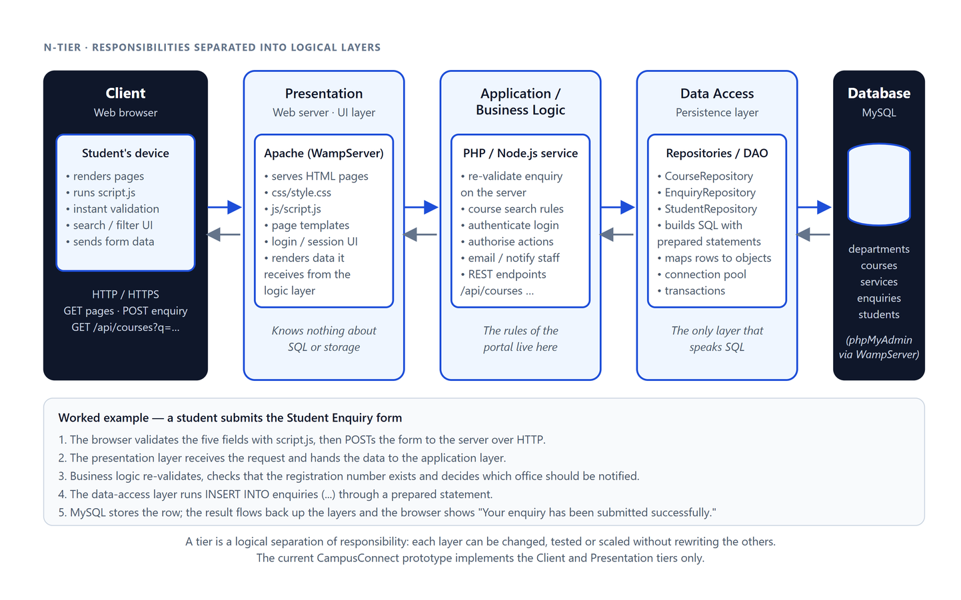
Figure 37: N-tier architecture — client → presentation → business logic → data access → database

6.4 Comparison
Aspect | One-tier | Two-tier | N-tier
Where the files live | Student's own disk | Web server document root (www/) | Web server, behind an application layer
How pages are loaded | file:// from the browser | HTTP request/response | HTTP request → application → data → back
Where the enquiry goes | Validated and shown in the browser only | Still only the browser (no server code) | Validated again on the server and stored in MySQL
Where course data lives | JavaScript objects in script.js | Same static files | courses table in the database, served by an API
Login | Placeholder toast | Placeholder toast | Real authentication in the business-logic layer
Benefit | Simplest to build and demo | Real client/server separation; works for many users | Separation of concerns; each layer scalable and replaceable
CampusConnect status | Implemented | Demonstrated via WampServer / live host | Designed (diagram) for future work
Table 7: One-tier vs two-tier vs N-tier for CampusConnect

7. Deliverable 6 — Development Environment
A development environment is the collection of tools, software and configuration used to create, test and debug a website. CampusConnect was built with the environment recommended in the lab manual:
Tool | Role in this project
Visual Studio Code | Code editor for HTML, CSS and JavaScript. Extensions used: Live Server (auto-reload preview), Prettier (formatting). The project folder is opened directly; no build step is required.
Google Chrome / Microsoft Edge | Running and testing the website. Both were used to check that the pages look and behave the same.
Browser Developer Tools (F12) | Elements panel to inspect HTML/CSS; Console to confirm there are no JavaScript errors; Network panel to see the HTTP requests for the page, stylesheet, script and fonts; Device toolbar to emulate tablet and mobile screens.
Git + GitHub | Version control and collaboration between the two team members; the repository also serves as the source-code submission.
WampServer (Apache) | Optional local web server used to demonstrate the two-tier model: the project is copied into C:\wamp64\www\ and opened through http://localhost/.
Static web host (live link) | The deployed copy of the site, so the instructor can open it from any device; behaves as a two-tier system in production.
Windows 11 | Lab operating environment.
Table 8: Development environment

7.1 Workflow used
1. Planning — read the lab manual, wrote the product specification (docs/IDEA.md) and the design system (docs/DESIGN.md), drew the sitemap and Excalidraw wireframes.
2. Foundation — created the folder structure, the shared header/footer, design tokens, buttons and the responsive grid in css/style.css.
3. Pages — implemented Home, Departments, Courses, Services and Contact one after another, reusing the same components.
4. Behaviour — added the mobile menu, course filter, detail dialogs, toast and enquiry validation to js/script.js.
5. Testing — clicked every link, ran the checklist in Section 8.2 in Chrome and Edge at desktop, tablet and mobile widths, and checked the console.
6. Server demonstration — ran the site through WampServer on localhost and deployed it to the live link.

7.2 How to run the website

Option A — one-tier (no server)
1. Download or clone the repository.
2. Open the campus-connect folder.
3. Double-click index.html; it opens in the default browser from file:///.
4. An internet connection is needed the first time so the Inter font and Material Symbols icons can load.

Option B — two-tier on localhost with WampServer
1. Start WampServer and wait for the tray icon to turn green (Apache running).
2. Copy the campus-connect folder into the WampServer web directory, normally C:\wamp64\www\.
3. Open a browser and go to http://localhost/campus-connect/.
4. Open DevTools › Network and reload: each file now arrives as an HTTP response from Apache (status 200).

Option C — live link
Open https://campus-connect-rose-nine.vercel.app/ from any device. The site is served by a web host, so this is the two-tier model over the Internet.

8. Deliverable 7 — Short Demonstration
The demonstration to the instructor follows the script below (about five minutes) and walks through every lab concept using the live website.

8.1 Demonstration script
# | Step | What to show / say
1 | Open the site | Open the live link (or http://localhost/campus-connect/). Point out the header, navigation, hero and footer that match the wireframe.
2 | Navigation | Click through Home → Departments → Courses → Services → Contact using the header; show the active-page highlight and the footer links.
3 | Departments | Six department cards; hover state; 'Download Catalog' shows a toast because the PDF belongs to a later tier.
4 | Courses — search | Type "software" — only BS Software Engineering remains; the count updates live.
5 | Courses — filter + empty state | Select Electrical Engineering with "python" typed — empty state appears; click Clear Filters.
6 | Programme dialog | Click Explore Program on any card; scroll the dialog; close with Esc.
7 | Services | Open the Library dialog — offers, how to access, hours, contact.
8 | Enquiry validation | Submit the empty form → field errors. Enter FA22-BSE-100 and a valid email → success message.
9 | Responsive | Press F12, toggle the device toolbar, choose a phone: hamburger menu, single-column cards, stacked form.
10 | Developer Tools | Elements: semantic tags. Console: no errors. Network: index.html, style.css, script.js and fonts returned by the server (two-tier).
11 | Architecture | Show the one-/two-/N-tier diagrams (Section 6) and explain the enquiry-form example flowing through the N-tier layers.
Table 9: Demonstration script

8.2 Testing checklist (results)
Test | Chrome | Edge | Notes
All five pages load | Pass | Pass | Opened from file://, localhost and the live link
All header and footer links work | Pass | Pass | No link leads to a missing page
Active page highlighted in navigation | Pass | Pass | class active + aria-current
Mobile menu opens and closes | Pass | Pass | Below 900 px; icon switches menu ↔ close
Course search (case-insensitive) | Pass | Pass | "SOFTWARE" and "software" give the same result
Department filter works with search | Pass | Pass | Count updates live
Empty state + Clear Filters | Pass | Pass | Shown when 0 programmes match
Programme / service dialogs open and close | Pass | Pass | Button, ×, Esc and backdrop
Form rejects empty fields and bad email | Pass | Pass | Per-field messages shown
Form accepts valid input | Pass | Pass | Success alert, form reset
Desktop / tablet / mobile layouts | Pass | Pass | 1440, 820 and 390 px viewports
No horizontal scrollbar at any width | Pass | Pass | Checked down to 320 px
Console has no errors | Pass | Pass | Verified on every page
Files not unnecessarily large | Pass | Pass | No raster images; CSS 21 KB, JS 30 KB
Table 10: Test results

8.3 Exit questions — prepared answers
Question | Answer
Difference between the Internet and the WWW? | The Internet is the global network of connected computers; the WWW is one service on it that provides linked web pages and resources over HTTP.
What is HTTP used for? | Communication between a web client (browser) and a web server: the client sends requests (GET index.html) and the server sends responses (200 OK + the file).
Role of a browser? | Client software that requests pages, then parses HTML, applies CSS and runs JavaScript to display them.
What is a web server? | Software (e.g. Apache) that receives HTTP requests, finds or generates the resource and sends the response.
Why WampServer? | It gives a local Windows environment with Apache, PHP and MySQL so the site can be tested on localhost and server-side features can be added later.
What is a development environment? | The tools, software and configuration used to build and test a website — here VS Code, Chrome/Edge with DevTools, Git and WampServer.
One-tier vs two-tier? | One-tier: presentation and logic run together in the browser from local files. Two-tier: the client requests the files from a separate web server over HTTP.
Why is N-tier useful? | Separating presentation, business logic, data access and the database lets each layer be changed, tested, secured and scaled independently.
What is a sitemap? | A diagram or list of a website's pages and how they link to each other; it plans navigation before coding.
Two constraints that affect web design? | Different screen sizes/resolutions and bandwidth (large files slow loading); also browser differences and readability.
Table 11: Exit-question answers

Appendix A — Complete Source Code
The full contents of every HTML, CSS and JavaScript file of the project are listed below exactly as submitted.

A.1 index.html
<!DOCTYPE html>
<html lang="en">
<head>
<meta charset="utf-8">
<meta name="viewport" content="width=device-width, initial-scale=1.0">
<title>CampusConnect - Home</title>
<meta name="description" content="CampusConnect is a mini university web portal for departments, courses, student services and contact details.">
<link rel="preconnect" href="https://fonts.googleapis.com">
<link rel="preconnect" href="https://fonts.gstatic.com" crossorigin>
<link href="https://fonts.googleapis.com/css2?family=Inter:wght@400;500;600;700&display=swap" rel="stylesheet">
<link href="https://fonts.googleapis.com/css2?family=Material+Symbols+Outlined:opsz,wght,FILL,GRAD@20..48,100..700,0..1,-50..200&display=block" rel="stylesheet">
<link rel="stylesheet" href="css/style.css">
</head>
<body>

<a class="skip-link" href="#main">Skip to main content</a>

<!-- ============================ SHARED HEADER ============================ -->
<header class="site-header">
<div class="container header-inner">
<a class="brand" href="index.html">
<span class="material-symbols-outlined brand-icon">school</span>
<span class="brand-name">CampusConnect</span>
</a>

<nav class="main-nav" aria-label="Main navigation">
<a class="active" href="index.html" aria-current="page">Home</a>
<a href="departments.html">Departments</a>
<a href="courses.html">Courses</a>
<a href="services.html">Services</a>
<a href="contact.html">Contact</a>
</nav>

<div class="header-actions">
<a class="btn btn-primary btn-sm" href="#" data-toast="Student login arrives with the database tier. For now, use the enquiry form on the Contact page.">Login</a>
<button class="nav-toggle" id="navToggle" type="button" aria-label="Toggle navigation" aria-expanded="false" aria-controls="mobileNav">
<span class="material-symbols-outlined">menu</span>
</button>
</div>
</div>

<div class="container">
<nav class="mobile-nav" id="mobileNav" aria-label="Mobile navigation">
<a class="active" href="index.html" aria-current="page">Home</a>
<a href="departments.html">Departments</a>
<a href="courses.html">Courses</a>
<a href="services.html">Services</a>
<a href="contact.html">Contact</a>
<a href="#" data-toast="Student login arrives with the database tier. For now, use the enquiry form on the Contact page.">Login</a>
</nav>
</div>
</header>

<main id="main">

<!-- ------------------------------- Hero ------------------------------- -->
<section class="hero">
<div class="container hero-inner">
<div class="hero-copy">
<h1>Your Campus.<br>Your Opportunities.</h1>
<p>
Explore departments, discover courses, access student services and stay
connected with your university - all from one portal.
</p>
<div class="hero-actions">
<a class="btn btn-primary" href="departments.html">Explore Departments</a>
<a class="btn btn-outline" href="courses.html">View Courses</a>
</div>
</div>

<div class="hero-figure">
<svg viewBox="0 0 200 200" xmlns="http://www.w3.org/2000/svg" aria-hidden="true" fill="none">
<path d="M100 24L28 62V72H172V62L100 24Z" fill="currentColor" opacity="0.95"></path>
<rect x="42" y="80" width="16" height="74" rx="2" fill="currentColor" opacity="0.8"></rect>
<rect x="74" y="80" width="16" height="74" rx="2" fill="currentColor" opacity="0.8"></rect>
<rect x="110" y="80" width="16" height="74" rx="2" fill="currentColor" opacity="0.8"></rect>
<rect x="142" y="80" width="16" height="74" rx="2" fill="currentColor" opacity="0.8"></rect>
<rect x="24" y="158" width="152" height="12" rx="2" fill="currentColor" opacity="0.95"></rect>
</svg>
</div>
</div>
</section>

<!-- --------------------------- Quick access --------------------------- -->
<section class="section">
<div class="container">
<div class="section-head">
<h2>Quick Access</h2>
<p>Direct navigation to the core areas of the campus portal.</p>
</div>

<div class="grid grid-4">
<a class="card card--link" href="departments.html">
<span class="card-icon"><span class="material-symbols-outlined">account_balance</span></span>
<h3>Departments</h3>
<p>Explore academic faculties, schools and degree specialisations.</p>
<span class="inline-link">Explore Departments <span class="material-symbols-outlined">arrow_forward</span></span>
</a>

<a class="card card--link" href="courses.html">
<span class="card-icon"><span class="material-symbols-outlined">school</span></span>
<h3>Courses &amp; Programs</h3>
<p>Browse undergraduate programme offerings, subjects and curriculum.</p>
<span class="inline-link">Browse Courses <span class="material-symbols-outlined">arrow_forward</span></span>
</a>

<a class="card card--link" href="services.html">
<span class="card-icon"><span class="material-symbols-outlined">volunteer_activism</span></span>
<h3>Student Services</h3>
<p>Find advising, library resources, career counselling and IT support.</p>
<span class="inline-link">Access Services <span class="material-symbols-outlined">arrow_forward</span></span>
</a>

<a class="card card--link" href="contact.html">
<span class="card-icon"><span class="material-symbols-outlined">contact_support</span></span>
<h3>Contact &amp; Enquiries</h3>
<p>Get in touch with campus offices or submit a student enquiry.</p>
<span class="inline-link">Contact Us <span class="material-symbols-outlined">arrow_forward</span></span>
</a>
</div>
</div>
</section>

<!-- --------------------------- Portal values -------------------------- -->
<section class="section section--surface">
<div class="container">
<div class="section-head">
<h2>Why Students Use CampusConnect</h2>
<p>One place for the information students look for most often.</p>
</div>

<div class="grid grid-4">
<div class="feature">
<span class="material-symbols-outlined">explore</span>
<div>
<h4>Easy Navigation</h4>
<p>Quick discovery across all academic departments.</p>
</div>
</div>
<div class="feature">
<span class="material-symbols-outlined">sentiment_satisfied</span>
<div>
<h4>Student Focused</h4>
<p>Essential services and guidance at your fingertips.</p>
</div>
</div>
<div class="feature">
<span class="material-symbols-outlined">menu_book</span>
<div>
<h4>Accessible Information</h4>
<p>Clear schedules, course outlines and requirements.</p>
</div>
</div>
<div class="feature">
<span class="material-symbols-outlined">hub</span>
<div>
<h4>Connected Campus</h4>
<p>Direct contact lines to campus support teams.</p>
</div>
</div>
</div>
</div>
</section>

<!-- ------------------------ Popular departments ----------------------- -->
<section class="section">
<div class="container">
<div class="section-head-row">
<div class="section-head">
<h2>Popular Departments</h2>
<p>Explore our most requested academic divisions and programmes.</p>
</div>
<a class="inline-link" href="departments.html">
View all 6 departments <span class="material-symbols-outlined">arrow_forward</span>
</a>
</div>

<div class="grid grid-4">
<div class="card">
<span class="card-icon"><span class="material-symbols-outlined">terminal</span></span>
<h3>Computer Science</h3>
<p>Algorithmic problem solving, software systems, AI and computing foundations.</p>
<a class="inline-link" href="departments.html">Explore Faculty <span class="material-symbols-outlined">arrow_forward</span></a>
</div>

<div class="card">
<span class="card-icon"><span class="material-symbols-outlined">layers</span></span>
<h3>Software Engineering</h3>
<p>Large-scale software design, architecture, testing and modern development lifecycles.</p>
<a class="inline-link" href="departments.html">Explore Faculty <span class="material-symbols-outlined">arrow_forward</span></a>
</div>

<div class="card">
<span class="card-icon"><span class="material-symbols-outlined">dns</span></span>
<h3>Information Technology</h3>
<p>Network systems, cybersecurity, cloud architecture and database operations.</p>
<a class="inline-link" href="departments.html">Explore Faculty <span class="material-symbols-outlined">arrow_forward</span></a>
</div>

<div class="card">
<span class="card-icon"><span class="material-symbols-outlined">bolt</span></span>
<h3>Electrical Engineering</h3>
<p>Circuit systems, embedded hardware, robotics and signal processing.</p>
<a class="inline-link" href="departments.html">Explore Faculty <span class="material-symbols-outlined">arrow_forward</span></a>
</div>
</div>
</div>
</section>

<!-- -------------------------- Services preview ------------------------ -->
<section class="section section--surface">
<div class="container">
<div class="section-head-row">
<div class="section-head">
<h2>Student Services</h2>
<p>Dedicated resources to support your academic journey and campus life.</p>
</div>
<a class="inline-link" href="services.html">
Explore all services <span class="material-symbols-outlined">arrow_forward</span>
</a>
</div>

<div class="grid grid-4">
<div class="card">
<span class="card-icon"><span class="material-symbols-outlined">explore</span></span>
<h3>Academic Advising</h3>
<p>Personalised guidance for course selection, degree progress and academic planning.</p>
</div>
<div class="card">
<span class="card-icon"><span class="material-symbols-outlined">auto_stories</span></span>
<h3>Library &amp; Commons</h3>
<p>Academic databases, study spaces, research archives and book lending.</p>
</div>
<div class="card">
<span class="card-icon"><span class="material-symbols-outlined">work</span></span>
<h3>Career Services</h3>
<p>Resume building, internship placements, employer networking and workshops.</p>
</div>
<div class="card">
<span class="card-icon"><span class="material-symbols-outlined">support_agent</span></span>
<h3>IT Support Desk</h3>
<p>Technical help with student portals, campus Wi-Fi, email and software tools.</p>
</div>
</div>
</div>
</section>

<!-- ------------------------------- CTA -------------------------------- -->
<section class="section">
<div class="container">
<div class="cta-band">
<div>
<h2>Have Questions About Campus Life or Academics?</h2>
<p>
Our student support team can help with admissions, course advice and campus
facilities. Send us an enquiry and we will get back to you.
</p>
</div>
<a class="btn btn-primary" href="contact.html">Submit a Student Enquiry</a>
</div>
</div>
</section>

</main>

<!-- ============================ SHARED FOOTER ============================ -->
<footer class="site-footer">
<div class="container">
<div class="footer-grid">
<div>
<a class="footer-brand" href="index.html">
<span class="material-symbols-outlined">school</span>
<span class="brand-name">CampusConnect</span>
</a>
<p>Connecting students with campus academic programmes, departments and support services.</p>
</div>

<div>
<h3 class="footer-title">Navigation</h3>
<nav class="footer-links" aria-label="Footer navigation">
<a href="index.html">Home</a>
<a href="departments.html">Departments</a>
<a href="courses.html">Courses</a>
<a href="services.html">Services</a>
<a href="contact.html">Contact</a>
</nav>
</div>

<div>
<h3 class="footer-title">Campus Contact</h3>
<ul class="footer-contact">
<li><span class="material-symbols-outlined">mail</span> info@campusconnect.edu</li>
<li><span class="material-symbols-outlined">call</span> (555) 234-5678</li>
<li><span class="material-symbols-outlined">location_on</span> University Hall, Campus Drive</li>
</ul>
</div>
</div>

<div class="footer-bottom">
<p>&copy; <span id="footerYear">2026</span> CampusConnect. All rights reserved.</p>
</div>
</div>
</footer>

<!-- Toast used by placeholder actions such as Login -->
<div class="toast" id="toast" role="status" aria-live="polite">
<span class="material-symbols-outlined">info</span>
<span class="toast-text"></span>
</div>

<script src="js/script.js"></script>
</body>
</html>

A.2 departments.html
<!DOCTYPE html>
<html lang="en">
<head>
<meta charset="utf-8">
<meta name="viewport" content="width=device-width, initial-scale=1.0">
<title>CampusConnect - Departments</title>
<meta name="description" content="Explore the six academic departments at CampusConnect and the programmes each one offers.">
<link rel="preconnect" href="https://fonts.googleapis.com">
<link rel="preconnect" href="https://fonts.gstatic.com" crossorigin>
<link href="https://fonts.googleapis.com/css2?family=Inter:wght@400;500;600;700&display=swap" rel="stylesheet">
<link href="https://fonts.googleapis.com/css2?family=Material+Symbols+Outlined:opsz,wght,FILL,GRAD@20..48,100..700,0..1,-50..200&display=block" rel="stylesheet">
<link rel="stylesheet" href="css/style.css">
</head>
<body>

<a class="skip-link" href="#main">Skip to main content</a>

<!-- ============================ SHARED HEADER ============================ -->
<header class="site-header">
<div class="container header-inner">
<a class="brand" href="index.html">
<span class="material-symbols-outlined brand-icon">school</span>
<span class="brand-name">CampusConnect</span>
</a>

<nav class="main-nav" aria-label="Main navigation">
<a href="index.html">Home</a>
<a class="active" href="departments.html" aria-current="page">Departments</a>
<a href="courses.html">Courses</a>
<a href="services.html">Services</a>
<a href="contact.html">Contact</a>
</nav>

<div class="header-actions">
<a class="btn btn-primary btn-sm" href="#" data-toast="Student login arrives with the database tier. For now, use the enquiry form on the Contact page.">Login</a>
<button class="nav-toggle" id="navToggle" type="button" aria-label="Toggle navigation" aria-expanded="false" aria-controls="mobileNav">
<span class="material-symbols-outlined">menu</span>
</button>
</div>
</div>

<div class="container">
<nav class="mobile-nav" id="mobileNav" aria-label="Mobile navigation">
<a href="index.html">Home</a>
<a class="active" href="departments.html" aria-current="page">Departments</a>
<a href="courses.html">Courses</a>
<a href="services.html">Services</a>
<a href="contact.html">Contact</a>
<a href="#" data-toast="Student login arrives with the database tier. For now, use the enquiry form on the Contact page.">Login</a>
</nav>
</div>
</header>

<main id="main">

<!-- ---------------------------- Page hero ---------------------------- -->
<section class="page-hero">
<div class="container">
<h1>Academic Departments</h1>
<p>
Explore the academic departments that shape our university's programmes,
courses and areas of study.
</p>
</div>
</section>

<!-- -------------------------- Departments grid ------------------------ -->
<section class="section">
<div class="container">
<div class="section-head">
<h2>Six Academic Divisions</h2>
<p>Each department runs its own undergraduate degree, faculty and research focus.</p>
</div>

<div class="grid grid-3">
<div class="card">
<span class="card-icon"><span class="material-symbols-outlined">terminal</span></span>
<h3>Computer Science</h3>
<p>Focusing on algorithmic problem solving, software systems, AI and computing foundations.</p>
<a class="inline-link" href="courses.html">View programme <span class="material-symbols-outlined">arrow_forward</span></a>
</div>

<div class="card">
<span class="card-icon"><span class="material-symbols-outlined">layers</span></span>
<h3>Software Engineering</h3>
<p>Emphasising large-scale software design, architecture, testing and modern development lifecycles.</p>
<a class="inline-link" href="courses.html">View programme <span class="material-symbols-outlined">arrow_forward</span></a>
</div>

<div class="card">
<span class="card-icon"><span class="material-symbols-outlined">dns</span></span>
<h3>Information Technology</h3>
<p>Covering network systems, cybersecurity, cloud architecture and database operations.</p>
<a class="inline-link" href="courses.html">View programme <span class="material-symbols-outlined">arrow_forward</span></a>
</div>

<div class="card">
<span class="card-icon"><span class="material-symbols-outlined">bolt</span></span>
<h3>Electrical Engineering</h3>
<p>Exploring circuit systems, embedded hardware, robotics and signal processing.</p>
<a class="inline-link" href="courses.html">View programme <span class="material-symbols-outlined">arrow_forward</span></a>
</div>

<div class="card">
<span class="card-icon"><span class="material-symbols-outlined">corporate_fare</span></span>
<h3>Business Administration</h3>
<p>Developing business knowledge across management, entrepreneurship, marketing and organisational strategy.</p>
<a class="inline-link" href="courses.html">View programme <span class="material-symbols-outlined">arrow_forward</span></a>
</div>

<div class="card">
<span class="card-icon"><span class="material-symbols-outlined">calculate</span></span>
<h3>Mathematics</h3>
<p>Building strong foundations in mathematical theory, analytical reasoning, statistics and applied mathematics.</p>
<a class="inline-link" href="courses.html">View programme <span class="material-symbols-outlined">arrow_forward</span></a>
</div>
</div>
</div>
</section>

<!-- ------------------------------- CTA -------------------------------- -->
<section class="section section--surface">
<div class="container">
<div class="cta-band">
<div>
<h2>Find the Right Programme for You</h2>
<p>
Explore the available courses and programmes to discover where your academic
interests can take you.
</p>
</div>
<a class="btn btn-primary" href="courses.html">View Courses</a>
</div>
</div>
</section>

</main>

<!-- ============================ SHARED FOOTER ============================ -->
<footer class="site-footer">
<div class="container">
<div class="footer-grid">
<div>
<a class="footer-brand" href="index.html">
<span class="material-symbols-outlined">school</span>
<span class="brand-name">CampusConnect</span>
</a>
<p>Connecting students with campus academic programmes, departments and support services.</p>
</div>

<div>
<h3 class="footer-title">Navigation</h3>
<nav class="footer-links" aria-label="Footer navigation">
<a href="index.html">Home</a>
<a href="departments.html">Departments</a>
<a href="courses.html">Courses</a>
<a href="services.html">Services</a>
<a href="contact.html">Contact</a>
</nav>
</div>

<div>
<h3 class="footer-title">Campus Contact</h3>
<ul class="footer-contact">
<li><span class="material-symbols-outlined">mail</span> info@campusconnect.edu</li>
<li><span class="material-symbols-outlined">call</span> (555) 234-5678</li>
<li><span class="material-symbols-outlined">location_on</span> University Hall, Campus Drive</li>
</ul>
</div>
</div>

<div class="footer-bottom">
<p>&copy; <span id="footerYear">2026</span> CampusConnect. All rights reserved.</p>
</div>
</div>
</footer>

<!-- Toast used by placeholder actions such as Login -->
<div class="toast" id="toast" role="status" aria-live="polite">
<span class="material-symbols-outlined">info</span>
<span class="toast-text"></span>
</div>

<script src="js/script.js"></script>
</body>
</html>

A.3 courses.html
<!DOCTYPE html>
<html lang="en">
<head>
<meta charset="utf-8">
<meta name="viewport" content="width=device-width, initial-scale=1.0">
<title>CampusConnect - Courses</title>
<meta name="description" content="Browse undergraduate programmes at CampusConnect, with subjects, skills and faculty details for each one.">
<link rel="preconnect" href="https://fonts.googleapis.com">
<link rel="preconnect" href="https://fonts.gstatic.com" crossorigin>
<link href="https://fonts.googleapis.com/css2?family=Inter:wght@400;500;600;700&display=swap" rel="stylesheet">
<link href="https://fonts.googleapis.com/css2?family=Material+Symbols+Outlined:opsz,wght,FILL,GRAD@20..48,100..700,0..1,-50..200&display=block" rel="stylesheet">
<link rel="stylesheet" href="css/style.css">
</head>
<body>

<a class="skip-link" href="#main">Skip to main content</a>

<!-- ============================ SHARED HEADER ============================ -->
<header class="site-header">
<div class="container header-inner">
<a class="brand" href="index.html">
<span class="material-symbols-outlined brand-icon">school</span>
<span class="brand-name">CampusConnect</span>
</a>

<nav class="main-nav" aria-label="Main navigation">
<a href="index.html">Home</a>
<a href="departments.html">Departments</a>
<a class="active" href="courses.html" aria-current="page">Courses</a>
<a href="services.html">Services</a>
<a href="contact.html">Contact</a>
</nav>

<div class="header-actions">
<a class="btn btn-primary btn-sm" href="#" data-toast="Student login arrives with the database tier. For now, use the enquiry form on the Contact page.">Login</a>
<button class="nav-toggle" id="navToggle" type="button" aria-label="Toggle navigation" aria-expanded="false" aria-controls="mobileNav">
<span class="material-symbols-outlined">menu</span>
</button>
</div>
</div>

<div class="container">
<nav class="mobile-nav" id="mobileNav" aria-label="Mobile navigation">
<a href="index.html">Home</a>
<a href="departments.html">Departments</a>
<a class="active" href="courses.html" aria-current="page">Courses</a>
<a href="services.html">Services</a>
<a href="contact.html">Contact</a>
<a href="#" data-toast="Student login arrives with the database tier. For now, use the enquiry form on the Contact page.">Login</a>
</nav>
</div>
</header>

<main id="main">

<!-- ---------------------------- Page hero ---------------------------- -->
<section class="page-hero">
<div class="container">
<h1>Courses &amp; Programs</h1>
<p>
Explore undergraduate programmes and discover the courses that match your
academic interests and future career path.
</p>
</div>
</section>

<!-- ------------------ Catalog: filters + programme grid ---------------- -->
<section class="section">
<div class="container">
<div class="section-head">
<h2>Undergraduate Catalog</h2>
<p>Search by keyword or filter by department, then open a programme for the full breakdown.</p>
</div>

<div class="filter-bar">
<div class="filter-field filter-field--grow">
<label for="courseSearch">Search programmes</label>
<input class="input" id="courseSearch" type="search" placeholder="Try &quot;software&quot;, &quot;python&quot; or &quot;networks&quot;">
</div>

<div class="filter-field">
<label for="departmentFilter">Filter by department</label>
<select class="select" id="departmentFilter">
<option value="all">All Departments</option>
<option value="cs">Computer Science</option>
<option value="se">Software Engineering</option>
<option value="it">Information Technology</option>
<option value="ee">Electrical Engineering</option>
<option value="bba">Business Administration</option>
<option value="math">Mathematics</option>
</select>
</div>

<p class="filter-count" id="courseCount">Showing 6 programs</p>
</div>

<div class="grid grid-3" id="courseList">
<article class="course-card card" data-department="cs"
data-keywords="bs computer science algorithms artificial intelligence machine learning python c++ java sql software development problem solving">
<div class="course-meta">
<span>Computer Science</span>
<span class="duration"><span class="material-symbols-outlined">schedule</span> 4 Years</span>
</div>
<h3>BS Computer Science</h3>
<p>Build foundations in computing, algorithms, software development, artificial intelligence and problem solving.</p>
<div class="card-footer">
<span class="tag">Undergraduate</span>
<button class="card-action" type="button" data-program="cs">
Explore Program <span class="material-symbols-outlined">arrow_forward</span>
</button>
</div>
</article>

<article class="course-card card" data-department="se"
data-keywords="bs software engineering requirements architecture testing agile scrum web technologies html css javascript databases c++ python uml">
<div class="course-meta">
<span>Software Engineering</span>
<span class="duration"><span class="material-symbols-outlined">schedule</span> 4 Years</span>
</div>
<h3>BS Software Engineering</h3>
<p>Learn software architecture, requirement engineering, testing, project management and modern development lifecycles.</p>
<div class="card-footer">
<span class="tag">Undergraduate</span>
<button class="card-action" type="button" data-program="se">
Explore Program <span class="material-symbols-outlined">arrow_forward</span>
</button>
</div>
</article>

<article class="course-card card" data-department="it"
data-keywords="bs information technology networks networking cybersecurity security cloud computing databases linux system administration">
<div class="course-meta">
<span>Information Technology</span>
<span class="duration"><span class="material-symbols-outlined">schedule</span> 4 Years</span>
</div>
<h3>BS Information Technology</h3>
<p>Study networking, cybersecurity, cloud computing, databases and practical information technology systems.</p>
<div class="card-footer">
<span class="tag">Undergraduate</span>
<button class="card-action" type="button" data-program="it">
Explore Program <span class="material-symbols-outlined">arrow_forward</span>
</button>
</div>
</article>

<article class="course-card card" data-department="bba"
data-keywords="bba business administration management marketing entrepreneurship finance accounting economics organisational strategy">
<div class="course-meta">
<span>Business Administration</span>
<span class="duration"><span class="material-symbols-outlined">schedule</span> 4 Years</span>
</div>
<h3>BBA (Business Administration)</h3>
<p>Develop knowledge in management, marketing, entrepreneurship, finance and organisational strategy.</p>
<div class="card-footer">
<span class="tag">Undergraduate</span>
<button class="card-action" type="button" data-program="bba">
Explore Program <span class="material-symbols-outlined">arrow_forward</span>
</button>
</div>
</article>

<article class="course-card card" data-department="ee"
data-keywords="bs electrical engineering circuits electromagnetism signal processing power systems embedded hardware robotics matlab microcontrollers">
<div class="course-meta">
<span>Electrical Engineering</span>
<span class="duration"><span class="material-symbols-outlined">schedule</span> 4 Years</span>
</div>
<h3>BS Electrical Engineering</h3>
<p>Master circuitry, electromagnetism, signal processing, power systems and embedded hardware architectures.</p>
<div class="card-footer">
<span class="tag">Undergraduate</span>
<button class="card-action" type="button" data-program="ee">
Explore Program <span class="material-symbols-outlined">arrow_forward</span>
</button>
</div>
</article>

<article class="course-card card" data-department="math"
data-keywords="bs mathematics logic calculus algebra analysis statistics numerical computational modelling probability r python">
<div class="course-meta">
<span>Mathematics</span>
<span class="duration"><span class="material-symbols-outlined">schedule</span> 4 Years</span>
</div>
<h3>BS Mathematics</h3>
<p>Explore mathematical logic, applied analysis, advanced statistics and computational modelling.</p>
<div class="card-footer">
<span class="tag">Undergraduate</span>
<button class="card-action" type="button" data-program="math">
Explore Program <span class="material-symbols-outlined">arrow_forward</span>
</button>
</div>
</article>
</div>

<div class="empty-state" id="courseEmpty" hidden>
<span class="material-symbols-outlined">search_off</span>
<h3>No programmes found</h3>
<p>
We could not find a programme matching your search. Try a broader keyword or
reset the filters.
</p>
<button class="btn btn-outline" id="clearFilters" type="button">
<span class="material-symbols-outlined">restart_alt</span> Clear Filters
</button>
</div>
</div>
</section>

<!-- --------------------------- Catalog banner ------------------------- -->
<section class="section section--surface">
<div class="container">
<div class="cta-band">
<div>
<h2>Need Detailed Syllabus &amp; Prerequisites?</h2>
<p>
The full undergraduate guidebook lists course prerequisites, credit hours and
semester-wise breakdowns for every programme.
</p>
</div>
<button class="btn btn-primary" type="button"
data-toast="The catalog PDF is not uploaded yet - it will be linked here once it is ready.">
<span class="material-symbols-outlined">file_download</span> Download Catalog (PDF)
</button>
</div>
</div>
</section>

</main>

<!-- ============================ SHARED FOOTER ============================ -->
<footer class="site-footer">
<div class="container">
<div class="footer-grid">
<div>
<a class="footer-brand" href="index.html">
<span class="material-symbols-outlined">school</span>
<span class="brand-name">CampusConnect</span>
</a>
<p>Connecting students with campus academic programmes, departments and support services.</p>
</div>

<div>
<h3 class="footer-title">Navigation</h3>
<nav class="footer-links" aria-label="Footer navigation">
<a href="index.html">Home</a>
<a href="departments.html">Departments</a>
<a href="courses.html">Courses</a>
<a href="services.html">Services</a>
<a href="contact.html">Contact</a>
</nav>
</div>

<div>
<h3 class="footer-title">Campus Contact</h3>
<ul class="footer-contact">
<li><span class="material-symbols-outlined">mail</span> info@campusconnect.edu</li>
<li><span class="material-symbols-outlined">call</span> (555) 234-5678</li>
<li><span class="material-symbols-outlined">location_on</span> University Hall, Campus Drive</li>
</ul>
</div>
</div>

<div class="footer-bottom">
<p>&copy; <span id="footerYear">2026</span> CampusConnect. All rights reserved.</p>
</div>
</div>
</footer>

<!-- Detail dialog: filled in by js/script.js -->
<div class="modal" id="detailModal" hidden>
<div class="modal-backdrop" data-close></div>
<div class="modal-panel" role="dialog" aria-modal="true" aria-label="Details">
<button class="modal-close" type="button" data-close aria-label="Close details">
<span class="material-symbols-outlined">close</span>
</button>
<div id="modalBody"></div>
</div>
</div>

<!-- Toast used by placeholder actions such as Login -->
<div class="toast" id="toast" role="status" aria-live="polite">
<span class="material-symbols-outlined">info</span>
<span class="toast-text"></span>
</div>

<script src="js/script.js"></script>
</body>
</html>

A.4 services.html
<!DOCTYPE html>
<html lang="en">
<head>
<meta charset="utf-8">
<meta name="viewport" content="width=device-width, initial-scale=1.0">
<title>CampusConnect - Services</title>
<meta name="description" content="Academic advising, library, careers, student affairs, IT support and admissions services for CampusConnect students.">
<link rel="preconnect" href="https://fonts.googleapis.com">
<link rel="preconnect" href="https://fonts.gstatic.com" crossorigin>
<link href="https://fonts.googleapis.com/css2?family=Inter:wght@400;500;600;700&display=swap" rel="stylesheet">
<link href="https://fonts.googleapis.com/css2?family=Material+Symbols+Outlined:opsz,wght,FILL,GRAD@20..48,100..700,0..1,-50..200&display=block" rel="stylesheet">
<link rel="stylesheet" href="css/style.css">
</head>
<body>

<a class="skip-link" href="#main">Skip to main content</a>

<!-- ============================ SHARED HEADER ============================ -->
<header class="site-header">
<div class="container header-inner">
<a class="brand" href="index.html">
<span class="material-symbols-outlined brand-icon">school</span>
<span class="brand-name">CampusConnect</span>
</a>

<nav class="main-nav" aria-label="Main navigation">
<a href="index.html">Home</a>
<a href="departments.html">Departments</a>
<a href="courses.html">Courses</a>
<a class="active" href="services.html" aria-current="page">Services</a>
<a href="contact.html">Contact</a>
</nav>

<div class="header-actions">
<a class="btn btn-primary btn-sm" href="#" data-toast="Student login arrives with the database tier. For now, use the enquiry form on the Contact page.">Login</a>
<button class="nav-toggle" id="navToggle" type="button" aria-label="Toggle navigation" aria-expanded="false" aria-controls="mobileNav">
<span class="material-symbols-outlined">menu</span>
</button>
</div>
</div>

<div class="container">
<nav class="mobile-nav" id="mobileNav" aria-label="Mobile navigation">
<a href="index.html">Home</a>
<a href="departments.html">Departments</a>
<a href="courses.html">Courses</a>
<a class="active" href="services.html" aria-current="page">Services</a>
<a href="contact.html">Contact</a>
<a href="#" data-toast="Student login arrives with the database tier. For now, use the enquiry form on the Contact page.">Login</a>
</nav>
</div>
</header>

<main id="main">

<!-- ---------------------------- Page hero ---------------------------- -->
<section class="page-hero">
<div class="container">
<h1>Student Services</h1>
<p>
Find the resources and support services available to help you succeed
throughout your university journey.
</p>
</div>
</section>

<!-- --------------------------- Services grid -------------------------- -->
<section class="section">
<div class="container">
<div class="section-head">
<h2>Campus Support</h2>
<p>Open any service to see what it offers, how to access it and who to contact.</p>
</div>

<div class="grid grid-3">
<div class="card">
<span class="card-icon"><span class="material-symbols-outlined">explore</span></span>
<h3>Academic Advising</h3>
<p>Personalised guidance for course selection, degree progress and academic planning.</p>
<button class="card-action" type="button" data-service="advising">
Access Resource <span class="material-symbols-outlined">arrow_forward</span>
</button>
</div>

<div class="card">
<span class="card-icon"><span class="material-symbols-outlined">menu_book</span></span>
<h3>Library</h3>
<p>Academic databases, study spaces, research resources and book lending services.</p>
<button class="card-action" type="button" data-service="library">
Access Resource <span class="material-symbols-outlined">arrow_forward</span>
</button>
</div>

<div class="card">
<span class="card-icon"><span class="material-symbols-outlined">work</span></span>
<h3>Career Services</h3>
<p>Support with resume building, internships, employer networking and career development.</p>
<button class="card-action" type="button" data-service="career">
Access Resource <span class="material-symbols-outlined">arrow_forward</span>
</button>
</div>

<div class="card">
<span class="card-icon"><span class="material-symbols-outlined">groups</span></span>
<h3>Student Affairs</h3>
<p>Guidance and support for student needs, campus life and university-related concerns.</p>
<button class="card-action" type="button" data-service="affairs">
Access Resource <span class="material-symbols-outlined">arrow_forward</span>
</button>
</div>

<div class="card">
<span class="card-icon"><span class="material-symbols-outlined">support_agent</span></span>
<h3>IT Support</h3>
<p>Technical assistance with student portals, campus Wi-Fi, email and software tools.</p>
<button class="card-action" type="button" data-service="it">
Access Resource <span class="material-symbols-outlined">arrow_forward</span>
</button>
</div>

<div class="card">
<span class="card-icon"><span class="material-symbols-outlined">school</span></span>
<h3>Admissions</h3>
<p>Information about admission requirements, programmes and the application process.</p>
<button class="card-action" type="button" data-service="admissions">
Access Resource <span class="material-symbols-outlined">arrow_forward</span>
</button>
</div>
</div>
</div>
</section>

<!-- ------------------------------- CTA -------------------------------- -->
<section class="section section--surface">
<div class="container">
<div class="cta-band">
<div>
<h2>Need More Help?</h2>
<p>
Our support team is available to help you find the right campus resource or
answer your questions.
</p>
</div>
<a class="btn btn-primary" href="contact.html">Submit a Student Enquiry</a>
</div>
</div>
</section>

</main>

<!-- ============================ SHARED FOOTER ============================ -->
<footer class="site-footer">
<div class="container">
<div class="footer-grid">
<div>
<a class="footer-brand" href="index.html">
<span class="material-symbols-outlined">school</span>
<span class="brand-name">CampusConnect</span>
</a>
<p>Connecting students with campus academic programmes, departments and support services.</p>
</div>

<div>
<h3 class="footer-title">Navigation</h3>
<nav class="footer-links" aria-label="Footer navigation">
<a href="index.html">Home</a>
<a href="departments.html">Departments</a>
<a href="courses.html">Courses</a>
<a href="services.html">Services</a>
<a href="contact.html">Contact</a>
</nav>
</div>

<div>
<h3 class="footer-title">Campus Contact</h3>
<ul class="footer-contact">
<li><span class="material-symbols-outlined">mail</span> info@campusconnect.edu</li>
<li><span class="material-symbols-outlined">call</span> (555) 234-5678</li>
<li><span class="material-symbols-outlined">location_on</span> University Hall, Campus Drive</li>
</ul>
</div>
</div>

<div class="footer-bottom">
<p>&copy; <span id="footerYear">2026</span> CampusConnect. All rights reserved.</p>
</div>
</div>
</footer>

<!-- Detail dialog: filled in by js/script.js -->
<div class="modal" id="detailModal" hidden>
<div class="modal-backdrop" data-close></div>
<div class="modal-panel" role="dialog" aria-modal="true" aria-label="Details">
<button class="modal-close" type="button" data-close aria-label="Close details">
<span class="material-symbols-outlined">close</span>
</button>
<div id="modalBody"></div>
</div>
</div>

<!-- Toast used by placeholder actions such as Login -->
<div class="toast" id="toast" role="status" aria-live="polite">
<span class="material-symbols-outlined">info</span>
<span class="toast-text"></span>
</div>

<script src="js/script.js"></script>
</body>
</html>

A.5 contact.html
<!DOCTYPE html>
<html lang="en">
<head>
<meta charset="utf-8">
<meta name="viewport" content="width=device-width, initial-scale=1.0">
<title>CampusConnect - Contact</title>
<meta name="description" content="Contact the CampusConnect campus office or submit a student enquiry.">
<link rel="preconnect" href="https://fonts.googleapis.com">
<link rel="preconnect" href="https://fonts.gstatic.com" crossorigin>
<link href="https://fonts.googleapis.com/css2?family=Inter:wght@400;500;600;700&display=swap" rel="stylesheet">
<link href="https://fonts.googleapis.com/css2?family=Material+Symbols+Outlined:opsz,wght,FILL,GRAD@20..48,100..700,0..1,-50..200&display=block" rel="stylesheet">
<link rel="stylesheet" href="css/style.css">
</head>
<body>

<a class="skip-link" href="#main">Skip to main content</a>

<!-- ============================ SHARED HEADER ============================ -->
<header class="site-header">
<div class="container header-inner">
<a class="brand" href="index.html">
<span class="material-symbols-outlined brand-icon">school</span>
<span class="brand-name">CampusConnect</span>
</a>

<nav class="main-nav" aria-label="Main navigation">
<a href="index.html">Home</a>
<a href="departments.html">Departments</a>
<a href="courses.html">Courses</a>
<a href="services.html">Services</a>
<a class="active" href="contact.html" aria-current="page">Contact</a>
</nav>

<div class="header-actions">
<a class="btn btn-primary btn-sm" href="#" data-toast="Student login arrives with the database tier. For now, use the enquiry form on the Contact page.">Login</a>
<button class="nav-toggle" id="navToggle" type="button" aria-label="Toggle navigation" aria-expanded="false" aria-controls="mobileNav">
<span class="material-symbols-outlined">menu</span>
</button>
</div>
</div>

<div class="container">
<nav class="mobile-nav" id="mobileNav" aria-label="Mobile navigation">
<a href="index.html">Home</a>
<a href="departments.html">Departments</a>
<a href="courses.html">Courses</a>
<a href="services.html">Services</a>
<a class="active" href="contact.html" aria-current="page">Contact</a>
<a href="#" data-toast="Student login arrives with the database tier. For now, use the enquiry form on the Contact page.">Login</a>
</nav>
</div>
</header>

<main id="main">

<!-- ---------------------------- Page hero ---------------------------- -->
<section class="page-hero">
<div class="container">
<h1>Contact CampusConnect</h1>
<p>
Have a question about academics, departments, courses or student services?
Get in touch with our campus support team.
</p>
</div>
</section>

<!-- --------------- Contact details + student enquiry form -------------- -->
<section class="section">
<div class="container contact-layout">

<!-- Left: campus contact details -->
<div class="panel">
<h2>Campus Office &amp; Enquiries</h2>
<p class="panel-sub">Office hours, address and the channels our administrative team monitors.</p>

<div class="contact-list">
<div class="contact-item">
<span class="material-symbols-outlined">location_on</span>
<div>
<h4>Campus Address</h4>
<p>University Hall<br>Campus Drive, Academic Quad</p>
</div>
</div>

<div class="contact-item">
<span class="material-symbols-outlined">call</span>
<div>
<h4>Phone</h4>
<p>(555) 234-5678<br>Central switchboard and front desk</p>
</div>
</div>

<div class="contact-item">
<span class="material-symbols-outlined">mail</span>
<div>
<h4>Email</h4>
<p>info@campusconnect.edu<br>Official student and public inbox</p>
</div>
</div>

<div class="contact-item">
<span class="material-symbols-outlined">schedule</span>
<div>
<h4>Office Hours</h4>
<p>Monday to Friday<br>9:00 AM to 5:00 PM</p>
</div>
</div>
</div>

<p class="note">
<strong>Student enquiries:</strong> for urgent academic advising, fee matters or
technical support, check the
<a href="services.html">Student Services directory</a> first - most questions are
answered there.
</p>
</div>

<!-- Right: enquiry form -->
<div class="panel">
<h2>Submit a Student Enquiry</h2>
<p class="panel-sub">Send us your question and our campus support team will get back to you.</p>

<div class="alert alert-error" id="formError" role="alert">
<span class="material-symbols-outlined">error</span>
<span>Please correct the highlighted fields before submitting.</span>
</div>

<div class="alert alert-success" id="formSuccess" role="status">
<span class="material-symbols-outlined">check_circle</span>
<span>Your enquiry has been submitted successfully. A representative will contact you shortly.</span>
</div>

<form class="form-grid" id="enquiryForm" novalidate>
<div class="form-row">
<div class="field">
<label for="fullName">Full Name <span class="req">*</span></label>
<input class="input" id="fullName" name="fullName" type="text" placeholder="Enter your full name">
<span class="field-error" id="fullNameError">
<span class="material-symbols-outlined">priority_high</span> Please enter your name (at least 3 characters).
</span>
</div>

<div class="field">
<label for="regNumber">Student Registration Number <span class="req">*</span></label>
<input class="input" id="regNumber" name="regNumber" type="text" placeholder="e.g. FA22-BSE-100">
<span class="hint">Format: year-department-roll number</span>
<span class="field-error" id="regNumberError">
<span class="material-symbols-outlined">priority_high</span> Enter a valid registration number, e.g. FA22-BSE-100 or 2023-SE-045.
</span>
</div>
</div>

<div class="form-row">
<div class="field">
<label for="email">Email Address <span class="req">*</span></label>
<input class="input" id="email" name="email" type="email" placeholder="Enter your email address">
<span class="field-error" id="emailError">
<span class="material-symbols-outlined">priority_high</span> Please enter a valid email address.
</span>
</div>

<div class="field">
<label for="subject">Subject <span class="req">*</span></label>
<input class="input" id="subject" name="subject" type="text" placeholder="What is your enquiry about?">
<span class="field-error" id="subjectError">
<span class="material-symbols-outlined">priority_high</span> Please enter a subject.
</span>
</div>
</div>

<div class="field">
<label for="message">Message <span class="req">*</span></label>
<textarea class="textarea" id="message" name="message" placeholder="Write your message here..."></textarea>
<span class="field-error" id="messageError">
<span class="material-symbols-outlined">priority_high</span> Please enter your message (at least 10 characters).
</span>
</div>

<div>
<button class="btn btn-primary" type="submit">
Send Enquiry <span class="material-symbols-outlined">send</span>
</button>
</div>
</form>
</div>

</div>
</section>

</main>

<!-- ============================ SHARED FOOTER ============================ -->
<footer class="site-footer">
<div class="container">
<div class="footer-grid">
<div>
<a class="footer-brand" href="index.html">
<span class="material-symbols-outlined">school</span>
<span class="brand-name">CampusConnect</span>
</a>
<p>Connecting students with campus academic programmes, departments and support services.</p>
</div>

<div>
<h3 class="footer-title">Navigation</h3>
<nav class="footer-links" aria-label="Footer navigation">
<a href="index.html">Home</a>
<a href="departments.html">Departments</a>
<a href="courses.html">Courses</a>
<a href="services.html">Services</a>
<a href="contact.html">Contact</a>
</nav>
</div>

<div>
<h3 class="footer-title">Campus Contact</h3>
<ul class="footer-contact">
<li><span class="material-symbols-outlined">mail</span> info@campusconnect.edu</li>
<li><span class="material-symbols-outlined">call</span> (555) 234-5678</li>
<li><span class="material-symbols-outlined">location_on</span> University Hall, Campus Drive</li>
</ul>
</div>
</div>

<div class="footer-bottom">
<p>&copy; <span id="footerYear">2026</span> CampusConnect. All rights reserved.</p>
</div>
</div>
</footer>

<!-- Toast used by placeholder actions such as Login -->
<div class="toast" id="toast" role="status" aria-live="polite">
<span class="material-symbols-outlined">info</span>
<span class="toast-text"></span>
</div>

<script src="js/script.js"></script>
</body>
</html>

A.6 css/style.css
/* ==========================================================================
CampusConnect - Global Stylesheet
One stylesheet for every page (index, departments, courses, services,
contact). Plain CSS - no framework, no build step.
========================================================================== */

/* --------------------------------------------------------------------------
1. Design tokens
-------------------------------------------------------------------------- */
:root {
/* Brand */
--brand: #1d4ed8;
--brand-hover: #1e40af;
--brand-soft: #eff6ff;
--brand-line: #bfdbfe;

/* Text */
--ink: #0f172a;
--ink-2: #475569;
--ink-3: #64748b;

/* Surfaces */
--bg: #f8fafc;
--surface: #ffffff;
--surface-2: #f1f5f9;
--footer-bg: #0f172a;

/* Lines and states */
--line: #e2e8f0;
--line-strong: #cbd5e1;
--danger: #dc2626;
--danger-soft: #fef2f2;
--success-soft: #f0fdf4;

/* Shape and depth */
--radius-sm: 8px;
--radius: 12px;
--radius-lg: 16px;
--shadow-sm: 0 1px 2px rgba(15, 23, 42, .06);
--shadow: 0 4px 14px rgba(15, 23, 42, .07);
--shadow-lg: 0 16px 40px rgba(15, 23, 42, .16);

/* Layout */
--container: 1200px;
--header-h: 68px;
--gap: 24px;
}

/* --------------------------------------------------------------------------
2. Base / reset
-------------------------------------------------------------------------- */
*,
*::before,
*::after { box-sizing: border-box; }

html { scroll-behavior: smooth; }

body {
margin: 0;
background: var(--bg);
color: var(--ink);
font-family: "Inter", "Segoe UI", Arial, sans-serif;
font-size: 16px;
line-height: 1.6;
-webkit-font-smoothing: antialiased;
}

img { max-width: 100%; display: block; }

a { color: var(--brand); text-decoration: none; }
a:hover { color: var(--brand-hover); }

h1, h2, h3, h4 {
margin: 0;
color: var(--ink);
line-height: 1.25;
letter-spacing: -.015em;
font-weight: 700;
}
h1 { font-size: 44px; }
h2 { font-size: 30px; }
h3 { font-size: 19px; font-weight: 600; }
h4 { font-size: 16px; font-weight: 600; }

p { margin: 0; }

ul { margin: 0; padding: 0; list-style: none; }

:focus-visible {
outline: 2px solid var(--brand);
outline-offset: 2px;
border-radius: 4px;
}

.material-symbols-outlined {
font-variation-settings: "FILL" 0, "wght" 400, "GRAD" 0, "opsz" 24;
user-select: none;
}

.container {
width: 100%;
max-width: var(--container);
margin: 0 auto;
padding: 0 32px;
}

/* Header and footer stay edge to edge; page content stays centred. */
.site-header > .container,
.site-footer > .container {
max-width: none;
padding: 0 40px;
}

.skip-link {
position: absolute;
left: -9999px;
top: 0;
z-index: 200;
padding: 10px 16px;
background: var(--brand);
color: #fff;
}
.skip-link:focus { left: 8px; top: 8px; color: #fff; }

/* --------------------------------------------------------------------------
3. Header - identical on every page.
Brand far left | navigation centered | login far right
-------------------------------------------------------------------------- */
.site-header {
position: sticky;
top: 0;
z-index: 100;
background: var(--surface);
border-bottom: 1px solid var(--line);
}

.header-inner {
display: grid;
grid-template-columns: 1fr auto 1fr;
align-items: center;
height: var(--header-h);
}

.brand {
display: inline-flex;
align-items: center;
gap: 10px;
color: var(--ink);
justify-self: start;
}
.brand:hover { color: var(--ink); }
.brand-icon { color: var(--brand); font-size: 26px; }
.brand-name {
font-size: 19px;
font-weight: 700;
letter-spacing: -.02em;
}

.main-nav {
display: flex;
align-items: center;
gap: 34px;
justify-self: center;
}
.main-nav a {
position: relative;
padding: 22px 0;
color: var(--ink-2);
font-size: 15px;
font-weight: 500;
}
.main-nav a:hover { color: var(--ink); }
.main-nav a.active { color: var(--brand); font-weight: 600; }
.main-nav a.active::after {
content: "";
position: absolute;
left: 0;
right: 0;
bottom: -1px;
height: 2px;
background: var(--brand);
}

.header-actions {
display: flex;
align-items: center;
gap: 10px;
justify-self: end;
}

.nav-toggle {
display: none;
align-items: center;
justify-content: center;
width: 40px;
height: 40px;
background: none;
border: 1px solid var(--line);
border-radius: var(--radius-sm);
color: var(--ink-2);
cursor: pointer;
}
.nav-toggle:hover { color: var(--ink); border-color: var(--line-strong); }

.mobile-nav {
display: none;
padding: 8px 0 16px;
background: var(--surface);
border-top: 1px solid var(--line);
}
.mobile-nav.open { display: block; }
.mobile-nav a {
display: block;
padding: 12px 0;
border-bottom: 1px solid var(--line);
color: var(--ink-2);
font-weight: 500;
}
.mobile-nav a.active { color: var(--brand); font-weight: 600; }

/* --------------------------------------------------------------------------
4. Buttons
-------------------------------------------------------------------------- */
.btn {
display: inline-flex;
align-items: center;
justify-content: center;
gap: 8px;
padding: 12px 22px;
border: 1px solid transparent;
border-radius: var(--radius-sm);
font-family: inherit;
font-size: 15px;
font-weight: 600;
line-height: 1.2;
cursor: pointer;
transition: background-color .15s ease, border-color .15s ease, color .15s ease;
}
.btn .material-symbols-outlined { font-size: 18px; }

.btn-primary { background: var(--brand); color: #fff; }
.btn-primary:hover { background: var(--brand-hover); color: #fff; }

.btn-outline {
background: var(--surface);
border-color: var(--line-strong);
color: var(--ink);
}
.btn-outline:hover { border-color: var(--brand); color: var(--brand); }

.btn-sm { padding: 9px 18px; font-size: 14px; }

/* --------------------------------------------------------------------------
5. Sections
Alternating surfaces plus a rule between sections so boundaries read.
-------------------------------------------------------------------------- */
.section {
padding: 72px 0;
background: var(--bg);
border-top: 1px solid var(--line);
}
.section--surface { background: var(--surface); }

.section-head { max-width: 720px; margin-bottom: 36px; }
.section-head h2 { margin-bottom: 10px; }
.section-head p { color: var(--ink-2); font-size: 16px; }

.section-head-row {
display: flex;
align-items: flex-end;
justify-content: space-between;
gap: 24px;
margin-bottom: 36px;
}
.section-head-row .section-head { margin-bottom: 0; }

.inline-link {
display: inline-flex;
align-items: center;
gap: 6px;
font-size: 15px;
font-weight: 600;
white-space: nowrap;
}
.inline-link .material-symbols-outlined { font-size: 18px; }

/* --------------------------------------------------------------------------
6. Hero areas
-------------------------------------------------------------------------- */
.hero {
padding: 76px 0;
background: var(--surface);
}
.hero-inner {
display: flex;
align-items: center;
justify-content: space-between;
gap: 56px;
}
.hero-copy { max-width: 620px; }
.hero-copy h1 { margin-bottom: 18px; }
.hero-copy p {
margin-bottom: 28px;
color: var(--ink-2);
font-size: 18px;
}
.hero-actions { display: flex; flex-wrap: wrap; gap: 14px; }

.hero-figure {
flex-shrink: 0;
display: flex;
align-items: center;
justify-content: center;
width: 300px;
height: 300px;
background: var(--brand-soft);
border: 1px solid var(--brand-line);
border-radius: var(--radius-lg);
}
.hero-figure svg { width: 176px; height: 176px; color: var(--brand); }

/* Compact hero used by the inner pages */
.page-hero {
padding: 56px 0;
background: var(--surface);
}
.page-hero h1 { margin-bottom: 14px; font-size: 38px; }
.page-hero p {
max-width: 760px;
color: var(--ink-2);
font-size: 18px;
}

/* --------------------------------------------------------------------------
7. Grids and cards
-------------------------------------------------------------------------- */
.grid { display: grid; gap: var(--gap); }
.grid-2 { grid-template-columns: repeat(2, 1fr); }
.grid-3 { grid-template-columns: repeat(3, 1fr); }
.grid-4 { grid-template-columns: repeat(4, 1fr); }

.card {
display: flex;
flex-direction: column;
padding: 26px;
background: var(--surface);
border: 1px solid var(--line);
border-radius: var(--radius);
box-shadow: var(--shadow-sm);
transition: border-color .15s ease, box-shadow .15s ease, transform .15s ease;
}
.section--surface .card { background: var(--bg); }

.card--link:hover {
border-color: var(--brand-line);
box-shadow: var(--shadow);
transform: translateY(-2px);
}

.card-icon {
display: inline-flex;
align-items: center;
justify-content: center;
width: 46px;
height: 46px;
margin-bottom: 18px;
background: var(--brand-soft);
border-radius: var(--radius-sm);
color: var(--brand);
}
.card-icon .material-symbols-outlined { font-size: 24px; }

.card h3 { margin-bottom: 8px; }
.card p {
flex-grow: 1;
color: var(--ink-2);
font-size: 14.5px;
}
.card .inline-link,
.card .card-action { margin-top: 20px; align-self: flex-start; }

.card-action {
display: inline-flex;
align-items: center;
gap: 6px;
padding: 0;
background: none;
border: 0;
color: var(--brand);
font-family: inherit;
font-size: 15px;
font-weight: 600;
cursor: pointer;
}
.card-action:hover { color: var(--brand-hover); }
.card-action .material-symbols-outlined { font-size: 18px; }

/* Feature strip (home page) */
.feature { display: flex; gap: 14px; align-items: flex-start; }
.feature .material-symbols-outlined { color: var(--brand); font-size: 28px; }
.feature h4 { margin-bottom: 4px; }
.feature p { color: var(--ink-2); font-size: 14.5px; }

/* Call-to-action band */
.cta-band {
display: flex;
align-items: center;
justify-content: space-between;
gap: 32px;
padding: 36px 40px;
background: var(--surface);
border: 1px solid var(--line);
border-radius: var(--radius-lg);
}
.section--surface .cta-band {
background: var(--brand-soft);
border-color: var(--brand-line);
}
.cta-band h2 { margin-bottom: 8px; font-size: 24px; }
.cta-band p { max-width: 640px; color: var(--ink-2); }
.cta-band .btn { flex-shrink: 0; }

/* --------------------------------------------------------------------------
8. Courses page - filter bar, program cards, empty state
-------------------------------------------------------------------------- */
.filter-bar {
display: flex;
flex-wrap: wrap;
align-items: flex-end;
gap: 16px;
margin-bottom: 32px;
padding: 20px;
background: var(--surface);
border: 1px solid var(--line);
border-radius: var(--radius);
}
.section--surface .filter-bar { background: var(--bg); }
.filter-field { display: flex; flex-direction: column; gap: 6px; }
.filter-field--grow { flex: 1 1 320px; }
.filter-field label {
color: var(--ink-2);
font-size: 13px;
font-weight: 600;
}
.filter-count {
margin-left: auto;
padding-bottom: 12px;
color: var(--ink-3);
font-size: 14px;
}

.course-meta {
display: flex;
align-items: center;
justify-content: space-between;
gap: 12px;
margin-bottom: 14px;
color: var(--ink-3);
font-size: 13px;
font-weight: 600;
text-transform: uppercase;
letter-spacing: .04em;
}
.course-meta .duration {
display: inline-flex;
align-items: center;
gap: 5px;
font-weight: 500;
text-transform: none;
letter-spacing: 0;
}
.course-meta .material-symbols-outlined { font-size: 16px; }

.card-footer {
display: flex;
align-items: center;
justify-content: space-between;
gap: 12px;
margin-top: 20px;
}
.card-footer .card-action { margin-top: 0; }

.tag {
display: inline-block;
padding: 4px 10px;
background: var(--surface-2);
border-radius: 999px;
color: var(--ink-2);
font-size: 12px;
font-weight: 600;
}
.section--surface .tag { background: var(--surface); border: 1px solid var(--line); }

.empty-state {
padding: 64px 20px;
background: var(--surface);
border: 1px dashed var(--line-strong);
border-radius: var(--radius);
text-align: center;
}
.empty-state .material-symbols-outlined { font-size: 40px; color: var(--ink-3); }
.empty-state h3 { margin: 12px 0 8px; }
.empty-state p { max-width: 460px; margin: 0 auto 20px; color: var(--ink-2); }

/* --------------------------------------------------------------------------
9. Forms
-------------------------------------------------------------------------- */
.form-grid { display: grid; gap: 20px; }
.form-row { display: grid; grid-template-columns: repeat(2, 1fr); gap: 20px; }

.field { display: flex; flex-direction: column; gap: 6px; }
.field > label {
color: var(--ink);
font-size: 14px;
font-weight: 600;
}
.field .hint { color: var(--ink-3); font-size: 13px; font-weight: 400; }
.req { color: var(--danger); }

.input,
.select,
.textarea {
width: 100%;
padding: 11px 14px;
background: var(--surface);
border: 1px solid var(--line-strong);
border-radius: var(--radius-sm);
color: var(--ink);
font-family: inherit;
font-size: 15px;
transition: border-color .15s ease, box-shadow .15s ease;
}
.textarea { min-height: 140px; resize: vertical; }
.input:focus,
.select:focus,
.textarea:focus {
outline: none;
border-color: var(--brand);
box-shadow: 0 0 0 3px rgba(29, 78, 216, .12);
}
.input.invalid,
.textarea.invalid { border-color: var(--danger); }

.field-error {
display: none;
align-items: center;
gap: 5px;
color: var(--danger);
font-size: 13px;
font-weight: 500;
}
.field-error.show { display: flex; }
.field-error .material-symbols-outlined { font-size: 15px; }

.alert {
display: none;
align-items: flex-start;
gap: 10px;
margin-bottom: 20px;
padding: 14px 16px;
border-radius: var(--radius-sm);
font-size: 14.5px;
}
.alert.show { display: flex; }
.alert .material-symbols-outlined { font-size: 20px; }
.alert-error {
background: var(--danger-soft);
border: 1px solid #fecaca;
color: #991b1b;
}
.alert-success {
background: var(--success-soft);
border: 1px solid #bbf7d0;
color: #166534;
}

/* Contact page layout */
.contact-layout {
display: grid;
grid-template-columns: 5fr 7fr;
gap: 32px;
align-items: start;
}
.panel {
padding: 30px;
background: var(--surface);
border: 1px solid var(--line);
border-radius: var(--radius);
box-shadow: var(--shadow-sm);
}
.panel > h2 { margin-bottom: 8px; font-size: 22px; }
.panel > .panel-sub { margin-bottom: 26px; color: var(--ink-2); font-size: 15px; }

.contact-list { display: grid; gap: 22px; }
.contact-item { display: flex; gap: 14px; align-items: flex-start; }
.contact-item .material-symbols-outlined { color: var(--brand); font-size: 22px; }
.contact-item h4 { margin-bottom: 2px; }
.contact-item p { color: var(--ink-2); font-size: 14.5px; }

.note {
margin-top: 26px;
padding: 16px;
background: var(--brand-soft);
border: 1px solid var(--brand-line);
border-radius: var(--radius-sm);
color: var(--ink-2);
font-size: 14px;
}
.note strong { color: var(--ink); }

/* --------------------------------------------------------------------------
10. Detail dialog - course programs and student services
-------------------------------------------------------------------------- */
.modal {
position: fixed;
inset: 0;
z-index: 200;
display: flex;
align-items: flex-start;
justify-content: center;
padding: 40px 20px;
overflow-y: auto;
}
.modal[hidden] { display: none; }

.modal-backdrop {
position: fixed;
inset: 0;
background: rgba(15, 23, 42, .55);
}
.modal-panel {
position: relative;
width: 100%;
max-width: 760px;
margin: auto;
padding: 34px;
background: var(--surface);
border-radius: var(--radius-lg);
box-shadow: var(--shadow-lg);
}
.modal-close {
position: absolute;
top: 16px;
right: 16px;
display: inline-flex;
align-items: center;
justify-content: center;
width: 36px;
height: 36px;
background: var(--surface-2);
border: 0;
border-radius: 50%;
color: var(--ink-2);
cursor: pointer;
}
.modal-close:hover { background: var(--line); color: var(--ink); }

.modal-eyebrow {
margin-bottom: 6px;
color: var(--brand);
font-size: 13px;
font-weight: 600;
text-transform: uppercase;
letter-spacing: .05em;
}
.modal-panel h2 { margin-bottom: 12px; padding-right: 40px; font-size: 26px; }
.modal-lead { margin-bottom: 26px; color: var(--ink-2); }

.detail-block { margin-bottom: 26px; }
.detail-block h3 {
margin-bottom: 12px;
color: var(--ink-3);
font-size: 15px;
text-transform: uppercase;
letter-spacing: .05em;
}
.detail-block p { color: var(--ink-2); font-size: 15px; }

.bullet-list { display: grid; gap: 9px; }
.bullet-list li {
display: flex;
gap: 9px;
align-items: flex-start;
color: var(--ink-2);
font-size: 15px;
}
.bullet-list .material-symbols-outlined {
flex-shrink: 0;
color: var(--brand);
font-size: 18px;
}

.chip-list { display: flex; flex-wrap: wrap; gap: 8px; }
.chip {
padding: 6px 12px;
background: var(--brand-soft);
border: 1px solid var(--brand-line);
border-radius: 999px;
color: var(--brand-hover);
font-size: 13px;
font-weight: 500;
}

.subject-grid { display: grid; grid-template-columns: repeat(2, 1fr); gap: 10px 24px; }

.faculty-note {
padding: 16px 18px;
background: var(--surface-2);
border-left: 3px solid var(--brand);
border-radius: 0 var(--radius-sm) var(--radius-sm) 0;
color: var(--ink-2);
font-size: 15px;
}

.modal-actions {
display: flex;
flex-wrap: wrap;
gap: 12px;
padding-top: 22px;
border-top: 1px solid var(--line);
}

/* --------------------------------------------------------------------------
11. Toast - used by the placeholder actions (Login, Download Catalog)
-------------------------------------------------------------------------- */
.toast {
position: fixed;
left: 50%;
bottom: 28px;
z-index: 300;
display: flex;
align-items: center;
gap: 10px;
max-width: 420px;
padding: 14px 18px;
background: var(--ink);
border-radius: var(--radius-sm);
box-shadow: var(--shadow-lg);
color: #fff;
font-size: 14.5px;
opacity: 0;
visibility: hidden;
transform: translate(-50%, 20px);
transition: opacity .2s ease, transform .2s ease, visibility .2s;
}
.toast.show { opacity: 1; visibility: visible; transform: translate(-50%, 0); }
.toast .material-symbols-outlined { font-size: 20px; }

/* --------------------------------------------------------------------------
12. Footer - identical on every page
-------------------------------------------------------------------------- */
.site-footer {
padding: 56px 0 28px;
background: var(--footer-bg);
color: #cbd5e1;
}
.footer-grid {
display: grid;
grid-template-columns: 2fr 1fr 1.4fr;
gap: 48px;
}
.footer-brand {
display: inline-flex;
align-items: center;
gap: 10px;
margin-bottom: 12px;
color: #fff;
}
.footer-brand:hover { color: #fff; }
.footer-brand .material-symbols-outlined { color: #93b4fd; font-size: 24px; }
.footer-brand .brand-name { font-size: 18px; }
.footer-grid p { max-width: 340px; color: #94a3b8; font-size: 14.5px; }

.footer-title {
margin-bottom: 14px;
color: #fff;
font-size: 13px;
font-weight: 600;
text-transform: uppercase;
letter-spacing: .07em;
}
.footer-links { display: grid; gap: 9px; }
.footer-links a { color: #94a3b8; font-size: 14.5px; }
.footer-links a:hover { color: #fff; }

.footer-contact { display: grid; gap: 10px; }
.footer-contact li {
display: flex;
align-items: center;
gap: 9px;
color: #94a3b8;
font-size: 14.5px;
}
.footer-contact .material-symbols-outlined { color: #93b4fd; font-size: 18px; }

.footer-bottom {
display: flex;
align-items: center;
justify-content: space-between;
gap: 16px;
margin-top: 44px;
padding-top: 22px;
border-top: 1px solid rgba(148, 163, 184, .25);
color: #94a3b8;
font-size: 13.5px;
}

/* --------------------------------------------------------------------------
13. Responsive
-------------------------------------------------------------------------- */
@media (max-width: 1024px) {
.grid-4 { grid-template-columns: repeat(2, 1fr); }
.grid-3 { grid-template-columns: repeat(2, 1fr); }
.hero-inner { gap: 32px; }
.hero-figure { width: 240px; height: 240px; }
.hero-figure svg { width: 140px; height: 140px; }
}

@media (max-width: 900px) {
.main-nav,
.header-actions .btn { display: none; }
.nav-toggle { display: inline-flex; }
.header-inner { grid-template-columns: 1fr auto; }
.contact-layout { grid-template-columns: 1fr; }
.footer-grid { grid-template-columns: 1fr 1fr; gap: 32px; }
}

@media (max-width: 760px) {
h1 { font-size: 34px; }
h2 { font-size: 25px; }
.container { padding: 0 20px; }
.section { padding: 52px 0; }
.hero { padding: 52px 0; }
.hero-inner { flex-direction: column; align-items: flex-start; }
.hero-figure { align-self: center; }
.page-hero h1 { font-size: 30px; }
.grid-2, .grid-3, .grid-4 { grid-template-columns: 1fr; }
.form-row { grid-template-columns: 1fr; }
.subject-grid { grid-template-columns: 1fr; }
.section-head-row { flex-direction: column; align-items: flex-start; }
.cta-band { flex-direction: column; align-items: flex-start; padding: 28px; }
.footer-grid { grid-template-columns: 1fr; }
.footer-bottom { flex-direction: column; align-items: flex-start; }
.filter-count { margin-left: 0; padding-bottom: 0; }
.modal-panel { padding: 26px 20px; }
}

A.7 js/script.js
/* ==========================================================================
CampusConnect - Global Script
One script file for every page. Plain (vanilla) JavaScript, no libraries.

Contents
1. Small helpers
2. Mobile navigation
3. Toast messages (placeholder actions such as Login / Download Catalog)
4. Program data (courses.html)
5. Service data (services.html)
6. Detail dialog renderer
7. Course search + department filter
8. Student enquiry form validation (contact.html)
9. Footer year
10. Boot
========================================================================== */

(function () {
"use strict";

/* ------------------------------------------------------------------------
1. Small helpers
------------------------------------------------------------------------ */
function $(selector, scope) {
return (scope || document).querySelector(selector);
}

function $$(selector, scope) {
return Array.prototype.slice.call((scope || document).querySelectorAll(selector));
}

function icon(name) {
return '<span class="material-symbols-outlined">' + name + "</span>";
}

/* ------------------------------------------------------------------------
2. Mobile navigation
------------------------------------------------------------------------ */
function initMobileNav() {
var toggle = $("#navToggle");
var drawer = $("#mobileNav");
if (!toggle || !drawer) return;

toggle.addEventListener("click", function () {
var open = drawer.classList.toggle("open");
toggle.setAttribute("aria-expanded", open ? "true" : "false");
$(".material-symbols-outlined", toggle).textContent = open ? "close" : "menu";
});
}

/* ------------------------------------------------------------------------
3. Toast messages
Any element carrying data-toast="..." shows that message when clicked.
Used for features that belong to a later tier (login, catalog download).
------------------------------------------------------------------------ */
var toastTimer = null;

function showToast(message) {
var toast = $("#toast");
if (!toast) return;

$(".toast-text", toast).textContent = message;
toast.classList.add("show");

window.clearTimeout(toastTimer);
toastTimer = window.setTimeout(function () {
toast.classList.remove("show");
}, 3600);
}

function initToastTriggers() {
document.addEventListener("click", function (event) {
var trigger = event.target.closest("[data-toast]");
if (!trigger) return;
event.preventDefault();
showToast(trigger.getAttribute("data-toast"));
});
}

/* ------------------------------------------------------------------------
4. Program data - powers the "Explore Program" dialog on courses.html
------------------------------------------------------------------------ */
var PROGRAMS = {
cs: {
eyebrow: "Computer Science",
title: "BS Computer Science",
lead:
"A four-year undergraduate degree built around algorithmic thinking, computer " +
"systems and artificial intelligence. The programme starts with programming and " +
"mathematics foundations and moves towards specialised electives in the final two years.",
master: [
"Designing and analysing algorithms, then reasoning about their time and space cost",
"Writing clean, tested code in C++, Python and Java",
"Modelling data and querying it efficiently with SQL",
"Understanding how an operating system schedules processes and manages memory",
"Building and evaluating machine learning models on real datasets"
],
subjects: [
"Programming Fundamentals (C++)",
"Object Oriented Programming",
"Data Structures & Algorithms",
"Discrete Mathematics",
"Database Systems (SQL)",
"Operating Systems",
"Computer Networks",
"Artificial Intelligence",
"Machine Learning with Python",
"Theory of Automata",
"Compiler Construction",
"Final Year Project"
],
skills: [
"C++", "Python", "Java", "SQL", "Git", "Linux", "Problem Solving", "Research Writing"
],
faculty:
"The department is led by faculty working in algorithms, computer vision and natural " +
"language processing. Most core courses are taught by PhD-qualified instructors, and " +
"each student is assigned an academic advisor who reviews the degree plan every semester.",
careers: [
"Software Developer",
"Data Scientist / ML Engineer",
"Research Assistant or MS/PhD study",
"Systems and Backend Engineer"
]
},

se: {
eyebrow: "Software Engineering",
title: "BS Software Engineering",
lead:
"Software Engineering focuses on building large systems that stay maintainable. " +
"Where Computer Science leans towards theory, this degree leans towards process: " +
"requirements, architecture, quality assurance and delivery, practised through team projects.",
master: [
"Gathering and documenting requirements, then turning them into use cases and specifications",
"Designing systems with UML, design patterns and layered architecture",
"Building full-stack applications with HTML, CSS, JavaScript and a database behind them",
"Writing unit and integration tests, and running code reviews",
"Managing a project with Agile / Scrum, version control and CI pipelines"
],
subjects: [
"Programming Fundamentals (C++)",
"Object Oriented Programming",
"Data Structures & Algorithms",
"Software Requirements Engineering",
"Software Design & Architecture",
"Database Systems",
"Web Technologies (HTML/CSS/JS)",
"Software Quality Assurance & Testing",
"Human Computer Interaction",
"Software Project Management",
"Python for Automation",
"Final Year Project"
],
skills: [
"C++", "Python", "JavaScript", "SQL", "UML", "Git & GitHub", "Agile / Scrum", "Testing"
],
faculty:
"Courses are taught by a mix of academic staff and instructors with industry delivery " +
"experience, so requirement and design work is graded the way it would be reviewed on a real " +
"project. Every batch runs a two-semester final year project with a supervisor and an " +
"external evaluation panel.",
careers: [
"Software Engineer",
"QA / Test Engineer",
"Business or Systems Analyst",
"DevOps and Release Engineer"
]
},

it: {
eyebrow: "Information Technology",
title: "BS Information Technology",
lead:
"An applied degree for students who want to run and secure the infrastructure that " +
"organisations depend on: networks, servers, databases and cloud platforms. Lab work " +
"carries a heavy weight in almost every core course.",
master: [
"Configuring routers, switches, subnets and secure network topologies",
"Administering Linux and Windows servers, users and permissions",
"Designing and tuning relational databases, plus backup and recovery",
"Deploying and monitoring applications on cloud platforms",
"Applying security controls and responding to common attack patterns"
],
subjects: [
"Introduction to Information Technology",
"Programming Fundamentals",
"Computer Networks",
"Network Security & Cryptography",
"Database Administration",
"Operating Systems & System Administration",
"Cloud Computing",
"Web Systems & Technologies",
"IT Infrastructure Management",
"Data Warehousing",
"Ethics in Information Technology",
"Final Year Project"
],
skills: [
"Linux", "Networking", "Cybersecurity", "SQL", "Cloud (AWS/Azure)", "Python Scripting", "Virtualisation"
],
faculty:
"The department maintains a dedicated networking and security lab, and several instructors " +
"hold industry certifications, so course content stays close to current certification tracks. " +
"Students are encouraged to take a semester-long internship in their final year.",
careers: [
"Network / Systems Administrator",
"Cybersecurity Analyst",
"Cloud Support Engineer",
"Database Administrator"
]
},

bba: {
eyebrow: "Business Administration",
title: "BBA (Business Administration)",
lead:
"A broad four-year business degree covering management, marketing, finance and " +
"entrepreneurship. The first two years are common to all students; specialisation is " +
"chosen in the third year and reinforced with case studies and a market research project.",
master: [
"Reading financial statements and building a working budget",
"Planning and costing a marketing campaign for a defined segment",
"Analysing organisational behaviour and leading small teams",
"Building a business plan with a financial model behind it",
"Presenting a recommendation to a non-technical audience"
],
subjects: [
"Principles of Management",
"Financial Accounting",
"Microeconomics & Macroeconomics",
"Business Mathematics & Statistics",
"Marketing Management",
"Organisational Behaviour",
"Human Resource Management",
"Corporate Finance",
"Business Research Methods",
"Entrepreneurship & New Venture Planning",
"Business Communication",
"Final Year Business Project"
],
skills: [
"Financial Analysis", "MS Excel", "Market Research", "Presentation", "Business Writing", "Team Leadership"
],
faculty:
"Teaching is case-driven, with faculty drawn from finance, marketing and management " +
"practice. The department runs a business incubator where final year students can pitch a " +
"venture idea and get mentoring support for one semester.",
careers: [
"Management Trainee",
"Marketing / Brand Executive",
"Financial Analyst",
"Entrepreneur or Family Business Owner"
]
},

ee: {
eyebrow: "Electrical Engineering",
title: "BS Electrical Engineering",
lead:
"A hardware-focused engineering degree spanning circuits, electronics, power systems " +
"and embedded design. Theory in each area is paired with a lab, and the final year project " +
"must produce a working prototype.",
master: [
"Analysing analogue and digital circuits from first principles",
"Programming microcontrollers and interfacing them with sensors",
"Processing and filtering signals in the time and frequency domain",
"Designing and protecting power distribution systems",
"Simulating designs in MATLAB and Proteus before building them"
],
subjects: [
"Linear Circuit Analysis",
"Electronic Devices & Circuits",
"Digital Logic Design",
"Signals & Systems",
"Electromagnetic Field Theory",
"Microprocessors & Embedded Systems",
"Control Systems",
"Power Generation & Distribution",
"Digital Signal Processing",
"Communication Systems",
"Robotics",
"Final Year Design Project"
],
skills: [
"MATLAB", "Simulink", "C for Embedded", "Proteus", "PCB Design", "Arduino / STM32", "Lab Instrumentation"
],
faculty:
"The department runs electronics, power and embedded systems labs that stay open outside " +
"class hours for project work. Faculty supervise student teams in national engineering " +
"design competitions each year.",
careers: [
"Electrical Design Engineer",
"Embedded Systems Engineer",
"Power Distribution Engineer",
"Automation / Control Engineer"
]
},

math: {
eyebrow: "Mathematics",
title: "BS Mathematics",
lead:
"A rigorous degree in pure and applied mathematics for students who enjoy proof and " +
"abstraction, with enough computational work to make the theory usable in modelling, " +
"statistics and data analysis.",
master: [
"Writing correct, readable mathematical proofs",
"Working confidently with calculus, linear algebra and differential equations",
"Building and testing statistical models on real data",
"Solving problems numerically when a closed form does not exist",
"Using Python, MATLAB and R to compute and visualise results"
],
subjects: [
"Calculus I, II & III",
"Linear Algebra",
"Real Analysis",
"Abstract Algebra",
"Ordinary & Partial Differential Equations",
"Probability & Statistics",
"Numerical Analysis",
"Complex Analysis",
"Topology",
"Mathematical Modelling",
"Operations Research",
"Final Year Research Project"
],
skills: [
"Mathematical Proof", "Python", "MATLAB", "R", "LaTeX", "Statistical Modelling", "Analytical Reasoning"
],
faculty:
"Small class sizes mean core analysis and algebra courses run close to a tutorial format. " +
"Faculty research covers applied analysis and computational statistics, and final year " +
"students often co-author a short paper with their supervisor.",
careers: [
"Data / Statistical Analyst",
"Actuarial or Risk Analyst",
"Teaching and MS/PhD study",
"Operations Research Analyst"
]
}
};

/* ------------------------------------------------------------------------
5. Service data - powers the "Access Resource" dialog on services.html
------------------------------------------------------------------------ */
var SERVICES = {
advising: {
eyebrow: "Student Services",
title: "Academic Advising",
lead:
"Every enrolled student is assigned an academic advisor from their own department. " +
"The advising office helps you plan your semester, stay on track for graduation and " +
"recover if a semester goes badly.",
offers: [
"Semester registration planning and course load advice",
"Degree audit: which credits are done and what is still required",
"Guidance on electives, specialisations and minor selection",
"Support for probation recovery, course repeats and grade improvement",
"Approval for credit transfer and semester freeze requests"
],
how: [
"Walk in to Academic Block A, Room 104 during office hours",
"Or book a 20-minute slot by emailing advising@campusconnect.edu",
"Bring your registration number and latest transcript to the meeting"
],
hours: "Monday to Friday, 9:00 AM to 4:00 PM",
contact: "advising@campusconnect.edu"
},

library: {
eyebrow: "Student Services",
title: "Library & Learning Commons",
lead:
"The central library holds the print collection, the digital database subscriptions and " +
"the quiet and group study areas. Your student card is also your library card.",
offers: [
"Book lending: up to 4 titles for 14 days, renewable twice",
"Digital access to IEEE, ACM, Springer and JSTOR from campus Wi-Fi",
"Silent reading hall plus bookable group discussion rooms",
"Past papers, thesis archive and final year project reports",
"Referencing and plagiarism-check support before submission"
],
how: [
"Search the catalogue from any campus terminal or the student portal",
"Reserve a group room at the circulation desk up to 3 days ahead",
"Off-campus database access is issued on request to final year students"
],
hours: "Monday to Saturday, 8:00 AM to 10:00 PM",
contact: "library@campusconnect.edu"
},

career: {
eyebrow: "Student Services",
title: "Career Services",
lead:
"Career Services connects students with internships and first jobs, and prepares them " +
"for the hiring process before they get there.",
offers: [
"CV and cover letter review with written feedback",
"Mock interviews, including technical interview practice",
"Internship and job board maintained with partner employers",
"Two campus career fairs each academic year",
"Workshops on LinkedIn, portfolio building and salary negotiation"
],
how: [
"Register on the student portal careers tab to see open listings",
"Book a CV review at least one week before an application deadline",
"Final year students are contacted directly about placement drives"
],
hours: "Monday to Friday, 10:00 AM to 5:00 PM",
contact: "careers@campusconnect.edu"
},

affairs: {
eyebrow: "Student Services",
title: "Student Affairs",
lead:
"Student Affairs handles campus life outside the classroom: societies, events, hostel " +
"matters, scholarships and student welfare.",
offers: [
"Student society registration, funding and event approvals",
"Hostel allotment, transport routes and campus card issues",
"Scholarship, financial aid and fee instalment applications",
"Confidential counselling and student wellbeing support",
"Handling of complaints, disciplinary matters and appeals"
],
how: [
"Student Affairs Office, Administration Block, ground floor",
"Scholarship and aid forms open in the first two weeks of each semester",
"Counselling appointments are booked privately by email"
],
hours: "Monday to Friday, 9:00 AM to 5:00 PM",
contact: "studentaffairs@campusconnect.edu"
},

it: {
eyebrow: "Student Services",
title: "IT Support Desk",
lead:
"The IT help desk supports every campus digital service: your student account, the " +
"portal, campus Wi-Fi, email and licensed software.",
offers: [
"Student portal and LMS account creation, password reset and lockouts",
"Campus Wi-Fi setup and device registration",
"University email, cloud storage and video conferencing access",
"Free licences for MATLAB, Microsoft 365, Visual Studio and design tools",
"Computer lab bookings and printing quota issues"
],
how: [
"Raise a ticket from the student portal help section for anything non-urgent",
"Walk in to the IT Desk, Computing Block, Room 12 for account lockouts",
"Typical response time is one working day"
],
hours: "Monday to Friday, 8:30 AM to 6:00 PM",
contact: "ithelp@campusconnect.edu"
},

admissions: {
eyebrow: "Student Services",
title: "Admissions Office",
lead:
"Admissions manages applications for every undergraduate programme, from the entry " +
"test through to enrolment and orientation.",
offers: [
"Programme eligibility criteria and merit information",
"Online application, entry test scheduling and result queries",
"Document verification and credit transfer assessment",
"Merit and need-based scholarship information for new students",
"Campus tours and orientation for admitted students"
],
how: [
"Applications open twice a year, in Fall and Spring intake windows",
"Apply online through the admissions portal and upload scanned documents",
"Admissions Office, Main Building, front desk, for in-person queries"
],
hours: "Monday to Saturday, 9:00 AM to 4:00 PM",
contact: "admissions@campusconnect.edu"
}
};

/* ------------------------------------------------------------------------
6. Detail dialog renderer
One dialog markup is reused by both the courses and services pages; the
body is rebuilt from the data objects above each time it opens.
------------------------------------------------------------------------ */
var lastFocused = null;

function listBlock(title, items) {
if (!items || !items.length) return "";
var rows = items
.map(function (item) {
return "<li>" + icon("check_circle") + "<span>" + item + "</span></li>";
})
.join("");
return (
'<div class="detail-block"><h3>' + title + '</h3><ul class="bullet-list">' + rows + "</ul></div>"
);
}

function chipBlock(title, items) {
if (!items || !items.length) return "";
var chips = items
.map(function (item) {
return '<span class="chip">' + item + "</span>";
})
.join("");
return (
'<div class="detail-block"><h3>' + title + '</h3><div class="chip-list">' + chips + "</div></div>"
);
}

function subjectBlock(title, items) {
if (!items || !items.length) return "";
var rows = items
.map(function (item) {
return "<li>" + icon("book_2") + "<span>" + item + "</span></li>";
})
.join("");
return (
'<div class="detail-block"><h3>' + title + '</h3>' +
'<ul class="bullet-list subject-grid">' + rows + "</ul></div>"
);
}

function programHtml(data) {
return (
'<p class="modal-eyebrow">' + data.eyebrow + " &middot; 4 Years &middot; Undergraduate</p>" +
"<h2>" + data.title + "</h2>" +
'<p class="modal-lead">' + data.lead + "</p>" +
listBlock("What you will master", data.master) +
subjectBlock("Core subjects", data.subjects) +
chipBlock("Skills and tools you will use", data.skills) +
'<div class="detail-block"><h3>Faculty and teaching</h3>' +
'<p class="faculty-note">' + data.faculty + "</p></div>" +
listBlock("Where graduates go", data.careers) +
'<div class="modal-actions">' +
'<a class="btn btn-primary" href="contact.html">Ask about this program</a>' +
'<a class="btn btn-outline" href="departments.html">View department</a>' +
"</div>"
);
}

function serviceHtml(data) {
return (
'<p class="modal-eyebrow">' + data.eyebrow + "</p>" +
"<h2>" + data.title + "</h2>" +
'<p class="modal-lead">' + data.lead + "</p>" +
listBlock("What this service offers", data.offers) +
listBlock("How to access it", data.how) +
'<div class="detail-block"><h3>Office hours and contact</h3>' +
'<p class="faculty-note"><strong>' + data.hours + "</strong><br>" + data.contact + "</p></div>" +
'<div class="modal-actions">' +
'<a class="btn btn-primary" href="contact.html">Contact this office</a>' +
"</div>"
);
}

function openModal(html) {
var modal = $("#detailModal");
if (!modal) return;

lastFocused = document.activeElement;
$("#modalBody", modal).innerHTML = html;
modal.hidden = false;
document.body.style.overflow = "hidden";
modal.scrollTop = 0;
$(".modal-close", modal).focus();
}

function closeModal() {
var modal = $("#detailModal");
if (!modal || modal.hidden) return;

modal.hidden = true;
document.body.style.overflow = "";
if (lastFocused) lastFocused.focus();
}

function initDetailModal() {
var modal = $("#detailModal");
if (!modal) return;

document.addEventListener("click", function (event) {
var programTrigger = event.target.closest("[data-program]");
if (programTrigger) {
var program = PROGRAMS[programTrigger.getAttribute("data-program")];
if (program) openModal(programHtml(program));
return;
}

var serviceTrigger = event.target.closest("[data-service]");
if (serviceTrigger) {
var service = SERVICES[serviceTrigger.getAttribute("data-service")];
if (service) openModal(serviceHtml(service));
return;
}

if (event.target.closest("[data-close]")) closeModal();
});

document.addEventListener("keydown", function (event) {
if (event.key === "Escape") closeModal();
});
}

/* ------------------------------------------------------------------------
7. Course search + department filter (courses.html)
------------------------------------------------------------------------ */
function initCourseFilter() {
var search = $("#courseSearch");
var department = $("#departmentFilter");
var list = $("#courseList");
if (!search || !department || !list) return;

var cards = $$(".course-card", list);
var empty = $("#courseEmpty");
var count = $("#courseCount");
var reset = $("#clearFilters");

function apply() {
var term = search.value.trim().toLowerCase();
var dept = department.value;
var visible = 0;

cards.forEach(function (card) {
var haystack = card.getAttribute("data-keywords").toLowerCase();
var matchesTerm = term === "" || haystack.indexOf(term) !== -1;
var matchesDept = dept === "all" || card.getAttribute("data-department") === dept;
var show = matchesTerm && matchesDept;

card.style.display = show ? "" : "none";
if (show) visible++;
});

count.textContent = "Showing " + visible + (visible === 1 ? " program" : " programs");
empty.hidden = visible !== 0;
}

search.addEventListener("input", apply);
department.addEventListener("change", apply);

if (reset) {
reset.addEventListener("click", function () {
search.value = "";
department.value = "all";
apply();
});
}

apply();
}

/* ------------------------------------------------------------------------
8. Student enquiry form validation (contact.html)
------------------------------------------------------------------------ */
function initEnquiryForm() {
var form = $("#enquiryForm");
if (!form) return;

var errorAlert = $("#formError");
var successAlert = $("#formSuccess");

// Registration numbers look like 2023-SE-045 or FA22-BSE-100
// (year or session - department - roll no).
var REG_PATTERN = /^(\d{4}|[A-Za-z]{2}\d{2})-[A-Za-z]{2,4}-\d{2,4}$/;
var EMAIL_PATTERN = /^[^\s@]+@[^\s@]+\.[^\s@]{2,}$/;

var rules = [
{
id: "fullName",
test: function (value) { return value.length >= 3; }
},
{
id: "regNumber",
test: function (value) { return REG_PATTERN.test(value); }
},
{
id: "email",
test: function (value) { return EMAIL_PATTERN.test(value); }
},
{
id: "subject",
test: function (value) { return value.length >= 3; }
},
{
id: "message",
test: function (value) { return value.length >= 10; }
}
];

function setFieldState(rule, valid) {
var field = $("#" + rule.id);
var error = $("#" + rule.id + "Error");
field.classList.toggle("invalid", !valid);
field.setAttribute("aria-invalid", valid ? "false" : "true");
error.classList.toggle("show", !valid);
}

function validate(showErrors) {
var allValid = true;

rules.forEach(function (rule) {
var valid = rule.test($("#" + rule.id).value.trim());
if (!valid) allValid = false;
if (showErrors) setFieldState(rule, valid);
});

return allValid;
}

// Clear a field's error as soon as the student fixes it.
rules.forEach(function (rule) {
var field = $("#" + rule.id);
field.addEventListener("input", function () {
if (field.classList.contains("invalid") && rule.test(field.value.trim())) {
setFieldState(rule, true);
}
});
});

form.addEventListener("submit", function (event) {
event.preventDefault();

var valid = validate(true);
errorAlert.classList.toggle("show", !valid);
successAlert.classList.toggle("show", valid);

if (valid) {
form.reset();
successAlert.scrollIntoView({ behavior: "smooth", block: "center" });
} else {
errorAlert.scrollIntoView({ behavior: "smooth", block: "center" });
}
});
}

/* ------------------------------------------------------------------------
9. Footer year
------------------------------------------------------------------------ */
function initFooterYear() {
var slot = $("#footerYear");
if (slot) slot.textContent = new Date().getFullYear();
}

/* ------------------------------------------------------------------------
10. Boot
------------------------------------------------------------------------ */
document.addEventListener("DOMContentLoaded", function () {
initMobileNav();
initToastTriggers();
initDetailModal();
initCourseFilter();
initEnquiryForm();
initFooterYear();
});
})();

