**Task 1**

Write a simple program that creates two threads sender and receiver. The sender thread sends a message string to the receiver thread. This program uses condition variables to achieve synchronization.

**Code:**

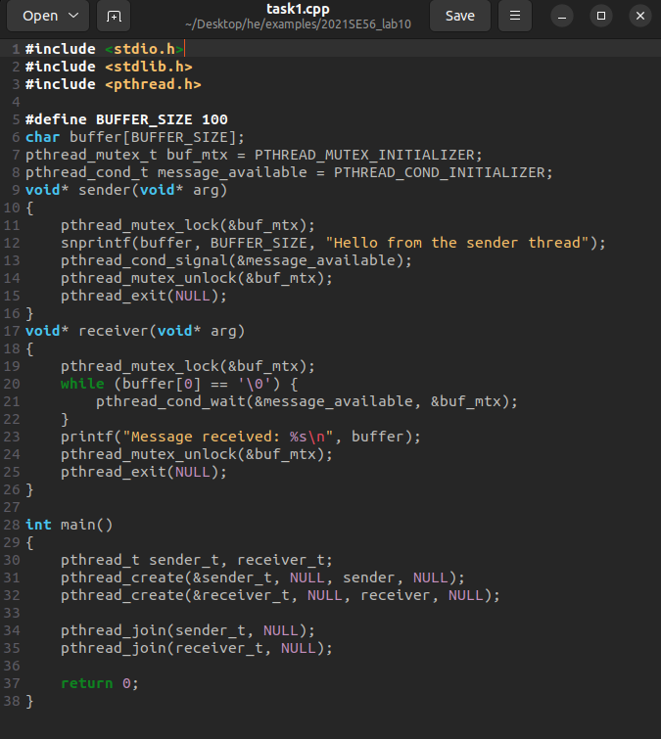

**Output:**

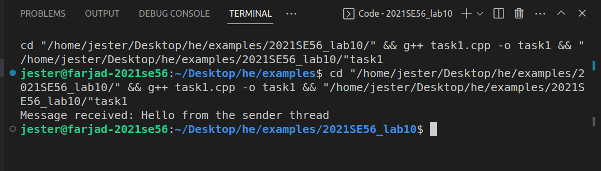

**Task 2**

Suppose, you have a bank account with some balance amount Rs. 100. It is not enough to meet one-month expenditure, so you asked your dad, brother, and cousin to deposit some money in your account. Now, suppose your dad, brother and cousin all tried to deposit money at the same time. To serve their request, server process creates three threads, one for each to let them deposit money. Suppose, to deposit money, thread updates account balance as follows:- 1. OldBalance = your_account.balance 2. NewBalance = OldBalance + depositedAmount 3. your_account.balance = NewBalance Now in your dad, brother and cousin’s case they started depositing money at the same time so all threads take OldBalance = 100. All threads do calculation of NewBalance separately as thread(1) NewBalance = 100 + 10000 ——> dad deposited Rs. 10000. thread(2) NewBalance = 100 + 5000 ——–> brother deposited Rs. 5000. thread(3) NewBalance = 100 + 5500 ——–> brother deposited Rs. 5500. Now suppose thread(2) updates your account balance as Rs. 5100, and just after that thread(1) updates your account balance to Rs. 10100. During updating thread(1) and thread(3), thread three(3) also run on the same time and it will set new balance to Rs. 5600. So, your final account balance is Rs. 5600. So, in effect, the money deposited by your brother and dad hasn’t been credited into your account

**Code:**

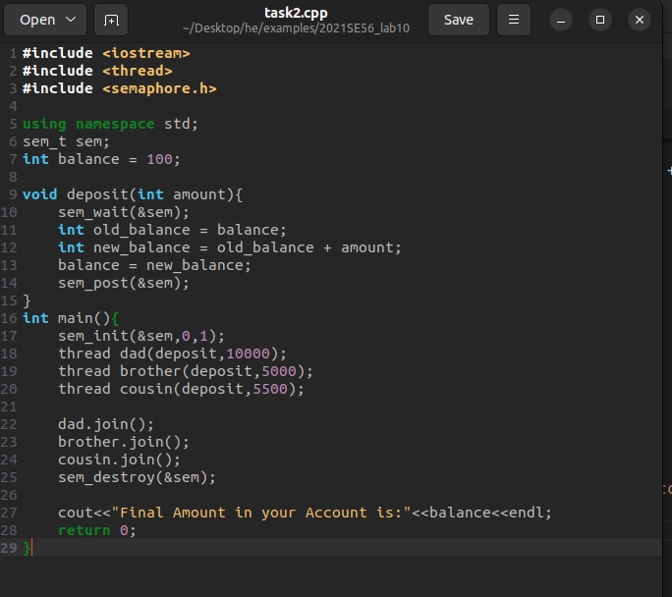

**Output:**

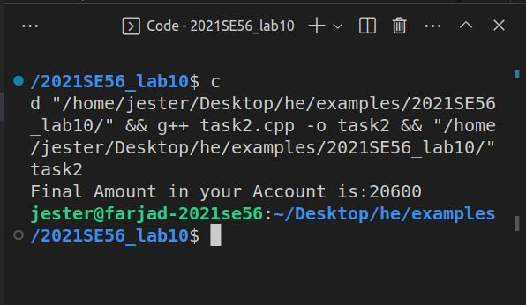

**Task 3**

Write a simple program that synchronizes threads by using semaphores.

**Code:**

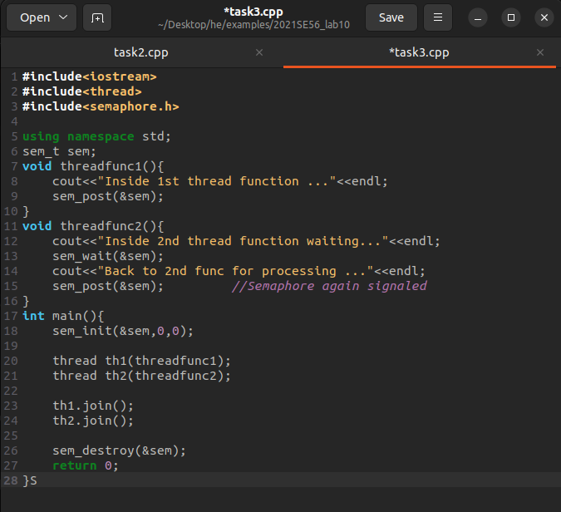

**Output:**

