**LIVROUTE**



**Supervisor**

Ma’am Alina Munir

**Submitted by**

Muhammad Salman  
{2021_SE_04}

Noman Ahmad  
{2021_SE_11}

Farjad Waseem  
{2021_SE_34}

**Department of Computer Science,**

University of Engineering and Technology, Lahore, New-Campus.

TABLE OF CONTENT

Usecase Diagram: 4

Class Diagram: 5

Object Diagram: 6

Package Diagram: 7

Deployment Diagram: 8

# Usecase Diagram:

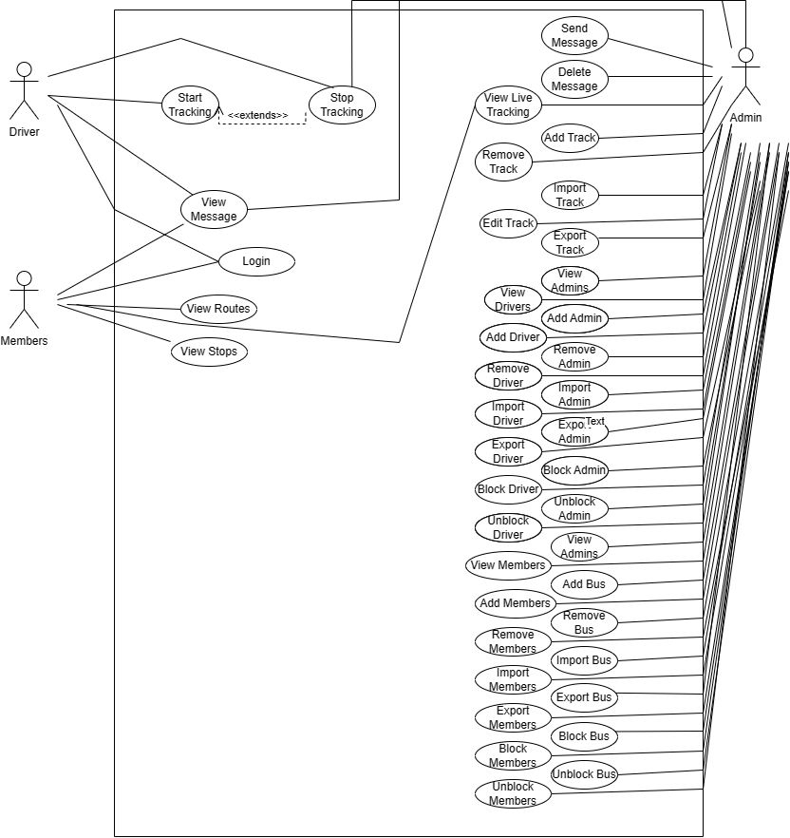

# Class Diagram:

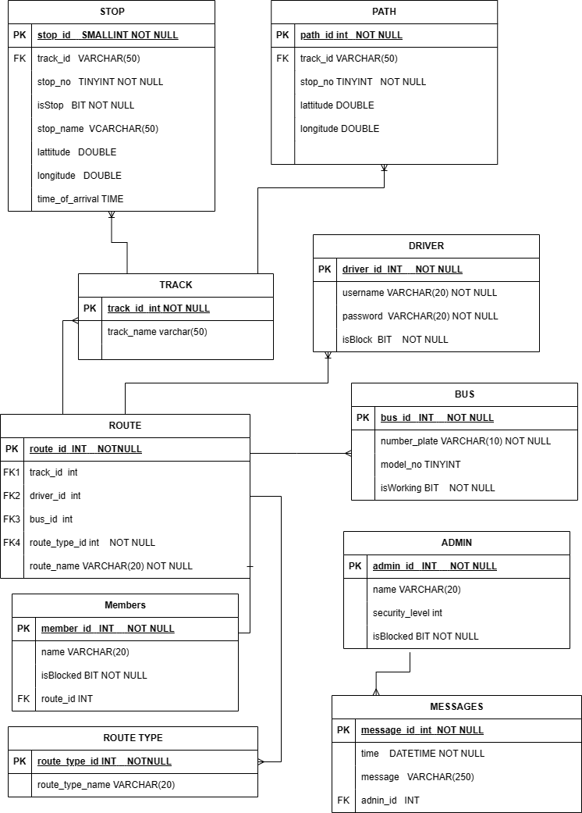

# Object Diagram:

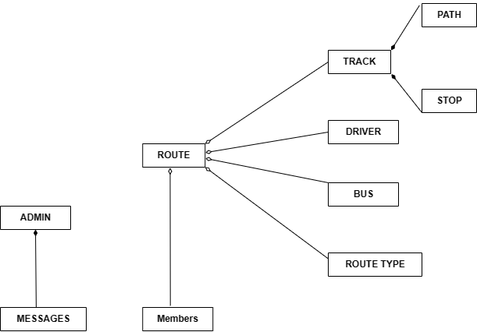

# Package Diagram:

# package

# Deployment Diagram:

