**Computer Networks Lab#4**



**Session: 2021**

**Submitted by:**

**M.Farjad Waseem 2021-SE-56**

**Submitted to:**

**Sir Umer Rasheed**

Department of Computer Science

University of Engineering and Technology, Lahore, New Campus

* Select the first UDP segment in your trace. What is the packet number[1] of this segment in the trace file? What type of application-layer payload or protocol message is being carried in this UDP segment? Look at the details of this packet in Wireshark. How many fields there are in the UDP header? (You shouldn’t look in the textbook! Answer these questions directly from what you observe in the packet trace.) What are the names of these fields?

Answer: 1;

* What languages (if any) does your browser indicate that it can accept to the server?

Your browser indicates that it can accept any language with the "Accept" header set to **Accept: */\***.

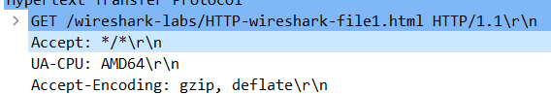

* What is the IP address of your computer? What is the IP address of the gaia.cs.umass.edu server?

- The IP address of my computer is 192.168.100.4. This is mentioned in the "Source Address" field of the IPv4 header.

- The IP address of the gaia.cs.umass.edu server is 128.119.245.12. This is mentioned in the "Destination Address" field of the IPv4 header.

* What is the status code returned from the server to your browser?

Status Code is 200.

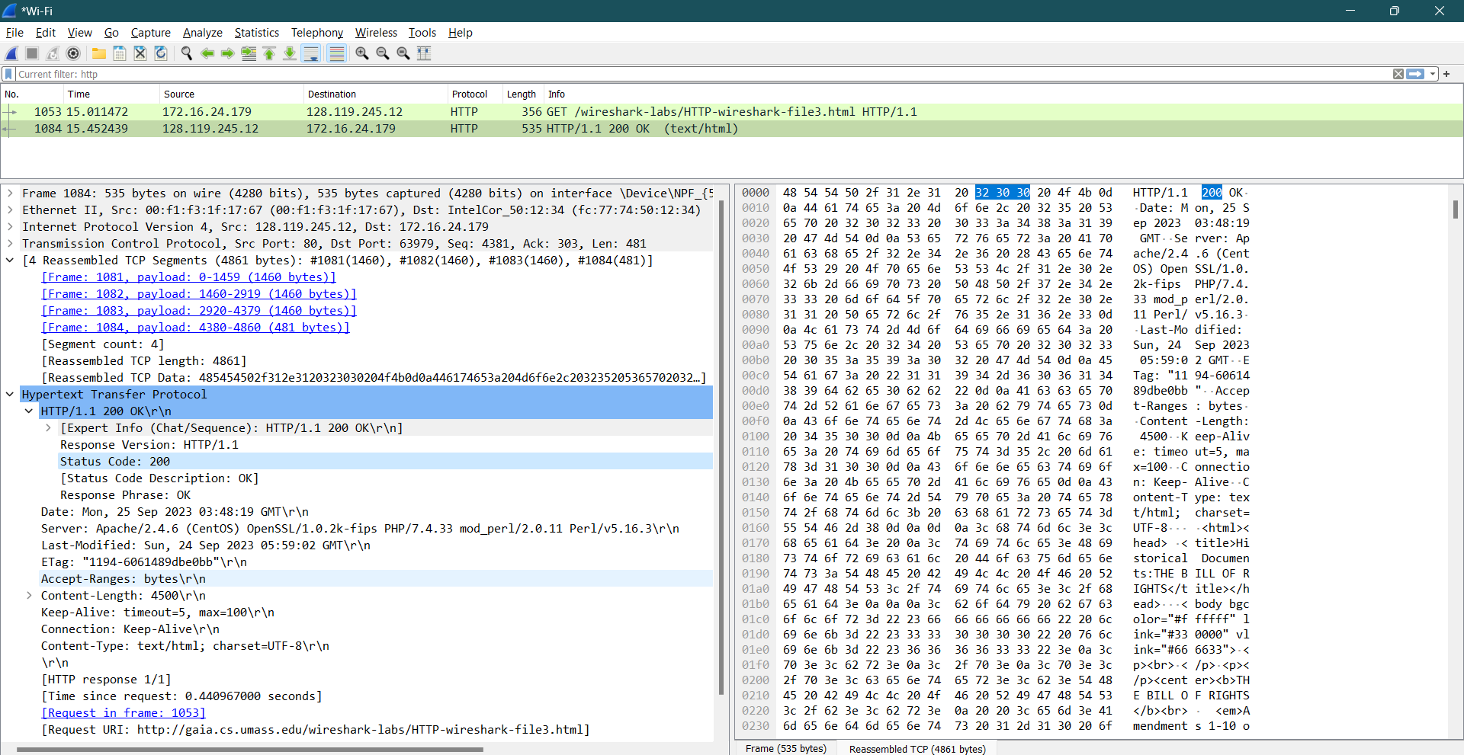

* When was the HTML file that you are retrieving last modified at the server?

Last-Modified: Sun, 24 Sep 2023 05:59:02 GMT\r\n

* How many bytes of content are being returned to your browser?

The number of bytes of content being returned to your browser is 302 bytes. This information can be determined from the "TCP payload (302 bytes)" section of the packet.

* By inspecting the raw data in the packet content window, do you see any headers within the data that are not displayed in the packet-listing window? If so, name one.

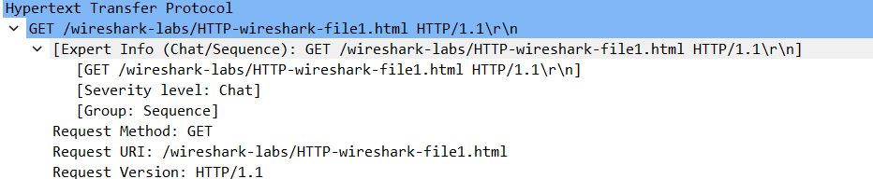

* Inspect the contents of the first HTTP GET request from your browser to the server. Do you see an “IF-MODIFIED-SINCE” line in the HTTP GET?

I don’t see an “IF-MODIFIED-SINCE” line in the HTTP GET. The first GET messege does not have “IF-MODIFIED-SINCE”.

* Inspect the contents of the server response. Did the server explicitly return the contents of the file? How can you tell?

Yes, the server explicitly returned the contents of the file. This can be determined by examining the HTTP response:

The "Content-Length" header in the response indicates a content length of 371 bytes, confirming that the server sent the file's contents.

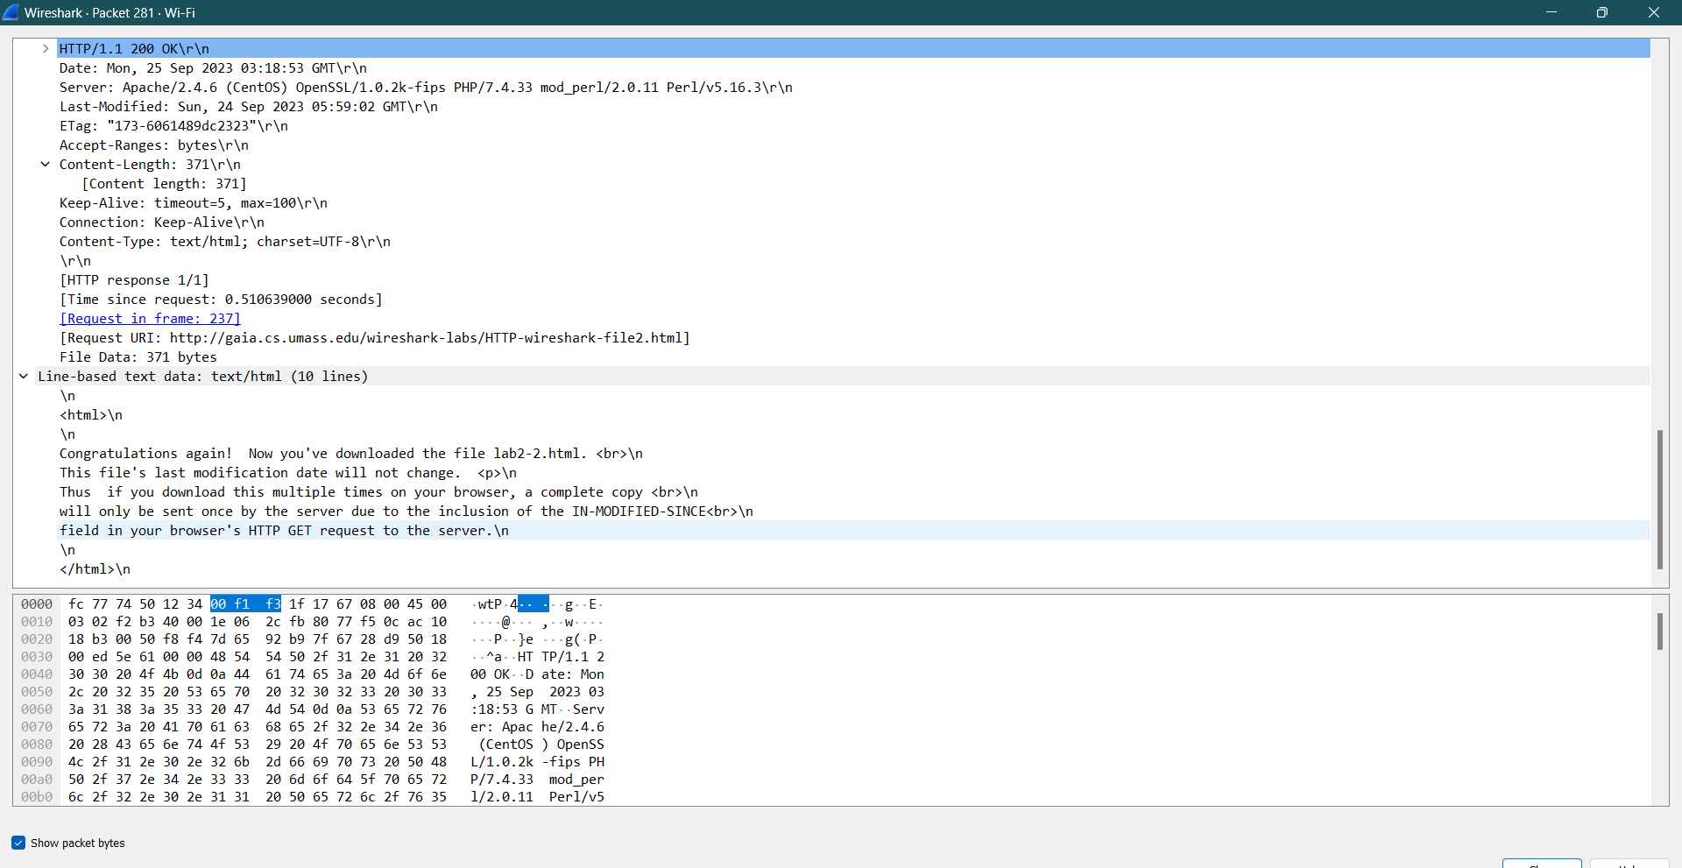

* Now inspect the contents of the second HTTP GET request from your browser to the server. Do you see an “IF-MODIFIED-SINCE:” line in the HTTP GET[2]? If so, what information follows the “IF-MODIFIED-SINCE:” header?

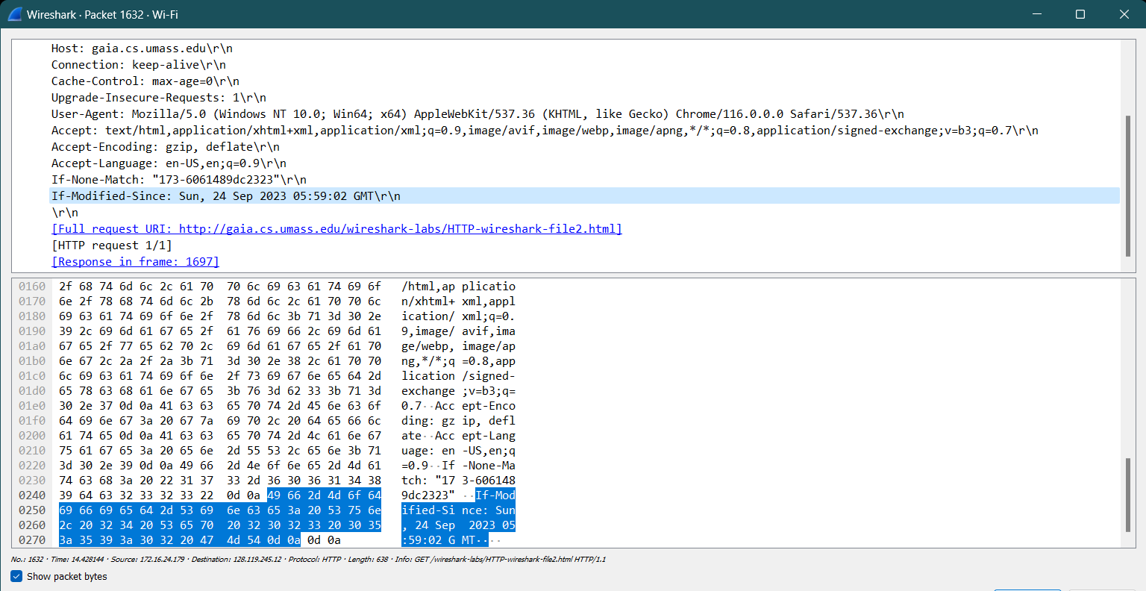

* What is the HTTP status code and phrase returned from the server in response to this second HTTP GET? Did the server explicitly return the contents of the file? Explain.

Server: Apache/2.4.6 (CentOS) OpenSSL/1.0.2k-fips PHP/7.4.33 mod_perl/2.0.11 Perl/v5.16.3\r\n

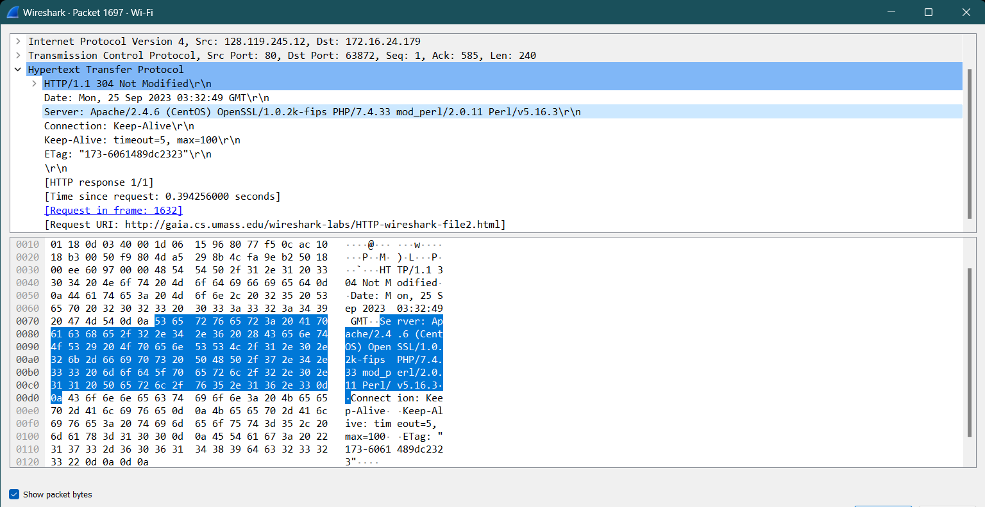

* How many HTTP GET request messages did your browser send? Which packet number in the trace contains the GET message for the Bill or Rights?

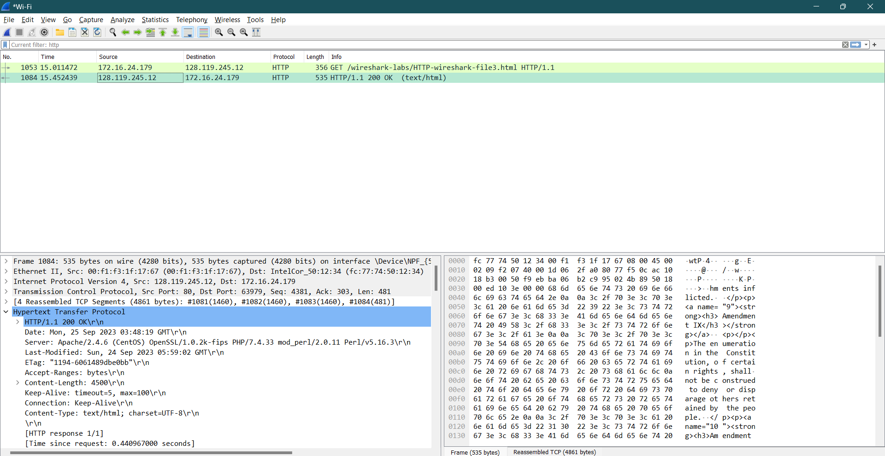

* Which packet number in the trace contains the status code and phrase associated with the response to the HTTP GET request?

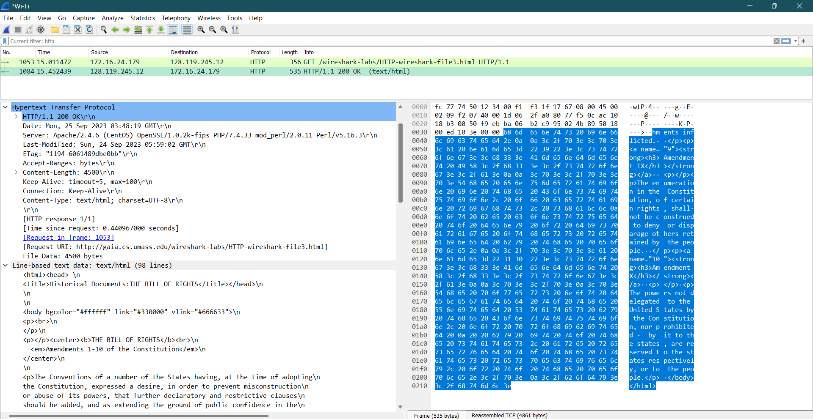

* What is the status code and phrase in the response?



* How many data-containing TCP segments were needed to carry the single HTTP response and the text of the Bill of Rights?

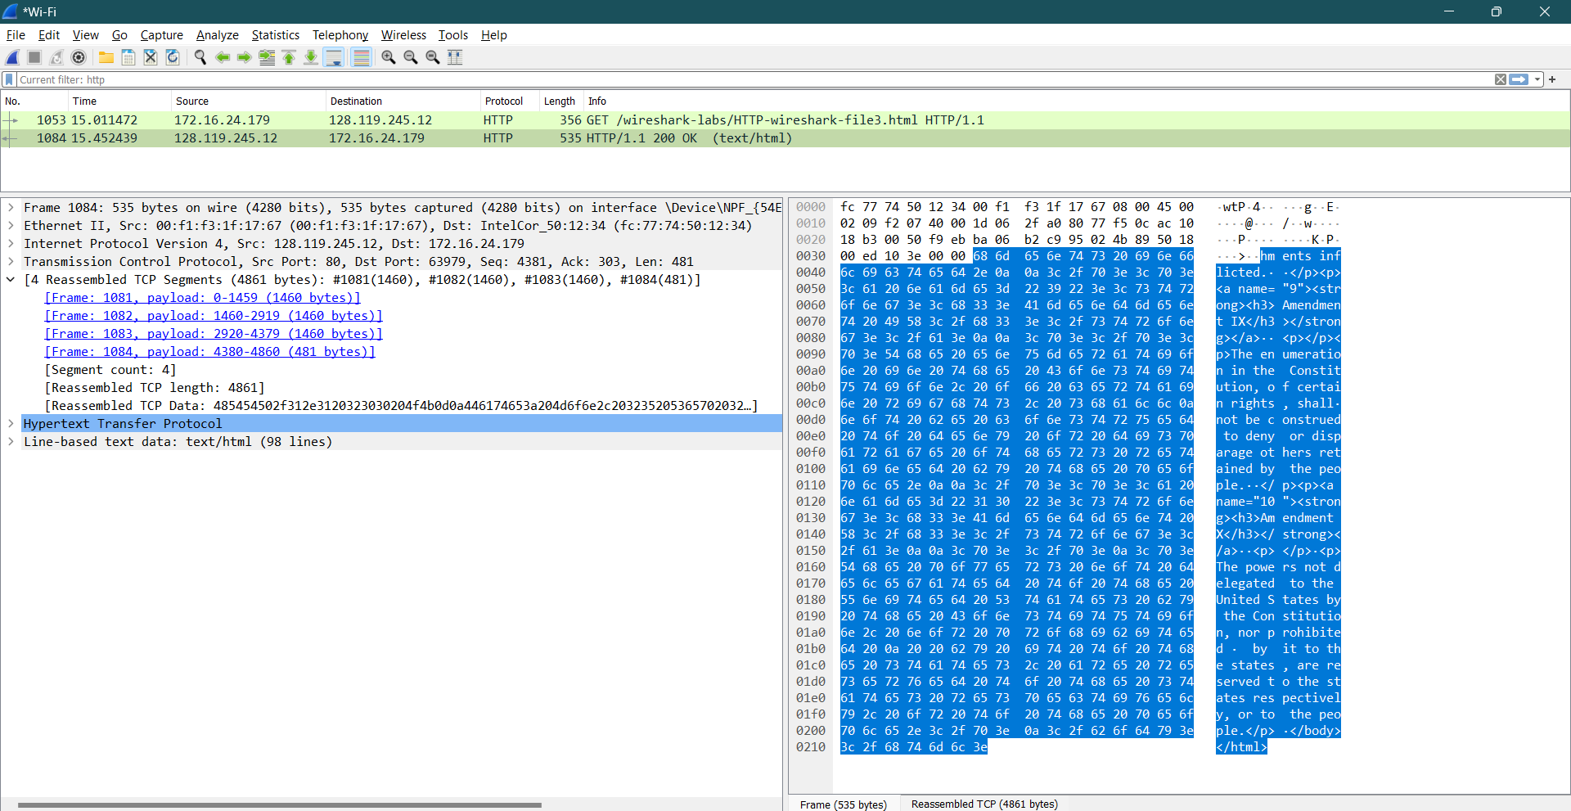

* How many HTTP GET request messages did your browser send? To which Internet addresses were these GET requests sent?

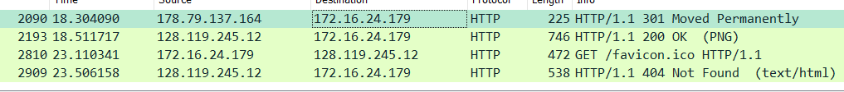

* Can you tell whether your browser downloaded the two images serially, or whether they were downloaded from the two web sites in parallel? Explain.

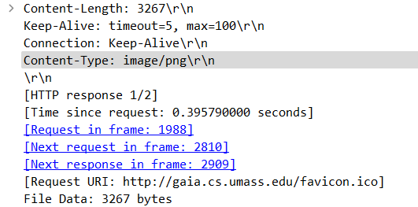

* What is the server’s response (status code and phrase) in response to the initial HTTP GET message from your browser?

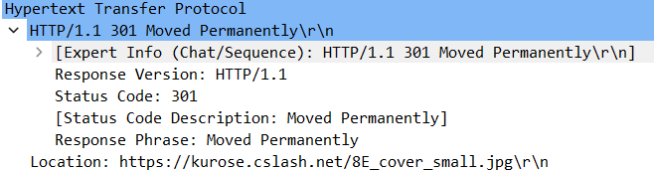

* When your browser’s sends the HTTP GET message for the second time, what new field is included in the HTTP GET message?

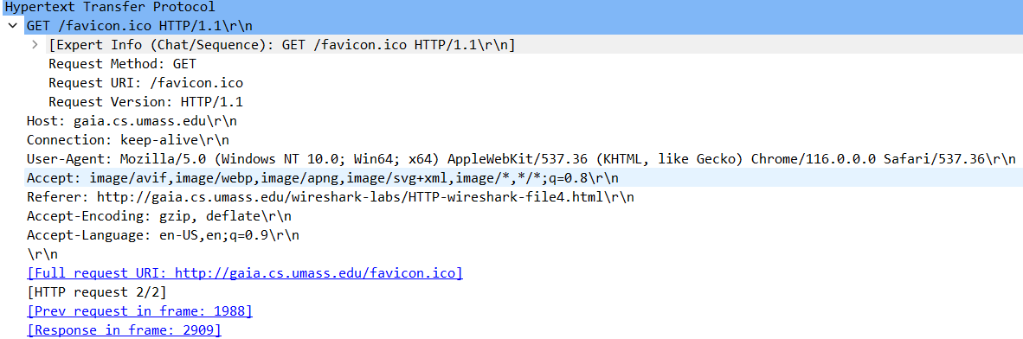

1. Remember that this “packet number” is assigned by Wireshark for listing purposes only; it is NOT a packet number contained in any real packet header.
2.