Remnant Chronicles Site Plan

Sarah Penfold

WDD 130

Overview

The purpose of this page is to allow fans to find information about Remnant chronicles. Including: Character info, book summaries, world building (Morrighan, Venda, Dalbreck), and fan art.

Audience
Fans who want more information on the series and a place for them to “nerd out”. If there is interest in reading Remnant chronicles, then they can get more information.

Branding

Website Logo
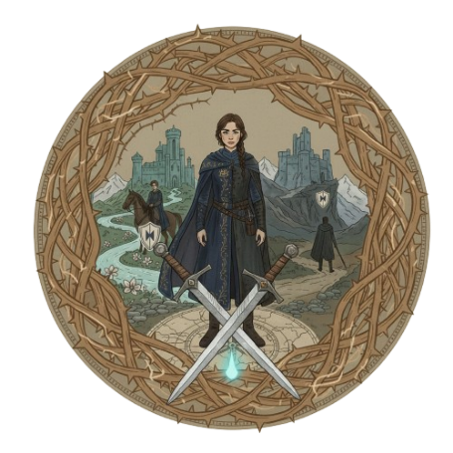

Style Guide

Color Palette
Primary | Secondary | Accent 1 | Accent 2
#A87C5C | #3C6E71 | #C7D1D4 | #808C99

Typography

Heading Font: Cinzel Decorative

https://fonts.google.com/selection?preview.text=Remnant%20chronicles&query=Cinzel+Decorative

Paragraph Font: Cardo

https://fonts.google.com/specimen/Cardo?preview.text=Remnant%20chronicles&query=Cardo

Navigation
Home Page2 Page3

Home

Character

Summary

World building

Fan art

Content

Home:
- links to characters
- book summary
- world building
- fan art
Characters:
- Information on characters
- full name
- family
- kingdom origin
- development throughout the book

Summary:
- Plot
- Love triangle development
- Themes
- Quotes
- Setting
- Underlying problem

World building:
- Morrighan
- Venda
- Dalbreck
- Ruler
  - Start to end
- Rivalry
- Alliance
- Topography
- Conspiracy Theories

Fan art:
- At least 8 pieces of art
- Whimsical illustration

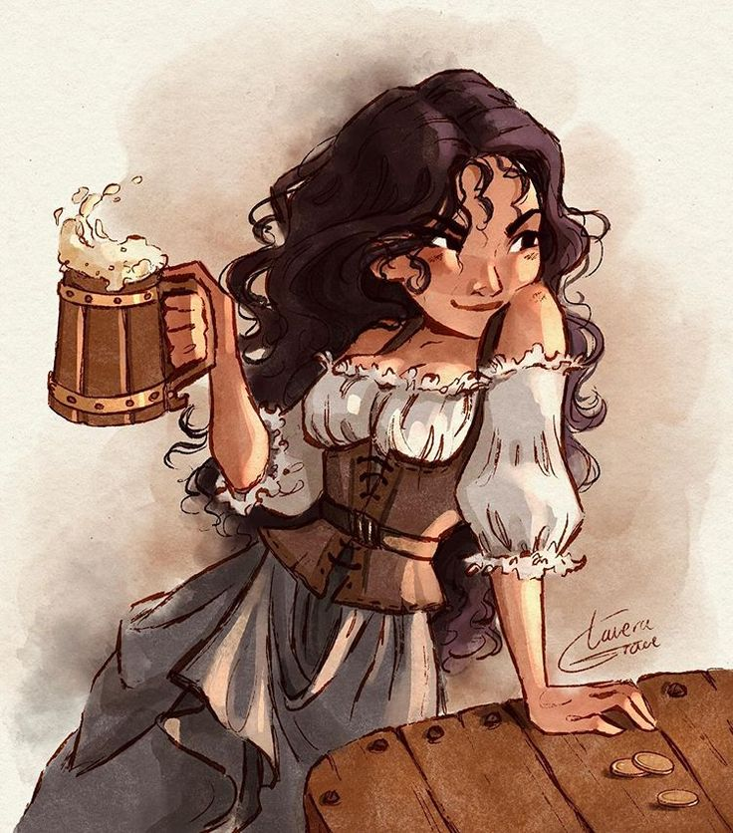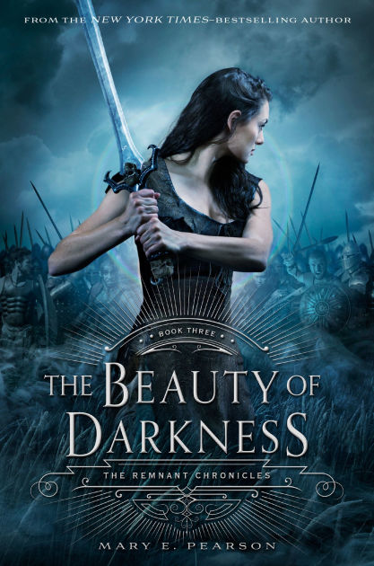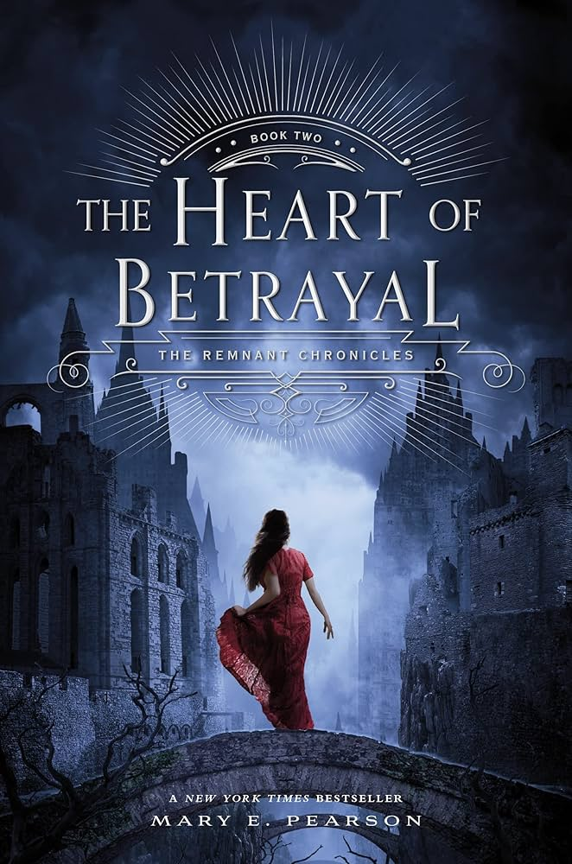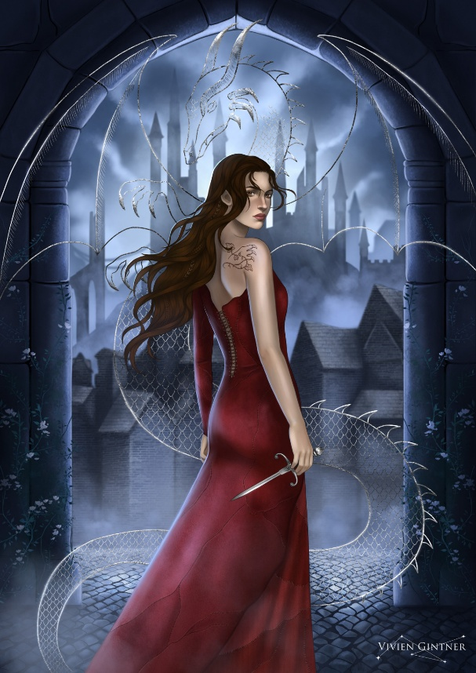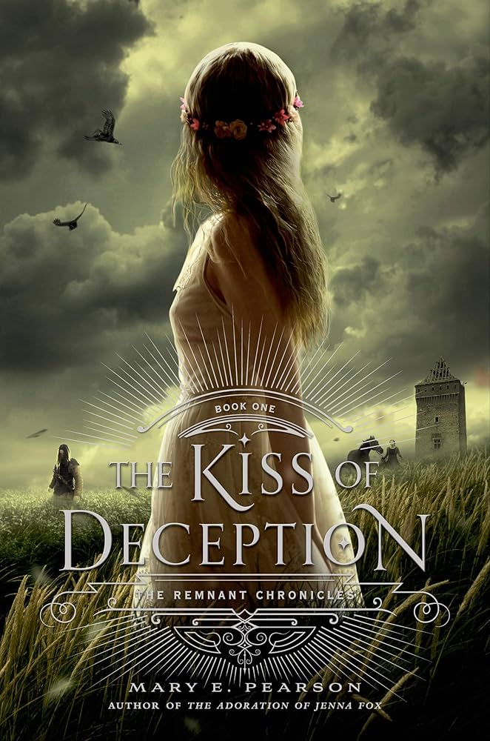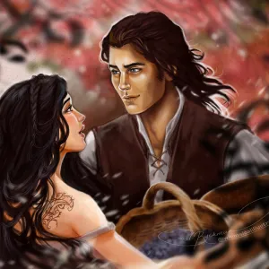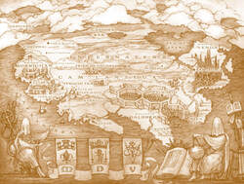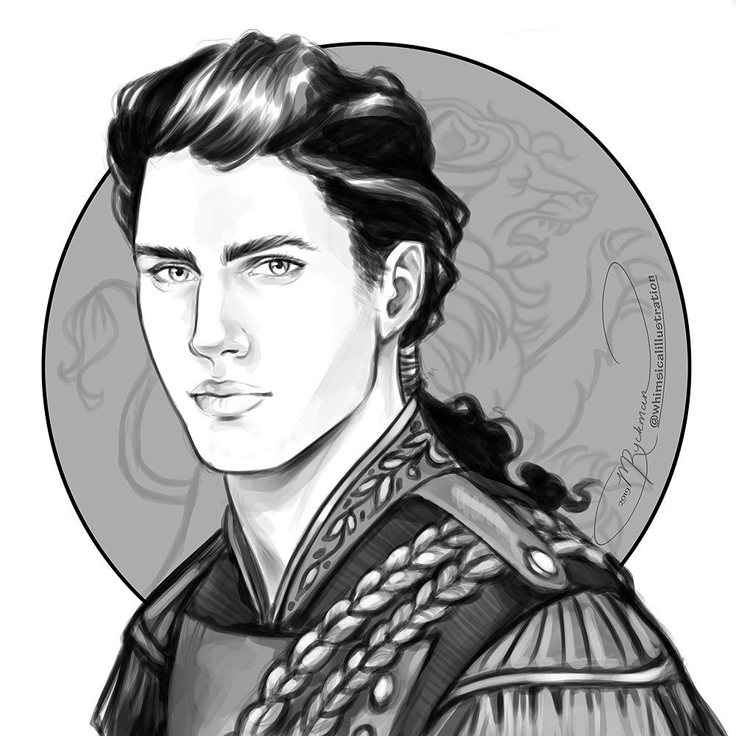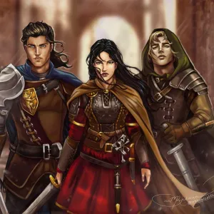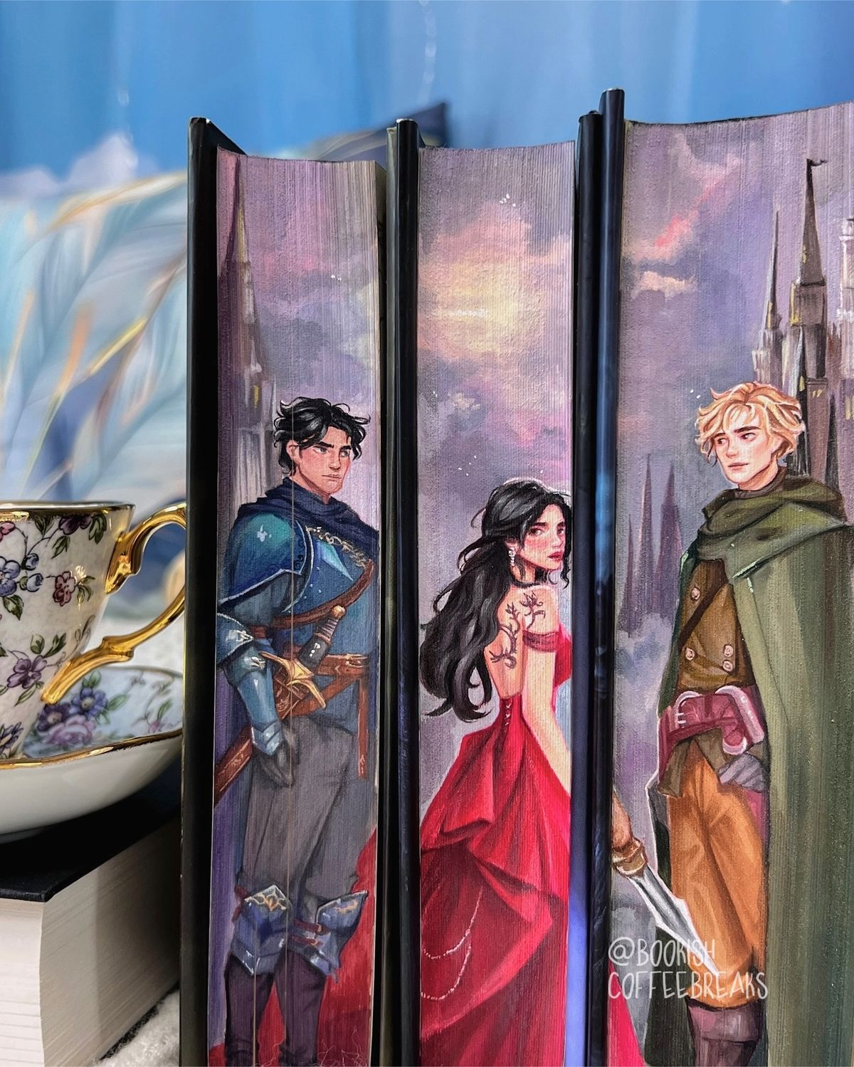

Wireframes
