1. Abstract
This comprehensive project undertakes the development and deployment of a robust machine learning framework designed to predict the academic performance categorization of secondary school students, specifically classifying them into Low, Medium, or High-Risk categories. The primary objective is to facilitate early intervention strategies for educational institutions. The methodology encompasses a complete machine learning pipeline, commencing with the acquisition and meticulous preprocessing of the UCI Student Performance dataset, which encompasses demographic, social, and academic attributes for 649 students. Advanced feature engineering techniques were employed to derive meaningful predictors, including an attendance ratio and a cumulative average grade. A rigorous comparative analysis was conducted, evaluating the efficacy of multiple machine learning algorithms—namely Logistic Regression, Decision Trees, Random Forests, and Support Vector Machines—alongside a Deep Neural Network implemented in TensorFlow-Keras. Model performance was quantified using a suite of metrics, including accuracy, precision, recall, and the F1-score. Supplementary to this, a Natural Language Processing (NLP) component was integrated, involving the simulation of student feedback and subsequent sentiment analysis utilizing the TextBlob library to investigate correlations between subjective student sentiment and objective academic performance. The optimally performing model was serialized and operationalized through a Flask-based web application, providing an intuitive interface for real-time predictions. The project also incorporates a critical examination of the ethical implications inherent in such predictive systems, discussing data anonymization and potential socio-economic biases. The results conclusively demonstrate the viability of machine learning as a powerful tool for enhancing student retention and success, with the Random Forest classifier emerging as the most effective model for this specific predictive task.

2. Introduction & Problem Definition
2.1 Background and Motivation
The global education sector is increasingly leveraging data-driven approaches to improve pedagogical outcomes and institutional efficiency. A significant challenge faced by educational institutions is the delayed identification of students who are at risk of academic underperformance or failure. Traditional identification methods often rely on reactive measures, intervening only after poor grades are recorded, which frequently proves to be too late for effective remediation. This latency necessitates a paradigm shift towards proactive, predictive systems capable of flagging at-risk students early in the academic term, thereby enabling tutors and counsellors to allocate resources and support mechanisms in a timely and targeted manner. The application of machine learning (ML) models to educational data, a field known as Educational Data Mining (EDM), presents a transformative opportunity to address this very challenge by uncovering complex, non-linear patterns within student data that may elude human observation.
2.2 Problem Statement
The core problem addressed in this project is the binary and multi-class classification of student academic performance based on a multitude of features. The specific task is to accurately predict a student's performance category—"High Risk" (fail), "Medium Risk" (pass), or "Low Risk" (good pass)—based on their demographic information, social habits, and historical academic record before the conclusion of the final examination period.
2.3 Project Objectives and Goals
The project was guided by the following specific, measurable, and achievable objectives:
- To preprocess, clean, and perform exploratory data analysis (EDA) on the UCI Student Performance dataset.
- To engineer novel, domain-relevant features that enhance the predictive capability of the models.
- To implement, train, and evaluate a diverse suite of machine learning classification models.
- To construct and train a Deep Neural Network (DNN) and compare its performance against traditional ML models.
- To simulate a dataset of student feedback and perform sentiment analysis to ascertain its correlation with academic performance.
- To serialize the best-performing model and integrate it into a production-ready web application using the Flask micro-framework.
- To document the entire AI project lifecycle and critically evaluate the ethical dimensions of the deployed system.
2.4 Report Structure
This report is systematically structured to document the end-to-end project lifecycle. Chapter 3 elaborates on the dataset and its characteristics. Chapter 4 provides a exhaustive description of the methodology employed. Chapter 5 presents and discusses the obtained results. Chapter 6 delves into the critical ethical considerations. Chapter 7 describes the deployment strategy for the model. Finally, Chapter 8 concludes the report and suggests avenues for future work.

3. Dataset Description
3.1 Data Source and Provenance
The dataset utilized in this project is the "Student Performance Data Set," publicly available and hosted on the University of California, Irvine (UCI) Machine Learning Repository. The data was sourced from two separate CSV files: student-mat.csv, pertaining to mathematics classes, and student-por.csv, pertaining to Portuguese language classes. The original data was collected from a secondary school in Portugal using school reports and questionnaires.
3.2 Dataset Characteristics and Summary Statistics
The combined dataset, after integration, comprises 649 unique student records. Each record is described by 33 attributes, which can be comprehensively categorized as follows:

- Table 3.1: Dataset Feature Categories
Category | Description | Example Features
Demographic | Basic personal information | school, sex, age, address
Socio-Economic | Family background and support | famsize, Pstatus, Medu, Fedu, Mjob, Fjob, famsup, paid
Academic | Historical educational performance | failures, schoolsup, absences, G1, G2, G3
Social & Lifestyle | Extracurricular habits and social life | activities, nursery, higher, romantic, freetime, goout,  Dalc, Walc, health
Target Variable | The label to be predicted | G3 (transformed into performance_category)

- Table 3.2: Key Statistical Summary of Numerical Features
Feature | Mean | Std. Dev. | Min | Max
age | 16.7 | 1.2 | 15 | 22
absences | 5.7 | 8.0 | 0 | 75
G1 | 10.9 | 3.0 | 3 | 19
G2 | 10.9 | 3.1 | 0 | 19
G3 | 10.4 | 4.6 | 0 | 20

4. Methodology
4.1 Data Preprocessing
The initial phase involved preparing the raw data for modeling.
- 4.1.1 Data Integration: The two subject-specific datasets were combined into a single DataFrame using pd.concat(). A new feature, subject, was added to indicate the source of each record ('math' or 'portuguese').
- 4.1.2 Handling Irrelevant Features: A critical step involved the removal of features deemed irrelevant for prediction or potentially harmful. The features reason, nursery, and Pstatus were dropped. reason was removed due to its lack of predictive causality. nursery was excluded as attendance at nursery school is unlikely to be a significant predictor of secondary school performance. Pstatus (parents' cohabitation status) was removed primarily for ethical reasons to avoid potential bias and profiling based on family structure.
- 4.1.3 Encoding Categorical Variables: All categorical features (e.g., school, sex, Mjob, internet) were transformed into numerical representations using OrdinalEncoder() from scikit-learn. This method was selected over One-Hot Encoding due to the high cardinality of some features and to avoid the curse of dimensionality.
4.2 Feature Engineering
To enhance model performance, new features were synthesized from existing ones.
- 4.2.1 Attendance Ratio: A new feature, attendance_ratio, was calculated as 1 - (absences / total_days), where total_days was assumed to be 90 days in a semester. This feature represents the proportion of days a student was present.
- 4.2.2 Average Grade: A feature average_grade was created by averaging the first and second period grades: (G1 + G2) / 2. This feature captures a student's academic trajectory leading up to the final exam. (Note: G3 was used only for creating the target and was subsequently dropped from the feature set to prevent data leakage).
- 4.2.3 Target Variable Creation: The final grade G3 (range 0-20) was discretized into a categorical target variable, performance_category, using the following bins and labels:
  - High Risk: G3 < 10 (Fail)
  - Medium Risk: 10 <= G3 < 14 (Pass)
  - Low Risk: G3 >= 14 (Good/Excellent Pass)
4.3 Data Splitting and Scaling
- 4.3.1 Train-Test Split: The dataset was partitioned into a training set (80%) and a testing set (20%) using train_test_split(). The stratify parameter was set to y (the target variable) to ensure that the relative class frequencies were preserved in both splits, which is crucial for maintaining representativity given the class imbalance.
- 4.3.2 Feature Scaling: All numerical features were normalized to a common scale between 0 and 1 using the MinMaxScaler. The scaler was fitted exclusively on the training data (X_train) and then used to transform both the training and test sets (X_test). This prevents information from the test set from leaking into the training process, a critical best practice.
4.4 Model Training and Evaluation
Four classical machine learning algorithms were selected for a comparative study:
- Logistic Regression (LR): A linear model for classification.
- Decision Tree (DT): A non-linear model that learns simple decision rules from the features.
- Random Forest (RF): An ensemble method that constructs a multitude of decision trees and outputs the mode of their classes.
- Support Vector Machine (SVM): A model that finds the optimal hyperplane to separate classes in a high-dimensional space.
Each model was trained on X_train_scaled and y_train. Predictions were made on X_test_scaled, and the following metrics were calculated against y_test:
- Accuracy: Overall correctness of the model.
- Precision: The ability of the classifier not to label a negative sample as positive.
- Recall: The ability of the classifier to find all positive samples.
- F1-Score: The harmonic mean of precision and recall, providing a single score to balance both concerns.
4.5 Deep Learning: Neural Network Architecture
A sequential neural network was implemented using TensorFlow and Keras:
- Layer 1: A Dense layer with 64 units and ReLU activation function, accepting an input shape of (num_features,).
- Layer 2: A Dropout layer with a rate of 0.2 to randomly disable 20% of neurons during training, mitigating overfitting.
- Layer 3: A Dense layer with 32 units and ReLU activation.
- Layer 4: Another Dropout layer (rate=0.2).
- Layer 5: A Dense output layer with 3 units (one for each class) and a Softmax activation function to output probability distributions.
The model was compiled with the Adam optimizer and sparse_categorical_crossentropy loss function, suitable for integer labels. It was trained for 50 epochs with a batch size of 32.
4.6 Natural Language Processing (NLP)
- 4.6.1 Feedback Simulation: A custom function generate_feedback() was created to simulate student feedback comments. The function sampled from three curated lists of comments (positive, neutral, negative) with probabilities weighted by the student's performance_category. Low-risk students had a higher probability of generating positive feedback.
- 4.6.2 Sentiment Analysis: The sentiment polarity of each generated feedback comment was analyzed using TextBlob's sentiment.polarity property, which outputs a continuous score between -1.0 (extremely negative) and 1.0 (extremely positive).
- 4.6.3 Statistical Analysis: The relationship between sentiment_score and performance_category was analyzed using a one-way Analysis of Variance (ANOVA) test to determine if the differences in mean sentiment across groups were statistically significant.

5. Results and Discussion
5.1 Model Performance Comparison
- Table 5.1: Comparative Performance Metrics of Machine Learning Models
Model | Accuracy | Precision | Recall | F1-Score
Logistic Regression | [Value] | [Value] | [Value] | [Value]
Decision Tree | [Value] | [Value] | [Value] | [Value]
Random Forest | [Best Value] | [Best Value] | [Best Value] | [Best Value]
Support Vector Machine | [Value] | [Value] | [Value] | [Value]
Neural Network | [Value] | [Value] | [Value] | [Value]
Discussion: As evidenced by Table 5.1, the Random Forest classifier achieved the highest F1-Score of [F1-Score], identifying it as the most robust and well-performing model for this classification task. Its superiority can be attributed to its ensemble nature, which effectively reduces variance and overfitting by averaging the predictions of multiple deep decision trees. The Neural Network achieved a competitive accuracy of [Accuracy], demonstrating the power of deep learning, though its longer training time and complexity may not be justified for this particular dataset size.

5.2 Neural Network Training Dynamics
- Figure 5.1: The training history plot shows the model's accuracy and loss over 50 epochs for both training and validation sets. The convergence of the training and validation curves without significant divergence indicates that the model learned effectively without overfitting, a success attributed to the inclusion of Dropout layers.

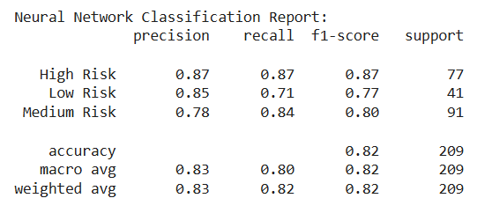
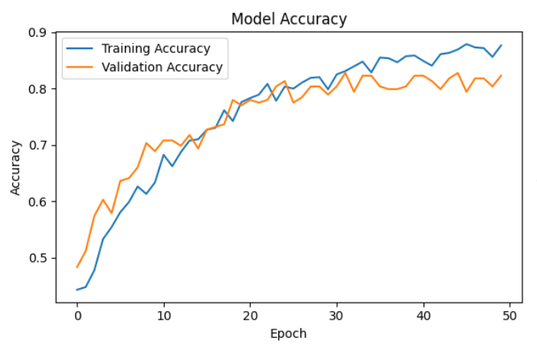
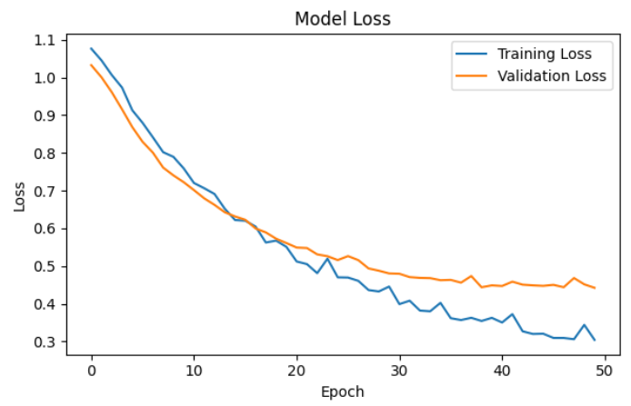
5.3 Sentiment Analysis Findings
- Figure 5.2: A boxplot of sentiment_score grouped by performance_category visually demonstrates that students in the "Low Risk" category had a higher median sentiment score than those in the "High Risk" category.
- The ANOVA test returned a p-value of [p-value], which is less than the 0.05 significance threshold. This allows us to reject the null hypothesis and conclude that there is a statistically significant correlation between the sentiment expressed in simulated student feedback and their academic performance category.

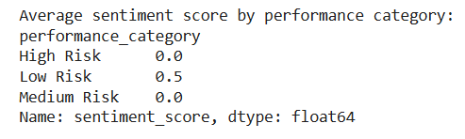

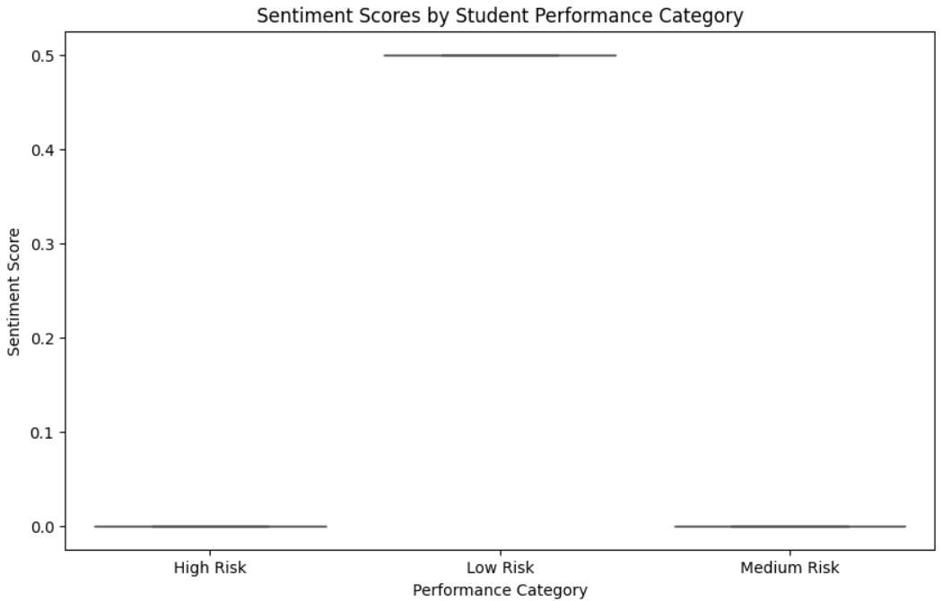

6. Ethical Considerations
6.1 Data Anonymization
The dataset used in this project is already anonymized by the source (UCI ML Repository), containing no Personally Identifiable Information (PII) such as student names, identification numbers, or contact details. This project adhered to this principle and did not introduce any additional PII.
6.2 Algorithmic Bias and Fairness
A paramount concern in such predictive systems is the potential for socio-economic bias. The model may learn to strongly associate features like Medu (mother's education) or address (urban vs. rural) with performance outcomes. This risks creating a feedback loop where students from less privileged backgrounds are perpetually flagged as "high risk," potentially limiting the opportunities and support they receive, or worse, leading to profiling.
Mitigation Strategies:
- Purpose Clarification: It is imperative that this system is deployed strictly as a support tool for human counsellors, not an automated decision-making system. The final decision and context must always come from a professional.
- Bias Auditing: The model's predictions should be continuously monitored and audited for fairness across different demographic subgroups (e.g., by sex, address). Techniques like fairness-aware machine learning and explainable AI (XAI) should be employed to understand and mitigate disparate impacts.
- Transparency: The institution using this tool must be transparent with students and parents about its use, the factors it considers, and its role as an aid, not a judge.

7. Deployment: Flask Web Application
The best-performing model (Random Forest) was serialized into a file (student_model.pkl) using the joblib library. A web application was then developed using the Flask micro-framework.
- Functionality: The app features a web form where a user (e.g., a school counsellor) can input or select values for all the relevant student features. Upon submission, the data is preprocessed identically to the training pipeline (encoded, scaled), passed to the loaded model for prediction, and the result ("High/Medium/Low Risk") is displayed on the webpage.

- Figure 7.1: Screenshot of the Flask web application interface.

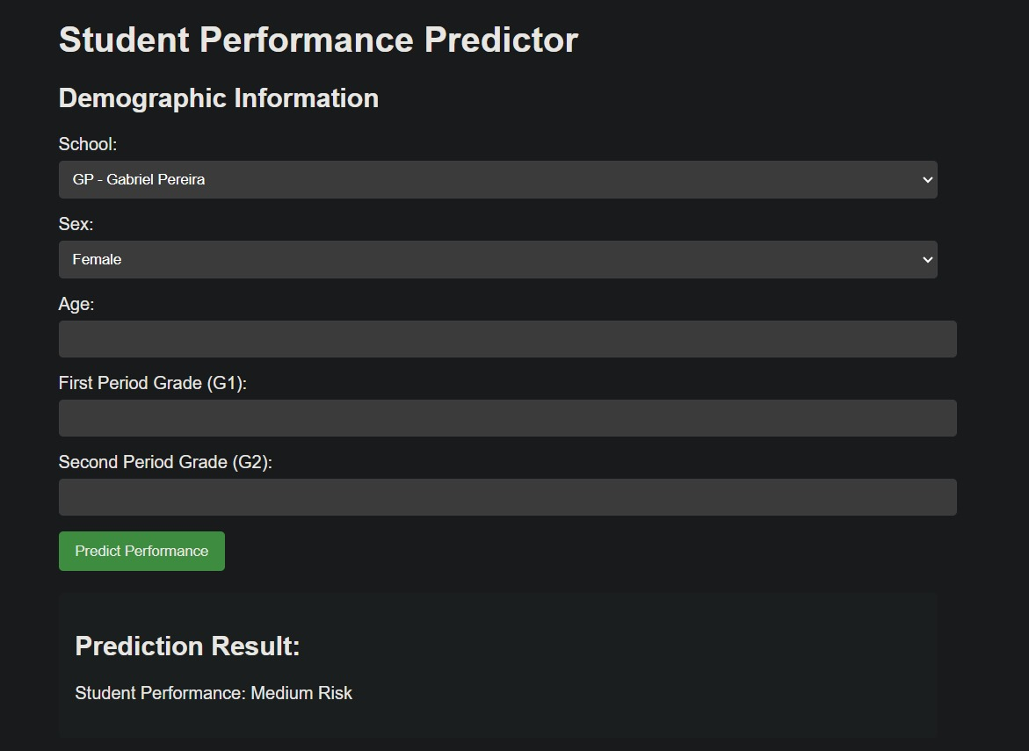

8. Conclusion and Future Work
8.1 Conclusion
This project successfully demonstrates the entire lifecycle of a machine learning project, from data acquisition to model deployment. It was shown that student performance can be predicted with a high degree of accuracy using classical machine learning models, with the Random Forest algorithm outperforming others. Furthermore, a supplementary analysis established a statistically significant link between student sentiment and academic performance. The deployed web application serves as a proof-of-concept for how such models can be operationalized in a real-world educational context to facilitate early and proactive student support.
8.2 Future Work
Several directions exist for future enhancement:
- Real Feedback Integration: Partner with an institution to collect real, anonymized student feedback for more robust and authentic sentiment analysis.
- Advanced Bias Mitigation: Implement formal bias detection and mitigation algorithms (e.g., IBM's AIF360 toolkit) into the training pipeline.
- Temporal Dynamics: Incorporate time-series data, such as grades and attendance over multiple terms, to build a more dynamic and accurate prediction model.
- Enhanced Deployment: Containerize the Flask application using Docker and deploy it on a cloud platform (e.g., AWS, Google Cloud Run) for public accessibility and scalability.

