Visualization Overview of Pakistani E-commerce Industry

1- Order Cancellation & Completion Analysis
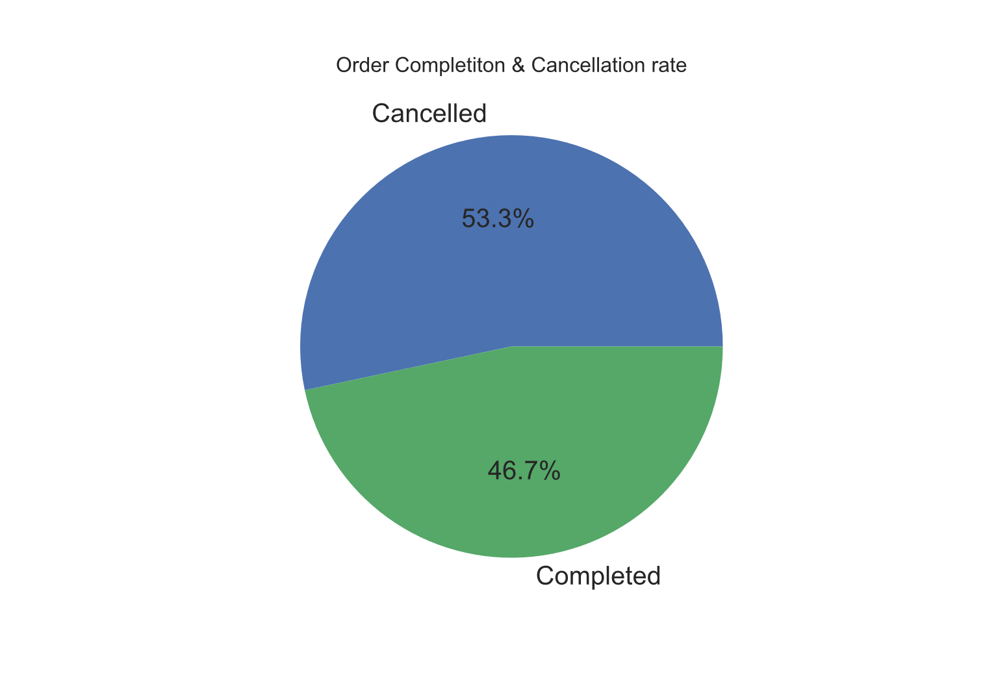
Cancellation rate is much higher than Completed rate. The Difference is about 6.6%. In Pakistan this is might be due to poor authorization system, Check and balance and product misinformation. Due to these problems people still not properly trust online platforms.

2- Price Overview in Terms of Order cancellation and completion
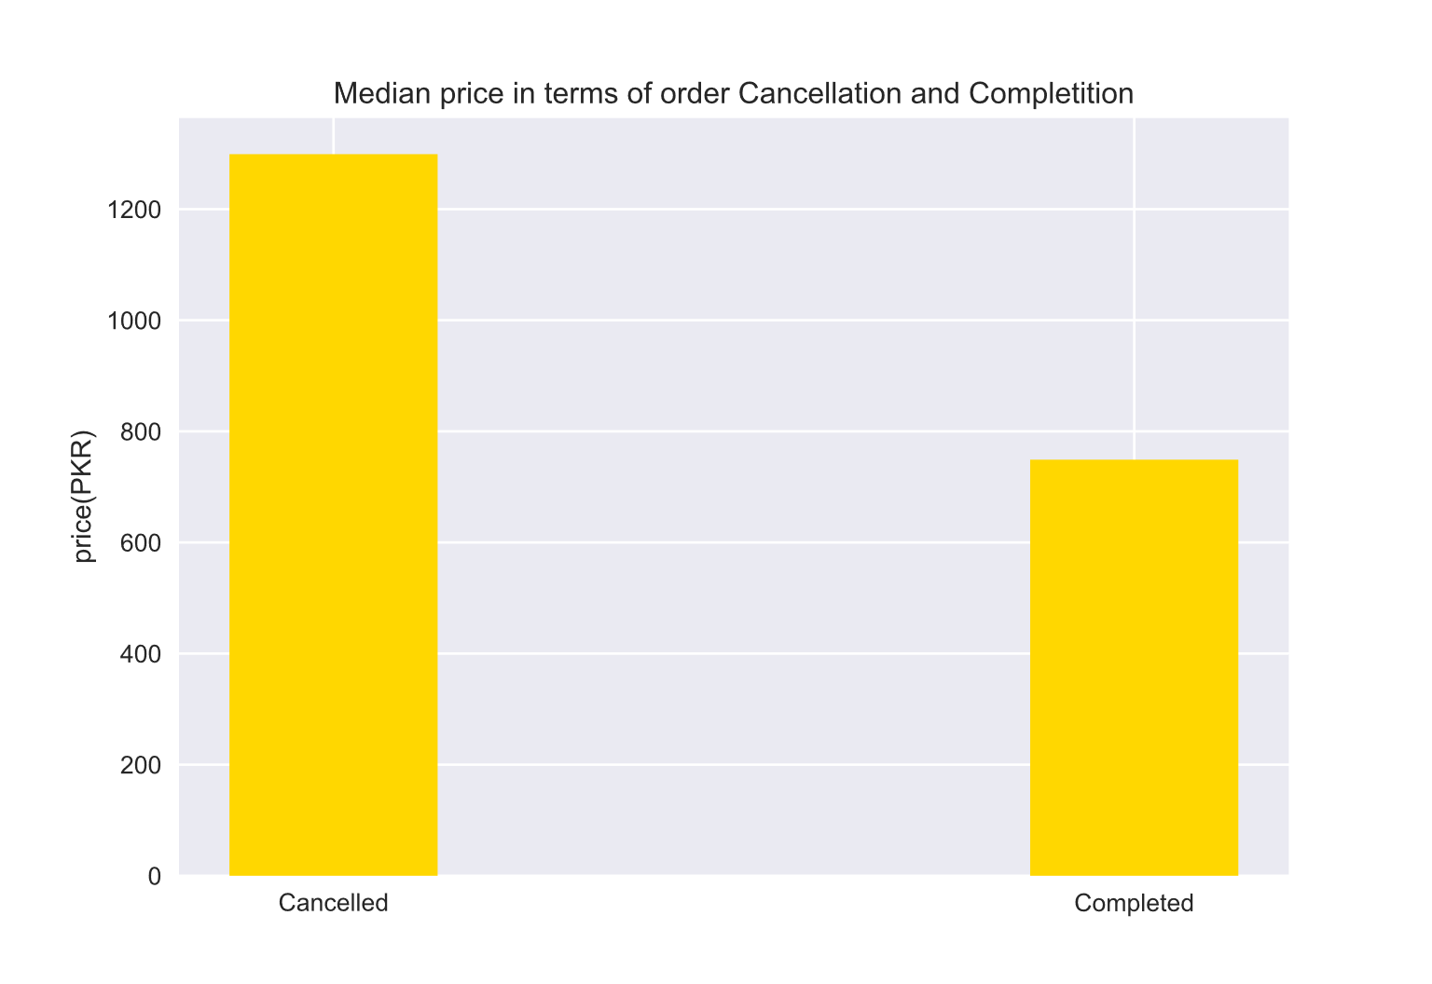
This bar graph explains complete story about price in terms of order cancelled and completed. The average price is higher in cancellation then completed orders. The price difference is about Rs 401 shows that people who cancelled any order may belongs to higher price category. Higher the price is people trust might be deflected because of more amount of loss. But for Economical prices people mindset takes a completely different view of cheaper so this might relax them in terms of few amounts less damage.

3- Product Categories
Cancellation:
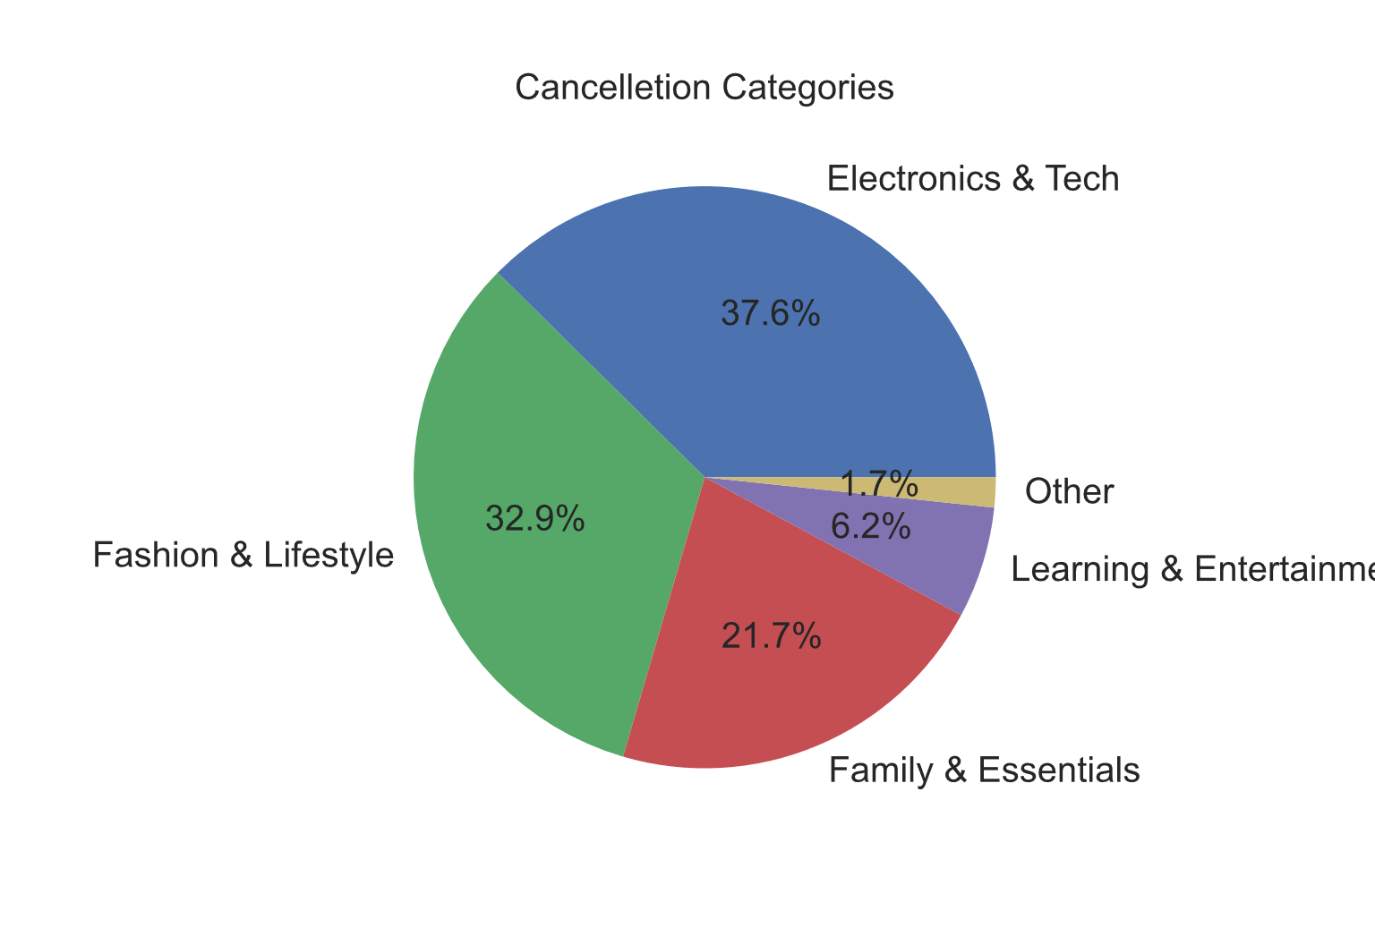
Completion: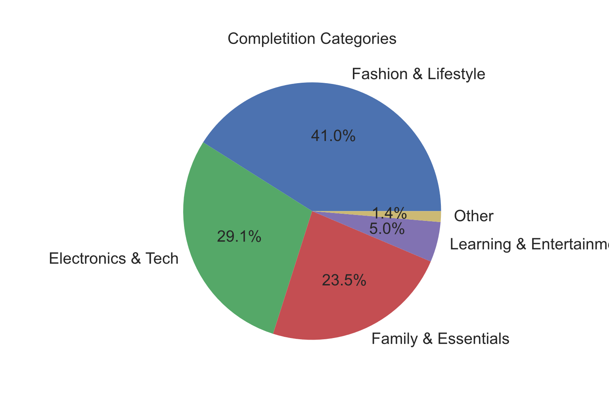

Order Outcome by Product Category

Category | Cancelled | Completed | Difference
Electronics & Tech | 37.6% | 29.1% | +8.5pp → over-represented in cancellations
Fashion & Lifestyle | 32.9% | 41.0% | −8.1pp → under-represented in cancellations (completes more reliably)
Family & Essentials | 21.7% | 23.5% | −1.8pp → roughly stable
Learning & Entertainment | 6.2% | 5.0% | +1.2pp → slightly more cancellations
Other | 1.7% | 1.4% | negligible

4 – Payment Method Used
Cancellation:

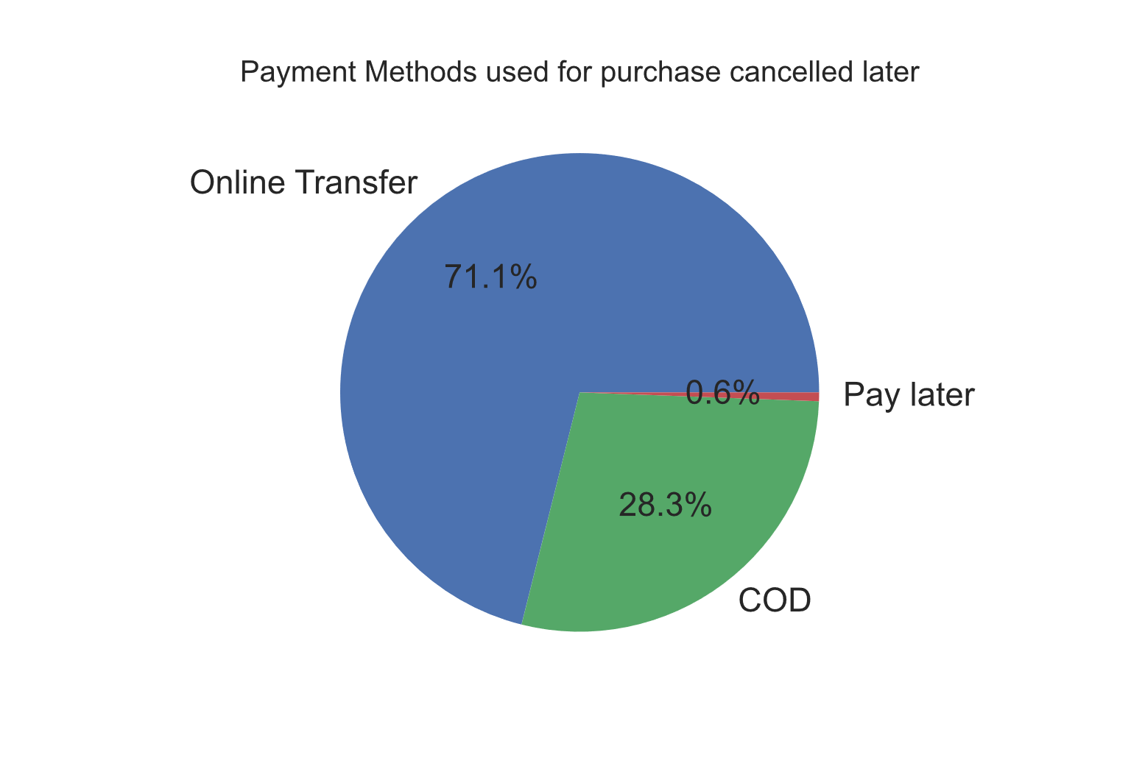

This shows almost 71% people who purchased something through online payment method later on cancel the order. This shows a clear picture of fear among people that early payment is not good idea because pay early might bound the buyer in terms of authority.

Completion:

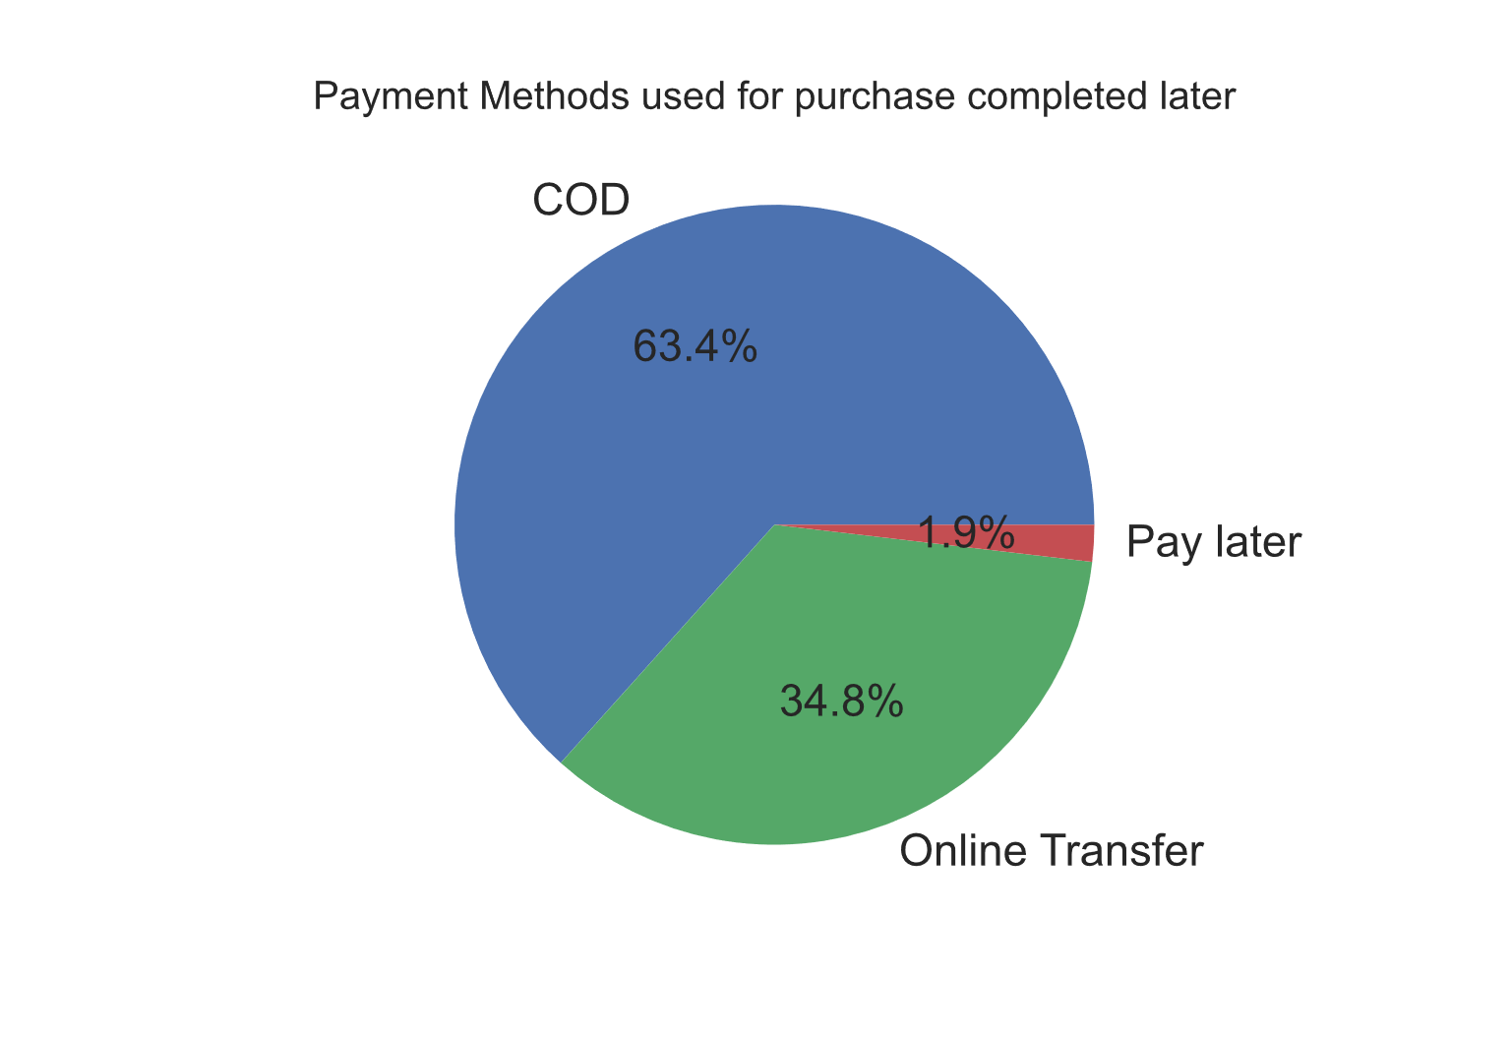

A clear shift in terms of payment source is clear. 63% of people show there in interest in Cash on Delivery with strong completion rate.

Conclusion:
Overall status of order is important as it decides the future of growing market and upcoming innovations among this market. This helps us to understand the vision of people and what they prefer and what they want. These visuals are not only numbers but also the revealing face of how market is performing and what are the loopholes that needs to be filled in order to capture a dominant market value in Pakistani Context.

Source.
https://www.kaggle.com/datasets/zusmani/pakistans-largest-ecommerce-dataset

