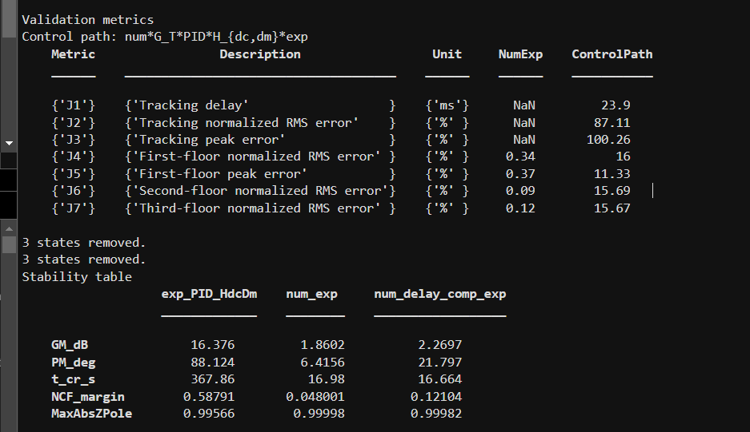
FEM 1
1 pole 1 zero delay comp
Ncf 0.1

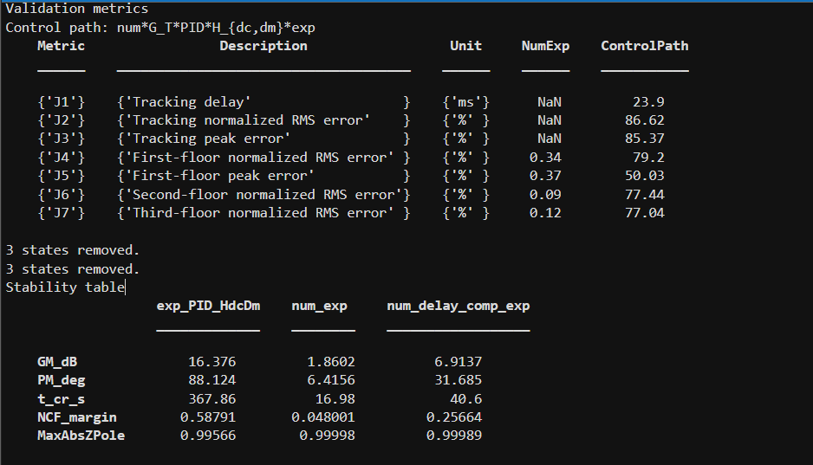

FEM 1
1 pole 1 zero delay comp
Ncf 0.3

