An Online Stability Indicator for Real-Time Hybrid Simulation
Emphasizing Physical Substructure Degradation
Mohamed Gomaa^{,2}, Edwin D. Patino, Juan Nicolas Villamizar², Johnny W. Condori Uribe, Shirley J. Dyke

Abstract
Real-time hybrid simulation (RTHS) has become increasingly important as an experimental tool for evaluating system-level structural response under realistic loading while averting the cost and impracticality of full-scale testing. Recent advances in real-time processing, high-quality sensing, and servo-hydraulic control techniques have accelerated RTHS adoption and enabled more complex experiments. However, a key barrier to reliable RTHS execution remains the potential loss of stability as the physical substructure evolves during testing, particularly under stiffness degradation. This paper addresses this challenge by first formulating a typical RTHS framework and transfer-system dynamics, then analyzing stability under a parameterized degradation of the physical substructure and presenting a computational procedure for determining the critical damage level. Building on this analysis, an online stability indicator based on the normalized coprime factor (NCF) margin is presented and simplified for efficient evaluation in single-input-single-output (SISO) settings. A controller-switching strategy is also demonstrated to support practical intervention during an experiment by transitioning from a high-performance controller to a high-robustness controller as stability margins diminish. The switching boundary is formulated using Lyapunov stability criteria to ensure closed-loop stability during the transition. The approach is demonstrated on a modified version of a well-established benchmark problem. Using virtual real-time hybrid simulation (vRTHS), the proposed indicator is shown to provide a timely warning of diminishing robustness, enabling a smooth controller transition that successfully maintains stable operation and response accuracy under progressive degradation.

Keywords: real-time hybrid simulation; stability indicator; normalized coprime factor; structural degradation; controller switching

1-Introduction
Despite the remarkable advances in computational modeling and simulation tools, experimental testing remains indispensable to provide sufficient understanding of complex structural systems. Computational models often rely on idealized assumptions and simplifications, and their applicability may be limited when dealing with new, untested innovations. Experimental calibration and validation may be required before they are likely to be adopted for predicting the response to new inputs [1].
The ideal experiment to provide the most realistic test conditions and accurate results would be a full-scale, real-time experiment. However, such a test is often infeasible due to the cost, time, scale, and physical constraints, especially for structural applications. These constraints inspired civil engineering researchers to embark on a multi-decade effort to establish cost-effective testing methods that provide meaningful data for understanding behavior, validating models, and capturing the full spectrum of responses up to failure. One testing method that has been a fundamental part of civil engineering research since the early 20th century is the quasi-static technique [2]. With this approach, a predefined loading input is applied to a structural component (e.g., a building column or bridge pier) at a slow rate to allow close observation of the evolution of damage and to determine the hysteretic behavior without the need for high-performance actuators. As a result of its nature, the quasi-static technique has some major limitations: 1) it focuses on obtaining component-level rather than structure-level information, and thus it neglects the interaction between the component being tested and the rest of the structure; 2) it requires a predefined loading protocol, which helps in understanding some of the mechanical component properties, but it may not reflect the actual, or the full range, of structural behavior during the real situation; and, 3) its inherently slow loading rate prevents it from capturing rate-dependent phenomena [3].
These shortcomings motivated a new, cost-effective and efficient experimental technique to evaluate the dynamic performance of large civil structures. Hybrid simulation (HS) has emerged to fill this role, finding its way into structural engineering in the late 1960s [4]. In HS, the structure under investigation is partitioned into two parts: a physical substructure and a numerical substructure. Typically, the physical substructure includes the more complex components of the system, while the numerical substructure models the portions that are well-understood. The interaction between the two substructures is maintained by a transfer system, comprising servo-hydraulic actuators, sensors, and controllers, that enforce compatibility conditions at their interface [5].
As a natural evolution of HS, real-time hybrid simulation (RTHS) was developed to capture rate-dependent properties of systems. Despite being a powerful and versatile testing methodology, RTHS posed new challenges to the research community, as the accuracy of the results is strongly influenced by the performance of the transfer system. Good performance requires both appropriate selection of the hardware and careful design of the controllers, which typically need to be customized to meet the test objectives and account for the unique dynamics of each experiment [6], [7]. Inadequate controller design may not only compromise the accuracy of the results, but also induce instability in the system, potentially creating safety hazards or damaging costly equipment.
To address these challenges, significant research has been carried out to establish the knowledge to improve a transfer system’s performance and stability. For instance, Dyke et al. [8] presented a substantial insight into understanding the physical substructure dynamics as they explained control-structure interaction and showed that actuators have an implicit feedback interaction path. Further, Carrion [6] and Maghareh et al. [9] studied transfer system modelling and developed a parametric model that describes the physical substructure dynamics, thereby laying the foundation for subsequent analytical investigations. Recognizing the need for collaborative progress and to provide a shared testbed that helps researchers standardize the evaluation process of diverse algorithms, benchmark problems were proposed for single-degree-of-freedom [10] and multi-degree-of-freedom [11] controlled substructures. These benchmarks have engaged a wide research community and led to notable advances in the field, with several studies demonstrating successful and effective implementations [12]–[16]. Additionally, more studies extended the framework to incorporate nonlinear experimental components, confirming the versatility of RTHS in capturing complex behaviors [17].
The promising use of RTHS has motivated extensive stability studies to empower researchers to execute more complex experiments. Foundational work to study the RTHS stability analytically was established by Gawthrop et al. [18] and Mercan & Ricles [19], who used delay differential equations to determine system delay margins. These initial works, however, were limited by the simplifying assumption that the experimental substructure had stiffness and damping only. This limitation was addressed by Chi et al. [20], Wallace et al. [21], and Kyrychko et al. [22], who extended the study to include single degree of freedom (SDOF) physical substructures with both stiffness and mass properties. Additionally, they studied the instability mechanism that arises based on the physical substructure properties. To broaden the scope of the investigation, Gao & You [23] and Zhu et al. [24] extended the delay-based indicators to multi-degree-of-freedom (MDOF) systems in their stability studies. Maghareh et al. [5] leveraged the critical delay and derived an efficient eigenvalue-based solution providing a means for selecting among multiple partitioning schemes. To address the need for real-time monitoring, Gálmez & Fermandois [25] and Ahmadizadeh & Mosqueda [26] studied an efficient, energy-based stability indicator for online monitoring. By relying on observed signals during the experiment, it avoids dependence on an explicit model of the transfer system and can be implemented with minimal overhead. However, since it is not predictive and relies on observed data, it cannot provide a tunable lead-time margin for safety interventions. It is therefore well-suited as a secondary safety layer alongside primary predictive indicator aware of the system dynamics.
One common assumption in the aforementioned RTHS stability studies is the reduction of the entire transfer system, including actuator dynamics and potential disruptions, to a lumped pure time delay effect. While being convenient for analysis, this model can fail to capture fundamentally different instability mechanisms, such as gain amplification driven by unmodeled dynamics or stiffness degradation.
Recognizing these limitations, Tang et al. [27] developed a gain-margin-based stability boundary predictor that explicitly accounts for high-order servo-hydraulic transfer-system dynamics with simultaneously varying magnitude and phase, showing that the common pure-delay assumption has a low-frequency validity limit and validating the new method experimentally on a shaking-table test. Moreover, H. Zhou et al. [28] proposed a relative stability indicator for RTHS that relies on two quantitative robustness measures, critical delay for phase tolerance and critical gain, and validated it by numerical and physical SDOF tests. In these studies, the physical substructure parameters are not constant over the course of the experiment, however, the stability indicators are evaluated using a pre-identified loop model and are not updated online as the dynamics evolve. Moreover, extending these methods to multi-input-multi-output (MIMO) systems is non-trivial, particularly for coupled MDOF systems where complex actuator interactions complicate the analysis. Table 1 provides a comparative summary of the RTHS stability indicators in literature, highlighting their capabilities across the selected evaluation criteria.
As shown in Table 1, most prior work adopts a lumped pure time-delay representation of the transfer system, which is referred to in this study as a low-fidelity representation. While this simplification enables stability assessment of the numerical substructure loop (shown in purple in Figure 1), it does not capture the dynamics of the outer controller loop (shown in blue in Figure 2), and therefore cannot evaluate its stability. Depending on the system dynamics and the disruption type, the outer controller loop can be the governing stability constraint. In this study, we present an example where physical-substructure degradation destabilizes the system while monitoring the global loop of the numerical substructure indicates enhanced robustness, motivating the importance of investigating the stability of the outer controller loop by employing high-fidelity models for the transfer system.
Although gain and delay margins are informative for offline experiment design and partitioning selection, computing them online for high-fidelity transfer system models is inherently challenging due to the computational burden of tracking multiple crossover frequencies and maintaining numerical stability in real time. Furthermore, extending these indicators to MIMO configurations introduces additional complications, as the standard loop-at-a-time extension, which perturbs one input/output channel while holding the others nominal, can be overly optimistic, as it ignores coupled, simultaneous variations across channels [32]. On the other hand, energy-based indicators are largely observation-driven, as they are computed from measured response histories and error accumulation rather than explicit model-based predictions. Consequently, they provide limited ability to define a tunable lead time for proactive intervention.
To address these gaps, we propose an online stability indicator with focus on the internal stability of the transfer system and its robustness against unmodeled disruptions. In establishing the indicator, special attention is given to physical system degradation, considering it as the most prevalent disruption to the plant during an RTHS experiment. An analytical solution quantifying the system's robustness to such degradation is presented, and the indicator's performance is illustrated through an example that is adapted from the RTHS benchmark problem.

2-Problem Formulation
The fundamental concept of RTHS is to partition a reference structural model into two substructures. Therefore, an RTHS consists of several major components, including: (i) a numerical substructure that can be evaluated in real-time on a computer; (ii) a physical substructure excited by actuators and instrumented with sensors; and, (iii) a transfer system, comprising the controller, servo-valve and actuator hydraulics, that enforces compatibility and equilibrium interface by synchronizing the physical substructure's response with the numerical evaluated response. Figure 1 illustrates a typical RTHS scheme where the numerical substructure is subjected to a ground acceleration, $a_{g}\left(t\right)$, where $d_{d}$ is the calculated desired displacement from the numerical model, and $f_{e}$ is the measured force from the physical substructure, while Figure 2 provides a closer look inside the transfer system block.
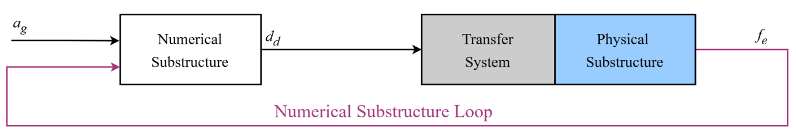
Figure 1: A block diagram illustrating the main components of a typical RTHS test
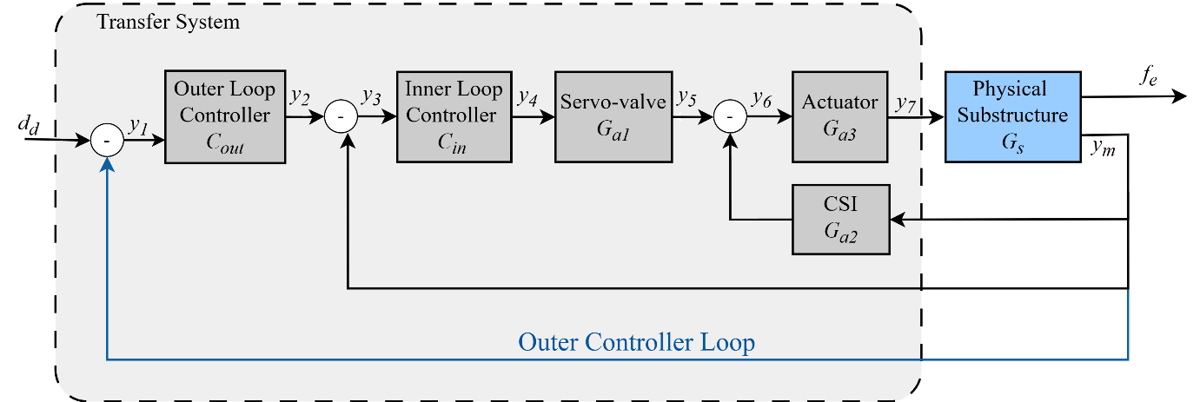
Figure 2: A block diagram decomposing the dynamics of the transfer system
To define the numerical substructure block, the following equation of motion of the reference model is used:
$$\begin{aligned}M_{r}\ddot{x}\left(t\right)+C_{r}\dot{x}\left(t\right)+K_{r}x\left(t\right)=-M_{r}Γa_{g}\left(t\right)\#\left(1\right)\end{aligned}$$
where $M_{r}$, $C_{r}$, and $K_{r}$ are the mass, damping, and stiffness matrices, $x\left(t\right)$, $\dot{x}\left(t\right)$ and $\ddot{x}\left(t\right)$ are the displacement, velocity, and acceleration vectors, $a_{g}\left(t\right)$ is the ground acceleration, $Γ$ is the influence vector mapping base motion to the active DOFs.
Then the partitioning is performed:
$$\begin{aligned}M_{r}=M_{n}+M_{e}, C_{r}=C_{n}+C_{e}, K_{r}=K_{n}+K_{e}\#\left(2\right)\end{aligned}$$
where the subscripts $n$ and $e$ denote the numerical and experimental substructures contributions, respectively. By substituting these into Equation (1) and rearranging:
$$\begin{aligned}M_{n}\ddot{x}+C_{n}\dot{x}+K_{n}x=-M_{r}Γa_{g}-\left(M_{e}\ddot{x}+C_{e}\dot{x}+K_{e}x\right)\#\left(3\right)\end{aligned}$$
$$\begin{aligned}M_{n}{\ddot{x}}_{n}+C_{n}{\dot{x}}_{n}+K_{n}x_{n}=-M_{r}Γa_{g}+f_{e}\#\left(4\right)\end{aligned}$$
Equation (4) represents the cornerstone to model the numerical substructure block which actively computes the required responses to be imposed on the physical substructure. Realizing this response is where the transfer system is engaged to ensure precise tracking and maintain stability in this process.
As shown in Figure 2, the transfer system can be represented by five blocks that represent its dynamic behavior, as follows:
i) Servo-valve: connects the electrical and mechanical parts of the system as it regulates the flow of high-pressure hydraulic oil into the actuator chambers. Despite the fact that its behavior often involves nonlinearities and higher-order dynamics, it can often be simplified to first-order or second-order dynamics [6], [32]. Thus, the servo-valve block $G_{a1}$ can be modeled in the frequency domain as the following transfer function:
$$\begin{aligned}G_{a1}\left(s\right)=\frac{a_{1}β_{0}}{s^{2}+β_{1}s+β_{2}}.\#\left(5\right)\end{aligned}$$
ii) Hydraulic actuator: converts the hydraulic energy into mechanical energy as a force or displacement that is imposed to the physical specimen. Assuming a double-ended linear actuator is used, its behavior can be represented using a first-order transfer function [6]. Thus, the actuator block $G_{a3}$ can be modeled as follows:
$$\begin{aligned}G_{a3}\left(s\right)=\frac{1}{s+a_{3}}\#\left(6\right)\end{aligned}$$
iii) Control structure interaction (CSI): represents the inherent physical coupling between the actuator and the experimental structure. As shown in [8], it can be represented by the following expression:
$$\begin{aligned}G_{a2}\left(s\right)=a_{2}s\#\left(7\right)\end{aligned}$$
iv) Inner loop controller: typically, a hardware-based proportional-integral-derivative (PID) controller provided with the servo-hydraulic system.
v) Outer loop controller: a user-defined controller where sophisticated control and compensation algorithms may be implemented. It should be executed on a real-time computer, taking in the target displacement from the numerical substructure and generating the command signal to send to the inner loop controller.
Finally, the physical substructure block represents the structural components that are being tested. For a single-degree-of-freedom (SDOF) linear structural system, the following expression can be used:
$$\begin{aligned}G_{s}\left(s\right)=\frac{1}{ms^{2}+cs+k}\#\left(8\right)\end{aligned}$$
where $m$ , $c$, and $k$ are the mass, damping coefficient, and stiffness of the specimen, respectively.
Moreover, the transfer function of a degraded physical substructure can be defined as:
$$\begin{aligned}G_{s}\left(s,α\right)=\frac{1}{ms^{2}+2ζ\sqrt{m\left(αk\right)}s+αk}\#\left(9\right)\end{aligned}$$
where $α$ is a degradation factor ranging from 1 for a healthy structure to 0 for a completely damaged structure, and $ζ$ is the damping ratio. Note that the degradation factor relates specifically to the loss in stiffness. In practice, degradation makes the specimen's behavior time-varying and not strictly linear. To address this, a short-window linear approximation is used to keep the analysis tractable and suitable for online evaluation. Although this method may not be accurate during brief intervals where properties change rapidly, it is typically accurate before and after such events, and during periods where degradation evolves slowly.
With the real-time hybrid simulation (RTHS) framework blocks defined, a vRTHS is performed to evaluate various stability indicators. This analysis considers a three-story reference building where a portion of the first story acts as the physical substructure represented by an SDOF frame. More details on this study are provided in section 6. The stability analysis begins by simulating a healthy structure ($α=1$) and then progressively reducing the degradation factor, $α$ ​, to simulate the accumulation of damage. The system is intentionally configured to become unstable during a typical seismic test, allowing for the assessment of different stability metrics available in the literature.
To motivate the need for an alternative stability metric and to establish a baseline for comparison, three potential stability indicators (SIs) are evaluated, including: (i) numerical critical time delay ($τ_{cr,N}$), defined as the maximum time delay that can be added to the numerical substructure's feedback loop before the system becomes unstable. Its evaluation typically relies on a simplified model where the entire transfer system is represented as a lumped pure time delay, as depicted in Figure 3 [5]. (ii) physical critical time delay ($τ_{cr,P}$), defined as the maximum time delay that can be added to the outer loop controller's feedback loop (indicated in blue in Figure 2) before instability occurs, and (iii) the physical controller gain margin ($GM_{P}$), which represents the maximum constant gain that can be applied to the outer loop controller's feedback loop. The outcome of these indicators during progressive structural damage is illustrated in Figure 4. The horizontal axis represents the degradation factor, $α$ , while the vertical axis shows each SI's value, normalized by its initial value for the healthy structure. Normalization is used to focus the analysis on the qualitative behavior and sensitivity of each indicator to degradation, rather than their absolute magnitudes.
Interpreting Figure 4 reveals that both critical time delay indicators ( $τ_{cr,N}$ and $τ_{cr,P}$) fail to accurately reflect the growing risk of instability arising from structural damage. Specifically, $τ_{cr,N}$ exhibits misleading behavior as its normalized value increases with damage, falsely suggesting enhanced stability, while $τ_{cr,P}$ remained nearly constant until exhibiting an abrupt drop, offering no advance warning. In contrast, the $GM_{P}$ exhibits a more gradual decrease before the onset of instability, suggesting that the instability triggered by the degradation is closer to being caused by a gain amplification in the outer controller loop than a time delay, a mechanism that delay margins struggle to detect. It's important to note that these observed behaviors are not universal, as the dominant instability mechanism and the performance of each indicator can change substantially depending on the specific dynamics of the transfer system and the physical substructure.
This study aims to present an online stability indicator for quantifying the system's robustness against different instability mechanisms driven by unmodeled dynamics or unforeseen disruptions, while also aiming to provide a sufficient time frame for effective intervention before instability occurs. To address a notable gap in the literature, this study focuses on the transfer system's internal stability, giving special consideration to physical system degradation, as it can manifest during an experiment in various forms, including, but not limited to, excessive specimen damage, the activation of unintended structural failure mechanisms, or the mechanical failure of test set-up components such as fasteners. Additionally, a controller switching strategy is proposed to leverage the stability indicator for real-time corrective action when degradation threatens system stability.

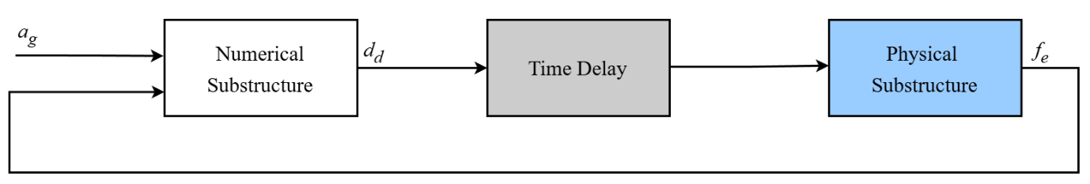
Figure 3 A block diagram illustrating the critical time delay stability indicator simplification

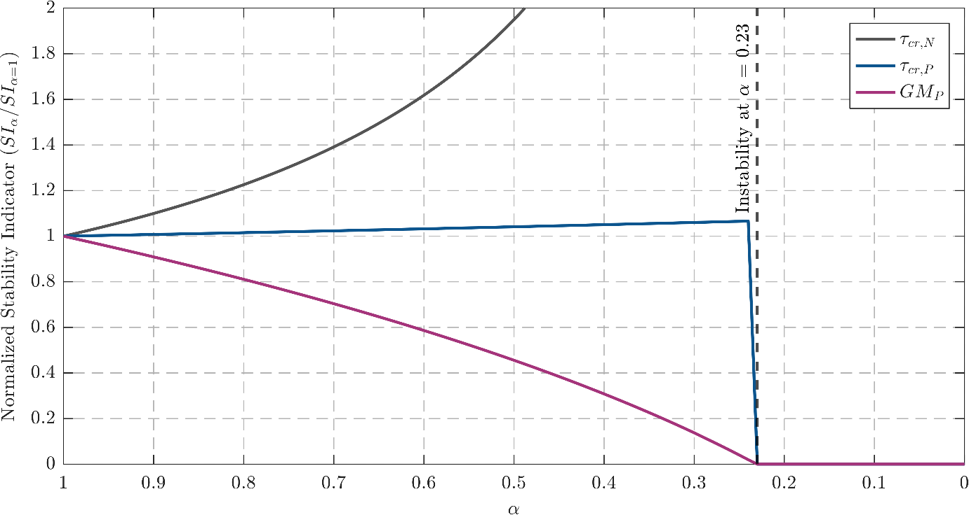
Figure 4: Evolution of the normalized stability indicators as a function of the physical substructure degradation factor

3-Stability Analysis of RTHS Under Structural Degradation

Physical substructure degradation constitutes a prevalent and often unavoidable phenomenon in realistic RTHS experiments. Such degradation can arise in various forms including gradual processes (e.g., steel bar yielding or fastener loosening) or more abrupt processes (e.g., concrete fracture or fastener rupture). As previously demonstrated in Figure 4, this degradation in physical substructure can drive the system toward instability through mechanisms that are not adequately captured by traditional time delay metrics. In this section, a closed-form solution for the instability boundary is provided as a function of the structural degradation ratio. Subsequently, this framework is leveraged to investigate the relationship between the physical substructure's initial dynamics and its capacity to tolerate damage before the onset of instability. The following derivation assumes the specimen dynamics can be approximated as linear within short windows of time using an equivalent stiffness, noting that real damage can alter more than a reduction in stiffness and those additional effects are not modeled explicitly but are treated as unmodeled dynamics. Alongside this assumption, the specimen mass is assumed to be constant over the test duration.
To derive the stability boundary, the system is simplified by reducing the block diagram of the transfer system demonstrated in Figure 2. By focusing on an SDOF physical substructure subjected to damage, the definition of $G_{s}\left(s,α\right)$ given in Equation 9 can be utilized. Starting from the innermost loop and moving outwards, for completeness, intermediate transfer functions are defined.
First, define
$$\begin{aligned}H_{y_{m},y_{6}}\left(s,α\right)=G_{s}\left(s,α\right)G_{a_{3}}\left(s\right)\#\left(10\right)\end{aligned}$$
then the CSI loop can be reduced to:
$$\begin{aligned}H_{y_{m} y_{5}}\left(s,α\right)=\frac{H_{y_{m} y_{6}}\left(s,α\right)}{1+H_{y_{m} y_{6}}\left(s,α\right)G_{a_{2}}\left(s\right)}\#\left(11\right)\end{aligned}$$
which expands to:
$$\begin{aligned}H_{y_{m} y_{5}}\left(s,α\right)=\frac{G_{s}\left(s,α\right)G_{a3}\left(s\right)}{1+G_{s}\left(s,α\right)G_{a3}\left(s\right)G_{a2}\left(s\right)}\#\left(12\right)\end{aligned}$$
Including the inner loop controller path,
$$\begin{aligned}H_{y_{m}y_{3}}\left(s,α\right)=H_{y_{m}y_{5}}\left(s,α\right)G_{a1}\left(s\right)C_{in}\left(s\right)\#\left(13\right)\end{aligned}$$
and explicitly,
$$\begin{aligned}H_{y_{m}y_{3}}\left(s,α\right)=\frac{C_{in}\left(s\right)G_{a1}\left(s\right)G_{s}\left(s,α\right)G_{a3}\left(s\right)}{1+G_{s}\left(s,α\right)G_{a3}\left(s\right)G_{a2}\left(s\right)}\#\left(14\right)\end{aligned}$$
Then $T\left(s,α\right)$ is defined by adding the unity gain feedback to the inner loop controller,
$$\begin{aligned}T\left(s,α\right)≔\frac{H_{y_{m}y_{3}}\left(s,α\right)}{1+H_{y_{m}y_{3}}\left(s,α\right)}\#\left(15\right)\end{aligned}$$
which yields
$$\begin{aligned}T\left(s,α\right)=\frac{C_{\text{in}}\left(s\right) G_{a1}\left(s\right) G_{s}\left(s,α\right) G_{a3}\left(s\right)}{1 + G_{s}\left(s,α\right) G_{a3}\left(s\right) G_{a2}\left(s\right) + C_{\text{in}}\left(s\right) G_{a1}\left(s\right) G_{s}\left(s,α\right) G_{a3}\left(s\right)}\#\left(16\right)\end{aligned}$$
The transfer system operates under a unity gain feedback scheme with an open-loop transfer function of $L\left(s,α\right)=C_{out}\left(s\right)T\left(s,α\right)$. System stability is therefore determined by the roots of the characteristic equation:
$$\begin{aligned}1+L\left(s,α\right)=0\#\left(17\right)\end{aligned}$$
This equation defines the poles of the closed-loop system. According to classical control theory, the system is stable if and only if all roots of this equation lie strictly in the left half of the complex plane. Instability arises if any root has a positive real part, indicating the presence of an unstable mode in the structural response.

Expanding the expression for $1+L\left(s,α\right)$ provides the system's full characteristic equation,
$$1+L\left(s,α\right)=$$
$$\begin{aligned}\frac{1+G_{s}\left(s,α\right)G_{a3}\left(s\right)G_{a2}\left(s\right)+C_{in}\left(s\right)G_{a1}\left(s\right)G_{s}\left(s,α\right)G_{a3}\left(s\right)+C_{out}\left(s\right)C_{in}\left(s\right)G_{a1}\left(s\right)G_{s}\left(s,α\right)G_{a3}\left(s\right)}{1+G_{s}\left(s,α\right)G_{a3}\left(s\right)G_{a2}\left(s\right)+C_{in}\left(s\right)G_{a1}\left(s\right)G_{s}\left(s,α\right)G_{a3}\left(s\right)}\#\left(18\right)\end{aligned}$$
To find the system's poles, the numerator is set to zero and the equation is solved. This approach implicitly ignores poles that are canceled by zeros. These specific poles correspond to the stability of the inner loops (the inner loop controller and CSI loops). Therefore, assuming these loops are already stable, the numerator is set to zero and we factor the expression, which gives:
$$\begin{aligned}1+G_{s}\left(s,α\right)\left[G_{a3}\left(s\right)G_{a2}\left(s\right)+C_{in}\left(s\right)G_{a1}\left(s\right)G_{a3}\left(s\right)+C_{out}\left(s\right)C_{in}\left(s\right)G_{a1}\left(s\right)G_{a3}\left(s\right)\right]=0\#\left(19\right)\end{aligned}$$
For clarity, the bracketed term is defined as $Y\left(s\right)$:
$$\begin{aligned}Y\left(s\right)≔G_{a3}\left(s\right)\left[G_{a2}\left(s\right)+C_{in}\left(s\right)G_{a1}\left(s\right)\left(C_{out}\left(s\right)+1\right)\right]\#\left(20\right)\end{aligned}$$
This step allows the stability boundary condition to be expressed in the following simplified form:
$$\begin{aligned}1+G_{s}\left(s,α\right)Y\left(s\right)=0\#\left(21\right)\end{aligned}$$
A key strength of this formulation lies in its decoupling of the degradation-dependent physical specimen, which is a function of $α$, from the rest of the transfer system components, encapsulated in the composite function $Y\left(s\right)$. This analytical separation allows solving for the stability boundary in terms of the degradation factor, $α$, directly.
By substituting $G_{s}\left(s,α\right)$ into this equation, the stability condition can be expressed in terms of the structural parameters, as
$$\begin{aligned}1+\frac{Y\left(s\right)}{ms^{2}+2ζ\sqrt{m\left(αk\right)} s+αk}=0\#\left(22\right)\end{aligned}$$
This step leads us to the final form of the characteristic equation, which is denoted as $CE\left(s,α\right)$:
$$\begin{aligned}CE\left(s,α\right)=ms^{2}+2ζ\sqrt{m\left(αk\right)}s+αk+Y\left(s\right)=0\#\left(23\right)\end{aligned}$$
Since controllers are typically designed based on a healthy system, the poles initially lie in the left-half complex plane. The experiment begins with $α=1$ (the undamaged state), and as damage accumulates ($α$ decreases), the poles shift gradually towards the imaginary axis. Instability occurs when a pole reaches this axis ($Re\left(s\right)=0$), providing a condition to solve for the degradation factor, $α$, and the corresponding oscillation frequency, $ω$. The critical degradation ratio, $α_{cr}$ ​, is thus defined as the maximum value of $α$ for which the equation $CE\left(jω,α\right)$ has a real solution for $ω$, that is
$$\begin{aligned}α_{cr}=\max{\{}α∈\left(0,1\right]∣∃ ω∈R: CE\left(jω,α\right)=0\}.\#\left(24\right)\end{aligned}$$

3.1-Computational Approach to Determine Critical Damage Ratio $α_{cr}$
To determine the value of $α_{cr}$ that satisfies the previously defined condition, the characteristic equation at $s=jω_{cr}$ is evaluated. A complex expression equals zero if and only if both its real and imaginary parts are simultaneously zero. Substituting $s=jω_{cr}$ into the characteristic equation yields:
$$\begin{aligned}CE\left(jω_{cr},α\right)=-mω_{cr}^{2}+j\left(2ζω_{cr}\sqrt{mαk}\right)+αk+Y\left(jω_{cr}\right)=0.\#\left(25\right)\end{aligned}$$
Let $Y\left(jω\right)=Re\{Y\left(jω\right)\}+j Im\{Y\left(jω\right)\}$. By separating Equation (25) into its real and imaginary components, a system of two real equations with two unknowns, $ω$ and $α$ is obtained. The real component equation is:
$$\begin{aligned}-mω_{cr}^{2}+αk+Re\{Y\left(jω_{cr}\right)\}=0.\#\left(26\right)\end{aligned}$$
Solving this for $α$:
$$\begin{aligned}α=\frac{mω_{cr}^{2}-Re\{Y\left(jω_{cr}\right)\}}{k}\#\left(27\right)\end{aligned}$$
Note that a system is susceptible to degradation-induced instability only if $α_{cr}∈\left(0,1\right)$. If all solutions for $α$ fall below zero, the system can tolerate any physical level of specimen degradation without losing stability.
The imaginary component equation is:
$$\begin{aligned}2ζω_{cr} \sqrt{mαk}+Im\{Y\left(jω_{cr}\right)\}=0.\#\left(28\right)\end{aligned}$$
Squaring both sides and solving for $α$:
$$\begin{aligned}α=\frac{{\left(Im\{Y\left(jω_{cr}\right)\}\right)}^{2}}{4ζ^{2}ω_{cr}^{2}mk}\#\left(29\right)\end{aligned}$$
Note that a system is susceptible to degradation-induced instability only if $α_{cr}∈\left(0,1\right)$. If all solutions for $α$ fall below zero, the system can tolerate any physically realizable level of specimen degradation without losing stability. By equating the two expressions for $α$
$$\begin{aligned}\frac{mω_{cr}^{2}- Re\{Y\left(jω_{cr}\right)\}}{k}=\frac{{\left(Im\{Y\left(jω_{cr}\right)\}\right)}^{2}}{4ζ^{2}mkω_{cr}^{2}}\#\left(30\right)\end{aligned}$$
Rearranging terms leads to the key equation:
$$\begin{aligned}4ζ^{2}mω_{cr}^{2}\left(mω_{cr}^{2}-Re\left\{Y\left(jω_{cr}\right)\right\}\right)={\left(Im\left(Y\left(jω_{cr}\right)\right\}\right)}^{2}\#\left(31\right)\end{aligned}$$
Although this equation contains complex-valued terms, it has only one real unknown, $ω_{cr}$ This greatly simplifies the numerical solution process, as standard root-finding algorithms can be applied directly to identify all candidate critical frequencies. Moreover, the formulation is computationally more stable and less prone to convergence issues.

3.2-Linking Structural Properties to RTHS Robustness
To investigate the relationship between the initial properties of a physical substructure and its damage tolerance, a parametric study is conducted on a family of structural specimens. These specimens are defined by varying the mass ($m$) and stiffness ($k$) parameters, with each system’s robustness evaluated by solving for $α_{cr}$ leveraging Equations (31) and (29). To maintain consistent performance and stability margins, outer and inner controllers are redesigned offline to achieve a target crossover frequency and phase margin for each specimen configuration.
The relationship between the specimen parameters (mass $m$ and initial stiffness $k_{o}$) and the critical degradation ratio, shown in Figure 5, shows that increasing the specimen mass and reducing the initial stiffness-to-mass ratio, which corresponds to a more flexible structure in its original undamaged state, leads to higher critical degradation ratios. Since higher $α_{cr}$ values indicate greater susceptibility to instability, the findings suggest that more flexible structures are more prone to loss of control stability and thus require more careful stability analysis. Figure 5 also highlights two specific configurations: one marker corresponds to the benchmark statement provided in [10], and the other to a modified configuration used in the illustrative example presented later in this study. In the modified configuration, the specimen mass is increased by 30% relative to the benchmark, making the initially healthy structure more flexible and therefore more susceptible to instability.

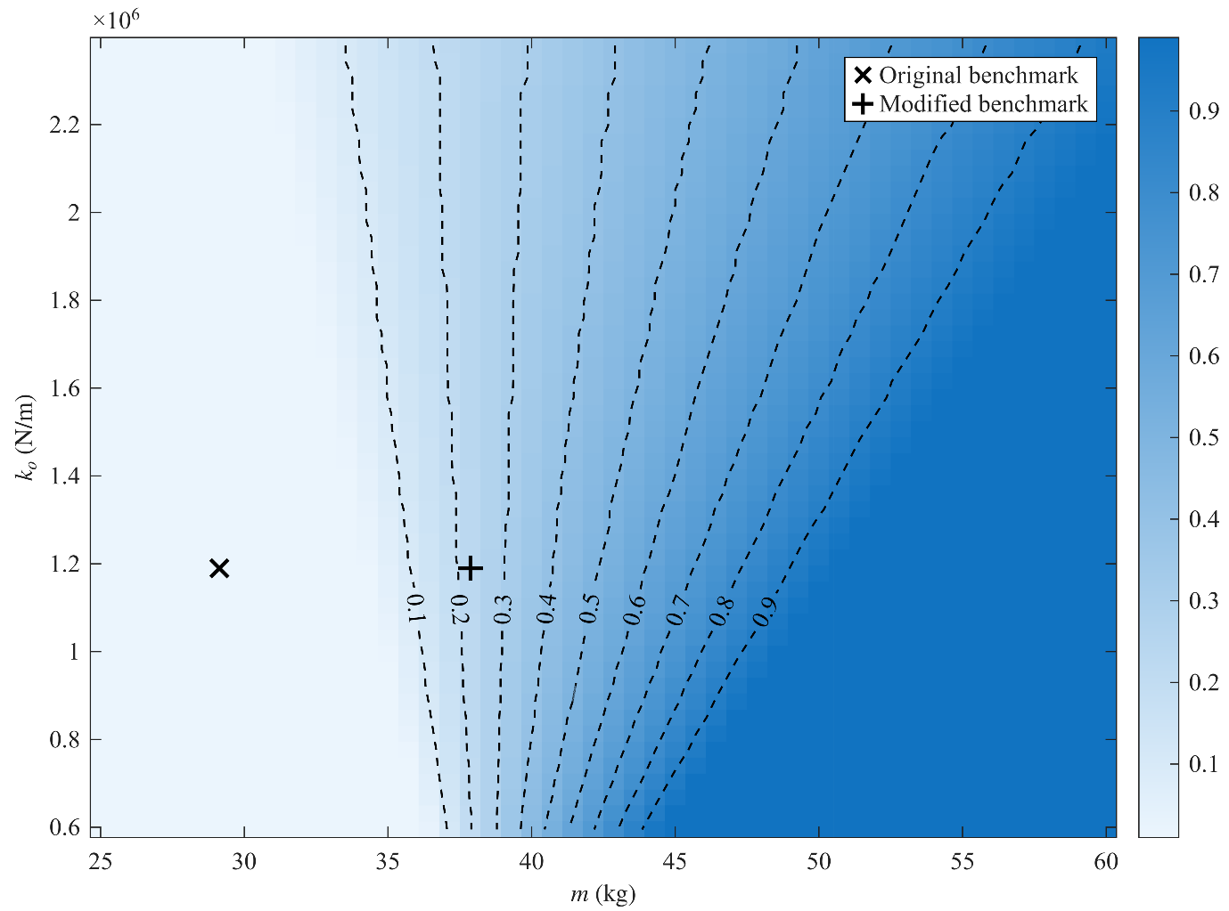
Figure 5: Heatmap of the critical degradation ratio, $α_{cr}$, defined as the residual stiffness fraction at which the outer controller loses stability. A lower $α_{cr}$ reflects a system that is more robust to physical degradation. The parameter configurations for both the original and modified benchmark problems are indicated by markers.

4-Integration into an RTHS Framework
The preceding section presented a numerical method for quantifying system robustness specifically against structural degradation. This section expands upon that foundation to develop a stability indicator that can be used during an experiment. The goal is to develop a metric that not only offers a continuous, real-time assessment of the system’s actual robustness but also accounts for a wider range of uncertainties that may arise during an experiment.
The foundational principles for quantifying stability in linear time-invariant feedback systems were established in the 1930s and 1940s through the pioneering work of Harry Nyquist and Hendrik Bode [33], [34]. Their approach was revolutionary as it introduced a graphical approach based on the frequency domain, allowing for stability assessment without calculating the system’s poles. Using their now-famous Nyquist and Bode plots, they developed two enduring and fundamental metrics for measuring system robustness: the Gain Margin (GM) and the Phase Margin (PM). These margins were determined by geometrically inspecting the plots, providing a practical way to assess system robustness.
The first of these metrics, GM, is defined as the factor by which the open-loop gain can be increased before the system reaches the point of instability. This value can be interpreted from either of the graphical methods: on a Bode plot, as demonstrated in Figure 6(a), the GM is found by measuring the vertical distance between the 0 dB line and the magnitude curve at the frequency where the phase shift is equal to $-180°$. On a Nyquist plot, it is the reciprocal of the magnitude where the curve intersects the negative real axis as shown in Figure 6(b). While there is no universal standard, a minimum GM of 6 decibels is often considered to be sufficient for adequate robustness [35].
The other fundamental metric is the PM, defined as the amount of additional open-loop phase lag needed to destabilize the closed-loop system at its unity-gain frequency. As illustrated in Figure 6(a), the PM on a Bode plot is the vertical distance between the phase curve and the $-180°$ line at this gain crossover frequency. Equivalently, on a Nyquist plot, it is the angle between the negative real axis and the point where the contour intersects the unit circle, as depicted in Figure 6(b).

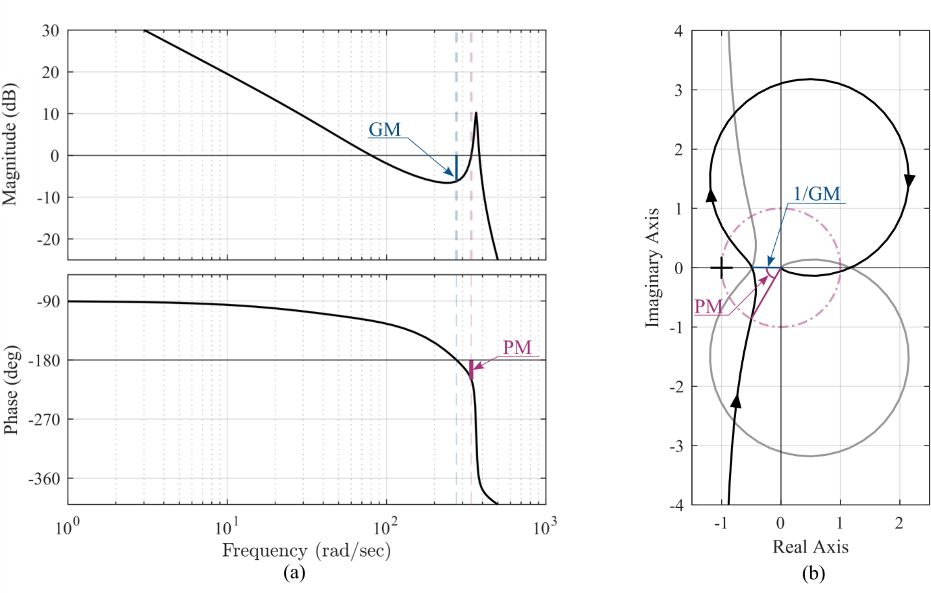
Figure 6: (a) Bode plot of the illustrative example system, demonstrating the graphical determination of GM and PM at their respective crossover frequencies, (b) corresponding Nyquist plot, demonstrating the graphical determination of GM and PM relative to the critical point (−1, 0j).
Imposing a constant phase shift across the entire frequency spectrum yields a physically unrealizable system. In contrast, a time delay offers a more realistic model by introducing a phase lag that increases with frequency. This approach leads to another important metric, the Delay Margin (DM), which can be approximated from the PM using the expression $DM≈PM/ω_{gc}$ [36]. Since many RTHS components are more likely to introduce delays rather than amplify gains to the inner loop system, prior studies have often considered the DM as the most descriptive indicator of system robustness. To ensure robust performance and adequate system damping, a PM of 45 to 60 degrees is often considered a desirable design target [37].
One significant limitation of the GM and PM indicators is that they can create a false sense of security [39]. This limitation is primarily present because they are fundamentally uncoupled indicators, evaluating robustness to either pure gain or pure phase variations, but not both simultaneously. Consequently, a system can display large, apparently safe gain and phase margins yet be vulnerable to instability from a small, combined gain-and-phase perturbation. A concrete example of such a scenario is detailed in [39]. This issue was less apparent when controllers were designed with graphical techniques, however, it has become a more pronounced concern with modern automated control design methods. Similarly, since a time delay added to a system can be modeled as a phase lag variable with the frequency, the DM fails to indicate potential low robustness against gain amplifications.
To overcome the limitations of classical GM and PM indicators, the disk margin is introduced to assess simultaneous gain and phase variations in a unified manner. This approach models uncertainty as a complex multiplicative perturbation and calculates the largest perturbation disk that preserves closed-loop stability. While a skew parameter can be used to adjust the relative weighting between gain and phase uncertainty, a symmetric disk (skew = 0) is frequently employed.
The application of disk margin analysis to MIMO systems, while theoretically feasible, presents practical efficiency challenges, particularly in real-time applications. Seiler et al. [39] discussed two methodologies: loop-at-a-time analysis, which evaluates isolated channels, and multi-loop analysis, which models simultaneous perturbations. The former can be an overly optimistic assessment of system robustness because it evaluates channels in isolation, so it may exhibit excellent single-loop margins yet be destabilized by small simultaneous perturbations in multiple channels. On the other hand, multi-loop disk margins effectively address simultaneous perturbations, however, their computation requires determining the smallest combination of independent gain and phase variations across all channels that can destabilize the closed loop. This involves solving an optimization problem at each frequency point in a dense sweep, a process that is iterative and computationally intensive, making it impractical for real-time applications.
A more unified assessment of a system’s tolerance to simultaneous gain and phase variations has been developed within the framework of $H_{∞}$​ control theory. The normalized coprime factor (NCF) margin, also known in the literature as the generalized stability margin, quantifies the size of the smallest perturbation to both the plant and controller that will cause instability [40]. This metric offers a unified assessment of the system’s tolerance to simultaneous gain and phase variations into a single measure.
Let the plant of the transfer system be denoted as $T\left(s,α\right)$ and the outer controller as $C_{out}\left(s\right)$. The NCF stability margin, denoted as $b_{g}\left(C_{out},T\right)$, is formally defined as [40]:
$$\begin{aligned}b_{g}\left(C_{out},T\right)={\left\|\left[\begin{aligned}C_{out} \\ I\end{aligned}\right]{\left(I+TC_{out}\right)}^{-1}\left[\begin{matrix}I & T\end{matrix}\right]\right\|}_{∞}^{-1}\#(32)\end{aligned}$$
For SISO systems, this expression can be greatly simplified. Dropping the functional dependencies for simplicity, the matrix inside the norm, denoted as H, becomes:
$$\begin{aligned}H=\frac{1}{\left(1+T C_{out}\right)}\left[\begin{matrix}C_{out} & T C_{out} \\ 1 & T\end{matrix}\right]\#(33)\end{aligned}$$
The $H_{∞}$-norm is found by taking the supremum, over all frequencies $ω$, of the maximum singular value ($σ_{max}$​) of $H(jω)$. The singular values are calculated from the eigenvalues of the matrix product$H\left(jω\right)H{\left(jω\right)}^{*}$, where * denotes the complex conjugate transpose. This product is:
$$\begin{aligned}H H^{*}=\frac{1}{{\left|1+T C_{out}\right|}^{2}}\left[\begin{matrix}C_{out} & T C_{out} \\ 1 & T\end{matrix}\right]\left[\begin{matrix}C_{out}^{*} & 1 \\ {\left(T C_{out}\right)}^{*} & T^{*}\end{matrix}\right]=\frac{1+{\left|T\right|}^{2}}{{\left|1+T C_{out}\right|}^{2}}\left[\begin{matrix}{\left|C_{out}\right|}^{2} & C_{out} \\ C_{out}^{*} & 1\end{matrix}\right]\#(34)\end{aligned}$$
To obtain the singular values, the eigenvalues of the final matrix term are calculated. Solving its characteristic equation,
$$\begin{aligned}\left({\left|C_{out}\right|}^{2}- λ\right)\left(1 – λ\right)- {\left|C_{out}\right|}^{2}= 0\#(35)\end{aligned}$$
yields the eigenvalues $λ_{1}=0$ and $λ_{max}=1+{\left|C_{out}\right|}^{2}$. The maximum singular value squared of $H$ is therefore:
$$\begin{aligned}σ_{max}^{2}(H)=\frac{\left(1+{\left|T\right|}^{2}\right)\left(1+{\left|C_{out}\right|}^{2}\right)}{{\left|1+TC_{out}\right|}^{2}}\#(36)\end{aligned}$$
The stability margin $b_{g}\left(C_{out},T\right)$ is the inverse of the ​$H_{∞}$-norm of $H$, which is equivalent to the infimum of the reciprocal of $σ_{max}(H)$. This leads to the final, simplified formula for the SISO NCF stability margin:
$$\begin{aligned}b_{g}\left(C_{out}, T\right)=\inf_{ω}\frac{\left(\left|1 + T\left(jω\right)C_{out}\left(jω\right)\right|\right)}{\sqrt{1+{\left|T\left(jω\right)\right|}^{2}} \sqrt{1+{\left|C_{out}\left(jω\right)\right|}^{2}}}\#\left(37\right)\end{aligned}$$

This expression is advantageous for online applications due to its computational efficiency. Since the singular value decomposition, the primary computational bottleneck, is resolved theoretically, the remaining online task is to simply evaluate the functions $C_{out}$ and $T$ at the frequencies of interest and find the minimum value. During operation, the controller and actuator dynamics are assumed to be known and constant, shifting the problem to one of online identification of the physical substructure. Figure 7, which extends the comparison presented in Figure 4 to include the proposed NCF-based indicator, the proposed margin captures the progression toward instability more consistently than the classical indicators.
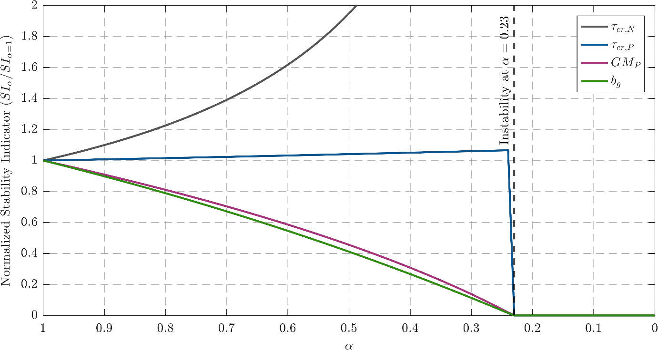
Figure 7: Evolution of the proposed RTHS stability indicator compared to other indicators as a function of the physical substructure degradation factor
Unlike classical stability margins and due to the way the NCF margin is defined, the proposed stability indicator is not only dependent on the overall open-loop dynamics $L$, but it is also affected by the way it is split to a controller, $C_{out}$, and a plant, $T$. Naturally, this dependency motivates the development of a normalized formula, the Scaled NCF margin, also known as Vinnicombe SISO expression. The scaled margin is defined as the maximum achievable generalized (NCF) margin over all constant input/output rescalings that preserve L and is given by [41]:
$$\begin{aligned}b_{s}(L)= \inf_{ω}\frac{\left|1+L\left(jω\right)\right|}{1+\left|L\left(jω\right)\right|} \#\left(38\right)\end{aligned}$$

While a closed-form solution for the optimally scaled NCF margin ($b_{s}$​) does not exist for MIMO systems, an iterative method was developed by Park & Bitmead [42]. Nevertheless, the generalized NCF margin ($b_{g}$​) can serve as a practical and conservative stability indicator, as it constitutes a lower bound on the scaled margin ($b_{g}≤b_{s}$​), a proof for SISO and MIMO systems can be found in [43]. Furthermore, ensuring a minimum value for $b_{g}$​ also guarantees that the system meets target Gain and Phase Margins ($GM$ and $PM$, respectively) as will be demonstrated. Therefore, monitoring the generalized NCF margin is a reliable method for ensuring sufficient system robustness against potential disruptions.
The scaled NCF margin effectively bridges modern robustness analysis with classical stability metrics by providing guaranteed lower bounds on the $GM$ and $PM$ by specifying one unified value. As rigorously proven in [44], these relationships are defined by the inequalities:
$$\begin{aligned}GM ≥\frac{1+b_{s}}{1-b_{s}}\#\left(39\right)\end{aligned}$$
$$\begin{aligned}PM≥2\sin^{-1}\left(b_{s}\right)\#\left(40\right)\end{aligned}$$
Figure 8 provides a direct mapping for selecting a target $b_{s}$​ that meets classical robustness requirements. For instance, a value of $b{}_{g}=0.4$is shown to guarantee the recommended values for both $GM$ and $PM$, making it a suitable design target.
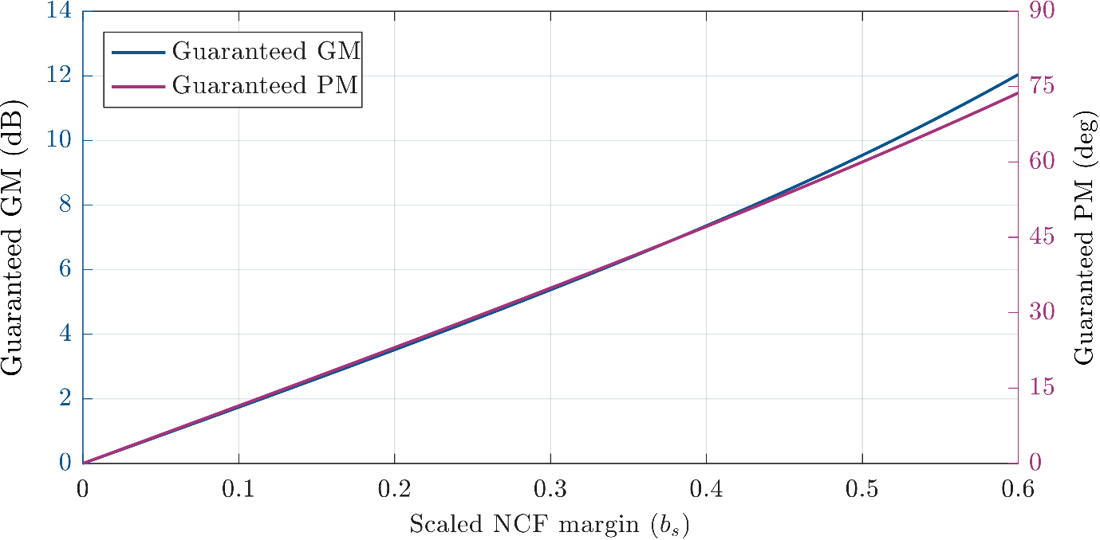
Figure 8: A visual representation of the guaranteed lower bounds on Gain Margin and Phase Margin as a function of the scaled NCF margin, $b_{s}$

5-Controller Switching
Beyond monitoring stability, a key purpose for developing an online stability indicator is to improve the safety of RTHS experiments by enabling real-time protective actions, such as switching controllers when the current configuration approaches instability. By preventing catastrophic failures, this safety mechanism not only protects the specimen and testing equipment but also encourages the research community to explore more aggressive test configurations and novel control strategies, ultimately accelerating advances in the field. Therefore, this section analyzes the stability of the system in preparation for and during such a controller transition, leveraging Lyapunov stability criteria to assess switching feasibility. Consider a general linear time-invariant (LTI) system with input,
$$\begin{aligned}\dot{x}\left(t\right)= Ax\left(t\right)+ Bu\left(t\right) \#\left(41\right)\end{aligned}$$
Note that, although here we are looking at a general state space system, equation 41 is representative of [point back to thee system] Since stability is an internal system characteristic and independent of the input, only the unforced response is considered by setting the input to zero, $u\left(t\right)=0$:
$$\begin{aligned}\dot{x}\left(t\right)= Ax\left(t\right)\#\left(42\right)\end{aligned}$$
Choose a quadratic Lyapunov candidate with a symmetric positive definite matrix $P$ [45]:
$\begin{aligned}V\left(x\right)= xᵀ Px, P = Pᵀ ≻ 0\#\left(43\right)\end{aligned}$
Using the product rule, the derivative is:
$$\begin{aligned}\dot{V}\left(x\right)= {\dot{x}}^{T}P x + x^{T}P \dot{x }\#\left(44\right)\end{aligned}$$
Substituting $\dot{x}=Ax$ yields:
$$\begin{aligned}\dot{V}\left(x\right)=xᵀ\left(AᵀP+PA\right)x \#\left(45\right)\end{aligned}$$
Thus, the Lyapunov condition is:
$$\begin{aligned}Aᵀ P + PA ≺ 0 \#\left(46\right)\end{aligned}$$
with $A$ being the closed-loop system matrix, the system is asymptotically stable if a symmetric positive definite matrix $P$ exists that satisfies this Lyapunov equation.
Because the controller transition occurs over a short time interval, the plant dynamics are assumed to be approximately constant during the switch. The closed-loop system is then constructed from the state-space realizations of the plant and controller, denoted by subscripts $T$ and $C$, respectively. With no direct feedthrough in the physical plant, the plant state-space model is:
$$\begin{aligned}{\dot{x}}_{T} = A_{T} x_{T}+ B_{T} y_{C} \#\left(47\right)\end{aligned}$$
$$\begin{aligned}y_{T} = C_{T} x_{T} \#\left(48\right)\end{aligned}$$
where $A_{T}, B_{T},$ and $C_{T}$ are the state space realization for the plant T, $x_{T}$ ​ is the plant state vector, $y_{C}$ is the control signal, and $y_{T}$ is the plant output. Similarly, for the controller:
$$\begin{aligned}{\dot{x}}_{C} = A_{C} x_{C}+ B_{C} e \#\left(49\right)\end{aligned}$$
$\begin{aligned}y_{C} = C_{C} x_{C}+ D_{C} e \#\left(50\right)\end{aligned}$
where $A_{C}, B_{C}, C_{C},$and $D_{C}$ are the state space realization for the controller, $x_{C}$ is the controller state vector, and $e=r-y_{T}$ is the error signal, with $r$ denoting the reference input. For stability analysis, the equation can be simplified by setting the reference signal to zero (r=0), which gives $e=r-y_{T}=-y_{T}$. Substituting the plant output from Equation (48):
$\begin{aligned} e = - C_{T} x_{T} \#\left(51\right)\end{aligned}$
Substituting $y_{c}$ and $e$ into Equations 47 and 49 yields:
$$\begin{aligned}{\dot{x}}_{T}= A_{T}x_{T}+ B_{T}\left(C_{C}x_{C}+ D_{C}e\right)= \left(A_{T}- B_{T}D_{C}C_{T}\right)x_{T}+ B_{T}C_{C}x_{C}\#\left(52\right)\end{aligned}$$
$$\begin{aligned}{\dot{x}}_{C}= A_{C}x_{C}+ B_{C}e = -B_{C}C_{T}x_{T}+ A_{C}x_{C}\#\left(53\right)\end{aligned}$$
Stacking the plant and controller states into a single state vector yields
$$\begin{aligned}\left[\begin{matrix}{\dot{x}}_{T} \\ {\dot{x}}_{C}\end{matrix}\right]= A_{cl}\left[\begin{matrix}x_{T} \\ x_{C}\end{matrix}\right] \#\left(54\right)\end{aligned}$$
The closed-loop state-space realization is given by:
$$\begin{aligned}A_{cl}= \left[\begin{matrix}A_{T}-B_{T}D_{C}C_{T} & B_{T}C_{C} \\ - B_{C}C_{T} & A_{C}\end{matrix}\right]\#\left(55\right)\end{aligned}$$
Now consider a combined controller $C_{comb}$ consisting of a convex combination of two controllers $C1$ and $C2$:
$$\begin{aligned}A_{comb}= γ A_{C1}+ \left(1-γ\right)A_{C2}\#\left(56\right)\end{aligned}$$
$$\begin{aligned}B_{comb}= γ B_{C1}+ \left(1-γ\right)B_{C2}\#\left(57\right)\end{aligned}$$
$$\begin{aligned}C_{comb}= γ C_{C1}+ \left(1-γ\right)C_{C2}\#\left(58\right)\end{aligned}$$
$$\begin{aligned}D_{comb}= γ D_{C1}+ \left(1-γ\right)D_{C2}\#\left(59\right)\end{aligned}$$
By substituting Equations (56-59) into Equation (56), the following is obtained:
$$\begin{aligned}A_{cl,comb}= \left[\begin{matrix}A_{T}-B_{T}D_{Comb}C_{T} & B_{T}C_{Comb} \\ - B_{Comb}C_{T} & A_{Comb}\end{matrix}\right]\#\left(60\right)\end{aligned}$$
$$\begin{aligned}A_{cl,comb}=γ\left[\begin{matrix}A_{T}-B_{T}D_{C1}C_{T} & B_{T}C_{C1} \\ - B_{C1}C_{T} & A_{C1}\end{matrix}\right]+(1-γ)\left[\begin{matrix}A_{T}-B_{T}D_{C2}C_{T} & B_{T}C_{C2} \\ - B_{C2}C_{T} & A_{C2}\end{matrix}\right]\#\left(61\right)\end{aligned}$$
$$\begin{aligned}A_{cl,comb}= γ A_{cl1}+ \left(1-γ\right)A_{cl2}\#\left(62\right)\end{aligned}$$
Rewriting the Lyapunov condition in Equation (46) in terms of $A_{cl,comb}$:
$$\begin{aligned}A_{cl,comb}^{T}P + P A_{cl,comb}= γ \left(A_{cl1}^{T}P + P A_{cl1}\right)+ \left(1-γ\right)\left(A_{cl2}^{T}P + P A_{cl2}\right)\#\left(63\right)\end{aligned}$$
If there exists a common symmetric positive definite matrix $P$ ($P = Pᵀ ≻ 0$) that satisfies the Lyapunov inequalities for both systems:
$$\begin{aligned}A_{cl1}^{T}P + P A_{cl1}≺ 0, A_{cl2}^{T}P + P A_{cl2}≺ 0\#\left(64\right)\end{aligned}$$
Then the Lyapunov inequality holds for the combined system too:
$$\begin{aligned}A_{cl,comb}^{T}P + P A_{cl,comb}≺ 0\#\left(65\right)\end{aligned}$$
where $γ ∈ \left[0, 1\right]$.
Through this analysis, it is clear that the stability for both instant switching and combining the controllers is guaranteed [45], [46]. Importantly, this conclusion rests on the fact that the combination parameter, $γ$, is applied on the internal controller parameters, which is not equivalent to merely combining the controller outputs. Although asymptotic stability is theoretically guaranteed under the common Lyapunov framework, this result relies on the assumption of exact linear models. In practice, noise, model uncertainty, and the linearization approximation used to represent the physical substructure may affect the switching behavior. Therefore, the following smooth transition function is employed to provide a gradual controller blending that is more robust to these real-world deviations,
$$\begin{aligned}γ\left(t\right)= \left\{\begin{aligned}0 ,&t < t^{*} \\ \frac{1}{1 + e^{-n\left(t -\frac{5}{n}\right)}},&t ≥ t^{*}\end{aligned}\right.\#\left(66\right)\end{aligned}$$
can be utilized, where $t^{*}$ is the point in time the decision to switch the controller is made based on monitoring the online stability indicator, and $n$ determines how fast the switch should be applied.
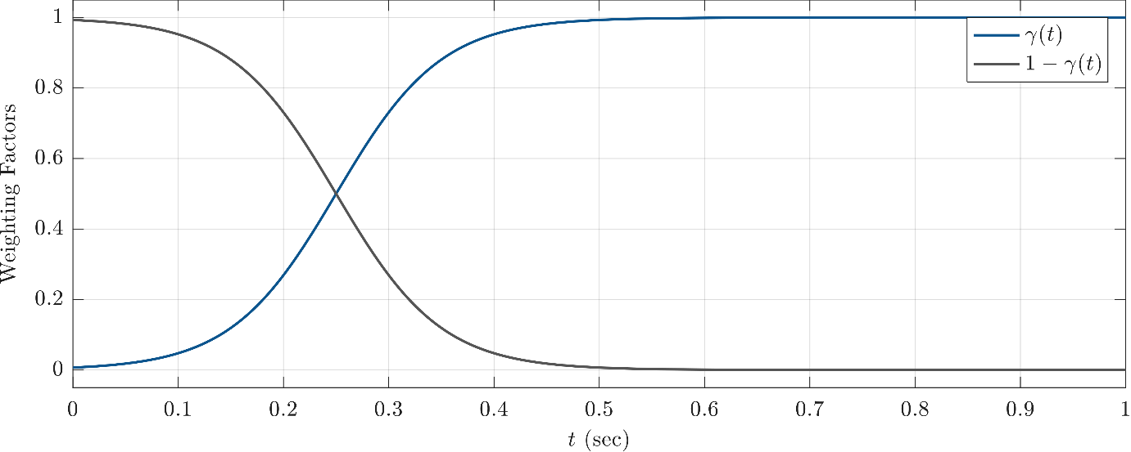
Figure 9: Profile of the smooth development of the combination parameter $γ$, showing a logistic transition from 0 to 1 starting at $t=t^{*}.$

6-Illustrative Example
In this section, we consider a modified version of the RTHS benchmark problem statement presented to the community in [10] to evaluate and demonstrate our proposed procedure. This benchmark problem examines a three-story steel frame as the reference structure, partitioned such that a portion of the first story is designated as the physical substructure. The numerical substructure models the remaining dynamics, which include the rest of the first story as well as the upper two stories. The benchmark problem statement provides a sample controller design using a proportional-integral (PI) controller augmented with a phase-lead compensator. The original identified parameters for the physical substructure are the mass ($m_{e}$) of $29.1 kg$, stiffness ($k_{e}$) of $1.19x{10}^{6}N/m$, and damping ($c_{e}$) of $114.6 N/m$. For this illustrative example, however, the experimental mass is increased by 30% to $37.83 kg$. This modification is intentionally introduced to render the system more susceptible to instability, as suggested by the sensitivity analysis in Figure 5. Moreover, virtual degradation will be progressively induced in the physical substructure to provide a challenging, dynamic scenario for assessing the proposed RTHS stability indicator.
In this study, the 1940 El Centro earthquake record with an intensity of 0.4g is selected to maintain a consistent comparison baseline with the results shown in the benchmark. Moreover, two distinct PI controllers are designed: 1) a high-performance controller (Controller A) optimized for precise tracking with low error, and 2) a high-robustness controller (Controller B) designed to maintain stability under significant specimen degradation. In practice, the controller may begin to exhibit undesirable behavior prior to reaching the theoretical instability limit, which means that Controller B must be designed with a stability margin that exceeds the expected level of specimen degradation during a typical RTHS. However, this increased robustness comes at the cost of tracking performance, a well-known trade-off in control design. Each controller is evaluated independently under a scenario where virtual degradation is progressively induced during the simulation. The system and controller parameters used in this study are summarized in Table 2. A vRTHS is presented to demonstrate the practical application of the proposed stability indicator. In this demonstration, the vRTHS begins with the high-performance controller (Controller A), and the online indicator is used to monitor stability margins and trigger a smooth transition to the high-robustness controller (Controller B) at the appropriate time.
In addition, the phase-lead block is redesigned to achieve comparable vRTHS performance to that of the original benchmark. This redesigned compensator is given by:
$$\begin{aligned}G_{T}\left(s\right)=50.5 \frac{s+86}{s+4036}\#\left(67\right)\end{aligned}$$
The transfer system for this illustrative example follows the block diagram in Figure 2, utilizing the parameters specified in Table 2. For the purpose of illustration, an analysis is first conducted to understand the system's expected behavior with each PI controller, focusing on damage tolerance and the stability of the switching process. This step is not a requirement for implementing the proposed framework but is included here to provide insight into the simulation results that follow. First, for Controller A, the composite transfer function $Y(s)$ is determined using Equation (20) as:
$$\begin{aligned}Y\left(s\right)=\frac{4.23×{10}^{6}s^{4}+1.798×{10}^{9}s^{3}+4.229×{10}^{11}s^{2}+5.121×{10}^{13}s+2.067×{10}^{15}}{s^{4}+428.3s^{3}+1.014×{10}^{5}s^{2}+3.299×{10}^{5}s}.\#\left(68\right)\end{aligned}$$

By solving Equations (31) and (29) with this function, the critical frequency and degradation ratio are found to be $ω_{cr}=280.72$ rad/s and $α_{cr}=0.23.$ Repeating this analytical procedure for the high-robustness controller (Controller B) yields a critical frequency of $ω_{cr}=281.37$ rad/s and a significantly lower critical degradation ratio of $α_{cr}=0.017$.
To guarantee stability during the controller transition, a common Lyapunov function $P$ must be found for both closed-loop systems. This search is performed iteratively by gradually decreasing the value of the degradation factor $α$ to determine the minimum value at which such a common function still exists. For a given $α$, the plant and both controllers are first converted to their state-space representations to construct the two closed-loop system matrices, $A_{cl1}$and$A_{cl2}$. The problem is then formulated as a search for a single symmetric positive-definite matrix $P$ that simultaneously satisfies the two Lyapunov Linear Matrix Inequalities, $A_{cl1}ᵀP+PA_{cl1}≺0$ and $A_{cl2}ᵀP+PA_{cl2}≺0$. This problem is solved numerically using a nonlinear optimization solver, which is enhanced with a multi-start algorithm to improve the reliability of finding a solution. This technique involves running the solver multiple times, each from a different random initial starting point and the best valid solution from all runs is selected. The successful identification of a common $P$ confirms that any switching at or above that $α$ level is guaranteed to be stable for the linear system considered.
For this specific example, the iterative search determined the switching stability boundary to be at $α=0.35$. At this boundary, the realization of state space matrices $A_{cl1}$and $A_{cl2}$ is:

$$\begin{aligned}A_{cl1}=\left[\begin{matrix}-430.4 & -439.4 & -402.2 & -366.0 & -315.7 & 1553.9 \\ 512.0 & 0.0 & 0.0 & 0.0 & 0.0 & 0.0 \\ 0.0 & 256.0 & 0.0 & 0.0 & 0.0 & 0.0 \\ 0.0 & 0.0 & 256.0 & 0.0 & 0.0 & 0.0 \\ 0.0 & 0.0 & 0.0 & 128.0 & 0.0 & 0.0 \\ 0.0 & 0.0 & 0.0 & 0.0 & -8.2 & 0.0\end{matrix}\right]\#\left(69\right)\end{aligned}$$
$$\begin{aligned}A_{cl2}=\left[\begin{matrix}-430.4 & -439.4 & -402.2 & -366.0 & -261.3 & 1266.8 \\ 512.0 & 0.0 & 0.0 & 0.0 & 0.0 & 0.0 \\ 0.0 & 256.0 & 0.0 & 0.0 & 0.0 & 0.0 \\ 0.0 & 0.0 & 256.0 & 0.0 & 0.0 & 0.0 \\ 0.0 & 0.0 & 0.0 & 128.0 & 0.0 & 0.0 \\ 0.0 & 0.0 & 0.0 & 0.0 & -8.2 & 0.0\end{matrix}\right]\#\left(70\right)\end{aligned}$$

and the common Lyapunov function $P$ found by the algorithm is:
$\begin{aligned}P=\left[\begin{matrix}0.0054 & 0.0033 & 0.0072 & 0.0047 & 0.0093 & -0.0434 \\ 0.0033 & 0.0024 & 0.0047 & 0.0035 & 0.0062 & -0.0328 \\ 0.0072 & 0.0047 & 0.0103 & 0.0071 & 0.0138 & -0.0672 \\ 0.0047 & 0.0035 & 0.0071 & 0.0054 & 0.0096 & -0.0564 \\ 0.0093 & 0.0062 & 0.0138 & 0.0096 & 0.0197 & -0.0996 \\ -0.0434 & -0.0328 & -0.0672 & -0.0564 & -0.0996 & 0.9568\end{matrix}\right] \#\left(71\right)\end{aligned}$
Figure 10 shows the evaluated stability margin $b_{g}$ for both controllers as a function of the physical substructure degradation factor. The plot suggests that a value of 0.04 for the stability margin is a sufficient boundary at the controller switching point. However, to provide a buffer against modeling errors and uncertainties, we specify a minimum 15-degree phase margin for switching. Utilizing Equation 40, this phase margin is equivalent to $b_{g}=0.13$. Therefore, it is selected as the controller switching threshold.

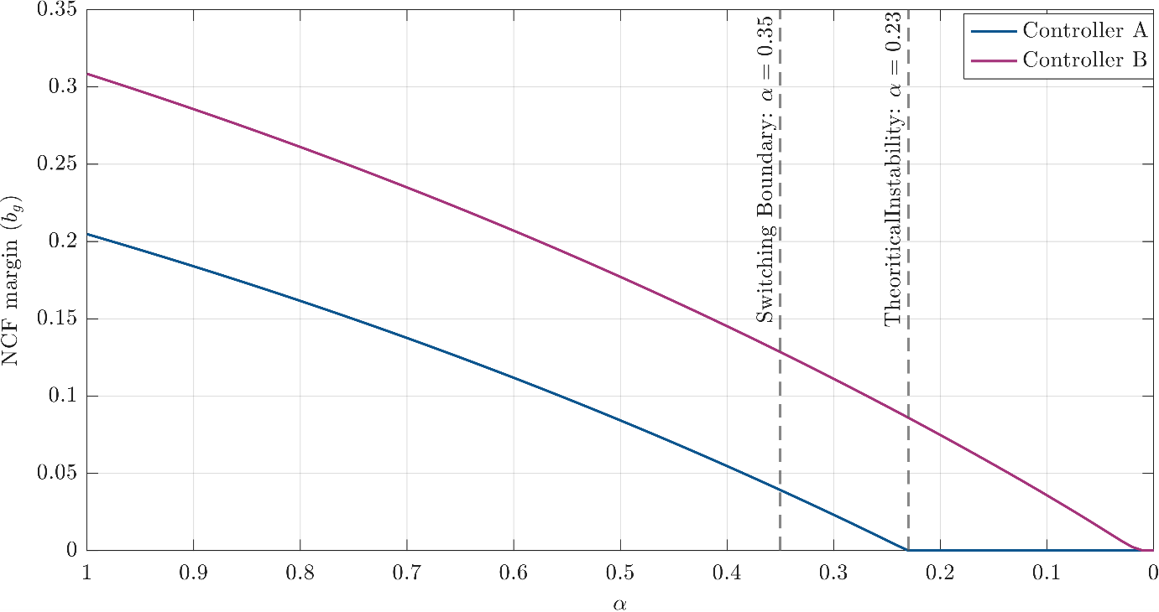
Figure 10: NCF stability margin versus physical substructure degradation factor $α$ for two PI controller designs (Controllers A and B)

To compare the controller designs for the modified and original benchmarks, Case I simulation is performed. In this scenario, the physical substructure is maintained undamaged. Therefore, the high-performance controller, Controller A, is utilized for the entire vRTHS. The comparison is performed using benchmark criteria $J_{4}$, $J_{5}$, and $J_{6}$, reported in Tables 3, 4, and 5, respectively, where $J_{4}$ is the normalized RMS global displacement error of the first-floor DOF, $J_{5}$ and $J_{6}$ are the normalized RMS relative displacement error of the second and third floors. For $J_{5}$ and $J_{6}$, numerical displacement is used since measured data are not available. These metrics are computed as [10]:
$$\begin{aligned}J_{4}=\sqrt{\frac{\sum_{i}^{N}{{\left[xₘ\left(i\right)-xᵣ^{\left(1\right)}\left(i\right)\right]}^{2}}}{\sum_{i}^{N}{{\left[xᵣ^{\left(1\right)}\left(i\right)\right]}^{2}}}}× 100, J_{5}=\sqrt{\frac{\sum_{i}^{N}{{\left[x_{n}^{\left(2\right)}-x_{r}^{\left(2\right)}\left(i\right)\right]}^{2}}}{\sum_{i}^{N}{{\left[xᵣ^{\left(2\right)}\left(i\right)\right]}^{2}}}}, J_{6}=\sqrt{\frac{\sum_{i}^{N}{{\left[x_{n}^{\left(3\right)}-x_{r}^{\left(3\right)}\left(i\right)\right]}^{2}}}{\sum_{i}^{N}{{\left[xᵣ^{\left(3\right)}\left(i\right)\right]}^{2}}}} \#\left(72\right)\end{aligned}$$
Figure 11 presents the simulation results. The first three subplots show the measured displacement from the vRTHS against the reference model's calculated displacement for the first, second, and third floors (in mm). The fourth subplot shows $α$ and $b_{g}$, both of which remain constant in this scenario. Finally, Tables 3–5 summarize the results, demonstrating that the controller designed for the modified benchmark exhibits performance comparable to that of the original benchmark. Tables 3–5 report $J_{4}$ $J_{5}$​, and $J_{6}$ values that closely match those of the original benchmark across all three floors, confirming that the redesigned controller and compensator achieve equivalent tracking accuracy. The low error values are consistent with the displacement time histories in Figure 11, where the vRTHS output closely follows the reference model throughout the simulation. This validates the modified benchmark as a reliable baseline for the degradation and switching studies that follow.
Case II examines the system response as progressive virtual damage is induced in the physical substructure, again utilizing Controller A. As shown in Figure 12, this test simulates a degradation scenario that ultimately leads to instability. Two primary damage events are initiated at $t=7$ sec and $t=12$ sec. Accordingly, the evaluation in Table 3 is partitioned into three segments. The first segment ($t<7$ sec), which occurs before damage is induced, shows performance comparable to the undamaged case. In the second segment ($7<t<12$ sec), the specimen exhibits some initial damage, causing controller performance to reduce while maintaining stability. Finally, in the third segment ($t>12$ sec), additional damage is induced, leading to undesirable behavior. The estimated stability margin is shown to update dynamically, reflecting the stability condition of the system. The positive stability margin value indicates that the system output theoretically remains bounded, despite the significant increase in oscillation magnitudes. Practically, however, this behavior should be avoided by establishing an adequate stability margin threshold. The degradation of tracking performance is also reflected quantitatively in Tables 3–5. During the first segment, the error metrics remain close to the undamaged Case I values, consistent with the time histories in Figure 12 where the response is still well-tracked. In the second segment, $J_{4}$ $J_{5}$​, and $J_{6}$ increase noticeably as the initial damage reduces tracking accuracy, and in the third segment, the errors diverge as the system approaches instability, and the metrics are no longer meaningful (denoted as NA in the tables). This progressive increase in the tabulated metrics is consistent with the growing oscillation amplitudes observed in Figure 12.
The simulation for Case III, presented in Figure 13, demonstrates the proposed method. This scenario employs both controllers, executing a switch at the predefined threshold of $b_{g}=0.13$. The transition between the controllers is observed to be smooth, and the system maintained stable performance throughout the test. A zoomed-in view of the switching interval is provided in Figure 14, highlighting the performance-robustness trade-off and confirming that the controller behavior remains smooth during the transition. Tables 3–5 confirm that the switching strategy preserves good tracking performance throughout the test. Prior to the switch, the error metrics are comparable to those of Controller A in the undamaged condition. After the transition to Controller B, the errors increase slightly, reflecting the performance-robustness trade-off visible in the zoomed-in view of Figure 14. Overall, the tabulated results demonstrate that the proposed framework successfully maintains bounded errors while avoiding the instability observed in Case II.
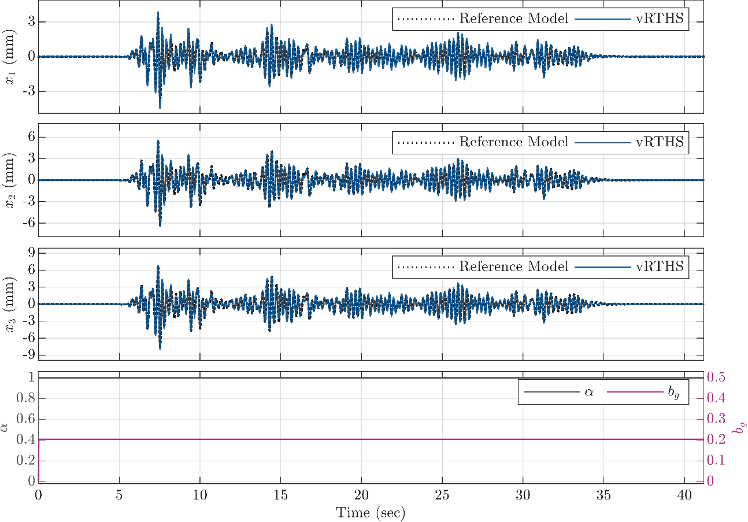
Figure 11. Simulation results for Case I, where the physical substructure is maintained undamaged and the high-performance controller is employed.

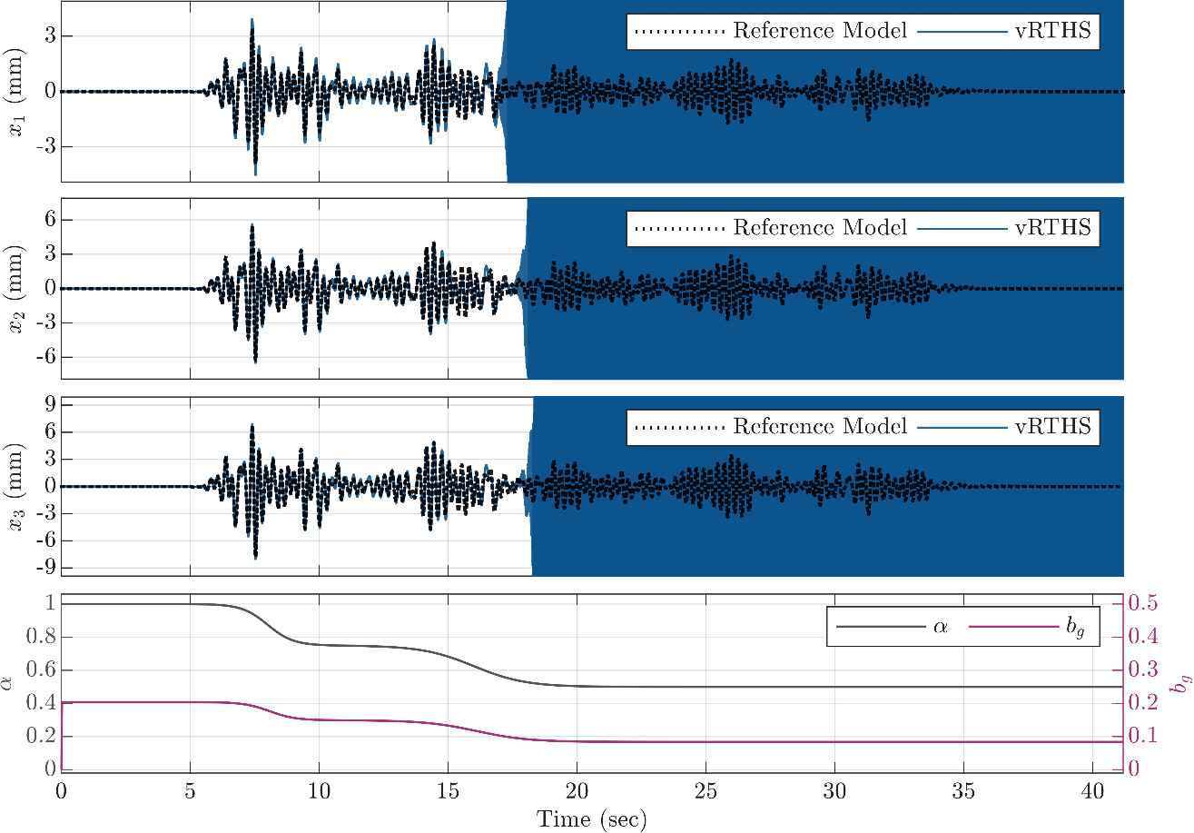
Figure 12: Case II results, demonstrating the high-performance controller's response to progressive damage.

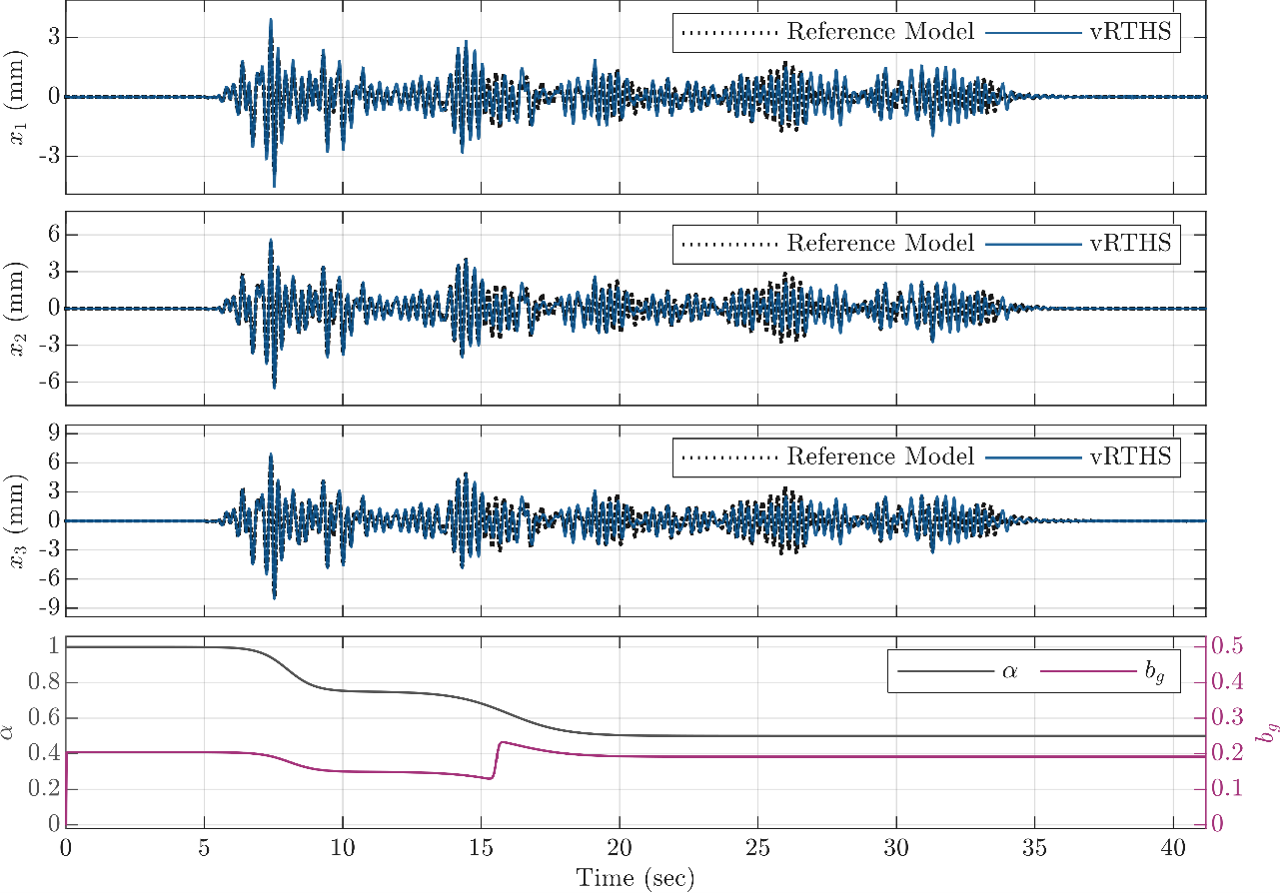
Figure 13: Case III results, demonstrating the effectiveness of the proposed control strategy, utilizing a smooth transition from the high-performance to the robust controller at the predefined stability threshold.
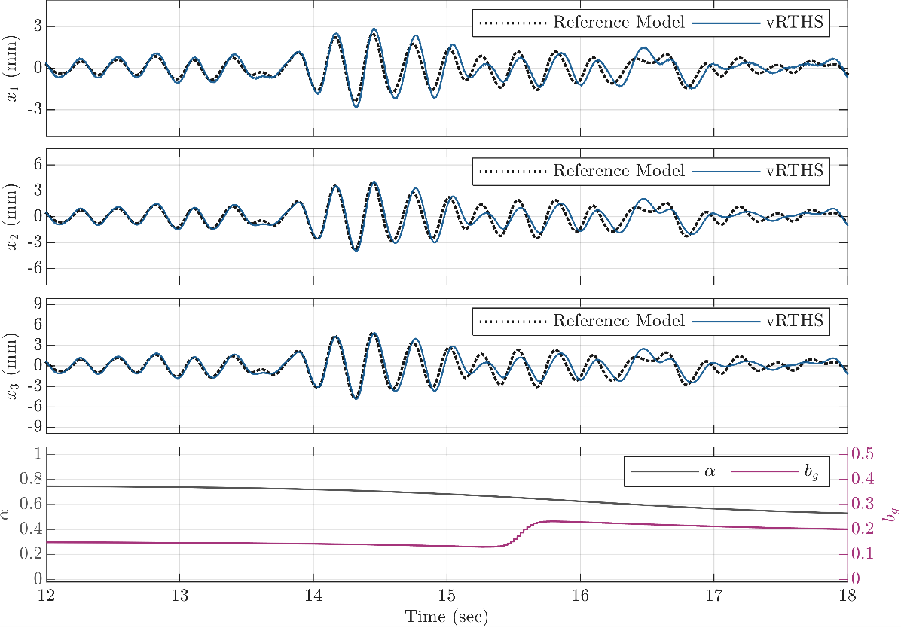
Figure 14: Zoomed-in time-history response for Case III, highlighting the performance-robustness trade-off

7-Conclusion
This work develops and demonstrates an online stability indicator based on the NCF stability margin that quantifies the robustness of the closed-loop system as the plant changes during testing and enables the adaptation of control techniques in response to those changes. While the indicator may be useful for detecting different types of adaptations, damage in the form of structural degradation is selected as a situation of interest to demonstrate its capabilities. For SISO settings, a closed-form stability boundary associated with specimen degradation is derived and utilized to perform a sensitivity analysis, showing that more flexible structures are more susceptible to instability caused by stiffness loss. A practical procedure is developed herein in which the indicator triggers a controller switch, and stability of the transition is ensured through the identification of a common Lyapunov function. An illustrative example based on a modified version of a benchmark problem confirms that the indicator provides an advance warning of diminishing robustness and potential instability, and that the controller transitions remain smooth, allowing the test to continue safely despite changes in the physical specimen. These results suggest that incorporating the proposed indicator into experimental systems can expand the range of feasible real-time hybrid simulations, enable more complex tests that are prone to changes in the physical substructure, and improve both test reliability and equipment safety by reducing the likelihood of unexpected instability.

Data Availability Statement
The simulation data that support the findings of this study are available from the corresponding author upon request.

Conflicts of Interest
The authors declare no conflicts of interest.

Funding
This work was supported by the U.S. National Science Foundation (NSF), Cyber-Physical Systems (CPS) program (Award No. CNS-2229136).

References

[1] S. J. Chapman, M. S. Williams, and A. Blakeborough, ‘Laboratory testing of structures under dynamic loads: an introductory review’, Philosophical Transactions of the Royal Society of London. Series A: Mathematical, Physical and Engineering Sciences, vol. 359, no. 1786, pp. 1651–1669, Sep. 2001, doi: 10.1098/rsta.2001.0860.
[2] R. T. Leon and G. G. Deierlein, ‘Considerations for the Use of Quasi-Static Testing’, Earthquake Spectra, vol. 12, no. 1, pp. 87–109, Feb. 1996, doi: 10.1193/1.1585869.
[3] M. Nakashima, H. Kato, and E. Takaoka, ‘Development of real-time pseudo dynamic testing’, Earthquake Engineering & Structural Dynamics, vol. 21, no. 1, pp. 79–92, 1992, doi: 10.1002/eqe.4290210106.
[4] S. A. Mahin, P.-S. B. Shing, C. R. Thewalt, and R. D. Hanson, ‘Pseudodynamic Test Method—Current Status and Future Directions’, Journal of Structural Engineering, vol. 115, no. 8, pp. 2113–2128, Aug. 1989, doi: 10.1061/(ASCE)0733-9445(1989)115:8(2113).
[5] A. Maghareh, S. J. Dyke, A. Prakash, and G. B. Bunting, ‘Establishing a predictive performance indicator for real-time hybrid simulation’, Earthquake Engineering & Structural Dynamics, vol. 43, no. 15, pp. 2299–2318, 2014, doi: 10.1002/eqe.2448.
[6] J. E. Carrion, ‘Model-based strategies for real-time hybrid testing’, Ph.D., University of Illinois at Urbana-Champaign, United States -- Illinois, 2007. Accessed: Aug. 23, 2025. [Online]. Available: https://www.proquest.com/docview/304858699/abstract/C7673E4A6EB14338PQ/1
[7] A. Najafi, G. A. Fermandois, S. J. Dyke, and B. F. Spencer, ‘Hybrid simulation with multiple actuators: A state-of-the-art review’, Engineering Structures, vol. 276, p. 115284, Feb. 2023, doi: 10.1016/j.engstruct.2022.115284.
[8] S. J. Dyke, B. F. Spencer, P. Quast, and M. K. Sain, ‘Role of Control-Structure Interaction in Protective System Design’, Journal of Engineering Mechanics, vol. 121, no. 2, pp. 322–338, Feb. 1995, doi: 10.1061/(ASCE)0733-9399(1995)121:2(322).
[9] A. Maghareh, C. E. Silva, and S. J. Dyke, ‘Servo-hydraulic actuator in controllable canonical form: Identification and experimental validation’, Mechanical Systems and Signal Processing, vol. 100, pp. 398–414, Feb. 2018, doi: 10.1016/j.ymssp.2017.07.022.
[10] C. E. Silva, D. Gomez, A. Maghareh, S. J. Dyke, and B. F. Spencer, ‘Benchmark control problem for real-time hybrid simulation’, Mechanical Systems and Signal Processing, vol. 135, p. 106381, Jan. 2020, doi: 10.1016/j.ymssp.2019.106381.
[11] J. W. Condori Uribe et al., ‘Experimental benchmark control problem for multi-axial real-time hybrid simulation’, Front. Built Environ., vol. 9, Nov. 2023, doi: 10.3389/fbuil.2023.1270996.
[12] H. Zhou, D. Xu, X. Shao, X. Ning, and T. Wang, ‘A robust linear-quadratic-gaussian controller for the real-time hybrid simulation on a benchmark problem’, Mechanical Systems and Signal Processing, vol. 133, p. 106260, Nov. 2019, doi: 10.1016/j.ymssp.2019.106260.
[13] A. Palacio-Betancur and M. Gutierrez Soto, ‘Adaptive tracking control for real-time hybrid simulation of structures subjected to seismic loading’, Mechanical Systems and Signal Processing, vol. 134, p. 106345, Dec. 2019, doi: 10.1016/j.ymssp.2019.106345.
[14] Z. Wang, X. Ning, G. Xu, H. Zhou, and B. Wu, ‘High performance compensation using an adaptive strategy for real-time hybrid simulation’, Mechanical Systems and Signal Processing, vol. 133, p. 106262, Nov. 2019, doi: 10.1016/j.ymssp.2019.106262.
[15] Y. Shangguan, Z. Wang, Y. Guo, Y. Chen, Y. Zeng, and H. Zhou, ‘Adaptive sliding-mode delay compensation for real-time hybrid simulations with multiple actuators’, Front. Built Environ., vol. 10, Aug. 2024, doi: 10.3389/fbuil.2024.1393710.
[16] A. J. Aguila, H. Li, A. Palacio-Betancur, K. A. Ahmed, I. Kovalenko, and M. Gutierrez Soto, ‘Conditional adaptive time series compensation and control design for multi-axial real-time hybrid simulation’, Front. Built Environ., vol. 10, May 2024, doi: 10.3389/fbuil.2024.1384235.
[17] A. Maghareh, S. J. Dyke, and C. E. Silva, ‘A Self-tuning Robust Control System for nonlinear real-time hybrid simulation’, Earthquake Engineering & Structural Dynamics, vol. 49, no. 7, pp. 695–715, 2020, doi: 10.1002/eqe.3260.
[18] P. j. Gawthrop, M. i. Wallace, S. a. Neild, and D. j. Wagg, ‘Robust real-time substructuring techniques for under-damped systems’, Structural Control and Health Monitoring, vol. 14, no. 4, pp. 591–608, 2007, doi: 10.1002/stc.174.
[19] O. Mercan and J. M. Ricles, ‘Stability analysis for real-time pseudodynamic and hybrid pseudodynamic testing with multiple sources of delay’, Earthquake Engineering & Structural Dynamics, vol. 37, no. 10, pp. 1269–1293, 2008, doi: 10.1002/eqe.814.
[20] F. Chi, J. Wang, and F. Jin, ‘Delay-dependent stability and added damping of SDOF real-time dynamic hybrid testing’, Earthq. Eng. Eng. Vib., vol. 9, no. 3, pp. 425–438, Sep. 2010, doi: 10.1007/s11803-010-0026-0.
[21] M. I. Wallace, J. Sieber, S. A. Neild, D. J. Wagg, and B. Krauskopf, ‘Stability analysis of real-time dynamic substructuring using delay differential equation models’, Earthquake Engineering & Structural Dynamics, vol. 34, no. 15, pp. 1817–1832, 2005, doi: 10.1002/eqe.513.
[22] Y. N. Kyrychko, K. B. Blyuss, A. Gonzalez-Buelga, S. J. Hogan, and D. J. Wagg, ‘Real-time dynamic substructuring in a coupled oscillator–pendulum system’, Proc. A, vol. 462, no. 2068, pp. 1271–1294, Jan. 2006, doi: 10.1098/rspa.2005.1624.
[23] X. S. Gao and S. You, ‘Dynamical stability analysis of MDOF real-time hybrid system’, Mechanical Systems and Signal Processing, vol. 133, p. 106261, 2019, doi: https://doi.org/10.1016/j.ymssp.2019.106261.
[24] F. Zhu, J.-T. Wang, F. Jin, F.-D. Chi, and Y. Gui, ‘Stability analysis of MDOF real-time dynamic hybrid testing systems using the discrete-time root locus technique’, Earthquake Engineering & Structural Dynamics, vol. 44, no. 2, pp. 221–241, 2015, doi: 10.1002/eqe.2467.
[25] C. Gálmez and G. Fermandois, ‘Online Stability Analysis for Real-Time Hybrid Simulation Testing’, Front. Built Environ., vol. 6, Aug. 2020, doi: 10.3389/fbuil.2020.00134.
[26] M. Ahmadizadeh and G. Mosqueda, ‘Online energy-based error indicator for the assessment of numerical and experimental errors in a hybrid simulation’, Engineering Structures, vol. 31, no. 9, pp. 1987–1996, Sep. 2009, doi: 10.1016/j.engstruct.2009.03.002.
[27] Z. Tang, M. Dietz, and Z. Li, ‘Substructuring stability analysis in light of comprehensive transfer system dynamics’, Bull Earthquake Eng, vol. 16, no. 1, pp. 129–154, Jan. 2018, doi: 10.1007/s10518-017-0192-9.
[28] H. Zhou, X. Shao, B. Zhang, P. Tan, and T. Wang, ‘Relative stability analysis for robustness design of real-time hybrid simulation’, Soil Dynamics and Earthquake Engineering, vol. 165, p. 107681, Feb. 2023, doi: 10.1016/j.soildyn.2022.107681.
[29] A. P. Darby, M. S. Williams, and A. Blakeborough, ‘Stability and Delay Compensation for Real-Time Substructure Testing’, Journal of Engineering Mechanics, vol. 128, no. 12, pp. 1276–1284, Dec. 2002, doi: 10.1061/(ASCE)0733-9399(2002)128:12(1276).
[30] L. Huang, C. Chen, Y. Pu, J. Wang, and T. Guo, ‘Stability analysis of real time hybrid simulation under coupled actuator delay and nonlinear behavior’, doi: 10.1002/eqe.3667.
[31] T. Wang, H. Zhou, X. Zhang, and T. Ran, ‘Stability of an explicit time-integration algorithm for hybrid tests, considering stiffness hardening behavior’, Earthq. Eng. Eng. Vib., vol. 17, no. 3, pp. 595–606, Jul. 2018, doi: 10.1007/s11803-018-0465-6.
[32] D. M. Williams, M. S. Williams, and A. Blakeborough, ‘Numerical Modeling of a Servohydraulic Testing System for Structures’, Journal of Engineering Mechanics, vol. 127, no. 8, pp. 816–827, Aug. 2001, doi: 10.1061/(ASCE)0733-9399(2001)127:8(816).
[33] H. Nyquist, ‘Regeneration Theory’, Bell System Technical Journal, vol. 11, no. 1, pp. 126–147, 1932, doi: 10.1002/j.1538-7305.1932.tb02344.x.
[34] H. W. Bode, Network analysis and feedback amplifier design. D. Van Nostrand Company, Inc., 1945.
[35] G. F. Franklin, J. D. Powell, M. L. Workman, and others, Digital control of dynamic systems, vol. 3. Addison-wesley Menlo Park, 1998.
[36] A. Ingimundarson and T. Hägglund, ‘Robust tuning procedures of dead-time compensating controllers’, Control Engineering Practice, vol. 9, no. 11, pp. 1195–1208, Nov. 2001, doi: 10.1016/S0967-0661(01)00065-X.
[37] K. Ogata, Modern Control Engineering, 5th edn. Upper Saddle River, NJ: Prentice Hall, 2010.
[38] K. Ogata, ‘Modern control engineering’, 2020.
[39] P. Seiler, A. Packard, and P. Gahinet, ‘An Introduction to Disk Margins [Lecture Notes]’, IEEE Control Systems Magazine, vol. 40, no. 5, pp. 78–95, Oct. 2020, doi: 10.1109/MCS.2020.3005277.
[40] K. Glover and D. McFarlane, ‘Robust stabilization of normalized coprime factor plant descriptions with H/sub infinity /-bounded uncertainty’, IEEE Transactions on Automatic Control, vol. 34, no. 8, pp. 821–830, Aug. 1989, doi: 10.1109/9.29424.
[41] G. Vinnicombe, ‘Measuring robustness of feedback systems’, PhD Thesis, University of Cambridge, 1992.
[42] J. Park and R. R. Bitmead, ‘Simultaneous scaling for MIMO controller certification’, in 2007 46th IEEE Conference on Decision and Control, Dec. 2007, pp. 4409–4414. doi: 10.1109/CDC.2007.4434796.
[43] K. M. Halsey, ‘Robust Stability in a Classical and Modern Context’, in Proceedings of the 44th IEEE Conference on Decision and Control, Dec. 2005, pp. 2308–2313. doi: 10.1109/CDC.2005.1582506.
[44] K. Zhou and J. C. Doyle, Essentials of robust control, vol. 104. Prentice hall Upper Saddle River, NJ, 1998.
[45] D. Liberzon, Switching in Systems and Control. in Systems & Control: Foundations & Applications. Boston, MA: Birkhäuser, 2003. doi: 10.1007/978-1-4612-0017-8.
[46] K. S. Narendra and J. Balakrishnan, ‘A common Lyapunov function for stable LTI systems with commuting A-matrices’, IEEE Transactions on Automatic Control, vol. 39, no. 12, pp. 2469–2471, Dec. 1994, doi: 10.1109/9.362846.

Table 1: Comparative summary of RTHS stability indicators
Criterion | Delay-Margin Based | Gain-Margin Based | Z-plane unit-circle | Energy Based | NCF Margin Based
Examples | [5], [18]–[24], [29], [30] | [27] | [28], [31] | [25], [26] | -
Quantifies stability under coupled gain and delay variations | No | No | Yes | Yes | Yes
Inherently extensible to MIMO systems | Partially (Not with high-fidelity representation of the transfer system) | Partially (Not with high-fidelity representation of the transfer system) | Partially (Not with high-fidelity representation of the transfer system) | Yes | Yes
Reliable for online application ª | Partially (Not with high-fidelity representation of the transfer system) | Partially (Not with high-fidelity representation of the transfer system) | Partially (Not with high-fidelity representation of the transfer system) | Yes | Yes (can be computationally expensive)
Tunable warning lead time | Yes | Yes | Yes | No | Yes
Transfer system dynamics representation ^{b} | Pure time delay simplification | High-fidelity representation | High-fidelity representation | N/A | High-fidelity representation
Scope of Stability  Analysis ^{c} | The numerical substructure loop (Figure 1) | The numerical substructure loop (Figure 1) | The numerical substructure loop (Figure 1) | The numerical substructure loop (Figure 1) | The outer controller loop (Figure 2)
Is Experimentally Verified | Yes (not evaluated in real-time) | Yes (not evaluated in real-time) | Yes (not evaluated in real-time) | Yes (evaluated in real-time) | No
ª This criterion denotes the indicator’s computational feasibility and reliability for online evaluation under time-varying physical-substructure dynamics. A functioning model-updating scheme is assumed to supply the required parameters online; additionally, these parameters are assumed to be approximately constant over the estimation window.
^{b} Although delay-margin-based indicators can be extended to incorporate high-fidelity representation of the transfer-system, they have primarily been studied using a lumped pure time-delay representation.
^{c} Although these stability indicators can be applied to any of the nested loops within the RTHS architecture, the table specifically denotes the loops evaluated in the cited examples. As noted earlier, this study focuses on the outer controller loop, since this approach enables detecting instability arising from structural degradation.

Table 2. Virtual system and controller parameters
Parameter | Nominal value | Units
a₁β₀ | 2.13 × 10¹³ | m Pa/s
a₂ | 4.23 × 10⁶ | m Pa
a₃ | 3.3 | 1/s
β₁ | 425 | non-dimensional
β₂ | 10 × 10⁴ | 1/s
mₑ | 37.83 | kg
kₑ | 1.19 × 10⁶ | N/m
cₑ | 114.6 | kg/s
Controller A Kₚ | 1.41 | non-dimensional
Controller A Kᵢ | 97.1 | non-dimensional
Controller B Kₚ | 0.978 | non-dimensional
Controller B Kᵢ | 78.6 | non-dimensional

Table 3: $J_{4}$, normalized RMS global displacement error of the first floor.
Simulation Case |  | Segment 1  (t < 7sec) | Segment 2  (7 < t < 12sec) | Segment 3  (t > 12sec) | Overall
Original Benchmark |  | 16.20% | 34.90% | 38.12% | 36.08%
Modified Benchmark | Case I | 18.39% | 33.61% | 37.83% | 35.53%
Modified Benchmark | Case II | 17.41% | 27.04% | NA | NA
Modified Benchmark | Case III | 17.41% | 27.04% | 78.67% | 62.88%

Table 4: $J_{5}$, normalized RMS relative displacement error of the second floor.
Simulation Case |  | Segment 1  (t < 7sec) | Segment 2  (7 < t < 12sec) | Segment 3  (t > 12sec) | Overall
Original Benchmark |  | 13.13% | 31.51% | 33.96% | 32.26%
Modified Benchmark | Case I | 14.07% | 27.85% | 30.92% | 29.14%
Modified Benchmark | Case II | 12.60% | 19.14% | NA | NA
Modified Benchmark | Case III | 12.60% | 19.14% | 69.81% | 55.14%

Table 5: $J_{6}$, normalized RMS relative displacement error of the third floor.
Simulation Case |  | Segment 1  (t < 7sec) | Segment 2  (7 < t < 12sec) | Segment 3  (t > 12sec) | Overall
Original Benchmark |  | 13.20% | 31.63% | 34.07% | 32.38%
Modified Benchmark | Case I | 14.13% | 28.00% | 31.08% | 29.31%
Modified Benchmark | Case II | 12.66% | 19.07% | NA | NA
Modified Benchmark | Case III | 12.66% | 19.07% | 69.36% | 54.83%

Corresponding author.
Graduate Research Assistant, Lyles School of Civil and Construction Engineering, Purdue University, West Lafayette, IN 47907.
Lecturer, Lyles School of Civil and Construction Engineering, Purdue University, West Lafayette, IN 47907.
Donald and Patricia Coates Professor of Innovation, School of Mechanical Engineering, and Lyles School of Civil and Construction Engineering, Purdue University, West Lafayette, IN 47907.

