**Name : Muhammad Hamza Iqbal**

**Roll No: BSEF17A509**

**OS LAB – 01**

**Basic Shell Commands:**

1. **Whoami is used to display user name**

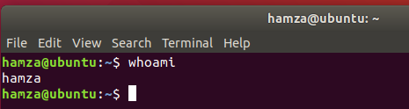

1. **Create file in /tmp**

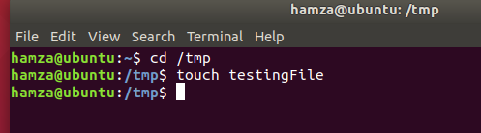

1. **To check info about file ls –l is use – in the beginning show it’s a file.**

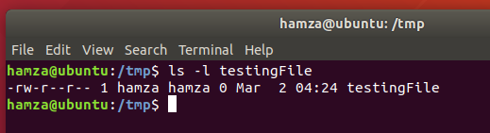

1. **rm is use to delete a file while rmdir is use to delete an empty directory.**

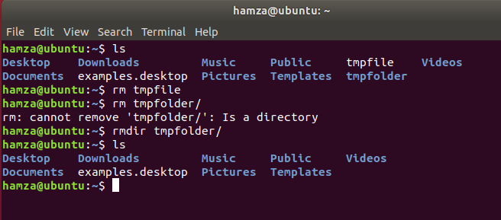

1. **cd /home is use to go back in home directory directly.**

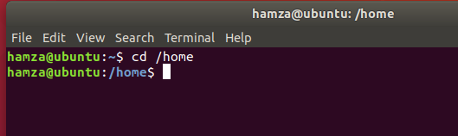

1. **mv “tryit&” “tryit_now” use to rename file.**

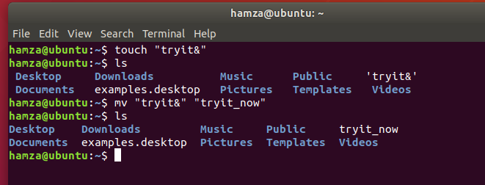

1. **alias myclear=”clear” use to give another name to a command.**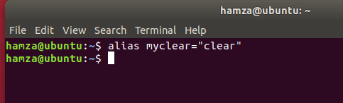
2. **(a)- output will be when u run cls at last then it display all directories in pwd.**

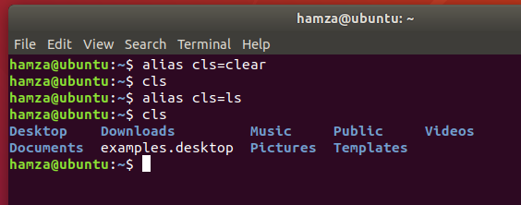

1. **(b)-Output will be can’t create directory with same name already exsit.**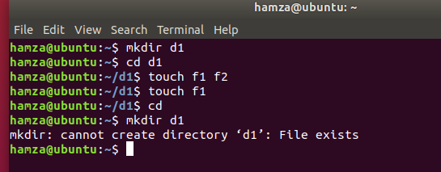

**QUESTIONS**

1. **‘mkdir /tmp/Bsef17a509 /tmp/Bsef17a509/Hamza /tmp/Bsef17a509/Hamza/OS’ this single command is use to create three directories.**

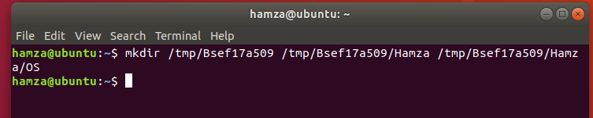

1. **ls –ad .* -l is use to display hidden files with details.**

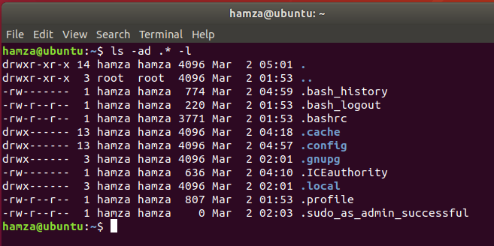

1. **1- rmdir /tmp/Bsef17a509/Hamza/OS/ /tmp/bsef17a509/Hamza/ /tmp/Bsef17a509/**

**Or**

**2**- rm –r /tmp/Bsef17a509

**These two method can be used to delete directories with subdirectories**.

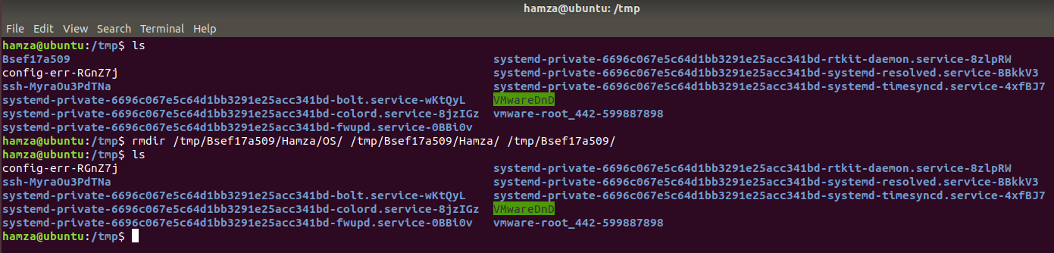

1. **cat > testFile is use to create file as well as allow to write.**

**cat -n testFil is use to display text with lines no.**

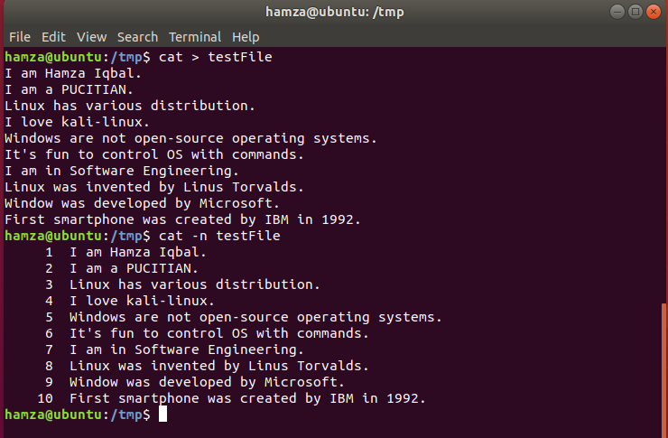

**5- mv “testFile” “test@file!” use to rename file.**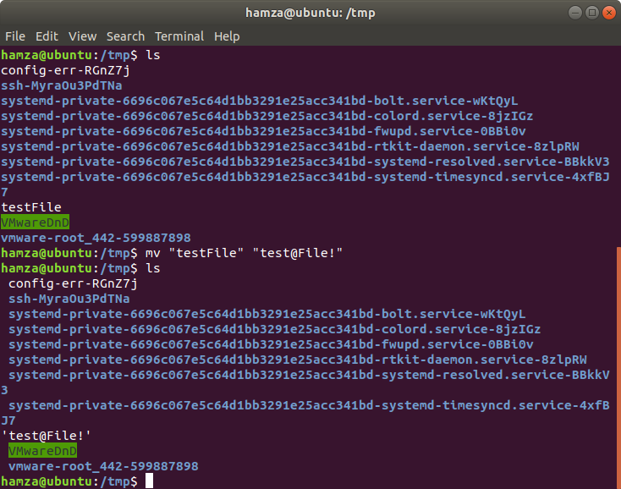

1. **tail -2 test@file! Is use to display last 2 lines.**

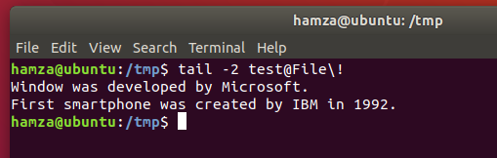

1. **alias unleash=”ls –ad .* -l” now unleash can be use to display hidden files with details.**

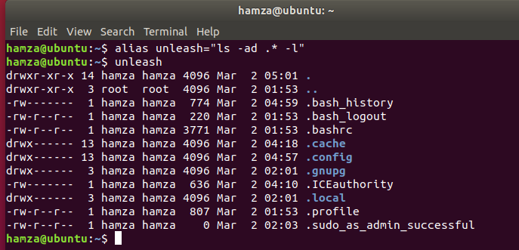

1. **I use man command-name to display command details.**
2. **Type type is use to display type command type if it’s builtin then it’s mean it’s internal command.**

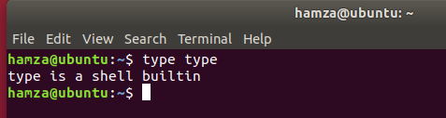

1. **rm –r directory-name can be use to remove directory.**

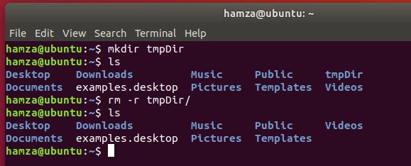

**Absolute/Relative Path**

1. **mkdir /home/dillawer/reports use to make directory in dillawer.**

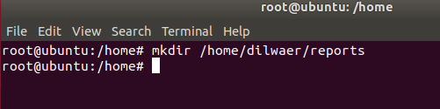

1. **sudo mkdir /home/abdul is use to make directory abdul in home.**

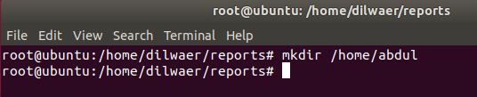

1. **touch ../../abdul/file1 is use to make file1 in abdul pwd reports.**

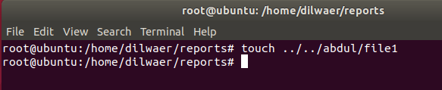

1. **mkdir ../staff/arif ../staff/rauf use to make directories in staff using relative path pwd abdul.**

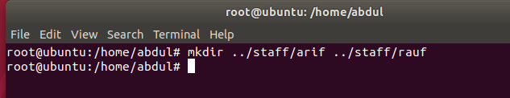

1. **touch arif/file2 rauf/file3 use to make file2 and file3 in arif and raud pwd staff.**

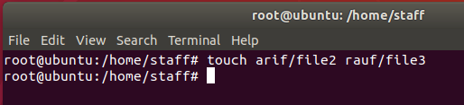

1. **cp /home/staff/arif/file2 /home/abdul/**

**cp /home/staff/rauf/file3 /home/abdul/**

**use to copy file2 and 3 in abdul using absolute path.**

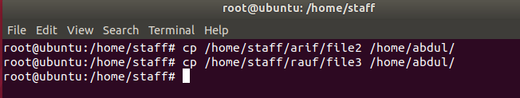

1. **cp –r ../staff/ ../dilwaer/newdir/ use to copy staff directory with it’s subdirectories to dilawer/newdir.**

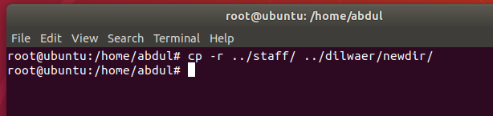

1. **rm –r ../../staff use to remove staff with it’s subdirectories pwd dilwaer/newdir.**

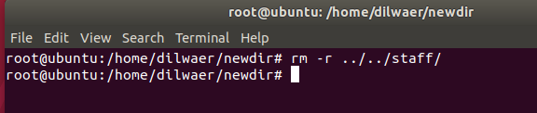

**9-mv staff/arif/file2 staff/arif/refile2 rename file2 with refile2 pwd**

**newdir.**

